Supplementary figures and tables
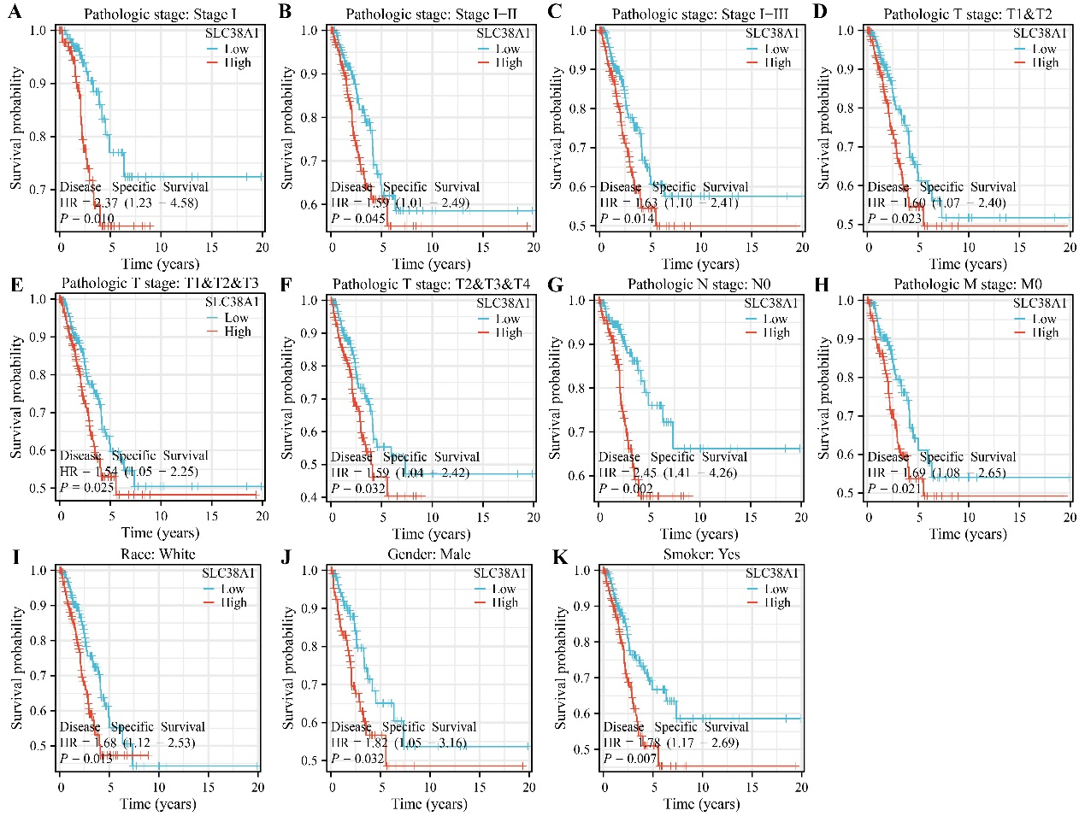
Figure S1. SLC38A1 overexpression and poor disease-free survival in subgroup LUAD patients.
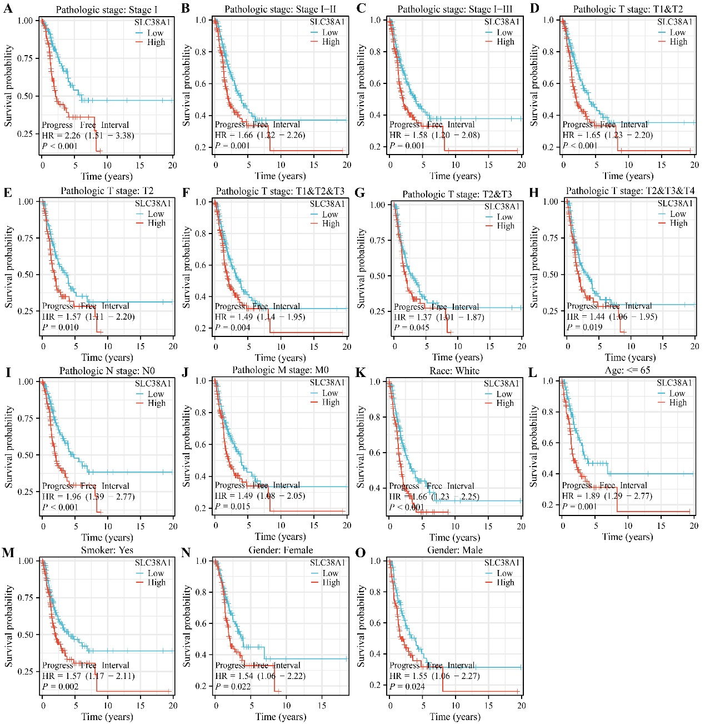
Figure S2. SLC38A1 overexpression and progression-free interval in subgroup LUAD patients.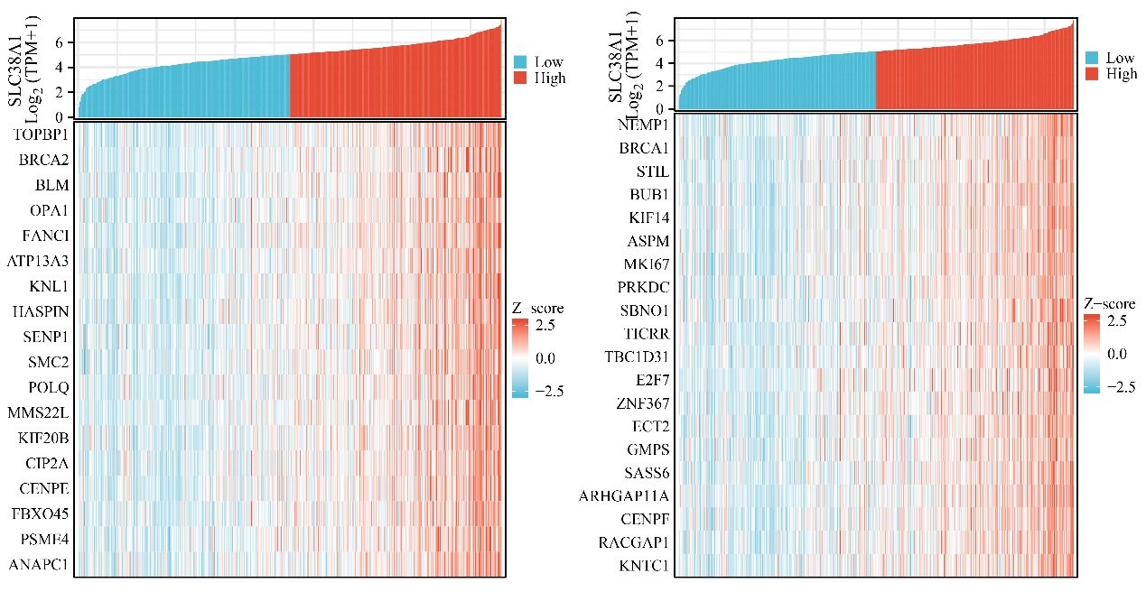
Figure S3. Visualization of SLC38A1 co-expressed genes using heatmap.
Table S.
Table S1. SLC38A1 co-expressed genes.
Gene | Coefficient | P value | Gene | Coefficient | P value
RECQL | 0.511405765 | 0 | KIF11 | 0.551908377 | 2.70768E-44
ANLN | 0.506852686 | 0 | KIF20B | 0.578918626 | 1.49424E-49
BRCA1 | 0.56632271 | 4.86256E-47 | CENPE | 0.574310792 | 1.27687E-48
DEPDC1 | 0.517826519 | 2.62198E-38 | SCAF11 | 0.52647468 | 9.19616E-40
VRK2 | 0.515666193 | 5.96509E-38 | TMTC3 | 0.503701992 | 0
UBA6 | 0.516572446 | 0 | NEDD1 | 0.549338169 | 8.0958E-44
R3HDM1 | 0.529776188 | 2.49458E-40 | BRCA2 | 0.609156465 | 4.7325E-56
POLQ | 0.586019215 | 5.12045E-51 | SBNO1 | 0.561762224 | 0
MPHOSPH9 | 0.529558856 | 2.71949E-40 | DENR | 0.519875027 | 0
NDC1 | 0.530504892 | 1.86678E-40 | DIAPH3 | 0.517811662 | 2.6369E-38
QSER1 | 0.521283467 | 0 | FANCI | 0.594362202 | 8.72988E-53
TAF2 | 0.522706007 | 0 | TICRR | 0.561295178 | 4.56924E-46
MCM10 | 0.508035643 | 1.03817E-36 | PLK4 | 0.547748836 | 1.58613E-43
DIP2B | 0.551960543 | 0 | ASXL2 | 0.541446223 | 2.20461E-42
ASPM | 0.565110987 | 8.37329E-47 | FANCD2 | 0.547414458 | 1.82637E-43
PSME4 | 0.572341764 | 3.16093E-48 | CCNA2 | 0.507934362 | 0
DNAJC10 | 0.503261898 | 5.9792E-36 | SKP2 | 0.502998175 | 6.58113E-36
SENP1 | 0.587386251 | 2.64896E-51 | MMS22L | 0.582363985 | 2.93774E-50
RIF1 | 0.550582297 | 0 | NCAPG2 | 0.53026323 | 2.05533E-40
RBL1 | 0.529914347 | 0 | HAUS6 | 0.526285521 | 9.90562E-40
GSK3B | 0.517267174 | 3.24568E-38 | CEP78 | 0.539069718 | 5.86239E-42
RAD54L | 0.517155136 | 3.38725E-38 | MKI67 | 0.562850579 | 2.29406E-46
DNM1L | 0.529409258 | 0 | INCENP | 0.501931997 | 0
TPX2 | 0.50802364 | 0 | CHEK1 | 0.548766907 | 1.03139E-43
KIF4A | 0.515456668 | 0 | NCAPD3 | 0.547283165 | 0
CDV3 | 0.510082465 | 0 | SACS | 0.511077221 | 3.35348E-37
CLSPN | 0.549593329 | 7.26478E-44 | ANAPC1 | 0.569955459 | 9.40498E-48
CBX5 | 0.534241101 | 4.17567E-41 | ASAP1 | 0.53554872 | 0
CENPI | 0.510060682 | 4.89857E-37 | NUP205 | 0.536009898 | 0
CEP152 | 0.524116127 | 2.31518E-39 | TBC1D31 | 0.560681987 | 5.98935E-46
POP1 | 0.532206119 | 9.4616E-41 | ATAD2 | 0.545968524 | 0
UBR5 | 0.5058386 | 0 | SASS6 | 0.558015193 | 1.93068E-45
TASOR2 | 0.504428944 | 3.90715E-36 | BUB1B | 0.538235173 | 8.24951E-42
NSD2 | 0.510427544 | 0 | RACGAP1 | 0.554502282 | 8.8786E-45
NCAPG | 0.540837345 | 2.8345E-42 | LARP4 | 0.508057981 | 1.02963E-36
NAA25 | 0.542234116 | 0 | CIP2A | 0.574373593 | 1.24036E-48
SLC38A1 | 1 | 0 | SGO2 | 0.532541254 | 0
CAND1 | 0.500814763 | 0 | GMPS | 0.558894088 | 1.31428E-45
NUP107 | 0.516992214 | 3.60412E-38 | TOPBP1 | 0.61875557 | 0
TIMELESS | 0.50549924 | 2.641E-36 | KIF15 | 0.521847708 | 5.58832E-39
ASCC3 | 0.514807442 | 8.25683E-38 | WDR43 | 0.507883756 | 1.09811E-36
TTK | 0.549436959 | 7.76342E-44 | YEATS2 | 0.507194316 | 0
LMNB1 | 0.526925359 | 7.70242E-40 | ZNF367 | 0.559245762 | 1.12646E-45
NUP155 | 0.509868323 | 5.26198E-37 | DDIAS | 0.539152555 | 5.66665E-42
KPNA1 | 0.517437098 | 0 | E2F7 | 0.559507634 | 1.00414E-45
ECT2 | 0.558949838 | 1.28256E-45 | ARL5B | 0.505777188 | 2.38505E-36
TTL | 0.509093314 | 7.01728E-37 | NEMP1 | 0.569441612 | 1.18801E-47
MSH6 | 0.506219313 | 0 | PATL1 | 0.500227667 | 1.79366E-35
TTF2 | 0.504456148 | 3.86852E-36 | ZNF146 | 0.522275224 | 4.73563E-39
CENPF | 0.55521722 | 0 | RFWD3 | 0.508894278 | 7.55482E-37
STAG1 | 0.512058958 | 2.32289E-37 | CKAP2L | 0.545014769 | 5.002E-43
KIF14 | 0.565271774 | 7.79171E-47 | BUB1 | 0.565357248 | 7.49905E-47
CASP8AP2 | 0.505617629 | 2.52881E-36 | MFN1 | 0.502892565 | 6.83868E-36
HELLS | 0.539829034 | 4.29273E-42 | ESCO2 | 0.526251805 | 1.00377E-39
MASTL | 0.50581607 | 0 | MTBP | 0.535781973 | 2.23939E-41
UTP20 | 0.544085592 | 7.37262E-43 | FBXO45 | 0.573229767 | 2.10187E-48
TMPO | 0.526747637 | 0 | EXO1 | 0.535786226 | 2.23553E-41
NCAPH | 0.516822127 | 3.84522E-38 | ZWILCH | 0.551622898 | 0
NAA50 | 0.54902879 | 0 | RSRC1 | 0.527564163 | 0
KIF18A | 0.543637978 | 8.88373E-43 | DHX36 | 0.534823972 | 3.30012E-41
STIL | 0.565948155 | 0 | ATR | 0.509702011 | 5.59763E-37
AGO2 | 0.552461006 | 2.1369E-44 | CKAP5 | 0.516088432 | 0
MCM8 | 0.526259525 | 1.00073E-39 | ATAD5 | 0.551235023 | 3.61088E-44
DLGAP5 | 0.516980977 | 0 | B3GNT5 | 0.534982171 | 0
PPAT | 0.502067916 | 9.22473E-36 | HASPIN | 0.588834184 | 1.31345E-51
E2F8 | 0.51217133 | 0 | GEN1 | 0.534848334 | 3.26779E-41
CCNT1 | 0.52982029 | 2.45124E-40 | SUZ12 | 0.50353884 | 0
MIS18BP1 | 0.510619433 | 0 | PTPN11 | 0.528538093 | 0
SGO1 | 0.520642862 | 8.89971E-39 | FANCB | 0.512742316 | 1.79772E-37
TOP2A | 0.532489613 | 8.44541E-41 | CEP97 | 0.503422588 | 5.63952E-36
RFC3 | 0.524258192 | 2.19039E-39 | KNTC1 | 0.554171364 | 1.02414E-44
ATP13A3 | 0.594056183 | 0 | XPOT | 0.544164427 | 0
SLC38A2 | 0.518665296 | 0 | CDCA2 | 0.534507286 | 3.75042E-41
SYNCRIP | 0.537201476 | 1.25779E-41 | PARPBP | 0.534500458 | 3.76077E-41
ESPL1 | 0.508858481 | 0 | KIF24 | 0.52883543 | 0
USP37 | 0.500825588 | 1.44578E-35 | ERCC6L | 0.521459446 | 6.49374E-39
CKAP2 | 0.535760227 | 0 | FAM72B | 0.509714119 | 5.5725E-37
BORA | 0.540380343 | 3.42177E-42 | FAM111B | 0.506472212 | 1.84765E-36
BRIP1 | 0.541289348 | 2.3522E-42 | SFTA2 | -0.517105813 | 0
SMC2 | 0.586867204 | 3.40341E-51 | PIK3R4 | 0.502817723 | 0
NCBP1 | 0.522666158 | 0 | PRPF40A | 0.514219638 | 1.03093E-37
DSCC1 | 0.515173279 | 0 | BLM | 0.59972404 | 5.9842E-54
KIF23 | 0.546278247 | 2.9458E-43 | WDHD1 | 0.538329276 | 0
KNL1 | 0.593817608 | 1.14291E-52 | ARHGAP11A | 0.556396214 | 3.90909E-45
SELENOI | 0.527907862 | 0 | OPA1 | 0.594516518 | 0
CENPO | 0.521501794 | 0 | PRKDC | 0.562175813 | 0
Table S2. Functions of SLC38A1 co-expressed genes.
ID | Description | Adjust P value | Count
GO:0048285 | organelle fission | 4.98218E-35 | 49
GO:0000280 | nuclear division | 6.92579E-35 | 47
GO:0140014 | mitotic nuclear division | 4.31091E-31 | 38
GO:0007059 | chromosome segregation | 1.26791E-29 | 39
GO:0098813 | nuclear chromosome segregation | 5.51291E-29 | 36
GO:0000819 | sister chromatid segregation | 1.66773E-24 | 29
GO:0000070 | mitotic sister chromatid segregation | 1.12786E-22 | 26
GO:0007346 | regulation of mitotic cell cycle | 2.99045E-19 | 34
GO:0044772 | mitotic cell cycle phase transition | 2.46156E-18 | 32
GO:1901987 | regulation of cell cycle phase transition | 4.36307E-18 | 31
GO:1901990 | regulation of mitotic cell cycle phase transition | 8.34821E-16 | 26
GO:0010948 | negative regulation of cell cycle process | 1.94235E-15 | 25
GO:0000075 | cell cycle checkpoint signaling | 4.41299E-15 | 20
GO:0006260 | DNA replication | 4.68192E-14 | 23
GO:1901988 | negative regulation of cell cycle phase transition | 7.17849E-14 | 22
GO:0006310 | DNA recombination | 9.26527E-14 | 24
GO:1903046 | meiotic cell cycle process | 1.63819E-13 | 20
GO:0006261 | DNA-templated DNA replication | 2.64807E-13 | 18
GO:0045786 | negative regulation of cell cycle | 4.46851E-13 | 25
GO:0051321 | meiotic cell cycle | 1.53071E-12 | 21
GO:0007093 | mitotic cell cycle checkpoint signaling | 2.22075E-12 | 16
GO:0140694 | non-membrane-bounded organelle assembly | 2.22075E-12 | 24
GO:0006302 | double-strand break repair | 2.2292E-12 | 21
GO:0007088 | regulation of mitotic nuclear division | 3.21501E-12 | 15
GO:0007051 | spindle organization | 3.54198E-12 | 18
GO:0140013 | meiotic nuclear division | 3.54198E-12 | 18
GO:0045930 | negative regulation of mitotic cell cycle | 1.31598E-11 | 19
GO:0051052 | regulation of DNA metabolic process | 2.71979E-11 | 25
GO:1901991 | negative regulation of mitotic cell cycle phase transition | 2.73093E-11 | 17
GO:0051983 | regulation of chromosome segregation | 6.53439E-11 | 13
GO:0051783 | regulation of nuclear division | 7.25995E-11 | 15
GO:0051304 | chromosome separation | 1.42062E-10 | 13
GO:0000910 | cytokinesis | 1.42062E-10 | 16
GO:0007052 | mitotic spindle organization | 2.05997E-10 | 14
GO:1902850 | microtubule cytoskeleton organization involved in mitosis | 2.17211E-10 | 15
GO:0033044 | regulation of chromosome organization | 2.40994E-10 | 17
GO:0007091 | metaphase/anaphase transition of mitotic cell cycle | 2.64141E-10 | 11
GO:0010965 | regulation of mitotic sister chromatid separation | 4.30865E-10 | 11
GO:0044784 | metaphase/anaphase transition of cell cycle | 4.30865E-10 | 11
GO:0045787 | positive regulation of cell cycle | 4.30865E-10 | 20
GO:0000724 | double-strand break repair via homologous recombination | 5.15934E-10 | 15
GO:0000725 | recombinational repair | 6.01527E-10 | 15
GO:0051306 | mitotic sister chromatid separation | 6.55604E-10 | 11
GO:0032508 | DNA duplex unwinding | 7.91732E-10 | 12
GO:0033045 | regulation of sister chromatid segregation | 1.17274E-09 | 11
GO:1905818 | regulation of chromosome separation | 1.17274E-09 | 11
GO:0042770 | signal transduction in response to DNA damage | 1.26083E-09 | 15
GO:0032392 | DNA geometric change | 1.55056E-09 | 12
GO:0045132 | meiotic chromosome segregation | 1.55056E-09 | 12
GO:0031570 | DNA integrity checkpoint signaling | 1.97882E-09 | 13
GO:0051302 | regulation of cell division | 3.01134E-09 | 15
GO:0071103 | DNA conformation change | 3.38691E-09 | 12
GO:0030071 | regulation of mitotic metaphase/anaphase transition | 3.38691E-09 | 10
GO:0006275 | regulation of DNA replication | 4.082E-09 | 13
GO:0007062 | sister chromatid cohesion | 5.31411E-09 | 10
GO:1902099 | regulation of metaphase/anaphase transition of cell cycle | 5.31411E-09 | 10
GO:0045839 | negative regulation of mitotic nuclear division | 9.28566E-09 | 9
GO:0000077 | DNA damage checkpoint signaling | 1.1225E-08 | 12
GO:0032465 | regulation of cytokinesis | 1.243E-08 | 11
GO:0070192 | chromosome organization involved in meiotic cell cycle | 1.94643E-08 | 10
GO:0044839 | cell cycle G2/M phase transition | 2.96912E-08 | 13
GO:0051784 | negative regulation of nuclear division | 3.0733E-08 | 9
GO:0007098 | centrosome cycle | 4.71947E-08 | 12
GO:0010639 | negative regulation of organelle organization | 6.09627E-08 | 18
GO:0000086 | G2/M transition of mitotic cell cycle | 9.82667E-08 | 12
GO:0090068 | positive regulation of cell cycle process | 1.20472E-07 | 15
GO:0031023 | microtubule organizing center organization | 1.42369E-07 | 12
GO:0034508 | centromere complex assembly | 1.99719E-07 | 7
GO:0034502 | protein localization to chromosome | 2.18224E-07 | 10
GO:0051225 | spindle assembly | 2.26108E-07 | 11
GO:0034501 | protein localization to kinetochore | 2.52748E-07 | 6
GO:1903083 | protein localization to condensed chromosome | 2.52748E-07 | 6
GO:0000281 | mitotic cytokinesis | 2.71624E-07 | 9
GO:0090329 | regulation of DNA-templated DNA replication | 3.75762E-07 | 8
GO:0000018 | regulation of DNA recombination | 4.86811E-07 | 11
GO:0007135 | meiosis II | 5.03859E-07 | 5
GO:0061983 | meiosis II cell cycle process | 5.03859E-07 | 5
GO:2001020 | regulation of response to DNA damage stimulus | 7.6473E-07 | 14
GO:0007094 | mitotic spindle assembly checkpoint signaling | 7.6473E-07 | 7
GO:0071173 | spindle assembly checkpoint signaling | 7.6473E-07 | 7
GO:0071174 | mitotic spindle checkpoint signaling | 7.6473E-07 | 7
GO:0044773 | mitotic DNA damage checkpoint signaling | 7.86754E-07 | 9
GO:0070601 | centromeric sister chromatid cohesion | 7.9571E-07 | 5
GO:0031577 | spindle checkpoint signaling | 8.92215E-07 | 7
GO:0010212 | response to ionizing radiation | 9.94393E-07 | 11
GO:0045841 | negative regulation of mitotic metaphase/anaphase transition | 1.04867E-06 | 7
GO:0044774 | mitotic DNA integrity checkpoint signaling | 1.13622E-06 | 9
GO:0071459 | protein localization to chromosome, centromeric region | 1.29294E-06 | 6
GO:1902100 | negative regulation of metaphase/anaphase transition of cell cycle | 1.43957E-06 | 7
GO:0051053 | negative regulation of DNA metabolic process | 1.43957E-06 | 11
GO:2001251 | negative regulation of chromosome organization | 1.6225E-06 | 9
GO:0033046 | negative regulation of sister chromatid segregation | 1.6225E-06 | 7
GO:0033048 | negative regulation of mitotic sister chromatid segregation | 1.6225E-06 | 7
GO:2000816 | negative regulation of mitotic sister chromatid separation | 1.6225E-06 | 7
GO:0051985 | negative regulation of chromosome segregation | 2.20499E-06 | 7
GO:1905819 | negative regulation of chromosome separation | 2.20499E-06 | 7
GO:0033047 | regulation of mitotic sister chromatid segregation | 2.5553E-06 | 7
GO:0090307 | mitotic spindle assembly | 2.78277E-06 | 8
GO:0045005 | DNA-templated DNA replication maintenance of fidelity | 3.93143E-06 | 7
GO:0061640 | cytoskeleton-dependent cytokinesis | 4.08816E-06 | 9
GO:0051298 | centrosome duplication | 4.69166E-06 | 8
GO:0032886 | regulation of microtubule-based process | 5.10175E-06 | 13
GO:0061982 | meiosis I cell cycle process | 5.59108E-06 | 10
GO:1902749 | regulation of cell cycle G2/M phase transition | 7.61935E-06 | 9
GO:2000779 | regulation of double-strand break repair | 8.82775E-06 | 9
GO:0007095 | mitotic G2 DNA damage checkpoint signaling | 9.07702E-06 | 6
GO:0051054 | positive regulation of DNA metabolic process | 9.07702E-06 | 13
GO:0006282 | regulation of DNA repair | 1.49378E-05 | 10
GO:0045144 | meiotic sister chromatid segregation | 1.89793E-05 | 4
GO:0051177 | meiotic sister chromatid cohesion | 1.89793E-05 | 4
GO:0031297 | replication fork processing | 2.31922E-05 | 6
GO:0051383 | kinetochore organization | 2.31922E-05 | 5
GO:0007127 | meiosis I | 3.35591E-05 | 9
GO:0010389 | regulation of G2/M transition of mitotic cell cycle | 3.36738E-05 | 8
GO:0016445 | somatic diversification of immunoglobulins | 3.67615E-05 | 7
GO:0045910 | negative regulation of DNA recombination | 3.90889E-05 | 6
GO:0051255 | spindle midzone assembly | 4.1494E-05 | 4
GO:0006473 | protein acetylation | 4.78796E-05 | 11
GO:0044818 | mitotic G2/M transition checkpoint | 5.61884E-05 | 6
GO:0030261 | chromosome condensation | 6.30425E-05 | 6
GO:0002200 | somatic diversification of immune receptors | 9.49848E-05 | 7
GO:0051303 | establishment of chromosome localization | 0.000102373 | 7
GO:2001021 | negative regulation of response to DNA damage stimulus | 0.000110216 | 7
GO:0050000 | chromosome localization | 0.000118534 | 7
GO:2000780 | negative regulation of double-strand break repair | 0.000159097 | 5
GO:1902115 | regulation of organelle assembly | 0.000163932 | 10
GO:0000076 | DNA replication checkpoint signaling | 0.000177676 | 4
GO:0016447 | somatic recombination of immunoglobulin gene segments | 0.000195594 | 6
GO:0045738 | negative regulation of DNA repair | 0.000205964 | 5
GO:0044843 | cell cycle G1/S phase transition | 0.000210237 | 11
GO:0051382 | kinetochore assembly | 0.000218305 | 4
GO:0051782 | negative regulation of cell division | 0.000218305 | 4
GO:0045931 | positive regulation of mitotic cell cycle | 0.000224314 | 8
GO:0010972 | negative regulation of G2/M transition of mitotic cell cycle | 0.000224314 | 6
GO:0043543 | protein acylation | 0.000224314 | 11
GO:0008608 | attachment of spindle microtubules to kinetochore | 0.000224314 | 5
GO:0007076 | mitotic chromosome condensation | 0.000262139 | 4
GO:2000042 | negative regulation of double-strand break repair via  homologous recombination | 0.000262139 | 4
GO:1902750 | negative regulation of cell cycle G2/M phase transition | 0.000262139 | 6
GO:0045143 | homologous chromosome segregation | 0.000282675 | 6
GO:0051310 | metaphase plate congression | 0.000282675 | 6
GO:0016570 | histone modification | 0.000362362 | 15
GO:0006997 | nucleus organization | 0.000364161 | 8
GO:0000082 | G1/S transition of mitotic cell cycle | 0.000364161 | 10
GO:0009314 | response to radiation | 0.000380392 | 14
GO:0007099 | centriole replication | 0.000391087 | 5
GO:0032467 | positive regulation of cytokinesis | 0.000391087 | 5
GO:0002562 | somatic diversification of immune receptors via germline  recombination within a single locus | 0.000407004 | 6
GO:0010569 | regulation of double-strand break repair via homologous recombination | 0.000407004 | 6
GO:0016444 | somatic cell DNA recombination | 0.000407004 | 6
GO:0044786 | cell cycle DNA replication | 0.000427823 | 5
GO:0046599 | regulation of centriole replication | 0.000528472 | 4
GO:0016572 | histone phosphorylation | 0.000528472 | 5
GO:0071824 | protein-DNA complex subunit organization | 0.000529407 | 10
GO:0007019 | microtubule depolymerization | 0.00057747 | 5
GO:0098534 | centriole assembly | 0.00057747 | 5
GO:0010824 | regulation of centrosome duplication | 0.000637632 | 5
GO:0006403 | RNA localization | 0.00065466 | 9
GO:0070507 | regulation of microtubule cytoskeleton organization | 0.000654712 | 8
GO:0051307 | meiotic chromosome separation | 0.000710116 | 4
GO:0065004 | protein-DNA complex assembly | 0.000842345 | 9
GO:0033314 | mitotic DNA replication checkpoint signaling | 0.000856353 | 3
GO:0051231 | spindle elongation | 0.000856353 | 3
GO:2000045 | regulation of G1/S transition of mitotic cell cycle | 0.000911145 | 8
GO:0006913 | nucleocytoplasmic transport | 0.000921395 | 11
GO:0051169 | nuclear transport | 0.000921395 | 11
GO:0051236 | establishment of RNA localization | 0.000957877 | 8
GO:0002204 | somatic recombination of immunoglobulin genes  involved in immune response | 0.000957877 | 5
GO:0002208 | somatic diversification of immunoglobulins involved in immune response | 0.000957877 | 5
GO:0045190 | isotype switching | 0.000957877 | 5
GO:0046605 | regulation of centrosome cycle | 0.000957877 | 5
GO:0010638 | positive regulation of organelle organization | 0.001003293 | 14
GO:0007064 | mitotic sister chromatid cohesion | 0.001041687 | 4
GO:0060623 | regulation of chromosome condensation | 0.001096024 | 3
GO:0000723 | telomere maintenance | 0.001672604 | 7
GO:0008156 | negative regulation of DNA replication | 0.00174054 | 4
GO:0036297 | interstrand cross-link repair | 0.00174054 | 4
GO:0001833 | inner cell mass cell proliferation | 0.001833525 | 3
GO:0007143 | female meiotic nuclear division | 0.001945322 | 4
GO:0006999 | nuclear pore organization | 0.002292974 | 3
GO:1902806 | regulation of cell cycle G1/S phase transition | 0.002512242 | 8
GO:0008630 | intrinsic apoptotic signaling pathway in response to DNA damage | 0.002600026 | 6
GO:0097193 | intrinsic apoptotic signaling pathway | 0.002692987 | 10
GO:0016446 | somatic hypermutation of immunoglobulin genes | 0.002756127 | 3
GO:0060707 | trophoblast giant cell differentiation | 0.002756127 | 3
GO:2000104 | negative regulation of DNA-templated DNA replication | 0.002756127 | 3
GO:0002566 | somatic diversification of immune receptors via somatic mutation | 0.003352578 | 3
GO:0032506 | cytokinetic process | 0.003541571 | 4
GO:0060236 | regulation of mitotic spindle organization | 0.003541571 | 4
GO:0045911 | positive regulation of DNA recombination | 0.003541571 | 5
GO:0043966 | histone H3 acetylation | 0.004016512 | 5
GO:0002381 | immunoglobulin production involved in immunoglobulin  -mediated immune response | 0.004259674 | 5
GO:0007292 | female gamete generation | 0.004547687 | 7
GO:1902018 | negative regulation of cilium assembly | 0.004649298 | 3
GO:0050657 | nucleic acid transport | 0.004650709 | 7
GO:0050658 | RNA transport | 0.004650709 | 7
GO:0071479 | cellular response to ionizing radiation | 0.004704584 | 5
GO:0090224 | regulation of spindle organization | 0.004958486 | 4
GO:0032200 | telomere organization | 0.005122268 | 7
GO:1902116 | negative regulation of organelle assembly | 0.005363603 | 4
GO:0046931 | pore complex assembly | 0.006172558 | 3
GO:1902117 | positive regulation of organelle assembly | 0.006172558 | 5
GO:0007018 | microtubule-based movement | 0.006356867 | 11
GO:0031109 | microtubule polymerization or depolymerization | 0.006620927 | 6
GO:1901989 | positive regulation of cell cycle phase transition | 0.006620927 | 6
GO:0001832 | blastocyst growth | 0.007001507 | 3
GO:0002312 | B cell activation involved in immune response | 0.008370298 | 5
GO:2001022 | positive regulation of response to DNA damage stimulus | 0.008371342 | 6
GO:0051781 | positive regulation of cell division | 0.009631221 | 5
GO:2001252 | positive regulation of chromosome organization | 0.009631221 | 5
GO:0018394 | peptidyl-lysine acetylation | 0.010218365 | 7
GO:0072698 | protein localization to microtubule cytoskeleton | 0.010274662 | 4
GO:0071478 | cellular response to radiation | 0.011115069 | 7
GO:0045739 | positive regulation of DNA repair | 0.012073109 | 5
GO:0010332 | response to gamma radiation | 0.012454618 | 4
GO:0060706 | cell differentiation involved in embryonic placenta development | 0.012587026 | 3
GO:1900151 | regulation of nuclear-transcribed mRNA catabolic process,  deadenylation-dependent decay | 0.012587026 | 3
GO:0040029 | regulation of gene expression, epigenetic | 0.012639325 | 6
GO:0007131 | reciprocal meiotic recombination | 0.012943905 | 4
GO:0044380 | protein localization to cytoskeleton | 0.012943905 | 4
GO:0140527 | reciprocal homologous recombination | 0.012943905 | 4
GO:0035825 | homologous recombination | 0.014649068 | 4
GO:0031440 | regulation of mRNA 3'-end processing | 0.015109214 | 3
GO:0045830 | positive regulation of isotype switching | 0.015109214 | 3
GO:1901992 | positive regulation of mitotic cell cycle phase transition | 0.015109214 | 5
GO:2001032 | regulation of double-strand break repair via nonhomologous end joining | 0.016664967 | 3
GO:0071214 | cellular response to abiotic stimulus | 0.017267937 | 9
GO:0104004 | cellular response to environmental stimulus | 0.017267937 | 9
GO:0000288 | nuclear-transcribed mRNA catabolic process, deadenylation-  dependent decay | 0.018095518 | 4
GO:0018205 | peptidyl-lysine modification | 0.018719694 | 10
GO:2000781 | positive regulation of double-strand break repair | 0.019007215 | 4
GO:0051168 | nuclear export | 0.019800569 | 6
GO:1902017 | regulation of cilium assembly | 0.019945922 | 4
GO:0006303 | double-strand break repair via nonhomologous end joining | 0.021001159 | 4
GO:0031396 | regulation of protein ubiquitination | 0.021093303 | 7
GO:0046685 | response to arsenic-containing substance | 0.023232841 | 3
GO:0022412 | cellular process involved in reproduction in multicellular organism | 0.023377848 | 10
GO:0021987 | cerebral cortex development | 0.023427686 | 5
GO:0002377 | immunoglobulin production | 0.02349658 | 7
GO:0015931 | nucleobase-containing compound transport | 0.02349658 | 7
GO:0009113 | purine nucleobase biosynthetic process | 0.02502462 | 2
GO:0031442 | positive regulation of mRNA 3'-end processing | 0.02502462 | 2
GO:0140719 | constitutive heterochromatin assembly | 0.02502462 | 2
GO:1903867 | extraembryonic membrane development | 0.02502462 | 2
GO:0018107 | peptidyl-threonine phosphorylation | 0.025503059 | 5
GO:0016573 | histone acetylation | 0.026177282 | 6
GO:0021543 | pallium development | 0.027640111 | 6
GO:0051261 | protein depolymerization | 0.028134051 | 5
GO:0007020 | microtubule nucleation | 0.028161562 | 3
GO:0071312 | cellular response to alkaloid | 0.028161562 | 3
GO:0051574 | positive regulation of histone H3-K9 methylation | 0.0294465 | 2
GO:2000615 | regulation of histone H3-K9 acetylation | 0.0294465 | 2
GO:0120033 | negative regulation of plasma membrane bounded cell projection assembly | 0.030092217 | 3
GO:0018393 | internal peptidyl-lysine acetylation | 0.030133057 | 6
GO:0000956 | nuclear-transcribed mRNA catabolic process | 0.030452381 | 5
GO:0006475 | internal protein amino acid acetylation | 0.03161677 | 6
GO:0006270 | DNA replication initiation | 0.031713689 | 3
GO:0033260 | nuclear DNA replication | 0.031713689 | 3
GO:0045191 | regulation of isotype switching | 0.031713689 | 3
GO:0031056 | regulation of histone modification | 0.031896086 | 6
GO:0002244 | hematopoietic progenitor cell differentiation | 0.031896086 | 5
GO:0018210 | peptidyl-threonine modification | 0.032757253 | 5
GO:1903313 | positive regulation of mRNA metabolic process | 0.032757253 | 5
GO:0043687 | post-translational protein modification | 0.033286052 | 3
GO:0034770 | histone H4-K20 methylation | 0.033286052 | 2
GO:0072711 | cellular response to hydroxyurea | 0.033286052 | 2
GO:0051028 | mRNA transport | 0.034521443 | 5
GO:0032984 | protein-containing complex disassembly | 0.034774429 | 7
GO:0030866 | cortical actin cytoskeleton organization | 0.035181887 | 3
GO:0045740 | positive regulation of DNA replication | 0.035181887 | 3
GO:0002714 | positive regulation of B cell mediated immunity | 0.037195153 | 3
GO:0002891 | positive regulation of immunoglobulin mediated immune response | 0.037195153 | 3
GO:0060261 | positive regulation of transcription initiation from  RNA polymerase II promoter | 0.037195153 | 3
GO:0043970 | histone H3-K9 acetylation | 0.037195153 | 2
GO:0051988 | regulation of attachment of spindle microtubules to kinetochore | 0.037195153 | 2
GO:0072520 | seminiferous tubule development | 0.037195153 | 2
GO:0072710 | response to hydroxyurea | 0.037195153 | 2
GO:1900262 | regulation of DNA-directed DNA polymerase activity | 0.037195153 | 2
GO:1900264 | positive regulation of DNA-directed DNA polymerase activity | 0.037195153 | 2
GO:0090305 | nucleic acid phosphodiester bond hydrolysis | 0.037195153 | 7
GO:1901983 | regulation of protein acetylation | 0.03814608 | 4
GO:1903320 | regulation of protein modification by small protein conjugation or removal | 0.038576972 | 7
GO:0090502 | RNA phosphodiester bond hydrolysis, endonucleolytic | 0.039530418 | 4
GO:0002440 | production of molecular mediator of immune response | 0.03984496 | 8
GO:0006177 | GMP biosynthetic process | 0.042055376 | 2
GO:0007100 | mitotic centrosome separation | 0.042055376 | 2
GO:2000105 | positive regulation of DNA-templated DNA replication | 0.042055376 | 2
GO:0006405 | RNA export from nucleus | 0.042234975 | 4
GO:2000134 | negative regulation of G1/S transition of mitotic cell cycle | 0.043849491 | 4
GO:0022411 | cellular component disassembly | 0.045439677 | 10
GO:0071897 | DNA biosynthetic process | 0.045562554 | 6
GO:0000212 | meiotic spindle organization | 0.046006419 | 2
GO:0001325 | formation of extrachromosomal circular DNA | 0.046006419 | 2
GO:0045842 | positive regulation of mitotic metaphase/anaphase transition | 0.046006419 | 2
GO:0051299 | centrosome separation | 0.046006419 | 2
GO:0070365 | hepatocyte differentiation | 0.046006419 | 2
GO:0090656 | t-circle formation | 0.046006419 | 2
GO:0090737 | telomere maintenance via telomere trimming | 0.046006419 | 2
GO:1900153 | positive regulation of nuclear-transcribed mRNA catabolic process,  deadenylation-dependent decay | 0.046006419 | 2
GO:1901970 | positive regulation of mitotic sister chromatid separation | 0.046006419 | 2
GO:2000767 | positive regulation of cytoplasmic translation | 0.046006419 | 2
GO:0045727 | positive regulation of translation | 0.048734741 | 5
GO:0061157 | mRNA destabilization | 0.049004962 | 4
GO:2000144 | positive regulation of DNA-templated transcription, initiation | 0.049069487 | 3
GO:0032147 | activation of protein kinase activity | 0.049674699 | 5
GO:0000793 | condensed chromosome | 1.57558E-25 | 32
GO:0098687 | chromosomal region | 3.72976E-23 | 34
GO:0000775 | chromosome, centromeric region | 4.33824E-21 | 27
GO:0005819 | spindle | 6.39263E-20 | 32
GO:0000779 | condensed chromosome, centromeric region | 1.5883E-17 | 21
GO:0000776 | kinetochore | 1.3721E-15 | 19
GO:0000922 | spindle pole | 8.06737E-10 | 15
GO:0005874 | microtubule | 4.22986E-08 | 20
GO:0072686 | mitotic spindle | 4.22986E-08 | 13
GO:0051233 | spindle midzone | 5.63339E-07 | 7
GO:0005814 | centriole | 1.48867E-05 | 10
GO:0000228 | nuclear chromosome | 1.62841E-05 | 12
GO:0005657 | replication fork | 1.6814E-05 | 7
GO:0005721 | pericentric heterochromatin | 2.47543E-05 | 5
GO:0034399 | nuclear periphery | 2.68236E-05 | 9
GO:0030496 | midbody | 2.68236E-05 | 11
GO:1990391 | DNA repair complex | 3.12737E-05 | 6
GO:0000800 | lateral element | 5.12578E-05 | 4
GO:0005871 | kinesin complex | 5.34673E-05 | 6
GO:0005876 | spindle microtubule | 9.92956E-05 | 7
GO:0005635 | nuclear envelope | 0.000242365 | 15
GO:0000792 | heterochromatin | 0.000342741 | 6
GO:0016605 | PML body | 0.000403086 | 7
GO:0000794 | condensed nuclear chromosome | 0.000468363 | 6
GO:0016363 | nuclear matrix | 0.000471518 | 7
GO:0005875 | microtubule associated complex | 0.000779299 | 8
GO:0043596 | nuclear replication fork | 0.000883455 | 4
GO:0000781 | chromosome, telomeric region | 0.000935589 | 8
GO:0005643 | nuclear pore | 0.001391469 | 6
GO:0045120 | pronucleus | 0.001430433 | 3
GO:0072687 | meiotic spindle | 0.001695833 | 3
GO:1990023 | mitotic spindle midzone | 0.001695833 | 3
GO:0010369 | chromocenter | 0.002042392 | 3
GO:0000795 | synaptonemal complex | 0.003022685 | 4
GO:0099086 | synaptonemal structure | 0.003022685 | 4
GO:0032153 | cell division site | 0.003022685 | 5
GO:0005828 | kinetochore microtubule | 0.003204548 | 3
GO:0000152 | nuclear ubiquitin ligase complex | 0.004070024 | 4
GO:0031965 | nuclear membrane | 0.008253644 | 9
GO:0032154 | cleavage furrow | 0.008271784 | 4
GO:0090734 | site of DNA damage | 0.009629007 | 5
GO:0044815 | DNA packaging complex | 0.010496031 | 7
GO:0000803 | sex chromosome | 0.012705293 | 3
GO:0031414 | N-terminal protein acetyltransferase complex | 0.017717315 | 2
GO:0070938 | contractile ring | 0.017717315 | 2
GO:0090543 | Flemming body | 0.018545189 | 3
GO:0097431 | mitotic spindle pole | 0.019486018 | 3
GO:0035861 | site of double-strand break | 0.019486018 | 4
GO:0000940 | outer kinetochore | 0.023120215 | 2
GO:0005845 | mRNA cap binding complex | 0.023120215 | 2
GO:0034518 | RNA cap binding complex | 0.026635141 | 2
GO:0001741 | XY body | 0.029731065 | 2
GO:0008278 | cohesin complex | 0.029731065 | 2
GO:0016607 | nuclear speck | 0.045274071 | 9
GO:0031248 | protein acetyltransferase complex | 0.045274071 | 4
GO:1902493 | acetyltransferase complex | 0.045274071 | 4
GO:0008094 | ATP-dependent activity, acting on DNA | 5.27696E-12 | 15
GO:0015631 | tubulin binding | 3.70656E-10 | 22
GO:0140097 | catalytic activity, acting on DNA | 1.33157E-09 | 17
GO:0003678 | DNA helicase activity | 2.21869E-09 | 11
GO:0008017 | microtubule binding | 2.21869E-09 | 18
GO:0004386 | helicase activity | 6.15807E-08 | 13
GO:0003777 | microtubule motor activity | 3.18463E-07 | 9
GO:0016887 | ATP hydrolysis activity | 1.23979E-06 | 16
GO:0008574 | plus-end-directed microtubule motor activity | 9.74864E-06 | 5
GO:0003774 | cytoskeletal motor activity | 1.89052E-05 | 9
GO:0003697 | single-stranded DNA binding | 0.000316567 | 8
GO:0017116 | single-stranded DNA helicase activity | 0.001157428 | 4
GO:0106310 | protein serine kinase activity | 0.002083807 | 12
GO:0017056 | structural constituent of nuclear pore | 0.002148546 | 4
GO:0032404 | mismatch repair complex binding | 0.002148546 | 3
GO:0140666 | annealing activity | 0.003446166 | 3
GO:0043138 | 3'-5' DNA helicase activity | 0.004101223 | 3
GO:0000217 | DNA secondary structure binding | 0.004693105 | 4
GO:0042393 | histone binding | 0.006298375 | 9
GO:0000400 | four-way junction DNA binding | 0.006386443 | 3
GO:0004674 | protein serine/threonine kinase activity | 0.006594702 | 12
GO:0016893 | endonuclease activity, active with either ribo- or deoxyribonucleic  acids and producing 5'-phosphomonoesters | 0.007750892 | 4
GO:0004712 | protein serine/threonine/tyrosine kinase activity | 0.007750892 | 12
GO:0035064 | methylated histone binding | 0.007750892 | 5
GO:0140034 | methylation-dependent protein binding | 0.007750892 | 5
GO:0140030 | modification-dependent protein binding | 0.008139338 | 7
GO:0008080 | N-acetyltransferase activity | 0.029479815 | 4
GO:0003684 | damaged DNA binding | 0.031580579 | 4
GO:0016891 | endoribonuclease activity, producing 5'-phosphomonoesters | 0.031580579 | 3
GO:0043015 | gamma-tubulin binding | 0.031580579 | 3
GO:0032356 | oxidized DNA binding | 0.031580579 | 2
GO:0051880 | G-quadruplex DNA binding | 0.031580579 | 2
GO:0070063 | RNA polymerase binding | 0.036117344 | 4
GO:0004596 | peptide alpha-N-acetyltransferase activity | 0.036117344 | 2
GO:0000340 | RNA 7-methylguanosine cap binding | 0.040695814 | 2
GO:0010485 | H4 histone acetyltransferase activity | 0.040695814 | 2
GO:0008022 | protein C-terminus binding | 0.042845528 | 6

