Supplementary Figures
Serum untargeted metabolomics analysis of colorectal cancer
Yanan Yi ^{1†}, Yaning Cao ^{2†}, Yong Guo⁴, Ya Cui ⁵, Chongxu Han ^{1*} and Wei Sun ^{3*}
*Correspondence: Hanchongxu@126.com; sunwei1018@sina.com
¹ Department of Laboratory Medicine, Northern Jiangsu People’s Hospital Affiliated to Yangzhou University, Yangzhou 225001, China
² Department of Laboratory Medicine, Changzhou Hospital of Traditional Chinese Medicine, Changzhou, Jiangsu, 213000, China
³ Institute of Basic Medical Sciences, Chinese Academy of Medical Sciences, School of Basic Medicine, Peking Union Medical College, Beijing 100005, China
⁴ Department of Laboratory Medicine, Suzhou TCM Hospital Affiliated to Nanjing University of Chinese Medicine, Suzhou 215000, China
⁵ Chengzhong Community Health Center, Jiangyan, Taizhou 225500, China
*Corresponding author: Prof. Wei Sun, E-mail: sunwei1018@sina.com
Prof. Chongxu Han, E-mail: Hanchongxu@126.com
† These authors contributed equally to this work

Figure S1 Assessment of QC samples.

Figure S2 Analysis of metabolic profiling variation. a. Score plot of OPLS-DA model of serum metabolic profiling between cancer and control in the discovery group. b. 200 permutation tests of the OPLS-DA model in the discovery group. c. Score plot of OPLS-DA model of serum metabolic profiling between cancer and control in the validation group. d. 200 permutation tests of the OPLS-DA model in the validation group. e. Chemical subclass classification pie chart of differential metabolites.

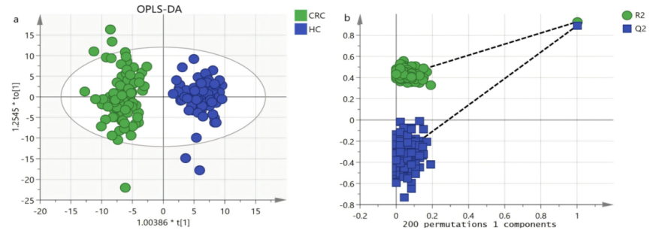

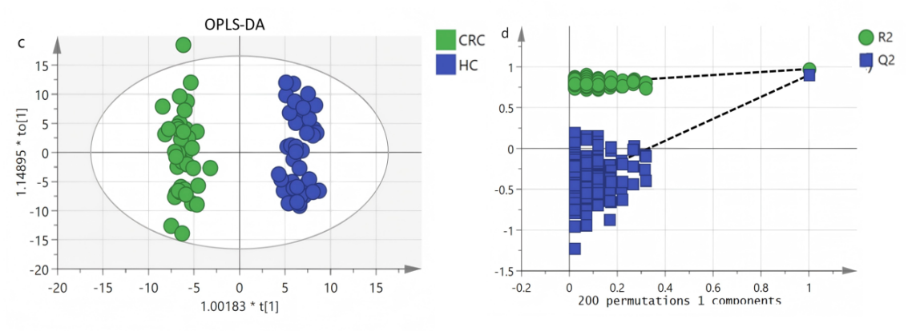
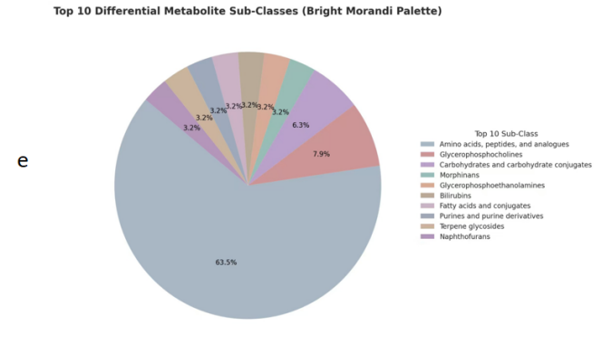

Figure S3 MS2 spectra of 7 metabolites (a) Guanosine, (b) Tyr Ser, (c) Phe Thr, (d) His Ile Gly, (e) Histidinyl-Tryptophan, (f) L-Histidine, (g) Urocanic acid
Metabolite | Compound | Compound ID | Adducts | Formula | Score | Fragmentation Score
Guanosine | 2.69_283.0923n | HMDB0000133 | M+H, M+Na | C10H13N5O5 | 52 | 69.8

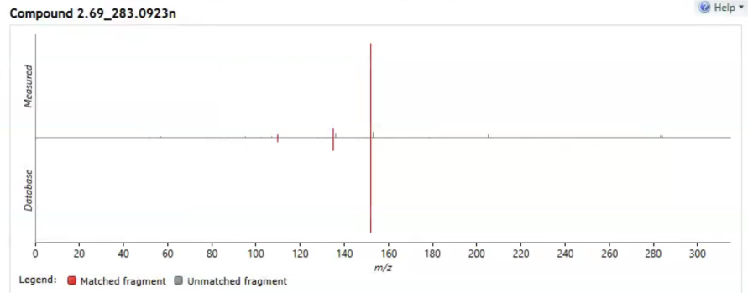

Metabolite | Compound | Compound ID | Adducts | Formula | Score | Fragmentation Score
Tyr Ser | 1.60_268.1064n | METLIN238143 | M+H, M+Na | C12H16N2O5 | 49.6 | 56
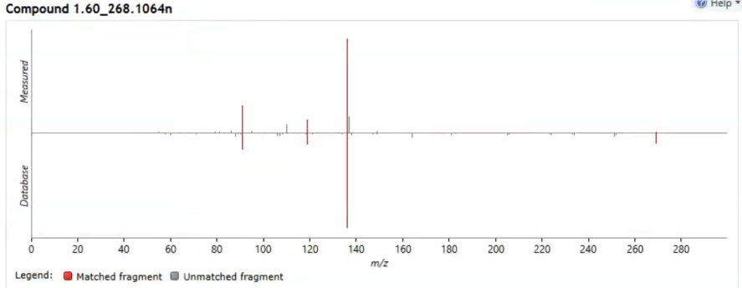

Metabolite | Compound | Compound ID | Adducts | Formula | Score | Fragmentation Score
Phe Thr | 2.94_267.1343m/z | METLIN23662 | M+H | C13H18N2O4 | 49.6 | 56.8

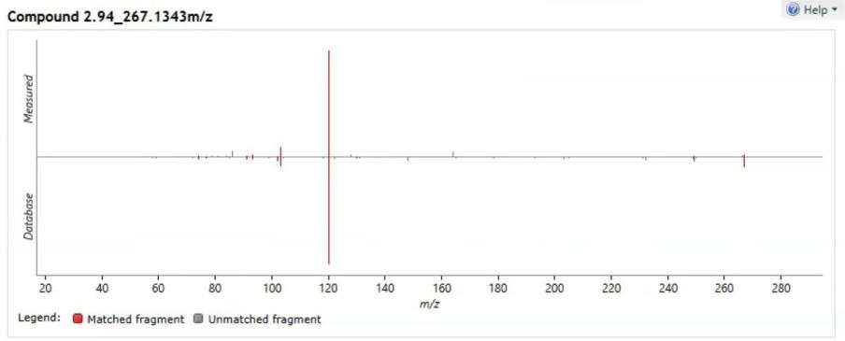

Metabolite | Compound | Compound ID | Adducts | Formula | Score | Fragmentation Score
His Ile Gly | 2.37_326.1828m/z | METIN2033 | M+NH4 | C14H23N5O4 | 55.7 | 87.5

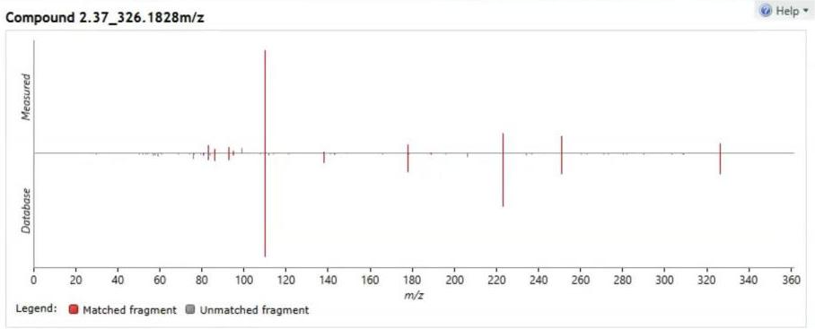

Metabolite | Compound | Compound ID | Adducts | Formula | Score | Fragmentation Score
Histidinyl-Tryptophan | 2.94_341.1496n | METLIN85802 | M+H-H2O, M+Na, M+H | C17H19N5O3 | 48.5 | 50.7

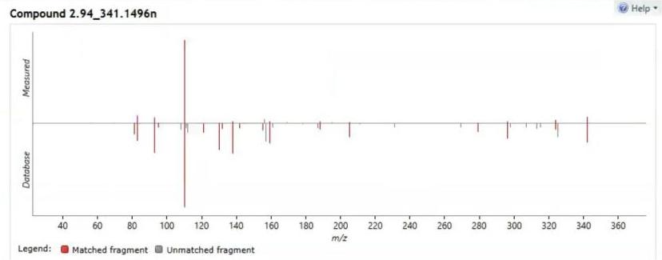

Metabolite | Compound | Compound ID | Adducts | Formula | Score | Fragmentation Score
L-Histidine | 1.21_156.0771m/z | METLIN21 | M+H | C6H9N3O2 | 49.2 | 51.3

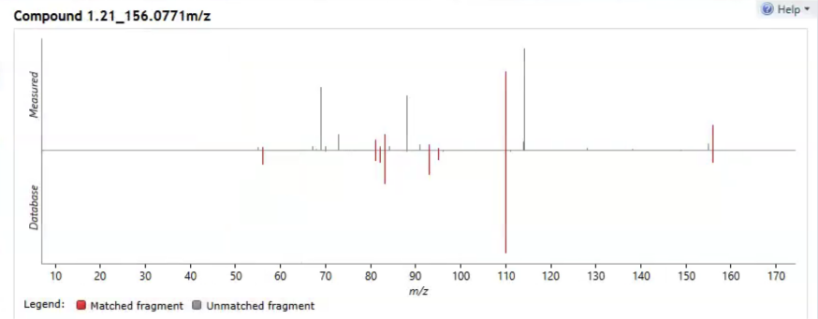

Metabolite | Compound | Compound ID | Adducts | Formula | Score | Fragmentation Score
Urocanic acid | 1.20_138.0432n | METLIN298 | M+H-H2O, M+H | C6H6N2O2 | 52 | 64.6

