Supplemental Appendix S1: A total of 1834 radiomics features were extracted from each ROI, including shape features (n=14), first-order features (n=18), and texture features (n=73): gray level co-occurrence matrix features (GLCM) (n=22), gray level dependence matrix features (GLDM) (n=14), gray level run length matrix features (GLRLM) (n=16), gray level size zone matrix features (GLSZM) (n=16), neighbouring gray tone difference matrix features (NGTDM) (n=5), as well as first-order and texture features transformed by exponential (n=91), gradient (n=91), logarithm (n=91), square (n=91), squareroot (n=91), local binary pattern (LBP) (n=273), Laplacian of Gaussian (LoG) (n=273), and wavelet (n=728) filter transformations.

Supplemental Table 1: DLCT scanning protocol and contrast agent injection scheme
Parameter | Center 1 | Center 2
CT scanner | Hawk Spectral CT (Philips  Healthcare, Netherlands) | IQon Spectral CT (Philips  Healthcare, Netherlands)
Tube voltage | 120 kVp | 120 kVp
Tube current | technique for automatic tube current modulation | technique for automatic tube current modulation
Helical pitch | 1.000 | 0.998
Detector  collimation | 256×0.625 mm | 64×0.625 mm
Rotation speed | 0.5 s/r | 0.75 s/r
Matrix for image reconstruction | 512×512 | 512×512
Scanning range | From the thoracic inlet to the base of the lung | From the thoracic inlet to the base of the lung
Spectral level | 3 | 1
Filter | Standard B | Standard B
Reconstruction section thickness | 1 mm | 1 mm
Reconstruction interval | 1 mm | 1 mm
Contrast agent | Ioversol 320(Hengrui company) | Iohexol 300(GE Healthcare)
Injection dose | 1.1 ml/kg | 1.0 ml/kg
Flow rate | The injection duration is set to 25 seconds, and the flow rate is calculated by dividing the total drug volume by 25 seconds | 2.5 ml/s
Arterial Phase Scanning Mode | Automatic contrast agent tracking was employed with a threshold of 150 HU and the arterial phase scan was initiated with an 8-second delay | Automatic contrast agent tracking was employed with a threshold of 150 HU and the arterial phase scan was initiated with an 8-second delay
Venous phase  scanning mode | 35 seconds after the arterial phase scan ended | 35 seconds after the arterial phase scan ended

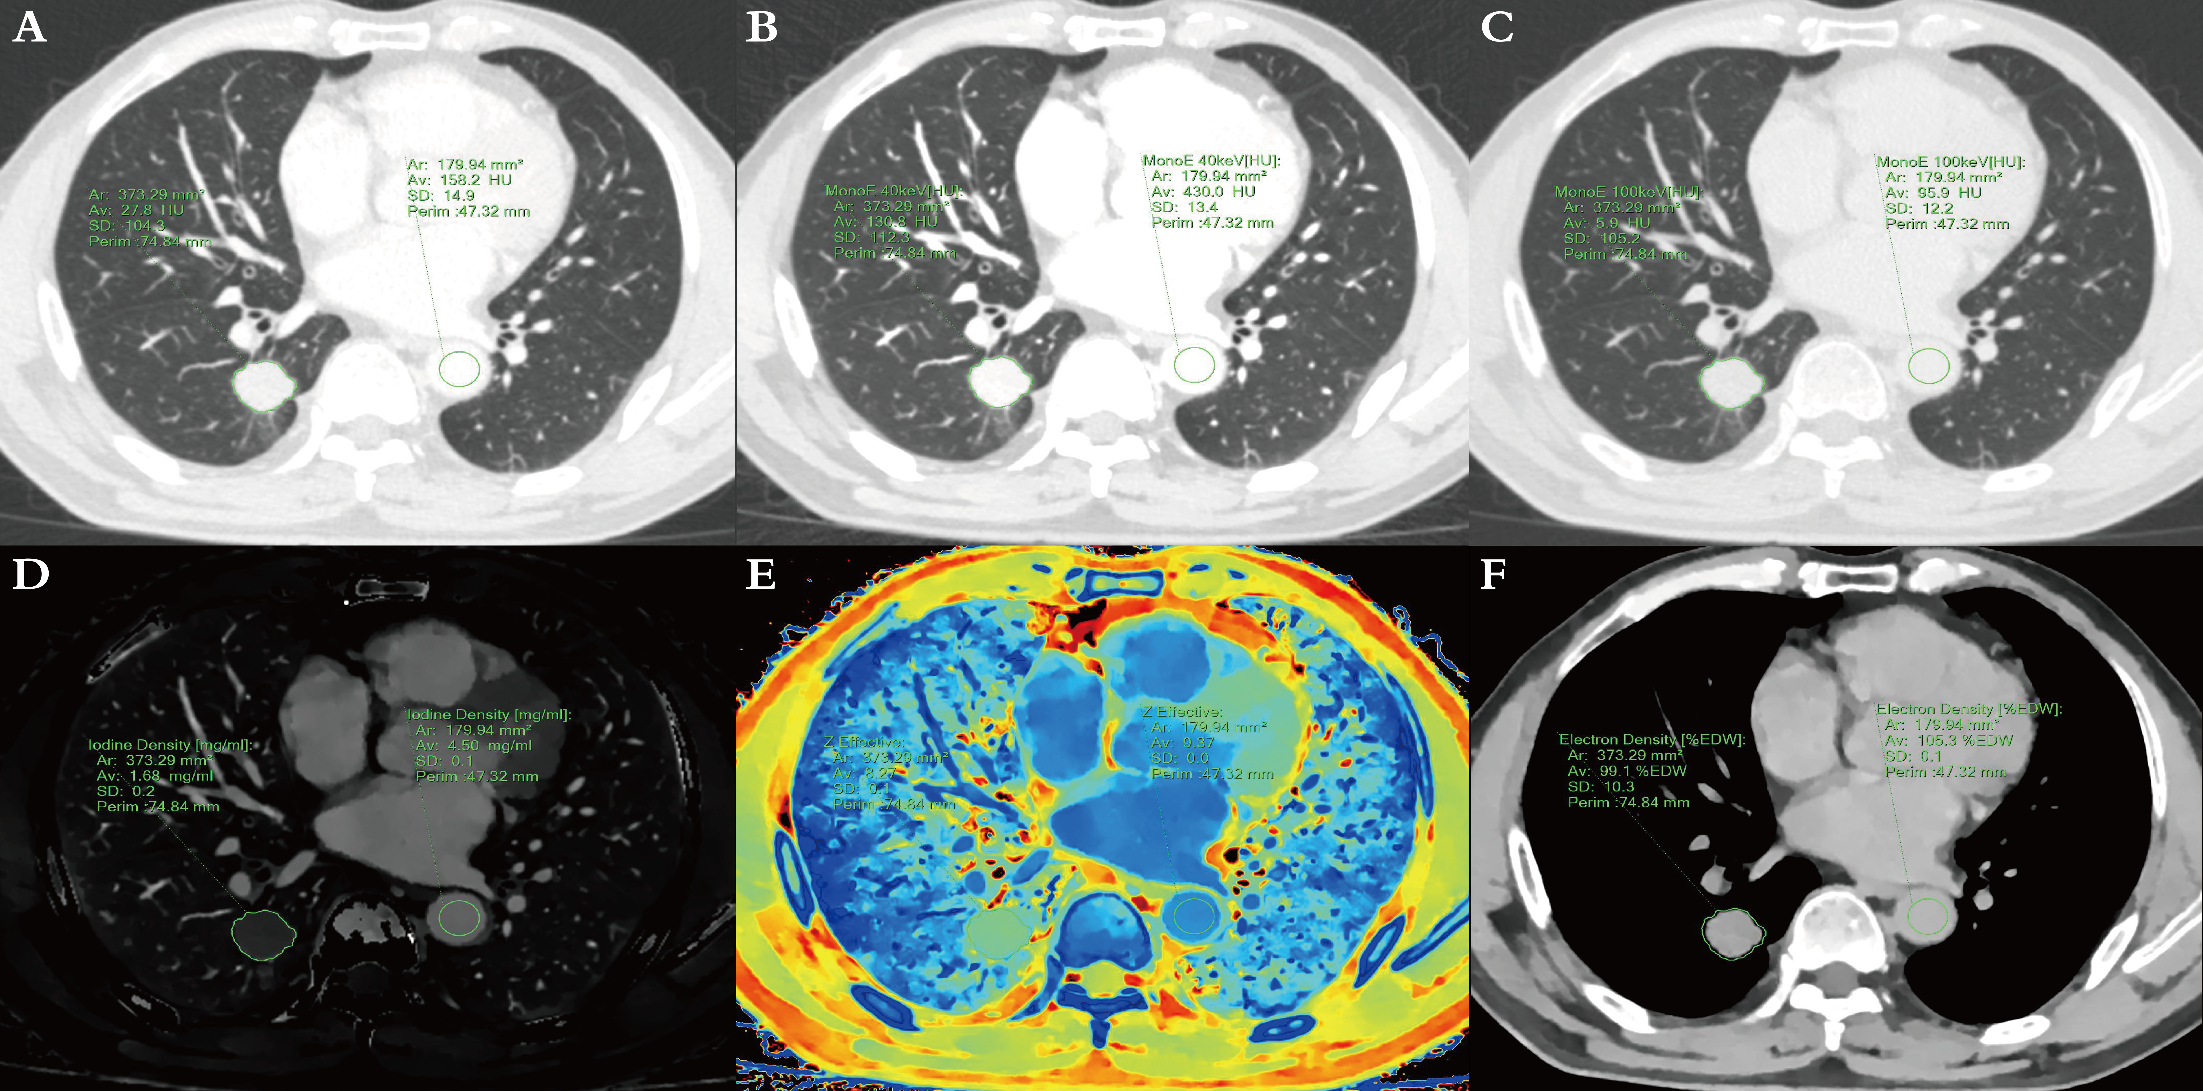
Supplemental Figure 1: Schematic diagram of DLCT quantitative parameter measurement. On the venous phase conventional 120 kVp lung window image (width, 1600 HU; level, -600 HU) (A), the ROI was delineated along the tumor contour. The "copy and paste" function was used to ensure consistency of the ROI across the virtual monoenergetic images (40 keV, B; 100 keV, C), iodine density (ID), effective atomic number (Zeff), and electron density (ED) maps (D-F). Additionally, an ROI was drawn on the aorta at the same level for NIC calculation.

Supplemental Figure 2: Radiomic features and corresponding weight coefficients selected from conventional (A), VMI 40keV (B), 65keV (C), 100keV (D), ID (E), Zeff (F), and ED (G) images.

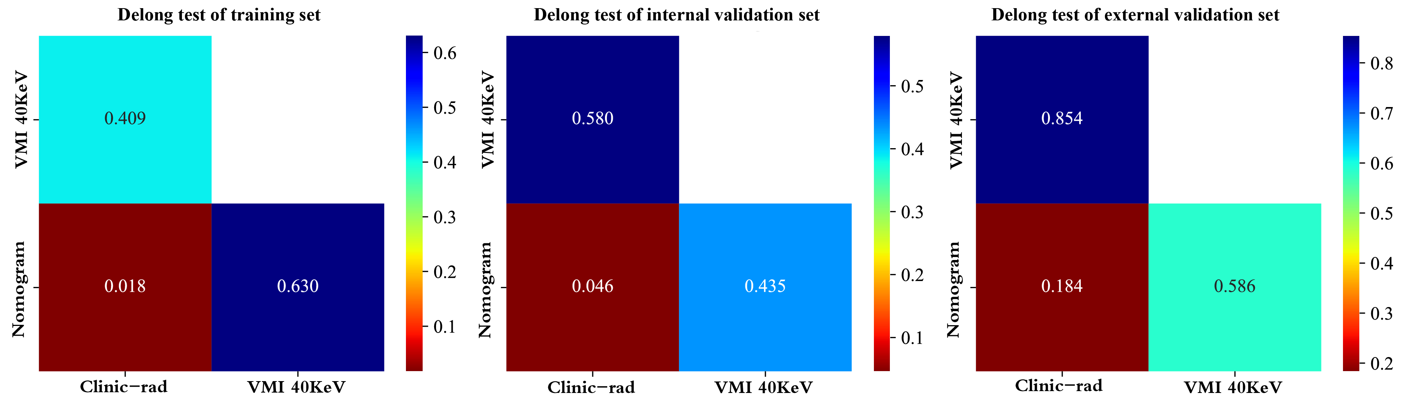
Supplemental Figure 3: The Delong test results of the clinical-radiological model, radiomics model, and nomogram in the training set, internal validation set, and external validation set.

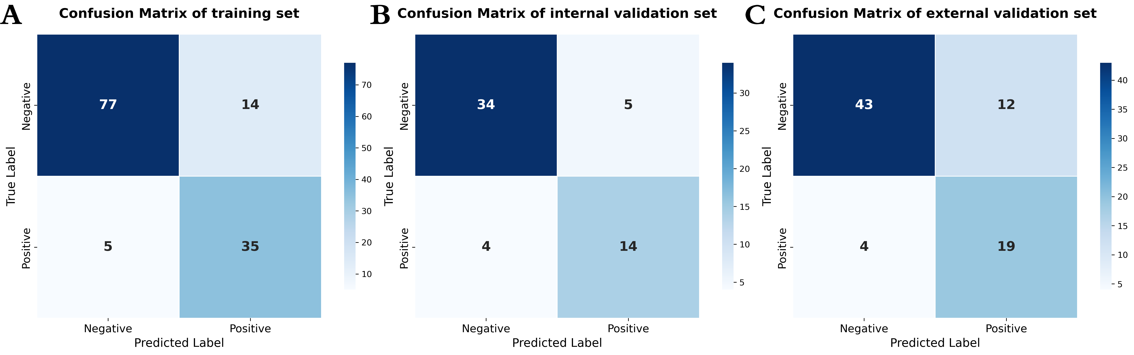
Supplemental Figure 4: Confusion matrices evaluating the predictive performance of the nomogram in the training, internal validation, and external validation sets.

Supplemental Table 2: Predictive performance of the nomogram across different nodule type of lung adenocarcinoma
Nodule type | AUC (95% CI) |  | Accuracy | Sensitivity | Specificity
pGGN/mGGN
Training set | 0.902 (0.770 - 1.000) |  | 0.940 | 0.818 | 0.959
Internal validation set | 0.833 (0.619 - 1.000) |  | 0.833 | 0.571 | 0.897
External validation set | 0.847 (0.673 - 1.000) |  | 0.816 | 0.778 | 0.825
Solid nodule
Training set | 0.749 (0.604 - 0.894) |  | 0.745 | 0.724 | 0.778
Internal validation set | 0.855 (0.680 - 1.000) |  | 0.857 | 0.818 | 0.900
External validation set | 0.781 (0.611 - 0.951) |  | 0.724 | 0.643 | 0.800
AUC area under the curve, CI confidence interval, pGGN pure ground-glass nodule, mGGN mixed ground-glass nodule.

