Hyperparameter Settings
For SSL, the method utilizes ResNet18 as the backbone network with a batch size of 128, trained for 200 epochs. It employs the SGD optimizer with a momentum of 0.9, weight decay of 0, and adopts a 10-epoch warm-up followed by 190 epochs of cosine annealing learning rate strategy. The initial learning rate is set to 1e-4, and after the warm-up, it adjusts to 0.2. The model projection layer follows the settings in the original paper. The data augmentation is shown in Supplementary Table 1.
For supervised learning, ResNet18 serves as the backbone network with a batch size of 128. It employs an early stopping strategy, training for 50 epochs. Specifically, training halts if the validation set loss doesn't decrease for 10 consecutive epochs. It uses the SGD optimizer with a momentum of 0.9 and weight decay of 10e-4. The initial learning rate for fine-tuning is set to 1e-3 (while the randomly initialized model's initial learning rate is 0.01), and the initial learning rate for linear evaluation is set to 0.1. The learning rate undergoes a fixed decay of 10x at epochs 10 and 30. The data augmentation is shown in Supplementary Table 2.

Supplementary Table and Figure
Supplementary Table 1. Data augmentation policy used by SSL
Data augmentation | parameter | probability
RandomResizedCrop | scale=(0.2, 1.0) | /
RandomColorJitter | (0.4, 0.4, 0.4, 0.1) | 0.8
RandomGrayscale | / | 0.2
RandomGaussianBlur | [0.1, 2.0] | 0.5
RandomHorizontalFlip | / | 0.5
Normalize | mean = [0.6684, 0.5115, 0.6791]  std = [0.2521, 0.2875, 0.2100] | /

Supplementary Table 2. Data augmentation policy used by supervised learning
Data augmentation | parameter | probability
RandomColorJitter | (0.25, 0.75, 0.25, 0.04) | 0.8
RandomHorizontalFlip | / | 0.5
Normalize | mean = [0.6684, 0.5115, 0.6791]  std = [0.2521, 0.2875, 0.2100] | /

Supplementary Table 3. The linear evaluation results of different sampling methods on the lung squamous cell carcinoma dataset.
 | Method | Acc | Auc | F1 score
Overlapping | SPSimCLR | 0.9326 | 0.9875 | 0.9082
Overlapping | SPMoCo-v3 | 0.9303 | 0.9874 | 0.9060
Overlapping | SinCLR | 0.9288 | 0.9867 | 0.9021
Non-overlapping | SPSimCLR | 0.9325 | 0.9881 | 0.9084
Non-overlapping | SPMoCo-v3 | 0.9308 | 0.9867 | 0.9059
Non-overlapping | SinCLR | 0.9283 | 0.9859 | 0.9013

Supplementary Table 4. The linear evaluation results for images with different tissue types on the lung squamous cell carcinoma dataset.
 | Method | Acc | Auc | F1 score
Single tissue | SPSimCLR | 0.9326 | 0.9875 | 0.9082
Single tissue | SPMoCo-v3 | 0.9303 | 0.9874 | 0.9060
Single tissue | SinCLR | 0.9288 | 0.9867 | 0.9021
Multiple tissues | SPSimCLR | 0.9262 | 0.9845 | 0.8971
Multiple tissues | SPMoCo-v3 | 0.9199 | 0.9837 | 0.8894
Multiple tissues | SinCLR | 0.9171 | 0.9815 | 0.8832

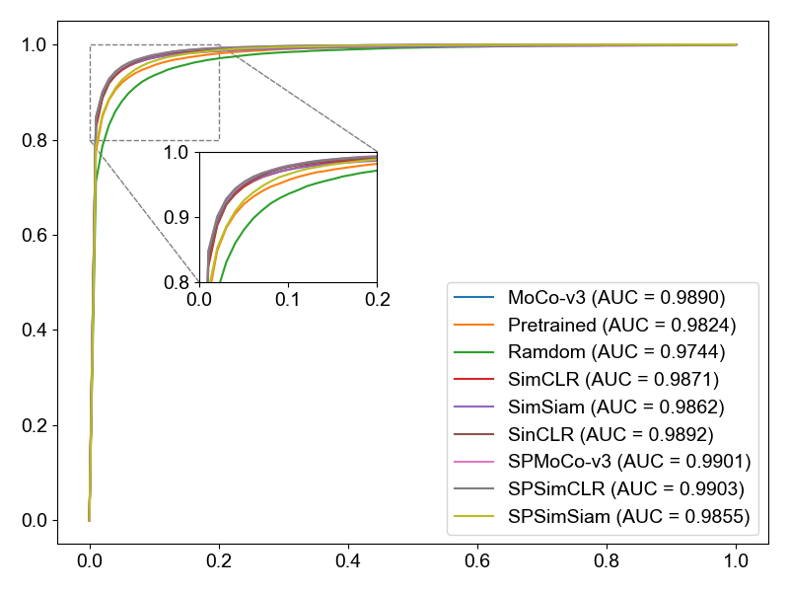
Supplementary Figure 1. The fine-tuning ROC curve of different methods on
the lung squamous cell carcinoma dataset.
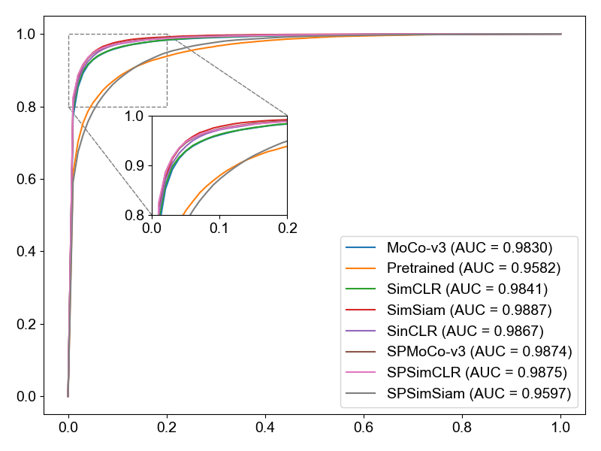
Supplementary Figure 2. The linear evaluation ROC curve of different methods on
the lung squamous cell carcinoma dataset.
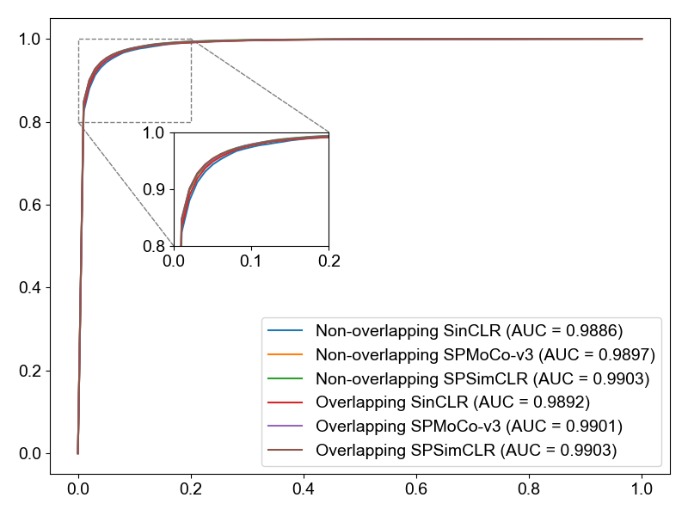
Supplementary Figure 3. The fine-tuning ROC curve of different sampling methods on the lung squamous cell carcinoma dataset.
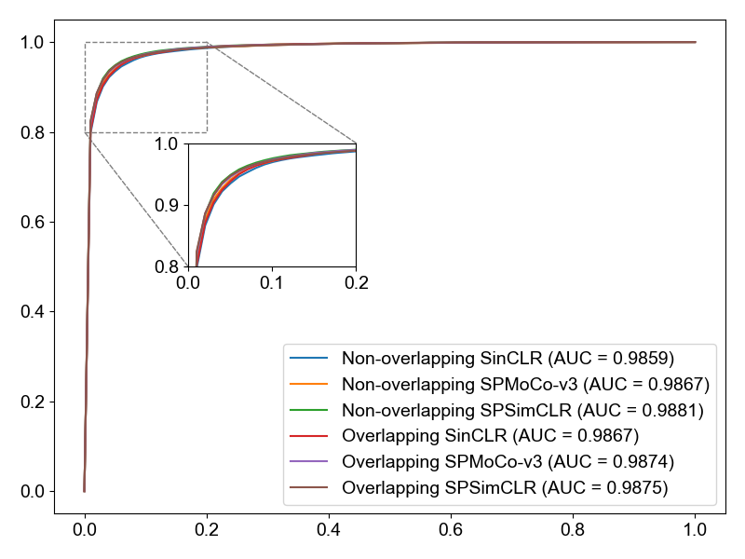
Supplementary Figure 4. The linear evaluation ROC curve of different sampling
methods on the lung squamous cell carcinoma dataset.
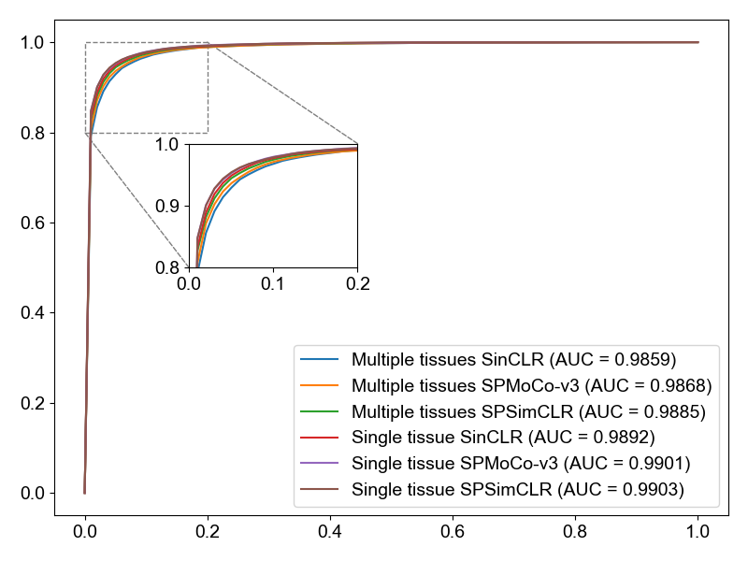
Supplementary Figure 5. The fine-tuning ROC curve for images with different tissue types on the lung squamous cell carcinoma dataset.
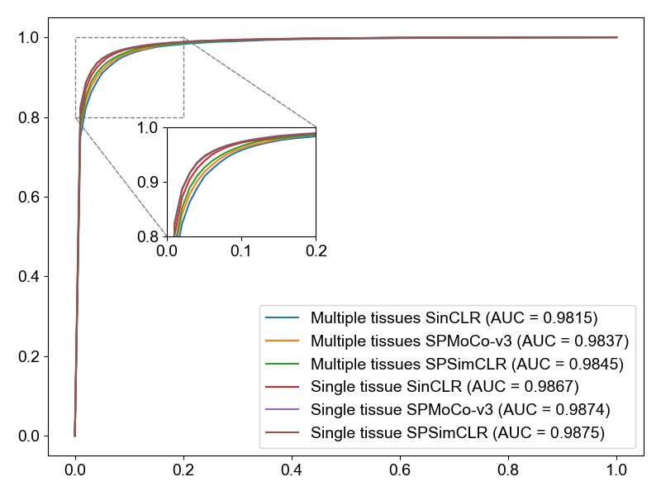
Supplementary Figure 6. The linear evaluation ROC curve for images with different tissue types on the lung squamous cell carcinoma dataset.
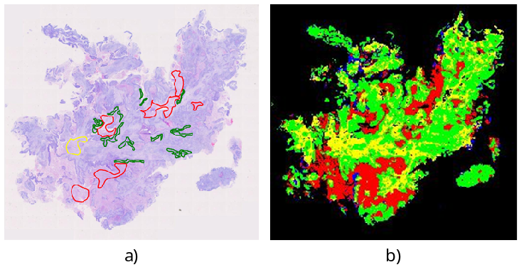
Supplementary Figure 7. Example of WSI analysis. (a) Partial ground truth annotations showing a subset of manually labeled regions. b) Model prediction results.

