SUPPLEMENTARY FIGURES

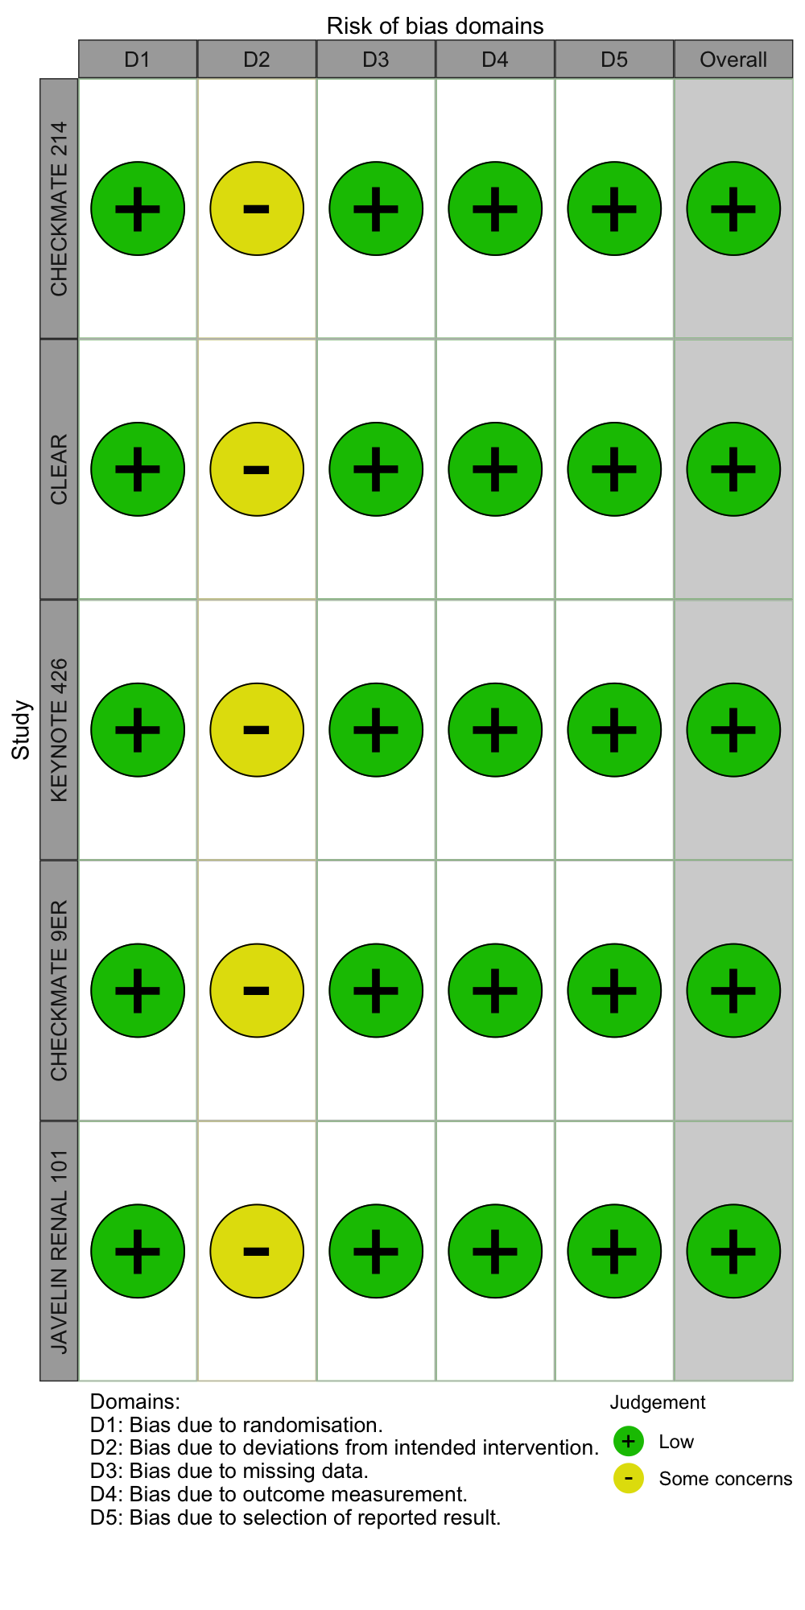
Figure S1. Risk of bias assessed with RoB2tool.
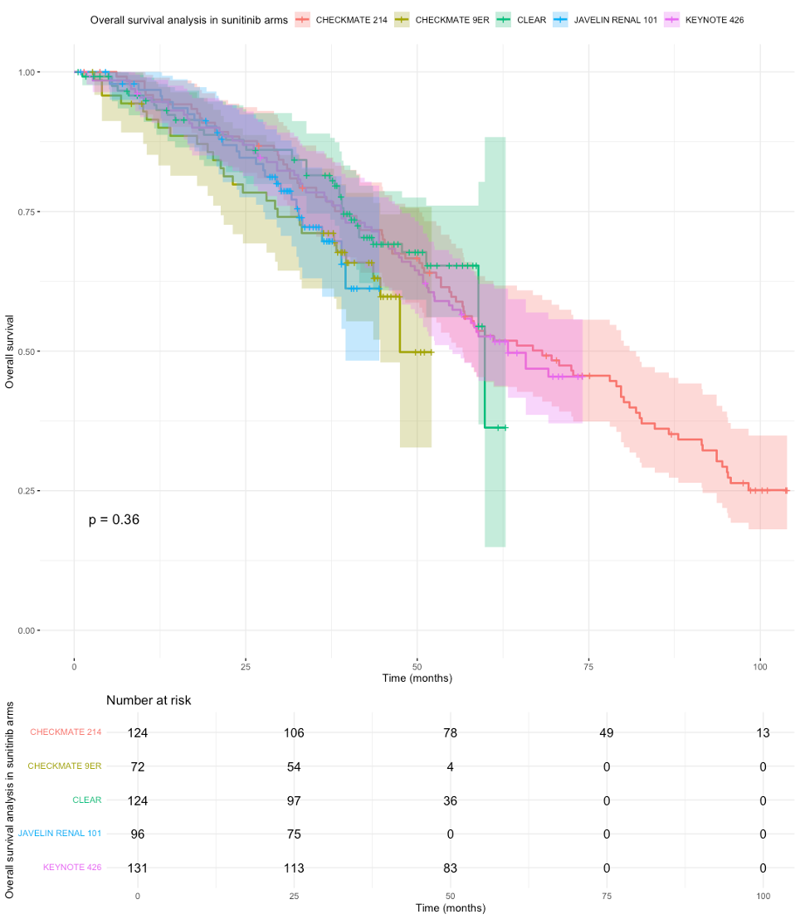
Figure S2. Individual patient data (IPD) based Kaplan Meier (KM) curve for OS in Sunitinib arms of the included studies.
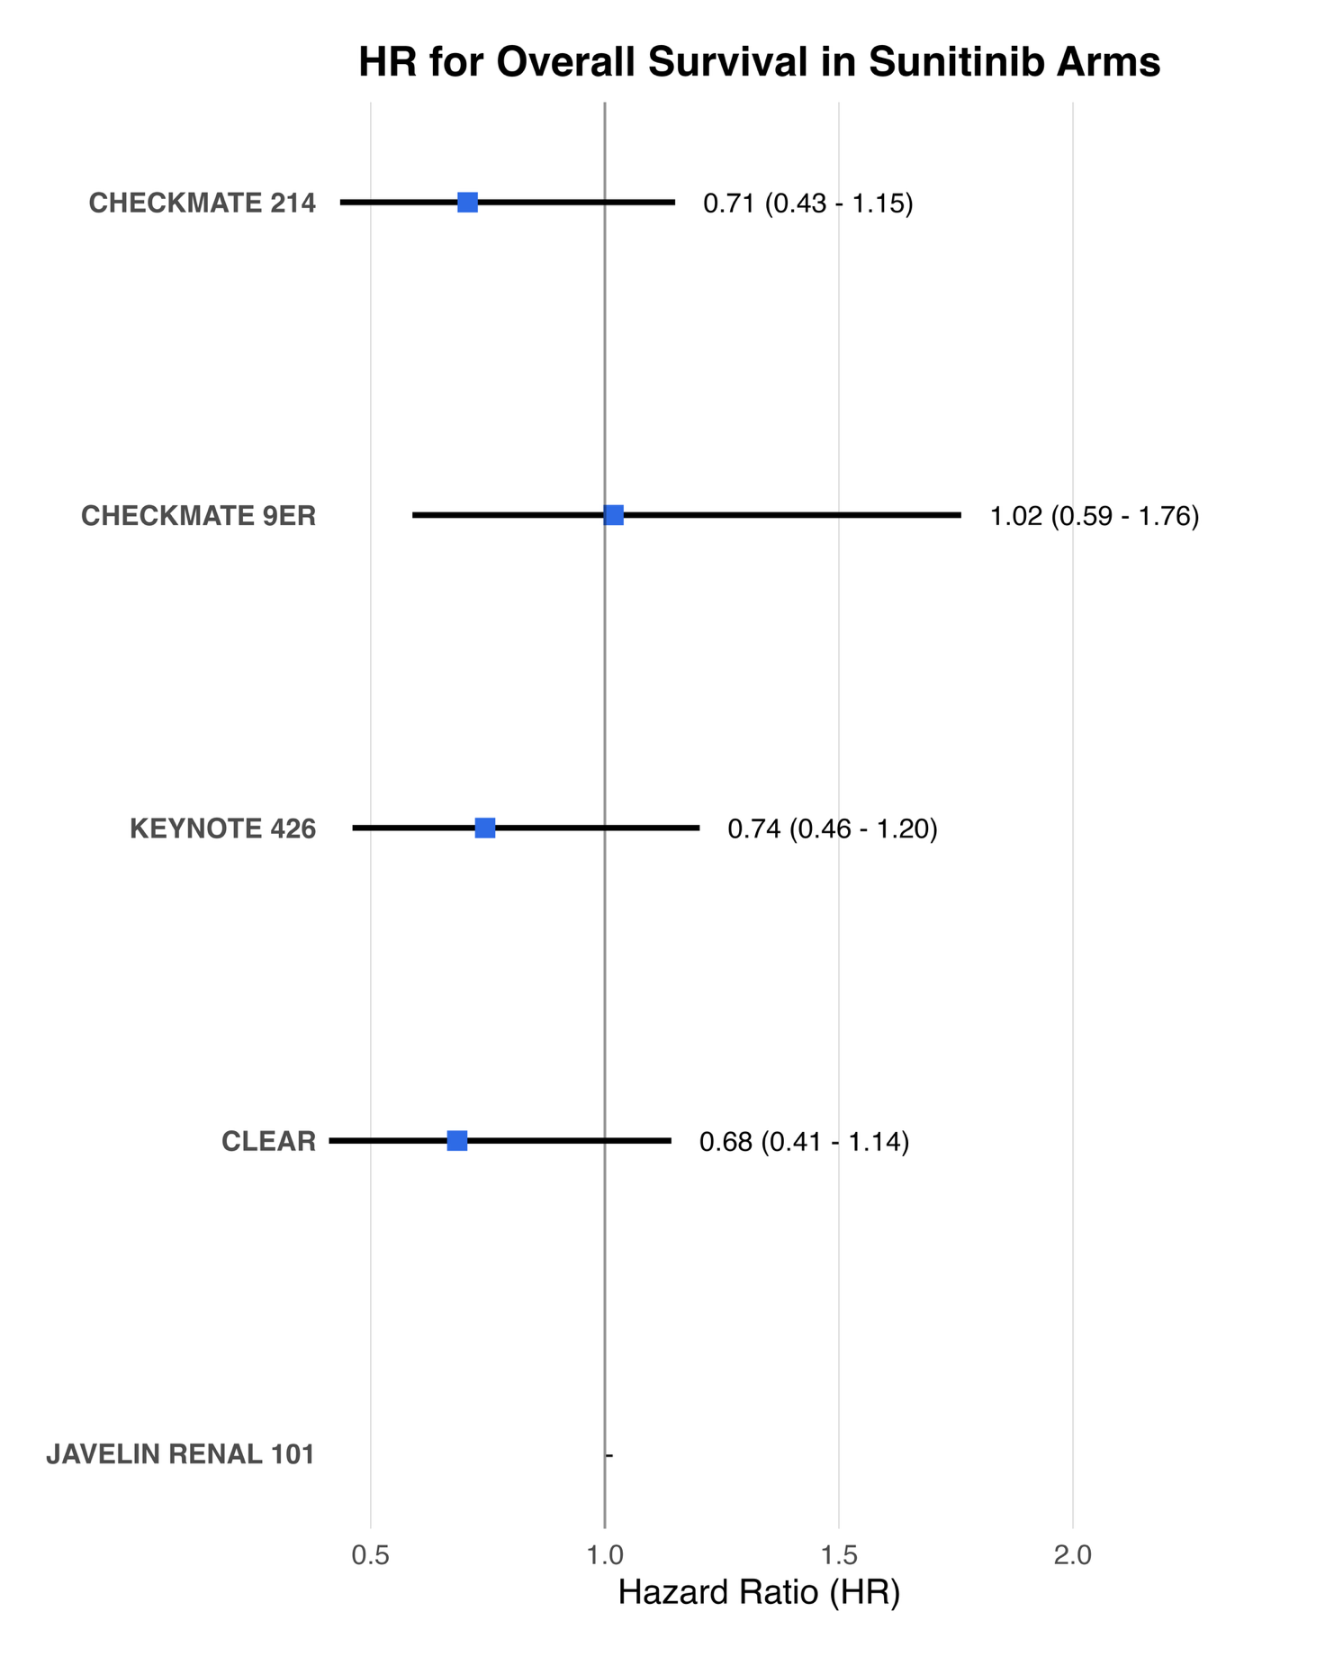
Figure S3. Individual patient data (IPD) based forest plot for Overall Survival (OS) in Sunitinib arms of the included studies.
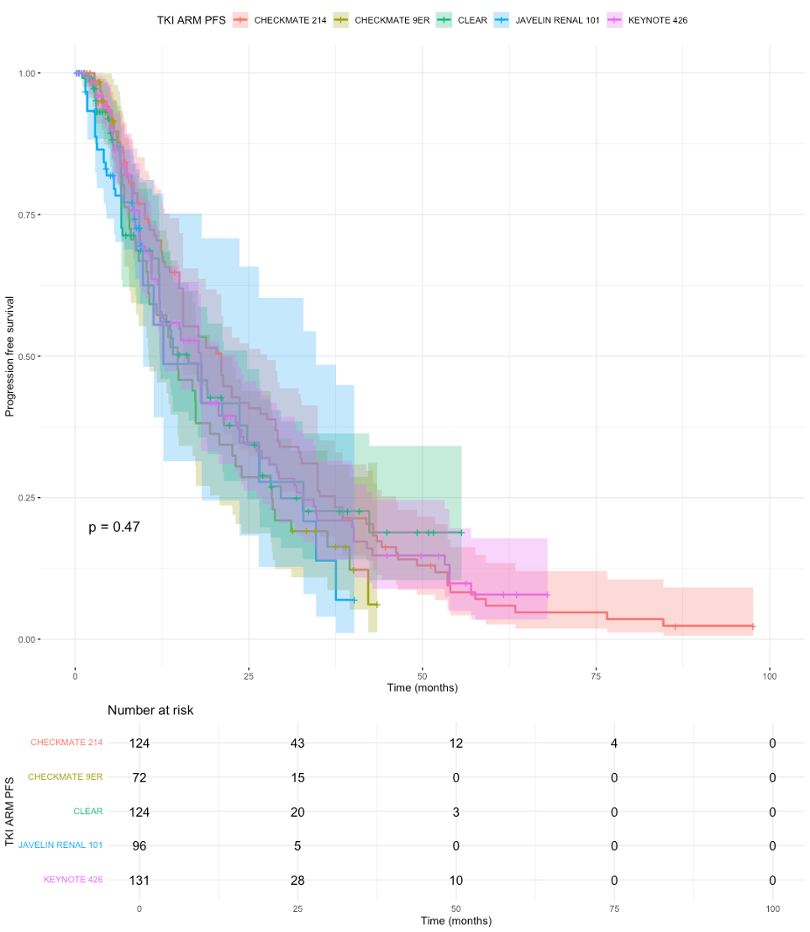
Figure S4. Individual patient data (IPD) based Kaplan Meier (KM) curve for PFS in Sunitinib arms of the included studies.
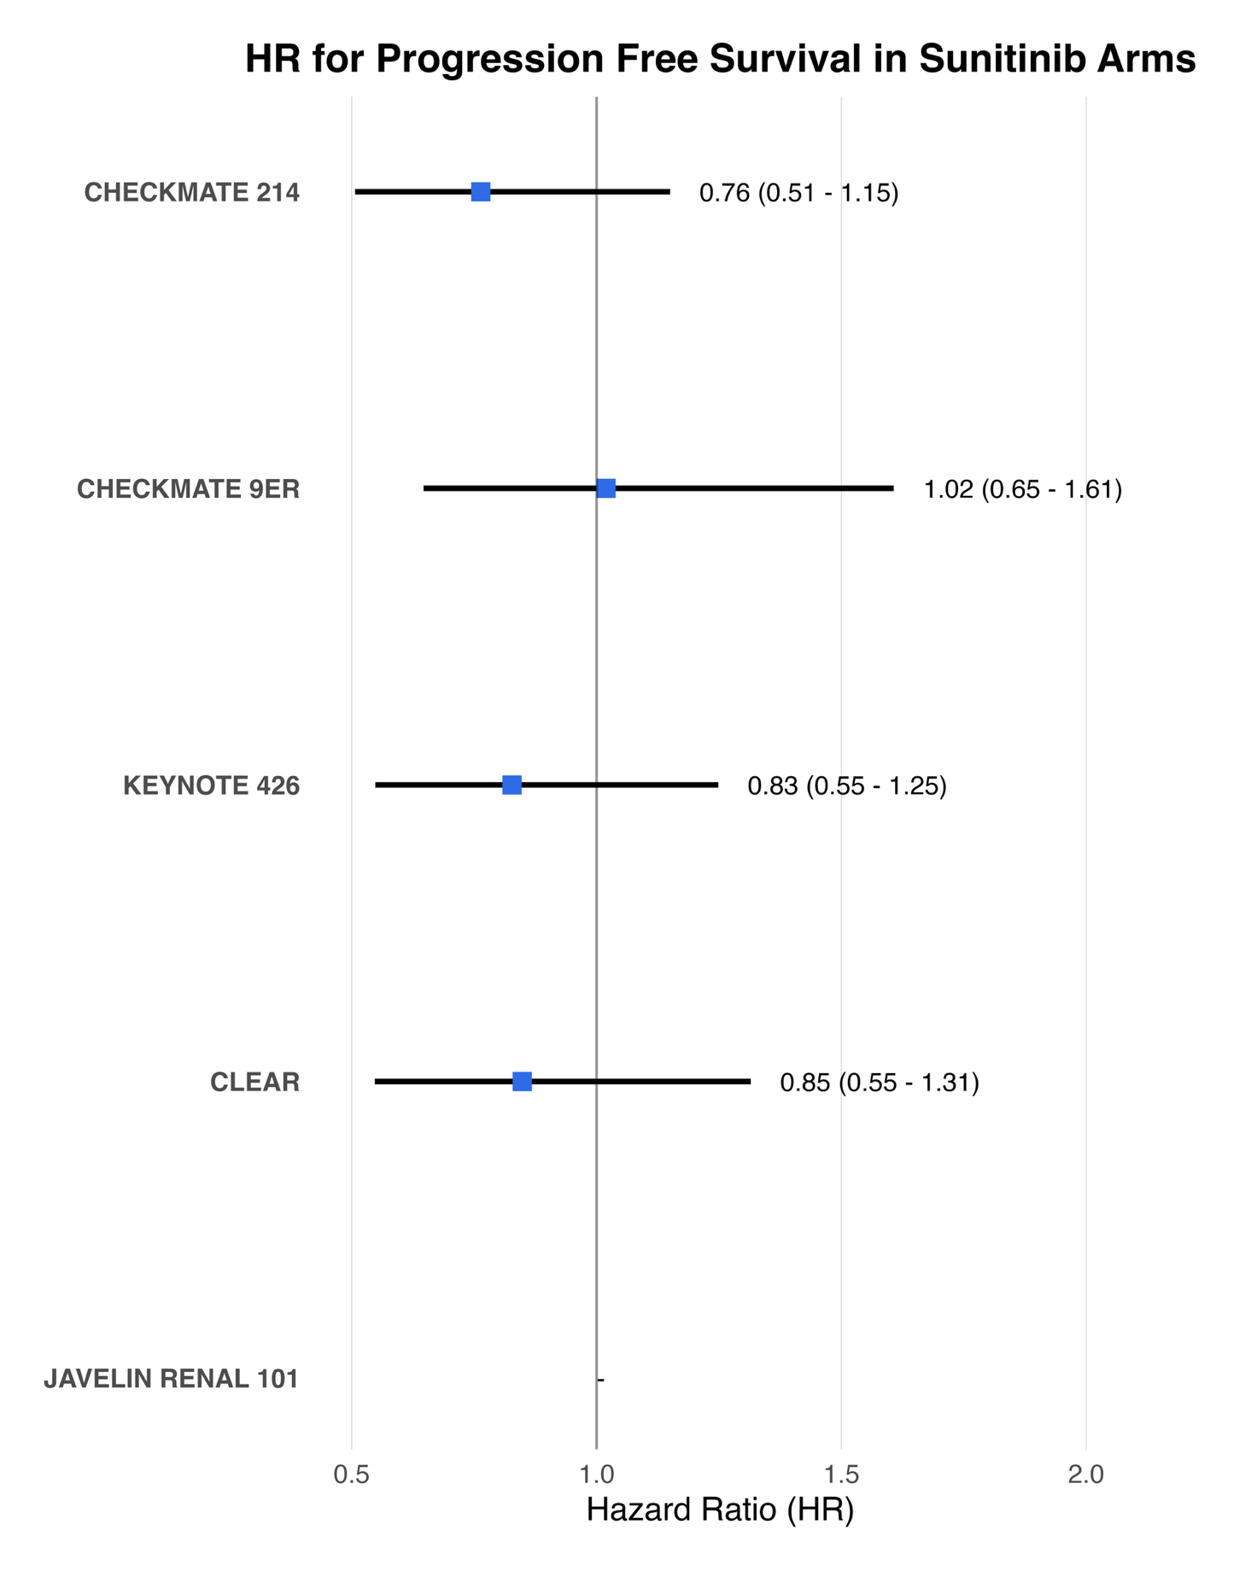
Figure S5. Individual patient data (IPD) based forest plot for PFS in Sunitinib arms of the included studies.

Reference Drug | Comparison Drug | PFS HR (95% CI) | P-value
AVELUMAB + AXITINIB | NIVOLUMAB + CABOZANTINIB | 1.08 (0.74 - 1.58) | 0.686583
AVELUMAB + AXITINIB | NIVOLUMAB + IPILIMUMAB | 1.13 (0.81 - 1.58) | 0.472488
AVELUMAB + AXITINIB | PEMBROLIZUMAB + AXITINIB | 0.93 (0.66 - 1.31) | 0.689856
AVELUMAB + AXITINIB | PEMBROLIZUMAB + LENVATINIB | 0.66 (0.46 - 0.96) | 0.02823
AVELUMAB + AXITINIB | SUNITINIB | 1.24 (0.94 - 1.64) | 0.127344
NIVOLUMAB + CABOZANTINIB | AVELUMAB + AXITINIB | 0.92 (0.63 - 1.35) | 0.686583
NIVOLUMAB + CABOZANTINIB | NIVOLUMAB + IPILIMUMAB | 1.05 (0.73 - 1.49) | 0.806184
NIVOLUMAB + CABOZANTINIB | PEMBROLIZUMAB + AXITINIB | 0.86 (0.60 - 1.24) | 0.423447
NIVOLUMAB + CABOZANTINIB | PEMBROLIZUMAB + LENVATINIB | 0.61 (0.42 - 0.90) | 0.012788
NIVOLUMAB + CABOZANTINIB | SUNITINIB | 1.15 (0.85 - 1.55) | 0.366945
NIVOLUMAB + IPILIMUMAB | AVELUMAB + AXITINIB | 0.89 (0.63 - 1.24) | 0.472488
NIVOLUMAB + IPILIMUMAB | NIVOLUMAB + CABOZANTINIB | 0.96 (0.67 - 1.36) | 0.806184
NIVOLUMAB + IPILIMUMAB | PEMBROLIZUMAB + AXITINIB | 0.83 (0.61 - 1.13) | 0.224898
NIVOLUMAB + IPILIMUMAB | PEMBROLIZUMAB + LENVATINIB | 0.59 (0.42 - 0.82) | 0.001995
NIVOLUMAB + IPILIMUMAB | SUNITINIB | 1.10 (0.87 - 1.39) | 0.433915
PEMBROLIZUMAB + AXITINIB | CAVELUMAB + AXITINIB | 1.07 (0.76 - 1.51) | 0.689856
PEMBROLIZUMAB + AXITINIB | NIVOLUMAB + CABOZANTINIB | 1.16 (0.81 - 1.67) | 0.423447
PEMBROLIZUMAB + AXITINIB | NIVOLUMAB + IPILIMUMAB | 1.21 (0.89 - 1.65) | 0.224898
PEMBROLIZUMAB + AXITINIB | PEMBROLIZUMAB + LENVATINIB | 0.71 (0.50 - 1.01) | 0.054848
PEMBROLIZUMAB + AXITINIB | SUNITINIB | 1.33 (1.03 - 1.72) | 0.02661
PEMBROLIZUMAB + LENVATINIB | AVELUMAB + AXITINIB | 1.51 (1.04 - 2.18) | 0.02823
PEMBROLIZUMAB + LENVATINIB | NIVOLUMAB + CABOZANTINIB | 1.63 (1.11 - 2.40) | 0.012788
PEMBROLIZUMAB + LENVATINIB | NIVOLUMAB + IPILIMUMAB | 1.71 (1.22 - 2.39) | 0.001995
PEMBROLIZUMAB + LENVATINIB | PEMBROLIZUMAB + AXITINIB | 1.41 (0.99 - 2.00) | 0.054848
PEMBROLIZUMAB + LENVATINIB | SUNITINIB | 1.87 (1.41 - 2.50) | 1.71E-05
SUNITINIB | AVELUMAB + AXITINIB | 0.81 (0.61 - 1.06) | 0.127344
SUNITINIB | NIVOLUMAB + CABOZANTINIB | 0.87 (0.64 - 1.18) | 0.366945
SUNITINIB | NIVOLUMAB + IPILIMUMAB | 0.91 (0.72 - 1.15) | 0.433915
SUNITINIB | PEMBROLIZUMAB + AXITINIB | 0.75 (0.58 - 0.97) | 0.02661
SUNITINIB | PEMBROLIZUMAB + LENVATINIB | 0.53 (0.40 - 0.71) | 1.71E-05

Table S1. Hazard ratio for progression free survival in the included trials.

Reference Drug | Comparison Drug | OS HR (95% CI) | P-value
AVELUMAB + AXITINIB | NIVOLUMAB + CABOZANTINIB | 1.64 (0.90 - 3.00) | 0.104937
AVELUMAB + AXITINIB | NIVOLUMAB + IPILIMUMAB | 0.97 (0.56 - 1.69) | 0.926928
AVELUMAB + AXITINIB | PEMBROLIZUMAB + AXITINIB | 1.36 (0.80 - 2.33) | 0.256279
AVELUMAB + AXITINIB | PEMBROLIZUMAB + LENVATINIB | 0.93 (0.51 - 1.69) | 0.806113
AVELUMAB + AXITINIB | SUNITINIB | 1.23 (0.75 - 2.02) | 0.417154
NIVOLUMAB + CABOZANTINIB | AVELUMAB + AXITINIB | 0.61 (0.33 - 1.11) | 0.104937
NIVOLUMAB + CABOZANTINIB | NIVOLUMAB + IPILIMUMAB | 0.59 (0.38 - 0.93) | 0.023084
NIVOLUMAB + CABOZANTINIB | PEMBROLIZUMAB + AXITINIB | 0.83 (0.54 - 1.28) | 0.397537
NIVOLUMAB + CABOZANTINIB | PEMBROLIZUMAB + LENVATINIB | 0.56 (0.34 - 0.94) | 0.029579
NIVOLUMAB + CABOZANTINIB | SUNITINIB | 0.75 (0.51 - 1.10) | 0.144644
NIVOLUMAB + IPILIMUMAB | AVELUMAB + AXITINIB | 1.03 (0.59 - 1.78) | 0.926928
NIVOLUMAB + IPILIMUMAB | NIVOLUMAB + CABOZANTINIB | 1.69 (1.07 - 2.65) | 0.023084
NIVOLUMAB + IPILIMUMAB | PEMBROLIZUMAB + AXITINIB | 1.40 (1.00 - 1.96) | 0.052261
NIVOLUMAB + IPILIMUMAB | PEMBROLIZUMAB + LENVATINIB | 0.95 (0.61 - 1.49) | 0.827965
NIVOLUMAB + IPILIMUMAB | SUNITINIB | 1.26 (0.96 - 1.66) | 0.100966
PEMBROLIZUMAB + AXITINIB | AVELUMAB + AXITINIB | 0.73 (0.43 - 1.25) | 0.256279
PEMBROLIZUMAB + AXITINIB | NIVOLUMAB + CABOZANTINIB | 1.21 (0.78 - 1.86) | 0.397537
PEMBROLIZUMAB + AXITINIB | NIVOLUMAB + IPILIMUMAB | 0.72 (0.51 - 1.00) | 0.052261
PEMBROLIZUMAB + AXITINIB | PEMBROLIZUMAB + LENVATINIB | 0.68 (0.44 - 1.05) | 0.080243
PEMBROLIZUMAB + AXITINIB | SUNITINIB | 0.90 (0.70 - 1.17) | 0.438589
PEMBROLIZUMAB + LENVATINIB | AVELUMAB + AXITINIB | 1.08 (0.59 - 1.97) | 0.806113
PEMBROLIZUMAB + LENVATINIB | NIVOLUMAB + CABOZANTINIB | 1.77 (1.06 - 2.97) | 0.029579
PEMBROLIZUMAB + LENVATINIB | NIVOLUMAB + IPILIMUMAB | 1.05 (0.67 - 1.65) | 0.827965
PEMBROLIZUMAB + LENVATINIB | PEMBROLIZUMAB + AXITINIB | 1.47 (0.95 - 2.26) | 0.080243
PEMBROLIZUMAB + LENVATINIB | SUNITINIB | 1.33 (0.90 - 1.95) | 0.15485
SUNITINIB | AVELUMAB + AXITINIB | 0.81 (0.49 - 1.34) | 0.417154
SUNITINIB | NIVOLUMAB + CABOZANTINIB | 1.34 (0.91 - 1.97) | 0.144644
SUNITINIB | NIVOLUMAB + IPILIMUMAB | 0.79 (0.60 - 1.05) | 0.100966
SUNITINIB | PEMBROLIZUMAB + AXITINIB | 1.11 (0.85 - 1.44) | 0.438589
SUNITINIB | PEMBROLIZUMAB + LENVATINIB | 0.75 (0.51 - 1.11) | 0.15485

Table S2. Hazard ratio for overall survival in included studies.

