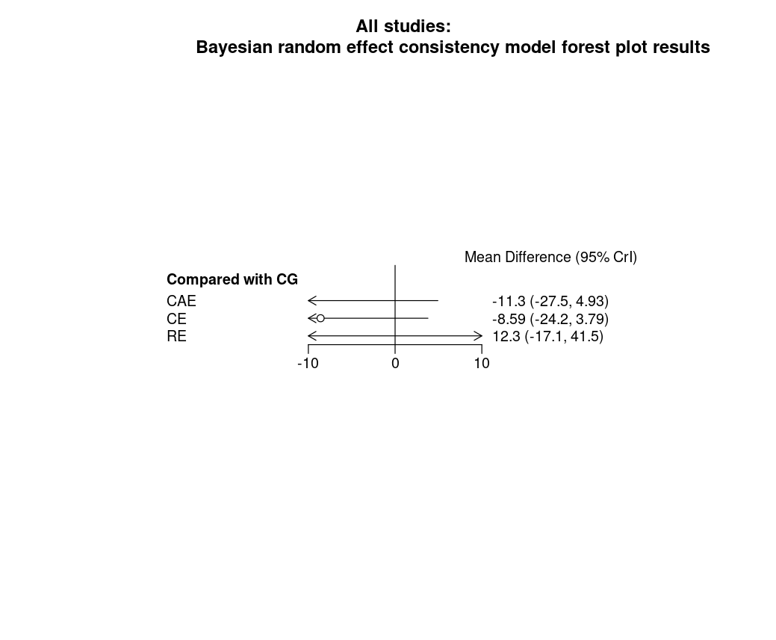
Litmus Rank-O-Gram: Higher SUCRA (Surface Under the Cumulative Ranking Curve) values and cumulative ranking curves nearer the top left indicate better performance
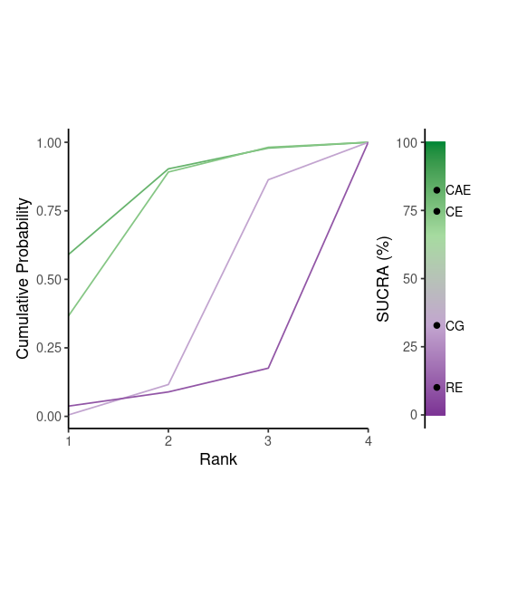

Radial SUCRA plot: Higher SUCRA values indicate better treatments; size of nodes represent number of participants and thickness of lines indicate number of trials conducted
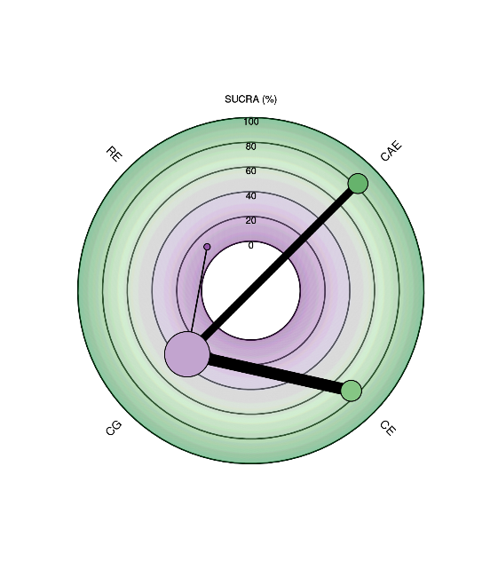

Numbers on the line indicate number of trials conducted for the comparison. Any shaded areas indicate existence of multi-arm trials between the comparisons.
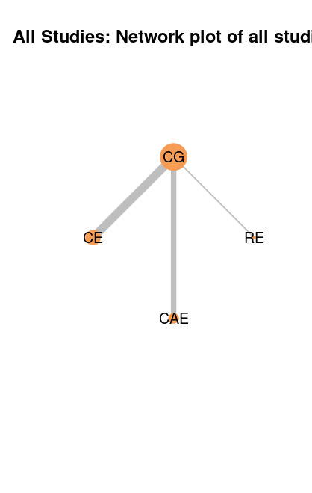
The size of the nodes and thickness of edges represent the number of studies that examined a treatment and compared two given treatments respectively.

Gelman convergence assessment plot for all studies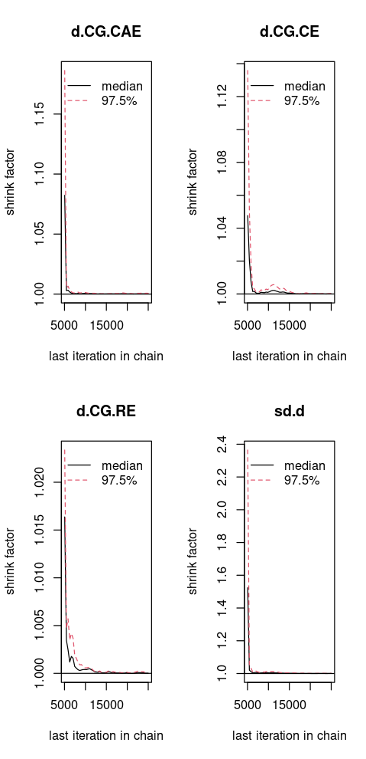

Deviance report for all studies and the sensitivity analysis
Residual deviance from NMA model and UME inconsistency model for all studies
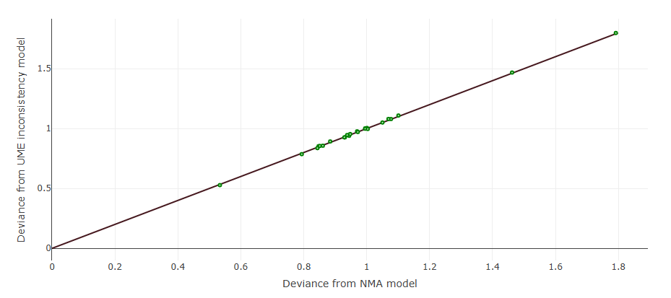
This plot represents each data point's contribution to the residual deviance for the NMA with consistency (horizontal axis) and the unrelated mean effect (ume) inconsistency models (vertical axis) along with the line of equality. The points on the equality line means there is no improvement in model fit when using the inconsistency model, suggesting that there is no evidence of inconsistency. Points above the equality line means they have a smaller residual deviance for the consistency model indicating a better fit in the NMA consistency model and points below the equality line means they have a better fit in the ume inconsistency model.

Per-arm residual deviance for all studies
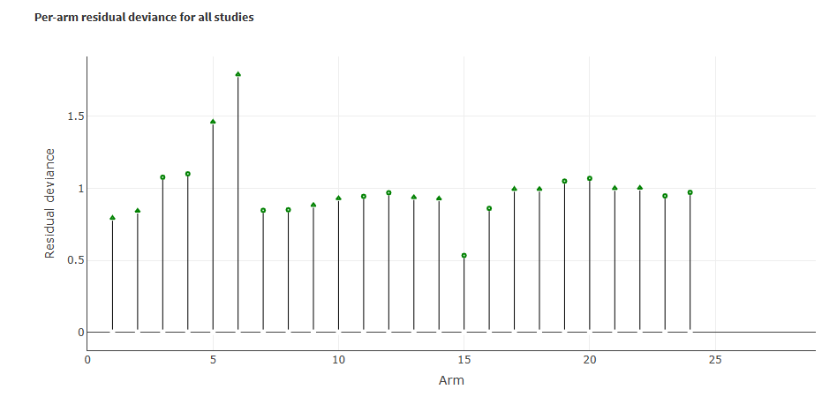
This stem plot represents the posterior residual deviance per study arm. The total number of stems equals the total number of data points in the network meta analysis. Going from left to right, the alternating symbols on the stems indicate the different studies. Each stem corresponds to the residual deviance ($dev.ab) associated with each arm in each study. The smaller residual deviance (the shorter stem), dev.ab, the better model fit for each data point. You can identify which stem corresponds to which study arm by hovering on the stem symbols.

Leverage plot for all studies
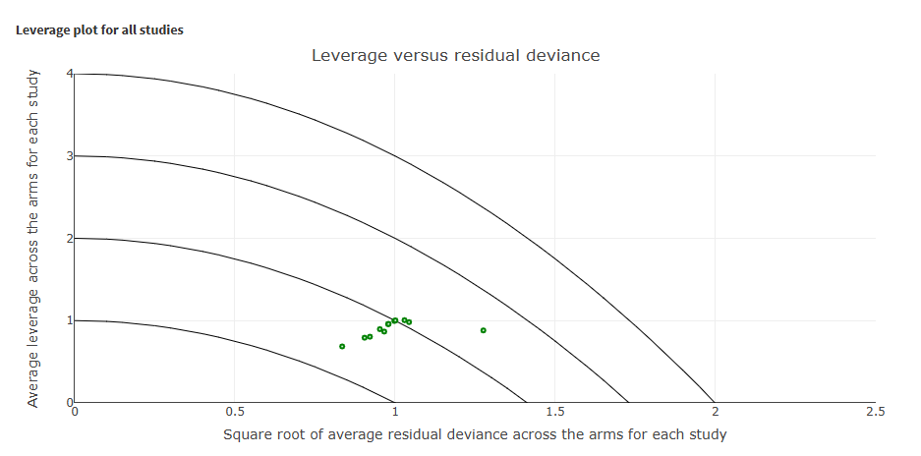
This leverage plot shows the average leverage across the arms for each study ({sum($lev.ab)}/{number of arms} for each study) versus the square root of the average residual deviance across the arms for each study (sqrt({sum($dev.ab)}/{number of arms}) for each study). The leverage for each data point, is calculated as the posterior mean of the residual deviance, minus the deviance at the posterior mean of the fitted values. The leverage plot may be used to identify influential and/or poorly fitting studies and can be used to check how each study is affecting the overall model fit and DIC. Curves of the form x2 + y = c, c = 1, 2, 3, ., where x represents square root of residual deviance, and y represents the leverage, are marked on the plot. Points lying on such parabolas each contribute an amount c to the DIC (Spiegelhalter et al., 2002). Points that lie outside the line with c = 3 can generally be identified as contributing to the model's poor fit. Points with a high leverage are influential, which means that they have a strong influence on the model parameters that generate their fitted values.

