Table S1. PRISMA 2020 checklist
Section and Topic | Item # | Checklist item | Location where item is reported
TITLE
Title | 1 | Identify the report as a systematic review. | 1
ABSTRACT
Abstract | 2 | See the PRISMA 2020 for Abstracts checklist. | 2-3
INTRODUCTION
Rationale | 3 | Describe the rationale for the review in the context of existing knowledge. | 4-5
Objectives | 4 | Provide an explicit statement of the objective(s) or question(s) the review addresses. | 5
METHODS
Eligibility criteria | 5 | Specify the inclusion and exclusion criteria for the review and how studies were grouped for the syntheses. | 6
Information sources | 6 | Specify all databases, registers, websites, organisations, reference lists and other sources searched or consulted to identify studies. Specify the date when each source was last searched or consulted. | 5-6
Search strategy | 7 | Present the full search strategies for all databases, registers and websites, including any filters and limits used. | 5-6, Supplementary file 2
Selection process | 8 | Specify the methods used to decide whether a study met the inclusion criteria of the review, including how many reviewers screened each record and each report retrieved, whether they worked independently, and if applicable, details of automation tools used in the process. | 6
Data collection process | 9 | Specify the methods used to collect data from reports, including how many reviewers collected data from each report, whether they worked independently, any processes for obtaining or confirming data from study investigators, and if applicable, details of automation tools used in the process. | 7
Data items | 10a | List and define all outcomes for which data were sought. Specify whether all results that were compatible with each outcome domain in each study were sought (e.g. for all measures, time points, analyses), and if not, the methods used to decide which results to collect. | 7
Data items | 10b | List and define all other variables for which data were sought (e.g. participant and intervention characteristics, funding sources). Describe any assumptions made about any missing or unclear information. | 7
Study risk of bias assessment | 11 | Specify the methods used to assess risk of bias in the included studies, including details of the tool(s) used, how many reviewers assessed each study and whether they worked independently, and if applicable, details of automation tools used in the process. | 6-7
Effect measures | 12 | Specify for each outcome the effect measure(s) (e.g. risk ratio, mean difference) used in the synthesis or presentation of results. | NA
Synthesis methods | 13a | Describe the processes used to decide which studies were eligible for each synthesis (e.g. tabulating the study intervention characteristics and comparing against the planned groups for each synthesis (item #5)). | 6-7
Synthesis methods | 13b | Describe any methods required to prepare the data for presentation or synthesis, such as handling of missing summary statistics, or data conversions. | 7
Synthesis methods | 13c | Describe any methods used to tabulate or visually display results of individual studies and syntheses. | 7
Synthesis methods | 13d | Describe any methods used to synthesize results and provide a rationale for the choice(s). If meta-analysis was performed, describe the model(s), method(s) to identify the presence and extent of statistical heterogeneity, and software package(s) used. | 7
Synthesis methods | 13e | Describe any methods used to explore possible causes of heterogeneity among study results (e.g. subgroup analysis, meta-regression). | NA
Synthesis methods | 13f | Describe any sensitivity analyses conducted to assess robustness of the synthesized results. | NA
Reporting bias assessment | 14 | Describe any methods used to assess risk of bias due to missing results in a synthesis (arising from reporting biases). | NA
Certainty assessment | 15 | Describe any methods used to assess certainty (or confidence) in the body of evidence for an outcome. | NA
RESULTS
Study selection | 16a | Describe the results of the search and selection process, from the number of records identified in the search to the number of studies included in the review, ideally using a flow diagram. | 7
Study selection | 16b | Cite studies that might appear to meet the inclusion criteria, but which were excluded, and explain why they were excluded. | Figure 1
Study characteristics | 17 | Cite each included study and present its characteristics. | 8-1; Table 1
Risk of bias in studies | 18 | Present assessments of risk of bias for each included study. | 8, Supplementary file 3
Results of individual studies | 19 | For all outcomes, present, for each study: (a) summary statistics for each group (where appropriate) and (b) an effect estimate and its precision (e.g. confidence/credible interval), ideally using structured tables or plots. | 10-16
Results of syntheses | 20a | For each synthesis, briefly summarise the characteristics and risk of bias among contributing studies. | 8
Results of syntheses | 20b | Present results of all statistical syntheses conducted. If meta-analysis was done, present for each the summary estimate and its precision (e.g. confidence/credible interval) and measures of statistical heterogeneity. If comparing groups, describe the direction of the effect. | 10-16
Results of syntheses | 20c | Present results of all investigations of possible causes of heterogeneity among study results. | NA
Results of syntheses | 20d | Present results of all sensitivity analyses conducted to assess the robustness of the synthesized results. | NA
Reporting biases | 21 | Present assessments of risk of bias due to missing results (arising from reporting biases) for each synthesis assessed. | NA
Certainty of evidence | 22 | Present assessments of certainty (or confidence) in the body of evidence for each outcome assessed. | NA
DISCUSSION
Discussion | 23a | Provide a general interpretation of the results in the context of other evidence. | 16-20
Discussion | 23b | Discuss any limitations of the evidence included in the review. | 20
Discussion | 23c | Discuss any limitations of the review processes used. | 20
Discussion | 23d | Discuss implications of the results for practice, policy, and future research. | 20
OTHER INFORMATION
Registration and protocol | 24a | Provide registration information for the review, including register name and registration number, or state that the review was not registered. | 5
Registration and protocol | 24b | Indicate where the review protocol can be accessed, or state that a protocol was not prepared. | 5
Registration and protocol | 24c | Describe and explain any amendments to information provided at registration or in the protocol. | NA
Support | 25 | Describe sources of financial or non-financial support for the review, and the role of the funders or sponsors in the review. | 21-22
Competing interests | 26 | Declare any competing interests of review authors. | 21-22
Availability of data, code and other materials | 27 | Report which of the following are publicly available and where they can be found: template data collection forms; data extracted from included studies; data used for all analyses; analytic code; any other materials used in the review. | 21-22

Table S2. Keywords Used for Database Searching
Concept / Keywords | Search Terms
Digital interventions / technologies | “digital interaction” OR “mobile applications” OR “mobile health” OR mhealth OR “m-health” OR telephone* OR phone* OR mobile* OR cellphone* OR app OR text* OR SMS OR smartphone* OR telemedicine OR “tele-medicine” OR telehealth OR “tele-health” OR telenursing OR “electronic health” OR ehealth OR “e-health” OR telecommunication* OR “cell phones” OR “smart phone” OR internet* OR software OR “software design” OR website OR “web site” OR webpage OR “web page” OR “web-based” OR “on-line” OR “computer based” OR “computer-based” OR “computer assisted” OR “computer-assisted” OR digital OR Online OR “virtual reality” OR “wearable devices” OR “health chatbots” OR “online platforms” OR “self-help programs” OR “health social networks”
Prostate cancer / survivorship | “prostate cancer” OR “prostatic neoplasms” OR “prostatic malignancy” OR “prostate cancer survivorship” OR “prostate cancer survivors”
Symptoms / outcomes | pain OR “chronic pain” OR “cancer-related pain” OR “neuropathic pain” OR “discomfort” OR “ache” OR “urinary incontinence” OR “loss of bladder control” OR “urinary frequency” OR “frequent urination” OR “urinary urgency” OR “nocturia” OR “nighttime urination” OR “urinary retention” OR “difficulty urinating” OR “erectile dysfunction” OR “sexual dysfunction” OR “decreased libido” OR “low sex drive” OR “orgasmic dysfunction” OR impotence OR fatigue OR “cancer-related fatigue” OR tiredness OR exhaustion OR “sleep disturbances” OR insomnia OR “sleep quality” OR sleeping OR anxiety OR depression OR “psychological distress” OR “mental health issues” OR stress OR “fear of cancer recurrence” OR “emotional distress” OR hopelessness OR “mood swings” OR “cognitive impairment” OR “memory loss” OR “difficulty concentrating” OR “mental fatigue” OR “brain fog” OR “bowel dysfunction” OR diarrhea OR “loose stools” OR constipation OR “fecal incontinence” OR “rectal bleeding” OR “physical functioning” OR “impaired mobility” OR “limited movement” OR “muscle weakness” OR “reduced physical activity” OR “decreased strength” OR “social functioning” OR isolation OR “reduced social interactions” OR “social stigma” OR loneliness OR “self-efficacy” OR “perceived control” OR “coping mechanisms” OR “hormonal symptoms” OR “hot flashes” OR sweating OR “night sweats" OR “gynecomastia” OR “breast enlargement” OR “lifestyle changes” OR “dietary modifications” OR “exercise routines” OR “behavioral changes” OR “quality of life” OR “health-related quality of life” OR HRQoL OR “life satisfaction” OR well-being OR wellbeing OR “role functioning” OR “global health status” OR “health status” OR “health utility” OR “patient-reported outcomes”
“Note: Search terms were combined using AND between concepts (Digital interventions AND Prostate cancer AND Symptoms/Outcomes)

Figure S1. Risk of bias in randomized controlled trial studies.
A:
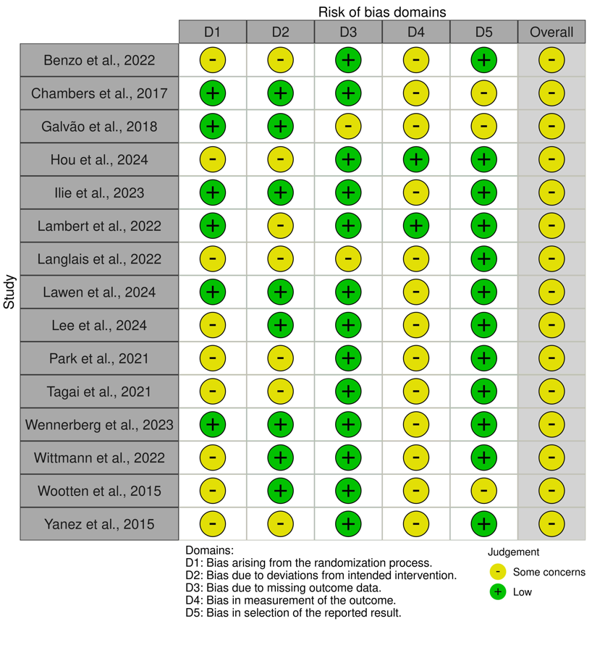

B:
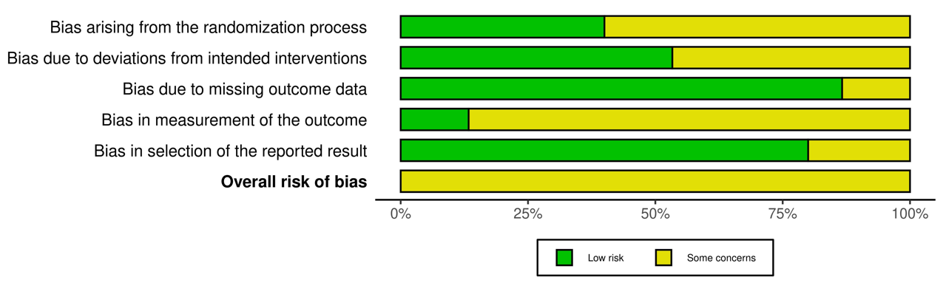

Figure S2. Risk of bias in non-randomized clinical trial studies.
A:
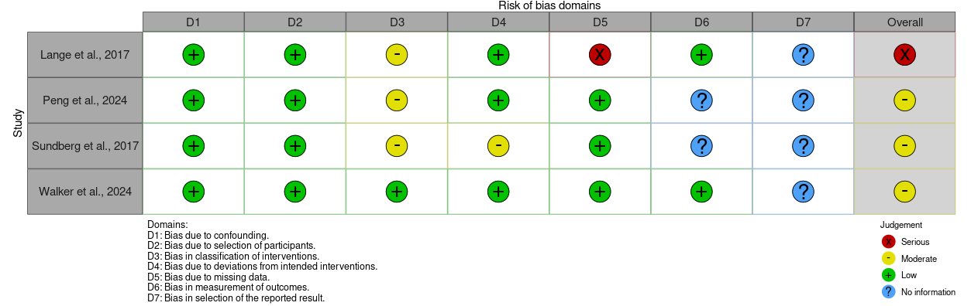

B:

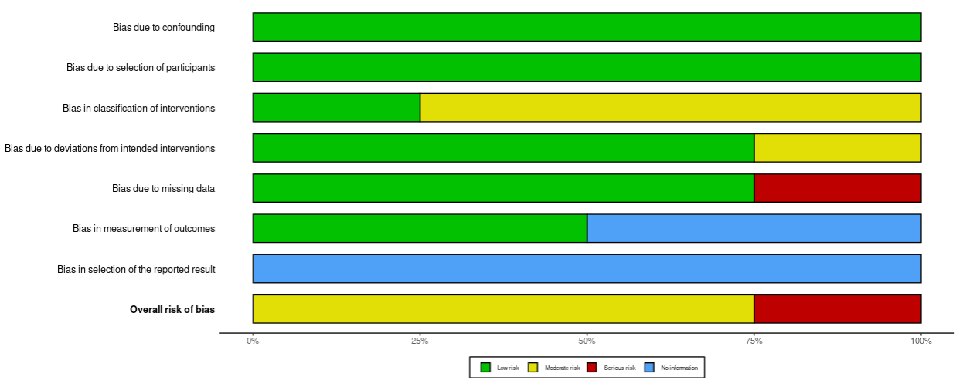

Table S3. Quality assessment using NIH Quality assessment Tool for Before-After (Pre-Post) studies with no control group

Criteria | Handley et al., 2022 | Heneka et al., 2024 | Myers et al., 2023 | O'Connor et al., 2021 | Sato et al., 2020
1. Was the study question or objective clearly stated? | Y | Y | Y | Y | Y
2. Were eligibility/selection criteria for the study population prespecified and clearly described? | Y | Y | Y | Y | Y
3. Were the participants in the study representative of those who would be eligible for the intervention in the general or clinical population of interest? | Y | Y | Y | Y | Y
4. Were all eligible participants that met the prespecified entry criteria enrolled? | NR | NR | NR | NR | N
5. Was the sample size sufficiently large to provide confidence in the findings? | Y | N | N | Y | N
6. Was the intervention clearly described and delivered consistently across the study population? | Y | Y | Y | Y | Y
7. Were the outcome measures prespecified, clearly defined, valid, reliable, and assessed consistently across all study participants? | Y | Y | Y | N | Y
8. Were the people assessing the outcomes blinded to the participants' interventions? | NR | NR | NR | NR | NR
9. Was the loss to follow-up after baseline 20% or less? Were those lost to follow-up accounted for in the analysis? | N | N | Y | Y | Y
10. Did the statistical methods examine changes in outcome measures from before to after the intervention? Were statistical tests done that provided p values for the pre-to-post changes? | Y | Y | Y | Y | N
11. Were outcome measures of interest taken multiple times  before the intervention and multiple times after the intervention (i.e., did they use an interrupted time-series design)? | N | N | N | N | N
12. If the intervention was conducted at a group level (e.g., a whole hospital, a community, etc.) did the statistical analysis take into account the use of individual-level data to determine  effects at the group level? | NA | NA | NA | NA | NA

Y, yes; N, no; NA, not applicable; NR, not reported

