Supplementary Figures
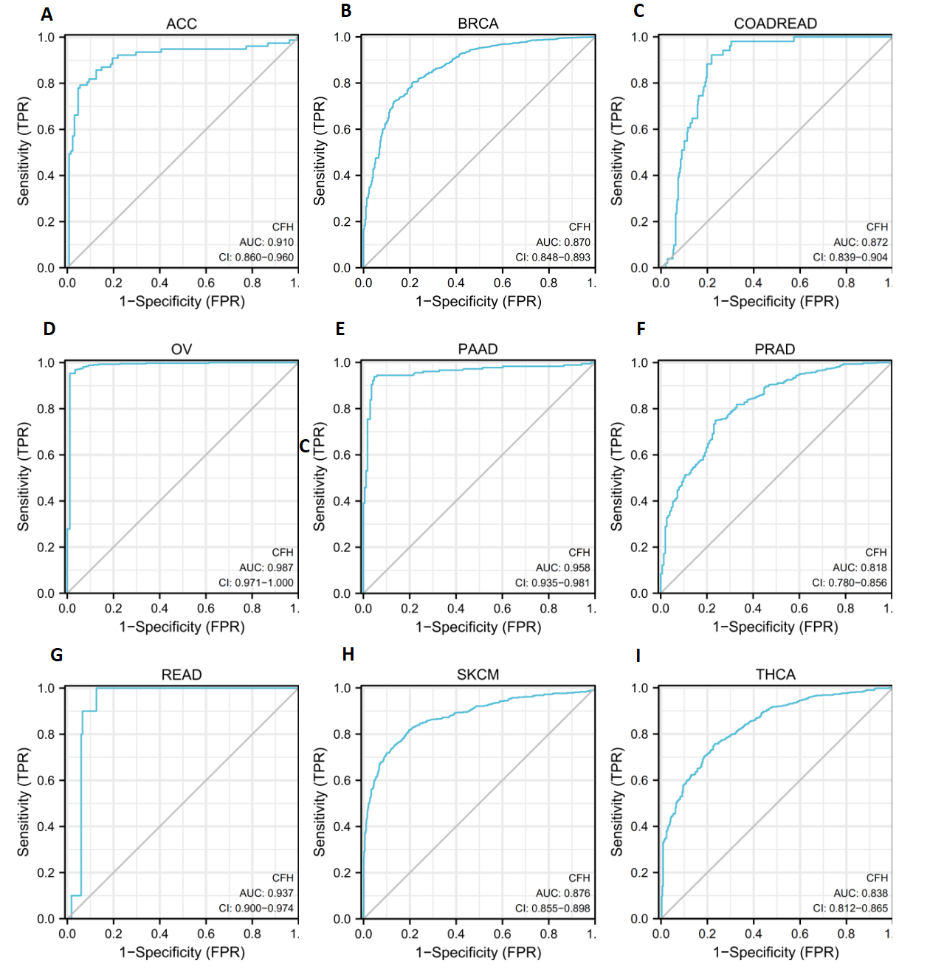
Supplementary Figure S1 | ROC curve of CFH expression profiles showed the efficiency level to distinguishing several cancers. X-axis represents false positive rates, and Y-axis represents true positive rates.

Supplementary Figure S2 | The correlations between CFH expression profiles and human leukocyte antigens (HLA) (A), C-X-C Motif Chemokine Receptor (CXCR) (B), and Chemokines (C) in cancer were evaluated by the TISIDB database.

Supplementary Figure S3 | CFH genomic mutation in types of cancer were analyzed by the cBioPortal platform (A-D) the molecular subgroups of pan-cancer were analyzed by the UALCAN database. (*P < 0.05, **P < 0.01, ***P < 0.001).

Supplementary Table

Abbreviations | Full names
ACC | Adrenocortical carcinoma
BLCA | Bladder Urothelial Carcinoma
BRCA | Breast invasive carcinoma
CESC | Cervical squamous cell carcinoma and endocervical adenocarcinoma
CHOL | Cholangiocarcinoma
COAD | Colon adenocarcinoma
COADREAD | Colon adenocarcinoma/Rectum adenocarcinoma Esophageal carcinoma
DLBC | Lymphoid Neoplasm Diffuse Large B-cell Lymphoma
ESCA | Esophageal carcinoma
FPPP | FFPE Pilot Phase II
GBM | Glioblastoma multiforme
GBMLGG | Glioma
HNSC | Head and Neck squamous cell carcinoma
KICH | Kidney Chromophobe
KIPAN | Pan-kidney cohort (KICH+KIRC+KIRP)
KIRC | Kidney renal clear cell carcinoma
KIRP | Kidney renal papillary cell carcinoma
LAML | Acute Myeloid Leukemia
LGG | Brain Lower Grade Glioma
LIHC | Liver hepatocellular carcinoma
LUAD | Lung adenocarcinoma
LUSC | Lung squamous cell carcinoma
MESO | Mesothelioma
OV | Ovarian serous cystadenocarcinoma
PAAD | Pancreatic adenocarcinoma
PCPG | Pheochromocytoma and Paraganglioma
PRAD | Prostate adenocarcinoma
READ | Rectum adenocarcinoma
SARC | Sarcoma
SKCM | Skin Cutaneous Melanoma
STAD | Stomach adenocarcinoma
STES | Stomach and Esophageal carcinoma
TGCT | Testicular Germ Cell Tumors
THCA | Thyroid carcinoma
THYM | Thymoma
UCEC | Uterine Corpus Endometrial Carcinoma
UCS | Uterine Carcinosarcoma
UVM | Uveal Melanoma
Supplementary Table S1 | cancer name abbreviations

