A.  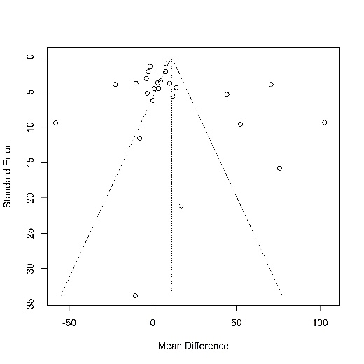 | B.  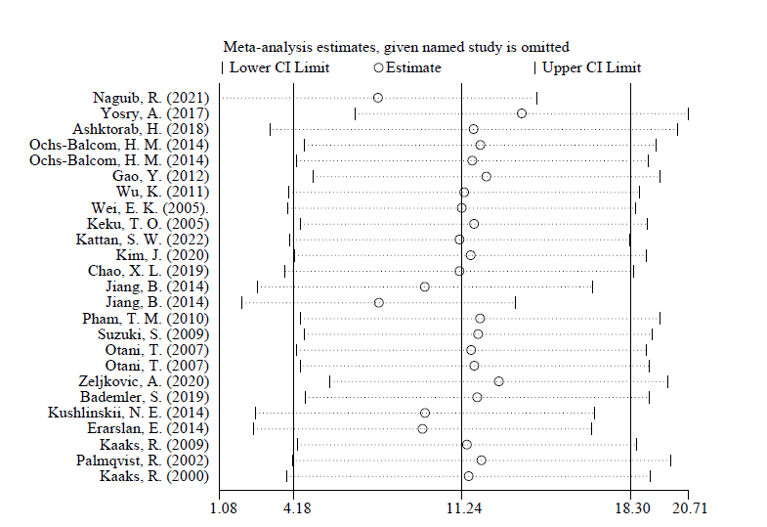
Supplementary 1. Funnel plot (A) and sensitivity analysis (B) in the meta-analysis of IGF-1 CRC patients

A.  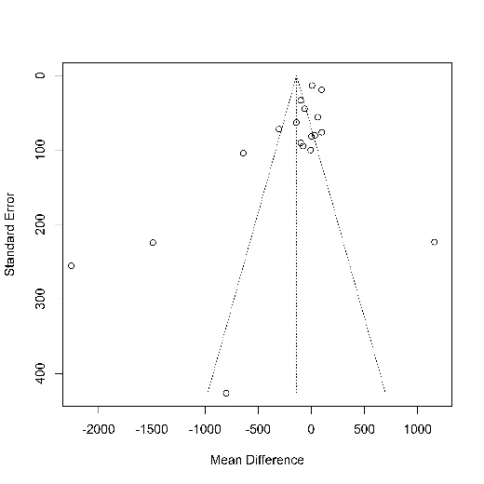 | B.  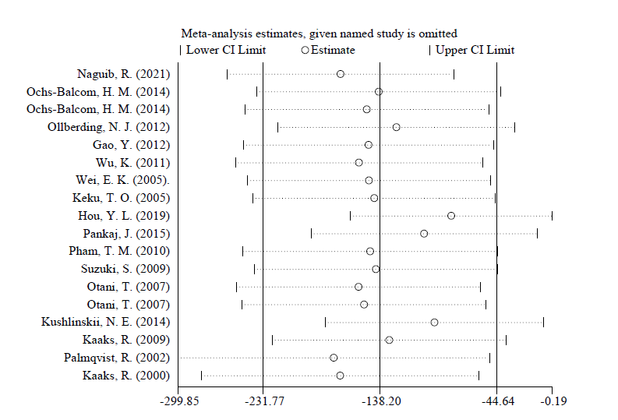
Supplementary 2. Funnel plot (A) and sensitivity analysis (B) in the meta-analysis of IGFBP3 CRC patients

A.  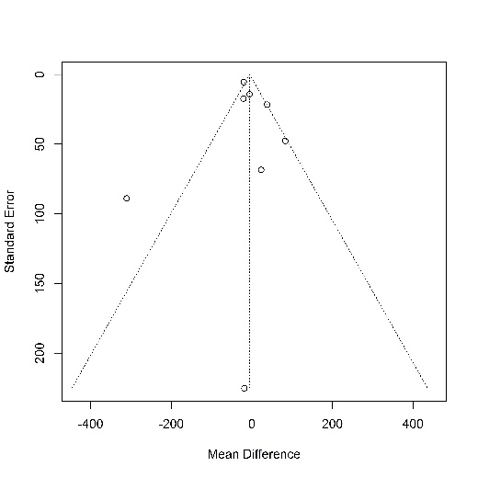 | B.  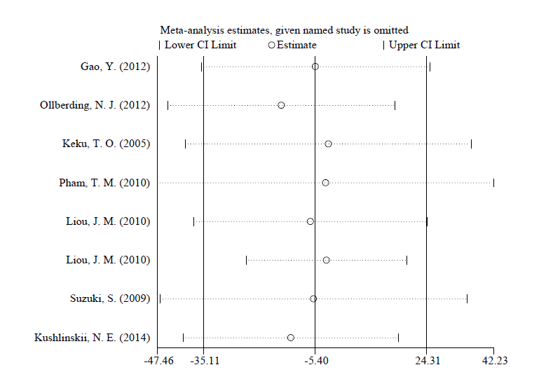
Supplementary 3. Funnel plot (A) and sensitivity analysis (B) in the meta-analysis of IGF-2 CRC patients

A.  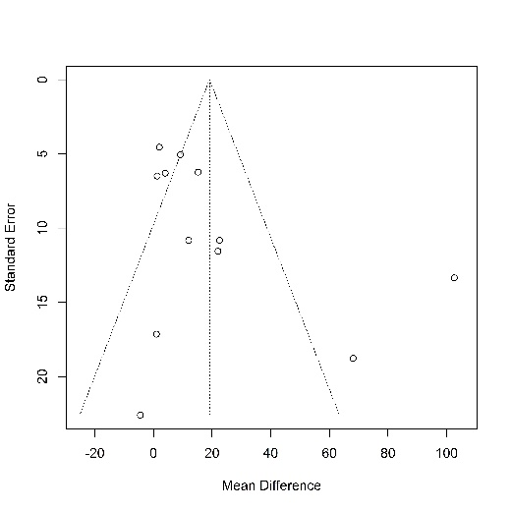 | B.  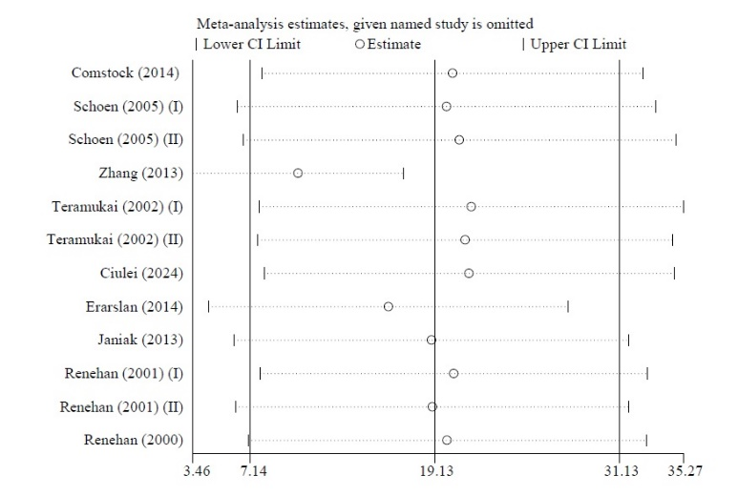
Supplementary 4. Funnel plot (A) and sensitivity analysis (B) in the meta-analysis of IGF-1 polyp patients

A.  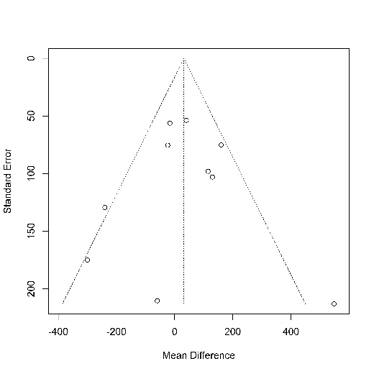 | B.  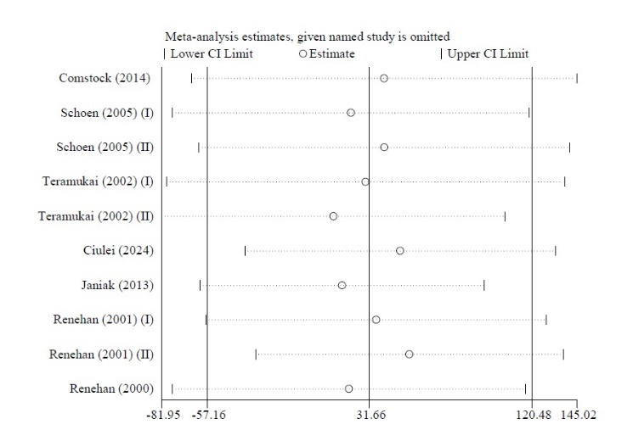
Supplementary 5. Funnel plot (A) and sensitivity analysis (B) in the meta-analysis of IGFBP3 polyp patients

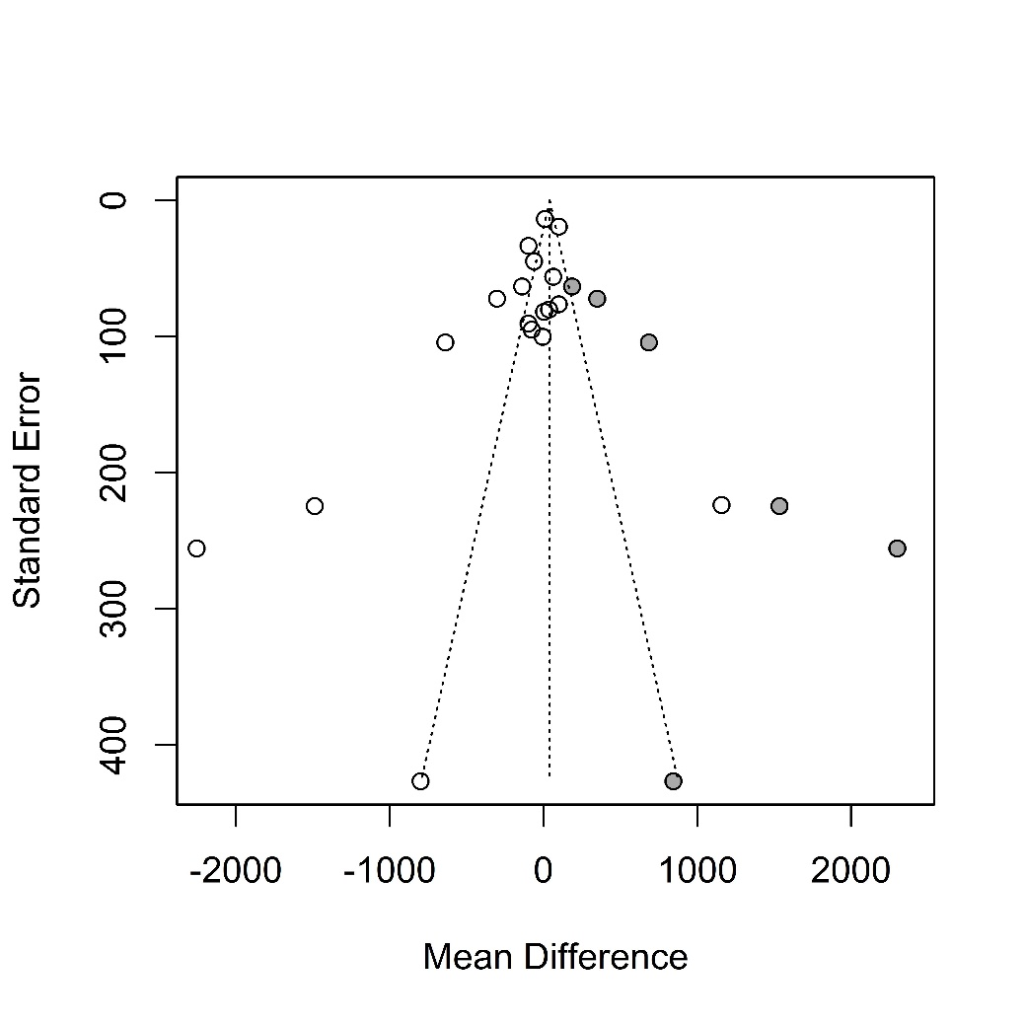
Supplementary 6. Funnel plot using by trim-and-fill meta-analysis in IGFBP3 CRC patients

A.  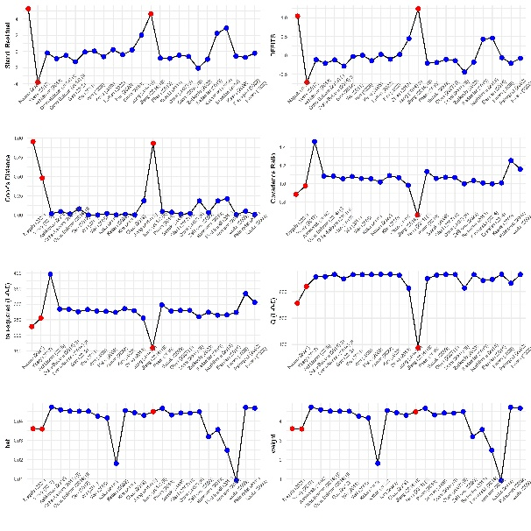 | B.  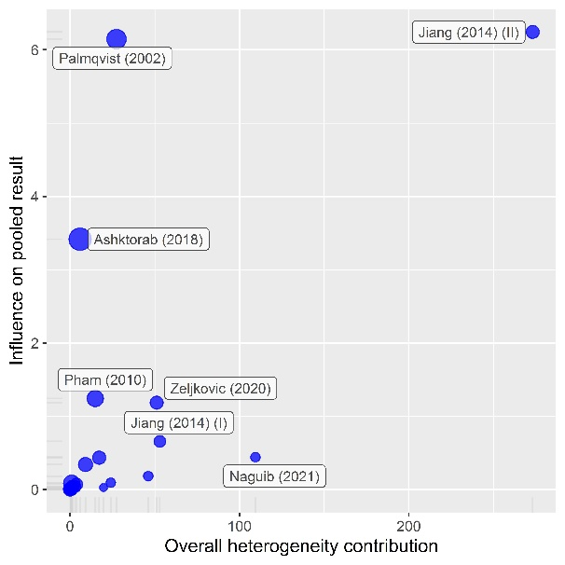
Supplementary 7. Influence diagnostics plot (A) to determine outlining studies and Baujat plot (B) to determine heterogeneity in studies related to IGF-1 CRC patients

