Supplementary Data S1: Chemotherapy Information
- Chemotherapy Regimens
  - Induction Chemotherapy (ICT):
    - Patients received 1-2 cycles of chemotherapy before radiotherapy.
    - Common regimens included TP (Paclitaxel and Nedaplatin) and DP (Docetaxel and Cisplatin).
  - Concurrent Chemoradiotherapy (CCRT):
    - CCRT combined chemotherapy with radiotherapy.
    - The most common regimen was TP (Paclitaxel and Nedaplatin).
  - Adjuvant Chemotherapy (ACT):
    - ACT was given after radiotherapy to reduce recurrence risk.
- Eligibility Criteria
Eligibility for chemotherapy was based on the following:
- Tumor Staging
  - Stage I: Most received CCRT due to limited tumor burden, with a few receiving ACT for high-risk features.
  - Stage II: Many underwent ICT followed by CCRT for locally advanced tumors. Some received ACT for high recurrence risk.
  - Stage III: Most received ICT and CCRT. ACT was used for residual disease post-radiotherapy.
  - Stage IVa: Most received ICT for extensive disease, followed by CCRT. ACT was used selectively for high-risk cases.
- Performance Status: Adequate status to tolerate treatment.
- Clinical Assessment: Individualized evaluations ensured optimal treatment.

Figure S1: Patient selection flow chart.
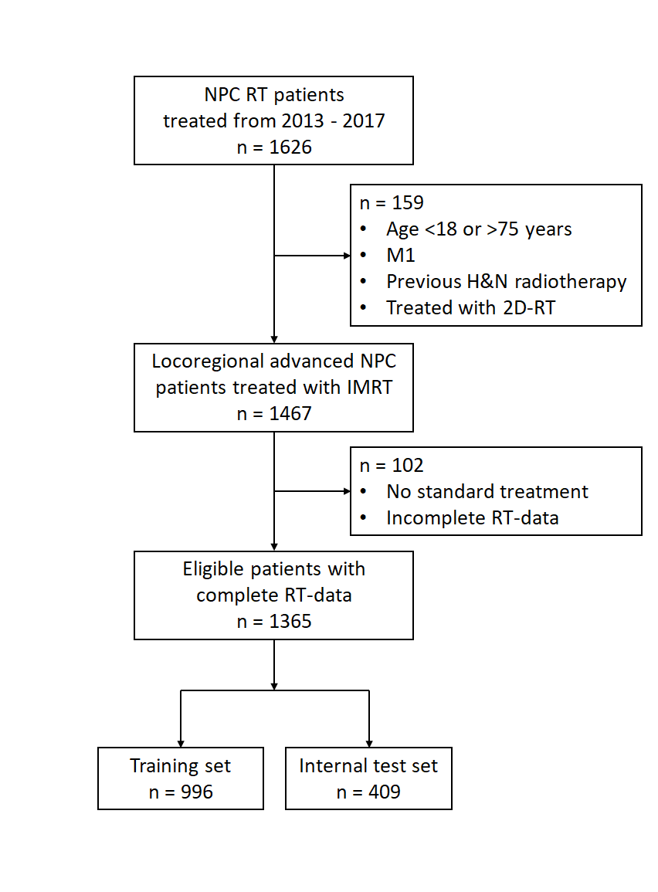
NPC: nasopharyngeal carcinoma, RT: radiotherapy, M1: Presence of Distant Metastasis, H&N: Head and Neck, 2D-RT: Conventional Two-Dimensional (2D) Radiation Therapy, IMRT: Intensity-modulated radiation therapy
Fig S2: Kaplan Meier curves to determine optimal grouping for different variables
T-stage  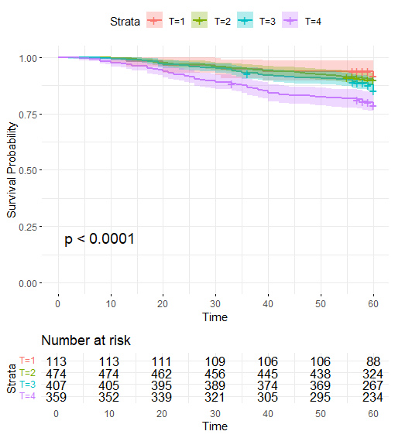 | T-stage (new categories)  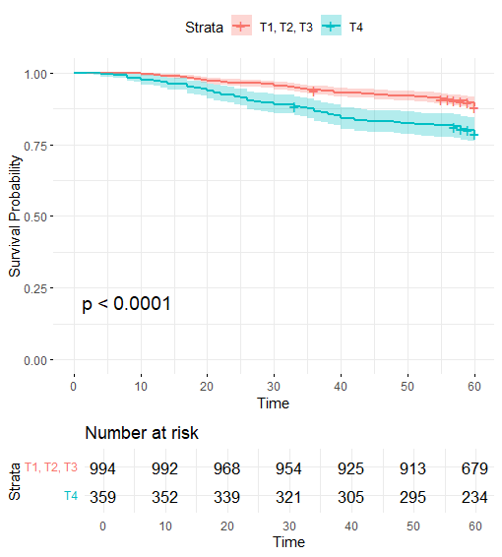
N-stage  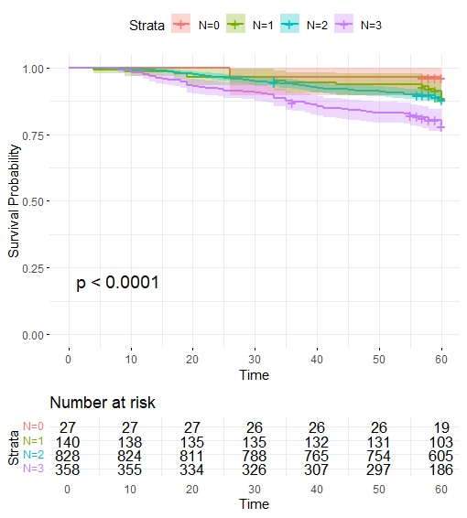 | N-stage (new categories)  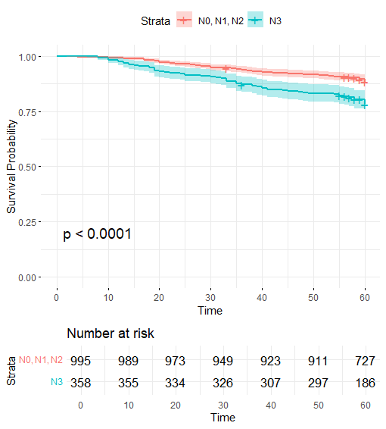
Stage  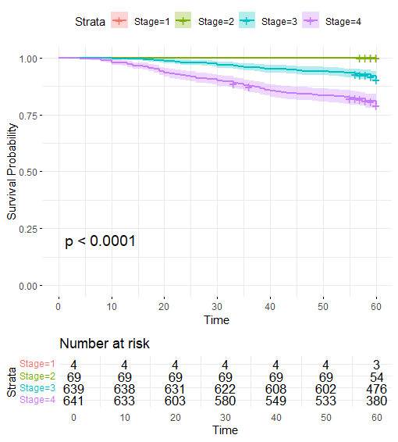 | Stage (new categories)  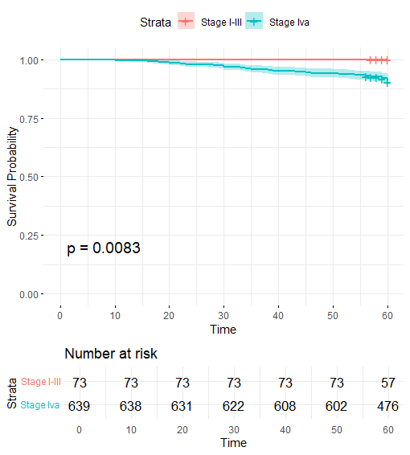
EBV negative and positive | EBV low and high
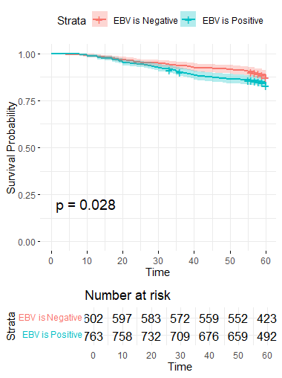 | 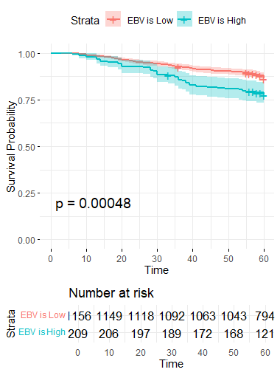
Performance score  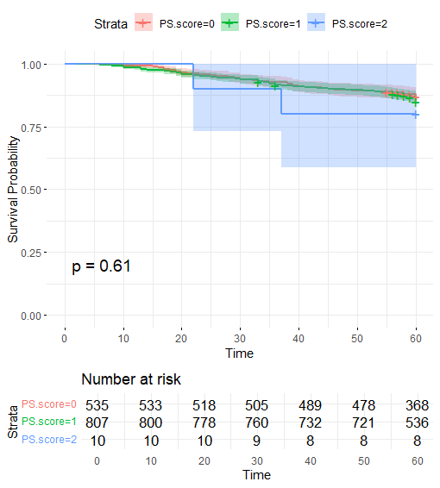 | Performance score (new categories)  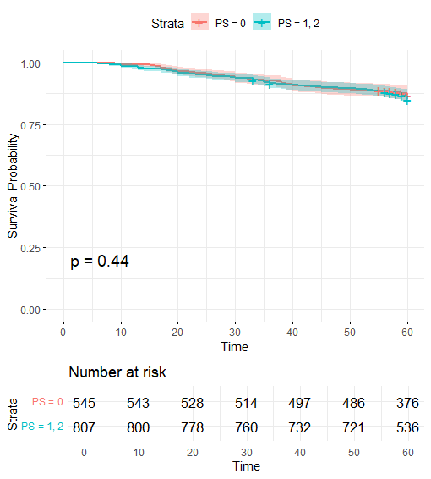

Figure S3: Distribution of the Epstein-Barr virus (EBV) DNA in two institutions: Hunan Cancer Hospital (HCH) and Cancer Hospital of Shantou University Medical College (SUMCCH). The red dashed line represents the cutoff value used for categorization.
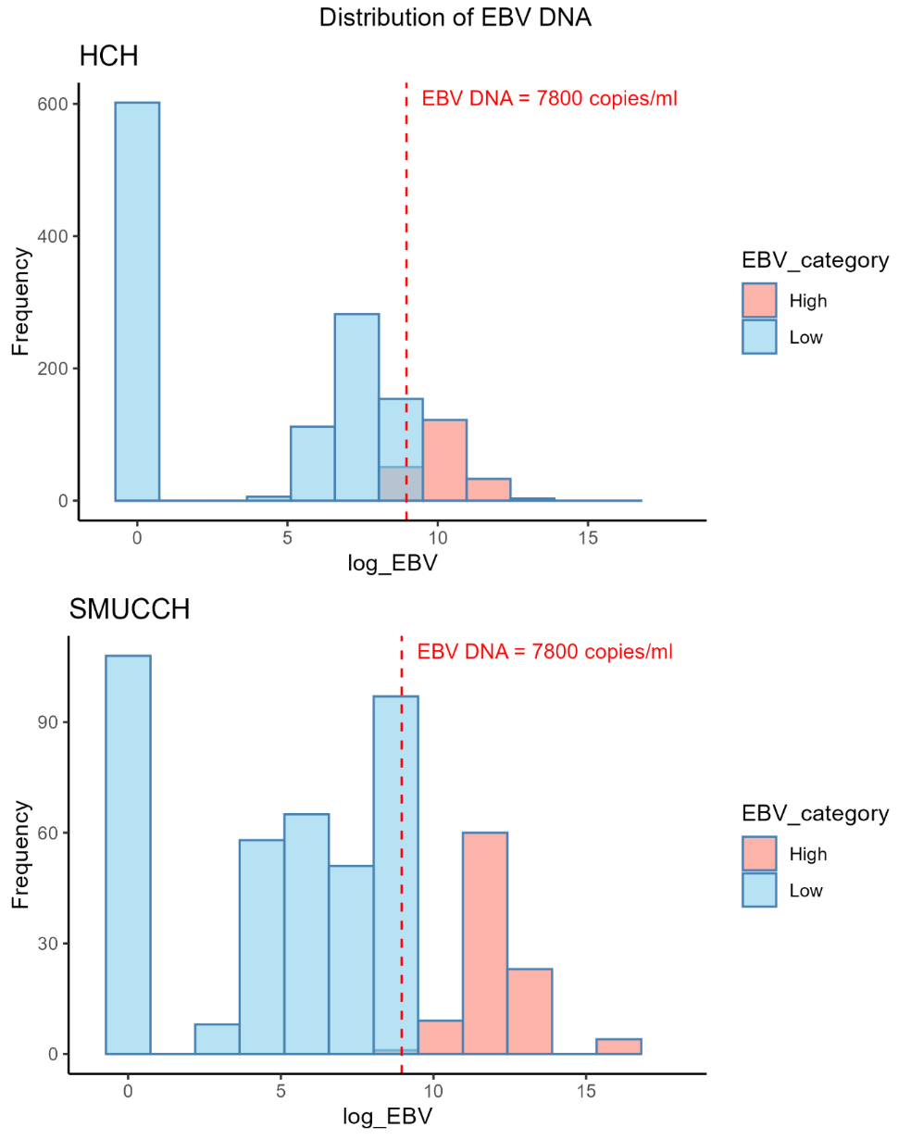
Table S1: The patient's characteristics between the training and internal test sets for different endpoints. The split was carried out separately four times for OS, PFS, LRC and DC using stratified sampling based on the event rate and treatment start date.
 | OS |  |  |  | PFS |  |  | LRC |  |  | DC
 | Training  set | Internal  test set | External  test set | P value | Training  set | Internal  test set | P value | Training  set | Internal  test set | P value | Training  set | Internal  test set | P value
Categorized variables | Frequency (proportion) |  |  | P value | Frequency (proportion) |  | P value | Frequency (proportion) |  | P value | Frequency (proportion) |  | P value
Sex |  |  |  | 0.63 |  |  | 0.33 |  |  | 0.93 |  |  | 0.70
Female | 257 (27) | 113 (28) | 125(26) |  | 267 (28) | 103 (25) |  | 260 (27) | 110 (27) |  | 262 (27) | 108 (26)
Male | 699 (73) | 296 (72) | 359(74) |  | 689 (72) | 306 (75) |  | 695 (73) | 300 (73) |  | 692 (73) | 303 (74)
T-stage |  |  |  | <0.05 |  |  | 0.06 |  |  | 0.10 |  |  | 0.57
T1 | 79 (8) | 34 (8) | 55(11) |  | 77 (8) | 36 (9) |  | 77 (8) | 36 (9) |  | 75 (8) | 38 (9)
T2 | 335 (35) | 140 (34) | 96(20) |  | 338 (35) | 137 (33) |  | 352 (37) | 123 (30) |  | 336 (35) | 139 (34)
T3 | 281 (29) | 131 (32) | 183(38) |  | 270 (28) | 142 (35) |  | 276 (29) | 136 (33) |  | 281 (29) | 131 (32)
T4 | 261 (27) | 104 (25) | 146(30) |  | 271 (28) | 94 (23) |  | 250 (26) | 115 (28) |  | 262 (27) | 103 (25)
N-stage |  |  |  | <0.05 |  |  | 0.79 |  |  | 0.85 |  |  | 0.07
N0 | 23 (2) | 4 (1) | 48(1) |  | 21 (2) | 6 (1) |  | 20 (2) | 7 (2) |  | 21 (2) | 6 (1)
N1 | 92 (10) | 49 (12) | 124(26) |  | 100 (10) | 41 (10) |  | 99 (10) | 42 (10) |  | 96 (10) | 45 (11)
N2 | 598 (63) | 236 (58) | 220(45) |  | 585 (61) | 249 (61) |  | 588 (62) | 246 (60) |  | 565 (59) | 269 (65)
N3 | 243 (25) | 120 (29) | 92(19) |  | 250 (26) | 113 (28) |  | 248 (26) | 115 (28) |  | 272 (29) | 91 (22)
PS |  |  | - | 0.78 |  |  | 0.57 |  |  | 0.18 |  |  | 0.55
0 | 376 (39) | 160 (39) |  |  | 370 (39) | 167 (41) |  | 384 (40) | 152 (37) |  | 384 (40) | 153 (37)
1 | 572 (60) | 247 (60) |  |  | 580 (61) | 238 (58) |  | 562 (59) | 257 (63) |  | 563 (59) | 255 (62)
2 | 8 (1) | 2 (0) |  |  | 6 (1) | 4 (1) |  | 9 (1) | 1 (0) |  | 7 (1) | 3 (1)
Continuous variables | Mean (sd) |  |  | P value | Mean (sd) |  | P value | Mean (sd) |  | P value | Mean (sd) |  | P value
Age | 48.1 (10.2) | 47.9 (9.7) | 59.0  (11.6) | <0.05 | 48.3 (9.8) | 47.5 (10.6) | 0.33 | 48.2 (10.0) | 47.7 (10.1) | 0.47 | 48.2 (9.8) | 47.6 (10.5) | 0.22
BMI | 23.5 (3.3) | 23.1 (3.1) | - | 0.04 | 23.4 (3.3) | 23.2 (3.2) | 0.46 | 23.3 (3.3) | 23.4 (3.2) | 0.52 | 23.3 (3.2) | 23.5 (3.4) | 0.41
Interval | 216.6 (208.1) | 197.4 (184.7) | - | 0.20 | 214.1 (203.9) | 203.3 (195.7) | 0.32 | 209.3 (199.2) | 214.4 (206.9) | 0.62 | 216.1 (207.1) | 198.7 (187.3) | 0.11
Volume | 42.4 (29.0) | 41.3 (28.4) | - | 0.60 | 41.8 (28.4) | 42.8 (29.8) | 0.80 | 41.7 (29.1) | 42.9 (28.0) | 0.22 | 42.3 (28.9) | 41.6 (28.6) | 0.93
Pack year | 14.8 (20.6) | 13.1 (20.1) | - | 0.21 | 13.9 (20.2) | 15.2 (21.3) | 0.24 | 13.8 (20.0) | 15.4 (21.6) | 0.37 | 14.4 (20.8) | 13.8 (19.4) | 0.93
EBV DNA | 9421.1 (35494.1) | 8545.4 (23500.6) | 119249  (814473) | <0.05 | 10516.0 (40392.7) | 8464.2 (24756.3) | 0.44 | 8535.0 (27969.2) | 10600.2 (43162.4) | 0.04 | 10364.5 (39032.4) | 8777.9 (27058.3) | 0.30
BMI: Body mass index, PS: WHO performance score, EBV: Epstein–Barr virus, OS: overall survival, PFS: progression-free survival, LRC: locoregional control, DC: distant control
Table S2: Univariable analysis results for the EBV complete case dataset, pack year complete case dataset, and the multivariate imputed training dataset.
 | EBV dataset (636 cases (47%)) |  | Pack year dataset (1,310 cases (96%)) |  | Imputed dataset (1,365 cases)
Variable | P value | Hazard ratio (95% CI) | P value | Hazard ratio (95% CI) | P value | Hazard ratio (95% CI)
OS
Sex | 0.036 | 1.782 (1.04-3.056) | 0.018 | 1.545 (1.076-2.219) | 0.078 | 1.238 (0.967-1.568)
Age | <0.001 | 1.067 (1.045-1.09) | <0.001 | 1.059 (1.042-1.075) | <0.001 | 1.059 (1.044-1.074)
BMI | 0.915 | 0.997 (0.935-1.062) | 0.811 | 0.995 (0.951-1.046) | 0.829 | 0.995 (0.954-1.039)
Interval | 0.755 | 1.000 (0.999-1.001) | 0.918 | 1.000 (0.999-1.001) | 0.513 | 0.999 (0.998-1.001)
T-stage | <0.001 | 2.688 (1.783-4.052) | <0.001 | 1.925 (1.427-2.597) | <0.001 | 1.969 (1.483-2.613)
N-stage | <0.001 | 1.902 (1.255-2.882) | <0.001 | 2.075 (1.539-2.796) | <0.001 | 2.029 (1.528-2.694)
PS | 0.001 | 1.811 (1.15-2.852) | 0.499 | 1.111 (0.820-1.502) | 0.200 | 1.209 (0.904-1.618)
Volume | <0.001 | 1.016 (1.011-1.021) | <0.001 | 1.009 (1.005-1.013) | <0.001 | 1.009 (1.005-1.013)
EBV status | 0.002 | 1.081 (1.008-1.024) | - | - | 0.016 | 1.061 (1.026-1.097)
Pack year | - | - | <0.001 | 1.014 (1.009-1.020) | <0.001 | 1.013 (1.008-1.018)
PFS
Sex | 0.115 | 2.018 (0.842-4.838) | 0.001 | 1.607 (1.205-2.144) | 0.006 | 1.315 (1.084-1.595)
Age | 0.116 | 1.027 (0.994-1.061) | <0.001 | 1.028 (1.016-1.041) | <0.001 | 1.029 (1.017-1.041)
BMI | 0.769 | 0.985 (0.889-1.091) | 0.674 | 0.992 (0.958-1.028) | 0.669 | 0.993 (0.959-1.027)
Interval | 0.246 | 0.999 (0.996-1.001) | 0.876 | 1.000 (0.999-1.001) | 0.999 | 1.000 (0.999-1.001)
T-stage | 0.926 | 1.036 (0.489-2.196) | <0.001 | 1.668 (1.310-2.124) | <0.001 | 1.669 (1.324-2.105)
N-stage | 0.071 | 1.833 (0.951-3.533) | <0.001 | 1.720 (1.351-2.190) | <0.001 | 1.657 (1.313-2.097)
PS | 0.150 | 1.678 (0.829-3.395) | 0.587 | 1.066 (0.842-1.356) | 0.237 | 1.150 (0.912-1.449)
Volume | 0.425 | 1.005 (0.993-1.016) | <0.001 | 1.008 (1.005-1.012) | <0.001 | 1.008 (1.005-1.011)
EBV | 0.498 | 1.027 (0.951-1.108) | - | - | 0.023 | 1.040 (1.013-1.068)
Pack year | - | - | <0.001 | 1.012 (1.008-1.017) | <0.001 | 1.011 (1.008-1.016)
LRC
Sex | 0.156 | 1.883 (0.786-4.513) | 0.071 | 1.678 (0.956-2.944) | 0.078 | 1.429 (0.961-2.124)
Age | 0.183 | 1.022 (0.990-1.056) | 0.410 | 1.009 (0.987-1.032) | 0.486 | 1.008 (0.986-1.030)
BMI | 0.763 | 0.985 (0.890-1.089) | 0.402 | 0.956 (0.893-1.025) | 0.194 | 0.956 (0.892-1.023)
Interval | 0.261 | 0.999 (0.996-1.001) | 0.418 | 1.000 (0.999-1.001) | 0.582 | 1.000 (0.999-1.001)
T-stage | 0.833 | 0.922 (0.435-1.954) | 0.430 | 1.213 (0.751-1.959) | 0.534 | 1.164 (0.722-1.875)
N-stage | 0.110 | 1.708 (0.886-3.292) | 0.279 | 1.299 (0.809-2.087) | 0.354 | 1.250 (0.780-2.003)
PS | 0.177 | 1.625 (0.803-3.289) | 0.207 | 1.353 (0.846-2.163) | 0.179 | 1.377 (0.864-2.196)
Volume | 0.722 | 1.002 (0.991-1.013) | 0.399 | 1.003 (0.996-1.010) | 0.400 | 1.003 (0.996-1.010)
EBV | 0.690 | 1.016 (0.942-1.095) | - | - | 0.508 | 1.007 (0.957-1.060)
Pack year | - | - | 0.086 | 1.008 (0.999-1.018) | 0.084 | 1.008 (0.999-1.017)
DC
Sex | 0.083 | 1.735 (0.930-3.237) | 0.039 | 1.561 (1.023-2.381) | 0.041 | 1.363 (1.012-1.835)
Age | 0.785 | 1.003 (0.980-1.027) | 0.936 | 1.001 (0.984-1.018) | 0.967 | 0.9997 (0.983-1.016)
BMI | 0.719 | 1.014 (0.941-1.092) | 0.724 | 0.991 (0.941-1.044) | 0.789 | 0.993 (0.943-1.046)
Interval | 0.380 | 0.999 (0.998-1.001) | 0.283 | 1.000 (0.999-1.001) | 0.213 | 0.9994 (0.998-1.001)
T-stage | 0.063 | 1.604 (0.976-2.638) | 0.033 | 1.472 (1.031-2.103) | 0.040 | 1.445 (1.016-2.055)
N-stage | 0.009 | 1.894 (1.171-3.063) | <0.001 | 2.024 (1.434-2.856) | <0.001 | 1.984 (1.412-2.787)
PS | 0.234 | 1.356 (0.821-2.242) | 0.896 | 1.023 (0.724-1.447) | 0.749 | 1.057 (0.750-1.490)
Volume | 0.001 | 1.013 (1.007-1.020) | 0.001 | 1.008 (1.004-1.013) | 0.001 | 1.008 (1.003-1.013)
EBV | <0.001 | 1.138 (1.070-1.211) | - | - | 0.063 | 1.075 (1.032-1.120)
Pack year | - | - | 0.007 | 1.011 (1.003-1.017) | 0.009 | 1.009 (1.002-1.016)
CI: confidence interval, BMI: Body mass index, PS: WHO performance score, EBV: Epstein–Barr virus, OS: overall survival, PFS: progression-free survival, LRC: locoregional control, DC: distant control

Table S3: The selection frequency after stepwise forward selection for each variable in the 10 imputation sets, variables selected in more than 5 of the 10 imputation sets were included in the final model.
OS |  | PFS |  | LRC |  | DC
Variable | Freq | Variable | Freq | Variable | Freq | Variable | Freq
Age | 10 | Age | 10 | Volume | 7 | N | 10
T | 10 | Volume | 10 | EBV | 3 | Volume | 10
N | 10 | N | 10 |  |  | EBV | 7
EBV status | 6 | Pack year | 7 |  |  | T | 0
Pack year | 0 | EBV | 1 |  |  | Pack year | 0
Volume | 0 | T | 0

OS: overall survival, PFS: progression-free survival, LRC: locoregional control, DC: distant control, Freq: frequency, EBV: Epstein–Barr virus

Table S4: Model variables, coefficient, and hazard ratios
Endpoints | Parameters | Category | Coefficients | Hazard ratio (95% CI) | p-value
OS | Age | Continuous | 0.057 | 1.06 (1.04, 1.08) | <0.05
OS | T-stage | T1-T3  T4 | 0  0.846 | 1  2.33 (1.66, 3.28) | <0.05
OS | N-stage | N0-N2  N3 | 0  0.985 | 1  2.68 (1.89, 3.79) | <0.05
OS | EBV status | Low | 0 | 1 | 0.13
OS | EBV status | High | 0.492 | 1.64 (0.86, 3.10)
PFS | Age | Continuous | 0.019 | 1.02 (1.01, 1.03) | <0.05
PFS | Volume | Continuous | 0.007 | 1.01 (1.00, 1.01) | <0.05
PFS | N-stage | N0-N2  N3 | 0  0.500 | 1  1.65 (1.25, 2.18) | <0.05
PFS | Pack year | Continuous | 0.007 | 1.01 (1.00, 1.01) | <0.05
LRC | Volume | Continuous | 0.006 | 1.01 (1.00 – 1.01) | 0.11
DC | N-stage | N0-N2  N3 | 0  0.776 | 1  2.17 (1.44, 3.29) | <0.05
DC | Volume | Continuous | 0.008 | 1.01 (1.00-1.01) | <0.05
DC | EBV status | Low | 0 | 1 | 0.09
DC | EBV status | High | 0.561 | 1.75 (0.91, 3.37)
C-index: concordance index, EBV: Epstein–Barr virus, CI: confidence interval, OS: overall survival, PFS: progression-free survival, LRC: locoregional control, DC: distant control

Fig S4: Nomograms for evaluating 5-year probabilities of (a) progression-free survival, (b) locoregional control, and (c) distant control.
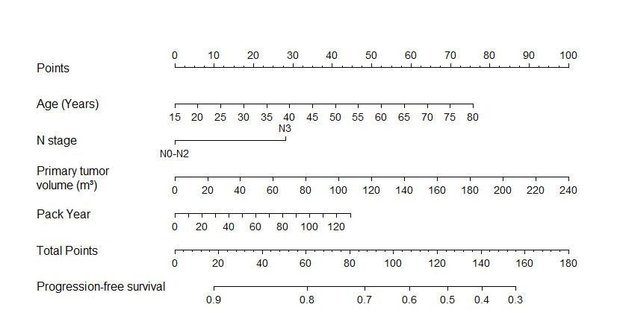
(a)
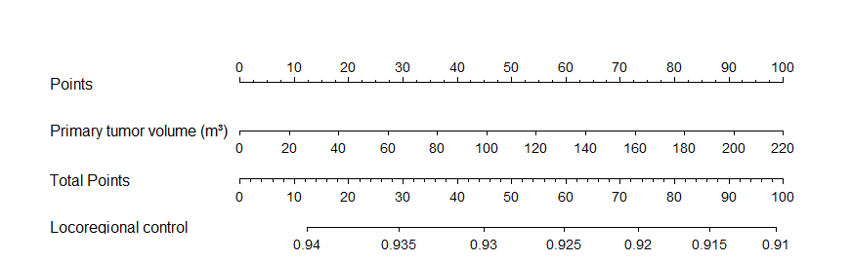
(b)
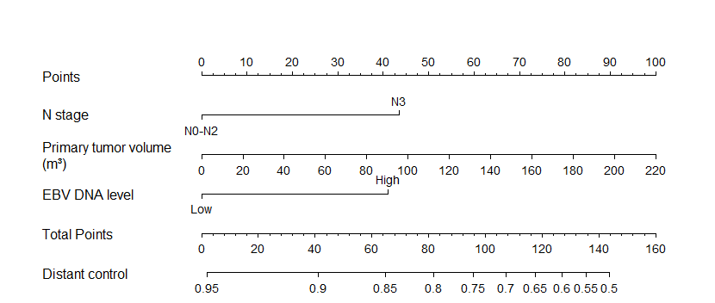
(c)

Table S5: Concordance index (95% confidence interval) of model on complete cases (CC) dataset trained on the multivariate imputation (MI) dataset. EBV status was missing 53.3% in the CC dataset and was included as predictor in overall survival and distant control. CC test set yielded similar C-indices to the MI dataset, indicating robustness to missing data handling.
Endpoints | MI training set | MI test set | CC test set
Overall survival | 0.73 (0.68-0.77) | 0.71 (0.64-0.77) | 0.77 (0.68, 0.86)
Distant control | 0.67 (0.61-0.73) | 0.59 (0.50-0.69) | 0.61 (0.48 - 0.74)

Figure S5: Decision curve analysis at the 5th year for all endpoints with the full threshold probability shown. X-axis shows the threshold probability, which is the threshold for preference of intervention, Y-axis shows the net benefit, which weighs the benefits of true positives against the harms of false positives. Grey lines (Treat all) represent the strategy of applying a more intensive therapy to all patients, while the black lines (Treat none) meaning all patients receive standard treatment. The DCA figure indicates for OS the clinical Cox model provides a greater net benefit than both the AJCC stage model and the treat all situation when taking thresholds between 5% and 35%; for PFS, the threshold is between 15% to 50%, and for DC between 10% and 25%. For locoregional recurrence, no differences in net benefit between the Cox model, the AJCC and the treat all situation can be observed.
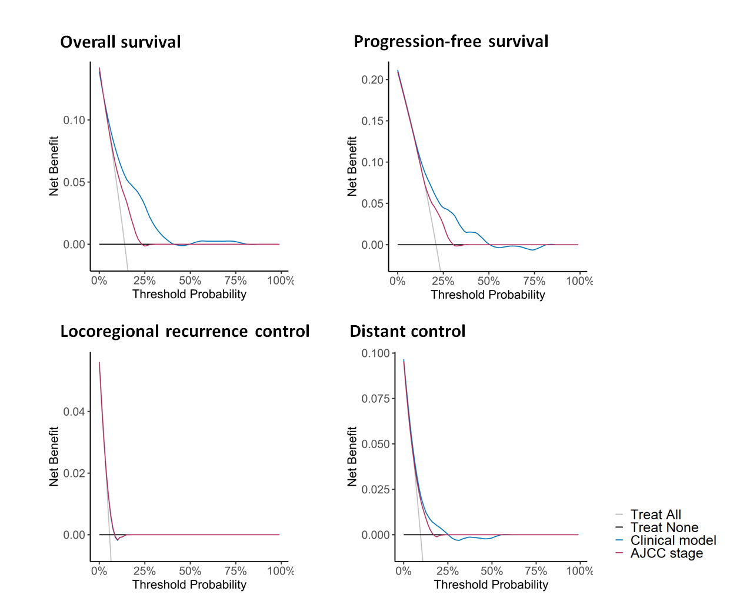

Figure S6: Kaplan-Meier curves comparing the Cox model and AJCC model in locoregional control and distant control in the training and internal test set.
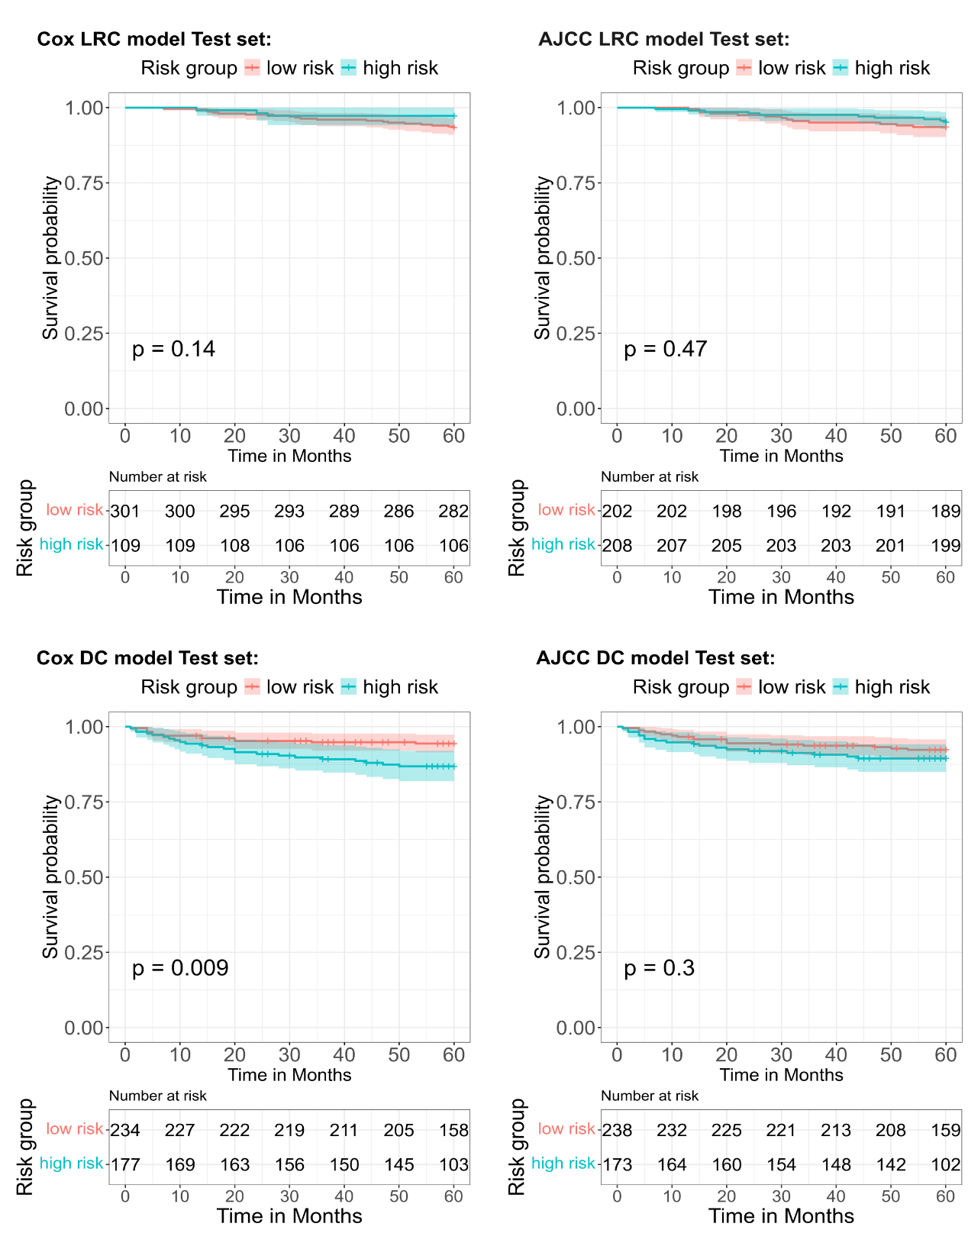
LRC: locoregional control, DC: distant control

Table S6: Closed testing procedure for model updating in the external dataset.
Model | Update level | Log-likelihood | LR Test comparison | p-value
M0 | Baseline hazard recalibration | -546.2
M1 | Recalibration (slope + baseline) | -542.9 | M1 vs. M0 | 0.01
M2 | Re-estimate coefficients | -540.8 | M2. Vs. M1 | 0.24
Abbreviations: LR, Likelihood-Ratio

Table S7: Calibration performance of the final Cox model for overall survival in the training set, internal test set, and external test set with different updated model.
Dataset | Training set | Internal Test set | External test set
Dataset | Training set | Internal Test set | Original model | Recalibrated (selected) | Re-estimate coefficient
AUC (95%CI) | 0.73 (0.68-0.77) | 0.71 (0.64-0.77) | 0.67 (0.61-0.72) | 0.67 (0.61-0.72) | 0.71 (0.64-0.78)
HL test X² (p-value) | 0.18 | 0.72 | <0.01 | 0.45 | 0.11
Calibration  slope (95%CI) | 0.95 (0.73-1.18) | 1.07 (0.81-1.33) | 0.55 (0.41-0.69) | 0.96 (0.48, 1.45) | 0.88 (0.37, 1.39)
Calibration  intercept (95%CI) | 0.01 (-0.04-0.04) | 0.01 (-0.05-0.05) | 0.05 (0.01-0.09) | 0.00 (-0.11, 0.11) | 0.02 (-0.10, 0.14)
AUC: Area under the ROC Curve, CI: confidence interval, HL test: Hosmer–Lemeshow (HL) test

Figure S7: Calibration plots in the internal test set for progression-free survival, locoregional recurrence control and distant control.
