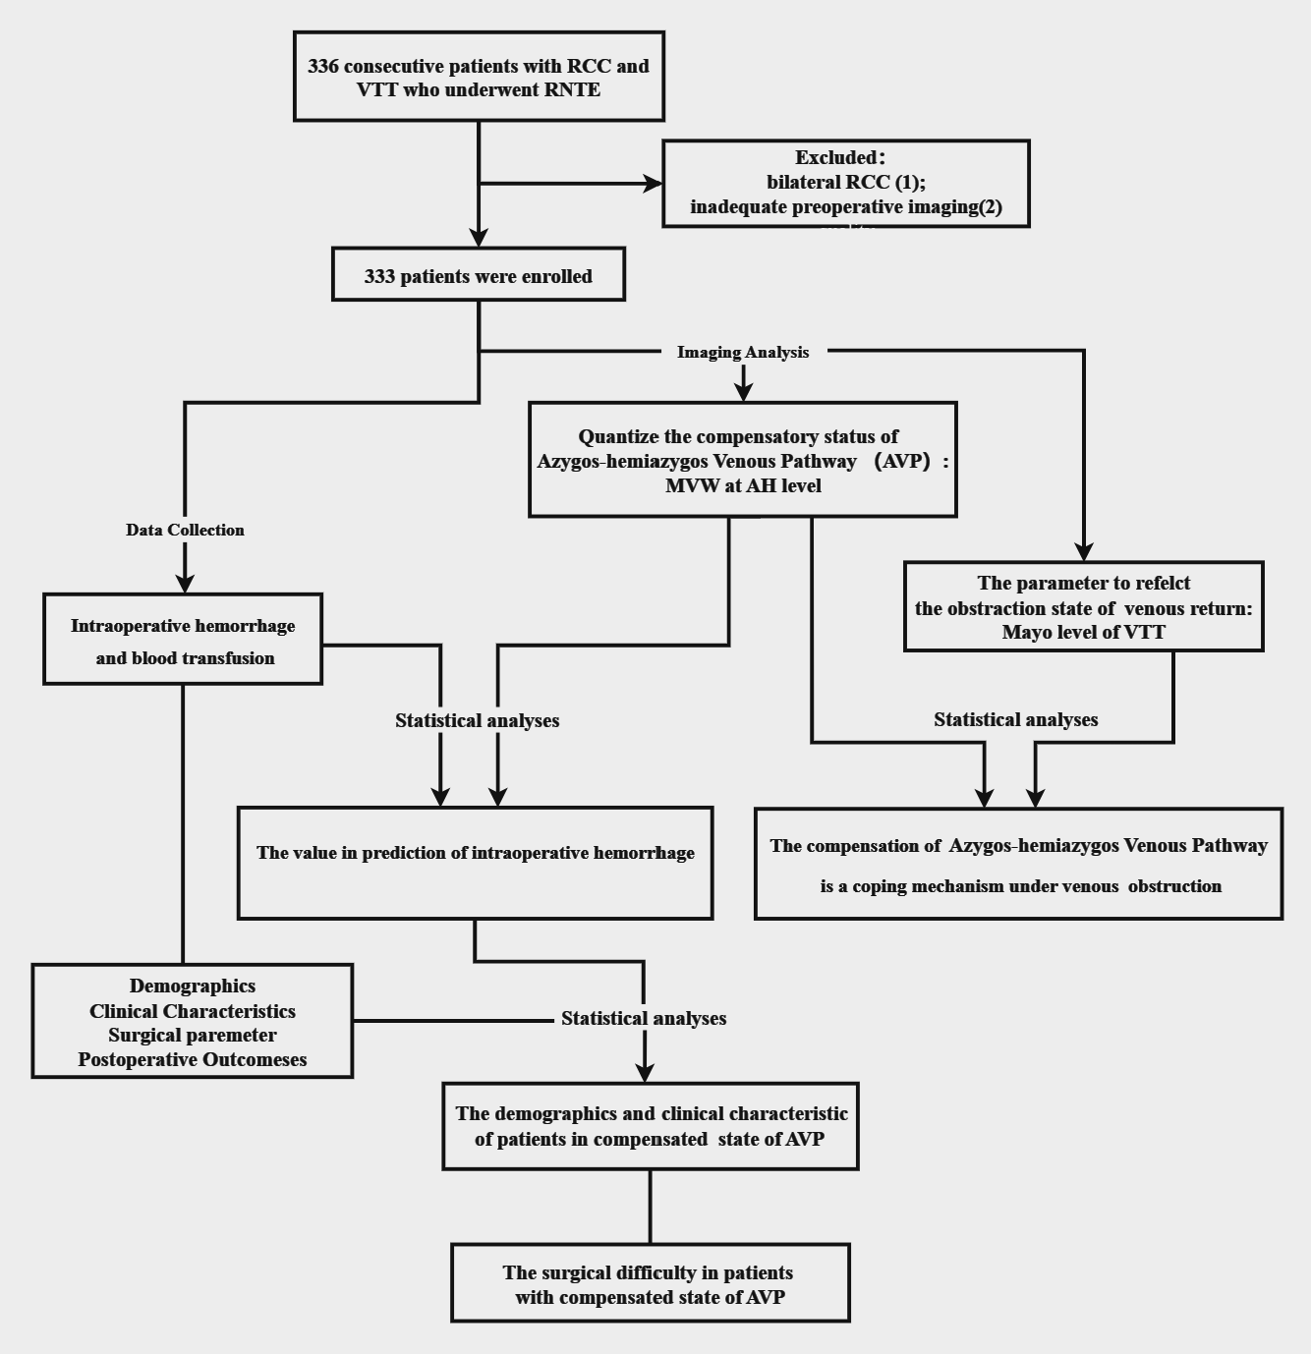
Figure S1 The flowchart of this study

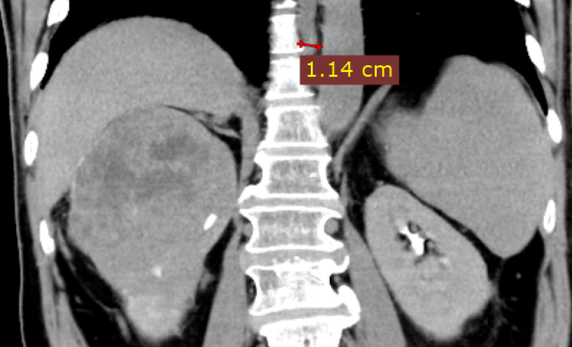  A | 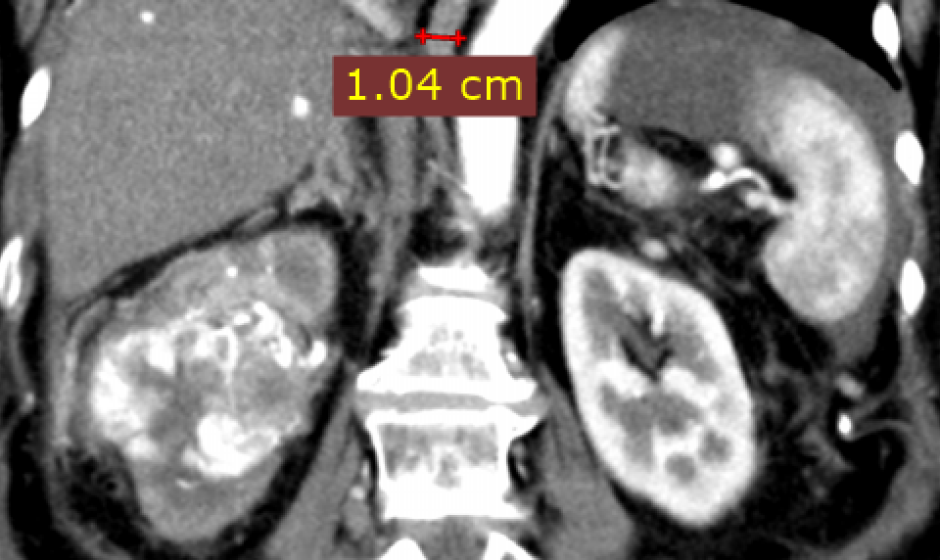  B
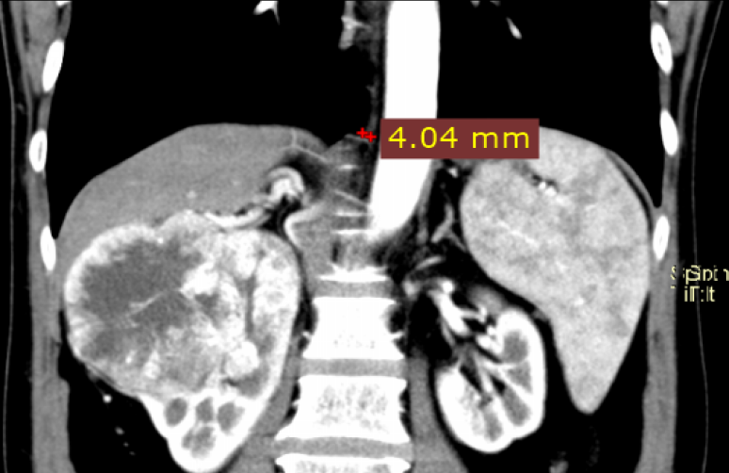  C | 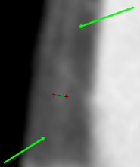  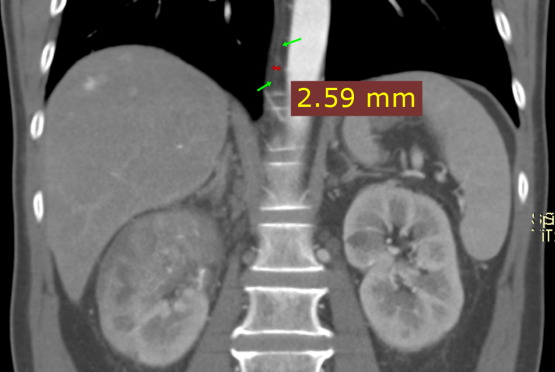  D
Figure.S2 contrast-enhanced CT of Elderly male patient 4(A) and Elderly female patient 3 (B) with right side lesion, shows the azygos vein was distinctly widened, with Maximum Venous Width at Aortic Hiatus level (MVW at AH level) of 11.4 mm and 10.4 mm, indicating a significantly more functional pathway between SVC and the perirenal venous network compared to patients shown in (C) (Elderly male patient 5, with MVW at AH level of 4.0 mm ) and (D) (Elderly male patient 6, with MVW at AH level of 3.4 mm).The intraoperative hemorrhage volumes were 8000 ml(A), 1500 ml(B), 400 ml(C), and 300 ml(D).

