Characteristic | Category | n (%)
Neoadjuvant chemotherapy | Yes | 16 (59.3)
 | No | 11 (40.7)
Peritoneal cytology at surgery (n: 23) | Negative | 20 (87.0)
 | Positive | 1 (4.3)
 | Not performed | 2 (8.7)
Pathologic T stage (pT) (n: 23) | pT1 | 1 (4.3)
 | pT2 | 2 (8.7)
 | pT3 | 5 (21.7)
 | pT4 | 15 (65.2)
Pathologic N stage (pN) (n: 23) | pN0 | 3 (13.0)
 | pN1 | 4 (17.4)
 | pN2 | 6 (26.1)
 | pN3 | 10 (43.5)
Adjuvant therapy status | Completed as planned | 19 (70.3)
 | Treatment discontinuation | 5 (18.5)
 | No adjuvant treatment | 3 (11.1)
Local radiotherapy | Yes | 14 (51.9)
 | No | 13 (48.1)
Supplementary Table S1: Surgical, pathologic, and treatment characteristics of patients with recurrent PM after curative-intent therapy (n: 27). For variables with incomplete data (pT, pN, peritoneal cytology), the denominator is the number of patients with available information.

Characteristic | All patients  (N = 166) | De novo PM  (N = 139) | Recurrent PM  (N = 27) | p
Primary tumor characteristics
WHO histology* |  |  |  | 0.243
- Tubular | 2 (2.2) | 1 (1.3) | 1 (6.7)
- Signet-ring cell | 54 (60.0) | 48 (64.0) | 6 (40)
- Mucinous | 3 (3.3) | 2 (2.7) | 1 (6.7)
- Poorly cohesive | 31 (34.4) | 24 (32.0) | 7 (46.7)
Tumor differentiation** |  |  |  | <0.001
- Well | 6 (4.8) | 0 (0.0) | 6 (24.0)
- Moderate | 8 (6.5) | 5 (5.1) | 3 (12.0)
- Poor | 110 (88.7) | 94 (94.9) | 16 (64.0)
Other metastatic sites
Number of metastatic sites |  |  |  | 0.053
- 2 | 46 (27.7) | 37 (26.6) | 9 (33.3)
- ≥3 | 48 (28.9) | 45 (32.4) | 3 (11.1)
Distant lymph node | 48 (28.9) | 43 (30.9) | 5 (18.5) | 0.186
Liver metastasis | 43 (25.9) | 38 (27.3) | 5 (18.5) | 0.329
Bone metastasis | 19 (11.4) | 18 (12.9) | 1 (3.7) | 0.164
Brain metastasis | 4 (2.4) | 4 (2.9) | 0 (0.0) | 0.370
Lung metastasis | 20 (12.0) | 19 (13.7) | 1 (3.7) | 0.143
Systemic treatment characteristics
Anti-HER2 therapy use (if HER2 positive)*** |  |  |  | 0.065
1st-line anti-HER2 | 14 (87.5) | 10 (83.3) | 4 (100)
Best supportive care | 2 (12.5) | 2 (16.7) | 0 (0)
First-line metastatic regimen |  |  |  | <0.001
FOLFOX / CapOX | 46 (34.1) | 42 (37.2) | 4 (18.2)
5-FU–cisplatin/carboplatin | 55 (40.7) | 49 (43.4) | 6 (27.3)
5-FU–platinum* + docetaxel | 21 (15.6) | 18 (15.9) | 3 (13.6)
5-FU–platinum* + anthracycline | 2 (1.5) | 2 (1.8) | 0 (0.0)
Irinotecan-based | 5 (3.7) | 1 (0.9) | 4 (18.2)
Other regimens** | 6 (4.4) | 1 (0.9) | 5 (22.7)
Supplementary Table S2: Detailed patient and tumor characteristics.
Abbreviations: 5-FU, 5-fluorouracil; CapOX, capecitabine + oxaliplatin; FOLFOX, 5-fluorouracil + leucovorin + oxaliplatin; HER2, human epidermal growth factor receptor 2; PM, peritoneal metastasis; WHO, World Health Organization.
*Cisplatin, carboplatin or oxaliplatin, **other regimens include single agent taxanes and single agent 5-FU.
Notes: *WHO histology was available for 90 patients (75 De novo, 15 Recurrent).
**Tumor differentiation was available for 124 patients (99 De novo, 25 Recurrent).
***Calculated among HER2-positive patients (n=16).
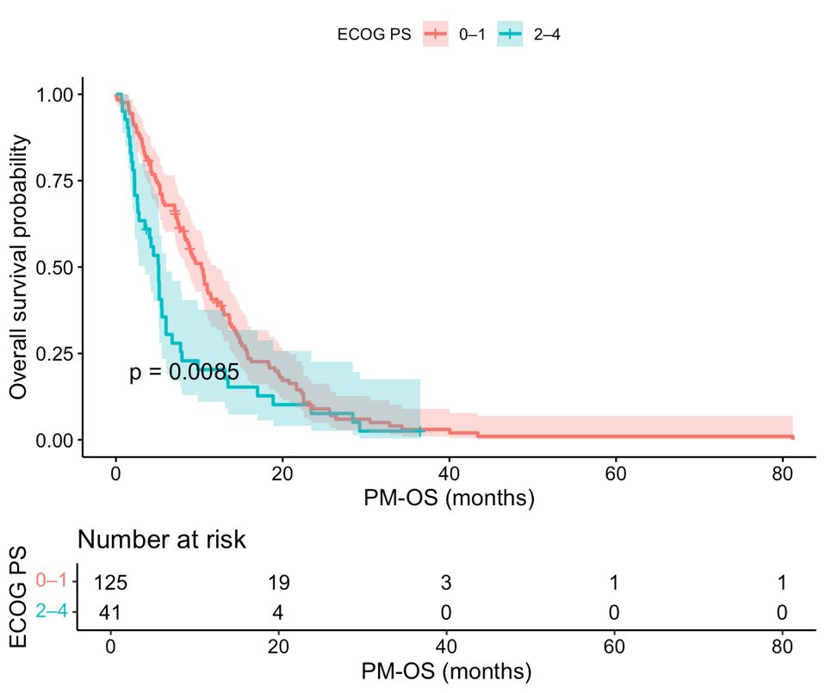
Supplementary Figure S1: Impact of Baseline Performance Status on Survival. Kaplan–Meier survival analysis stratified by baseline performance status. Patients with an ECOG-PS of 0–1 had significantly better survival compared to those with an ECOG-PS of 2–4 (Median PM-OS: 10.32 vs. 5.13 months; p=0.009).

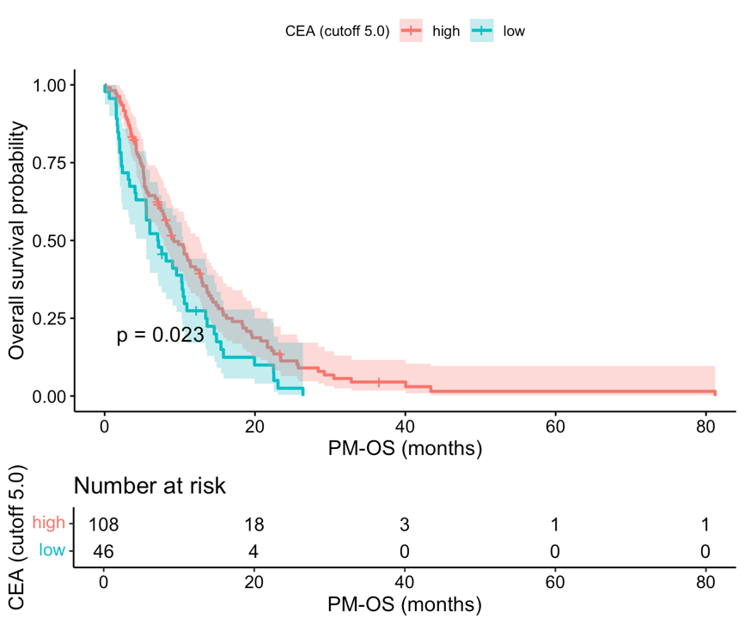

Supplementary Figure S2: Prognostic Value of Serum CEA Levels. Survival outcomes according to baseline serum CEA levels. Elevated CEA levels (≥5.0 ng/mL) were associated with significantly worse survival compared to normal levels (Median PM-OS: 7.06 vs. 9.1 months; p=0.002).

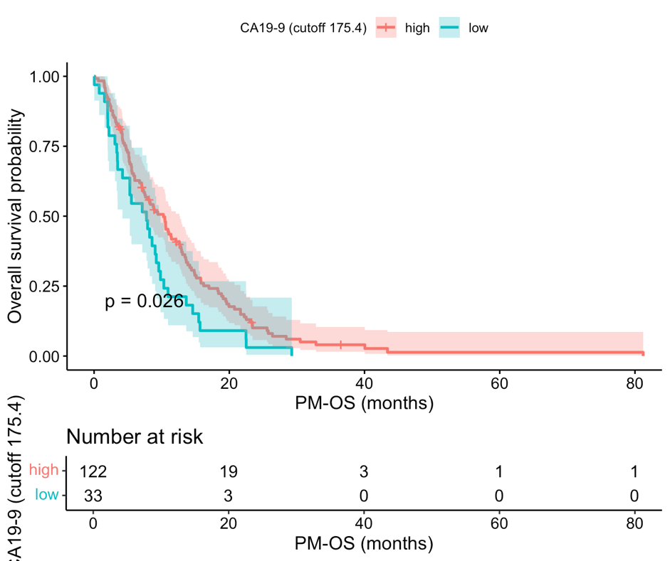
Supplementary Figure S3: Prognostic Value of Serum Ca 19-9 Levels. Survival analysis using the data-driven optimized cut-off of 175.4 U/mL, which significantly stratified prognosis (Median PM-OS: 10.25 vs. 7.75 months; p=0.026).

Supplementary Figure Legends

Supplementary Figure S1. Impact of Baseline Performance Status on Survival. Kaplan–Meier survival analysis stratified by baseline performance status. Patients with an ECOG-PS of 0–1 had significantly better survival compared to those with an ECOG-PS of 2–4 (Median PM-OS: 10.32 vs. 5.13 months; p=0.009).

Supplementary Figure S2. Prognostic Value of Serum CEA Levels. Survival outcomes according to baseline serum CEA levels. Elevated CEA levels (≥5.0 ng/mL) were associated with significantly worse survival compared to normal levels (Median PM-OS: 7.06 vs. 9.1 months; p=0.002).

Supplementary Figure S3. Prognostic Value of Serum Ca 19-9 Levels. Survival analysis using the data-driven optimized cut-off of 175.4 U/mL, which significantly stratified prognosis (Median PM-OS: 10.25 vs. 7.75 months; p=0.026).

