Supplementary Materials for
Noninvasive Preoperative Risk Stratification of Prostate Cancer via a Foundational Model based Deep Learning with PSMA PET/CT

This PDF file includes:
Materials and Methods Section S1 to S
Supplementary Figures S1 to S
Supplementary Table S1 to S2

Supplementary Methods
Section S1: PSMA-PET/CT imaging specifics, PSMA-PET/CT image preprocessing
Section S2: Feature extraction

Section S1: PSMA-PET/CT imaging specifics, PSMA-PET/CT image preprocessing
PSMA-PET/CT imaging specifics
[¹⁸F]PSMA-1007 was produced in-house using a cyclotron and an automated synthesis module (ALLINONE, Trasis, Belgium). PET/CT was performed on either a Siemens Biograph mCT system (Siemens Healthineers, Erlangen, Germany) or a United Imaging uMI 780 system (United Imaging Healthcare, Shanghai, China). Low-dose, non-contrast CT was acquired for attenuation correction and anatomical localization (120 kV; slice thickness 3 mm; increment 2 mm; soft-tissue reconstruction). Whole-body 3D PET emission imaging was acquired from the skull base to the knees (matrix 200 × 200) immediately after CT. Images were reviewed on a multimodality workstation (Syngo; Siemens Healthineers), with PET, CT, and fused PET/CT images reconstructed and displayed in axial, coronal, and sagittal planes.
PSMA-PET/CT image preprocessing
PSMA PET/CT images were preprocessed as follows: (1) Tumor segmentation: Intraprostatic tumor masks were segmented on co-registered PET/CT images using a semi-automatic tool in 3D Slicer (version 4.8.0; www.slicer.org) by an experienced nuclear medicine physician (B.L., >10 years of experience in oncologic PET/CT, primarily FDG-PET/CT). The masks were subsequently reviewed and manually refined in 3D Slicer by a senior nuclear medicine physician (S.S., >15 years of experience in oncologic PET/CT, primarily FDG-PET/CT) to improve reliability. (2) CT intensity conversion: CT images were converted to Hounsfield units (HU) using the rescale slope and intercept provided in the DICOM headers. (3) PET SUV conversion: PET images were converted to standardized uptake value (SUV) maps using patient body weight, injected activity, and decay correction based on acquisition timing. (4) Resampling: PET and CT volumes were resampled to isotropic voxels (1 × 1 × 1 mm³). Image volumes were resampled using linear interpolation, while segmentation masks were resampled using nearest-neighbor interpolation. (5) Intensity normalization: PET SUV images were normalized (using a predefined SUV bound) and mapped to [0, 255]. CT images were windowed (window width 350; window level 50) and mapped to [0, 255]. (6) Alignment and padding/cropping: PET and mask volumes were aligned to the CT volume center, and zero-padding or cropping was applied as needed to match CT dimensions. (7) Fixed-position cropping: PET, CT, and mask volumes were cropped by fixed-position cropping to obtain ROIs of size H × 256 × 256, where H denotes the number of slices along the cranio–caudal axis after cropping.

Supplementary Figures
Supplementary Figure S1. Sensitivity and specificity of SUVmax for predicting ISUP Grade Group ≥3 and ≥4 across various cutoff thresholds.
Supplementary Figure S2. Confusion matrices and receiver operating characteristic (ROC) curves of four traditional radiomics classifiers (Naive Bayes, Decision Tree, k-Nearest Neighbors, and Random Forest) across five-fold cross-validation.

Figure S1. Sensitivity and specificity of SUVmax for predicting ISUP Grade Group ≥3 and ≥4 across various cutoff thresholds.
Line plots depict the changes in sensitivity and specificity as SUVmax thresholds vary. Solid lines represent sensitivity, while dashed lines represent specificity. Vertical dotted lines indicate the optimal cutoff values based on Youden’s index: 10.2 for ISUP ≥3 and 10.9 for ISUP ≥4.

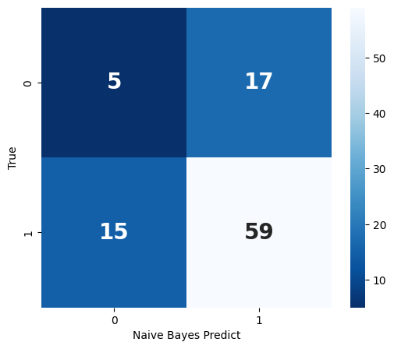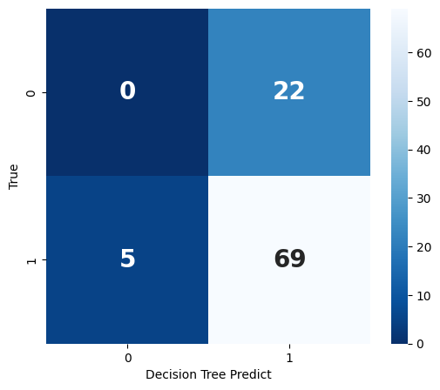
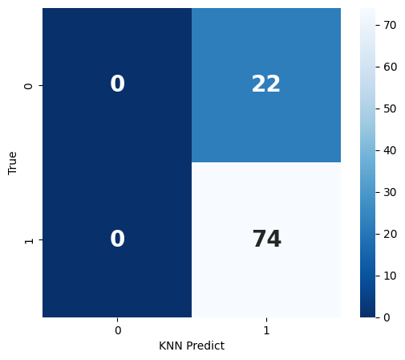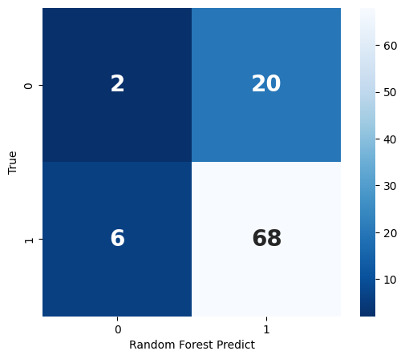

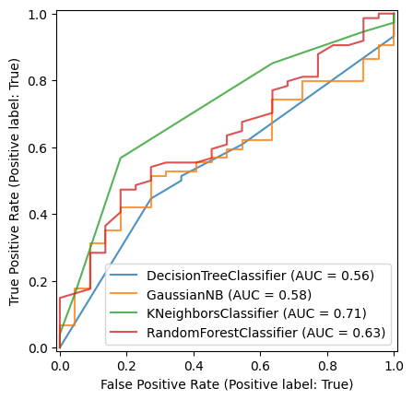

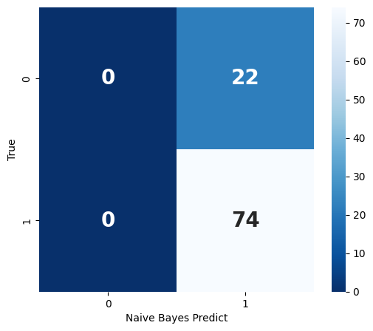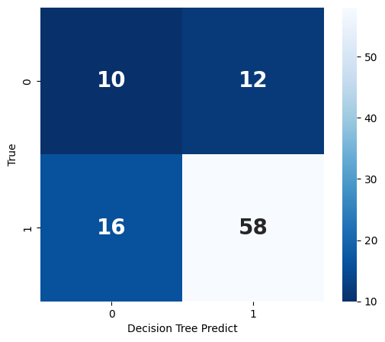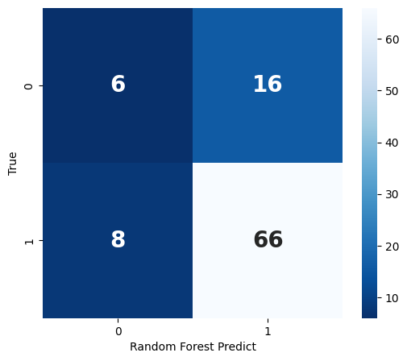
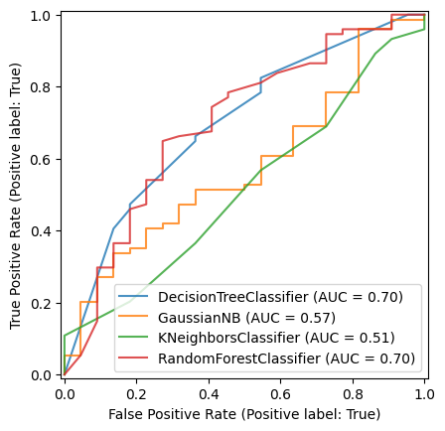

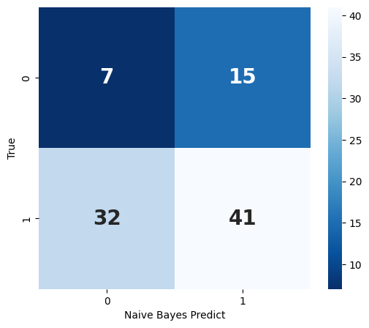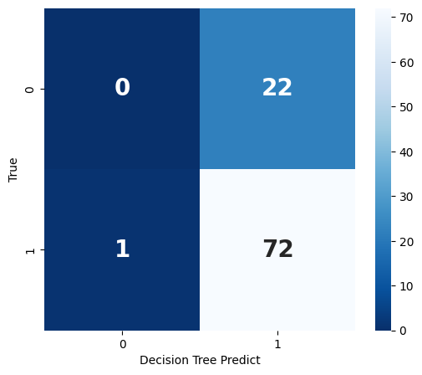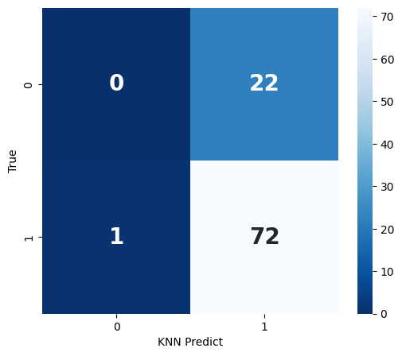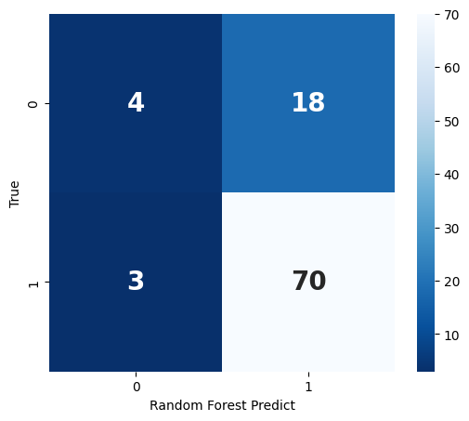
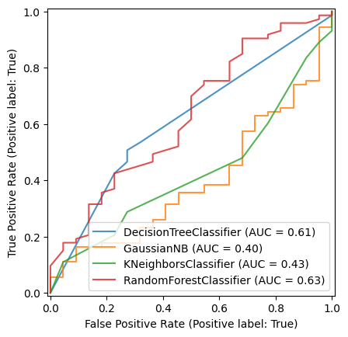

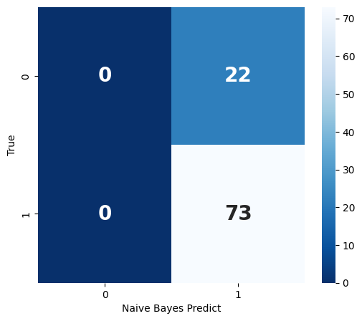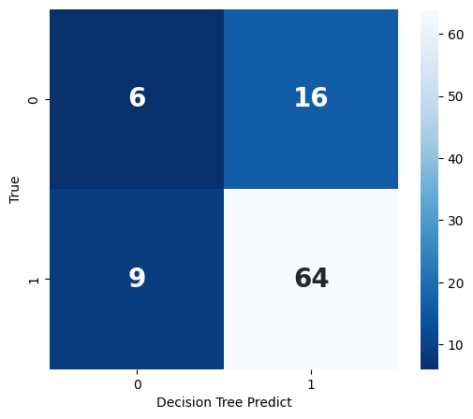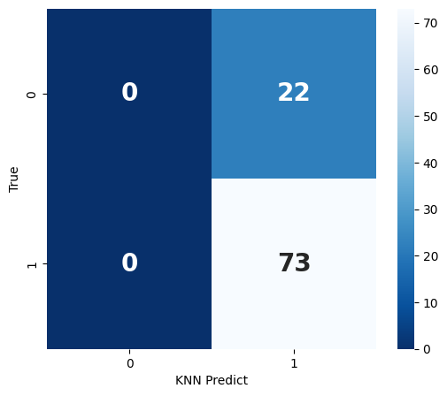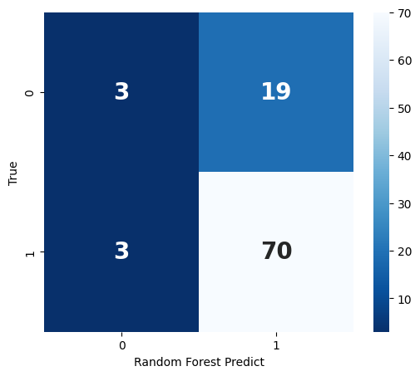
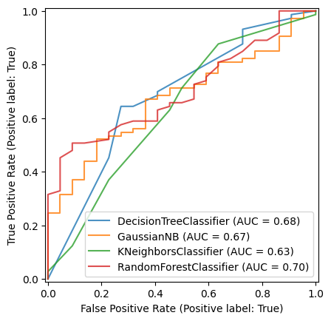

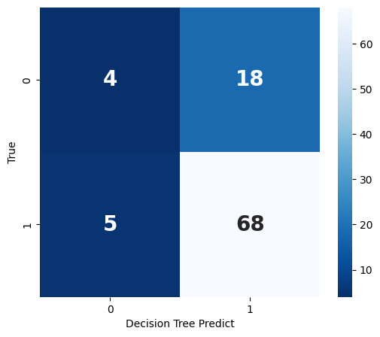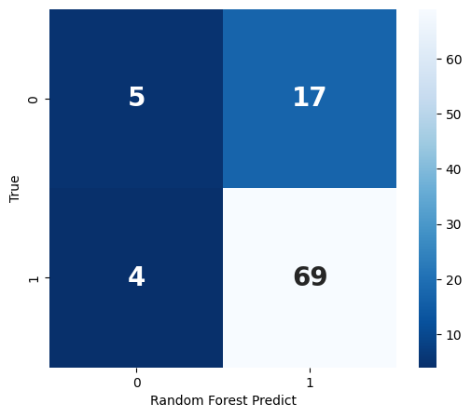
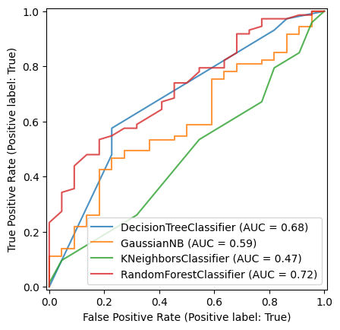

Figure S2. Confusion matrices and receiver operating characteristic (ROC) curves of four traditional radiomics classifiers (Naive Bayes, Decision Tree, k-Nearest Neighbors, and Random Forest) across five-fold cross-validation. The models demonstrated variable performance across folds, with area under the ROC curve (AUC) values generally below 0.75, indicating limited and unstable discriminative capability of handcrafted radiomics features for the ISUP Grade Group classification task.

Supplementary Tables
Supplementary Table S1. Performance of traditional radiomics models (AUC, 5-fold cross-validation).
Supplementary Table S2. Performance of traditional radiomics models (ACC, 5-fold cross-validation).

Supplementary Table S1. Performance of traditional radiomics models (AUC, 5-fold cross-validation).
Model | 1 | 2 | 3 | 4 | 5 | Mean±SD
Naive Bayes | 0.58 | 0.57 | 0.4 | 0.67 | 0.59 | 0.562±0.099
Decision Tree | 0.56 | 0.7 | 0.61 | 0.68 | 0.68 | 0.646±0.059
KNN | 0.71 | 0.51 | 0.43 | 0.63 | 0.47 | 0.550±0.117
Random Forest | 0.63 | 0.7 | 0.63 | 0.7 | 0.72 | 0.676±0.043
AUC: area under the receiver operating characteristic curve.

Supplementary Table S2. Performance of traditional radiomics models (ACC, 5-fold cross-validation).
Model | 1 | 2 | 3 | 4 | 5 | Mean±SD
Naive Bayes | 0.667 | 0.771 | 0.505 | 0.768 | 0.768 | 0.696±0.115
Decision Tree | 0.719 | 0.708 | 0.758 | 0.737 | 0.758 | 0.736±0.023
KNN | 0.771 | 0.771 | 0.758 | 0.768 | 0.768 | 0.767±0.005
Random Forest | 0.729 | 0.75 | 0.779 | 0.768 | 0.779 | 0.761±0.021
ACC: accuracy.

