Supplementary Table 1. List of primer sequences used in qRT-PCR analysis.
Gene | Forward primer | Reverse primer
Gapdh | TGACCTCAACTACATGGTCTACA | CCGTGAGTGGAGTCATACTGG
Arg1 | CCTATGTGTCATTTGGGTGGATG | GGTTGTCAGGGGAGTGTTGAT
Nos2 | GGAGTGACGGCAAACATGACT | TCGATGCACAACTGGGTGAAC
Rb1 | CAGGGCTGTGTTGACATCGGAGTA | TCCACGGGAAGGACAAATCTGTTC
S100a8 | GGAAATCACCATGCCCTCTAC | GTCACTATTGATGTCCAATTCTCTGAA
S100a9 | GCACAGTTGGCAACCTTTATG | TGATTGTCCTGGTTTGTGTCC
Il10 | CTTACTGACTGGCATGAGGATCA | GCAGCTCTAGGAGCATGTGG
Cox2 | TTCCAATCCATGTCAAAACCGT | CTGGTCAAATCCTGTGCTCAT
Cybb | CCTCTACCAAAACCATTCGGAG | CTGTCCACGTACAATTCGTTCA
Tlr4 | AAATGCACTGAGCTTTAGTGGT | GGCTGTTTGTTCCCAAATCAGAA
Tgfb | CCGCAACAACGCCATCTATG | CCCGAATGTCTGACGTATTGAAG
Il6 | CTGCAAGAGACTTCCATCCAG | AGTGGTATAGACAGGTCTGTTGG
Ccl2 | TTAAAAACCTGGATCGGAACCAA | GCATTAGCTTCAGATTTACGGGT
Ccl3 | TTCTCTGTACCATGACACTCTGC | CGTGGAATCTTCCGGCTGTAG
Ccl4 | TTCCTGCTGTTTCTCTTACACCT | CTGTCTGCCTCTTTTGGTCAG
Ccl5 | GCTGCTTTGCCTACCTCTCC | TCGAGTGACAAACACGACTGC
Ccl8 | TCTACGCAGTGCTTCTTTGCC | AAGGGGGATCTTCAGCTTTAGTA
Ccl12 | ATTTCCACACTTCTATGCCTCCT | GCATTAGCTTCAGATTTACGGGT
Cxcl1 | CTGGGATTCACCTCAAGAACATC | CAGGGTCAAGGCAAGCCTC
Cxcl5 | GTTCCATCTCGCCATTCATGC | GCGGCTATGACTGAGGAAGG
Cxcl16 | CCTTGTCTCTTGCGTTCTTCC | TCCAAAGTACCCTGCGGTATC
Cx3cl1 | ACGAAATGCGAAATCATGTGC | CTGTGTCGTCTCCAGGACAA
Tnfa | CCCTCACACTCAGATCATCTTCT | GCTACGACGTGGGCTACAG
Gapdh: glyceraldehyde-3-phosphate dehydrogenase; Arg1: Arginase1; Nos2: Nitric oxide synthase2; Rb1: Retinoblastoma 1; S100a8: Recombinant S100 Calcium Binding Protein a8; S100a9: Recombinant S100 Calcium Binding Protein a9; Il10: Interleukin-10; Cox2: cyclooxygenase-2; Cybb: Cytochrome b-245 heavy chain gene; Tlr4: Toll-like Receptor 4; Tgfb: Transforming Growth Factor Beta; Il6: Interleukin 6; Ccl2: C-C Motif Chemokine Ligand 2; Ccl3: C-C Motif Chemokine Ligand 3; Ccl4: C-C Motif Chemokine Ligand 4; Ccl5: C-C Motif Chemokine Ligand 5; Ccl8: C-C Motif Chemokine Ligand 8; Ccl12: C-C Motif Chemokine Ligand 12; Cxcl1: C-X-C Motif Chemokine Ligand 1; Cxcl5: C-X-C Motif Chemokine Ligand 5; Cxcl16: C-X-C Motif Chemokine Ligand 16; Cx3cl1: C-X3-C Motif Chemokine Ligand 1; Tnfa: Tumor Necrosis Factor Alpha
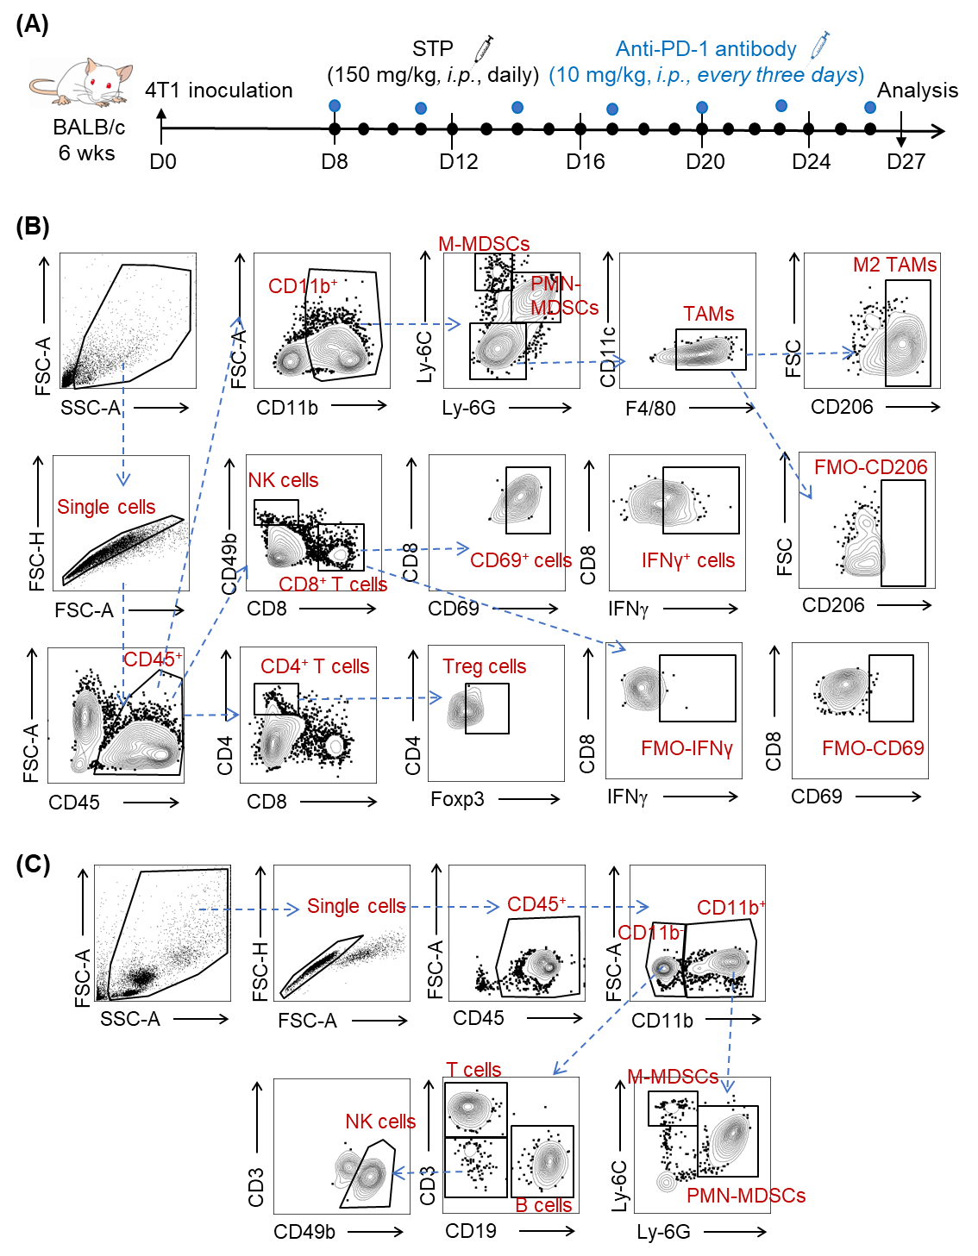Supplementary Figure 1. (A) Schematic representation of the experimental design: STP synergizes with anti-PD-1 treatment in an orthotopic 4T1 breast cancer model. (B) Gating strategy for tumor-infiltrating immune cell populations analyzed in Fig. 1. FMO controls were used as the reference for gating. (C) Gating strategy for peripheral blood immune cell populations analyzed in Fig. 2.

