Additional File 1
Figure S1. Survival outcomes for patients with t(4;14) treated with VRd versus D-VRd
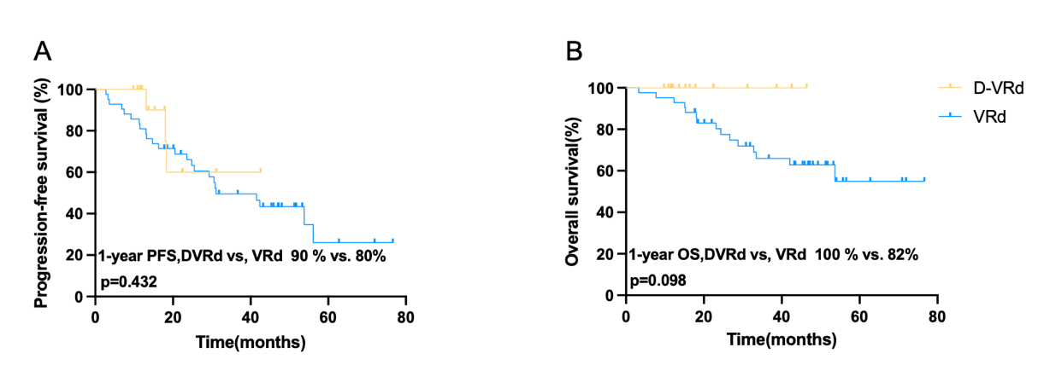
A Progression-free survival for patients with t(4;14). B Overall survival for patients with t(4;14).

Figure S2. Forest plot of treatment interaction analyses.
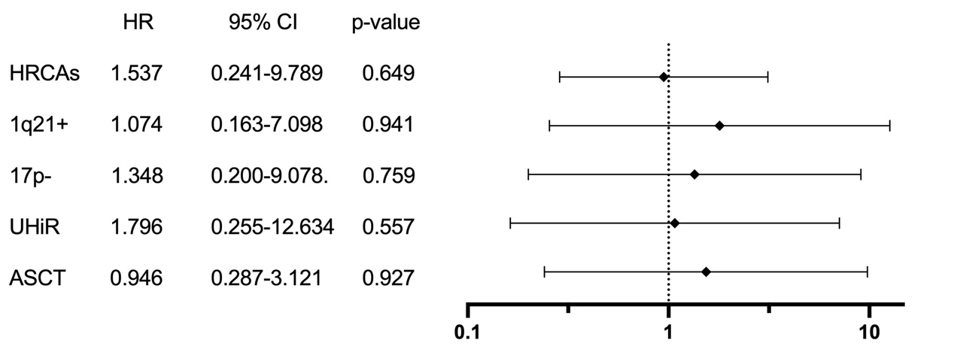
Subgroup analyses assessing the consistency of treatment effect (D-VRd versus VRd) across key baseline factors. The hazard ratios (HRs) represent the effect of D-VRd compared to VRd within each subgroup. P values for interaction assess whether the treatment effect differs significantly between subgroups.

Figure S3 Survival outcomes by transplantation status in D-VRd and VRd groups
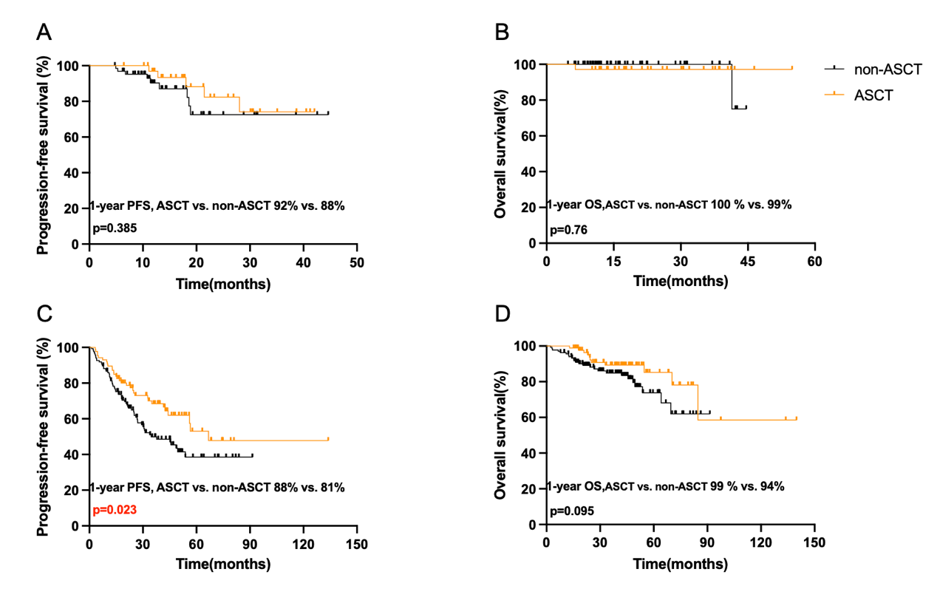
A Progression-free survival(PFS) in D-VRd group.B Overall surviva(OS) in in D-VRd group. C PFS in VRd group. D OS in VRd group.

Table.S1 Univariate and Multivariate analysis: hazards of progression
 | Univariate analysis |  |  |  | Multivariate analysis
 | p-value | Hazards ratio | 95.0% CI |  | p-value | Hazards ratio | 95.0% CI
treatment | 0.049 | 1.777 | 1.003-3.146 |  | 0.036 | 1.844 | 1.04-3.272
gender | 0.089 | 0.723 | 0.497-1.051 |  | -
R-ISS III | 0.007 | 1.697 | 1.152-2.5 |  | 0.08 | 1.456 | 0.956-2.218
ASCT | 0.016 | 0.611 | 0.41-0.912 |  | 0.044 | 0.662 | 0.443-0.99
HRCAs | 0.016 | 1.612 | 1.094-1.374 |  | 0.113 | 1.402 | 0.924-2.13
Age | 0.427 | 1.612 | 0.987-1.031 |  | -
R-ISS Revised International staging system, HRCAs High-risk cytogenetic abnormalities, ASCT Autologous stem cell transplantation.

