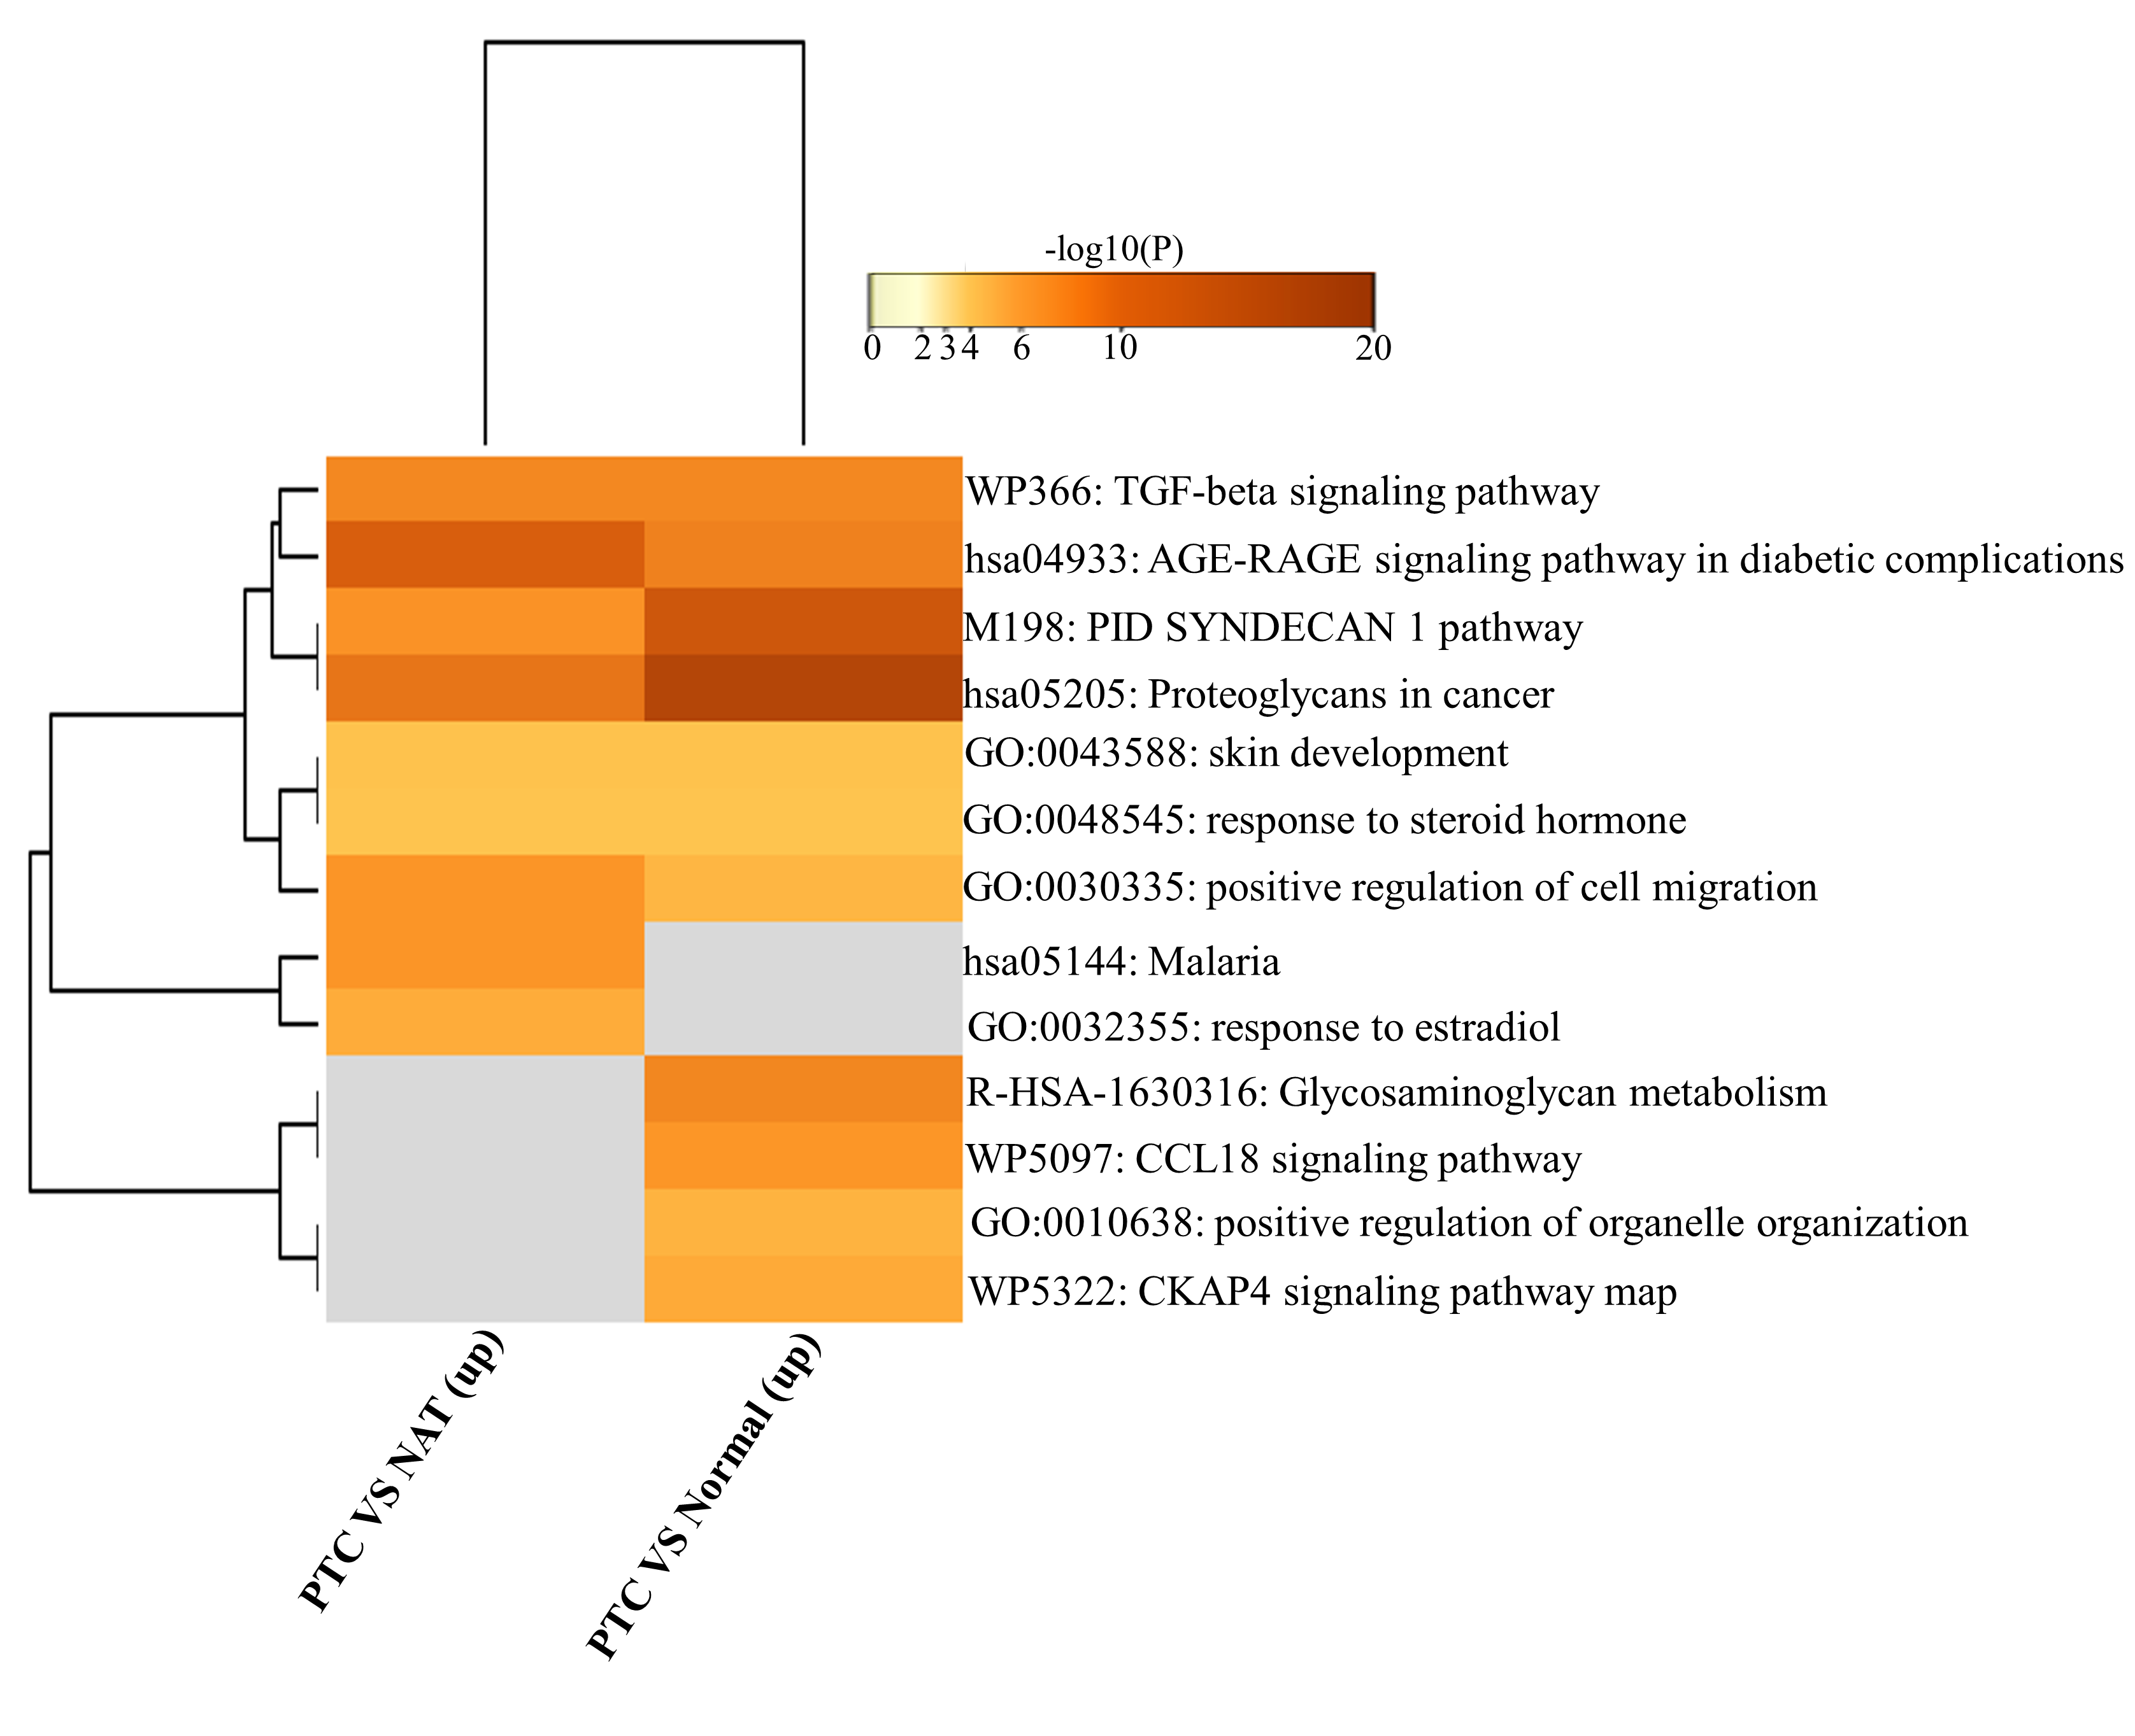
Supplementary Fig. S2. Heat map displaying the enrichment of hub genes clusters PTC and NAT groups. Each group is colored by -log 10(P) values using a discrete color scale representing statistical significance. The functional annotation terms and their corresponding categories are M (canonical pathways), GO (Gene Ontology), WP (Wiki pathways), R-HSA (Reactome Gene Sets), and hsa (KEGG pathway).

