Supplementary Materials
CS2164 combined with radiation impaired tumor growth by interfering with DNA damage repair process
Shun-li Peng^{1,}*, Yu-ling Zhou^{2,}*, Xuexia Liang^{1,}*, Ren-wei Jiang¹, Shuai Yang¹, Qiao-dan Liu^{1,3,#}, Xiao-mou Peng^{3,#}
* Equal contribution # Correspondence:

¹Cancer Center, the Fifth Affiliated Hospital of Sun Yat-sen University, Zhuhai, Guangdong, 519000, China;
²Cancer Center, the Central Hospital of Yueyang, Yueyang, Hunan, 414000, China;
³Center of Infectious Diseases, the Fifth Affiliated Hospital of Sun Yat-sen University, Zhuhai, Guangdong, 519000, China.

Transcriptome Sequencing Procedure
- Transcriptome experimental method
Total RNA was isolated using the Trizol Reagent (Invitrogen Life Technologies), after which the concentration, quality and integrity were determined using a NanoDrop spectrophotometer (Thermo Scientific). Three micrograms of RNA were used as input material for the RNA sample preparations. Sequencing libraries were generated according to the following steps. Firstly, mRNA was purified from total RNA using poly-T oligo-attached magnetic beads. Fragmentation was carried out using divalent cations under elevated temperature in an Illumina proprietary fragmentation buffer. First strand cDNA was synthesized using random oligonucleotides and Super Script II. Second strand cDNA synthesis was subsequently performed using DNA Polymerase I and RNase H. Remaining overhangs were converted into blunt ends via exonuclease/polymerase activities and the enzymes were removed. After adenylation of the 3′ ends of the DNA fragments, Illumina PE adapter oligonucleotides were ligated to prepare for hybridization. To select cDNA fragments of the preferred 400-500 bp in length, the library fragments were purified using the AMPure XP system (Beckman Coulter,Beverly, CA, USA). DNA fragments with ligated adaptor molecules on both ends were selectively enriched using Illumina PCR Primer Cocktail in a 15 cycle PCR reaction. Products were purified (AMPure XP system) and quantified using the Agilent high sensitivity DNA assay on a Bioanalyzer 2100 system (Agilent). The sequencing library was then sequenced on NovaSeq 6000 platform (Illumina).
- Transcriptome analysis flow
2.1 Quality control
Samples are sequenced on the platform to get image files, which are transformed by the software of the sequencing platform, and the original data in FASTQ format (Raw Data) is generated. Sequencing data contains a number of connectors, low-quality Reads, so we use Cutadapt (v1.15) software to filter the sequencing data to get high quality sequence（Clean Data）for further analysis .
2.2 Reads mapping
The reference genome and gene annotation files were downloaded from genome website. The filtered reads were mapping to the reference genome using HISAT2 v2.0.5.
2.3 Differential expression analysis
we used HTSeq (0.9.1) statistics to compare the Read Count values on each gene as the original expression of the gene. FPKM was used for visualization in heatmaps. The difference expression of genes was analyzed by DESeq (1.39.0) with screened conditions as follows: expression difference multiple |log2FoldChange| ≥ 1, significant P-value < 0.05. At the same time, We used R language Pheatmap (1.0.8) software package to perform bi-directional clustering analysis of all different genes of samples. We got heatmap according to the expression level of the same gene in different samples and the expression patterns of different genes in the same sample with Euclidean method to calculate the distance and Complete Linkage method to cluster.
2.4 GO and KEGG enrichment analysis
we mapped all the genes to Terms in the Gene Ontology database and calculated the numbers of differentially enriched genes in each Term. Using topGO (2.40.0) to perform GO enrichment analysis on the differential genes, calculate P-value by hypergeometric distribution method (the standard of significant enrichment is P-value <0.05), and find the GO term with significantly enriched differential genes to determine the main biological functions performed by differential genes. ClusterProfiler (3.16.1) software was used to carry out the enrichment analysis of the KEGG pathway of differential genes, focusing on the significant enrichment pathway with P-value <0.05.

The transcriptome sequencing procedure was conducted by Shanghai Personal Biotechnology Cp. Ltd.

Supplementary Figures
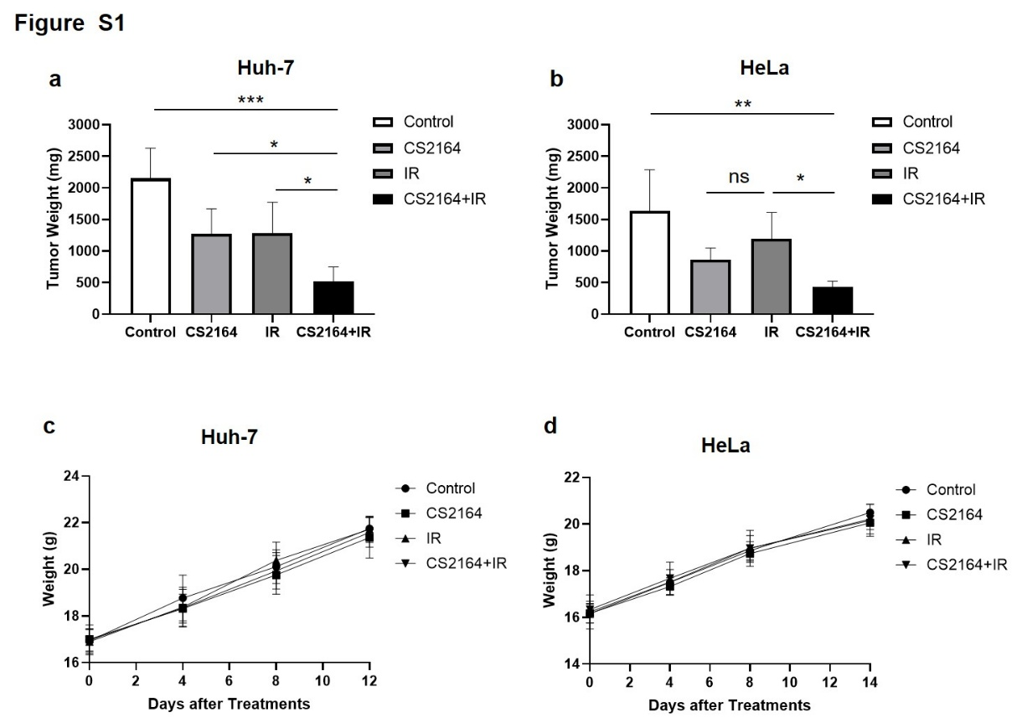
Figure S1. a-b. The tumor weight of mice with Huh-7 and HeLa xenografts. b. The weight of mice with HeLa xenografts. c-d. The body weight of mice with Huh-7 and HeLa xenografts. Data are presented as the means ± standard deviation (SD), n ≥ 3; ns, not significant; *p < 0.05; **p < 0.01, ***p < 0.001.
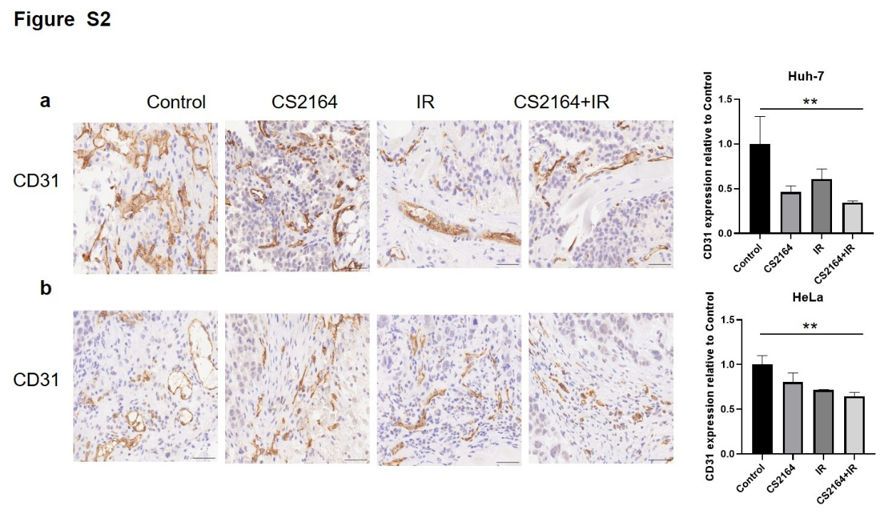
Figure S2. The results of CD31 staining image and statistic chart based on xenografts tissues. Data are presented as the means ± standard deviation (SD), n ≥ 3; ns, not significant; *p < 0.05; **p < 0.01, ***p < 0.001.
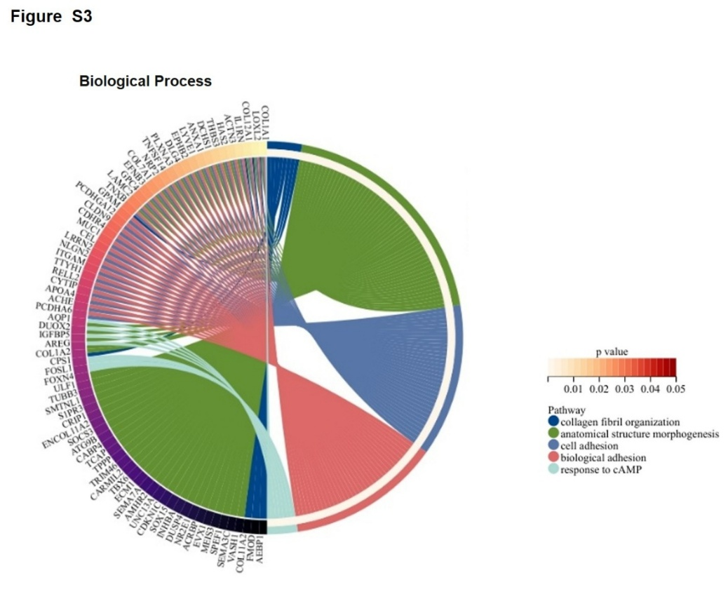
Figure S3. Results based on Biological Process enrichment analysis. Pathway including collagen fibri organization, anatomical structure morphogenesis, cell adhension, biological adhension and response to cAMP were enriched. DEGs were enriched in Biological Process pathways with multiple colors. The DEGs among the above pathways were displayed with colored strip and converged into a circle. The color of the strips from red to white represented an increase in p-value.
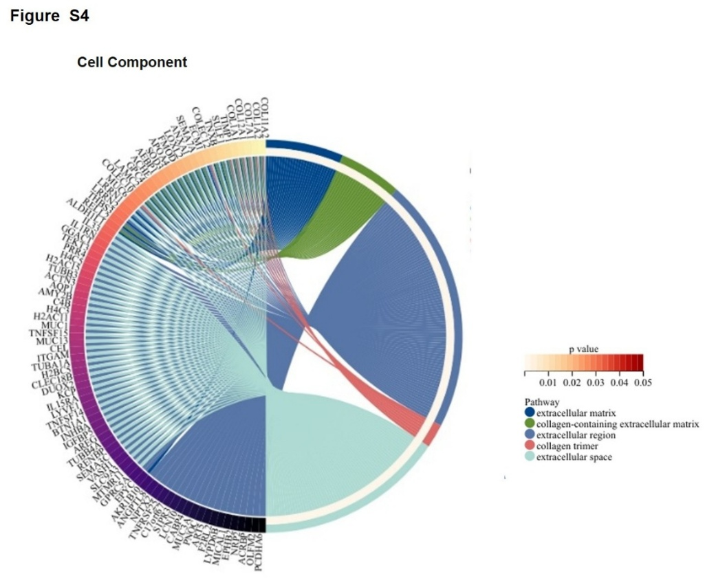
Figure S4. Results based on Cell Component enrichment analysis. Pathway including extracellular matrix, collagen-containning extracellular matrix, extracellular region, collagen trimer and extracellular space were enriched. DEGs were enriched in Cell Component pathways with multiple colors. The DEGs among the above pathways were displayed with colored strip and converged into a circle. The color of the strips from red to white represented an increase in p-value.
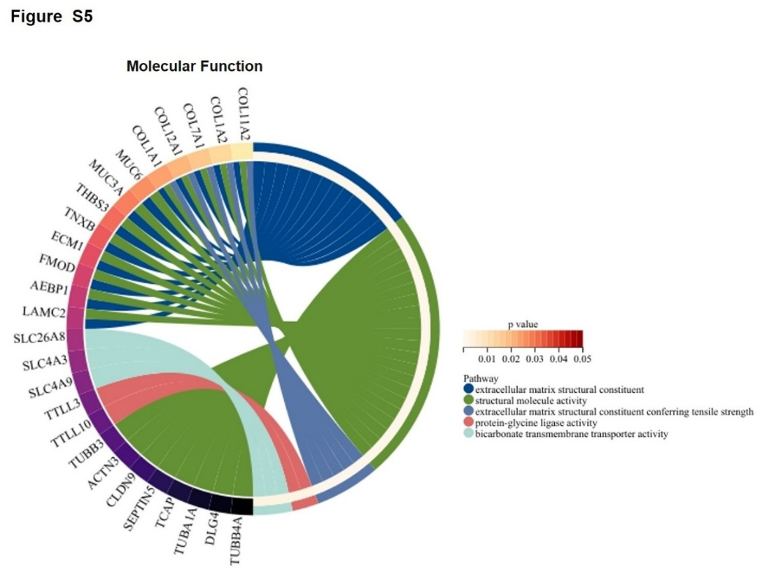
Figure S5. Results based on Molecular Function enrichment analysis. Pathway including extracellular matrix structural constituent, structural molecule activity, exyracellular matrix structural constituent conferring tensile strenth, protein-glycine ligase activity and bicarbonate transmembrane transporter activity were enriched. DEGs were enriched in Molecular Function pathways with multiple colors. The DEGs among the above pathways were displayed with colored strip and converged into a circle. The color of the strips from red to white represented an increase in p-value.
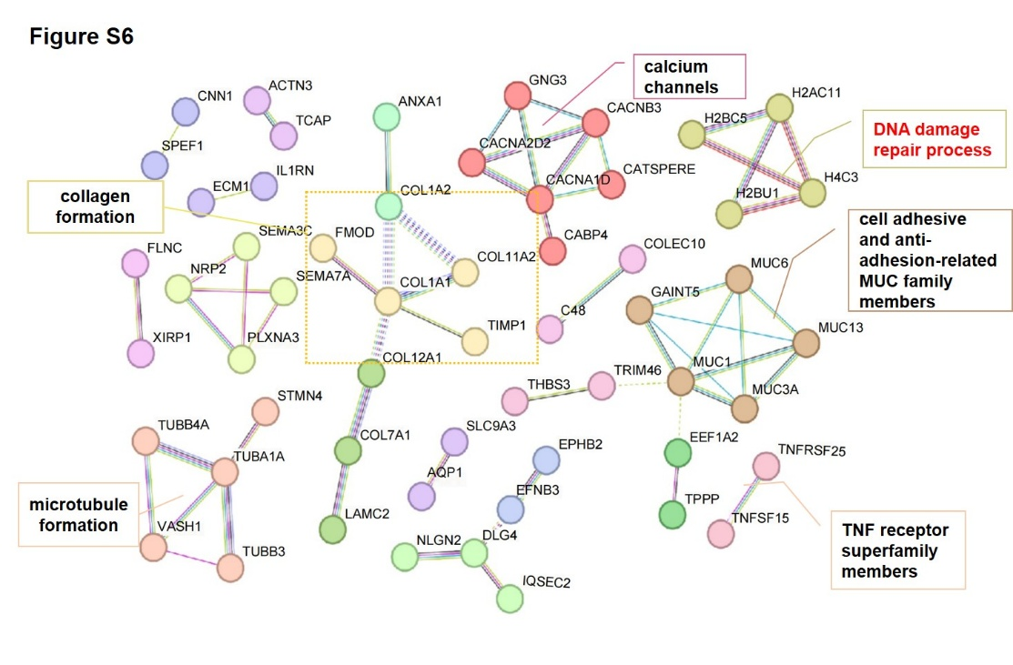
Figure S6. PPI analysis results based on Differentially expressed genes (DEGs) between the CS2164 plus radiation treatment group and the control group. A protein-protein interaction (PPI) network performed by STRING database. The regulatory network showed core regulatory genes related with DNA damage repair process, cell adhesive and anti-adhesion-related MUC family members, TNF receptor superfamily members, TNF receptor superfamily members, collagen formation, and calcium channels, ect. The combined node scores ranged from 0.900 to 0.999, and the co-expression coefficient was more than 0.700. Among the regulatory networks, a series of DEGs with high interaction scores (> 0.9), high combined scores (> 0.9), and high co-expression coefficients (> 0.9) were screened out. Then, the network was clustered by MCL inflation parameter, and the names and core genes of the important clstuers have been labeled.
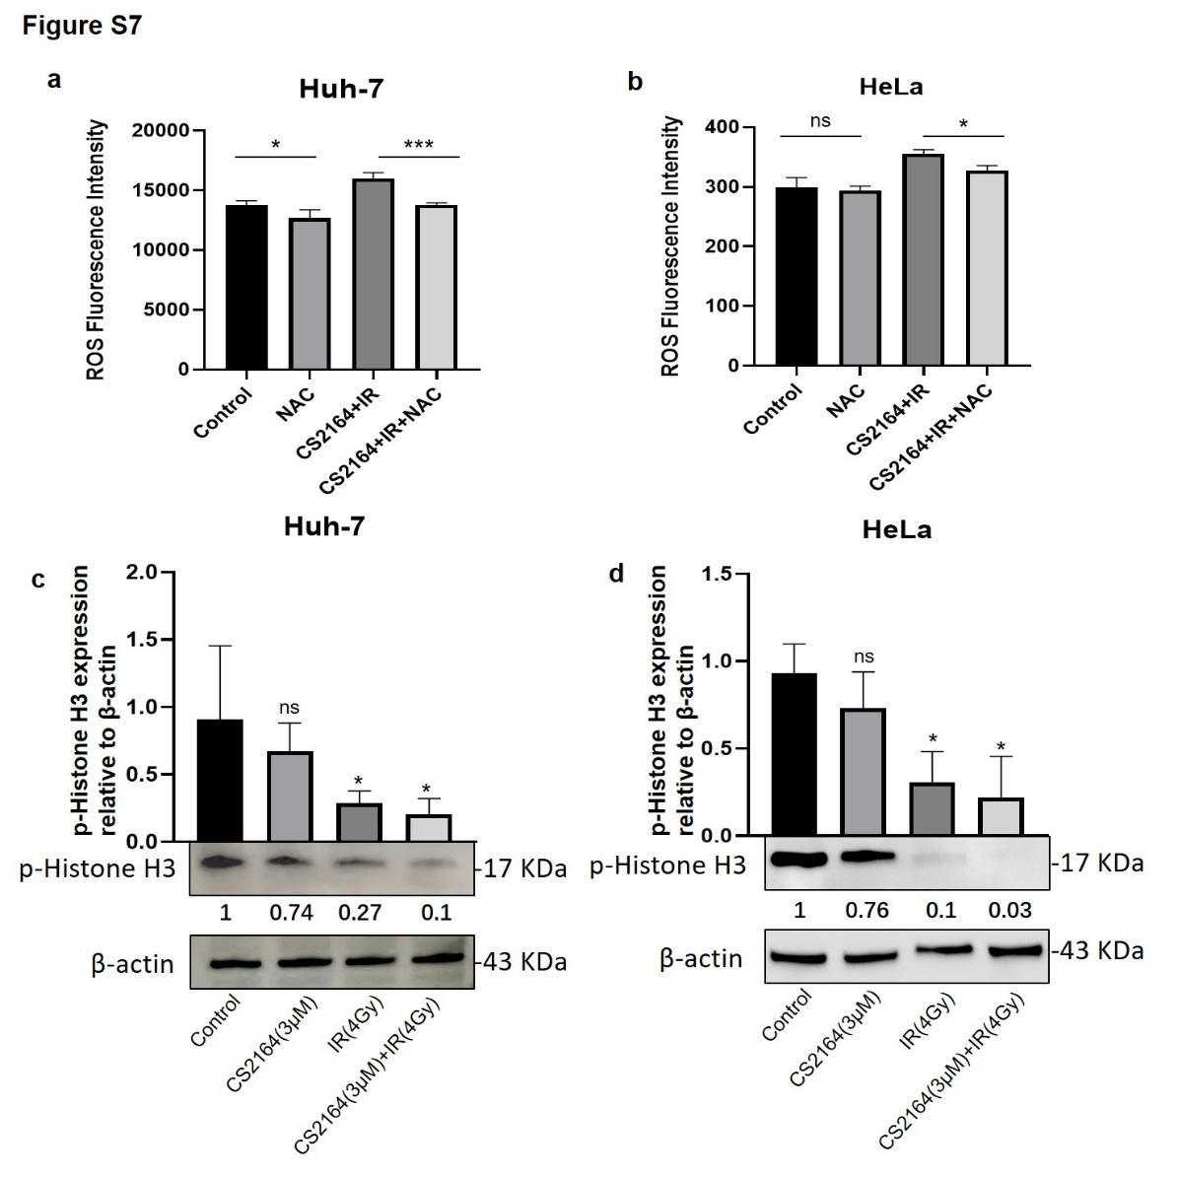
Figure S7. a-b. The ROS level increased after treatment of CS2164 (3μM) combined with radiation (4Gy), which could be partially rescued by NAC. Data are presented as the means ± standard deviation (SD), n ≥ 3; ns, not significant; *p < 0.05; **p < 0.01, ***p < 0.001. c-d. CS2164 in combination with radiation decreased p-Histone H3 expression in Huh-7 and HeLa cells. The expression of p-Histone H3 in protein level measured by Western Blotting.
Supplementary Table
Table 1. Sensitivity Enhancement Ratio (SER) of Huh-7 cells.
CS2164 concentration | D0 | n | R2
0μM | 1.780 | 1.796 | 0.9935
3μM | 1.585 | 1.636 | 0.9981

Table 2. Sensitivity Enhancement Ratio (SER) of HeLa cells.
CS2164 concentration | D0 | n | R2
0μM | 2.138 | 1.804 | 0.9886
3μM | 1.521 | 2.550 | 0.9946

