Supplementary Appendix

Figure 1. Cochrane Risk-of-Bias tool for RCTs
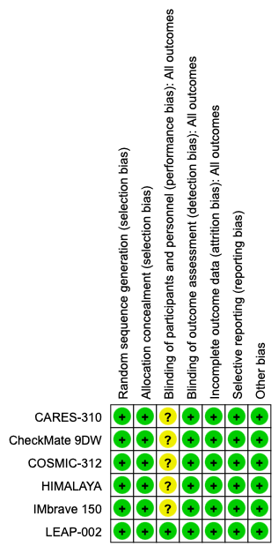

Figure 2. Rankogram for unadjusted random-effects Bayesian NMA results for efficacy outcomes A. Overall Survival; B. Progression Free Survival; C. Overall Response Rate.
A.

B.

C.

Figure 3. Rankogram for unadjusted random-effects Bayesian NMA results for safety outcomes A. Treatment Related Adverse Events (TRAEs); B. Grade 3-4 TRAEs; C. Therapy Discontinuation Rate (TDR) related to TRAEs.
A.

B.

C.

Table S2. Selected grade 3-4 treatment-related adverse events reported in the selected trials
Trial | Experimental regimen | Comparator | Selected grade 3-4 TRAEs in experimental arm | Selected grade 3-4 TRAEs in control arm | Notes
IMbrave150 | Atezolizumab + bevacizumab | Sorafenib | Detailed counts not uniformly reported in the updated report used for this review | Detailed counts not uniformly reported in the updated report used for this review | Overall grade 3-4 TRAEs: 43% vs 46%
HIMALAYA | Durvalumab + tremelimumab | Sorafenib | Detailed counts not uniformly reported in the 4-year update used for this review | Detailed counts not uniformly reported in the 4-year update used for this review | Overall grade 3-4 TRAEs: 25.8% vs 36.9%
CheckMate 9DW | Nivolumab + ipilimumab | Sorafenib or lenvatinib | Immune-mediated hepatitis, colitis, and pneumonitis reported; exact grade 3-4 counts not uniformly available in the source used | Comparator-specific detailed counts not uniformly available in the source used | Overall grade 3-4 TRAEs: 41% vs 42%
CARES-310 | Camrelizumab + rivoceranib | Sorafenib | Hypertension 102/272; AST increased 45/272; ALT increased 35/272 | Hypertension 40/269; AST increased 14/269; ALT increased 8/269 | Marked vascular and hepatic toxicity signal
LEAP-002 | Lenvatinib + pembrolizumab | Lenvatinib | Hypertension 69/395; AST increased 27/395 | Hypertension 68/399; AST increased 17/399 | Overall grade 3-4 TRAEs: 62.8% vs 58.0%
COSMIC-312 | Cabozantinib + atezolizumab | Sorafenib | ALT increased 38/429; hypertension 37/429; AST increased 37/429 | ALT increased 6/207; hypertension 17/207; AST increased 8/207 | Overall grade 3-4 TRAEs: 55% vs 34%

Table S3. Treatment discontinuation due to TRAEs in selected trials
Trial | Experimental arm | Control arm | Discontinuation due to TRAEs (%) | Interpretive note
IMbrave150 | Atezolizumab + bevacizumab | Sorafenib | 10 vs 12 | No excess discontinuation signal
HIMALAYA | Durvalumab + tremelimumab | Sorafenib | 8.2 vs 11.0 | Favorable relative tolerability
CheckMate 9DW | Nivolumab + ipilimumab | Sorafenib or lenvatinib | 18 vs 10 | Higher discontinuation with dual checkpoint blockade
CARES-310 | Camrelizumab + rivoceranib | Sorafenib | 24 vs 4 | Most unfavorable discontinuation profile
LEAP-002 | Lenvatinib + pembrolizumab | Lenvatinib | 18 vs 11 | Higher discontinuation with combination therapy
COSMIC-312 | Cabozantinib + atezolizumab | Sorafenib | 38 vs 23 | Substantial discontinuation burden

Table S4. Treatment-related deaths reported in the selected trial
Trial | Experimental arm | Control arm | Treatment-related deaths | Notes
IMbrave150 | Atezolizumab + bevacizumab | Sorafenib | 6 vs 1 | Grade 5 treatment-related events in the updated report
HIMALAYA | Durvalumab + tremelimumab | Sorafenib | Reported, but arm-level counts not consistently detailed in the 4-year update used | Long-term safety remained favorable overall
CheckMate 9DW | Nivolumab + ipilimumab | Sorafenib or lenvatinib | Reported, but exact arm-level counts were not fully detailed in the source used for this review | Immune-mediated fatal toxicity remains clinically relevant
CARES-310 | Camrelizumab + rivoceranib | Sorafenib | 1 vs 1 | Experimental arm: multiple organ dysfunction syndrome
LEAP-002 | Lenvatinib + pembrolizumab | Lenvatinib | 4 vs 3 | Deaths included gastrointestinal hemorrhage and hepatorenal syndrome
COSMIC-312 | Cabozantinib + atezolizumab | Sorafenib | 6 vs 1 | Experimental arm had multiple grade 5 TRAEs

