Supplementary Figure S1. Overview of study quality using the RoB2 checklist. Risk of bias from randomization was low in four studies and moderate in seven studies; no studies had high risk of bias.
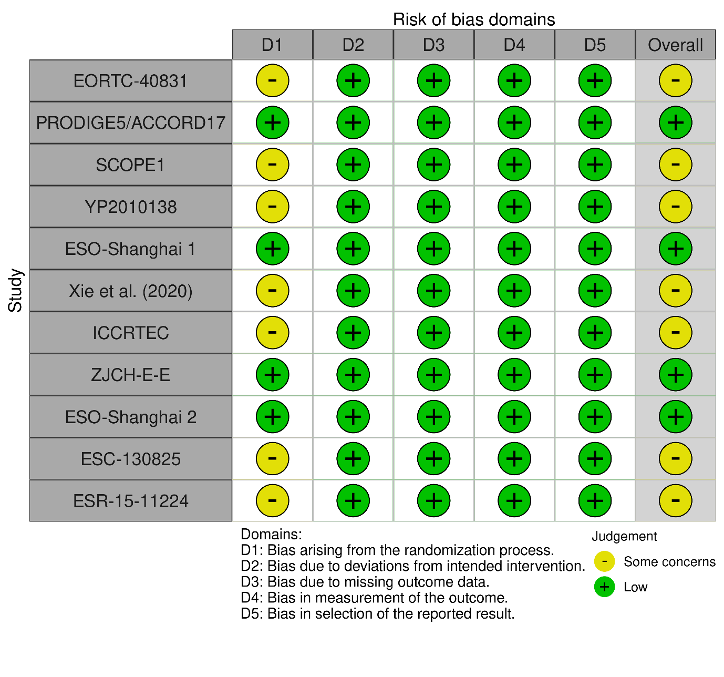

Supplementary Figure S2. Leave-one-out cross validation (sensitivity analyses).
(a)
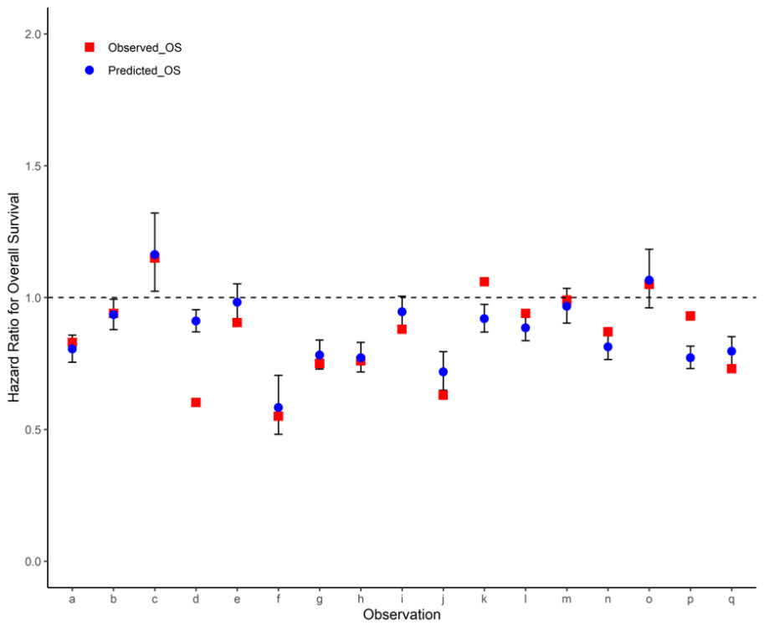
(b)
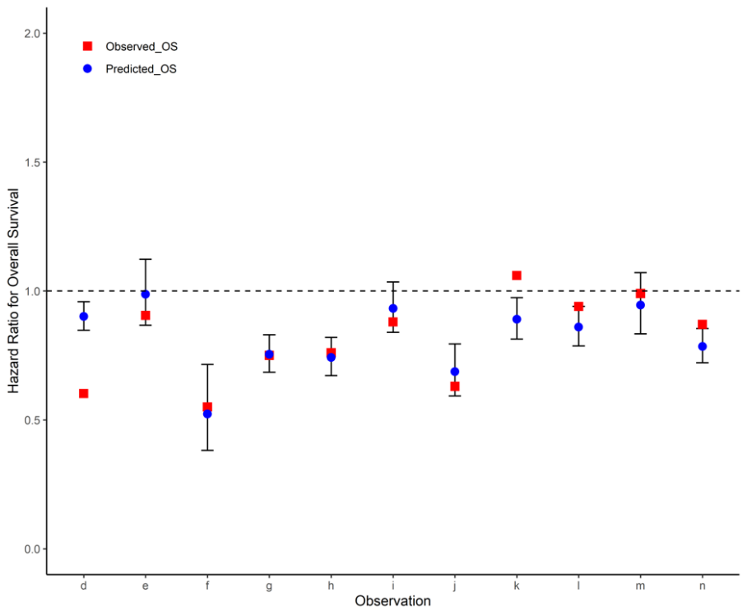
(a) Including the 11 RCTs from the main analysis and two additional RCTs that did not report EFS definitions. (b) Limiting the main analysis to the eight studies conducted in China.
RCT, randomized controlled trial.

