Supplementary file:
Table S1. Summary of unadjusted between-group comparisons: inflammatory, immune, endothelial, and vascular imaging markers
Marker | Cancer (A=0) | Cancer (A=1) | P  (A=1 vs 0) | Cancer (overall) | Control (overall) | P  (Cancer vs Control)
hsCRP (mg/L) | 4.14 [3.07, 5.30] | 4.47 [3.39, 5.83] | 0.006 | 4.25 [3.17, 5.44] | 2.04 [1.48, 2.77] | <0.001
IL-6 (pg/mL) | 2.86 [2.31, 3.57] | 3.24 [2.38, 4.14] | 0.008 | 2.94 [2.32, 3.69] | 2.02 [1.70, 2.55] | <0.001
SII | 787.63 [559.25, 1086.70] | 868.76 [576.38, 1169.29] | 0.219 | 812.63 [561.59, 1102.84] | 494.88 [328.21, 690.44] | <0.001
SIRI | 1.63 [1.14, 2.18] | 1.76 [1.21, 2.22] | 0.144 | 1.67 [1.16, 2.19] | 0.91 [0.59, 1.20] | <0.001
Treg (%) | 6.24 [5.38, 7.34] | 7.07 [6.29, 8.01] | <0.001 | 6.44 [5.49, 7.53] | 5.49 [4.87, 6.53] | <0.001
NK (%) | 11.45 [10.05, 13.36] | 10.16 [8.76, 12.34] | <0.001 | 11.25 [9.73, 13.24] | 12.23 [10.58, 13.92] | <0.001
MDSC (%) | 3.59 [2.86, 4.40] | 4.70 [3.84, 5.72] | <0.001 | 3.80 [3.02, 4.76] | 2.86 [2.19, 3.56] | <0.001
VCAM-1 (ng/mL) | 887.42 [786.84, 977.87] | 1022.48 [909.80, 1115.28] | <0.001 | 910.37 [816.34, 1009.65] | 849.95 [759.50, 939.10] | <0.001
cIMT (mm) | 0.65 [0.57, 0.73] | 0.76 [0.68, 0.83] | <0.001 | 0.67 [0.59, 0.76] | 0.62 [0.55, 0.72] | <0.001

Table S2. Sensitivity analyses: robustness of the associations between key inflammatory/immune/endothelial markers and atherosclerosis.
Marker  (per SD) | Primary | Sensitivity 1 | Sensitivity 2 | Sensitivity 3
hsCRP | 1.44 (1.09–1.92); P=0.011 | 1.50 (1.15–1.95); P=0.003 | 1.44 (1.09–1.92); P=0.011 | 1.66 (1.03–2.70); P=0.039
IL-6 | 1.31 (1.00–1.72); P=0.053 | 1.47 (1.16–1.87); P=0.002 | 1.31 (1.00–1.72); P=0.053 | 1.45 (0.93–2.25); P=0.100
MHR | 1.33 (1.00–1.77); P=0.047 | 1.28 (0.98–1.66); P=0.070 | 1.33 (1.00–1.77); P=0.047 | 1.41 (0.90–2.21); P=0.130
Treg (%) | 1.46 (1.07–2.00); P=0.017 | 1.80 (1.37–2.38); P<0.001 | 1.46 (1.07–2.00); P=0.017 | 1.59 (0.93–2.71); P=0.091
NK (%) | 0.69 (0.52–0.92); P=0.011 | 0.62 (0.48–0.81); P<0.001 | 0.69 (0.52–0.92); P=0.011 | 0.56 (0.37–0.87); P=0.010
VCAM-1 | 2.58 (1.82–3.64); P<0.001 | 2.54 (1.87–3.44); P<0.001 | 2.58 (1.82–3.64); P<0.001 | 3.32 (1.91–5.79); P<0.001
Note. Primary analysis: cancer cohort; outcome = atherosclerosis; Model 3 (fully adjusted).
Sensitivity 1: full cohort (cancer + controls); outcome = atherosclerosis; adjusted for clinical risk factors and medications, with additional adjustment for group.
Sensitivity 2: cancer cohort; outcome = PlaquePresence (identical to atherosclerosis in this dataset).
Sensitivity 3: cancer cohort excluding participants with hypertension or diabetes; outcome = atherosclerosis; same adjustment strategy.

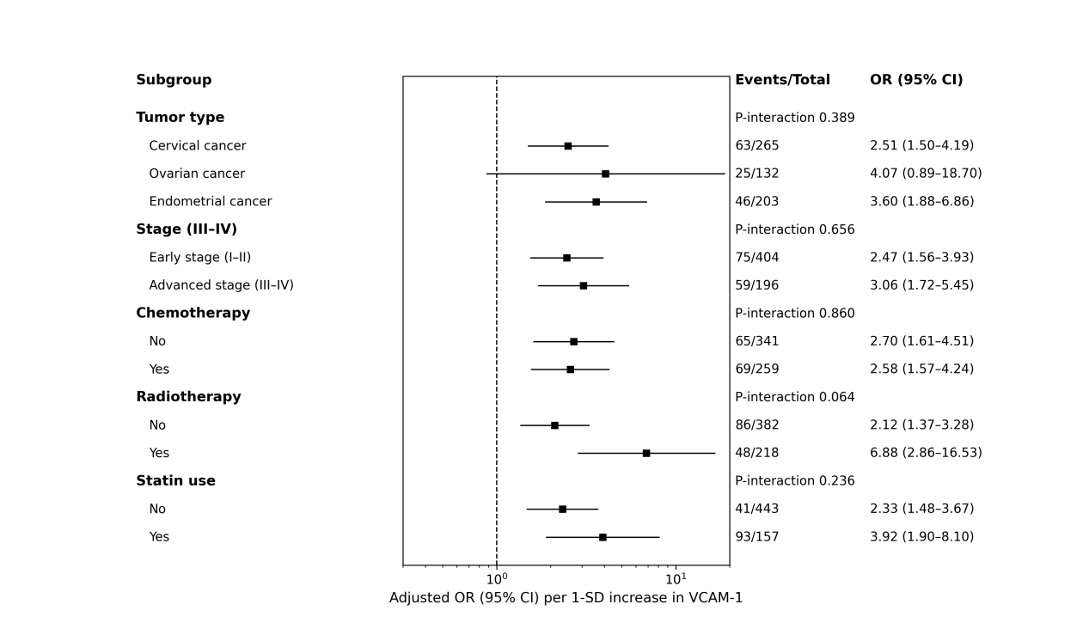
Figure S1. Subgroup analyses of the association between VCAM‑1 and imaging-defined atherosclerosis in the cancer cohort.
Forest plot shows adjusted odds ratios (ORs) and 95% confidence intervals (CIs) for atherosclerosis per 1‑SD increase in VCAM‑1 within prespecified subgroups (tumor type, stage, chemotherapy, radiotherapy, and statin use). Models were adjusted for age, BMI, smoking, hypertension, diabetes, LDL‑C, HDL‑C, triglycerides, statin use, aspirin use, tumor type, advanced stage, chemotherapy, and radiotherapy; the stratifying variable was omitted from the corresponding subgroup-specific model. P-interaction values were obtained by adding an interaction term between VCAM‑1 and the subgroup variable in the fully adjusted model.

