Supplementary Table S1.Disproportionality analysis of selected pulmonary adverse events associated with osimertinib according to individual signal detection algorithms
PT | n | ROR(95% CI) | PRR (χ2) | IC (IC025) | EBGM(EBGM05)
interstitial lung disease | 484 | 12.4 ( 11.33 - 13.57 ) | 12.29 ( 4944.39 ) | 3.6 ( 3.43 ) | 12.11 ( 11.07 )
pneumonia | 282 | 1.25 ( 1.12 - 1.39 ) | 1.25 ( 17 ) | 0.32 ( 0.16 ) | 1.25 ( 1.12 )
pneumonitis | 203 | 11.71 ( 10.41 - 13.18 ) | 11.66 ( 2706.41 ) | 3.52 ( 3.3 ) | 11.49 ( 10.21 )
lung disorder | 193 | 4.99 ( 4.34 - 5.73 ) | 4.97 ( 640.52 ) | 2.31 ( 2.08 ) | 4.95 ( 4.31 )
pulmonary embolism | 105 | 3.24 ( 2.81 - 3.73 ) | 3.23 ( 296.18 ) | 1.69 ( 1.46 ) | 3.22 ( 2.79 )
pulmonary oedema | 53 | 3.12 ( 2.57 - 3.78 ) | 3.11 ( 149.98 ) | 1.63 ( 1.32 ) | 3.1 ( 2.56 )
pulmonary mass | 39 | 3.84 ( 2.93 - 5.03 ) | 3.84 ( 110.69 ) | 1.93 ( 1.47 ) | 3.82 ( 2.92 )
pulmonary toxicity | 32 | 6.27 ( 4.57 - 8.59 ) | 6.27 ( 171.21 ) | 2.64 ( 2 ) | 6.22 ( 4.54 )
pulmonary thrombosis | 25 | 3.28 ( 2.32 - 4.65 ) | 3.28 ( 50.56 ) | 1.71 ( 1.11 ) | 3.27 ( 2.31 )
pneumonia aspiration | 23 | 1.45 ( 1.01 - 2.09 ) | 1.45 ( 4.1 ) | 0.54 ( -0.01 ) | 1.45 ( 1.01 )
Note:1.Concordant signals were defined as drug–event pairs meeting the predefined thresholds for all four algorithms (ROR₀.₀₂₅>1; PRR≥2, χ²≥4, n≥3; IC₀₂₅>0; EBGM₀₅>2);2.Partial signals were defined as drug–event pairs meeting the signal criteria for one or more algorithms but not all four predefined thresholds required for classification as concordant signals.

Supplementary Figure S2. Original forest plot of top-ranked preferred term (PT)-level signals associated with osimertinib before clinical prioritization.

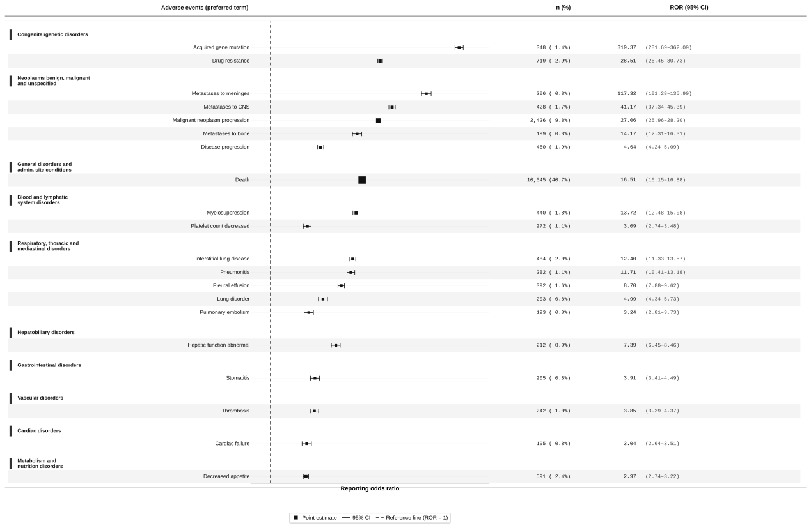
The figure shows the original preferred term (PT)-level disproportionality signals identified for osimertinib in the FAERS database prior to clinical prioritization. PTs were ranked by reporting odds ratio (ROR), and the forest plot displays ROR estimates with 95% confidence intervals. Only PTs fulfilling the predefined positivity criteria across all four signal detection algorithms (ROR, PRR, BCPNN, and EBGM) were retained. This figure is provided as supplementary material to present the full original signal spectrum underlying the clinically selected PTs shown in Figure 1B.

Supplementary Table S3. Hub gene identification in the protein–protein interaction network by four centrality algorithms
Gene | Degree | MCC | Closeness | Betweenness
CTNNB1 | 14¹ | 42.19 | 0.8235¹ | 5.6167¹
KRAS | 13² | 46.22 | 0.7686² | 3.6667²
STAT3 | 12³ | 44.92 | 0.7206³ | 3.6500³
TP53 | 12 | 44.92 | 0.7206 | 3.6500
PIK3CA | 12 | 51.48 | 0.7206 | 1.7333
AKT1 | 11 | 47.46 | 0.6782 | 2.6667
NRAS | 11 | 51.17 | 0.6782 | 1.4667
PTPN11 | 11 | 51.17 | 0.6782 | 1.4667
PTEN | 11 | 56.79³ | 0.6782 | 0.7000
ERBB2 | 10 | 55.07 | 0.6405 | 0.8667
BRAF | 9 | 64.26¹ | 0.6068 | 0.2000
MET | 9 | 62.84² | 0.6068 | 0.2000
FGFR1 | 7 | 51.47 | 0.5490 | 1.1167
CREBBP | 6 | 43.60 | 0.5241 | 0.8333
EP300 | 6 | 54.26 | 0.5241 | 0.1667
SCN5A | 2 | 1.00 | 0.1176 | 1.0000
KCNH2 | 1 | 1.00 | 0.0784 | 0.0000
TNNI3 | 1 | 1.00 | 0.0784 | 0.0000
Abbreviations: MCC, Maximal Clique Centrality. Superscripts ¹–³ denote rank 1–3 for each metric. Bold values indicate top-3 ranked genes per algorithm. Italic gene names (lower section) indicate isolated or near-isolated nodes (Degree ≤ 2) in the PPI network. Hub gene prioritisation: the top 10 genes ranked by Degree are designated as key hub genes.

