SUPPLEMENTARY DATA (tables and figures)
Supplementary Table S1. Univariate Cox regression analysis for factors associated with invasive disease-free survival (iDFS). The diagnostic method compares mammography with symptomatic diagnosis.
Variables | HR | 95% CI | SE | p-value
Age | 0.98 | 0.98-0.99 | 0.002 | <0.0001
Diagnostic method | 0.41 | 0.33-0.512 | 0.045 | <0.0001
Stage
II | 1.84 | 1.54-2.20 | 0.167 | <0.0001
III | 4.64 | 3.87-5.56 | 0.42 | <0.0001
Lymph Nodes +/- | 2.54 | 2.20-2.94 | 0.18 | <0.0001
HG
2 | 2.01 | 1.53-2.64 | 0.27 | <0.0001
3 | 3.56 | 2.7-4.69 | 0.49 | <0.0001
Ki67 | 1.01 | 1.01-1.02 | 0.002 | <0.0001
Chemotherapy use | 1.84 | 1.58-2.14 | 0.14 | <0.0001

Supplementary Table S2. Multivariate Cox regression analysis for factors associated with invasive disease-free survival (iDFS). The diagnostic method compares mammography with symptomatic diagnosis.
Variable | HR | 95% CI | SE | p-value
Age | 1.006 | 0.99-1.02 | 0.0076 | 0.42
Diagnostic method | 0.84 | 0.56-1.27 | 0.175 | 0.43
Stage
II | 1.37 | 0.83-2.24 | 0.34 | 0.21
III | 4.02 | 2.32-6.98 | 1.12 | 0.000
HG
2 | 1.21 | 0.65-2.24 | 0.38 | 0.54
3 | 1.44 | 0.75-2.74 | 0.47 | 0.267
Ki67 | 1.01 | 1.008-1.023 | .003 | 0.000
Chemotherapy use | 0.64 | 0.411-1.02 | 0.15 | 0.063

Supplementary Table S3. Time period (categorical diagnostic era) adjusted multivariate Cox model
Covariate | HR | 95% CI | p-value
Time periods*
2000–2009 vs 1981–1999 | 18.85 | 2.98–119.10 | 0.002
2010–2022 vs 1981–1999 | 66.46 | 9.21–479.61 | <0.001
Clinical/pathological variables
Age at diagnosis (per year) | 1.00 | 0.99–1.02 | 0.761
Stage II vs I | 1.90 | 1.36–2.67 | <0.001
Stage III vs I | 4.51 | 2.88–7.05 | <0.001
Grade 2 vs 1 | 1.19 | 0.78–1.82 | 0.413
Grade 3 vs 1 | 1.54 | 0.94–2.50 | 0.085
Ki-67 (per 1%) | 1.01 | 1.01–1.02 | <0.001
Chemotherapy (yes vs no) | 0.64 | 0.44–0.92 | 0.017
* After adjustment for time period (diagnostic era), stage and Ki-67 remained independently associated with invasive recurrence
Supplementary Table S4. Stratified Cox model allowing different baseline hazards by time period (diagnostic era) *
Covariate | HR | 95% CI | p-value
Age at diagnosis (per year) | 1.00 | 0.99–1.02 | 0.784
Stage II vs I | 1.95 | 1.38–2.76 | <0.001
Stage III vs I | 4.64 | 2.94–7.31 | <0.001
Grade 2 vs 1 | 1.20 | 0.78–1.83 | 0.407
Grade 3 vs 1 | 1.54 | 0.95–2.51 | 0.079
Ki-67 (per 1%) | 1.01 | 1.01–1.02 | <0.001
Chemotherapy (yes vs no) | 0.63 | 0.44–0.92 | 0.017
* Results were consistent in a stratified Cox model, confirming that associations for stage and Ki-67 persist when allowing different baseline hazards across time periods (diagnostic eras)

Supplementary Table S5. Sensitivity analysis modeling year of diagnosis as a continuous covariate (per 10 years).
Covariate | HR | 95% CI | p-value
Year of diagnosis (per 10 years) * | 7.45 | 4.16–13.36 | <0.001
Age at diagnosis (per year) | 1.00 | 0.99–1.02 | 0.519
Stage II vs I | 1.76 | 1.27–2.45 | 0.001
Stage III vs I | 4.41 | 2.85–6.83 | <0.001
Grade 2 vs 1 | 1.24 | 0.80–1.91 | 0.338
Grade 3 vs 1 | 1.49 | 0.91–2.45 | 0.113
Ki-67 (per 1%) | 1.02 | 1.01–1.02 | <0.001
Chemotherapy (yes vs no) | 0.68 | 0.47–0.98 | 0.040
*Modeling year of diagnosis as a continuous covariate (per 10 years) confirmed calendar time as an independent predictor, while stage and Ki-67 remained robust predictors

Supplementary Table S6. Multivariate analysis including time periods (diagnostic era) but excluding Ki-67 *
Covariate | HR | 95% CI | p-value
Time periods (diagnostic eras)
2000–2009 vs 1981–1999 | 1.30 | 0.74–2.28 | 0.364
2010–2022 vs 1981–1999 | 2.36 | 1.31–4.25 | 0.004
Age at diagnosis (per year) | 0.99 | 0.98–1.00 | 0.088
Stage II vs I | 1.70 | 1.29–2.25 | <0.001
Stage III vs I | 4.17 | 3.03–5.73 | <0.001
Grade 2 vs 1 | 1.78 | 1.32–2.39 | <0.001
Grade 3 vs 1 | 2.97 | 2.19–4.04 | <0.001
Chemotherapy (yes vs no) | 0.80 | 0.61–1.06 | 0.120
Excluding Ki-67 did not change the association of stage and grade, with recurrence risk

Supplementary Table S7. Multivariate analysis including time period-stratified Cox model. excluding Ki-67 *
Covariate | HR | 95% CI | p-value
Age at diagnosis (per year) | 0.99 | 0.98–1.00 | 0.092
Stage II vs I | 1.72 | 1.31–2.27 | <0.001
Stage III vs I | 4.24 | 3.08–5.85 | <0.001
Grade 2 vs 1 | 1.77 | 1.32–2.38 | <0.001
Grade 3 vs 1 | 2.98 | 2.19–4.05 | <0.001
Chemotherapy (yes vs no) | 0.79 | 0.59–1.04 | 0.092
* Results were concordant when allowing different baseline hazards across time periods and removing Ki-67

Supplementary Table S8. Sensitivity analysis restricted to the most recent time period (2010–2022): multivariate Cox model including Ki-67
Covariate | HR | 95% CI | p-value
Age at diagnosis (per year) | 1.00 | 0.99–1.02 | 0.753
Stage II vs I | 2.32 | 1.48–3.63 | <0.001
Stage III vs I | 6.74 | 3.84–11.84 | <0.001
Grade 2 vs 1 | 1.23 | 0.66–2.30 | 0.506
Grade 3 vs 1 | 1.68 | 0.87–3.25 | 0.121
Ki-67 (per 1%) | 1.02 | 1.01–1.02 | <0.001
Chemotherapy (yes vs no) | 0.56 | 0.35–0.90 | 0.016

Supplementary Table S9. Sensitivity analysis replacing AJCC stage with nodal involvement (10-year invasive recurrence; era-stratified Cox models) for all years and for the period 2010-2022.
Covariate | All years |  |  | Time period: 2010-2022
Covariate | HR | 95% CI | p-value | HR | 95% CI | p-value
Nodal involvement (+ vs -) | 2.28 | 1.61–3.24 | <0.001 | 2.41 | 1.67–3.46 | <0.001
Age at diagnosis (per year) | 1.01 | 0.99–1.02 | 0.417 | 1.00 | 0.99–1.02 | 0.529
Grade 2 vs 1 | 1.38 | 0.74–2.57 | 0.304 | 1.43 | 0.73–2.80 | 0.303
Grade 3 vs 1 | 1.83 | 0.95–3.53 | 0.070 | 2.06 | 1.02–4.18 | 0.045
Ki-67 (per 1%) | 1.02 | 1.01–1.02 | <0.001 | 1.02 | 1.01–1.02 | <0.001
Chemotherapy (yes vs no) | 0.81 | 0.53–1.24 | 0.330 | 0.77 | 0.50–1.21 | 0.258

Supplementary Table S10. Univariate analysis for variables associated to early invasive recurrence (<60 months)
Variable | HR | 95% CI | SE | p-value
Age | 1.001 | 0.99- 1.00 | .0033 | 0.689
Diagnostic method | .806 | 0.58-1.10 | .1294 | 0.181
Stage
II | 1.152 | 0.87-1.51 | .1588 | 0.303
III | 1.572 | 1.21-2.04 | .2093 | 0.001
Lymph Node | 1.432 | 1.16-1.75 | .1491 | 0.001
HG
2 | 1.245 | 0.80-1.92 | .2764 | 0.323
3 | 1.366 | 0.89- 2.09 | .2972 | 0.151
Ki67 | 1.001 | 0.99- 1.00 | .0030 | 0.696
Chemotherapy use | 1.07 | 0.87-1.32 | 0.11 | 0.482

Supplementary Table S11. Univariate analysis for variables associated to late invasive recurrence (≥60 months)
Variable | HR | 95% CI | SE | p-value
Age | 1.02 | 1.01-1.03 | 0.0004 | 0.000
Diagnostic method | 0.77 | 0.57-1.05 | 0.110 | 0.102
Stage
II | 1.29 | 1.02 1.64 | 0.158 | 0.034
III | 1.48 | 1.13-1.95 | 0.206 | 0.004
Lymph Node | 1.20 | 0.98- 1.48 | 0.12 | 0.075
HG
2 | 1.45 | 1.02-2.06 | 0.26 | 0.035
3 | 1.48 | 1.01-2.15 | 0.28 | 0.040
Ki67 | 1.00 | 0.99-1.01 | 0.003 | 0.146
Chemotherapy use | 1.06 | 0.84-1.32 | 0.12 | 0.59

Supplementary Table S12. Multivariate analysis for variables associated with late invasive recurrence (≥60 months)
Variable | HR | 95% CI | SE | p-value
Age | 1.02 | 1.01- 1.03 | .0063 | 0.000
Stage
II | 1.12 | 0.83-1.51 | 0.172 | 0.452
III | 1.49 | 1.07-2.08 | 0.25 | 0.018
HG
2 | 1.25 | 0.88-1.79 | 0.22 | 0.206
3 | 1.33 | 0.909-1.95 | 0.26 | 0.141

Supplementary Table S13. Clinical characteristics of HR+/HER2- breast cancer patients based on type of invasive recurrence (spatial recurrence).
Variable | Ipsilateral+Contralateral; n=248 | Distance; n=595 | p-value
Age (median, range) | 53 (25.7-86.1) | 54(19-88.9) | 0.44
Diagnostic method % |  |  | <0.0001
Mammography | 38.97 | 16.18
Symptoms | 61.03 | 83.8
Stage |  |  | <0.0001
I | 46.37 | 12.5
II | 40.32 | 40.03
III | 13.31 | 47.40
Lymph Nodes |  |  | <0.0001
- | 64.07 | 25.26
+ | 35.93 | 74.74
Histological grade |  |  | <0.0001
I | 19.63 | 12.34
II | 51.53 | 45.61
III | 28.83 | 42.06
Ki67 (median, range) | 20 (1-90) | 30 (1-95) | 0.0002
Chemotherapy use |  |  | <0.0001
Yes | 45.65 | 24.95
No | 54.35 | 75.05

Supplementary Table S14. Univariate analysis for variables associated to distant recurrence
Variable | OR | 95% CI | Std Err | p-value
Age | 0.98 | 0.97-0.98 | 0.003 | <0.0001
Diagnostic method | 0.27 | 0.20-0.36 | 0.403 | <0.0001
Stage
I | Ref
II | 3.24 | 2.50-4.19 | 0.42 | <0.0001
III | 10.1 | 7.89-13.12 | 1.31 | <0.0001
Lymph Nodes | 4.27 | 3.54-5.16 | 0.40 | <0.0001
Histological grade
1 | Ref
2 | 2.37 | 1.64-3.44 | 0.45 | <0.0001
3 | 5.16 | 3.57-7.46 | 0.97 | <0.0001
Ki67 | 1.02 | 1.01-1.02 | 0.002 | <0.0001
Chemotherapy use | 2.61 | 2.15-3.16 | 0.257 | <0.0001

Supplementary Table S15. Multivariate analysis for variables associated with distant recurrence
Variable | OR | 95% CI | Std Err | p-value
Age | 0.99 | 0.97-1.01 | 0.008 | 0.42
Diagnostic method | 0.64 | 0.35-0.19 | 0.20 | 0.162
Stage  II  III | 3.31  12.8 | 1.37-7.97  5.20-31.6 | 1.48  5.90 | 0.007  <0.0001
Histological grade  2  3 | 2.59  3.55 | 0.78-8.61  1.07-11.8 | 1.58  2.18 | 0.11  0.038
Ki67 | 1.01 | 1.00-1.02 | 0.0046 | 0.012
Chemotherapy use | 0.66 | 0.36-1.19 | 0.19 | 0.169

Supplementary Table S16. Sensitivity analysis replacing AJCC stage with nodal involvement (10-year distant recurrence; era-stratified Cox models for all years (full cohort) and the period between 2010 and 2022.
Covariate | All years |  |  | Time period: 2010-2022
Covariate | HR | 95% CI | p-value | HR | 95% CI | p-value
Nodal involvement (+ vs -) | 4.41 | 2.65–7.33 | <0.001 | 4.76 | 2.83–8.02 | <0.001
Age at diagnosis (per year) | 1.00 | 0.98–1.02 | 0.999 | 1.00 | 0.98–1.02 | 0.911
Grade 2 vs 1 | 2.14 | 0.81–5.69 | 0.127 | 1.96 | 0.73–5.26 | 0.182
Grade 3 vs 1 | 2.92 | 1.06–8.00 | 0.037 | 2.83 | 1.02–7.84 | 0.046
Ki-67 (per 1%) | 1.01 | 1.00–1.02 | 0.002 | 1.01 | 1.00–1.02 | 0.012
Chemotherapy (yes vs no) | 0.89 | 0.51–1.55 | 0.688 | 0.88 | 0.50–1.56 | 0.665

Supplementary Table S17. Early vs late distant recurrence and metastatic site

Type of metastasis | Early distant recurrence | Late distant recurrence | p-value
Total (N: 570) | 333 (100%) | 237 (100%) | 0.0816
Visceral disease  (N: 271; 47.5%) | 160 (48.0%) | 111 (46.8%) | 0.0816
Non visceral disease  (N: 299; 52.4%) | 173 (51.9) | 126 (53.1%) | 0.0816
Brain Metastases  (N: 39; 6.8%) | 30 (76.9) | 9 (23.0)

Early distant recurrence: 6-60 months since time of diagnosis; late distant recurrence ≥60 months. Visceral disease: Lung, liver, and/or brain metastasis; non-visceral disease: bone and distant nodal recurrence.

FIGURES

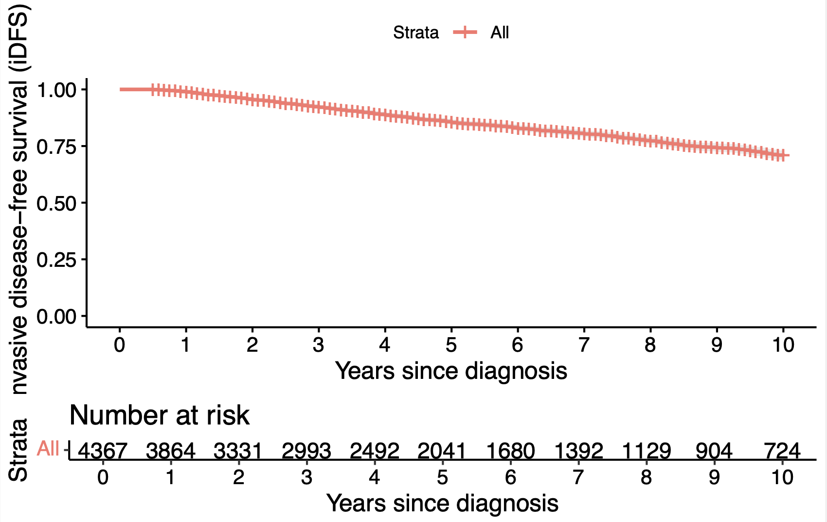
Supplementary Figure S1. iDFS for the entire cohort

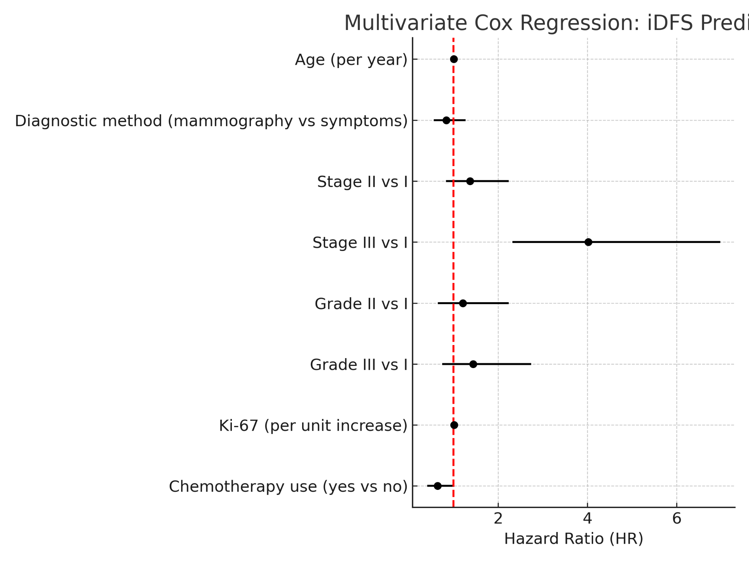
Supplementary Figure S2. Forest plot showing the results of the multivariate Cox regression analysis for invasive disease-free survival (iDFS). Hazard ratios (HR) with 95% confidence intervals are shown for each variable. Reference categories: Stage I, Grade 1, and no chemotherapy. The red dashed line indicates HR = 1 (no effect)
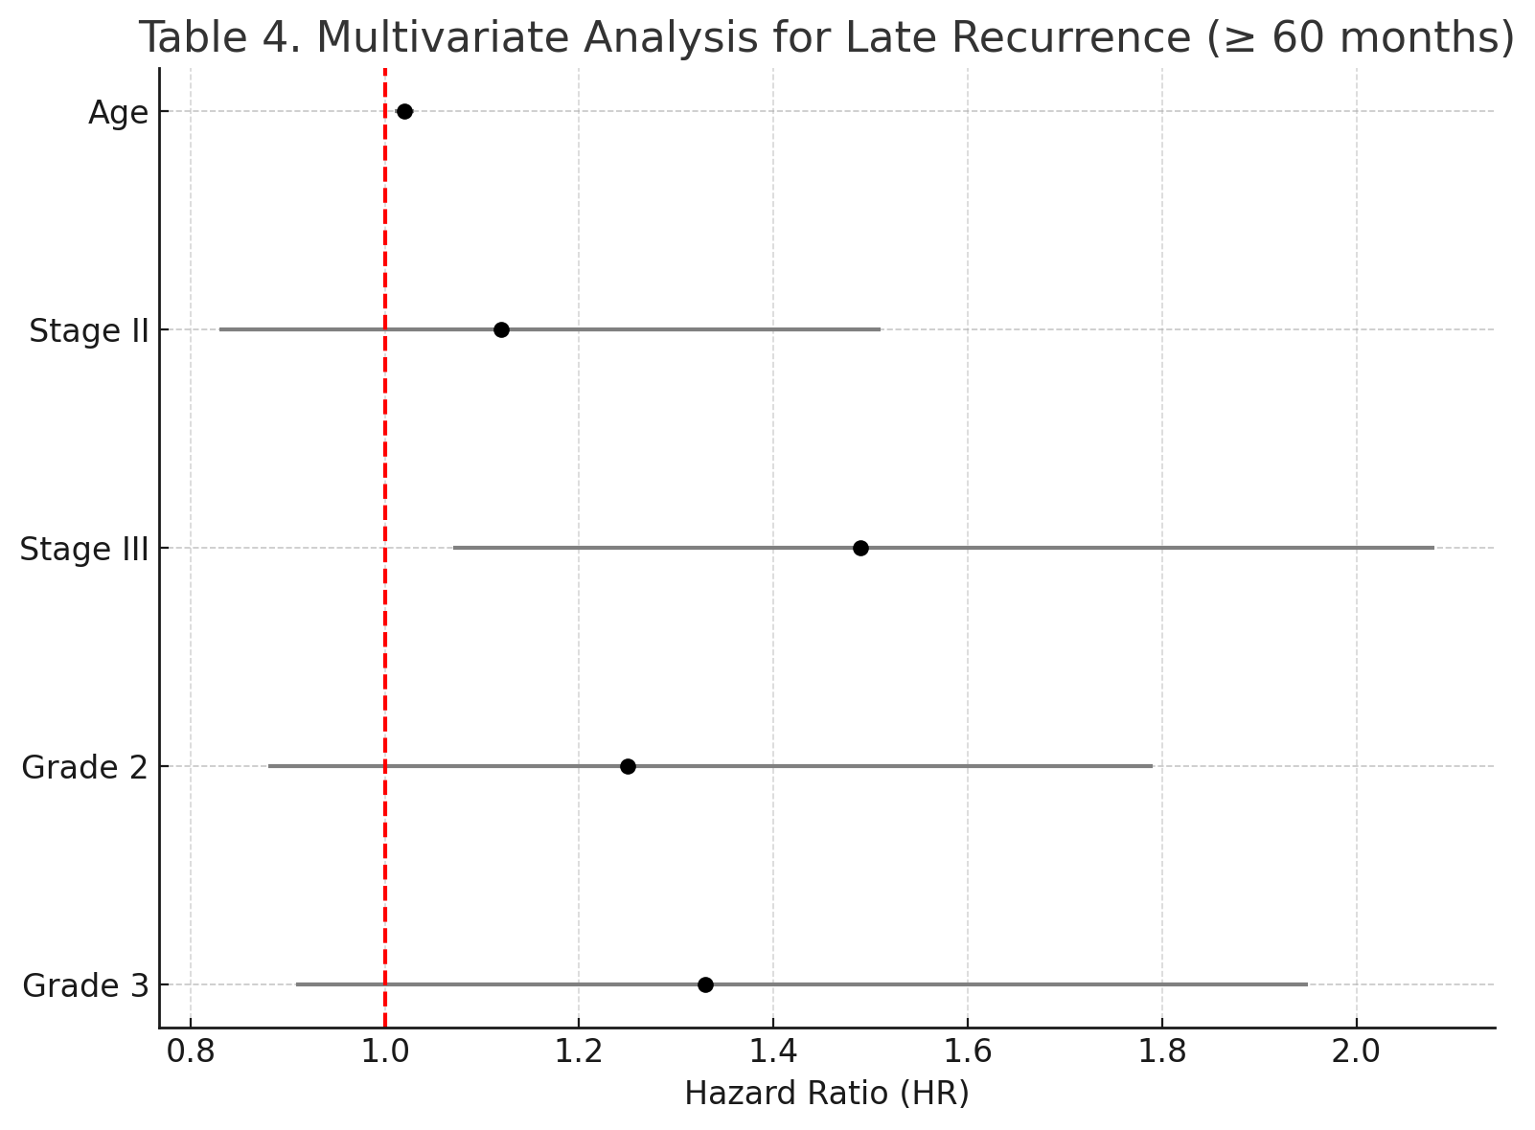
Supplementary Figure S3. Forest plot of multivariate analysis identifying factors associated with late recurrence (≥60 months) in patients with early-stage HR+/HER2− breast cancer. Hazard ratios (HR) with 95% confidence intervals (CI) are shown for each variable. Stage III disease was significantly associated with increased risk of late recurrence (HR 1.49; 95% CI: 1.07–2.08; p=0.018), while age also showed a modest but statistically significant effect (HR 1.02 per year; 95% CI: 1.01–1.03; p<0.001). Other variables did not reach statistical significance.

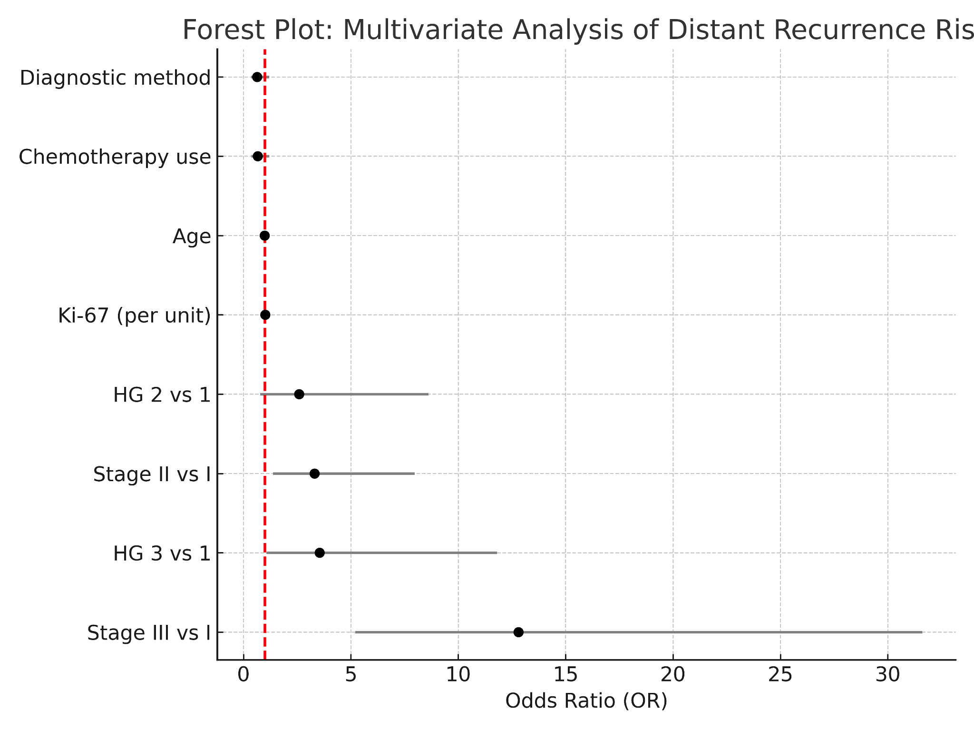
Supplementary Figure S4. Forest plot of multivariate logistic regression analysis showing factors associated with distant recurrence in early-stage HR+/HER2- breast cancer. Odds ratios (ORs) and 95% confidence intervals (CIs) are plotted for each variable. Ki67, stage and histological grade (HG 3) were significantly associated with increased risk of distant recurrence. A red vertical line indicates the null value (OR = 1.0).

