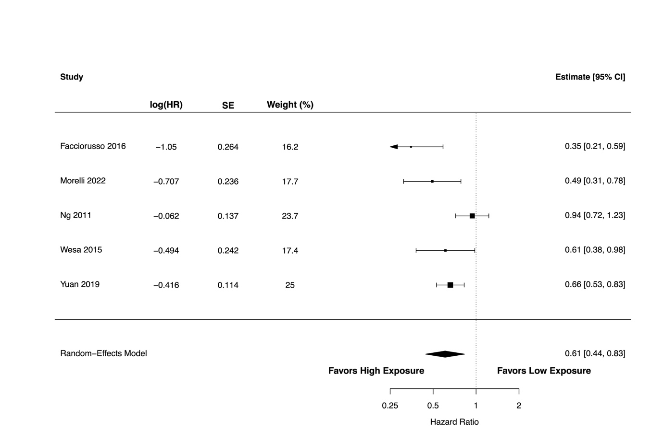
Supplementary Figure S1. A forest plot showing the association between high versus low circulating 25(OH)D levels and overall survival in metastatic colorectal cancer patients.

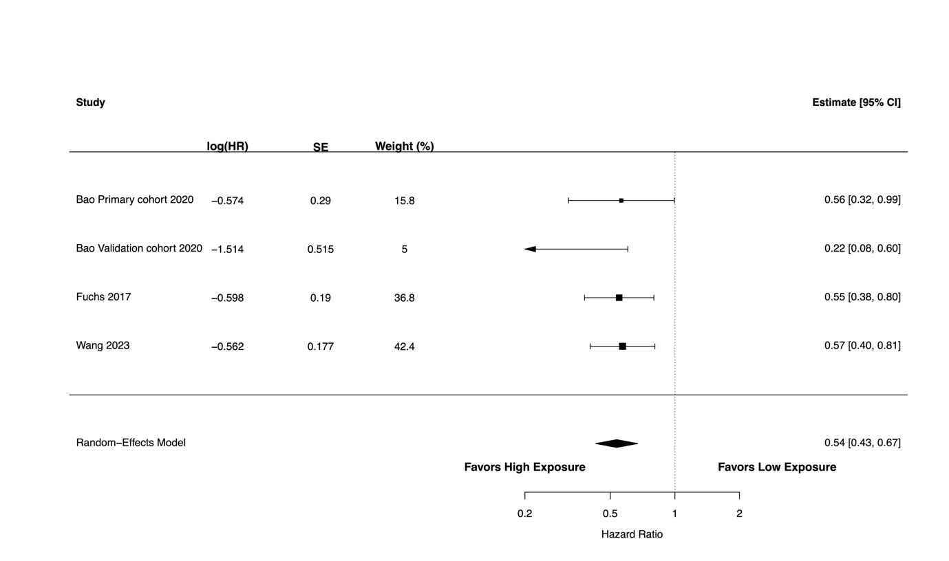
Supplementary Figure S2. A forest plot showing the association between high versus low circulating 25(OH)D levels and overall survival in stage III colorectal cancer patients.

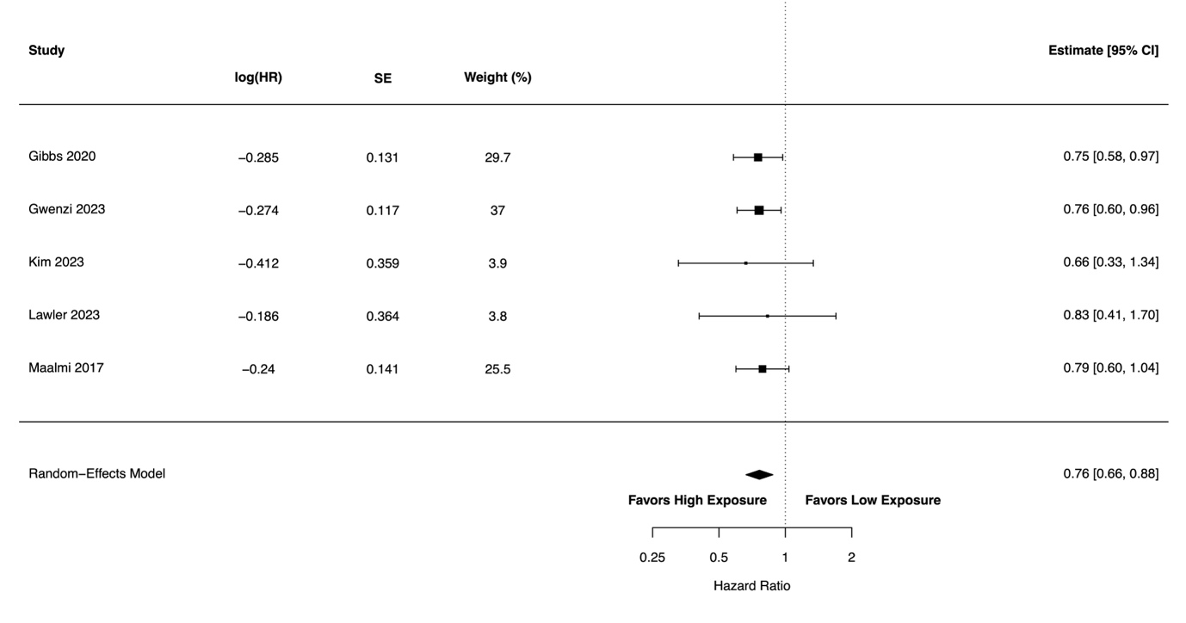
Supplementary Figure S3. A forest plot showing the association between high versus low circulating 25(OH)D levels and colorectal cancer-specific survival, from a sensitivity analysis restricted to studies with comparable vitamin D thresholds (≥50 nmol/L or ≥20 ng/mL vs. <30 nmol/L or <12 ng/mL).

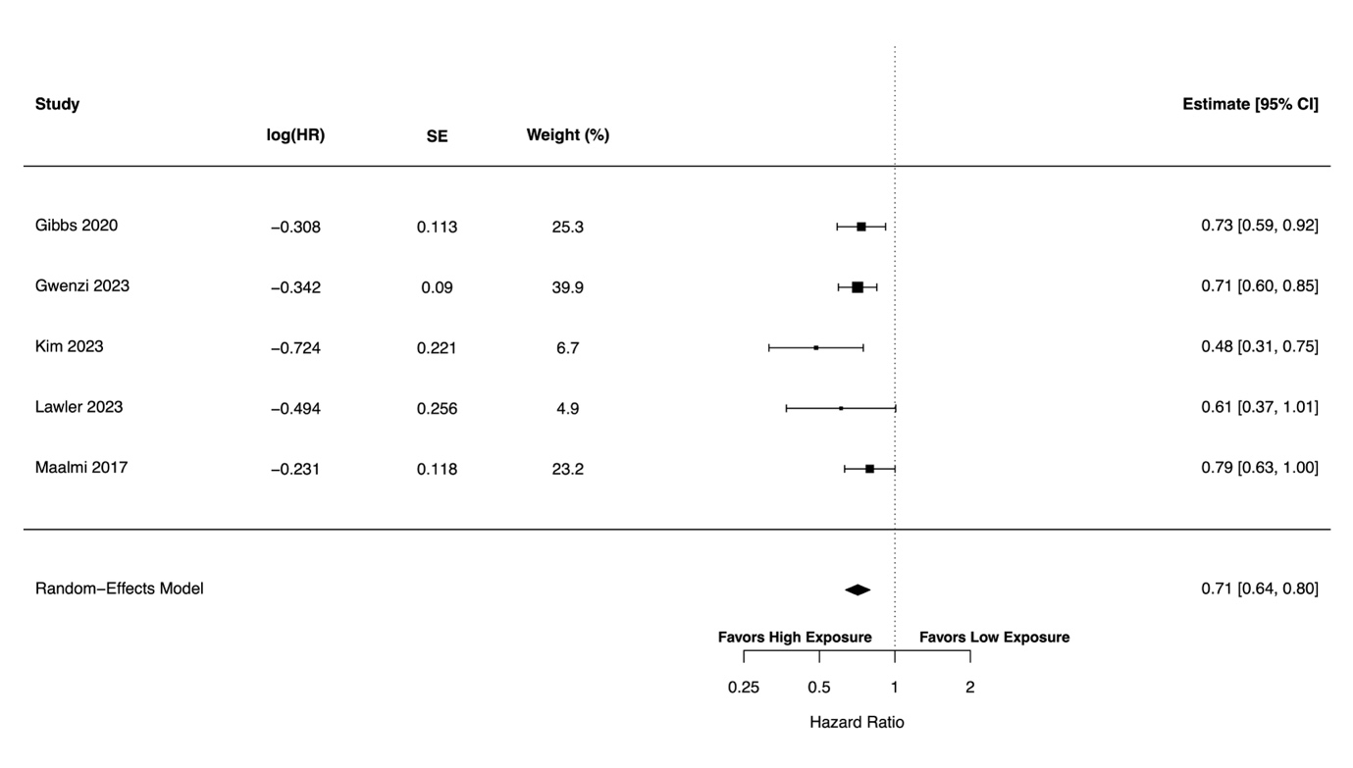
Supplementary Figure S4. A forest plot showing the association between high versus low circulating 25(OH)D levels and overall survival, from a sensitivity analysis restricted to studies with comparable vitamin D thresholds (≥50 nmol/L or ≥20 ng/mL vs. <30 nmol/L or <12 ng/mL).

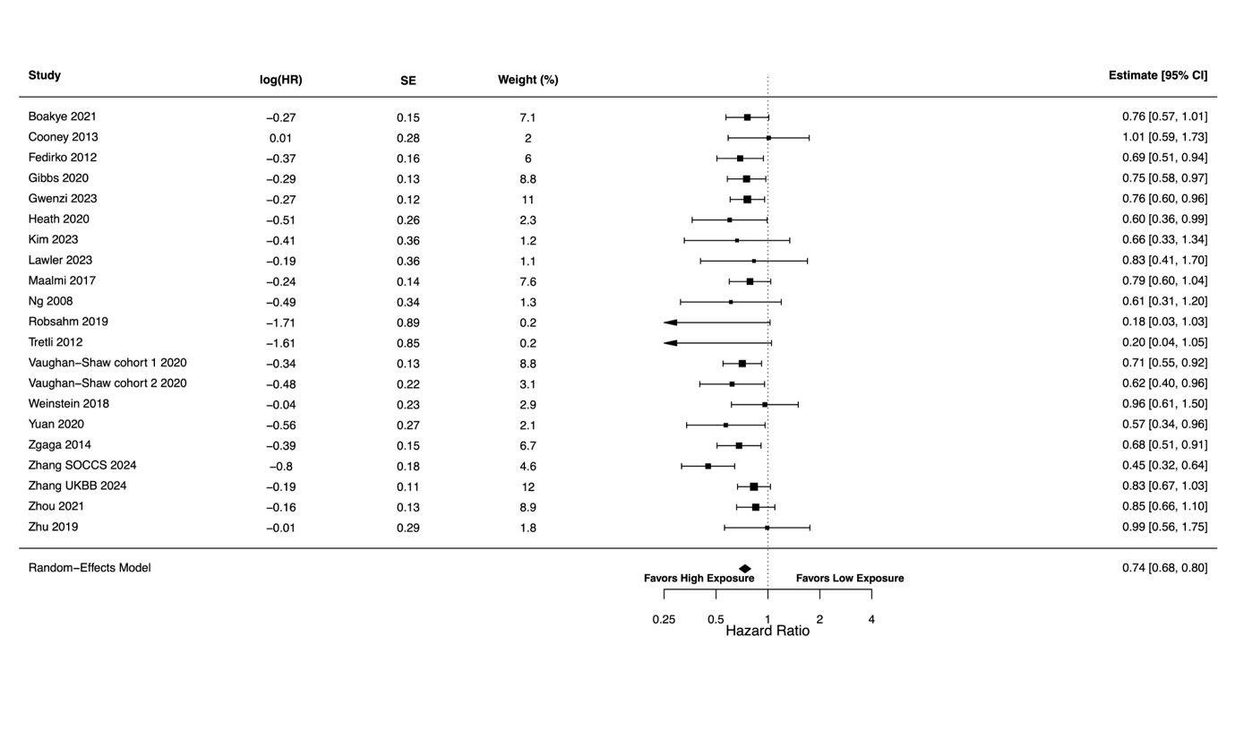
Supplementary Figure S5. A forest plot showing the association between high versus low circulating 25(OH)D levels and colorectal cancer-specific survival, from a sensitivity analysis excluding a study rated as low quality.

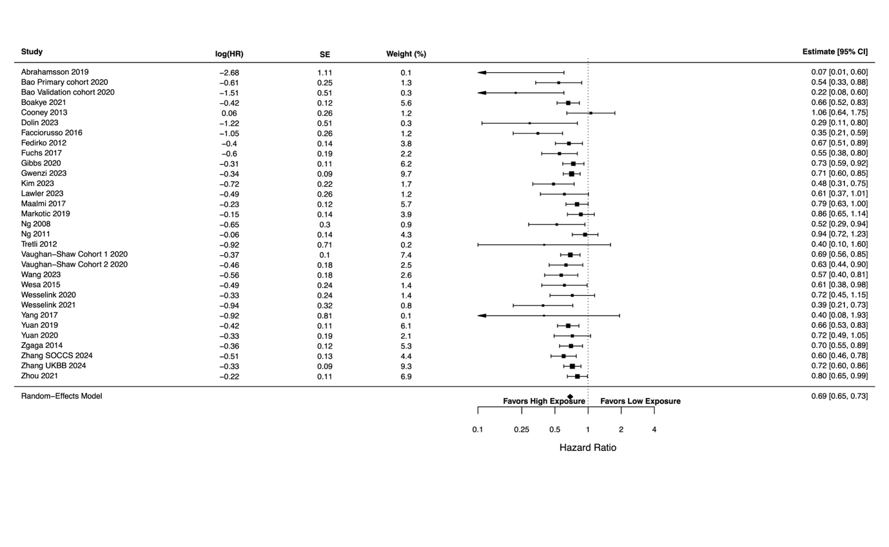
Supplementary Figure S6. A forest plot showing the association between high versus low circulating 25(OH)D levels and overall survival, from a sensitivity analysis excluding a study rated as low quality.

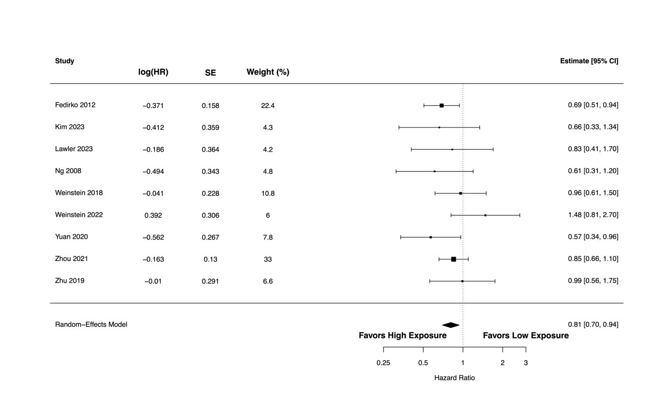
Supplementary Figure S7. A forest plot showing the association between high versus low pre-diagnostic circulating 25(OH)D levels and colorectal cancer-specific survival.

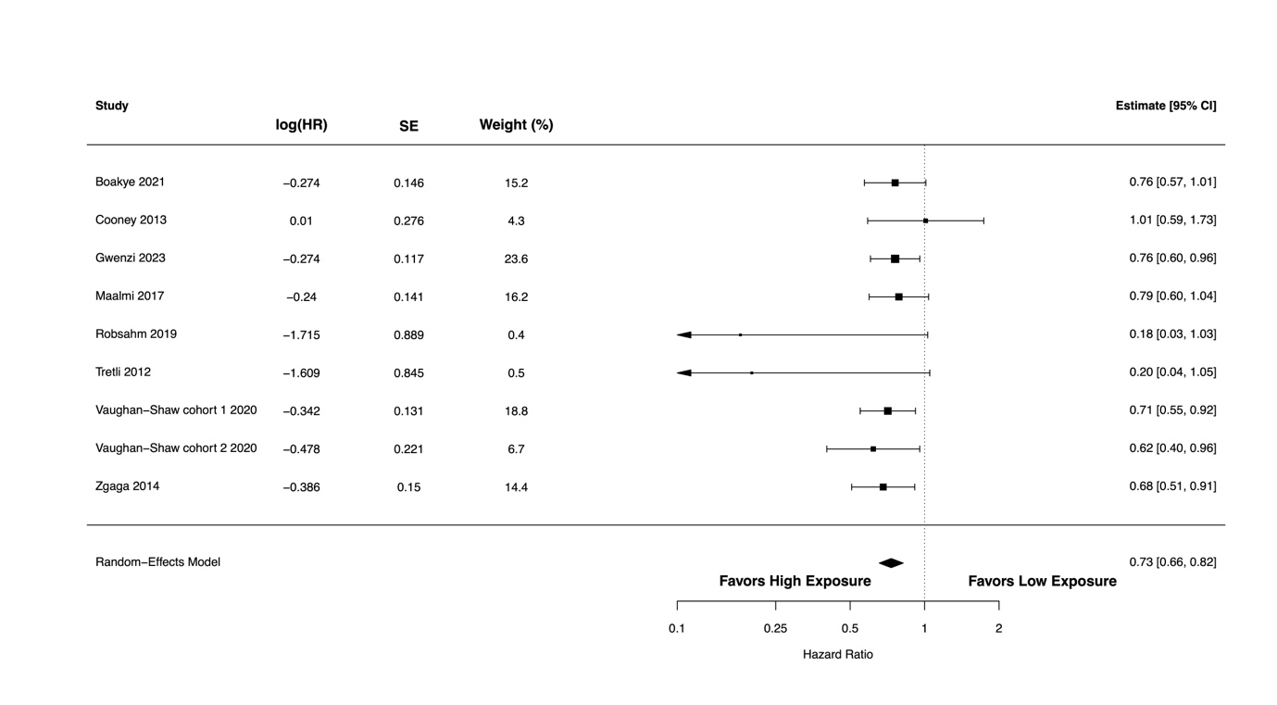
Supplementary Figure S8. A forest plot showing the association between high versus low post-diagnostic circulating 25(OH)D levels and colorectal cancer-specific survival.

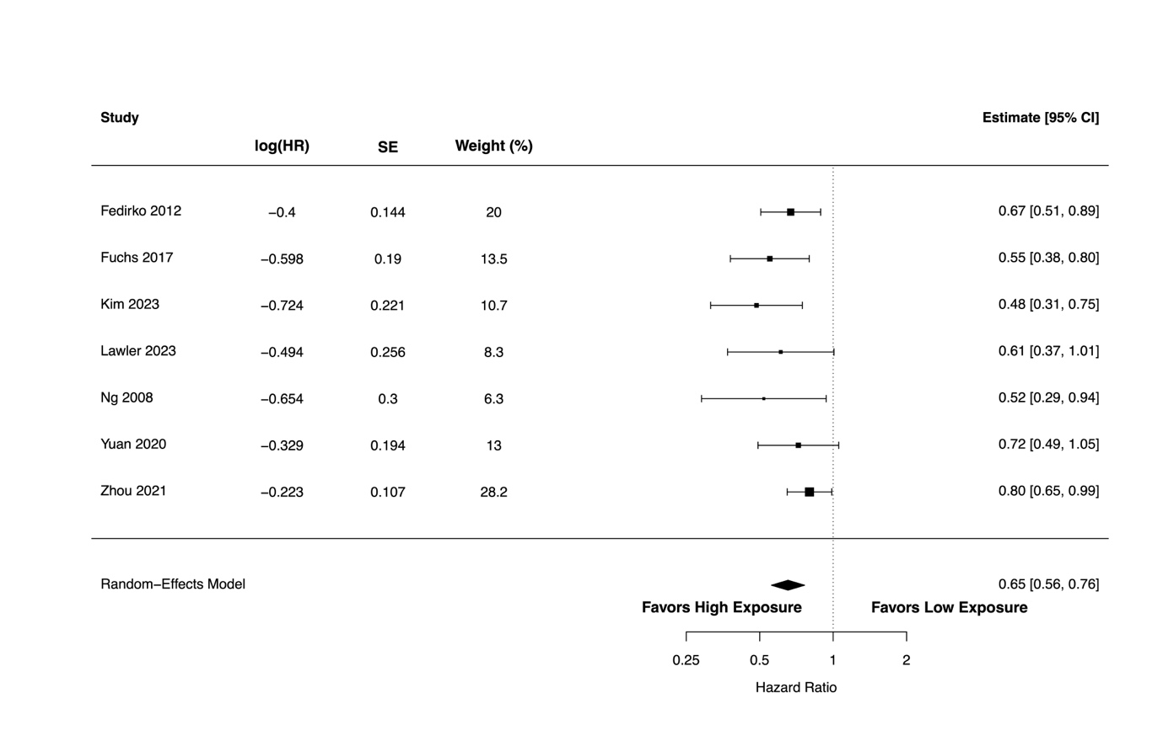
Supplementary Figure S9. A forest plot showing the association between high versus low pre-diagnostic circulating 25(OH)D levels and overall survival.

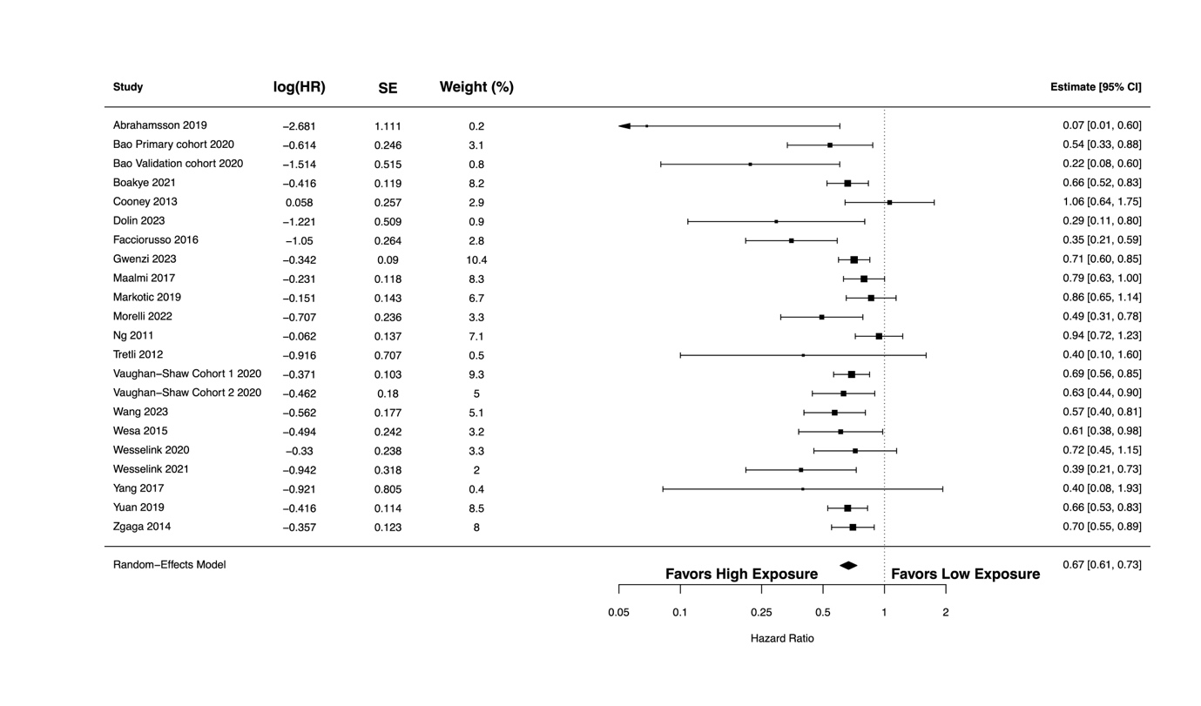
Supplementary Figure S10. A forest plot showing the association between high versus low post-diagnostic circulating 25(OH)D levels and overall survival.

