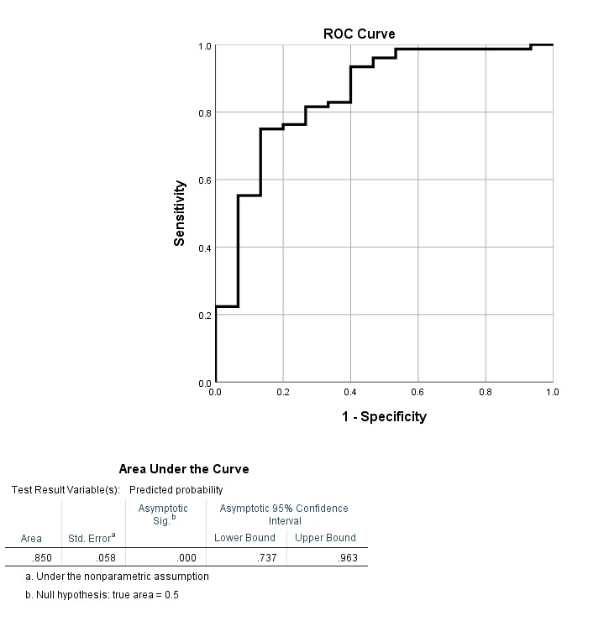
Supplementary Graph: Receiver Operating Characteristic (ROC) Curve for the Final Model

