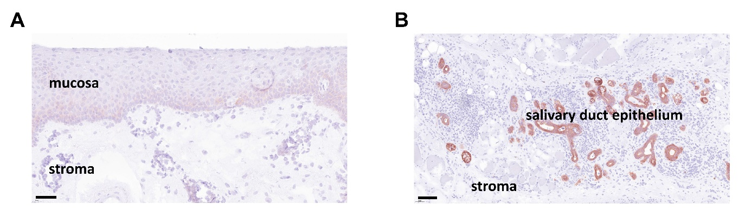
Supplementary Figure 1. Representative images of EpCAM-positive tissue structures additional to HNSCC in patient tissue samples with primary and recurrent HNSCC. (A) Representative light microscopy image of marginally EpCAM-positive non-malignant mucosa (scale bar: 60 µm) and (B) representative light microscopy image of EpCAM-positive salivary gland tissue (scale bar: 100 µm) of immunohistochemically stained HNSCC tissue samples (hematoxylin staining of nuclei; anti-EpCAM-antibody VU1D9: red).
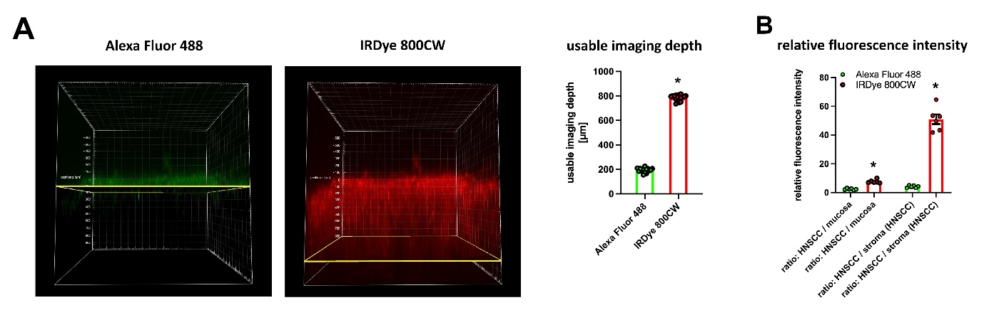
Supplementary Figure 2. Comparison of the imaging properties of fluorescence immunostainings with either a dye emitting in the visible light range (AlexaFluor488) or a near-infrared dye emitting in the near-infrared light range (IRDye800CW). (A) Representative images and quantitative data on the usable imaging depth of immunostainings with the anti-EpCAM-antibody MT201 labeled either with AlexaFluor488 (visible light range) or IRDye800CW (near-infrared light range) as assessed by confocal laserscanning microscopy (scale bar: 50 µm; mean ± SEM for n = 15; * p < .05 vs Alexa Fluor 488). (B) Quantitative data on the relative fluorescence intensity ratios of HNSCC to non-malignant mucosa and of HNSCC to HNSCC-associated stroma as assessed in immunostainings with the anti-EpCAM-antibody MT201 labeled either with AlexaFluor488 (visible light range) or IRDye800CW (near-infrared light range) by confocal laserscanning microscopy (scale bar: 100 µm; mean ± SEM for n = 6; * p < .05 vs Alexa Fluor 488).

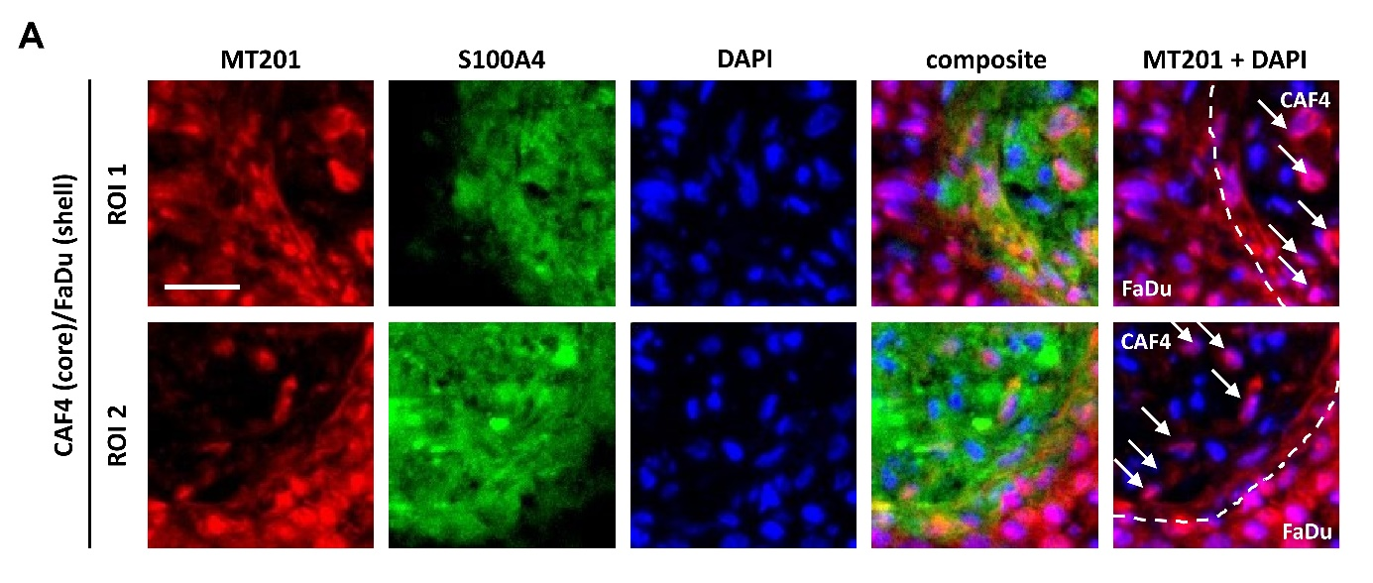
Supplementary Figure 3. Representative images of single HNSCC cells infiltrating into the HNSCC-associated fibroblast area in bicellular core-shell-spheroids of HNSCC and HNSCC-associated fibroblast cells. (A) Two representative regions of interest extracted from a multi-color epifluorescence microscopy image of an immunohistochemically stained cryo-section of a bicellular core-shell-spheroid of HNSCC (FaDu; shell) and HNSCC-associated fibroblasts (CAF-4; core) illustrating single EpCAM-positive HNSCC cells (white arrows) infiltrating into the S100A4-positive HNSCC-associated fibroblast area (scale bar: 30µm; EpCAM/MT201: red; S100A4/fibroblasts: green; DAPI/DNA: blue; white dashed line: FaDu/CAF-4 border).

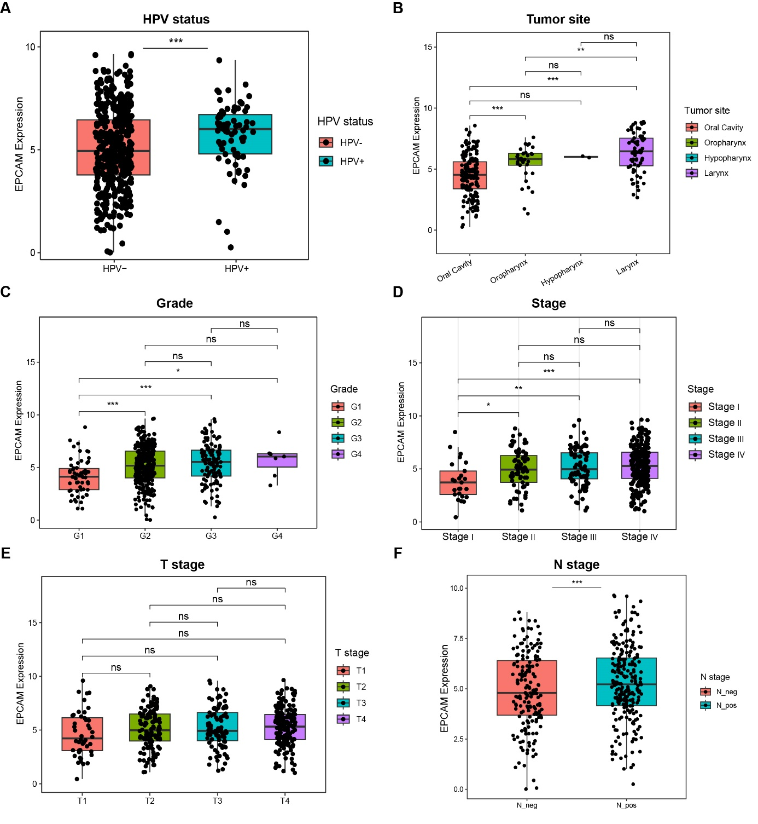
Supplementary Figure 4. Association between EpCAM RNA levels and clinicopathological characteristics of HNSCC. (A) EpCAM RNA levels in HPV-negative (HPV−) and HPV-positive (HPV+) tumors. (B) EpCAM RNA levels according to tumor site (oral cavity, oropharynx, hypopharynx, and larynx). (C) EpCAM RNA levels stratified by histological grade (G1–G4). (D) EpCAM RNA levels according to clinical stage (Stage I–IV). (E) EpCAM RNA levels according to T stage (T1–T4). (F) EpCAM RNA levels according to lymph node status (N− vs. N+). (Statistical differences were analyzed using the Wilcoxon rank-sum test. For multiple comparisons, p values were adjusted using the Benjamini-Hochberg (BH) method. ns, not significant; *p < 0.05; **p < 0.01; ***p < 0.001).

Supplementary Table 1. Tumor meta-data of HNSCC pathology of patients analyzed within this study from the LMU cohort. Table with tumor meta-data for the HNSCC pathology of all patients analyzed in this study (localization; p16-status; grading; TNM classification; parameters for HNSCC invasiveness).

Primary HNSCC
# | localisation | p16-status | grading | TNM | V-status | L-status | Pn-status
1 | oropharynx | p16⁺ | N/A | pT2 pN1 cM0 | V0 | L0 | Pn0
2 | oropharynx | p16⁺ | N/A | pT1 pN0 cM0 | V0 | L0 | Pn0
3 | oropharynx | p16⁻ | G2 | pT2a pN1 cM0 | V0 | L1 | Pn0
4 | oropharynx | p16⁻ | G2 | pT1 pN0 cM0 | V0 | L0 | Pn0
5 | oropharynx | p16⁻ | G2 | pT2 pN0 cM0 | V0 | L0 | Pn0
6 | larynx | N/A | G2 | pT1 pN1 cM0 | V0 | L0 | Pn0
7 | larynx | N/A | G2 | pT2 pN0 cM0 | V0 | L0 | Pn0
8 | oral cavity | N/A | G2 | pT1 pN0 cM0 | V0 | L1 | Pn0
9 | hypopharynx | N/A | G3 | pT4a pN2a cM0 | V0 | L1 | Pn0
Recurrent HNSCC
# | localisation | p16-status | grading | TNM | V-status | L-status | Pn-status
10 | oropharynx | p16⁻ | G3 | rpT2 cN0 cM0 | V0 | L0 | Pn1
11 | oropharynx | p16⁻ | G2 | rpT4a pN0 cM0 | V0 | L1 | Pn1
12 | hypopharynx | N/A | G2 | rpT4a cN0 cM0 | V0 | L0 | Pn0
13 | neopharynx (larynx) | N/A | G3 | rpT1 pN0 cM0 | V0 | L1 | Pn0
14 | oropharynx | p16⁻ | G3 | rpT4a pN1 cM0 | V0 | L1 | Pn0
15 | oropharynx | p16⁻ | G2 | rpT3 cN0 cM0 | V0 | L1 | Pn1
16 | larynx | N/A | G3 | rpT4a cN0 cM0 | V0 | L1 | Pn1
17 | larynx | N/A | G2 | rpT3 cN0 cM0 | V0 | L0 | Pn0
18 | larynx | N/A | G3 | rpT4a pN0 cM0 | V0 | L0 | Pn1

Supplementary Table 2. Tumor meta-data of HNSCC pathology of patients analyzed within this study from the UKE cohort. Table with tumor meta-data for the HNSCC pathology of all patients analyzed in this study (localization; p16-status; grading; TNM classification; parameters for HNSCC invasiveness).

Primary HNSCC
# | localisation | p16-status | grading | TNM | V-status | L-status | Pn-status
1 | larynx | p16⁻ | G2 | pT2 pN1 cM0 | V0 | L1 | Pn0
2 | oropharynx | p16⁻ | G2 | pT2a pN1 cM0 | V0 | L0 | Pn0
3 | oropharynx | p16⁻ | G2 | pT1 pN0 cM0 | V0 | L0 | Pn0
4 | larynx | p16⁻ | G2 | pT2 pN0 cM0 | V0 | L1 | Pn0
5 | larynx | N/A | G2 | pT1 pN1 cM0 | V0 | L0 | Pn0
6 | oropharynx | p16⁺ | G2 | pT2 pN0 cM0 | V0 | L0 | Pn0
7 | hypopharynx | p16⁻ | G2 | pT2a pN1 cM0 | V0 | L1 | Pn0
8 | larynx | p16⁻ | G3 | pT1 pN0 cM0 | V0 | L0 | Pn0
Recurrent HNSCC
# | localisation | p16-status | grading | TNM | V-status | L-status | Pn-status
9 | oropharynx | p16⁻ | G2 | rpT2 cN0 cM0 | V0 | L1 | Pn0
10 | larynx | p16⁻ | G3 | rpT4a pN0 cM0 | V0 | L1 | Pn1
11 | larynx | N/A | G3 | rpT3 cN0 cM0 | V0 | L0 | Pn0
12 | oropharynx | p16⁺ | G3 | rpT4a cN0 cM0 | V0 | L1 | Pn1
13 | larynx | p16⁻ | G2 | rpT3 pN0 cM0 | V0 | L0 | Pn1
14 | oropharynx | p16⁻ | G3 | rpT4a cN0 cM0 | V0 | L1 | Pn0

