Supplementary Table 1 Mutations of driver genes in Panc02 cells.

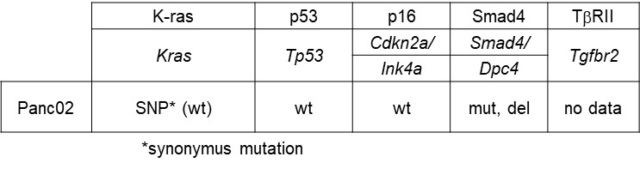

Mutations of representative pancreatic cancer driver genes in Panc02 cells are shown based on previous reports [1].

1. Wang Y, Zhang Y, Yang J, Ni X, Liu S, Li Z, Hodges SE, Fisher WE, Brunicardi FC, Gibbs RA, Gingras M-C, Li M. Genomic sequencing of key genes in mouse pancreatic cancer cells. Curr Mol Med. 2012;12:331–41.

Supplementary Table 2 The gene list upregulated in Panc02 3P cells.

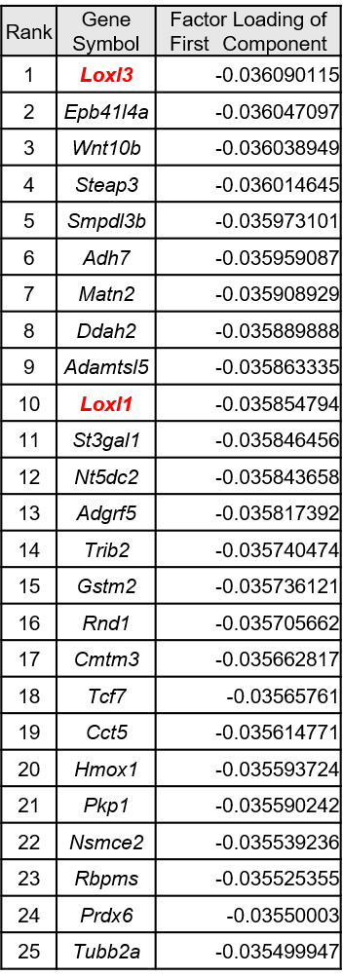
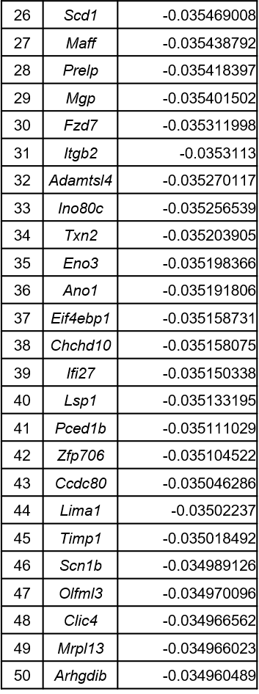
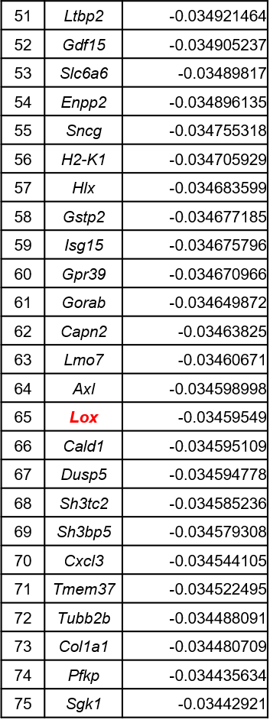

The result of RNA-seq analysis in Fig. 3A. The top 75 genes in the first component are enlisted.

Supplementary Fig. 1 Results of RNA-seq with PCA.
The results of RNA-seq analysis in Fig. 3A were applied to PCA.

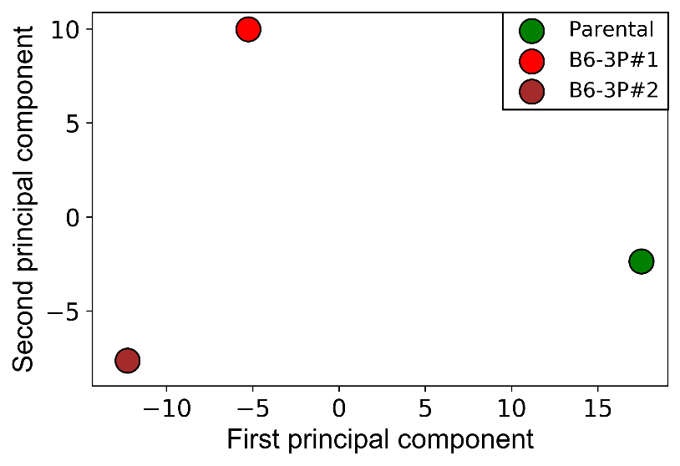

Supplementary Fig. 2 Expression of Lox family genes in Panc02 derivatives.
The mRNA expression of the LOX family genes was examined in the Panc02 derivatives by real-time PCR analysis. The expression was normalized by that of Hprt1. Data are presented as mean ± SD (n = 2).

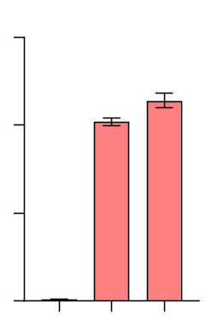
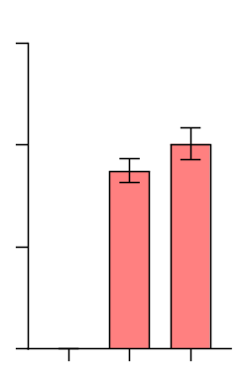
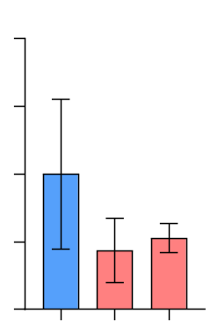
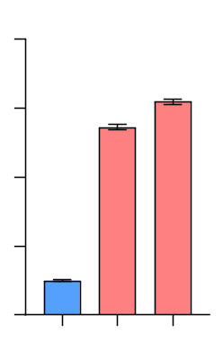
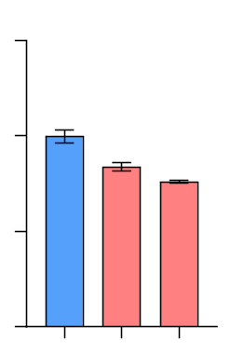
***
***
Parental
3P#1
3P#2
Lox
Relative expression normalized by Hprt1
(parental = 1)
0
100
150
50
Parental
3P#1
3P#2
Loxl1
0
1000
1500
500
Parental
3P#1
3P#2
Loxl2
0
1.5
2
0.5
1
Parental
3P#1
3P#2
Loxl3
Relative expression normalized by Hprt1
(parental = 1)
0
6
8
2
4
Parental
3P#1
3P#2
Loxl4
0
1
1.5
0.5
***
**

***

Supplementary Fig. 3 Correlation between LOX3 expression and the disease-free survival of
pancreatic adenocarcinoma patients.
The TCGA database was analyzed and divided into high and low groups of LOX3 gene (log-rank
test, n = 138). Kaplan-Meier plot is indicated.
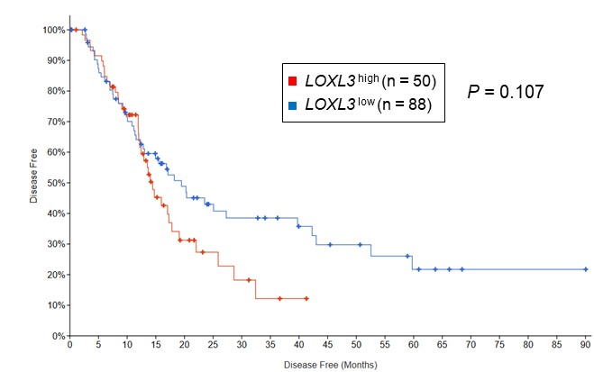

Supplementary Fig. 4. Uncropped full-length immunoblot images corresponding to Fig. 4B.
Experiment #1 corresponds to the blot presented in Fig. 4B, whereas Experiment #2 represents an independent replicate experiment. Original chemiluminescence images, membrane images, and merged views are shown for E-cadherin (135 kDa) and α-tubulin (52 kDa), together with molecular weight markers and sample labels.
