Supplemental figures

Supplemental figure 1
Supplemental figure 1: Increased HIF-2α protein in HIF1A ko HCT116 cells. Western Blot analysis of HIF-2 protein expression after four and 24 hours under normoxia (21% O2), moderate (1% O2) and severe (0.1% O2) hypoxia.

Supplemental figure 2
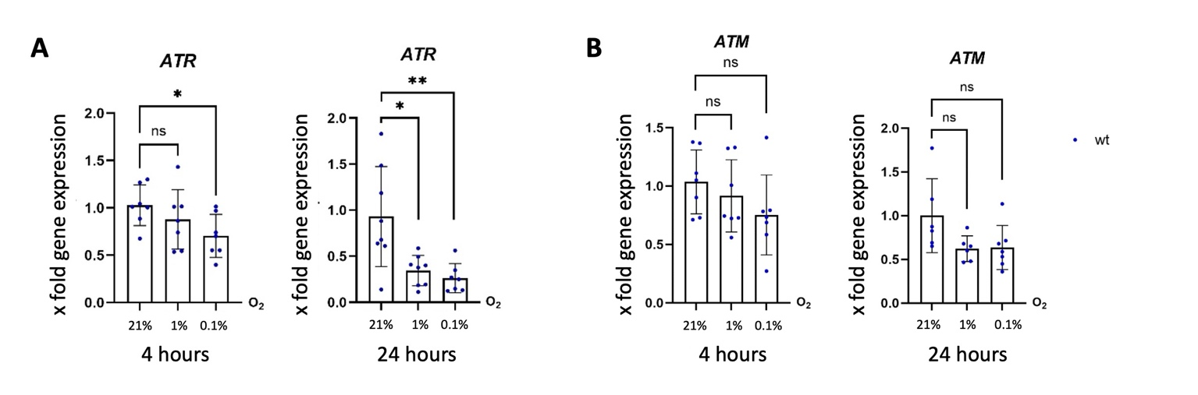
Supplemental figure 2: Hypoxia-dependent downregulation of ATR expression but not altered ATM expression in HCT116 wild-type cells. Expression of ATR (A) and ATM (B) mRNA (A) in HCT116 wild-type cells after 4 and 24 hours under normoxia (21% O₂), moderate hypoxia (1% O₂), and severe hypoxia (0.1% O₂). Quantitative PCR analysis revealed a significant downregulation of ATR mRNA expression after 4 hours of severe and 24 hours of hypoxic incubation (n = 11), whereas ATM mRNA levels remained unchanged under all conditions.

Supplemental figure 3
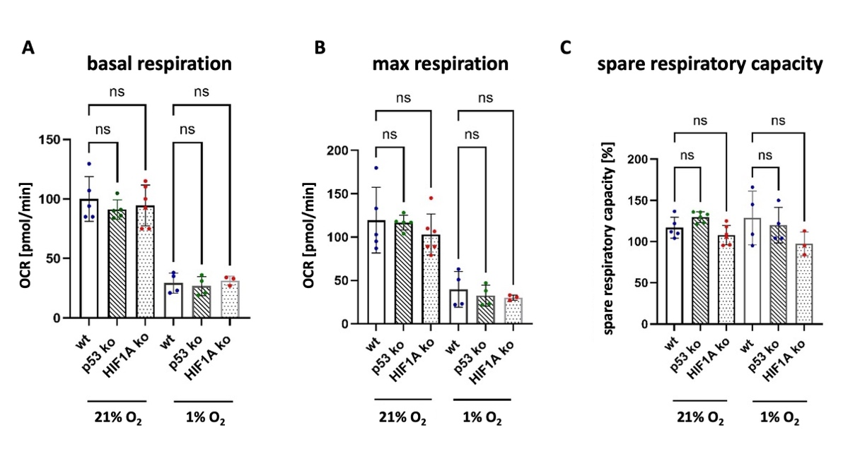
Supplemental figure 3: Loss of p53 or HIF1A does not affect mitochondrial respiration in HCT116 cells under normoxia or hypoxia. We compared mitochondrial stress test results for HCT116 wild-type (WT), p53 knockout (KO), and HIF1A knockout (KO) cells under normoxia (21% O₂) and moderate hypoxia (1% O₂). Neither the p53 knockout nor the HIF1A knockout alters the basal (A) or maximal (B) respiratory rate under normoxia or hypoxia. Therefore, the respiratory capacity (C) of the knockout cell lines does not differ from that of the wild-type cell line. WT and p53 KO: n = 5 under normoxia and n = 4 under hypoxia. HIF1A KO: n = 6 under normoxia and n = 3 under hypoxia.

Supplemental figure 4

Supplemental figure 4: HIF1A ko validation. (A) qPCR of showed a strong downregulation of HIF1A gene expression after CRIPR-Cas9 knockout. (B) Western blot analysis revealed a clear knockout of HIF-1α under the applied conditions. Example picture of a Western blot. (C) Target genes of HIF-1α were highly downregulated after knockout procedure under all applied conditions

Supplemental Western blot single pictures

Western Blots for Figure 1 B
V1 wt 4 hours
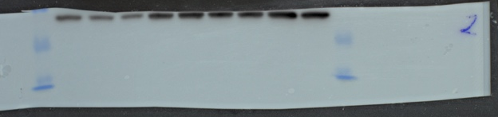
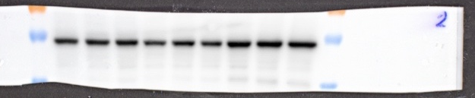
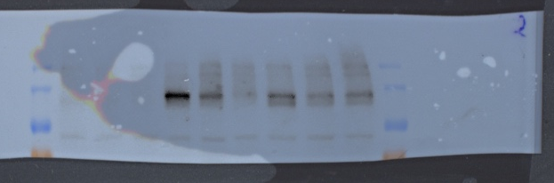
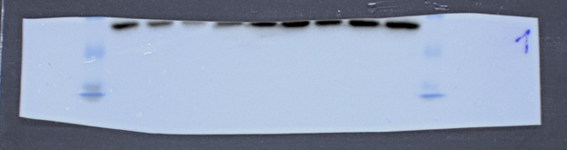
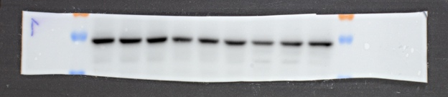
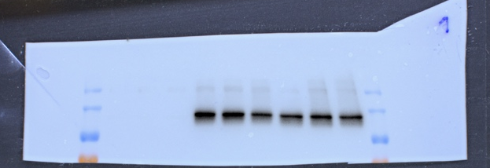
V1 wt 24 hours
HIF1A
P53
RPLP01
RPLP01
P53
HIF1A

V2 wt 4 hours
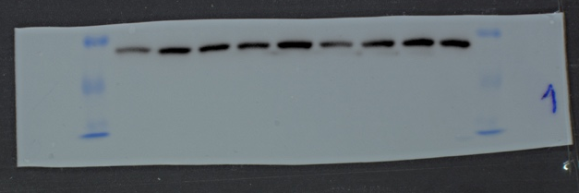
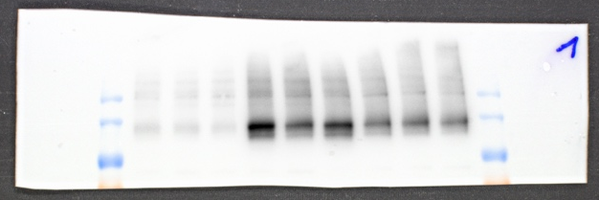
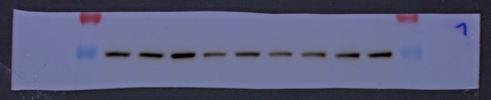
HIF1A
RPLP01
P53

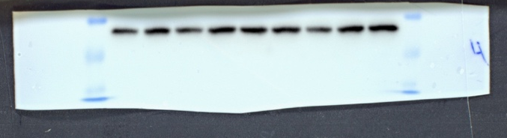
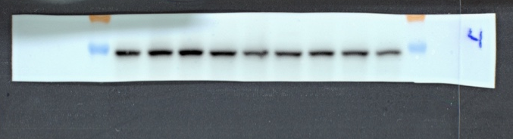
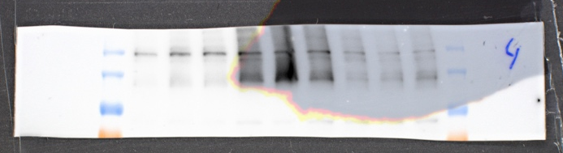
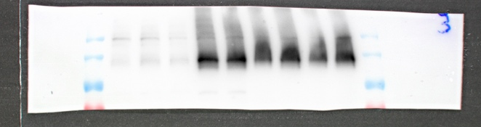
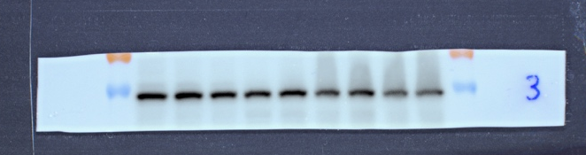
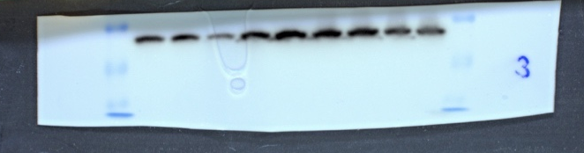
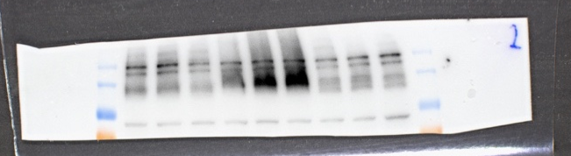
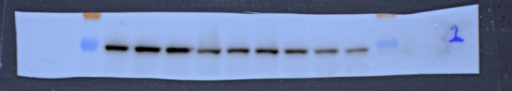
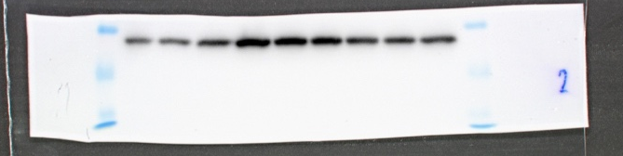
RPLP01
P53
HIF1A
RPLP01
P53
HIF1A
RPLP01
P53
HIF1A
HIF1A
P53
RPLP01

V2 wt 24 hours

V3 wt 4 hours

V3 wt 24 hours

V 4 wt 4 hours

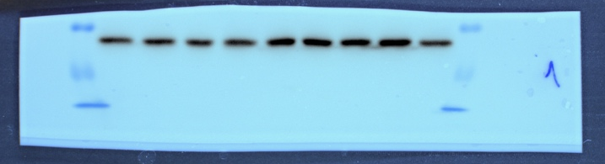
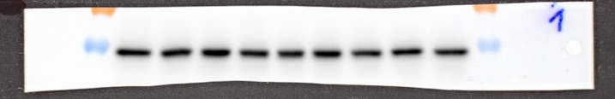
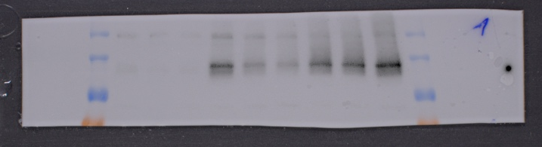
HIF1A

P53

RPLP01

V4 wt 24 hours

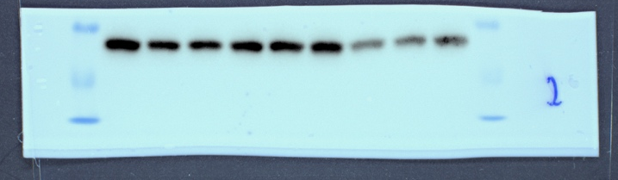
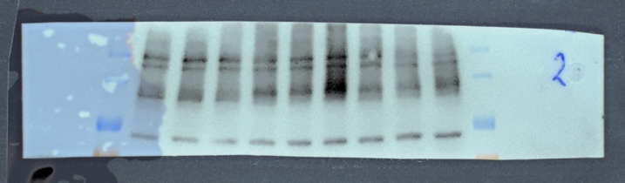
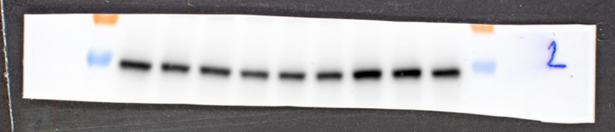
HIF1A

P53

RPLP01

Western Blots for Figure 1 B/C
V1 wt 4 hours – phospho p53

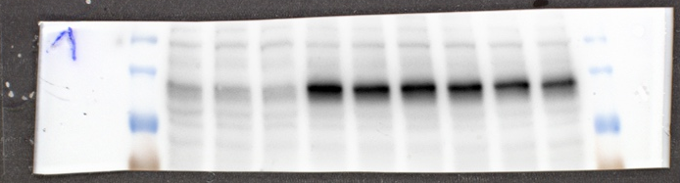
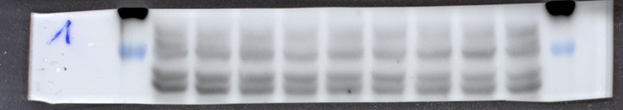
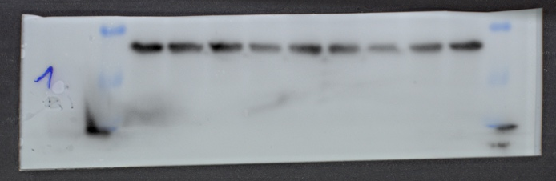
Phospho P53
RPLP01
HIF1A

V1 wt 24 hours - phospho p53

HIF1A
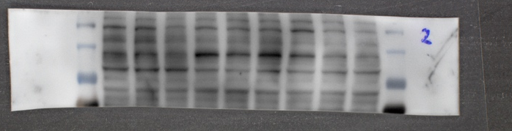

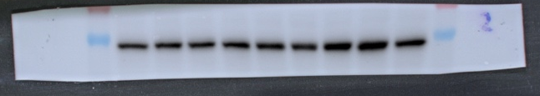
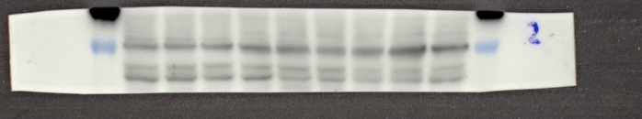
Phospho P53
P53

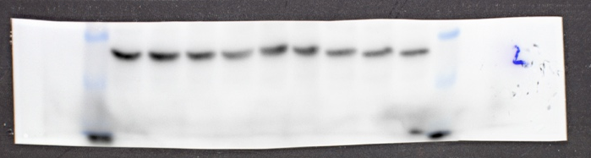
RPLP01

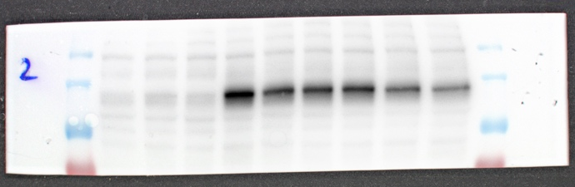
V2 wt 4 hours – phospho p53

HIF1A

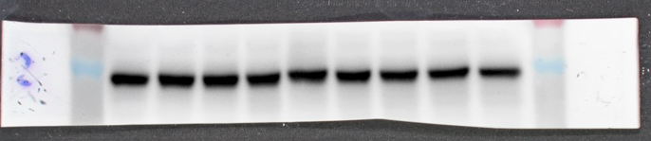
Phospho P53
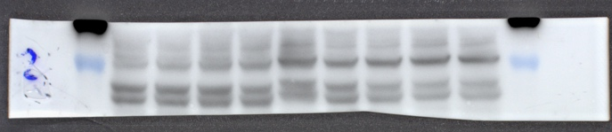
P53

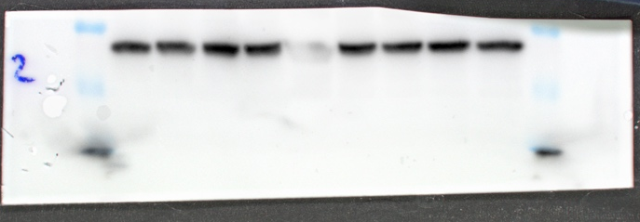
RPLP01

V2 wt 24 hours – phospho p53

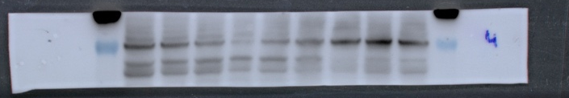
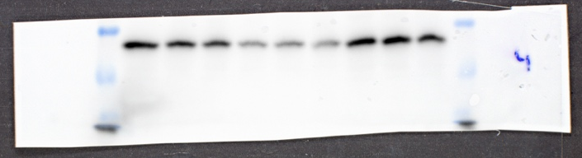
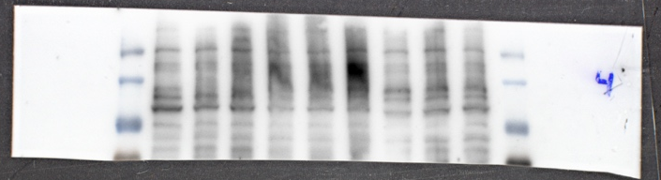
HIF1A

Phospho P53
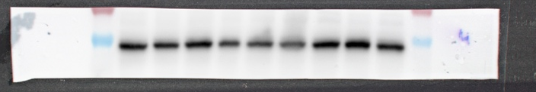
P53

RPLP01

V3 wt 4 hours – phospho p53

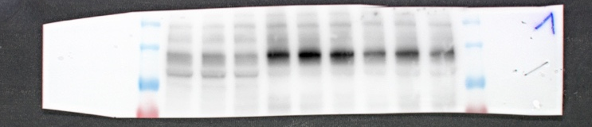
HIF1A

Phospho P53
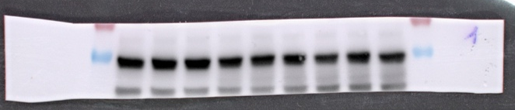
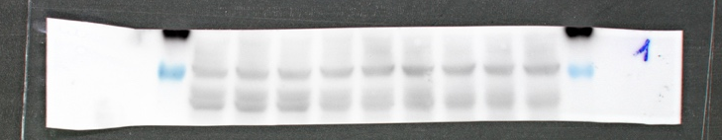
P53

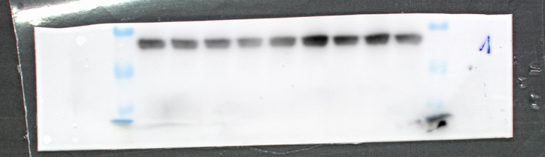
RPLP01

V3 wt 24 hours – phospho p53
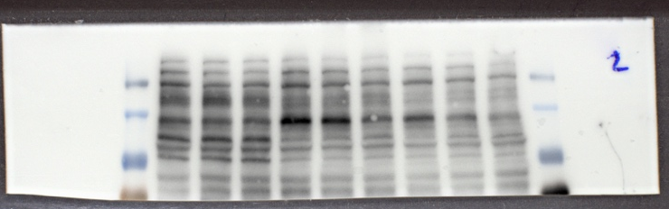

HIF1A

Phospho P53
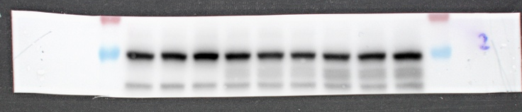
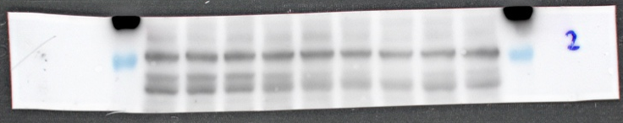
P53

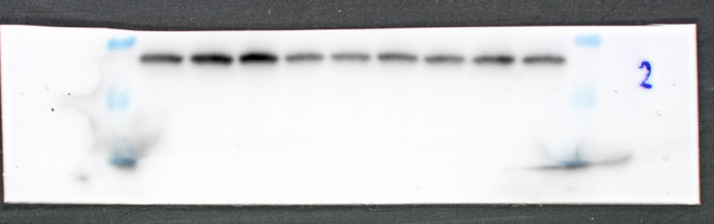
RPLP01

V4 wt 4 hours – phospho p53

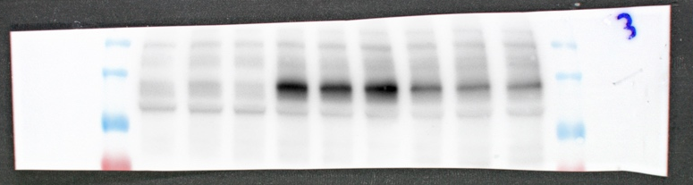
HIF1A

Phospho P53
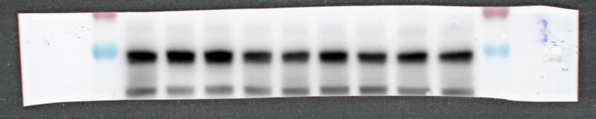
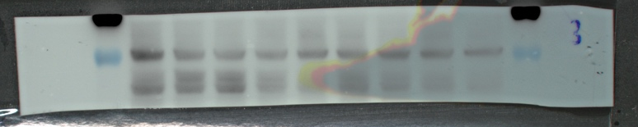
P53

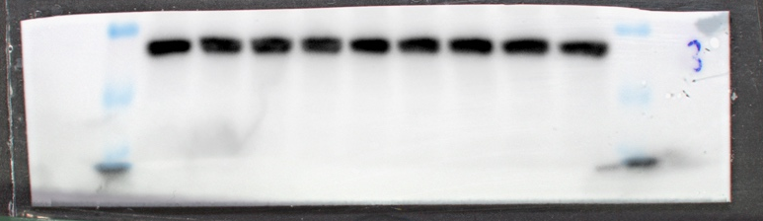
RPLP01

V4 wt 24 hours – phospho p53

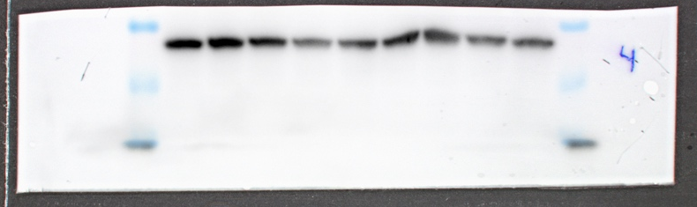
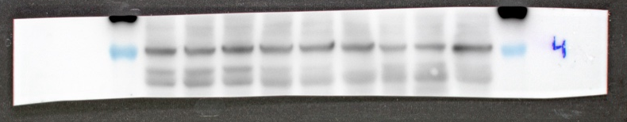
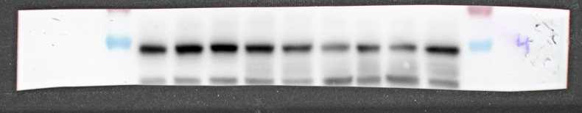
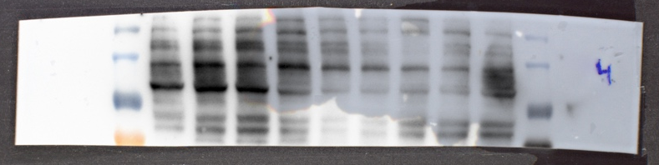
RPLP01
Phospho P53
P53
HIF1A

V5 wt 4 hours – phospho p53

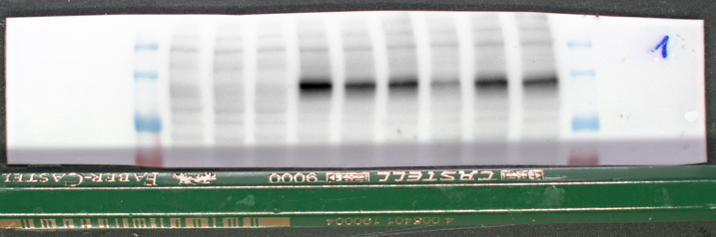
HIF1A

Phospho P53
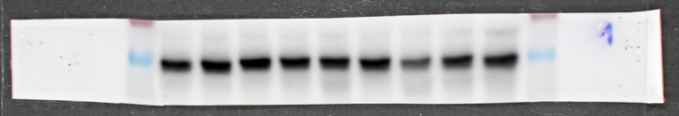
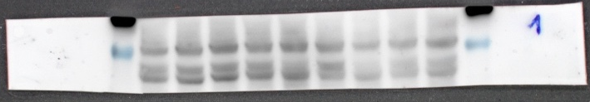
P53

RPLP01
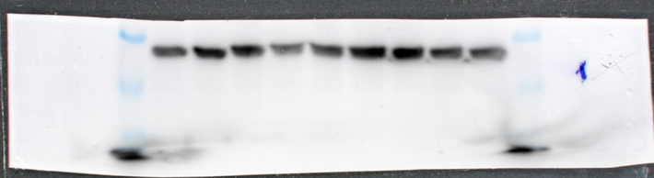

V5 wt 24 hours – phopsho p53

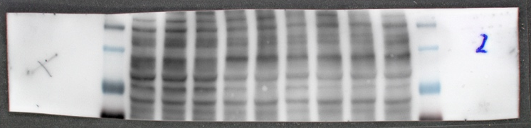
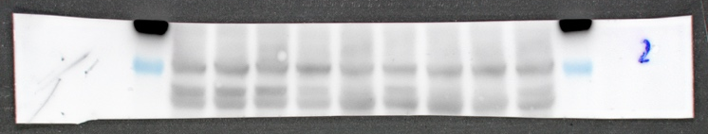
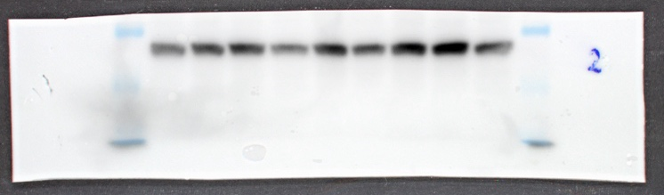
HIF1A

Phospho P53
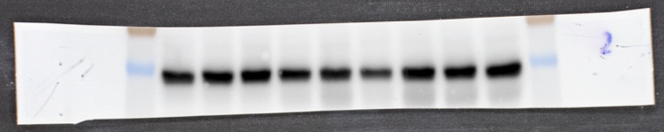
P53

RPLP01

V6 wt 4 hours – phospho p53

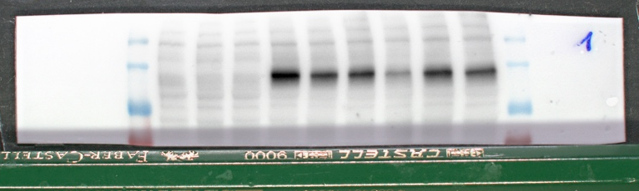
HIF1A

Phospho P53
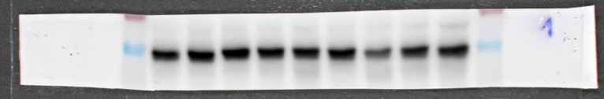
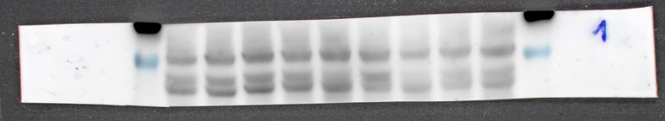
P53

RPLP01
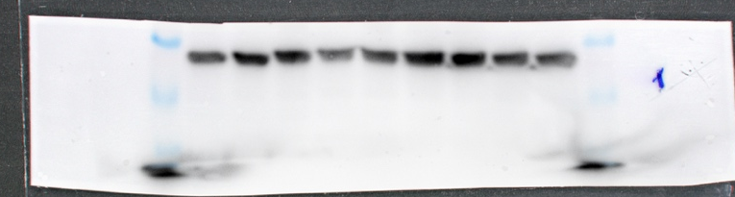

V6 wt 24 hours – phospho p53

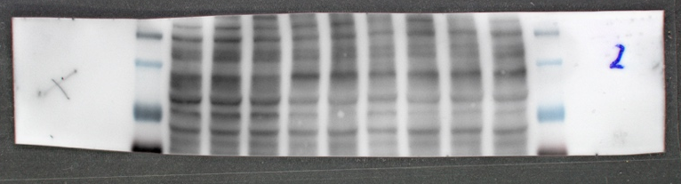
HIF1A

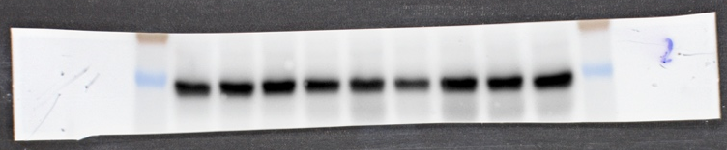
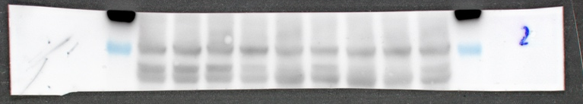
Phospho P53
P53

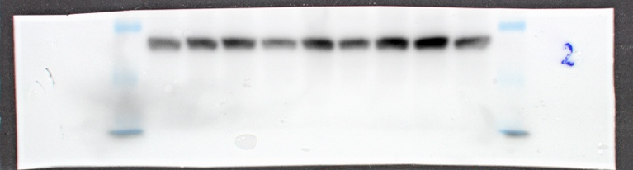
RPLP01

V7 wt 24 hours – phosphp P53 (Example Blot in Fig. 1C)

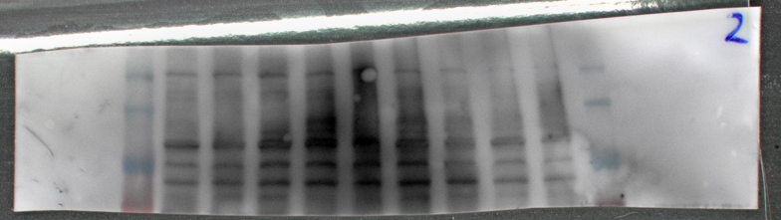

HIF1A

Phospho P53
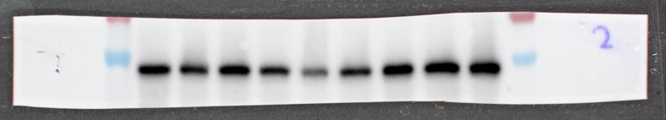
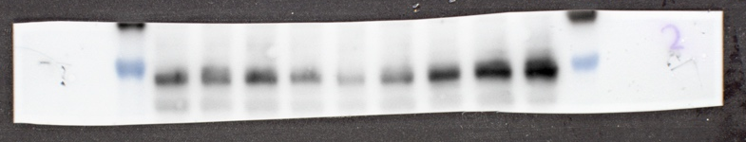
P53

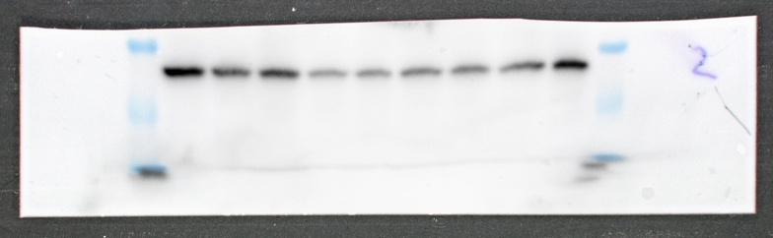
RPLP01

Western Blots for Figure 3 B/F
V1 p53 ko 4 hours

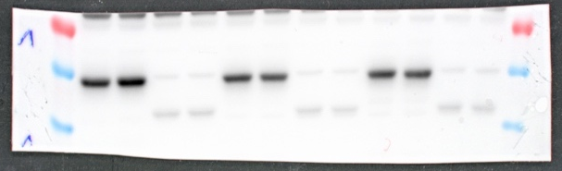
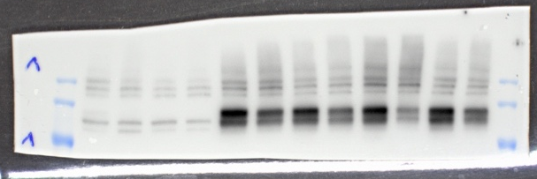
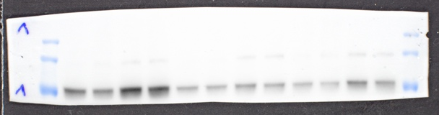
P53
ARNT

HIF1A

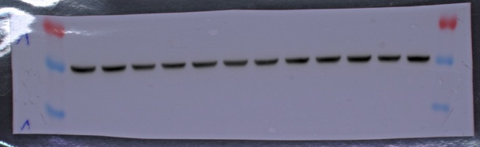
α-Tubulin

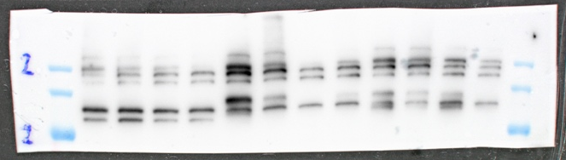
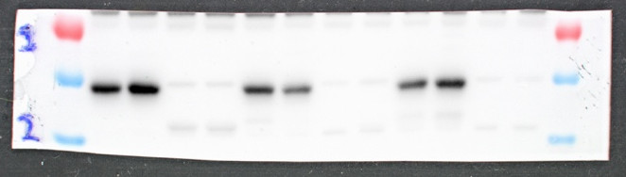
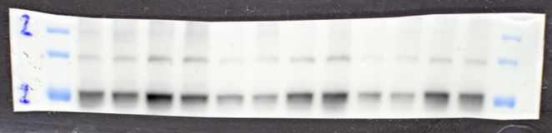
V1 p53 ko 24 hours

HIF1A

ARNT

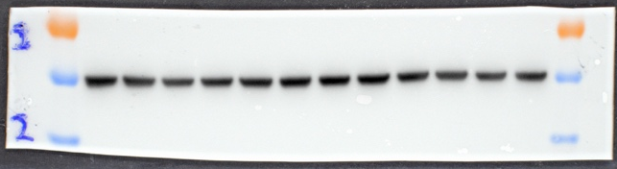
α-Tubulin
P53

V2 p53 ko 4 hours (Example Blot in Fig. 3B)

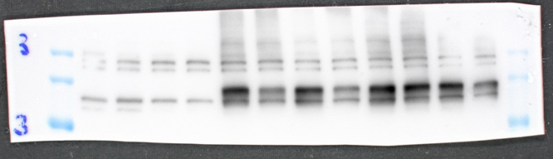
HIF1A

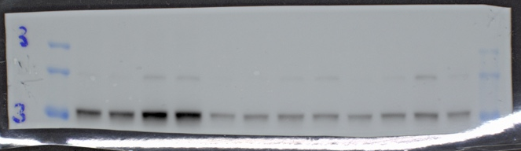
ARNT

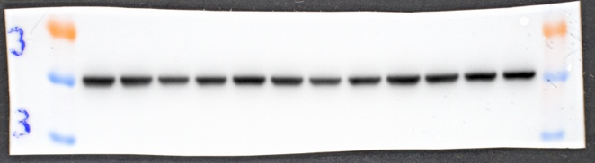
α-Tubulin
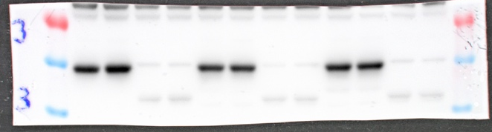
P53

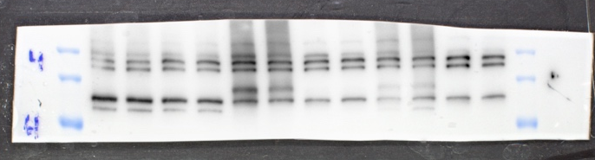
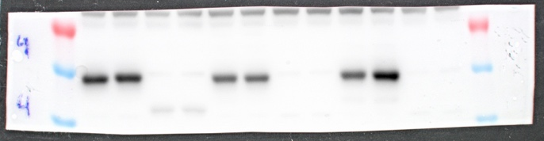
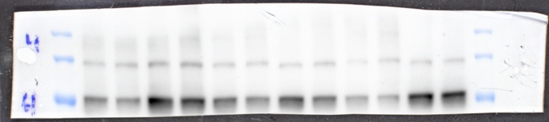
V2 p53 ko 24 hours
ARNT
P53
HIF1A

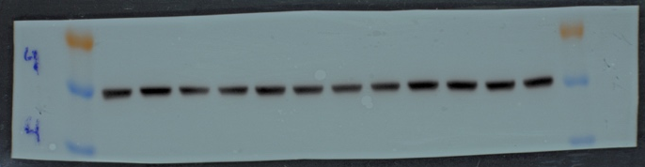
α-Tubulin

V3 p53 ko 4 hours

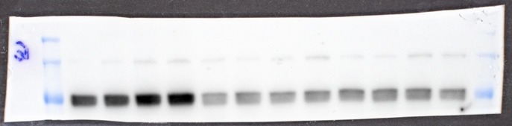
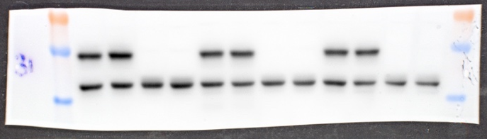
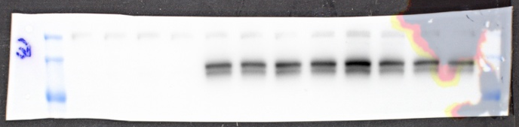
β-Actin
P53
ARNT
HIF1A

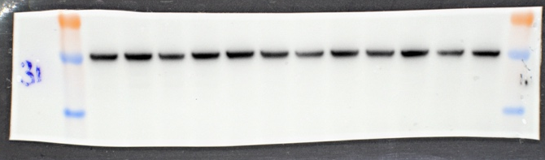
α-Tubulin

V3 p53 ko 24 hours (Example Blot in Fig. 3B)

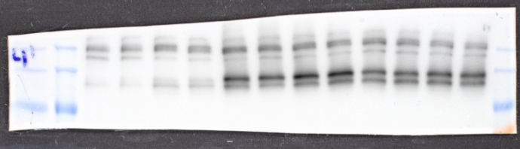
HIF1A

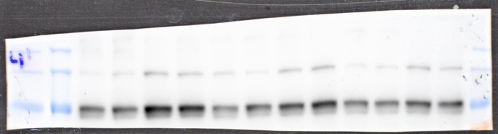
ARNT

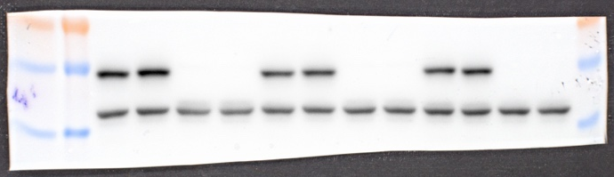
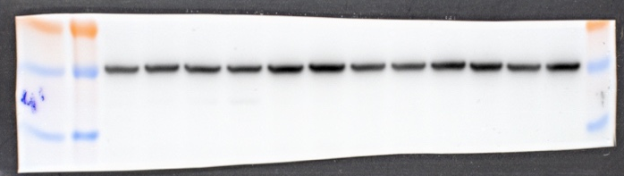
α-Tubulin
P53
β-Actin

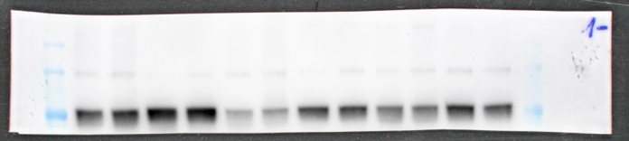
P53
ARNT
V4 p53 ko 4 hours
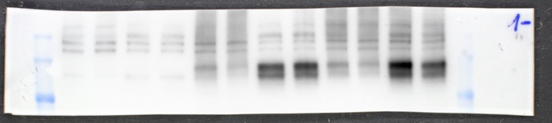
HIF1A

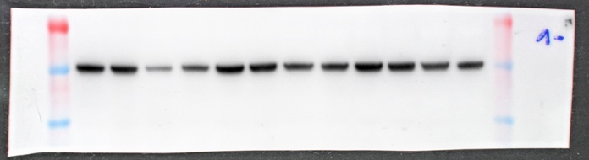
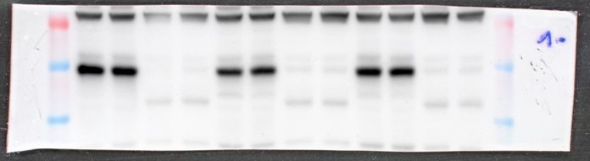
α-Tubulin

V4 p53 ko 24 hours

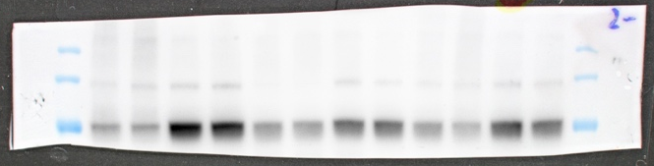
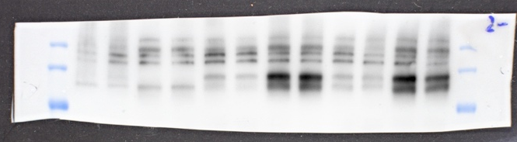
P53
HIF1A
ARNT

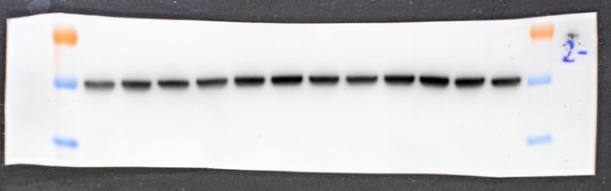
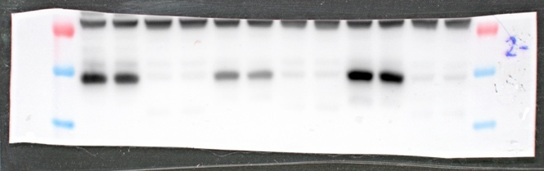
α-Tubulin

V5 p53 ko 4 hours
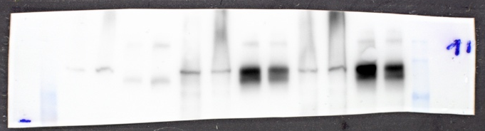
HIF1A

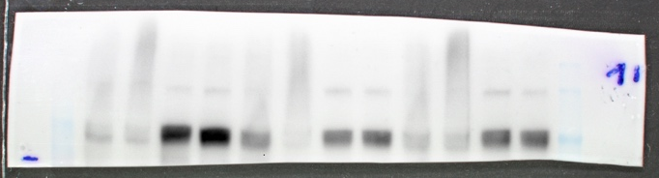
ARNT

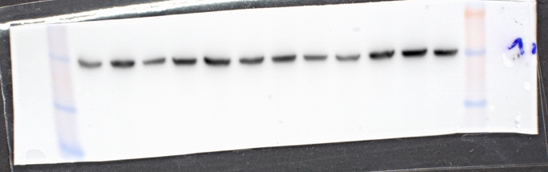
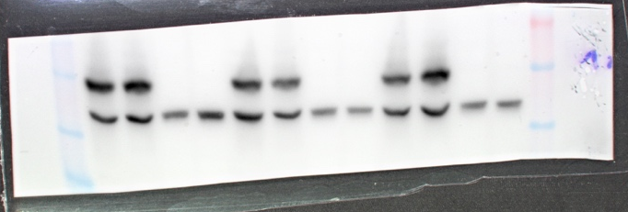
α-Tubulin
P53

V5 p53 ko 24 hours

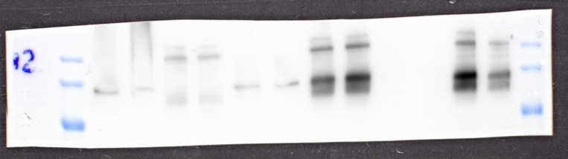

HIF1A

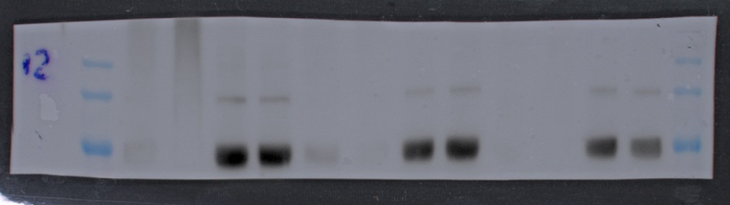

ARNT

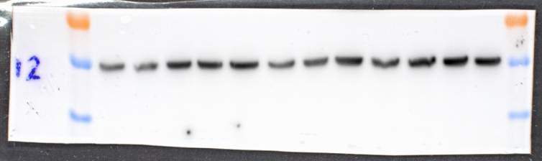
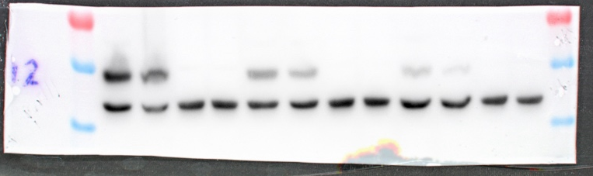
P53
α-Tubulin
β-Actin

Western Blots for Figure 8 B
V1 HIF1A ko 4 hours

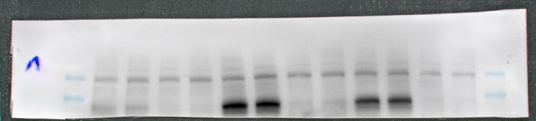
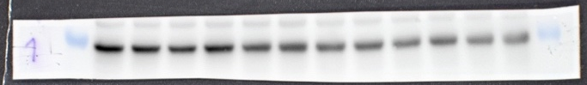

HIF1A

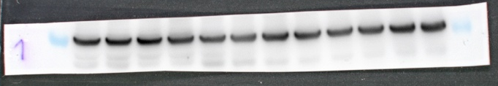
α-Tubulin
P53

V1 HIF1A ko 24 hours

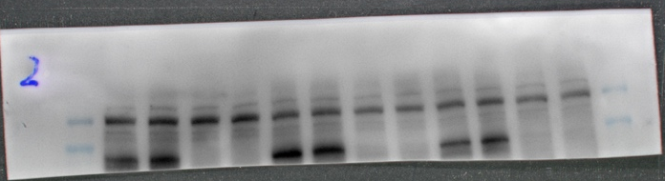

HIF1A

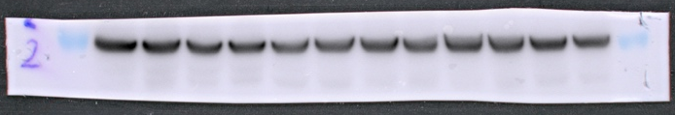
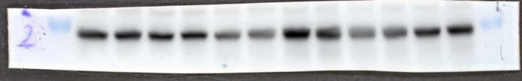
α-Tubulin
P53

V2 HIF1A ko 4 hours

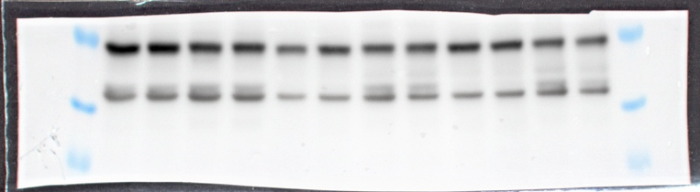
P53

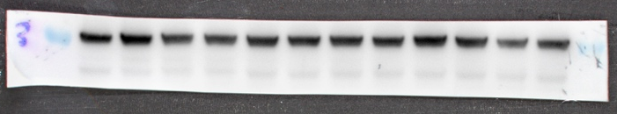
β-Actin
residue after stripping
α-Tubulin

V2 HIF1A ko 24 hours
α-Tubulin
P53
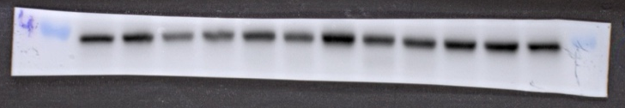
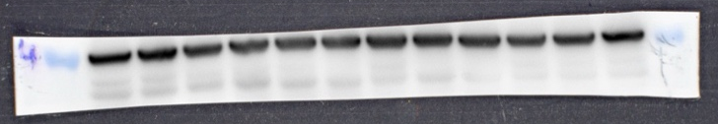

P53

V3 HIF1A ko 4 hours

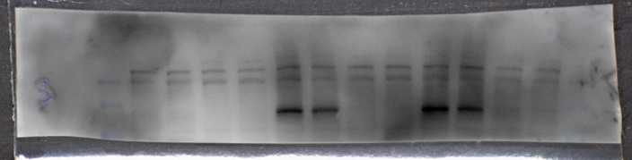
HIF1A

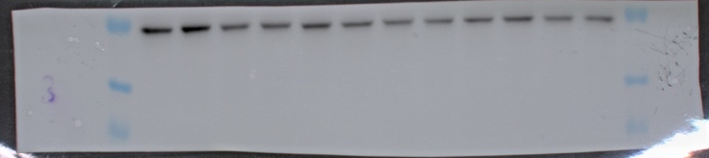
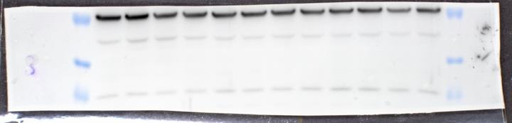
α-Tubulin

V3 HIF1A ko 24 hours

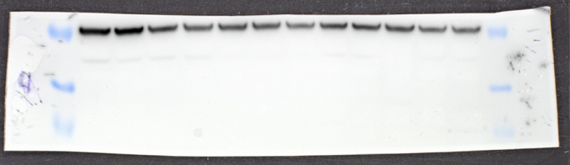
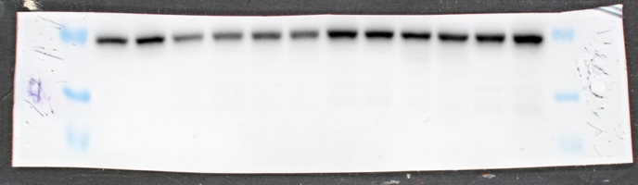
α-Tubulin
P53

V4 HIF1A ko 4 hours
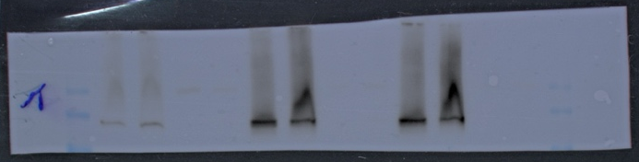

HIF1A

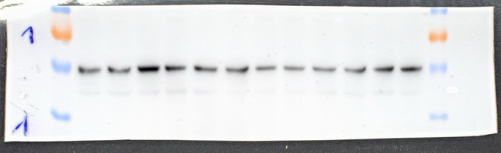
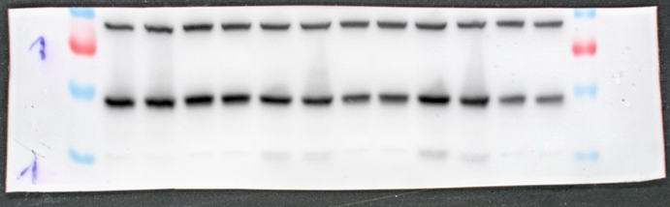
α-Tubulin
P53

V4 HIF1A ko 24 hours

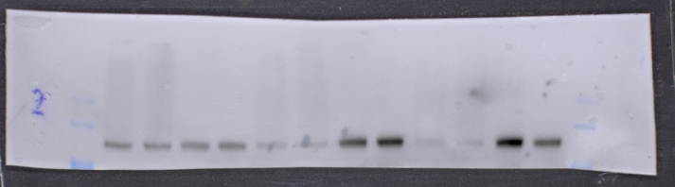

HIF2A

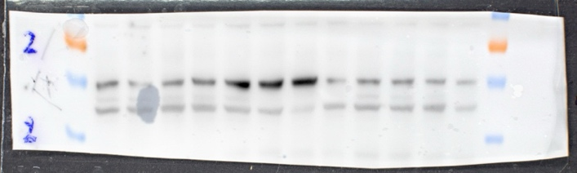
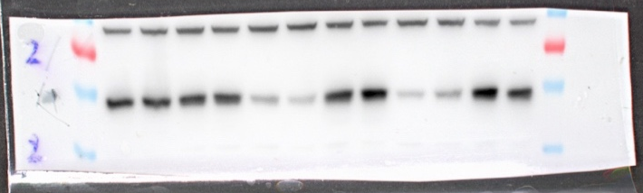
α-Tubulin

P53

V5 HIF1A ko 4 hours

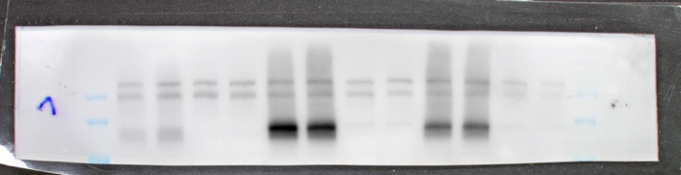
HIF1A

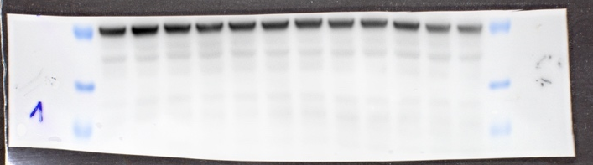
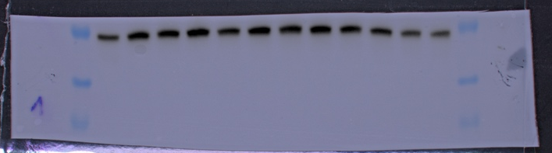
P53
α-Tubulin

V5 HIF1A ko 24 hours
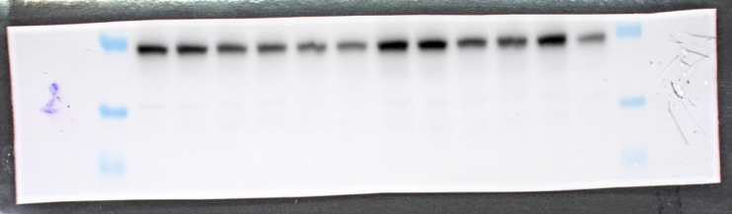
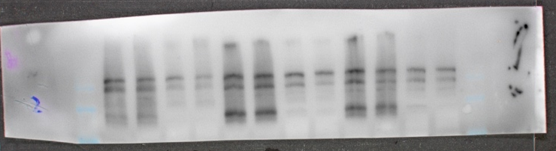
P53

HIF1A

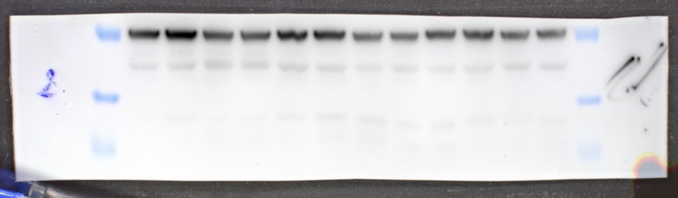
α-Tubulin

V6 HIF1A ko 4 hours

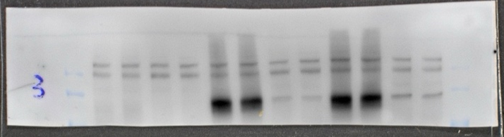
HIF1A

P53
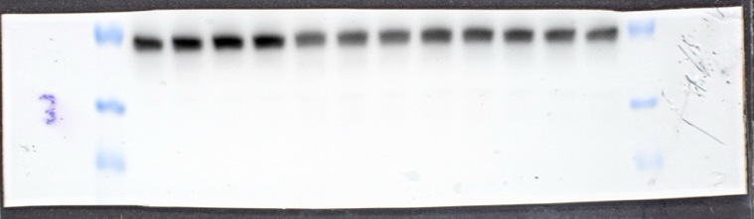
α-Tubulin

V7 HIF1A ko 4 hours

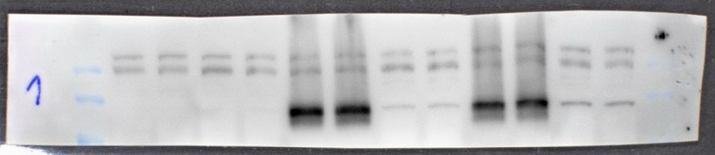
HIF1A
P53

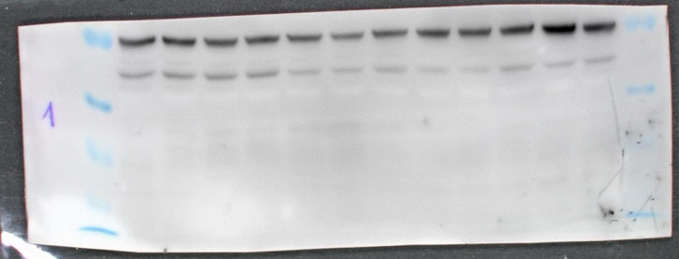
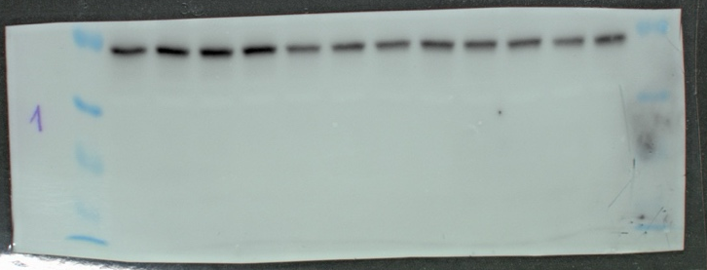
α-Tubulin

