Supplementary Tables
Supplementary Table 1 Initial metastatic site of ES-SCEC patients
Metastatic Site | Number | %
Liver metastasis | 66 | 58.9
Bone metastasis | 35 | 31.3
Lung metastasis | 26 | 23.2
Adrenal metastasis | 5 | 4.5
Pancreatic metastasis | 4 | 3.6
Brain metastasis | 3 | 2.7
Pleural metastasis | 3 | 2.7
Peritoneal metastasis | 3 | 2.7
Distant lymph node metastasis
Retroperitoneal lymph node | 28 | 25.0
Cervical lymph node | 18 | 16.1
Paravascular iliac Lymph node | 2 | 1.8
Axillary lymph node | 2 | 1.8
Inguinal lymph node | 1 | 0.9
Abbreviations: ES-SCEC, extensive-stage small cell esophageal carcinoma.

Supplementary Table 2 Univariate analysis of the prognostic factors for PFS in ES-SCEC patients
Variables | N (%) | Median PFS (m，95%CI) | Chi-square | p value | HR (95%CI) | p value
Length of disease
≤ 7 cm | 87 (73.2) | 5.1 (4.6-5.6) | 7.2 | 0.007* | 0.55 (0.35-0.87) | 0.011*
> 7 cm | 25 (26.8) | 3.3 (2.8-3.8) |  |  | 1.00
CT cycle
< 4 | 39 (34.8) | 3.0 (2.6-3.4) | 26.3 | <0.001* | 2.71 (1.80-4.07) | <0.001*
≥ 4 | 73 (65.2) | 6.0 (5.2-6.8) |  |  | 1.00
ICIs
Yes | 33 (29.5) | 5.3 (4.4-6.2) | 2.6 | 0.110 | 1.00
No | 79 (70.5) | 4.7 (4.0-5.6) |  |  | 1.39 (0.91-2.13) | 0.125
TRT
Yes | 38 (33.9) | 7.0 (5.9-8.1) | 22.1 | <0.001* | 0.39 (0.25-0.59) | <0.001*
No | 74 (66.1) | 4.0 (3.4-4.6) |  |  | 1.00
T stage (8th) |  |  | 13.4 | 0.004* |  | 0.007*
T2 | 12 (10.7) | 5.0 (3.3-6.7) |  |  | 0.61 (0.31-1.20) | 0.151
T3 | 45 (40.2) | 6.0 (4.6-7.5) |  |  | 0.43 (0.27-0.69) | 0.001*
T4a | 20 (17.9) | 5.0 (4.0-6.0) |  |  | 0.60 (0.25-1.05) | 0.073
T4b | 35 (31.3) | 3.3 (2.3-4.3) |  |  | 1.00
Abbreviations: ES-SCEC, extensive-stage small cell esophageal carcinoma; PFS, progression-free survival; HR, hazard ratio; CI, confidence interval; CT, chemotherapy; TRT, thoracic radiotherapy; ICIs, immune checkpoint inhibitors.

Supplementary Table 3 Univariate analysis of the prognostic factors for OS in ES-SCEC patients
Variables | N (%) | Median OS (m，95%CI) | Chi-square | p value | HR (95%CI) | p value
Length of disease
≤ 7 cm | 87 (73.2) | 10.4 (9.0-11.8) | 10.3 | 0.001* | 0.48 (0.30-0.76) | 0.002*
> 7 cm | 25 (26.8) | 6.4 (4.7-8.2) |  |  | 1.00
POU2F3
Positive | 7 (8.0) | 6.0 (4.2-7.8) | 6.3 | 0.012* | 1.00
Negative | 80 (92.0) | 10.1 (8.6-11.6) |  |  | 0.35 (0.15-0.83) | 0.018*
CT cycle
< 4 | 39 (34.8) | 6.5 (5.7-7.3) | 13.3 | <0.001* | 2.11 (1.39-3.20) | <0.001*
≥ 4 | 73 (65.2) | 10.8 (8.8-12.8) |  |  | 1.00
ICIs
Yes | 33 (29.5) | 13.8 (5.6-16.4) | 4.6 | 0.027* | 0.60 (0.40-0.90) | 0.029*
No | 79 (70.5) | 8.6 (7.5-9.9) |  |  | 1.00
T stage (8th) |  |  | 22.7 | <0.001* |  | <0.001*
T2 | 12 (10.7) | 11.5 (6.3-16.7) |  |  | 0.36 (0.17-0.76) | 0.008*
T3 | 45 (40.2) | 11.1 (9.0-13.0) |  |  | 0.36 (0.22-0.59) | <0.001*
T4a | 20 (17.9) | 10.9 (7.9-13.9) |  |  | 0.39 (0.21-0.72) | 0.003*
T4b | 35 (31.3) | 6.5 (5.0-7.9) |  |  | 1.00
Abbreviations: ES-SCEC, extensive-stage small cell esophageal carcinoma; OS, overall survival; HR, hazard ratio; CI, confidence interval; CT, chemotherapy; ICIs, immune checkpoint inhibitors.

Supplementary Table 4 OS (A) and PFS (B) for different treatment groups in patients with ES-SCEC (n = 112).
Groups | N | Median OS (m，95%CI) | Median PFS (m，95%CI)
TRT | 2 | 3.0 (-) | 1.8 (-)
CT | 43 | 7.6 (6.1-9.1) | 4.0 (3.1-4.9)
CT + ICIs | 26 | 11.0 (8.7-13.3) | 5.0 (4.3-5.7)
CT + TRT | 29 | 10.9 (9.1-12.7) | 7.0 (6.5-7.5)
CT + S | 5 | 7.2 (5.1-9.3) | 2.0 (0.9-3.1)
CT + ICIs + TRT | 7 | 16.9 (14.0-19.8) | 10.1 (6.8-13.4)
Abbreviations: ES-SCEC, extensive-stage small cell esophageal carcinoma; OS, overall survival; PFS, progression-free survival; ICIs, immune checkpoint inhibitors; S, surgery; CT, chemotherapy; TRT, thoracic radiotherapy.

Supplementary Table 5 Distribution of TRT, tumor length, CT cycle and T stage in CT and CT + ICIs groups (n = 105)
Factors | CT | CT + ICIs | p Value
TRT |  |  | 0.076
Yes | 29 | 7
No | 43 | 26
Tumor length |  |  | 0.165
≤ 7cm | 53 | 29
> 7cm | 19 | 4
CT cycle |  |  | 0.535
< 4 | 24 | 9
≥ 4 | 48 | 24
T stage |  |  | 0.347
T2-4a | 48 | 25
Tb | 24 | 8
Abbreviations: CT, chemotherapy; TRT, thoracic radiotherapy; ICIs, immune checkpoint inhibitors.
Supplementary Table 6 Distribution of TRT, tumor length, CT cycle and T stage in CT and CT + ICIs groups (n = 74)
Factors | CT | CT + ICIs | p Value
TRT |  |  | 0.939
Yes | 9 | 7
No | 32 | 26
Tumor length |  |  | 0.056
≤ 7cm | 27 | 29
> 7cm | 14 | 4
CT cycle |  |  | 0.204
< 4 | 17 | 9
≥ 4 | 24 | 24
T stage |  |  | 0.119
T2-4a | 24 | 25
Tb | 17 | 8
Abbreviations: CT, chemotherapy; TRT, thoracic radiotherapy; ICIs, immune checkpoint inhibitors.

Supplementary Table 7 Distribution of ICIs, tumor length, CT cycle and T stage in CT and CT + TRT groups (n = 105)
Factors | CT | CT + TRT | p Value
ICIs |  |  | 0.056
Yes | 26 | 7
No | 43 | 29
Tumor length |  |  | 0.955
≤ 7cm | 54 | 28
> 7cm | 15 | 8
CT cycle |  |  | 0.761
< 4 | 21 | 12
≥ 4 | 48 | 24
T stage |  |  | 0.365
T2-4a | 50 | 23
T4b | 19 | 13
Abbreviations: CT, chemotherapy; TRT, thoracic radiotherapy; ICIs, immune checkpoint inhibitors.

Supplementary Figures

Supplementary Figure 1 H&E and immunohistochemical staining of a POU2F3-positive SCEC case.
(A) H&E ×200; (B) CgA negative; (C) Syn negative; (D) CD56 positive; (E) p40 negative; (F) Ki-67 95%; (G) Partially positive for INSM1; (H) POU2F3 positive; (I) Diffuse positive for p53; (J) Rb1 negative (Envision ×200)

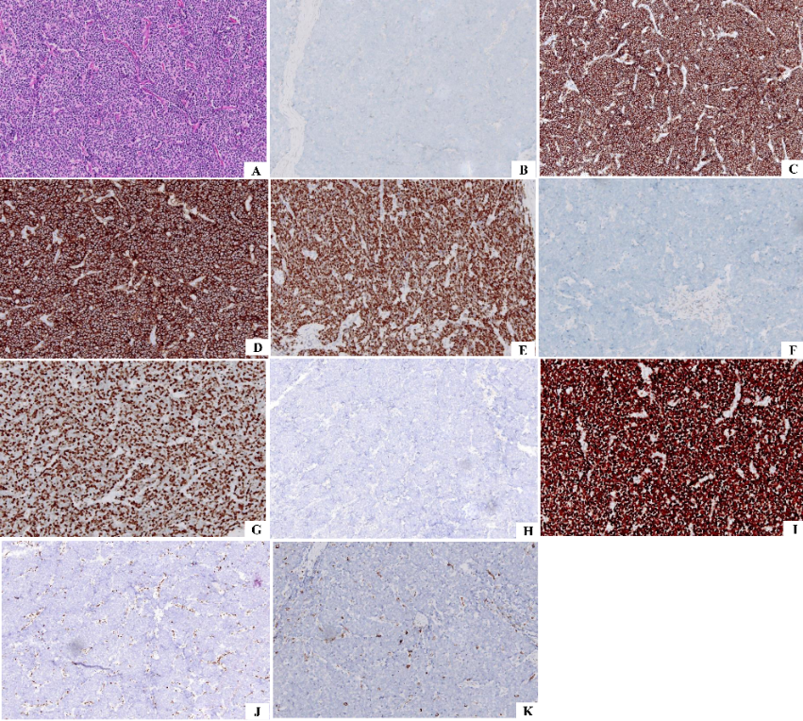

Supplementary Figure 2 H&E and immunohistochemical staining of a POU2F3-negative SCEC case.
(A) H&E ×200; (B) CgA negative; (C) Syn positive; (D) CD56 positive; (E) INSM1 positive; (F) p40 negative; (G) Ki-67 80%; (H) POU2F3 negative; (I) Diffuse positive for p53; (J) Rb1 negative; (K) PD-L1 22C3 CPS <10 (Envision ×200)

Supplementary Figure 3 OS (A) and PFS (B) curves for different treatment groups in patients with ED-SCEC (n = 112).
OS, overall survival; PFS, progression-free survival; ICIs, immune checkpoint inhibitors; S, surgery; CT, chemotherapy; TRT, thoracic radiotherapy. Among the six groups, p < 0.001.

Supplementary Figure 4 OS curves in ICIs vs. non-ICIs in patients with ES-SCEC (n = 74).
Abbreviations: OS, overall survival; ICIs, immune checkpoint inhibitors; ES-SCEC, extensive-stage small cell esophageal carcinoma.

