Intervention | Outcome | Participant | RCT
Melatonin OR “Melatonin supplementation” OR "n acetyl 5 methoxytryptamine" OR melaton OR ramelteon OR rozerem OR "tak 375” OR tasimelteon OR agomelatine OR valdoxan OR "s 20098" OR melaxen OR “melatonin agonist” OR Melatoniin OR circadin OR “HT 903” OR melapure OR armonia OR melamil OR benedorm OR “BP 2013” OR BP2013 OR JL5DK93RCL OR sleepwell OR “melatonin receptor agonist” | Fatigue OR lassitude OR tiredness OR weariness OR exhaustion OR listlessness OR lethargy OR sluggishness OR sleepiness OR drowsiness OR somnolence OR tired OR wear OR exhaust OR Fatigability OR "Cancer Fatigue" OR "Muscle Fatigue" OR "Mental Fatigue" OR "Fatigue Syndrome Chronic" OR lethargic OR weakness | Neoplasm OR neoplasms OR cancer OR malignancy OR carcinoma OR tumour OR tumor OR Neoplasia OR Malignancies | "Randomized Controlled Trial" OR "Controlled Clinical Trial" OR "Clinical Trial" OR "Random Allocation" OR "Single-Blind Method" OR "Double-Blind Method" OR "Cross-Over Studies" OR "Clinical Trials as Topic" OR "Comparative Study" OR "Follow-Up Studies" OR "clinical trial*" OR "controlled trial*" OR "intervention" OR "Randomised" OR "Randomized" OR "randomly" OR "placebo" OR "trial" OR "assignment" OR "RCT" OR "cross-over" OR "parallel" OR "single-blind" OR "double-blind"

Table1. Supplemental Search strategy

Date: 10 January 2026
 | Search strategy |  | Number
Pubmed | ("melatonin"[MeSH Terms] OR "melatonin"[Title/Abstract] OR "Melatonin supplementation"[Title/Abstract] OR "n acetyl 5 methoxytryptamine"[Title/Abstract] OR "melaton"[Title/Abstract] OR "ramelteon"[Title/Abstract] OR "rozerem"[Title/Abstract] OR "tasimelteon"[Title/Abstract] OR "agomelatine"[Title/Abstract] OR "valdoxan"[Title/Abstract] OR "melaxen"[Title/Abstract] OR "melatonin agonist"[Title/Abstract] OR "circadin"[Title/Abstract] OR "armonia"[Title/Abstract] OR "melamil"[Title/Abstract] OR "benedorm"[Title/Abstract] OR "sleepwell"[Title/Abstract] OR "melatonin receptor agonist"[Title/Abstract]) AND ("Fatigue"[MeSH Terms] OR "Fatigue"[Title/Abstract] OR "lassitude"[Title/Abstract] OR "tiredness"[Title/Abstract] OR "weariness"[Title/Abstract] OR "exhaustion"[Title/Abstract] OR "listlessness"[Title/Abstract] OR "lethargy"[Title/Abstract] OR "sluggishness"[Title/Abstract] OR "sleepiness"[Title/Abstract] OR "drowsiness"[Title/Abstract] OR "somnolence"[Title/Abstract] OR "tired"[Title/Abstract] OR "wear"[Title/Abstract] OR "exhaust"[Title/Abstract] OR "Fatigability"[Title/Abstract] OR "Cancer Fatigue"[Title/Abstract] OR "Muscle Fatigue"[Title/Abstract] OR "Mental Fatigue"[Title/Abstract] OR "chronic Fatigue Syndrome"[Title/Abstract] OR "lethargic"[Title/Abstract] OR "weakness"[Title/Abstract]) AND ("neoplasms"[MeSH Terms] OR "neoplasms"[Title/Abstract] OR "Neoplasm"[Title/Abstract] OR "cancer"[Title/Abstract] OR "cancers"[Title/Abstract] OR "malignancy"[Title/Abstract] OR "carcinoma"[MeSH Terms] OR "carcinoma"[Title/Abstract] OR "tumour"[Title/Abstract] OR "tumor"[Title/Abstract] OR "Neoplasia"[Title/Abstract] OR "Neoplasias"[Title/Abstract] OR "Malignancies"[Title/Abstract] OR "Malignant Neoplasm"[Title/Abstract] OR "Benign Neoplasm"[Title/Abstract]) |  | 101
Scopus | ( ( ALL ( melatonin ) OR TITLE-ABS-KEY ( "Melatonin supplementation" ) OR TITLE-ABS-KEY ( "n acetyl 5 methoxytryptamine" ) OR TITLE-ABS-KEY ( melaton ) OR TITLE-ABS-KEY ( ramelteon ) OR TITLE-ABS-KEY ( rozerem ) OR TITLE-ABS-KEY ( tasimelteon ) OR TITLE-ABS-KEY ( agomelatine ) OR TITLE-ABS-KEY ( valdoxan ) OR TITLE-ABS-KEY ( melaxen ) OR TITLE-ABS-KEY ( "melatonin agonist" ) OR TITLE-ABS-KEY ( circadin ) OR TITLE-ABS-KEY ( armonia ) OR TITLE-ABS-KEY ( melamil ) OR TITLE-ABS-KEY ( benedorm ) OR TITLE-ABS-KEY ( sleepwell ) OR TITLE-ABS-KEY ( "melatonin receptor agonist" ) ) ) AND ( ( ALL ( fatigue ) OR TITLE-ABS-KEY ( lassitude ) OR TITLE-ABS-KEY ( tiredness ) OR TITLE-ABS-KEY ( weariness ) OR TITLE-ABS-KEY ( exhaustion ) OR TITLE-ABS-KEY ( listlessness ) OR TITLE-ABS-KEY ( lethargy ) OR TITLE-ABS-KEY ( sluggishness ) OR TITLE-ABS-KEY ( sleepiness ) OR TITLE-ABS-KEY ( drowsiness ) OR TITLE-ABS-KEY ( somnolence ) OR TITLE-ABS-KEY ( tired ) OR TITLE-ABS-KEY ( wear ) OR TITLE-ABS-KEY ( exhaust ) OR TITLE-ABS-KEY ( fatigability ) OR TITLE-ABS-KEY ( "Cancer Fatigue" ) OR TITLE-ABS-KEY ( "Muscle Fatigue" ) OR TITLE-ABS-KEY ( "Mental Fatigue" ) OR TITLE-ABS-KEY ( "chronic Fatigue Syndrome" ) OR TITLE-ABS-KEY ( lethargic ) OR TITLE-ABS-KEY ( weakness ) ) ) AND ( ( ALL ( neoplasms ) OR TITLE-ABS-KEY ( neoplasm ) OR ALL ( cancer ) OR ALL ( cancers ) OR TITLE-ABS-KEY ( malignancy ) OR ALL ( carcinoma ) OR TITLE-ABS-KEY ( tumour ) OR TITLE-ABS-KEY ( tumor ) OR TITLE-ABS-KEY ( neoplasia ) OR TITLE-ABS-KEY ( neoplasias ) OR TITLE-ABS-KEY ( malignancies ) OR TITLE-ABS-KEY ( "Malignant Neoplasm" ) OR TITLE-ABS-KEY ( "Benign Neoplasm" ) ) ) |  | 6741
ISI web of science | #1: Melatonin (Topic) or “Melatonin supplementation” (Topic) or "n acetyl 5 methoxytryptamine" (Topic) or melaton (Topic) or ramelteon (Topic) or rozerem (Topic) or tasimelteon (Topic) or agomelatine (Topic) or valdoxan (Topic) or melaxen (Topic) or “melatonin agonist” (Topic) or circadin (Topic) or armonia (Topic) or melamil (Topic) or benedorm (Topic) or sleepwell (Topic) or “melatonin receptor agonist” (Topic)  #2: Fatigue (Topic) or lassitude (Topic) or weariness (Topic) or exhaustion (Topic) or listlessness (Topic) or lethargy (Topic) or sluggishness (Topic) or sleepiness (Topic) or drowsiness (Topic) or somnolence (Topic) or tired (Topic) or wear (Topic) or exhaust (Topic) or Fatigability (Topic) or "Cancer Fatigue" (Topic) or "Muscle Fatigue" (Topic) or "Mental Fatigue" (Topic) or "chronic Fatigue Syndrome " (Topic) or lethargic (Topic) or weakness (Topic)  #3: neoplasms (Topic) or Neoplasm (Topic) or cancer (Topic) or cancers (Topic) or malignancy (Topic) or carcinoma (Topic) or tumour (Topic) or tumor (Topic) or Neoplasia (Topic) or Neoplasias (Topic) or Malignancies (Topic) or "Malignant Neoplasm" (Topic) or "Benign Neoplasm" (Topic)  #1 AND #2 AND #3 |  | 213
All |  |  | 7055
Duplicate |  |  | 616
Remained for screening title and abstract |  |  | 6439
Hand searching |  |  | 3
Final for full text evaluation |  |  | 18
Search strategy in PubMed, Scopus, Google Scholar, and Web of Science.

Certainty assessment |  |  |  |  |  |  | № of patients |  | Effect |  | Certainty | Importance
№ of studies | Study design | Risk of bias | Inconsistency | Indirectness | Imprecision | Other considerations | melatonin | placebo | Relative  (95% CI) | Absolute  (95% CI) | Certainty | Importance
fatigue (follow-up: range 1 week to 144 weeks)
18 | randomised trials | seriousª | serious^{b} | not serious | serious^{c} | none | 999 | 785 | - | SMD 0.45 SD lower  (0.69 lower to 0.2 lower) | ⨁◯◯◯  Very low^{a,b,c} | IMPORTANT
CI: confidence interval; SMD: standardised mean difference

Explanations
a. Serious risk of bias since 9 studies were at high risk of bias. Downgraded
b. Serious inconsistency since I2 = 78%, Downgraded
c. serious imprecision. Although the result is statistically significant, the 95% confidence interval (−0.69 to −0.20) does not reach the prespecified minimal clinically important difference (MCID) of 0.5, so its clinical importance is uncertain. Downgraded

Supplemental Table 2: Effect of Melatonin on Cancer-Related Fatigue: GRADE evidence profile assessment

 | Number of effect sizes | SMD (95%CI) | P-value | heterogeneity
 |  |  |  | P heterogeneity | I² | P between sub-groups
Subgroup analyses of melatonin supplementation on fatigue scores in cancer patients
Overall effect | 18 | SMD: −0.45; 95% CI: −0.69, −0.2 | P < 0.001 | P < 0.001 | 78%
Country of origin
Developed (Denmark, USA, Canada, Greece) | 12 | SMD: −0.15; 95% CI: −0.27, −0.03 | P=0.012 | P =0.003 | 61.7% | P < 0.001
Developing (Iran) | 6 | SMD: −0.64; 95% CI: −0.8, −0.48 | P < 0.001 | P < 0.001 | 81.1% | P < 0.001
Intervention dose (mg/day)
<20 | 8 | SMD: −0.55; 95% CI: −0.7, −0.4 | P < 0.001 | P < 0.001 | 80.1% | P < 0.001
≥20 | 10 | SMD: −0.17; 95% CI: −0.3, −0.05 | P = 0.008 | P = 0.001 | 67.7% | P < 0.001
Trial duration (weeks)
≤4 | 8 | SMD: −0.54; 95% CI: −0.76, −0.33 | P < 0.001 | P= 0.008 | 63.3% | P < 0.001
>4 | 10 | SMD: −0.27; 95% CI: −0.38, −0.16 | P < 0.001 | P < 0.001 | 83.2% | P < 0.001
Outcome measurement
FACIT-F | 7 | SMD: −0.56; 95% CI: −0.83, −0.29 | P < 0.001 | P= 0.02 | 60% | P < 0.001
Other questionnaires | 11 | SMD: −0.29; 95% CI: −0.4, −0.19 | P < 0.001 | P < 0.001 | 83.1% | P < 0.001
General risk of bias
Low risk of bias | 9 | SMD: −0.11; 95% CI: −0.23, −0.00 | P =0.088 | P =0.25 | 21.4% | P < 0.001
High risk of bias/ Some concerns | 9 | SMD: −0.67; 95% CI: −0.83, −0.52 | P < 0.001 | P < 0.001 | 78% | P < 0.001
Adjustment
Adjusted | 7 | SMD: −0.1; 95% CI: −0.23, 0.03 | P= 0.124 | P= 0.001 | 73.6% | P < 0.001
Non-adjusted | 11 | SMD: −0.65; 95% CI: −0.8, −0.5 | P < 0.001 | P = 0.006 | 59.3% | P < 0.001

Supplemental Table 3. Pooled estimates of the effects of melatonin consumption on fatigue scores in cancer patients across different subgroups. Abbreviations: CI, confidence interval; SMD, standard mean differences; FACIT-F, Functional Assessment of Chronic Illness Therapy–Fatigue questionnaire. Country classification was based on the United Nations classification system.

Supplementary figure legends:
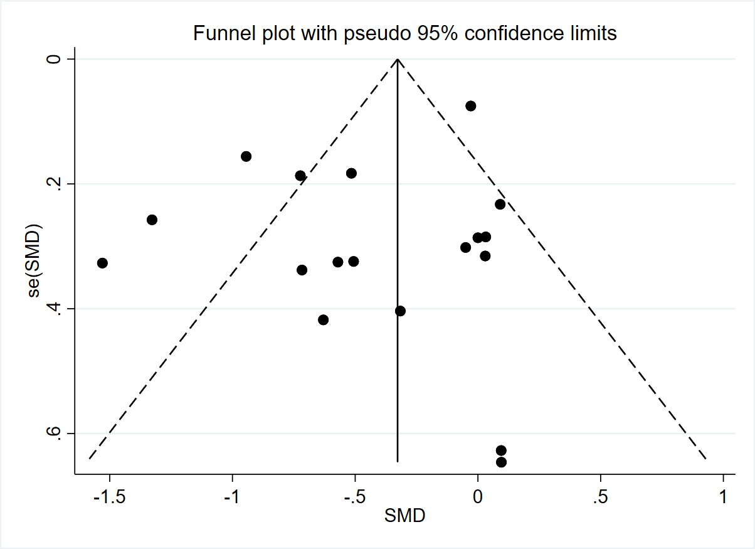
Supplementary Figure 1: Funnel plot for fatigue score

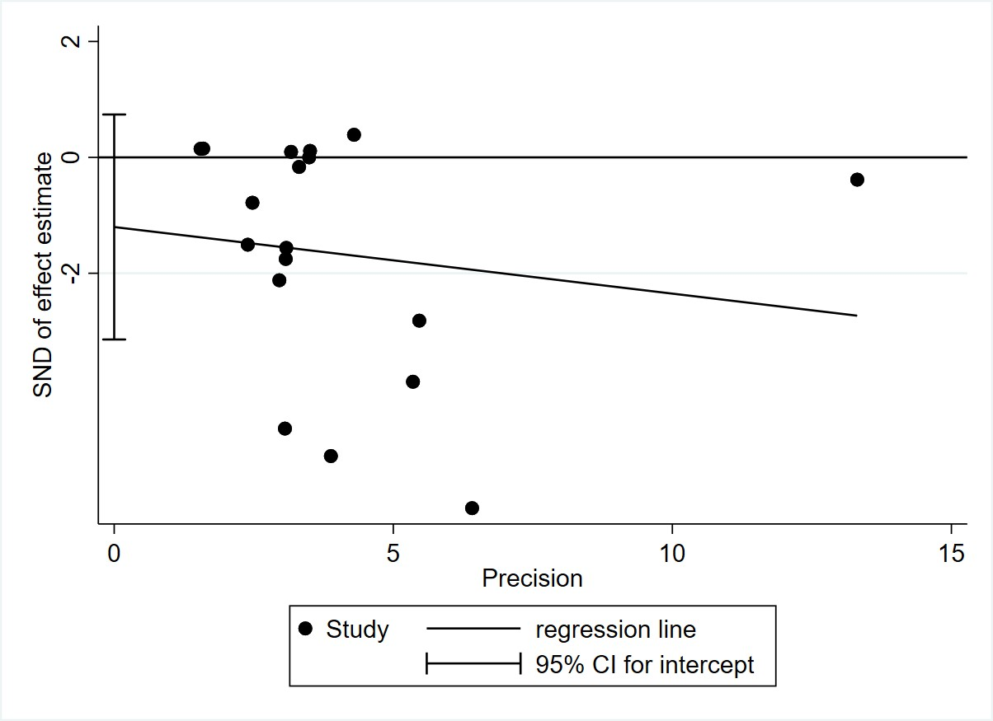
Supplementary figure 2: Egger test for fatigue score

