Supplementary Material
Using Machine Learning Algorithms Based on Laboratory Indicators to Establish a Diagnostic Model for Lung Cancer

Jie Wu ª†, Lu Zhang ª†, Zheng Zhang ª, Shuo Gao ª, Seng Wang ª, Xuewen Zheng ª, Xuejing Xu ª, Hai Ding ª*, Han Shen ª*, Hong Yan ^{b}*
ª Department of Laboratory Medicine, Affiliated Drum Tower Hospital, Medical School of Nanjing University, Zhongshan Road 321, Nanjing 210008, Jiangsu Province, China.
^{b} Laboratory Medicine Center, the Second Affiliated Hospital of Nanjing Medical University, Nanjing, China.
Correspondence: sea00god@sina.com; shenhan10366@sina.com; yanhong@njmu.edu.cn.
†These authors contributed equally to this work and share first authorship.
*Corresponding Author: Hai Ding*, Han Shen*, Hong Yan*.

Supplementary Figures and Tables

Supplementary Figures
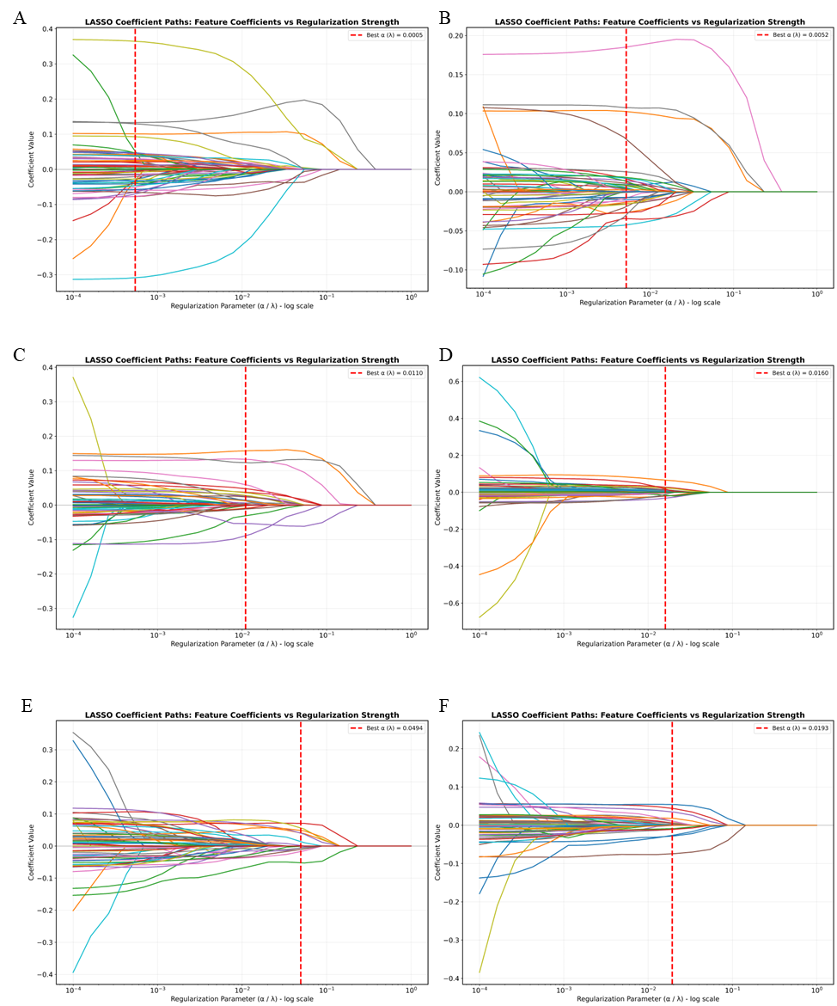
Supplementary Figure 1 Lasso coefficient paths. (A) health-benign pulmonary disease group; (B) health-early-stage lung cancer group; (C) health-advanced lung cancer group; (D) benign pulmonary disease-early-stage lung cancer group; (E) benign pulmonary disease-advanced lung cancer group; (F) early-stage-advanced lung cancer group.

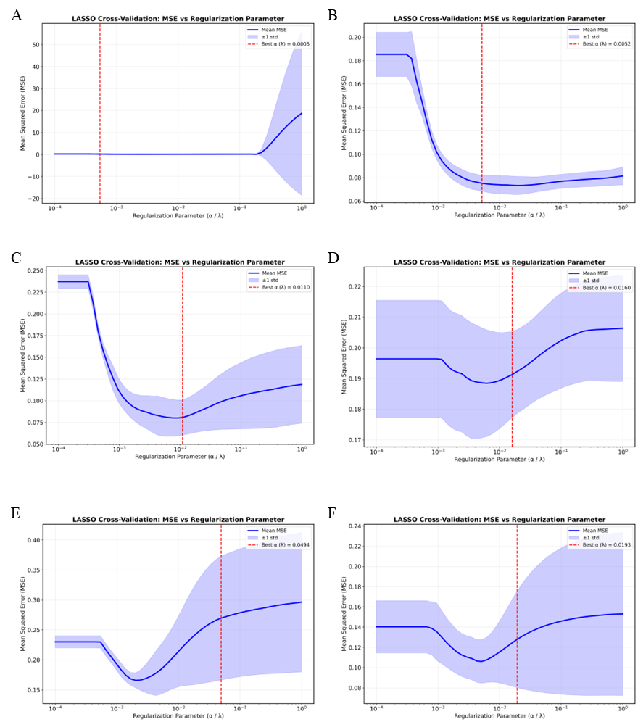
Supplementary Figure 2 Lasso cross validation curve. (A) health-benign pulmonary disease group; (B) health-early-stage lung cancer group; (C) health-advanced lung cancer group; (D) benign pulmonary disease-early-stage lung cancer group; (E) benign pulmonary disease-advanced lung cancer group; (F) early-stage-advanced lung cancer group.

Supplementary Tables
Supplementary Table 1 Clinical feature table of six groups
Index | Healthy (a) | Benign (b) | Early-Lung cancer (c) | Advanced Lung Cancer (d) | P value
 |  |  |  |  | a-b | a-c | a-d | b-c | b-d | c-d
Age | (44, 56) | 55.84±11.32 | (55, 69) | (57, 70.25) | 0.000 | 0.000 | 0.000 | 0.000 | 0.000 | 0.000
CRP | (2.2, 5) | (2.8,5.1) | (2.9,5.2) | (3.35,9.95) | 0.291 | 0.095 | 0.000 | 0.739 | 0.000 | 0.000
CYFRA21 | (1.23,2.08) | (1.32, 2.42) | (1.53, 2.84) | (1.975,6.12) | 0.006 | 0.000 | 0.000 | 0.000 | 0.000 | 0.000
NSE | 13.04±2.90 | 12.01±2.39 | (6.8,13.1) | (8.55,34.55) | 0.000 | 0.708 | 0.000 | 0.000 | 0.000 | 0.000
CA125 | (5.97,10.85) | (7.55,13.57) | (6.86,13.1) | (8.52,34.87) | 0.049 | 0.642 | 0.008 | 0.007 | 0.011 | 0.009
CEA | (0.5,1.41) | (1.08,2.37) | (1.18,2.94) | (1.80,8.63) | 0.135 | 0.001 | 0.001 | 0.000 | 0.001 | 0.001
WBC | (4.8,6.9) | (4.8,6.67) | (4.6,6.5) | (4.8,7.25) | 0.014 | 0.005 | 0.073 | 0.873 | 0.001 | 0.000
NEUT% | (51.5,62.5) | (52.8, 63.77) | (52.82, 65.87) | (57.6, 71.4) | 0.005 | 0.000 | 0.000 | 0.324 | 0.000 | 0.000
LYMPH% | 32.89±8.19 | (27.35, 37.32) | (25.22, 37.17) | 25.94±9.67 | 0.032 | 0.000 | 0.000 | 0.320 | 0.000 | 0.000
MONO% | (5.5,7.3) | 6.31±1.68 | (5, 6.9) | 6.72±1.71 | 0.613 | 0.072 | 0.042 | 0.235 | 0.015 | 0.000
EOS% | (1.5, 3.4) | (1.1, 3) | (1.2, 3.07) | (1.3, 3.7) | 0.016 | 0.025 | 0.350 | 0.534 | 0.101 | 0.170
BASO% | (0.3, 0.6) | (0.3, 0.6) | (0.3, 0.6) | (0.3, 0.6) | 0.136 | 0.159 | 0.032 | 0.723 | 0.361 | 0.189
NEUT# | (2.7, 4.1) | (2.6, 4) | (2.5, 4.07) | (3, 5) | 0.829 | 0.826 | 0.000 | 0.679 | 0.000 | 0.000
LYMPH# | (1.6, 2.3) | (1.3, 2.1) | (1.3, 2) | (1.1, 1.8) | 0.000 | 0.000 | 0.000 | 0.441 | 0.010 | 0.024
MONO# | (0.3, 0.5) | (0.3, 0.4) | (0.3, 0.4) | (0.3, 0.5) | 0.005 | 0.000 | 0.006 | 0.423 | 0.000 | 0.000
EOS# | (0.08, 0.21) | (0.06, 0.16) | (0.06, 0.16) | (0.07, 0.22) | 0.011 | 0.012 | 0.436 | 0.742 | 0.006 | 0.005
BASO# | (0.02, 0.04) | (0.02, 0.03) | (0.02, 0.03) | (0.02, 0.03) | 0.004 | 0.000 | 0.075 | 0.900 | 0.441 | 0.323
RBC | 4.60±0.48 | 4.42±0.47 | (4.11, 4.66) | (4.1, 4.67) | 0.000 | 0.000 | 0.000 | 0.722 | 0.847 | 0.958
Hb | (129, 151) | (125, 145.5) | (124, 141.75) | 132.1±15.35 | 0.000 | 0.000 | 0.000 | 0.068 | 0.116 | 0.713
HCT | 41.95±3.842 | (37.7, 43.4) | 40.18±3.74 | 39.34±4.252 | 0.000 | 0.000 | 0.000 | 0.245 | 0.638 | 0.709
MCV | (88.9, 93.5) | (88.75, 93.65) | (88.3, 93.4) | (88.37, 94.52) | 0.588 | 0.430 | 0.949 | 0.158 | 0.700 | 0.500
MCH | (29.6, 31.5) | (29.5, 31.5) | (29.2, 31.2) | (29.15, 31.2) | 0.952 | 0.012 | 0.016 | 0.016 | 0.018 | 0.449
MCHC | 334.8±8.15 | (327, 341) | 332.05±10.08 | 329.58±10.04 | 0.267 | 0.000 | 0.000 | 0.017 | 0.000 | 0.005
RDW | (12.4, 13.2) | (12.4, 13.2) | (12.4, 13.3) | (12.4, 13.3) | 0.836 | 0.305 | 0.273 | 0.154 | 0.177 | 0.688
PLT | (186, 225) | (167.5, 237) | (165, 242) | (179.25, 252.25) | 0.001 | 0.000 | 0.736 | 0.935 | 0.023 | 0.011
PDW | (10, 16.2) | (9.4, 11.2) | (9.6, 11.375) | (9.5, 12.1) | 0.000 | 0.000 | 0.000 | 0.037 | 0.000 | 0.002
MPV | (9.8, 16.2) | (16, 16.5) | (16, 16.5) | (15.7, 16.5) | 0.000 | 0.000 | 0.000 | 0.991 | 0.000 | 0.000
PT | 10.66±0.67 | (11.2, 11.9) | (11.2, 11.9) | 11.86±0.75 | 0.000 | 0.000 | 0.000 | 0.620 | 0.046 | 0.001
INR | 0.92±0.045 | (0.97, 1.04) | (0.98, 1.05) | (0.99, 1.08) | 0.025 | 0.000 | 0.000 | 0.000 | 0.000 | 0.051
APTT | (26, 28.4) | (25.3, 28.1) | (25.5, 27.9) | (25.75, 29.1) | 0.010 | 0.042 | 0.036 | 0.359 | 0.013 | 0.018
TT | (17.2, 18.4) | (17.5, 18.6) | (17.4, 18.6) | (17.1, 18.3) | 0.027 | 0.082 | 0.567 | 0.190 | 0.269 | 0.768
FIB | (2.4, 3) | (2.4, 3.25) | (2.3, 3.2) | (2.7, 4.3) | 0.575 | 0.644 | 0.072 | 0.820 | 0.077 | 0.075
DEJT | (0.13, 0.28) | (0.13, 0.45) | (0.16, 0.53) | (0.24, 0.97) | 0.044 | 0.000 | 0.000 | 0.130 | 0.000 | 0.000
ALT | (13.9, 28.2) | (13.7, 25.85) | (12.7, 24.5) | (11.97, 24.1) | 0.778 | 0.060 | 0.523 | 0.177 | 0.694 | 0.564
AST | (17.8, 24.6) | (17.75, 25.05) | (16.9, 24.3) | (16.17, 24.32) | 0.644 | 0.585 | 0.342 | 0.265 | 0.174 | 0.521
AKP | (54.7, 76.7) | (61.8, 85.75) | (59.5, 88.47) | (67.57, 96.92) | 0.016 | 0.000 | 0.000 | 0.305 | 0.000 | 0.000
GGT | (17.3, 38.2) | (16.95, 36.15) | (15.62, 31.77) | (17.77, 35.42) | 0.881 | 0.058 | 0.376 | 0.034 | 0.403 | 0.509
LDH | 171.38±41.62 | (149, 188.5) | (148.25, 190) | (151.5, 210) | 0.341 | 0.812 | 0.008 | 0.084 | 0.002 | 0.007
TBIL | (9.9, 16.4) | (9.05, 15.45) | (9.4, 14.4) | (8.95, 14.125) | 0.252 | 0.035 | 0.005 | 0.516 | 0.077 | 0.132
DBIL | (1.7, 3) | (1.5, 2.7) | (1.6, 2.5) | (1.5, 2.7) | 0.109 | 0.014 | 0.720 | 0.617 | 0.510 | 0.323
CHE | 8.84±3.72 | (7.4, 9.8) | (7, 9.4) | (6.4, 8.8) | 0.532 | 0.028 | 0.002 | 0.006 | 0.001 | 0.051
TP | (64.9, 71.8) | 69.36±5.50 | 68.69±5.92 | (64.55, 71.325) | 0.004 | 0.094 | 0.940 | 0.085 | 0.039 | 0.249
ALB | 43.40±3.47 | (40.3, 44.45) | (40, 43.6) | (38.07, 42.12) | 0.000 | 0.000 | 0.000 | 0.016 | 0.000 | 0.000
GLO | 24.54±3.74 | 26.96±4.38 | 26.78±4.60 | (25.07, 30.72) | 0.000 | 0.000 | 0.000 | 0.566 | 0.058 | 0.016
A/G | (1.63, 1.97) | (1.44, 1.76) | (1.4, 1.79) | (1.28, 1.6025) | 0.000 | 0.000 | 0.783 | 0.804 | 0.655 | 0.643
TBA | (1.7, 4.5) | (2.1, 5.6) | (2, 5.7) | (2.1, 5.6) | 0.002 | 0.002 | 0.073 | 0.408 | 0.496 | 0.328
LAP | (21.9, 28.6) | (22.65, 37.75) | (22.7, 37.8) | (23.07, 39.72) | 0.000 | 0.000 | 0.000 | 0.845 | 0.193 | 0.187
ADA | (5.8, 8.9) | (7, 10.2) | (7.2, 10.6) | (7.87, 11.55) | 0.000 | 0.000 | 0.000 | 0.741 | 0.010 | 0.007
GLU | (4.13, 4.9) | (4.39, 5.44) | (4.42, 5.72) | (4.39, 5.62) | 0.000 | 0.000 | 0.000 | 0.334 | 0.591 | 0.935
BUN | 5.66±2.90 | 5.43±1.62 | (4.6, 6.5) | (4.8, 6.62) | 0.234 | 0.816 | 0.153 | 0.055 | 0.001 | 0.022
CREA | (56, 76) | (54, 73) | (53, 73) | (57, 76.25) | 0.067 | 0.010 | 0.925 | 0.621 | 0.093 | 0.025
UA | 332.18±79.13 | (253, 351) | (247, 350) | (261, 379) | 0.001 | 0.000 | 0.464 | 0.310 | 0.045 | 0.003
TCO2 | 26.91±2.87 | (25.1, 28.65) | (25.1, 28.2) | (24.8, 27.62) | 0.909 | 0.268 | 0.010 | 0.166 | 0.006 | 0.032
CHOL | (0.89, 1.68) | (1.01, 2.75) | (0.93, 2.11) | (1, 3.54) | 0.002 | 0.230 | 0.000 | 0.003 | 0.127 | 0.000
TRIG | (4.3, 5.52) | (3.67, 5.28) | (3.70, 5.28) | (2.68, 5.18) | 0.000 | 0.000 | 0.000 | 0.118 | 0.012 | 0.000
HDL-C | 1.32±0.33 | (1.09, 1.5) | (1.1, 1.5) | (0.95, 1.33) | 0.605 | 0.940 | 0.000 | 0.558 | 0.000 | 0.000
LDL-C | (2.33, 3.13) | 2.97±0.74 | (2.29, 3.43) | (2.24, 3.31) | 0.000 | 0.011 | 0.295 | 0.103 | 0.425 | 0.370
APOAⅠ | 1.32±0.29 | (1.135, 1.52) | (1.14, 1.52) | (1.03, 1.37) | 0.278 | 0.112 | 0.424 | 0.779 | 0.449 | 0.455
APOB | (0.68, 0.99) | (0.67, 0.96) | (0.63, 0.93) | (0.635, 0.93) | 0.389 | 0.000 | 0.105 | 0.006 | 0.353 | 0.282
Ca | 2.31±0.11 | 2.30±0.10 | (2.22, 2.36) | (2.21, 2.36) | 0.764 | 0.119 | 0.294 | 0.043 | 0.192 | 0.957
PHOS | 1.19±0.22 | 1.82±0.16 | (1.09, 1.29) | 1.15±0.17 | 0.546 | 0.875 | 0.029 | 0.273 | 0.057 | 0.003
K | 3.71±4.09 | 3.89±0.33 | (3.73, 4.15) | (3.715, 4.19) | 0.322 | 0.398 | 0.379 | 0.070 | 0.112 | 0.711
Na | (138.4, 140.9) | 139.99±2.06 | (139, 141.6) | 139.75±2.58 | 0.026 | 0.000 | 0.383 | 0.065 | 0.325 | 0.023
CL | 104.57±2.42 | 105.48±2.52 | (103.9, 107.2) | 104.52±2.87 | 0.002 | 0.000 | 0.864 | 0.240 | 0.009 | 0.000

Supplementary Table 2 Feature variable selection (applicable to healthy vs. benign pulmonary disease group)

Feature | Coefficient | Absolute_Coefficient
PT | 0.365 | 0.365
INR | -0.309 | 0.309
MPV | 0.133 | 0.133
LDL-C | 0.129 | 0.129
Age | 0.101 | 0.101
APOAⅠ | 0.094 | 0.094
HDL-C | -0.078 | 0.078
A/G | -0.077 | 0.077
LYMPH# | -0.071 | 0.071
TRIG | -0.065 | 0.065
GLO | -0.064 | 0.064
PDW | -0.059 | 0.059
Ca | -0.057 | 0.057
EOS# | -0.051 | 0.051
DBIL | 0.048 | 0.048
BASO% | -0.047 | 0.047
TP | 0.047 | 0.047
APOB | -0.046 | 0.046
CHOL | 0.045 | 0.045
MONO# | 0.044 | 0.044
EOS% | 0.043 | 0.043
CHE | 0.043 | 0.043
APTT | -0.041 | 0.041
AST | 0.041 | 0.041
NEUT% | -0.041 | 0.041
Sex | 0.040 | 0.040
GLU | 0.039 | 0.039
LAP | 0.037 | 0.037
CRP | -0.037 | 0.037
TBIL | -0.035 | 0.035
BUN | -0.032 | 0.032
TBA | 0.031 | 0.031
ALT | 0.028 | 0.028
MONO% | -0.028 | 0.028
LDH | -0.028 | 0.028
PHOS | 0.026 | 0.026
BASO# | 0.025 | 0.025
TT | 0.023 | 0.023
CYFRA21-1 | 0.021 | 0.021
GGT | -0.021 | 0.021
NEUT# | 0.018 | 0.018
MCHC | -0.017 | 0.017
AKP | -0.017 | 0.017
FIB(CON.) | -0.016 | 0.016
MCH | 0.014 | 0.014
NSE | -0.014 | 0.014
CL | 0.012 | 0.012
Hb | 0.012 | 0.012
Na | 0.011 | 0.011
CREA | 0.010 | 0.010
ADA | -0.008 | 0.008
TCO2 | 0.008 | 0.008
DEJT | -0.007 | 0.007
ALB | -0.006 | 0.006
CA125 | 0.004 | 0.004
UA | 0.004 | 0.004
CEA | 0.004 | 0.004
RDW | -0.003 | 0.003
PLT | -0.002 | 0.002
K | -0.001 | 0.001

Supplementary Table 3 Feature variable selection (applicable to health vs. early-stage lung cancer group)
Feature | Coefficient | Absolute Coefficient
MPV | 0.185 | 0.185
PT | 0.108 | 0.108
Age | 0.103 | 0.103
LDL-C | 0.068 | 0.068
APTT | -0.043 | 0.043
A/G | -0.034 | 0.034
APOB | -0.030 | 0.030
ALB | -0.027 | 0.027
TRIG | -0.027 | 0.027
GLU | 0.026 | 0.026
GGT | -0.019 | 0.019
CL | 0.018 | 0.018
PHOS | 0.017 | 0.017
AST | 0.017 | 0.017
BUN | -0.016 | 0.016
PDW | -0.015 | 0.015
AKP | 0.014 | 0.014
CHOL | 0.014 | 0.014
FIB(CON.) | -0.013 | 0.013
BASO# | -0.012 | 0.012
LAP | 0.011 | 0.011
MCV | -0.010 | 0.010
Sex | 0.009 | 0.009
NEUT% | 0.009 | 0.009
LDH | -0.008 | 0.008
INR | 0.008 | 0.008
ALT | 0.008 | 0.008
EOS# | -0.008 | 0.008
UA | -0.007 | 0.007
CEA | 0.006 | 0.006
CHE | 0.005 | 0.005
NEUT# | 0.004 | 0.004
NSE | 0.004 | 0.004
rbc | 0.003 | 0.003
Na | 0.002 | 0.002
APOAⅠ | 0.001 | 0.001
TBIL | -0.001 | 0.001
Supplementary Table 4 Feature variable selection (applicable to health vs. advanced lung cancer group)
Feature | Coefficient | Absolute_Coefficient
Age | 0.158 | 0.158
MPV | 0.133 | 0.133
PT | 0.122 | 0.122
TRIG | -0.090 | 0.090
LDL-C | 0.060 | 0.060
A/G | -0.053 | 0.053
CHOL | 0.048 | 0.048
CYFRA21-1 | 0.037 | 0.037
GLU | 0.036 | 0.036
ALB | -0.030 | 0.030
INR | 0.029 | 0.029
NSE | 0.026 | 0.026
TBA | 0.024 | 0.024
PHOS | 0.014 | 0.014
APOAⅠ | 0.013 | 0.013
K | 0.012 | 0.012
PDW | -0.012 | 0.012
RDW | -0.010 | 0.010
BASO% | -0.009 | 0.009
AST | 0.006 | 0.006
ADA | 0.005 | 0.005
ALT | 0.002 | 0.002
LYMPH# | -0.002 | 0.002
DEJT | 0.002 | 0.002
BASO# | -0.001 | 0.001

Supplementary Table 5 Feature variable selection (applicable to benign pulmonary disease vs. early-stage lung cancer group)
Feature | Coefficient | Absolute_Coefficient
Age | 0.066 | 0.066
CA125 | -0.032 | 0.032
NSE | 0.028 | 0.028
INR | 0.023 | 0.023
GGT | -0.021 | 0.021
MCH | -0.021 | 0.021
TRIG | 0.018 | 0.018
CHOL | -0.016 | 0.016
CEA | 0.014 | 0.014
APOB | -0.011 | 0.011
Sex | 0.008 | 0.008
PDW | 0.007 | 0.007
APTT | 0.004 | 0.004
TBA | -0.004 | 0.004
TCO2 | -0.003 | 0.003
GLU | 0.001 | 0.001
AKP | 0.001 | 0.001

Supplementary Table 6 Feature variable selection (applicable to benign pulmonary disease vs. advanced lung cancer)
Feature | Coefficient | Absolute Coefficient
CYFRA21-1 | 0.071 | 0.071
INR | 0.057 | 0.057
ALB | -0.052 | 0.052
FIB(CON.) | 0.049 | 0.049
Age | 0.041 | 0.041
NSE | 0.041 | 0.041
MPV | -0.018 | 0.018
BUN | 0.015 | 0.015
HDL-C | -0.011 | 0.011
APOAⅠ | -0.007 | 0.007
A/G | -0.006 | 0.006
MONO# | 0.002 | 0.002
Supplementary Table 7 Feature variable selection (applicable to early-stage lung vs. advanced lung cancer group)
Feature | Coefficient | Absolute Coefficient
MPV | -0.075 | 0.075
FIB(CON.) | 0.054 | 0.054
NSE | 0.044 | 0.044
CA125 | 0.035 | 0.035
Sex | -0.028 | 0.028
ALB | -0.027 | 0.027
CHOL | 0.018 | 0.018
HDL-C | -0.011 | 0.011
LYMPH% | -0.011 | 0.011
APOB | 0.011 | 0.011
INR | 0.011 | 0.011
A/G | -0.009 | 0.009
MONO% | 0.007 | 0.007
AKP | 0.006 | 0.006
BUN | 0.005 | 0.005
PT | 0.004 | 0.004
ADA | 0.001 | 0.001

