Table. S1The Clinical characteristics of clinical subjects(Supplementary clinical samples)
Characteristics | HC(N=15) | NSCLC(N=15) | Total(N=30) | P-value | FDR
Sex(n,%) |  |  |  | 1 | 1
Female | 8(26.67%) | 9(30.00%) | 17(56.67%)
Male | 7(23.33%) | 6(20.00%) | 13(43.33%)
Age
Median(IQR) | 50 (47,54) | 67(58,72) | 55(50,67)
Median[min-max] | 50.00[40.00,57.00] | 67.00[41.00,83.00] | 55.00[40.00,83.00]
Smoking |  |  |  | 0.22 | 1
No | 12(40.00%) | 15(50.00%) | 27(90.00%)
Yes | 3(10.00%) | 0(0.0e+0%) | 3(10.00%)
PLT(*10^9/L）
Mean±SD | 262.47 ± 51.63 | 200.07 ± 58.32 | 231.27 ± 62.74
Median[min-max] | 262.00 [165.00,347.00] | 192.00 [122.00,323.00] | 235.50 [122.00,347.00]
PDW-SD（fL)
Mean±SD | 10.95 ± 1.52 | 11.75 ± 1.83 | 11.35 ± 1.70
Median[min-max] | 10.70 [8.70,13.80] | 11.50 [8.90,17.10] | 11.05 [8.70,17.10]
MPV（fL）
Mean±SD | 9.54 ± 1.25 | 10.29 ± 0.91 | 9.91 ± 1.12
Median[min-max] | 10.20 [7.90,13.10] | 10.00 [8.70,12.70] | 9.85 [7.90,13.10]
WBC(*10^9/L）
Mean±SD | 6.40 ± 1.40 | 5.37 ± 1.54 | 5.88 ± 1.54
Median[min-max] | 6.40 [3.60,8.90] | 5.65 [2.82,8.53] | 5.95 [2.82,8.90]

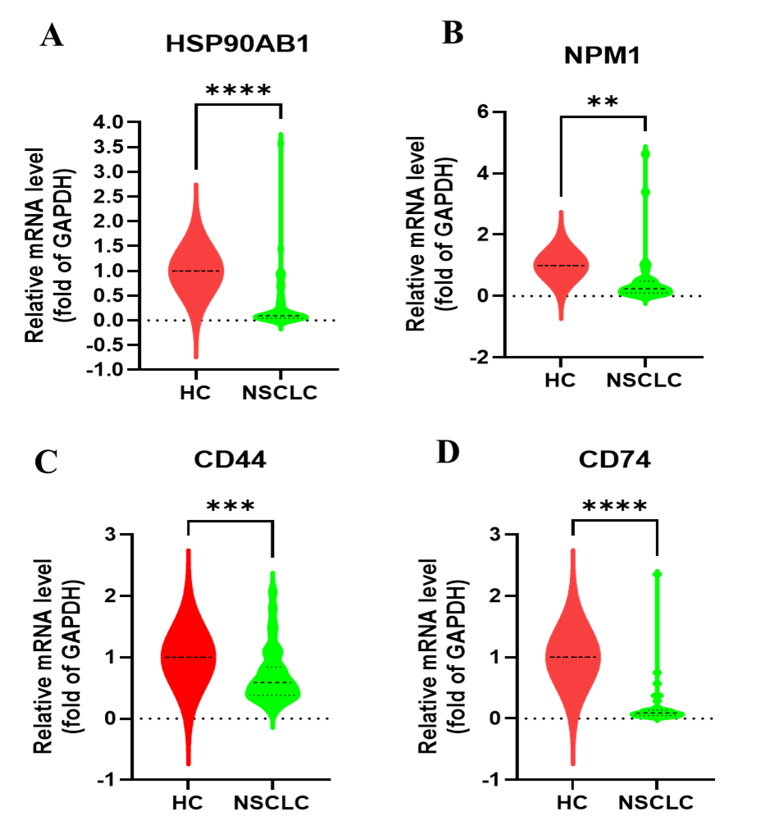
Fig. S1 Differential expression of the four target genes, HSP90AB1, NPM1, CD44, and CD74, was analyzed in clinical samples from healthy controls (comprising 8 females and 7 males) and 15 NSCLC patients (including 9 females and 6 males).
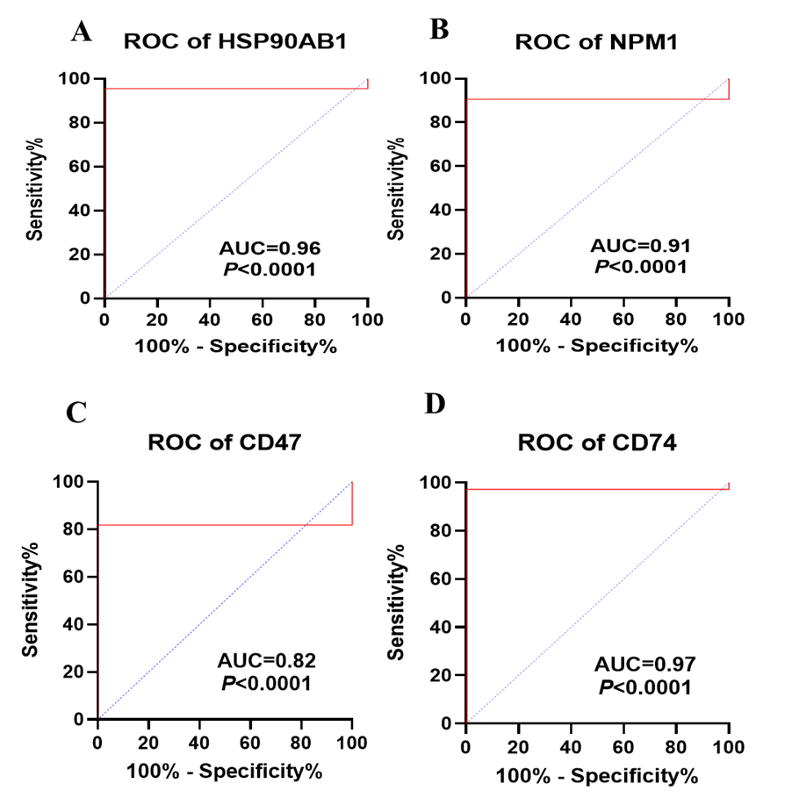
Fig.S2 ROC curves of (A) HSP90AB1, (B) NPM1, (C) CD44, (D) CD74. Using disease status as the input variable (15 NSCLC cases and 15 healthy controls), a traversal algorithm was applied for threshold determination. Multiple cutoff values were generated. The 95% confidence intervals (CIs) for sensitivity and specificity were computed using the Wilson/Brown method. ROC curves were constructed based on the relative expression levels of the target gene and the internal reference gene in clinical samples. The P-values for all four target genes were less than 0.0001.

