Supplementary materials

Supplementary Table 1. Surgical and Pathologic Characteristics by Time Period in Patients Receiving Upfront Radical Resection as Primary Treatment for Rectal Cancer
Supplementary Table 2. Surgical and Pathologic Characteristics by Time Period in Patients Receiving Neoadjuvant Therapy Followed by Radical Resection for Rectal Cancer
Supplementary Table 3. Initial Systemic Therapy Regimens by Time Period Among Patients with Rectal Cancer
Supplementary Table 4. Initial Systemic Therapy Regimens by Time Period Among Patients with Rectal Cancer Treated with Concurrent Chemoradiotherapy as Primary Treatment (n = 1,900)
Supplementary Table 5. Initial Systemic Therapy Regimens by Time Period Among Patients with Rectal Cancer Treated with Chemotherapy Alone as Primary Treatment (n = 97)
Supplementary Table 6. Multivariable Cox Proportional Hazards Regression Analysis for 3-Year Overall Survival Among Patients with Non-Metastatic Rectal Cancer
Supplementary Table 7. Complete-Case Sensitivity Analysis of the Multivariable Cox Proportional Hazards Regression Model for 3-Year Overall Survival
Supplementary Table 8. Annual Standardized Mortality Ratios in Patients with Rectal Cancer, by Age Group

Supplementary Figure 1. Flow diagram
Supplementary Figure 2. Trends in the use of targeted agents among patients with rectal cancer
Supplementary Figure 3. Adjusted 3-year overall survival curves from the complete-case sensitivity analysis
Supplementary Figure 4. Standardized mortality ratios by age group across periods

Supplementary Table 1. Surgical and Pathologic Characteristics by Time Period Among Patients Receiving Upfront Radical Resection as Primary Treatment for Rectal Cancer
Characteristics |  | Period 1  2008–2010  (n = 905) | Period 2  2011–2013  (n = 840) | Period 3  2014–2016  (n = 578) | Period 4  2017–2019  (n = 687) | Period 5  2020–2022  (n = 649) | Total  (n = 3,659) | P value
Surgical Characteristics
Surgical approach | Local excision | 49 (5.4) | 33 (3.9) | 20 (3.5) | 49 (7.1) | 26 (4.0) | 177 (4.8) | <0.001
 | Open surgery | 380 (42.0) | 141 (16.8) | 49 (8.5) | 24 (3.5) | 18 (2.8) | 612 (16.7)
 | Laparoscopic | 470 (51.9) | 643 (76.5) | 460 (79.6) | 476 (69.3) | 431 (66.4) | 2,480 (67.8)
 | Robotic | 6 (0.7) | 23 (2.7) | 49 (8.5) | 138 (20.1) | 174 (26.8) | 390 (10.7)
Type of surgery | TAE/TEM | 49 (5.4) | 33 (3.9) | 20 (3.5) | 49 (7.1) | 26 (4.0) | 177 (4.8) | <0.001
 | AR | 164 (18.1) | 160 (19.0) | 42 (7.3) | 34 (4.9) | 30 (4.6) | 430 (11.8)
 | LAR | 661 (73.0) | 610 (72.6) | 450 (77.9) | 491 (71.5) | 423 (65.2) | 2,635 (72.0)
 | uLAR | 16 (1.8) | 9 (1.1) | 31 (5.4) | 67 (9.8) | 123 (19.0) | 246 (6.7)
 | APR | 12 (1.3) | 15 (1.8) | 9 (1.6) | 11 (1.6) | 6 (0.9) | 53 (1.4)
 | ISR | 3 (0.3) | 7 (0.8) | 22 (3.8) | 34 (4.9) | 35 (5.4) | 101 (2.8)
 | Hartmann procedure | 0 (0.0) | 6 (0.7) | 4 (0.7) | 1 (0.1) | 6 (0.9) | 17 (0.5)
Pathologic Findings
Lymphatic invasion | No | 640 (70.7) | 553 (65.8) | 385 (66.6) | 495 (72.1) | 503 (77.5) | 2,576 (70.4) | <0.001
 | Yes | 241 (26.6) | 217 (25.8) | 182 (31.5) | 187 (27.2) | 145 (22.3) | 972 (26.6)
 | NA | 24 (2.7) | 70 (8.3) | 11 (1.9) | 5 (0.7) | 1 (0.2) | 111 (3.0)
Venous invasion | No | 712 (78.7) | 670 (79.8) | 446 (77.2) | 556 (80.9) | 513 (79.0) | 2,897 (79.2) | <0.001
 | Yes | 162 (17.9) | 90 (10.7) | 69 (11.9) | 60 (8.7) | 62 (9.6) | 443 (12.1)
 | NA | 31 (3.4) | 80 (9.5) | 63 (10.9) | 71 (10.3) | 74 (11.4) | 319 (8.7)
Perineural invasion | No | 802 (88.6) | 609 (72.5) | 364 (63.0) | 440 (64.0) | 466 (71.8) | 2,681 (73.3) | <0.001
 | Yes | 76 (8.4) | 155 (18.5) | 204 (35.3) | 243 (35.4) | 182 (28.0) | 860 (23.5)
 | NA | 27 (3.0) | 76 (9.0) | 10 (1.7) | 4 (0.6) | 1 (0.2) | 118 (3.2)
Surgical margin status | Negative | 882 (97.5) | 822 (97.9) | 567 (98.1) | 674 (98.1) | 640 (98.6) | 3,585 (98.0) | 0.255
Surgical margin status | Positive | 12 (1.3) | 8 (1.0) | 10 (1.7) | 9 (1.3) | 6 (0.9) | 45 (1.2)
Surgical margin status | NA | 11 (1.2) | 10 (1.2) | 1 (0.2) | 4 (0.6) | 3 (0.5) | 29 (0.8)
No. of lymph nodes retrieved, median [IQR] |  | 15 [11–22] | 16 [12–22] | 16 [14–21] | 17 [14–22] | 17 [14–22] | 16 [13–22] | <0.001
Pathologic T stage | pT0 | 66 (7.3) | 34 (4.0) | 16 (2.8) | 22 (3.2) | 21 (3.2) | 159 (4.3) | <0.001
 | pTis | 8 (0.9) | 8 (1.0) | 7 (1.2) | 6 (0.9) | 3 (0.5) | 32 (0.9)
 | pT1 | 124 (13.7) | 165 (19.6) | 123 (21.3) | 155 (22.6) | 162 (25.0) | 729 (19.9)
 | pT2 | 217 (24.0) | 184 (21.9) | 136 (23.5) | 175 (25.5) | 154 (23.7) | 866 (23.7)
 | pT3 | 427 (47.2) | 392 (46.7) | 265 (45.8) | 267 (38.9) | 242 (37.3) | 1,593 (43.5)
 | pT4 | 63 (7.0) | 57 (6.8) | 31 (5.4) | 62 (9.0) | 67 (10.3) | 280 (7.7)
Pathologic N stage | pN0 | 495 (54.7) | 473 (56.3) | 346 (59.9) | 387 (56.3) | 398 (61.3) | 2,099 (57.4) | 0.013
 | pN1 | 232 (25.6) | 215 (25.6) | 155 (26.8) | 164 (23.9) | 148 (22.8) | 914 (25.0)
 | pN2 | 128 (14.1) | 115 (13.7) | 55 (9.5) | 85 (12.4) | 77 (11.9) | 460 (12.6)
 | pNx | 50 (5.5) | 37 (4.4) | 22 (3.8) | 51 (7.4) | 26 (4.0) | 186 (5.1)
TAE, transanal excision; TEM, transanal endoscopic microsurgery; AR, anterior resection; LAR, low anterior resection; uLAR, ultra-low anterior resection; APR, abdominoperineal resection; ISR, intersphincteric resection; NA, not available; IQR, interquartile range.
Values are presented as n (%) or median [IQR], as appropriate. Percentages may not sum to 100% due to rounding.
Supplementary Table 2. Surgical and Pathologic Characteristics by Time Period Among Patients Receiving Neoadjuvant Therapy Followed by Radical Resection for Rectal Cancer
Characteristics |  | Period 1  2008–2010  (n = 332) | Period 2  2011–2013  (n = 402) | Period 3  2014–2016  (n = 355) | Period 4  2017–2019  (n = 549) | Period 5  2020–2022  (n = 588) | Total  (n = 2,226) | P value
Surgical Characteristics
Surgical approach | Local excision | 19 (5.7) | 15 (3.7) | 19 (5.4) | 39 (7.1) | 20 (3.4) | 112 (5.0) | <0.001
 | Open surgery | 237 (71.4) | 114 (28.4) | 54 (15.2) | 75 (13.7) | 37 (6.3) | 517 (23.2)
 | Laparoscopic | 67 (20.2) | 244 (60.7) | 217 (61.1) | 247 (45.0) | 294 (50.0) | 1,069 (48.0)
 | Robotic | 9 (2.7) | 29 (7.2) | 65 (18.3) | 188 (34.2) | 237 (40.3) | 528 (23.7)
Type of surgery | TAE/TEM | 19 (5.7) | 15 (3.7) | 19 (5.4) | 39 (7.1) | 20 (3.4) | 112 (5.0) | <0.001
 | AR | 58 (17.5) | 90 (22.4) | 19 (5.4) | 6 (1.1) | 13 (2.2) | 186 (8.4)
 | LAR | 209 (63.0) | 251 (62.4) | 214 (60.3) | 246 (44.8) | 208 (35.4) | 1,128 (50.7)
 | uLAR | 13 (3.9) | 5 (1.2) | 39 (11.0) | 119 (21.7) | 187 (31.8) | 363 (16.3)
 | APR | 24 (7.2) | 28 (7.0) | 28 (7.9) | 24 (4.4) | 30 (5.1) | 134 (6.0)
 | ISR | 8 (2.4) | 11 (2.7) | 33 (9.3) | 113 (20.6) | 125 (21.3) | 290 (13.0)
 | Hartmann procedure | 1 (0.3) | 2 (0.5) | 3 (0.8) | 2 (0.4) | 5 (0.9) | 13 (0.6)
Pathologic Findings
Lymphatic invasion | No | 278 (83.7) | 297 (73.9) | 300 (84.5) | 484 (88.2) | 519 (88.3) | 1,878 (84.4) | <0.001
 | Yes | 36 (10.8) | 46 (11.4) | 39 (11.0) | 54 (9.8) | 66 (11.2) | 241 (10.8)
 | NA | 18 (5.4) | 59 (14.7) | 16 (4.5) | 11 (2.0) | 3 (0.5) | 107 (4.8)
Venous invasion | No | 277 (83.4) | 295 (73.4) | 287 (80.8) | 407 (74.1) | 470 (79.9) | 1,736 (78.0) | <0.001
 | Yes | 33 (9.9) | 38 (9.5) | 16 (4.5) | 18 (3.3) | 29 (4.9) | 134 (6.0)
 | NA | 22 (6.6) | 69 (17.2) | 52 (14.6) | 124 (22.6) | 89 (15.1) | 356 (16.0)
Perineural invasion | No | 289 (87.0) | 271 (67.4) | 233 (65.6) | 386 (70.3) | 431 (73.3) | 1,610 (72.3) | <0.001
 | Yes | 20 (6.0) | 70 (17.4) | 106 (29.9) | 152 (27.7) | 154 (26.2) | 502 (22.6)
 | NA | 23 (6.9) | 61 (15.2) | 16 (4.5) | 11 (2.0) | 3 (0.5) | 114 (5.1)
Surgical margin status | Negative | 306 (92.2) | 392 (97.5) | 338 (95.2) | 528 (96.2) | 565 (96.1) | 2,129 (95.6) | <0.001
Surgical margin status | Positive | 13 (3.9) | 7 (1.7) | 16 (4.5) | 13 (2.4) | 20 (3.4) | 69 (3.1)
Surgical margin status | NA | 13 (3.9) | 3 (0.7) | 1 (0.3) | 8 (1.5) | 3 (0.5) | 28 (1.3)
No. of lymph nodes retrieved, median [IQR] |  | 11 [7–14] | 9 [6–14] | 11 [7–15] | 13 [9–18] | 15 [12–19] | 13 [8–17] | <0.001
Pathologic T stage | ypT0 | 69 (20.8) | 73 (18.2) | 64 (18.0) | 126 (23.0) | 98 (16.7) | 430 (19.3) | 0.021
 | ypTis | 7 (2.1) | 8 (2.0) | 5 (1.4) | 7 (1.3) | 13 (2.2) | 40 (1.8)
 | ypT1 | 21 (6.3) | 17 (4.2) | 18 (5.1) | 34 (6.2) | 29 (4.9) | 119 (5.3)
 | ypT2 | 93 (28.0) | 125 (31.1) | 97 (27.3) | 131 (23.9) | 155 (26.4) | 601 (27.0)
 | ypT3 | 132 (39.8) | 174 (43.3) | 152 (42.8) | 225 (41.0) | 254 (43.2) | 937 (42.1)
 | ypT4 | 10 (3.0) | 5 (1.2) | 19 (5.4) | 26 (4.7) | 39 (6.6) | 99 (4.4)
Pathologic N stage | ypN0 | 215 (64.8) | 275 (68.4) | 262 (73.8) | 385 (70.1) | 376 (63.9) | 1,513 (68.0) | 0.001
 | ypN1 | 73 (22.0) | 84 (20.9) | 56 (15.8) | 87 (15.8) | 139 (23.6) | 439 (19.7)
 | ypN2 | 21 (6.3) | 30 (7.5) | 17 (4.8) | 38 (6.9) | 52 (8.8) | 158 (7.1)
 | ypNx | 23 (6.9) | 13 (3.2) | 20 (5.6) | 39 (7.1) | 21 (3.6) | 116 (5.2)
TAE, transanal excision; TEM, transanal endoscopic microsurgery; AR, anterior resection; LAR, low anterior resection; uLAR, ultra-low anterior resection; APR, abdominoperineal resection; ISR, intersphincteric resection; NA, not available; IQR, interquartile range.
Values are presented as n (%) or median [IQR], as appropriate. Percentages may not sum to 100% due to rounding.
Supplementary Table 3. Initial Systemic Therapy Regimens by Time Period Among Patients with Rectal Cancer
Characteristics | Period 1  2008–2010 | Period 2  2011–2013 | Period 3  2014–2016 | Period 4  2017–2019 | Period 5  2020–2022 | Total | P value
Patients treated with conventional chemotherapy (n = 3,510)
FL | 481 (59.6) | 356 (48.6) | 112 (22.3) | 28 (3.9) | 26 (3.5) | 1,003 (28.6) | <0.001
FOLFOX | 58 (7.2) | 67 (9.2) | 32 (6.4) | 105 (14.6) | 54 (7.2) | 316 (9.0)
FOLFIRI | 3 (0.4) | 11 (1.5) | 28 (5.6) | 21 (2.9) | 24 (3.2) | 87 (2.5)
Capecitabine | 200 (24.8) | 224 (30.6) | 253 (50.4) | 447 (62.3) | 470 (62.6) | 1,594 (45.4)
XELOX | 47 (5.8) | 59 (8.1) | 70 (13.9) | 112 (15.6) | 170 (22.6) | 458 (13.0)
Others | 18 (2.2) | 15 (2.0) | 7 (1.4) | 5 (0.7) | 7 (0.9) | 52 (1.5)
Regimens among patients who received targeted therapy (n = 497)
Bevacizumab | 22 (48.9) | 41 (61.2) | 67 (67.7) | 136 (84.5) | 102 (81.6) | 368 (74.0) | <0.001
Cetuximab | 19 (42.2) | 23 (34.3) | 29 (29.3) | 22 (13.7) | 17 (13.6) | 110 (22.1)
Others | 4 (8.9) | 3 (4.5) | 3 (3.0) | 3 (1.9) | 6 (4.8) | 19 (3.8)
FL, 5-fluorouracil plus leucovorin; FOLFOX, 5-fluorouracil, leucovorin, and oxaliplatin; FOLFIRI, 5-fluorouracil, leucovorin, and irinotecan; XELOX, capecitabine and oxaliplatin.
Values are presented as n (%). Percentages may not sum to 100% due to rounding.

Supplementary Table 4. Initial Systemic Therapy Regimens by Time Period Among Patients with Rectal Cancer Treated with Concurrent Chemoradiotherapy as Primary Treatment (n = 1,900)
Characteristics | Period 1  2008–2010 | Period 2  2011–2013 | Period 3  2014–2016 | Period 4  2017–2019 | Period 5  2020–2022 | Total | P value
Regimens among patients who received conventional chemotherapy (n = 1,898)
FL | 201 (56.1) | 185 (47.4) | 55 (19.7) | 7 (1.8) | 18 (3.7) | 466 (24.6) | <0.001
FOLFOX | 0 (0.0) | 0 (0.0) | 1 (0.4) | 0 (0.0) | 8 (1.6) | 9 (0.5)
FOLFIRI | 0 (0.0) | 2 (0.5) | 4 (1.4) | 1 (0.3) | 3 (0.6) | 10 (0.5)
Capecitabine | 144 (40.2) | 197 (50.5) | 218 (78.1) | 377 (97.7) | 434 (89.5) | 1,370 (72.2)
XELOX | 4 (1.1) | 1 (0.3) | 0 (0.0) | 1 (0.3) | 22 (4.5) | 28 (1.5)
Others | 9 (2.5) | 5 (1.3) | 1 (0.4) | 0 (0.0) | 0 (0.0) | 15 (0.8)
Regimens among patients who received targeted therapy (n = 215)
Bevacizumab | 5 (55.6) | 19 (59.4) | 31 (75.6) | 57 (87.7) | 58 (85.3) | 170 (79.1) | <0.001
Cetuximab | 2 (22.2) | 12 (37.5) | 10 (24.4) | 8 (12.3) | 9 (13.2) | 41 (19.1)
Others | 2 (22.2) | 1 (3.1) | 0 (0.0) | 0 (0.0) | 1 (1.5) | 4 (1.9)
FL, 5-fluorouracil plus leucovorin; FOLFOX, 5-fluorouracil, leucovorin, and oxaliplatin; FOLFIRI, 5-fluorouracil, leucovorin, and irinotecan; XELOX, capecitabine and oxaliplatin.
Values are presented as n (%). Percentages may not sum to 100% due to rounding.
Supplementary Table 5. Initial Systemic Therapy Regimens by Time Period Among Patients with Rectal Cancer Treated with Chemotherapy Alone as Primary Treatment (n = 97)
Characteristics | Period 1  2008–2010 | Period 2  2011–2013 | Period 3  2014–2016 | Period 4  2017–2019 | Period 5  2020–2022 | Total | P value
Regimens among patients who received conventional chemotherapy (n = 96)
FL | 5 (20.8) | 4 (33.3) | 2 (12.5) | 1 (3.8) | 1 (5.6) | 13 (13.5) | 0.002
FOLFOX | 5 (20.8) | 1 (8.3) | 2 (12.5) | 11 (42.3) | 7 (38.9) | 26 (27.1)
FOLFIRI | 1 (4.2) | 0 (0.0) | 6 (37.5) | 10 (38.5) | 7 (38.9) | 24 (25.0)
Capecitabine | 3 (12.5) | 0 (0.0) | 2 (12.5) | 1 (3.8) | 0 (0.0) | 6 (6.3)
XELOX | 7 (29.2) | 5 (41.7) | 2 (12.5) | 0 (0.0) | 1 (5.6) | 15 (15.6)
Others | 3 (12.5) | 2 (16.7) | 2 (12.5) | 3 (11.5) | 2 (11.1) | 12 (12.5)
Regimens among patients who received targeted therapy (n = 53)
Bevacizumab | 2 (40.0) | 3 (100.0) | 6 (75.0) | 16 (72.7) | 10 (66.7) | 37 (69.8) | 0.400
Cetuximab | 3 (60.0) | 0 (0.0) | 2 (25.0) | 3 (13.6) | 4 (26.7) | 12 (22.6)
Others | 0 (0.0) | 0 (0.0) | 0 (0.0) | 3 (13.6) | 1 (6.7) | 4 (7.5)
FL, 5-fluorouracil plus leucovorin; FOLFOX, 5-fluorouracil, leucovorin, and oxaliplatin; FOLFIRI, 5-fluorouracil, leucovorin, and irinotecan; XELOX, capecitabine and oxaliplatin.
Values are presented as n (%). Percentages may not sum to 100% due to rounding. P values were calculated using Pearson’s chi-squared test.
Supplementary Table 6. Multivariable Cox Proportional Hazards Regression Analysis for 3-Year Overall Survival Among Patients with Non-Metastatic Rectal Cancer
Variable |  | HR | 95% CI | P value
Age at diagnosis | Continuous, per 1-year increase | 1.05 | 1.04–1.06 | <0.001
Sex | Male | (ref)
 | Female | 0.83 | 0.68–1.02 | 0.083
Diagnosis period | Period 1 (2008–2010) | (ref)
 | Period 2 (2011–2013) | 1.55 | 1.14–2.11 | 0.005
 | Period 3 (2014–2016) | 1.48 | 1.07–2.06 | 0.018
 | Period 4 (2017–2019) | 1.11 | 0.80–1.55 | 0.539
 | Period 5 (2020–2022) | 0.81 | 0.56–1.17 | 0.256
Clinical T stage | 1 | (ref)
 | 2 | 1.10 | 0.58–2.08 | 0.778
 | 3 | 1.38 | 0.74–2.59 | 0.313
 | 4 | 2.39 | 1.25–4.56 | 0.008
 | Missing | 0.90 | 0.29–2.76 | 0.852
Clinical N stage | 0 | (ref)
 | 1 | 1.89 | 1.32–2.69 | <0.001
 | Missing | 1.98 | 0.70–5.59 | 0.199
Histology | Adenocarcinoma | (ref)
 | Others | 1.09 | 0.65–1.85 | 0.737
Differentiation | Well differentiated | (ref)
 | Moderately differentiated | 1.19 | 0.94–1.50 | 0.139
 | Poorly differentiated | 5.98 | 4.23–8.45 | <0.001
 | Missing | 2.44 | 1.53–3.89 | <0.001
Primary treatment | (C)RT alone | (ref)
 | Neoadjuvant (C)RT followed by surgery | 0.23 | 0.17–0.31 | <0.001
 | Systemic therapy alone | 2.21 | 1.44–3.39 | <0.001
 | Upfront surgery | 0.27 | 0.20–0.36 | <0.001
HR, hazard ratio; CI, confidence interval; (C)RT, chemotherapy and/or radiotherapy.
Patients with non-metastatic rectal cancer diagnosed between 2008 and 2022 were included. Follow-up was truncated at 36 months for this analysis. The primary model included all 6,314 patients, with 412 deaths within 36 months. Missing values for clinical T stage, clinical N stage, and differentiation were retained as separate categories.
The proportional hazards assumption was assessed using Schoenfeld residuals; the global test for the primary model was not statistically significant at the 0.05 level. Multicollinearity was assessed using generalized variance inflation factors.

Supplementary Table 7. Complete-Case Sensitivity Analysis of the Multivariable Cox Proportional Hazards Regression Model for 3-Year Overall Survival
Variable |  | HR | 95% CI | P value
Age at diagnosis | Continuous, per 1-year increase | 1.05 | 1.04–1.06 | <0.001
Sex | Male | (ref)
 | Female | 0.73 | 0.58–0.93 | 0.009
Diagnosis period | Period 1 (2008–2010) | (ref)
 | Period 2 (2011–2013) | 1.25 | 0.88–1.76 | 0.214
 | Period 3 (2014–2016) | 1.14 | 0.81–1.61 | 0.440
 | Period 4 (2017–2019) | 0.81 | 0.57–1.16 | 0.260
 | Period 5 (2020–2022) | 0.59 | 0.40–0.89 | 0.011
Clinical T stage | 1 | (ref)
 | 2 | 1.13 | 0.58–2.19 | 0.718
 | 3 | 1.49 | 0.77–2.86 | 0.232
 | 4 | 2.65 | 1.35–5.20 | 0.004
Clinical N stage | 0 | (ref)
 | 1 | 1.77 | 1.23–2.54 | 0.002
Histology | Adenocarcinoma | (ref)
 | Others | 0.99 | 0.49–2.03 | 0.988
Differentiation | Well differentiated | (ref)
 | Moderately differentiated | 1.23 | 0.96–1.58 | 0.099
 | Poorly differentiated | 6.33 | 4.31–9.30 | <0.001
Primary treatment | (C)RT alone | (ref)
 | Neoadjuvant (C)RT followed by surgery | 0.21 | 0.15–0.30 | <0.001
 | Systemic therapy alone | 1.82 | 1.00–3.29 | 0.049
 | Upfront surgery | 0.25 | 0.18–0.35 | <0.001
HR, hazard ratio; CI, confidence interval; (C)RT, chemotherapy and/or radiotherapy.
This complete-case sensitivity analysis used the same covariates as the primary model and included 5,256 patients with 335 deaths within 36 months. Patients with missing covariate data were excluded from this sensitivity analysis. Follow-up was truncated at 36 months. The proportional hazards assumption was assessed using Schoenfeld residuals, and multicollinearity was assessed using generalized variance inflation factors.

Supplementary Table 8. Annual Standardized Mortality Ratios in Patients with Rectal Cancer, by Age Group
Year of  Diagnosis | Age group | n | Observed  deaths | Expected  deaths* | SMR† | Lower 95% CI | Upper 95% CI
2008 | <60 | 215 | 9 | 0.29 | 31.56 | 14.40 | 59.92
 | 60–69 | 122 | 5 | 0.92 | 5.46 | 2.41 | 12.75
 | ≥70 | 50 | 3 | 2.09 | 1.44 | 0.52 | 4.20
 | Total | 387 | 17 | 3.29 | 5.17 | 3.01 | 8.27
2009 | <60 | 255 | 10 | 0.34 | 29.57 | 14.15 | 54.38
 | 60–69 | 129 | 10 | 0.97 | 10.33 | 4.95 | 19.00
 | ≥70 | 82 | 4 | 3.42 | 1.17 | 0.47 | 2.99
 | Total | 466 | 24 | 4.73 | 5.08 | 3.25 | 7.55
2010 | <60 | 240 | 13 | 0.32 | 40.84 | 21.72 | 69.84
 | 60–69 | 117 | 6 | 0.88 | 6.83 | 2.50 | 14.87
 | ≥70 | 89 | 12 | 3.71 | 3.23 | 1.67 | 5.65
 | Total | 446 | 31 | 4.91 | 6.31 | 4.29 | 8.96
2011 | <60 | 271 | 11 | 0.36 | 30.60 | 15.26 | 54.76
 | 60–69 | 132 | 8 | 0.99 | 8.08 | 3.48 | 15.91
 | ≥70 | 108 | 19 | 4.51 | 4.22 | 2.54 | 6.59
 | Total | 511 | 38 | 5.86 | 6.49 | 4.59 | 8.91
2012 | <60 | 210 | 6 | 0.28 | 21.54 | 7.87 | 46.89
 | 60–69 | 103 | 7 | 0.77 | 9.06 | 3.63 | 18.66
 | ≥70 | 85 | 14 | 3.55 | 3.95 | 2.16 | 6.62
 | Total | 398 | 27 | 4.60 | 5.87 | 3.87 | 8.54
2013 | <60 | 181 | 10 | 0.24 | 41.65 | 19.94 | 76.61
 | 60–69 | 121 | 12 | 0.91 | 13.22 | 6.82 | 23.09
 | ≥70 | 93 | 18 | 3.88 | 4.64 | 2.75 | 7.33
 | Total | 395 | 40 | 5.03 | 7.96 | 5.68 | 10.83
2014 | <60 | 175 | 10 | 0.23 | 43.08 | 20.63 | 79.24
 | 60–69 | 99 | 9 | 0.74 | 12.11 | 5.53 | 23.00
 | ≥70 | 87 | 14 | 3.63 | 3.86 | 2.11 | 6.47
 | Total | 361 | 33 | 4.60 | 7.17 | 4.93 | 10.07
2015 | <60 | 115 | 6 | 0.15 | 39.34 | 14.36 | 85.62
 | 60–69 | 81 | 6 | 0.61 | 9.87 | 3.60 | 21.49
 | ≥70 | 71 | 15 | 2.96 | 5.06 | 2.83 | 8.35
 | Total | 267 | 27 | 3.72 | 7.25 | 4.78 | 10.55
2016 | <60 | 170 | 8 | 0.23 | 35.48 | 15.28 | 69.91
 | 60–69 | 99 | 4 | 0.74 | 5.38 | 2.19 | 13.79
 | ≥70 | 94 | 18 | 3.92 | 4.59 | 2.72 | 7.25
 | Total | 363 | 30 | 4.89 | 6.13 | 4.14 | 8.76
2017 | <60 | 189 | 10 | 0.25 | 39.89 | 19.10 | 73.37
 | 60–69 | 115 | 2 | 0.86 | 2.32 | 0.72 | 8.37
 | ≥70 | 73 | 11 | 3.05 | 3.61 | 1.80 | 6.46
 | Total | 377 | 23 | 4.16 | 5.53 | 3.50 | 8.30
2018 | <60 | 222 | 10 | 0.29 | 33.96 | 16.26 | 62.46
 | 60–69 | 128 | 9 | 0.96 | 9.37 | 4.28 | 17.79
 | ≥70 | 82 | 11 | 3.42 | 3.22 | 1.60 | 5.75
 | Total | 432 | 30 | 4.68 | 6.42 | 4.33 | 9.16
2019 | <60 | 265 | 10 | 0.35 | 28.45 | 13.62 | 52.33
 | 60–69 | 160 | 11 | 1.20 | 9.16 | 4.57 | 16.39
 | ≥70 | 98 | 14 | 4.09 | 3.42 | 1.87 | 5.75
 | Total | 523 | 35 | 5.64 | 6.20 | 4.32 | 8.63
2020 | <60 | 209 | 12 | 0.28 | 43.29 | 22.34 | 75.62
 | 60–69 | 122 | 7 | 0.92 | 7.65 | 3.06 | 15.75
 | ≥70 | 93 | 15 | 3.88 | 3.87 | 2.16 | 6.38
 | Total | 424 | 34 | 5.07 | 6.70 | 4.64 | 9.37
2021 | <60 | 242 | 7 | 0.32 | 21.81 | 8.74 | 44.94
 | 60–69 | 179 | 3 | 1.34 | 2.23 | 0.81 | 6.53
 | ≥70 | 121 | 4 | 5.05 | 0.79 | 0.32 | 2.03
 | Total | 542 | 14 | 6.71 | 2.09 | 1.14 | 3.50
2022 | <60 | 189 | 0 | 0.25 | 0.00 | NA | NA
 | 60–69 | 135 | 4 | 1.01 | 3.95 | 1.60 | 10.11
 | ≥70 | 98 | 5 | 4.09 | 1.22 | 0.54 | 2.85
 | Total | 422 | 9 | 5.35 | 1.68 | 0.77 | 3.19
SMR, Standardized Mortality Ratio; CI, Confidence Interval.
Reference data for SMR calculation: <60 years, population 40,377 640, deaths 53,555, mortality rate 0.00; 60–69 years, population 4,876,816, deaths 36,596, mortality rate 0.01; ≥70 years, population 4,451,207, deaths 185,703, mortality rate 0.04; total, population 49,705,663, deaths 275,854, mortality rate 0.01.
*Expected deaths were estimated by applying age-specific mortality rates from the reference population to the corresponding age distribution of the study population.
†SMR = observed deaths ÷ expected deaths.
Supplementary Figure 1 Flow diagram

Supplementary Figure 2 Trends in the use of targeted agents among patients with rectal cancer

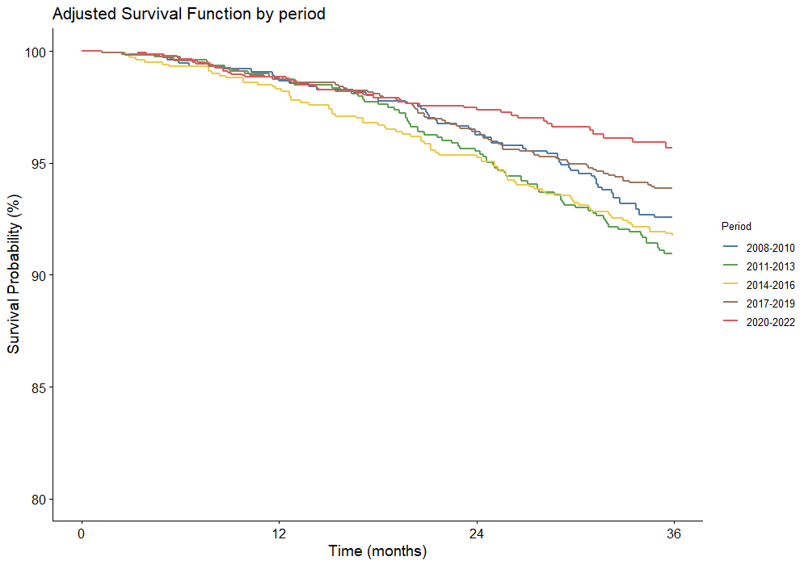
Supplementary Figure 3. Adjusted 3-year overall survival curves from the complete-case sensitivity analysis
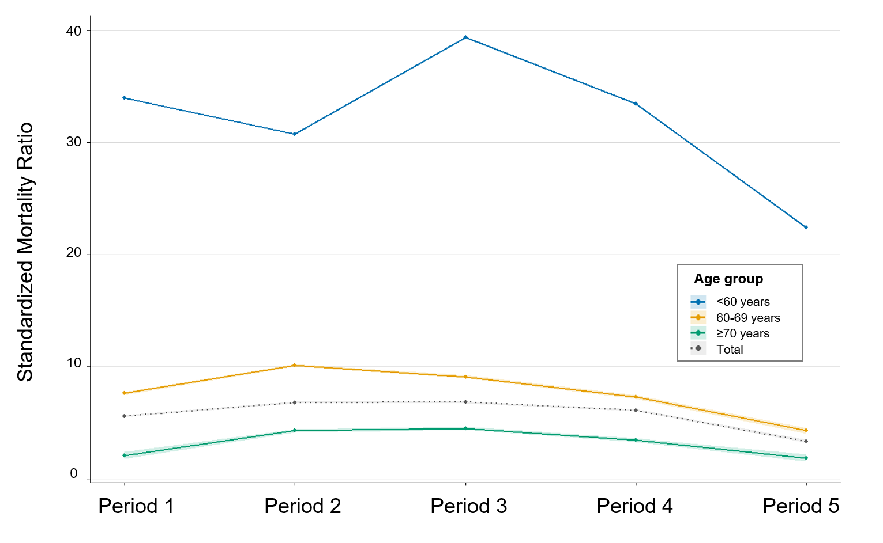
Supplementary Figure 4 Standardized mortality ratios by age group across periods
SMR values greater than 1 indicate higher mortality than expected relative to the age-matched general Korean population.

