Supplementary Information: Synthesis and characterization of F-α-DDB-derivative

Synthesis
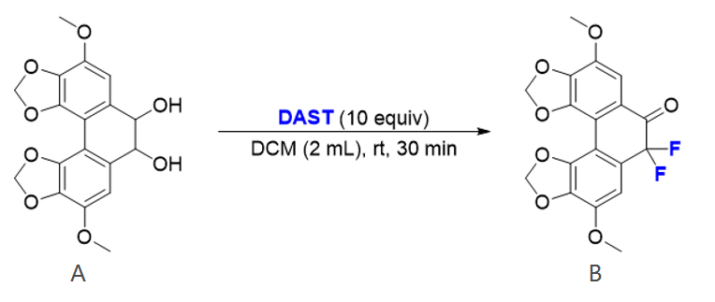
Figure S1. Synthetic route for F-α-DDB-derivative.

Compound A, the precursor used for the synthesis of F-α-DDB-derivative, was prepared according to a previously reported patent procedure [1]. The fluorination reaction was performed based on a reported synthetic transformation strategy, with minor modifications [2].

A 10 mL plastic reaction tube was charged with compound A (0.056 mmol, 20 mg, 1.0 equiv). DAST (100 mg, 0.56 mmol, 10 equiv), pre-weighed in a microcentrifuge tube, was diluted with 1 mL of dichloromethane (DCM) at room temperature and added to the reaction vessel. The reaction mixture was then stirred at room temperature for 30 min. During the reaction, substantial consumption of the starting material was observed, accompanied by a rapid color change of the reaction mixture from orange to brown and finally to black within a few seconds. Upon completion, the reaction was quenched by the addition of an appropriate amount of water. No marked exotherm or gas evolution, suggestive of residual unreacted DAST, was observed during quenching, and the organic phase gradually changed from black to brown-orange. The reaction mixture was extracted three times with DCM, and the combined organic layers were concentrated under reduced pressure. The crude residue was purified by column chromatography using petroleum ether/ethyl acetate (10:1, v/v) as the eluent. The product spot was visualized under short-wave UV light at 254 nm and exhibited pale yellow fluorescence under long-wave UV light at 365 nm.

Characterization
Figure S2. Chemical structure of F-α-DDB-derivative. The compound was identified as 7,7-difluoro-4,9-dimethoxyphenanthro[3,4-d:5,6-d']bis([1,3]dioxole)-6(7H)-one, with the molecular formula C18H12F2O7 and a molecular weight of 378.28.

Yellow solid, 20%. MP: 240–242 oC. 1H NMR (400 MHz, CDCl3) δ 7.31 (s, 1H), 7.06 (s, 1H), 6.16 (s, 2H), 6.09 (s, 2H), 3.97 (s, 6H).; 19F NMR (376 MHz, CDCl3) δ -103.83 (s); 13C NMR (100 MHz, CDCl3) δ 185.63 (t, J = 27.1 Hz), 146.00, 145.14, 143.68, 143.57, 142.65, 138.95, 125.45, 125.06, 122.57 (d, J = 10.9 Hz), 109.79 (t, J = 245.4 Hz), 109.65, 107.24 (t, J = 6.4 Hz), 106.66 (t, J = 5.2 Hz), 102.77, 102.26, 56.93, 56.81; LCMS (ESI, m/z): 379.05 (M+H+); LCMS (EI, m/z): 378 (M+); IR (film): 3617, 3164, 3003, 2944, 2628, 2410, 2293, 2253, 1633, 1444, 1376, 1193, 1039, 918, 750 cm-1.

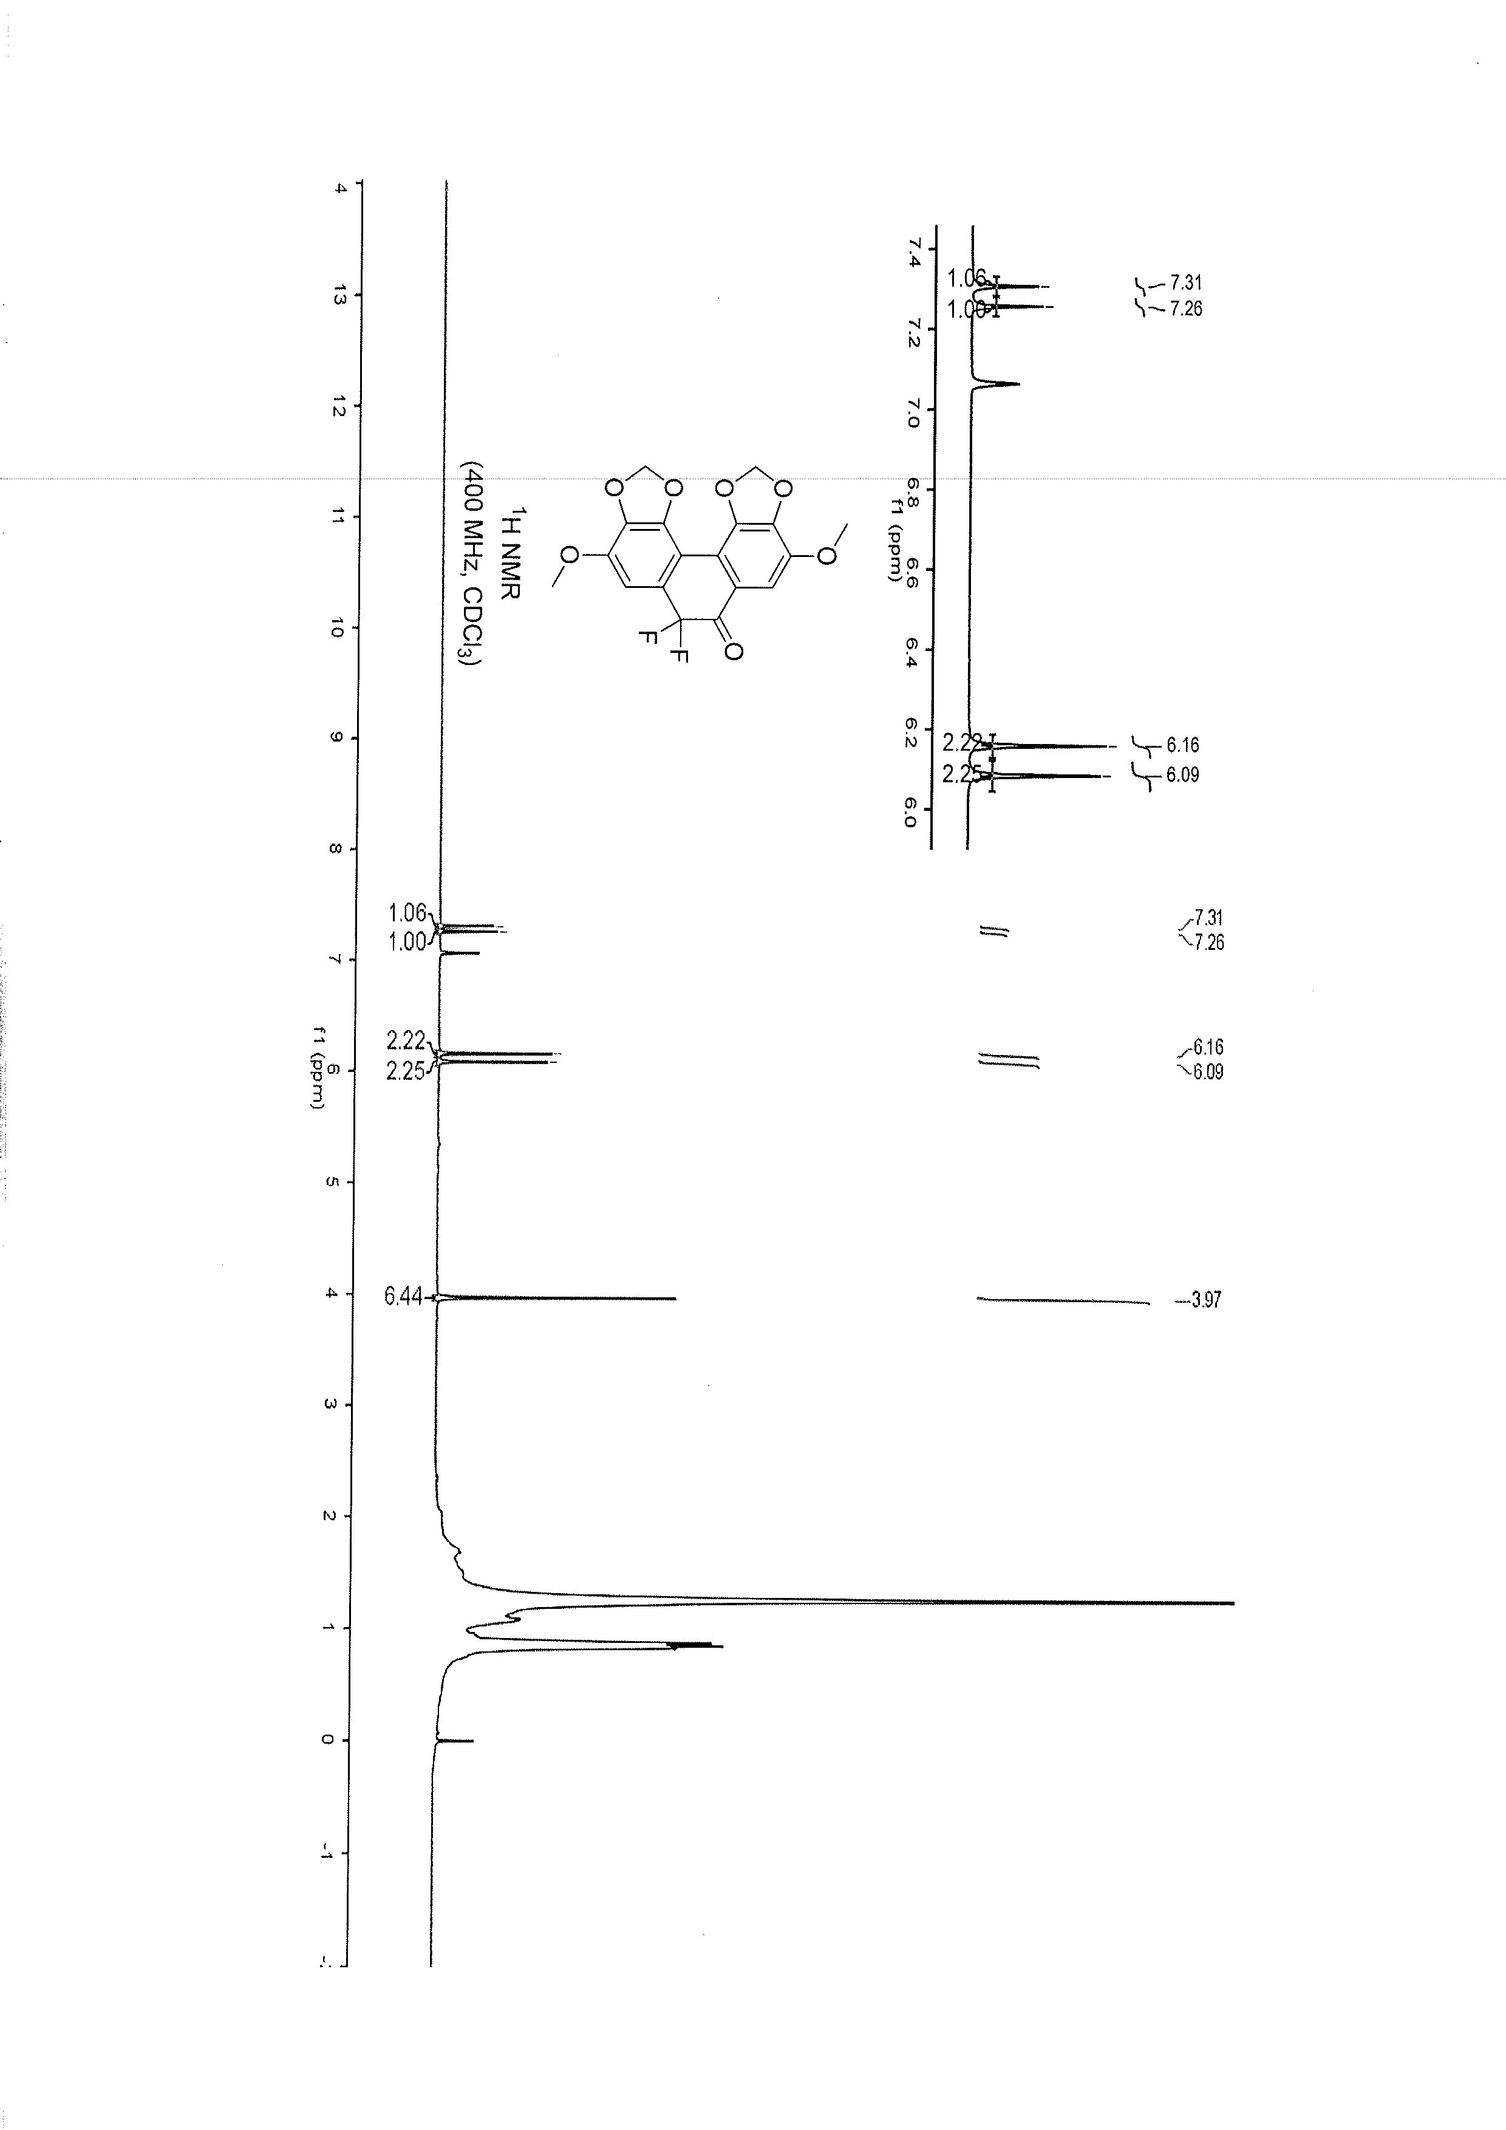
Figure S3. ¹H NMR spectrum of F-α-DDB-derivative.
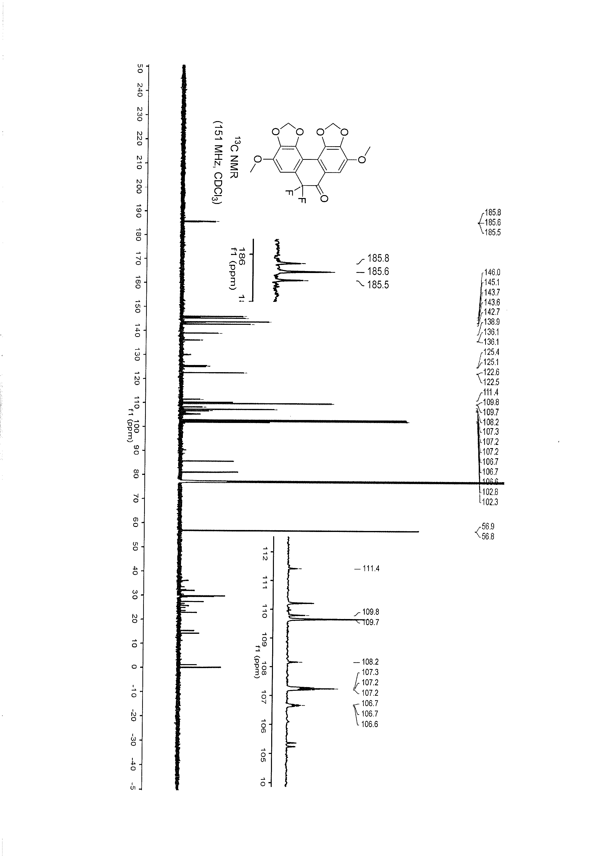
Figure S4. ¹³C NMR spectrum of F-α-DDB-derivative.

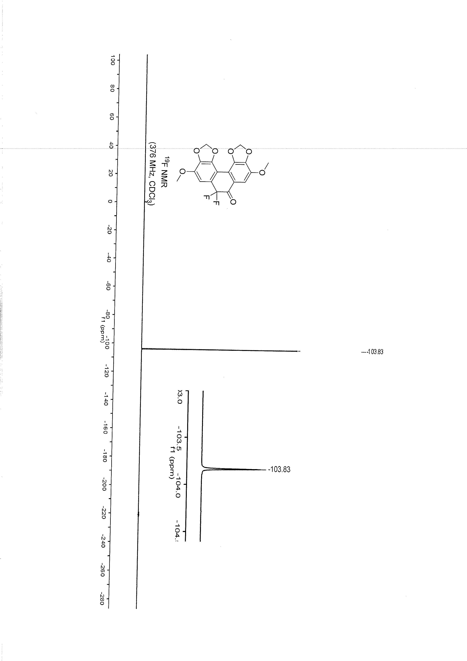
Figure S5. ¹⁹F NMR spectrum of F-α-DDB-derivative.

Single-crystal structure data
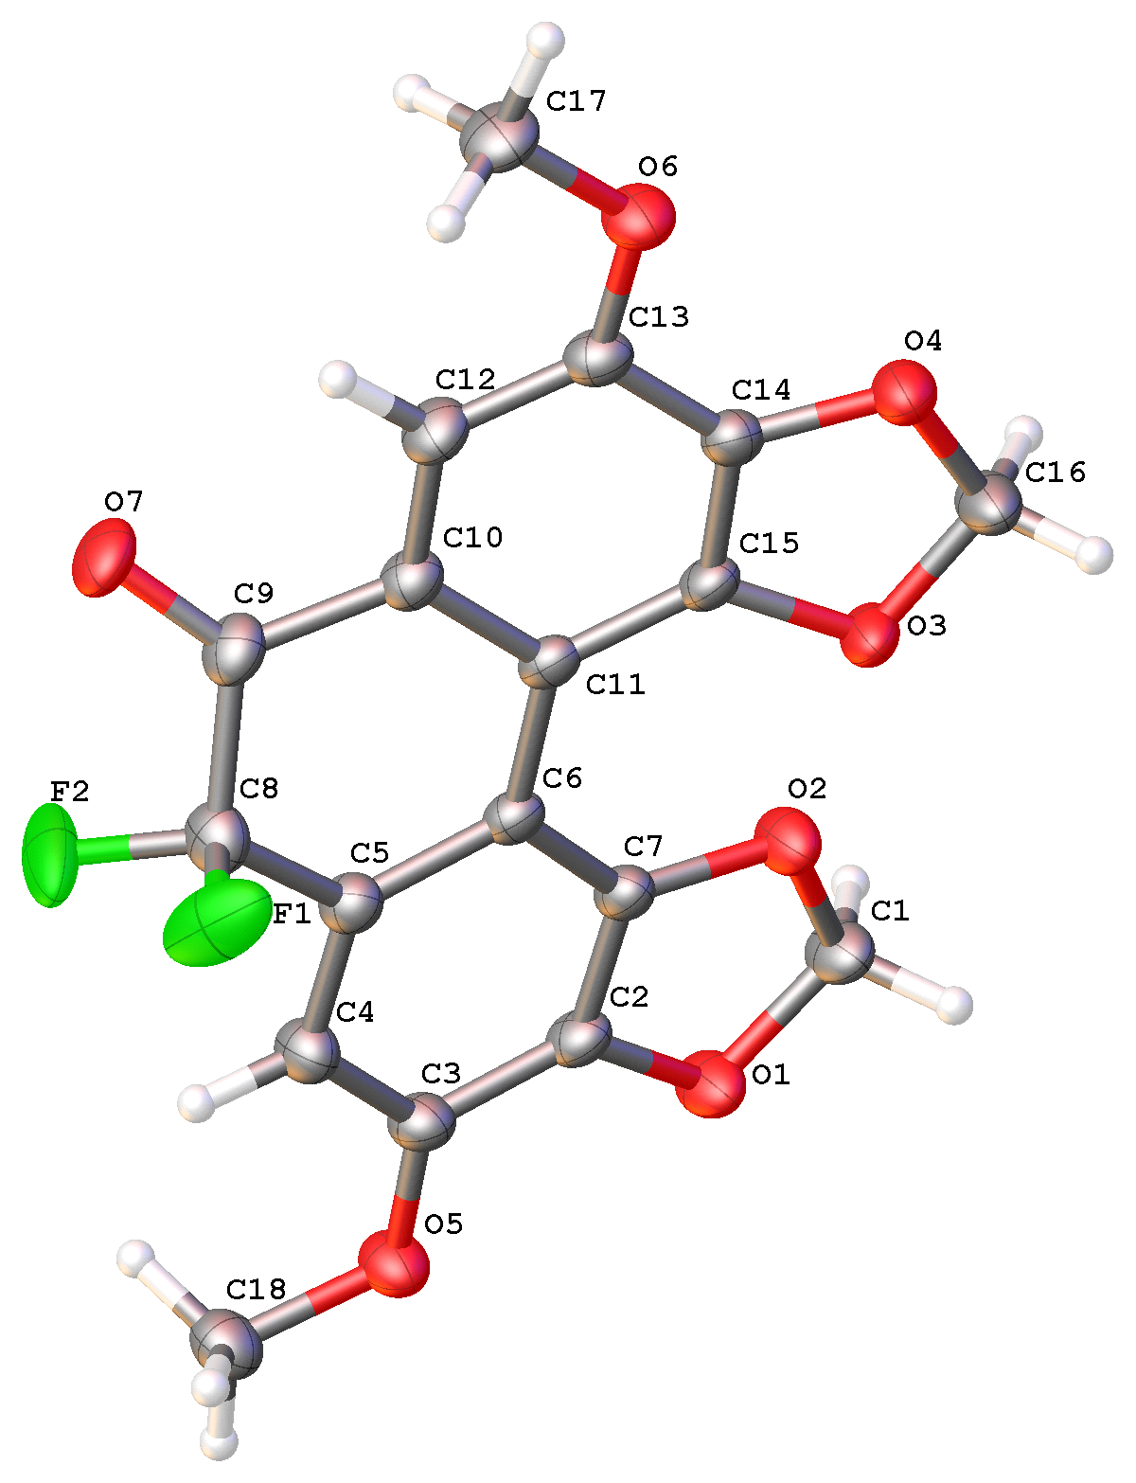
Figure S6. Single-crystal X-ray structure of F-α-DDB-derivative (CCDC 2557516).
Table 1. Crystal data and structure refinement for mj20710_0m.
Identification code | mj20710_0m
Empirical formula | C₁₈ H₁₂ F₂ O₇
Formula weight | 378.28
Temperature | 173.0 K
Wavelength | 1.34139 Å
Crystal system | Monoclinic
Space group | P 1 21/n 1
Unit cell dimensions | a = 4.4427(2) Å α = 90°
 | b = 19.2576(8) Å β = 96.291(2)°
 | c = 19.5203(8) Å γ = 90
Volume | 1660.02(12) Å3
Z | 4
Density (calculated) | 1.514 Mg/m³
Absorption coefficient | 0.733 mm-1
F(000) | 776
Crystal size | 0.09 x 0.08 x 0.06 mm³
Theta range for data collection | 4.440 to 54.962°
Index ranges | -5<=h<=5, -21<=k<=23, -23<=l<=23
Reflections collected | 17453
Independent reflections | 3157 [R(int) = 0.0589]
Completeness to theta = 53.594? | 99.6 %
Absorption correction | Semi-empirical from equivalents
Max. and min. transmission | 0.7508 and 0.4740
Refinement method | Full-matrix least-squares on F²
Data / restraints / parameters | 3157 / 0 / 274
Goodness-of-fit on F² | 1.047
Final R indices [I>2sigma(I)] | R1 = 0.0497, wR2 = 0.1338
R indices (all data) | R1 = 0.0625, wR2 = 0.1436
Extinction coefficient | n/a
Largest diff. peak and hole | 0.210 and -0.207 e.Å-3

Table 2. Atomic coordinates ( x 104) and equivalent isotropic displacement parameters (Å2x 103)
for mj20710_0m. U(eq) is defined as one third of the trace of the orthogonalized Uij tensor.
 | x | y | z | U(eq)
O(1) | 8205(4) | 2694(1) | 658(1) | 59(1)
O(2 | 5525(4) | 1922(1) | 1265(1) | 55(1)
O(3) | 1438(4) | 1339(1) | 1882(1) | 56(1)
O(4) | -1076(4) | 681(1) | 2624(1) | 56(1)
O(5) | 10233(4) | 4009(1) | 1116(1) | 55(1)
O(6) | -1191(4) | 932(1) | 4032(1) | 55(1)
C(1) | 7018(6) | 2004(1) | 658(1) | 56(1)
C(2) | 7724(5) | 2968(1) | 1285(1) | 44(1)
C(3) | 8685(5) | 3608(1) | 1529(1) | 45(1)
C(4) | 7972(5) | 3774(1) | 2183(1) | 48(1)
C(5) | 6385(5) | 3311(1) | 2558(1) | 42(1)
C(6) | 5328(4) | 2655(1) | 2309(1) | 38(1)
C(7) | 6112(4) | 2508(1) | 1651(1) | 40(1)
C(8) | 5780(5) | 3544(1) | 3255(1) | 51(1)
C(9) | 5081(5) | 2978(1) | 3756(1) | 49(1)
C(10) | 3556(5) | 2357(1) | 3453(1) | 43(1)
C(11) | 3636(4) | 2200(1) | 2742(1) | 36(1)
C(12) | 2049(5) | 1944(1) | 3893(1) | 49(1)
C(13) | 440(5) | 1361(1) | 3659(1) | 44(1)
C(14) | 465(5) | 1211(1) | 2972(1) | 42(1)
C(15) | 1988(5) | 1612(1) | 2535(1) | 41(1)
C(16) | -101(7) | 702(1) | 1950(1) | 65(1)
C(17) | -1312(6) | 1104(1) | 4742(1) | 61(1)
C(18) | 11314(6) | 4662(1) | 1396(1) | 56(1)
F(1) | 3399(10) | 3950(2) | 3237(1) | 97(1)
F(2) | 8152(9) | 3920(2) | 3586(1) | 96(1)
O(7) | 5840(8) | 3029(2) | 4388(1) | 62(1)
F(3) | 3321(14) | 3320(2) | 4195(2) | 83(2)
F(4) | 7671(11) | 2880(2) | 4070(2) | 76(2)
O(8) | 5588(18) | 4165(2) | 3382(3) | 61(2)

Table 3. Bond lengths [Å] and angles [°] for mj20710_0m.
O(1)-C(1) | 1.429(3)
O(1)-C(2) | 1.370(2)
O(2)-C(1) | 1.429(2)
O(2)-C(7) | 1.366(2)
O(3)-C(15) | 1.375(2)
O(3)-C(16) | 1.416(3)
O(4)-C(14) | 1.367(2)
O(4)-C(16) | 1.430(3)
O(5)-C(3) | 1.357(2)
O(5)-C(18) | 1.433(3)
O(6)-C(13) | 1.361(2)
O(6)-C(17) | 1.431(3)
C(1)-H(1A) | 0.9900
C(1)-H(1B) | 0.9900
C(2)-C(3) | 1.373(3)
C(2)-C(7) | 1.385(3)
C(3)-C(4) | 1.384(3)
C(4)-H(4) | 0.9500
C(4)-C(5) | 1.394(3)
C(5)-C(6) | 1.416(3)
C(5)-C(8) | 1.484(3)
C(6)-C(7) | 1.396(2)
C(6)-C(11) | 1.479(3)
C(8)-C(9) | 1.520(3)
C(8)-F(1) | 1.312(4)
C(8)-F(2) | 1.379(3)
C(8)-O(8) | 1.226(5)
C(9)-C(10) | 1.467(3)
C(9)-O(7) | 1.248(3)
C(9)-F(3) | 1.388(4)
C(9)-F(4) | 1.258(4)
C(10)-C(11) | 1.425(2)
C(10)-C(12) | 1.395(3)
C(11)-C(15) | 1.384(3)
C(12)-H(12) | 0.9500
C(12)-C(13) | 1.382(3)
C(13)-C(14) | 1.372(3)
C(14)-C(15) | 1.382(3)
C(16)-H(16A) | 0.9900
C(16)-H(16B) | 0.9900
C(17)-H(17A) | 0.9800
C(17)-H(17B) | 0.9800
C(17)-H(17C) | 0.9800
C(18)-H(18A) | 0.9800
C(18)-H(18B) | 0.9800
C(18)-H(18C) | 0.9800
C(2)-O(1)-C(1) | 105.35(14)
C(7)-O(2)-C(1) | 106.70(15)
C(15)-O(3)-C(16) | 106.46(15)
C(14)-O(4)-C(16) | 104.54(15)
C(3)-O(5)-C(18) | 116.28(16)
C(13)-O(6)-C(17) | 117.20(17)
O(1)-C(1)-O(2) | 107.90(15)
O(1)-C(1)-H(1A) | 110.1
O(1)-C(1)-H(1B) | 110.1
O(2)-C(1)-H(1A) | 110.1
O(2)-C(1)-H(1B) | 110.1
H(1A)-C(1)-H(1B) | 108.4
O(1)-C(2)-C(3) | 125.65(17)
O(1)-C(2)-C(7) | 110.72(17)
C(3)-C(2)-C(7) | 123.63(17)
O(5)-C(3)-C(2) | 117.55(17)
O(5)-C(3)-C(4) | 126.81(19)
C(2)-C(3)-C(4) | 115.64(17)
C(3)-C(4)-H(4) | 119.4
C(3)-C(4)-C(5) | 121.18(19)
C(5)-C(4)-H(4) | 119.4
C(4)-C(5)-C(6) | 123.87(17)
C(4)-C(5)-C(8) | 116.22(18)
C(6)-C(5)-C(8) | 119.91(17)
C(5)-C(6)-C(11) | 120.15(16)
C(7)-C(6)-C(5) | 112.98(17)
C(7)-C(6)-C(11) | 126.87(17)
O(2)-C(7)-C(2) | 108.83(16)
O(2)-C(7)-C(6) | 128.49(17)
C(2)-C(7)-C(6) | 122.68(17)
C(5)-C(8)-C(9) | 116.28(17)
F(1)-C(8)-C(5) | 112.5(2)
F(1)-C(8)-C(9) | 102.9(2)
F(1)-C(8)-F(2) | 105.8(3)
F(2)-C(8)-C(5) | 112.5(2)
F(2)-C(8)-C(9) | 105.9(2)
O(8)-C(8)-C(5) | 120.3(3)
O(8)-C(8)-C(9) | 123.1(3)
C(10)-C(9)-C(8) | 116.36(17)
O(7)-C(9)-C(8) | 121.9(2)
O(7)-C(9)-C(10) | 121.7(2)
F(3)-C(9)-C(8) | 103.1(2)
F(3)-C(9)-C(10) | 111.7(2)
F(4)-C(9)-C(8) | 100.4(3)
F(4)-C(9)-C(10) | 115.6(3)
F(4)-C(9)-F(3) | 108.4(4)
C(11)-C(10)-C(9) | 120.39(17)
C(12)-C(10)-C(9) | 116.61(17)
C(12)-C(10)-C(11) | 122.99(19)
C(10)-C(11)-C(6) | 119.99(17)
C(15)-C(11)-C(6) | 127.13(16)
C(15)-C(11)-C(10) | 112.88(17)
C(10)-C(12)-H(12) | 119.2
C(13)-C(12)-C(10) | 121.66(18)
C(13)-C(12)-H(12) | 119.2
O(6)-C(13)-C(12) | 127.01(18)
O(6)-C(13)-C(14) | 117.19(18)
C(14)-C(13)-C(12) | 115.79(18)
O(4)-C(14)-C(13) | 125.84(18)
O(4)-C(14)-C(15) | 111.20(16)
C(13)-C(14)-C(15) | 122.88(19)
O(3)-C(15)-C(11) | 128.15(16)
O(3)-C(15)-C(14) | 108.02(17)
C(14)-C(15)-C(11) | 123.77(17)
O(3)-C(16)-O(4) | 107.94(16)
O(3)-C(16)-H(16A) | 110.1
O(3)-C(16)-H(16B) | 110.1
O(4)-C(16)-H(16A) | 110.1
O(4)-C(16)-H(16B) | 110.1
H(16A)-C(16)-H(16B) | 108.4
O(6)-C(17)-H(17A) | 109.5
O(6)-C(17)-H(17B) | 109.5
O(6)-C(17)-H(17C) | 109.5
H(17A)-C(17)-H(17B) | 109.5
H(17A)-C(17)-H(17C) | 109.5
H(17B)-C(17)-H(17C) | 109.5
O(5)-C(18)-H(18A) | 109.5
O(5)-C(18)-H(18B) | 109.5
O(5)-C(18)-H(18C) | 109.5
H(18A)-C(18)-H(18B) | 109.5
H(18A)-C(18)-H(18C) | 109.5
H(18B)-C(18)-H(18C) | 109.5
Symmetry transformations used to generate equivalent atoms.

Table 4. Anisotropic displacement parameters (Å2x 103) for mj20710_0m.
The anisotropic displacement factor exponent takes the form: -2p²[h²a*²U11 + ... + 2hk a*b*U12 ]
 | U11 | U22 | U33 | U23 | U13 | U12
O(1) | 94(1) | 51(1) | 34(1) | -4(1) | 24(1) | -9(1)
O(2) | 87(1) | 46(1) | 36(1) | -8(1) | 21(1) | -9(1)
O(3) | 88(1) | 52(1) | 29(1) | -1(1) | 5(1) | -20(1)
O(4) | 78(1) | 51(1) | 39(1) | 0(1) | 9(1) | -14(1)
O(5) | 76(1) | 49(1) | 44(1) | -1(1) | 21(1) | -12(1)
O(6) | 70(1) | 56(1) | 41(1) | 3(1) | 20(1) | -8(1)
C(1) | 89(2) | 50(1) | 32(1) | -2(1) | 18(1) | -4(1)
C(2) | 57(1) | 47(1) | 28(1) | 2(1) | 9(1) | 5(1)
C(3) | 56(1) | 44(1) | 37(1) | 4(1) | 12(1) | -1(1)
C(4) | 64(1) | 42(1) | 41(1) | -5(1) | 15(1) | -3(1)
C(5) | 50(1) | 43(1) | 35(1) | -1(1) | 10(1) | 4(1)
C(6) | 43(1) | 41(1) | 30(1) | 3(1) | 5(1) | 6(1)
C(7) | 54(1) | 36(1) | 31(1) | 0(1) | 6(1) | 4(1)
C(8) | 63(1) | 49(1) | 44(1) | -11(1) | 16(1) | -1(1)
C(9) | 54(1) | 61(1) | 33(1) | -8(1) | 12(1) | -2(1)
C(10) | 49(1) | 48(1) | 32(1) | -1(1) | 9(1) | 3(1)
C(11) | 42(1) | 39(1) | 29(1) | 3(1) | 5(1) | 9(1)
C(12) | 59(1) | 59(1) | 31(1) | -2(1) | 14(1) | -1(1)
C(13) | 51(1) | 46(1) | 36(1) | 6(1) | 12(1) | 5(1)
C(14) | 50(1) | 40(1) | 37(1) | 3(1) | 4(1) | 2(1)
C(15) | 52(1) | 42(1) | 26(1) | 2(1) | 3(1) | 5(1)
C(16) | 109(2) | 49(1) | 36(1) | 0(1) | 14(1) | -20(1)
C(17) | 78(2) | 71(2) | 38(1) | 4(1) | 22(1) | -5(1)
C(18) | 68(2) | 48(1) | 56(1) | -2(1) | 19(1) | -9(1)
F(1) | 140(3) | 98(2) | 56(2) | -2(2) | 22(2) | 71(2)
F(2) | 137(3) | 114(2) | 39(1) | -28(1) | 24(2) | -76(2)
O(7) | 79(2) | 79(2) | 28(1) | -7(1) | 6(1) | -14(2)
F(3) | 145(5) | 48(2) | 69(3) | -20(2) | 72(3) | -16(2)
F(4) | 90(3) | 57(2) | 71(3) | 5(2) | -32(3) | -1(2)
O(8) | 94(5) | 39(2) | 52(3) | -8(2) | 21(3) | -2(3)

Table 5. Hydrogen coordinates ( x 10⁴) and isotropic displacement parameters (Å²x 10 ³) for mj20710_0m
 | x | y | z | U(eq)
H(1A) | 8679 | 1662 | 655 | 67
H(1B) | 5568 | 1929 | 242 | 67
H(4) | 8576 | 4210 | 2378 | 58
H(12) | 2131 | 2066 | 4366 | 59
H(16A) | 1269 | 307 | 1887 | 77
H(16B) | -1869 | 670 | 1596 | 77
H(17A) | -2156 | 1571 | 4776 | 92

Supplementary references
- Lin GQ, Zhao Q, Zhu C, Zhang P, Zhou P, Shi XL, inventors; Shanghai Institute of Organic Chemistry, Chinese Academy of Sciences, assignee. Biologically active biphenyl cyclooctene lignan derivatives. China patent CN101844970A. 2010 Sep 29.
- Peng YY. Synthesis and transformation of important fluorinated intermediates [master’s thesis]. Beijing: University of Chinese Academy of Sciences; 2021. Chinese.

