Prognostic value of combined FIB-4 and AFP in predicting survival after hepatectomy for hepatocellular carcinoma: A multicenter cohort study

Yuting Yang¹, Haojie Yang^{2,3}, Yangfeng Du¹, Shuxiang Hou², Kelan Zhang², Zemin Xiao¹

1.Department of Oncology, Changde Hospital, Xiangya School of Medicine, Central South University (The First People's Hospital of Changde City), Changde 415000,Hunan Province, China
2.Department of General Surgery, Changde Hospital, Xiangya School of Medicine, Central South University(The First People's Hospital of Changde City), Changde 415000, Hunan Province, China
3.Department of Hepatobiliary Surgery, Guangxi Medical University Cancer Hospital, Nanning 530021, Guangxi Province, China

*Corresponding authors: Shuxiang Hou 467431905@qq.com
Zemin Xiao xiaozemin02@163.com
Kelan Zhang zsurgeon@163.com
Yuting Yang, Haojie Yang and Yangfeng Du have contributed equally to this work.

Background: Accurate prognostic assessment remains challenging in patients with hepatocellular carcinoma (HCC). Although the fibrosis-4 (FIB-4) index is widely used for non-invasive evaluation of liver fibrosis, its prognostic value in HCC remains uncertain. This study evaluates the prognostic utility of the FIB-4 index, alpha-fetoprotein (AFP), and the combined AFP-FIB-4 score for long-term survival in patients with HCC following hepatectomy.
Methods: A retrospective analysis was conducted on 1174 HCC patients who underwent hepatectomy at the First People’s Hospital of Changde City and Guangxi Medical University Cancer Hospital between 2014 and 2024. Survival analysis, Cox regression, and receiver operating characteristic (ROC) curve analysis were employed to assess the predictive performance of the FIB-4 index, AFP, and the combined AFP-FIB-4 score for long-term survival.
Results: Multivariate Cox regression analysis demonstrated that the FIB-4 index was not an independent predictor of disease-free survival (DFS) or overall survival (OS) in HCC patients. In contrast, AFP emerged as an independent risk factor for both DFS (HR=1.391, 95%CI=1.193-1.623, P<0.001) and OS (HR=1.267, 95%CI= 1.080-1.486, P =0.004). Notably, the combined AFP-FIB-4 score served as a stronger independent prognostic factor for both DFS (HR=1.404, 95% CI=1.204-1.638, P<0.001) and OS (HR=1.378, 95%CI=1.196-1.588, P<0.001). Subgroup analysis revealed that the FIB-4 index alone failed to significantly predict prognosis in patients with Barcelona Clinic Liver Cancer (BCLC) stage B or C (P>0.05), while AFP was ineffective in distinguishing prognosis in patients with BCLC stage 0 or A (P>0.05). However, the AFP-FIB-4 score successfully stratified each BCLC stage subgroup into two groups with significantly different prognoses (all P<0.05). ROC analysis demonstrated that the AFP-FIB-4 score achieved a significantly higher area under the curve (AUC 0.623) compared with AFP (AUC 0.553) and the FIB-4 index (AUC 0.565).
Conclusion: Incorporating AFP into the FIB-4 index enhances its prognostic performance. The AFP-FIB-4 score serves as a robust predictor of DFS and OS in HCC patients undergoing hepatectomy across different BCLC stages.
Keywords
Hepatocellular carcinoma, FIB-4 index, Alpha-fetoprotein, AFP-FIB-4 score, Prognosis

Introduction
Hepatocellular carcinoma (HCC) is one of the most prevalent malignant tumors globally and is the second leading cause of cancer-related mortality, with an increasing incidence trend[1]. Over half of new cases and mortality occur in China due to the high prevalence of hepatitis B virus (HBV) infection[1]. Although hepatectomy remains a potentially curative treatment for both early-stage and intermediate–advanced HCC patients[2, 3], the high postoperative recurrence rate significantly limits long-term survival[4].
The clinical course of HCC patients is frequently complicated by varying degrees of hepatic fibrosis, which profoundly influences treatment outcomes and prognosis[5]. Advanced fibrosis or cirrhosis has been shown to markedly increase the risk of postoperative complications and reduce long-term survival[5-8]. Although liver biopsy remains the gold standard for assessing liver fibrosis[9], its invasiveness and associated risks limit its routine use[10]. The Fibrosis-4 (FIB-4) index, a practical, cost-effective, and non-invasive alternative, has gained attention for its strong clinical utility across various liver diseases[11, 12]. This index integrates age, platelet count, aspartate aminotransferase (AST), and alanine aminotransferase (ALT) to estimate fibrosis severity[11, 13, 14]. While some studies have demonstrated the potential value of the FIB-4 index in predicting post-hepatectomy outcomes in patients with HCC[15, 16],conflicting evidence suggests that this single marker may exhibit limited sensitivity for accurately predicting long-term survival[13, 17]. These contradictory findings may be attributed to the multifactorial nature of HCC prognosis, which depends not only on liver function status but also on tumor biological behavior.
Given this complexity, while the FIB-4 index provides valuable assessment of liver fibrosis and correlates well with hepatic function[18], it inherently lacks the capacity to capture tumor-specific biological characteristics[19].This limitation suggests that comprehensive HCC prognostic evaluation may require the integration of tumor-specific biomarkers with liver function indicators to achieve more accurate risk stratification. Alpha-fetoprotein (AFP), the most widely utilized biomarker in HCC diagnosis and management, demonstrates strong associations with aggressive histological features including vascular invasion, poor differentiation, and satellite lesions, thereby serving as a critical indicator in the prognostic evaluation of HCC patients[20, 21].
Notably, while FIB-4 captures the liver fibrosis and AFP reflects tumor aggressiveness, the potential synergistic prognostic value of combining these complementary biomarkers has not been systematically investigated. Therefore, this study was designed to address this critical knowledge gap by investigating whether the integration of these complementary biomarkers can provide superior prognostic stratification compared to either marker alone.

Materials and methods

Study design and patient selection
Between May 2014 and May 2024, we included all patients with HCC who underwent hepatectomy at Changde Hospital, Xiangya School of Medicine, Central South University (The First People's Hospital of Changde City) and Guangxi Medical University Cancer Hospital in our study. Inclusion criteria were: (1) confirmed diagnosis of HCC based on the results of postoperative pathology; (2) completion of curative hepatectomy; (3) availability of comprehensive preoperative clinical and laboratory data; (4) 18 ≤age <80 years. Exclusion criteria included: (1) previous anti-tumor treatments; (2) presence of concurrent malignancies; (3) hematologic disorders, including but not limited to idiopathic thrombocytopenic purpura (ITP), aplastic anemia, myelodysplastic syndromes (MDS), and various types of leukemia or lymphoma; (4) preoperative cardiopulmonary, cerebral, or renal dysfunction.

Diagnosis and definitions
HCC was diagnosed through postoperative histopathological examination. Curative hepatectomy was characterized by the complete macroscopic resection of the tumor with histologically negative margins, indicating effective removal of malignant tissue[22]. The FIB-4 index was calculated using the formula: FIB-4 = AST (IU/L) × age (years) / [platelet count (×10⁹/L) × ALT (IU/L)^{1/2}][11]. An optimal cutoff threshold of 3.0 was based on the maximum Youden Index derived from receiver operating characteristic (ROC) curve analysis. Based on this threshold, patients with FIB-4 index ≥ 3.0 were classified as having high FIB-4 scores and assigned a binary value of 1, while those with FIB-4 index < 3.0 were classified as having low FIB-4 scores and assigned a binary value of 0. The preoperative AFP cutoff was established at our institutional routine standard of 200 ng/mL, as ROC analyses showed no statistically significant differences in predictive performanc among conventional thresholds (100, 200, and 400 ng/mL; DeLong test, all P > 0.05; Figure 5).Patients with serum AFP levels < 200 ng/mL were classified as having low AFP levels[23, 24] and assigned a binary value of 0, while those with serum AFP levels ≥ 200 ng/mL were classified as having high AFP levels and assigned a binary value of 1[25]. The combined AFP-FIB-4 score was calculated by summing the binary values of the two variables, yielding a composite score ranging from 0 to 2. Patients with a composite score of 0 were categorized as AFP-FIB-4 score 1, while those with composite scores of 1 or 2 were initially analyzed separately. However, preliminary analyses revealed no statistically significant prognostic differences between patients with composite scores of 1 and 2 (all P>0.05). To ensure the model's simplicity and practical utility for clinical decision-making, we chose to merge these two subgroups into a single category designated as AFP-FIB-4 score 2. The aspartate aminotransferase to platelet ratio index (APRI) score was calculated as 100 × ([AST/ULN]/PLT count [10⁹/L]) and was categorised into two grades: grade 1 (<1.5) and grade 2 (≥1.5)[11].

Follow-up
Patients with HCC underwent follow-up assessments one month after hepatectomy, with subsequent evaluations every 3 months during the first year and then every 3 to 6 months in subsequent years, depending on individual clinical needs. Each follow-up included testing for serum AFP, biochemical analysis, ultrasound, and magnetic resonance imaging (MRI) or computed tomography (CT). The study endpoints were OS and DFS. OS was defined as the time from surgery to death or study conclusion, while DFS was defined as the time from hepatectomy to tumor recurrence.

Statistical Analysis
All statistical analyses were performed using R software (version 4.2.1; The R Foundation for Statistical Computing, Vienna, Austria). Continuous variables were presented as mean ± standard deviation for normally distributed data and as median with range for non-normally distributed data. To handle missing data, variables with a high proportion of missingness were excluded, whereas those with minimal missing data were imputed using the mean or median[26]. Survival analysis was conducted using Kaplan-Meier curves, with differences assessed by the log-rank test. Independent prognostic factors were identified using Cox proportional hazards regression. The optimal cutoff for the FIB-4 index was determined using ROC curve analysis to maximize diagnostic accuracy. Statistical significance was set at a p-value < 0.05.

Results

Study population
Between May 2014 and May 2024, a total of 1518 patients with HCC underwent hepatectomy with curative intent. Of these, 251 patients (16.5%) had received other treatments before hepatectomy; 38 patients (2.5%) had concurrent hematologic disorders; 32 patients (2.1%) had additional malignant tumors; and 23 patients (1.5%) had preoperative cerebral, cardiopulmonary, or renal dysfunction. After applying the exclusion criteria, 1174 patients (77.3%) were included in our study.

Patient characteristics

Demographic and clinical characteristics of the studied HCC cohort (n=1174) are presented in Table 1. Based on the established cutoff threshold of 3.0, 868 patients (73.9%) were classified as having low FIB-4 scores (< 3.0), while 306 patients (26.1%) were classified as having high FIB-4 scores (≥ 3.0). Regarding serum AFP levels, 615 patients (52.4%) were classified as having low AFP levels (< 200 ng/mL), while 559 patients (47.6%) were classified as having high AFP levels (≥ 200 ng/mL). According to the combined AFP-FIB-4 scoring system, 446 patients (38.0%) were categorized as AFP-FIB-4 score 1, while 728 patients (62.0%) were categorized as AFP-FIB-4 score 2.

Univariate and multivariate analysis of prognostic factors for long-term survival

We conducted univariate analysis and Cox proportional hazards regression to identify potential factors associated with DFS and OS. For multivariate analysis, preliminary correlation analysis revealed significant collinearity between the AFP-FIB-4 score and serum AFP levels. To address this multicollinearity issue and ensure the validity of our statistical analysis, these two variables were evaluated in separate Cox proportional hazards regression models. Table 2 presents the results of the univariate and multivariate analyses for DFS. Univariate analysis identified significant associations between DFS and the AFP-FIB-4 score, FIB-4 ≥ 3.0, AST ≥ 80 U/L, AFP ≥ 200 ng/mL, platelet count ≥ 100×10⁹/L, tumor capsule, BCLC stage B or C, tumor number, tumor size ≥ 5 cm. Multivariate analysis revealed seven independent risk factors for DFS: AFP-FIB-4 score, AFP ≥ 200 ng/mL, platelet count ≥ 100×10⁹/L, tumor capsule, BCLC stage B or C, tumor size ≥ 5 cm, and tumor number (all P < 0.05).

As shown in Table 3, univariate analysis for OS identified several factors associated with poor prognosis, including APRI ≥ 1.5, AFP-FIB-4 score, FIB-4 ≥ 3.0, AST ≥ 80 U/L, AFP ≥ 200 ng/mL, albumin ≥ 35 g/L, tumor capsule, BCLC stage B or C, tumor number, and tumor size ≥ 5 cm. Multivariate analysis revealed six independent risk factors for poor prognosis: AFP-FIB-4 score, AFP ≥ 200 ng/mL, tumor capsule, BCLC stage B or C, tumor size ≥ 5 cm, and tumor number (all P < 0.05).

Comparative performance of FIB-4 index, AFP, and AFP-FIB-4 score across BCLC stages

Survival analyses were performed among patients with different FIB-4 scores, serum AFP levels and AFP-FIB-4 score across BCLC stages.
Among patients with early-stage disease (BCLC stage 0/A), those with high FIB-4 scores (≥ 3.0) exhibited significantly inferior DFS and OS compared to those with low FIB-4 scores (< 3.0) (P = 0.002 for DFS and P < 0.001 for OS; Figure 1A and 1B). Conversely, in patients with intermediate to advanced disease (BCLC stages B and C), FIB-4 scores failed to demonstrate prognostic significance for either survival endpoint, with no statistically significant differences observed between low and high FIB-4 score groups (P = 0.699 and P = 0.126 for BCLC stage B; P = 0.363 and P = 0.184 for BCLC stage C; Figure 1C-F).
In contrast to FIB-4, serum AFP levels demonstrated a distinct prognostic pattern across different disease stages. Among patients with early-stage disease (BCLC stage 0/A), AFP levels failed to discriminate survival outcomes, with no significant differences in either DFS or OS between low AFP (< 200 ng/mL) and high AFP (≥ 200 ng/mL) groups (P = 0.289 for DFS and P = 0.199 for OS; Figure 2A and 2B). Conversely, in patients with intermediate to advanced disease (BCLC stages B and C), elevated serum AFP levels (≥ 200 ng/mL) were associated with significantly inferior survival outcomes compared to those with low AFP levels (< 200 ng/mL). Specifically, patients with high AFP levels demonstrated worse DFS (P < 0.001 for BCLC stage B and P = 0.004 for BCLC stage C) and OS (P = 0.019 for BCLC stage B and P < 0.001 for BCLC stage C) (Figure 2C-F).
Most importantly, the AFP-FIB-4 combined scoring system achieved what individual biomarkers could not: effective prognostic stratification across all BCLC stages. Patients with high AFP-FIB-4 scores (score 2) demonstrated consistently worse survival outcomes compared to those with low scores (score 1) in early-stage (P =0.001 and P< 0.001), intermediate-stage (P=0.007 and P=0.042), and advanced-stage disease (P < 0.001 and P = 0.007) for DFS and OS, respectively (Figure 3).
Comparison of predictive capacity of AFP, ALBI, FIB-4 index and AFP-FIB-4 scores
ROC curve analysis was performed to evaluate the predictive performance of individual biomarkers and their combination for long-term survival. The integrated AFP-FIB-4 scoring system demonstrated superior discriminatory capacity (AUC = 0.623) compared to individual biomarkers: FIB-4 index (AUC = 0.565, p < 0.001), ALBI (AUC = 0.517, p < 0.001) and AFP (AUC = 0.553, p < 0.001) (Figure 4).
Subgroup Analysis
Subgroup analyses were performed to evaluate the prognostic value of the AFP-FIB-4 score across different clinical strata (Tables 4 and 5). The results indicated that the AFP-FIB-4 score lacked significant discriminative power for DFS in patients characterized by age ≥ 60 years, tumor size < 5 cm, Child-Pugh class B, PLT <100×10⁹/L, APRI ≥1.5, AST ≥80 U/L and ALT ≥80 U/L (all P >0.05; Table 4). Similarly, no significant association was observed between the AFP-FIB-4 score and OS in subgroups including age ≥60 years, negative HBsAg, tumor number ≥2, Child-Pugh class B, Albumin < 35g/L, PLT <100×10⁹/L, APRI≥1.5, AST≥80 U/L, and ALT≥80 U/L (all P > 0.05; Table 5).

Discussion
The management of HCC presents unique challenges due to the dual influence of liver function and tumor biology on survival outcomes[27, 28]. While the BCLC staging system effectively integrates survival prognosis with treatment recommendations, significant heterogeneity exists within each stage category[29]. This heterogeneity is particularly concerning given that nearly half of patients with early-stage disease succumb within five years despite receiving guideline-recommended therapy[30, 31]. Such outcomes underscore the critical need for refined risk stratification tools that can identify high-risk patients across all disease stages, enabling more personalized treatment approaches and intensive surveillance strategies.
Our observation regarding the stage-specific performance of individual biomarkers aligns with and expands upon recent literature. Previous studies have heavily emphasized the utility of the FIB-4 index as a reflection of background liver cirrhosis and a predictor of recurrence in HCC patients undergoing curative resection or ablation[32, 33]. Concurrently, AFP is widely recognized as a surrogate for tumor biological behavior and a robust prognostic biomarker for HCC[34, 35]. However, investigations into the stage-specific prognostic performance of FIB-4 and AFP across different BCLC stages remain sparse, and their synergistic potential when combined has rarely been explored. In this comprehensive analysis of a substantial HCC patient cohort, we systematically evaluated the prognostic utility of individual biomarkers (FIB-4 index and AFP) and their novel combination (AFP-FIB-4 score) across different BCLC stages. Our findings revealed distinct stage-specific prognostic patterns: while the FIB-4 index demonstrated predictive value exclusively in early-stage disease (BCLC 0/A), AFP showed prognostic significance primarily in intermediate to advanced stages (BCLC B/C). Notably, the integrated AFP-FIB-4 scoring system overcame these individual limitations, achieving consistent prognostic stratification across all BCLC stages with statistically significant discrimination of both DFS and OS outcomes. ROC curve analysis further validated the superior discriminatory capacity of the combined score (AUC = 0.623) compared to either biomarker alone (FIB-4: AUC = 0.565; AFP: AUC = 0.553). This comprehensive prognostic performance suggests that the AFP-FIB-4 score may serve as a clinically valuable tool for universal risk stratification in HCC patients across all disease stages. Moreover, while recent deep-learning imaging protocols offer high accuracy, their clinical application is often hindered by prohibitive costs and poor standardization[36], the AFP-FIB-4 score leverages routinely available, objective laboratory parameters.
In our study, multivariate analysis demonstrated that FIB-4 index failed to emerge as an independent prognostic factor. This finding is consistent with previous studies[13, 37]. The FIB-4 index, calculated from platelet count, age, ALT, and AST levels, primarily reflects hepatic inflammation and fibrosis status[38]. The observed association between FIB-4 index and survival outcomes likely reflects the severity of underlying liver disease, thereby indirectly influencing patient prognosis. Nevertheless, when tumor-related variables directly associated with biological behavior—including tumor stage, size, and number—were incorporated into the multivariate model, these factors demonstrated more pronounced prognostic significance, rendering the predictive value of FIB-4 index non-significant in the multivariate analysis.
Differences in prognostic performance of FIB-4 index and AFP across BCLC stages can be attributed to multiple factors. In BCLC stage 0 or A, where tumor burden is minimal and metastasis is absent[29], liver fibrosis is a key determinant of patient outcomes[38]. The FIB-4 index effectively evaluates fibrosis severity, providing insights into liver functional reserve and potential postoperative complications[39], thereby helping to distinguish survival differences. The mechanism underlying its effectiveness in early stages lies in its ability to reflect the risk of multicentric occurrence (de novo recurrence) and the liver's tolerance to curative treatments like resection or ablation[40]. Conversely, AFP levels are often low at this stage due to the limited presence of tumor cells, many of which are well-differentiated and have low synthetic activity[41, 42]. Moreover, non-tumor liver conditions such as hepatitis or cirrhosis can cause mild AFP elevation[43], reducing its specificity and limiting its standalone prognostic value. In BCLC stages B or C, the disease typically involves a higher tumor burden, multiple nodules, vascular invasion, or distant metastases[29]. Here, tumor biology becomes the primary determinant of prognosis, while liver function plays a relatively lesser role. Consequently, the predictive value of FIB-4 diminishes. However, AFP levels are often markedly elevated due to aggressive tumor behavior and active synthesis, correlating strongly with malignancy and effectively distinguishing survival outcomes in these patients. Marked AFP elevation in these patients is often associated with epithelial-mesenchymal transition (EMT) and vascular invasion[44, 45], directly reflecting a high proliferative capacity. The prognosis of HCC is a complex process influenced by both liver function and tumor biology[46]. Compared with other scoring systems like ALBI and PALBI, which focus predominantly on hepatic functional reserve via albumin and bilirubin levels, FIB-4[47] offers a unique advantage by incorporating age and AST, potentially capturing a broader spectrum of chronic liver injury and inflammation. However, ALBI[48] may be more sensitive in detecting subtle changes in bilirubin metabolism that FIB-4 might overlook.
In our study, the prognostic power of the AFP-FIB-4 score was attenuated in high-risk/inflammatory subgroups (PLT < 100 × 109/L, APRI ≥ 1.5, elevated AST/ALT, and Child-Pugh B status) but remained robust in favorable cohorts (PLT ≥ 100 × 109/L, APRI < 1.5, normal transaminase levels, and Child-Pugh A status). This discrepancy is likely due to several reasons. Methodologically, severe thrombocytopenia or acute inflammatory flare-ups artificially inflate and cluster FIB-4 values at the higher end. This compression of statistical variance diminishes its intra-strata discriminatory power and causes the score to reflect acute injury rather than chronic fibrosis. Conversely, in well-compensated patients, the absence of such mathematical distortion unlocks optimal statistical resolution. Stable transaminases allow the FIB-4 score to serve as a true surrogate for baseline chronic fibrosis, which acts synergistically with AFP to maximize risk stratification without confounding effects.
Our study has several limitations. First, its retrospective design may introduce biases, and the lack of external validation further limits the robustness of our findings. Future research should include prospective studies and external validation to address these limitations. Second, the study population was limited to Chinese patients with HCC, predominantly infected with HBV (85%), which restricts the generalizability of our results to other etiologies, such as hepatitis C virus (HCV) or alcohol-related liver diseases. Third, while we derived the optimal FIB-4 index cutoff value through ROC curve analysis within our study population, this threshold lacks universal validation and standardization in clinical practice. The clinical utility of this cutoff value requires further validation through independent cohorts and prospective studies before widespread clinical implementation can be recommended. Last, our exploratory subgroup analyses lacked multiple-comparison adjustments (e.g., Bonferroni correction) and should be interpreted cautiously as hypothesis-generating rather than confirmatory.
Conclusion
In conclusion, our study demonstrates that incorporating AFP into the FIB-4 index enhances its prognostic performance. The AFP-FIB-4 score is a robust predictor of DFS and OS in patients with HCC undergoing hepatectomy across different BCLC stages. Higher AFP-FIB-4 scores were associated with increased postoperative recurrence rates and poorer long-term survival. In clinical practice, the primary utility of this score lies in its synergistic integration of liver fibrosis and tumor burden indicators. By transcending the stage-specific limitations inherent to individual biomarkers, the score enables robust and consistent prognostic stratification across the entire BCLC spectrum, from early-stage to advanced disease.

Abbreviations
HCC Hepatocellular carcinoma
FIB-4 Fibrosis-4
AFP Alpha-fetoprotein
ROC Receiver operating characteristic
DFS Disease-free survival
OS Overall survival
BCLC Barcelona Clinic Liver Cancer
HBV Hepatitis B virus
AST Aspartate aminotransferase
ALT Alanine aminotransferase
APRI Aspartate aminotransferase to platelet ratio index
MRI Magnetic resonance imaging
CT Computed tomography
HCV Hepatitis C virus

Data availability statement
The data supporting these findings are included in the manuscript and its supplementary materials. Further inquiries may be directed to the corresponding authors.
Ethics statement and consent to participate
The study was reviewed and approved by the ethics committees of Guangxi Medical University Cancer Hospital (approval number: KY2026390) and The First People’s Hospital of Changde City(approval number: 2025-260-01).
Due to the retrospective nature of this study, the requirement for individual informed consent was waived by the ethics committee. All data analyses were performed in strict accordance with the principles of the Declaration of Helsinki, as well as the ethical guidelines established by Guangxi Medical University Cancer Hospital and The First People’s Hospital of Changde City.
Author contributions
YTY, HJY and YFD contributed equally to this work. SXH: Conceptualization, Data curation, Follow-up with postoperative patients, Writing-review & editing. YFD: Conceptualization, Supervision, Writing-review & editing. ZMX and KLZ: Conceptualization, Supervision, Writing-review & editing. HJY: Data curation, Formal analysis, Writing-original draft, Writing-review & editing. YTY: Formal analysis, Writing-original draft, Writing-review & editing.
Funding
This research was supported by Hunan Provincial Natural Science Foundation Of China (2026JJ82491,2026JJ82492) and The science and technology innovation Program of Changde City (2016KZ10,2016KZ09,2016KZ01).
Acknowledgments
The authors extend their sincere gratitude to the patients who participated in this study.
Conflict of interest
The authors declare that this research was conducted in the absence of any commercial or financial relationships that could be construed as a potential conflict of interest.
Competing interests
No competing interests were declared by the authors.
Consent for publication
Not applicable.

Table 1 Baseline Characteristics of patients with HCC treated by surgical resection
Variables | No. of patients (n=1174)
Age ,years | 47.3±11.21
Sex ratio (M:F) | 1026:148
Liver cirrhosis  Yes  No | 976(83.13%)  198(16.87%)
HbsAg  Negative  Positive | 169(14.4%)  1005(85.6%)
AFP ,ng/mL  <200  ≥200 | 615(52.40%)  559(47.60%)
BCLC stage  0 or A  B or C | 430(36.63%)  744(63.37%)
Child-Pugh class  A  B | 1116(95.06%)  58(4.94%)
Edmondson-Steiner grading  I-II  III-IV | 747(63.6%)  427(36.4%)
Tumor size,cm | 6.5(2.0-11.0)
Tumor capsule  Complete  Incomplete | 480(40.89%)  694(59.11%)
Albumin ,g/L | 40.07±4.47
Platelet count,10⁹/L | 184.07±79.27
AST,U/L | 43.0(32.0-63.0)
ALT,U/L | 40.0(28.0-57.0)
Tumour number  <2  ≥2 | 832(70.87%)  342(29.13%)
Total bilirubin,μmol/L | 13.2(9.4-17.5)
FIB-4  <3.0  ≥3.0 | 868(73.90%)  306(26.10%)
AFP-FIB-4 score
score 1 | 446(38.0%)
score 2 | 728(62.0%)
APRI
<1.5  ≥1.5 | 1016 (86.5%)  158(13.5%)

Abbreviations:HBsAg, hepatitis B surface antigen; M, male; F, female;
AFP, alpha-fetoprotein; BCLC, Barcelona Clinic Liver Cancer;
AST, aspartate aminotransferase; ALT, alanine aminotransferase;
HCC, hepatocellular carcinoma; FIB-4, fibrosis-4;
APRI, aspartate aminotransferase to platelet ratio index.

Table 2 Cox proportional hazards regression to identify predictors of disease free survival in HCC patients treated by resection
Variables | Univariate analysis |  |  | Multivariate analysis(a) |  |  | Multivariate analysis(b)
Variables | HR | 95% CI | P values | HR | 95% CI | P values | HR | 95% CI | P values
Age (≥60 years) | 0.936 | 0.755-1.16 | 0.545
Male | 1.093 | 0.866-1.379 | 0.454
APRI≥1.5 | 0.981 | 0.862-1.116 | 0.771
AFP-FIB-4 score 2 | 1.428 | 1.274-1.602 | <0.001 |  |  |  | 1.404 | 1.204-1.638 | <0.001
FIB-4≥3.0 | 1.211 | 1.025-1.431 | 0.024 | 0.944 | 0.723-1.233 | 0.674 | 0.954 | 0.733-1.24 | 0.724
AST≥80U/L | 1.290 | 1.048-1.588 | 0.016 | 1.198 | 0.941-1.526 | 0.143 | 0.983 | 0.767-1.26 | 0.893
ALT≥80U/L | 0.954 | 0.748-1.216 | 0.702
AFP≥200 ng/mL | 1.575 | 1.353-1.833 | <0.001 | 1.391 | 1.193-1.623 | <0.001
Edmondson-Steiner grading III-IV | 1.321 | 0.856-1.753 | 0.372
Total bilirubin  ≥17.1μmol/L | 1.046 | 0.883-1.239 | 0.604
Platelet≥100×10⁹/L | 1.313 | 1.03-1.674 | 0.028 | 1.153 | 0.87-1.529 | 0.321 | 1.438 | 1.083-1.91 | 0.012
Albumin≥35g/L | 0.922 | 0.691-1.231 | 0.583
Tumor capsule | 1.582 | 1.351-1.853 | <0.001 | 1.264 | 1.073-1.49 | 0.005 | 1.276 | 1.083-1.503 | 0.004
Child-Pugh B class | 1.304 | 0.9-1.888 | 0.161
BCLC stage B or C | 1.779 | 1.589-1.992 | <0.001 | 1.391 | 1.211-1.596 | <0.001 | 1.400 | 1.22-1.606 | <0.001
Tumor size≥5cm | 1.855 | 1.565-2.199 | <0.001 | 1.357 | 1.123-1.64 | 0.002 | 1.324 | 1.096-1.599 | 0.004
Tumor number | 2.129 | 1.815-2.496 | <0.001 | 1.702 | 1.439-2.014 | <0.001 | 1.681 | 1.42-1.99 | <0.001
Liver cirrhosis | 1.020 | 0.836-1.245 | 0.843
Positive HBsAg | 1.224 | 0.974-1.538 | 0.084
Abbreviations:HBsAg, hepatitis B surface antigen; AFP, alpha-fetoprotein; BCLC, barcelona clinic liver cancer; AST, aspartate aminotransferase; ALT, alanine aminotransferase; HCC, hepatocellular carcinoma; FIB-4, fibrosis-4; APRI, aspartate aminotransferase to platelet ratio index; HR = hazard ratio; CI = confidence interval; (a), adjusting for AFP-FIB-4; (b), adjusting for AFP.

Table 3 Cox proportional hazards regression to identify predictors of overall survival in HCC patients treated by resection
Variables | Univariate analysis |  |  | Multivariate analysis(a) |  |  | Multivariate analysis(b)
Variables | HR | 95% CI | P values | HR | 95% CI | P values | HR | 95% CI | P values
Age (≥60 years) | 1.030 | 0.827-1.284 | 0.791
Male | 0.993 | 0.789-1.25 | 0.955
APRI≥1.5 | 1.189 | 1.05-1.345 | 0.006 | 0.996 | 0.83-1.195 | 0.966 | 0.978 | 0.817-1.171 | 0.809
AFP-FIB-4 score 2 | 1.561 | 1.382-1.763 | <0.001 |  |  |  | 1.378 | 1.196-1.588 | <0.001
FIB-4≥3.0 | 1.523 | 1.287-1.801 | <0.001 | 1.159 | 0.883-1.521 | 0.287 | 0.914 | 0.688-1.214 | 0.535
AST≥80U/L | 1.438 | 1.165-1.774 | 0.001 | 1.189 | 0.925-1.528 | 0.177 | 1.145 | 0.891-1.47 | 0.291
ALT≥80U/L | 0.976 | 0.759-1.256 | 0.852
AFP≥200 ng/mL | 1.465 | 1.252-1.715 | <0.001 | 1.267 | 1.08-1.486 | 0.004
Edmondson-Steiner grading III-IV | 1.280 | 0.756-2.168 | 0.289
Total bilirubin  ≥17.1μmol/L | 1.130 | 0.945-1.351 | 0.180
Platelet≥100×10⁹/L | 1.008 | 0.798-1.274 | 0.944
Albumin≥35g/L | 1.362 | 1.047-1.771 | 0.021 | 1.247 | 0.953-1.632 | 0.107 | 1.226 | 0.938-1.602 | 0.136
Tumor capsule | 2.080 | 1.755-2.465 | <0.001 | 1.669 | 1.4-1.99 | <0.001 | 1.69 | 1.418-2.014 | <0.001
Child-Pugh B class | 1.224 | 0.865-1.731 | 0.253
BCLC stage B or C | 1.884 | 1.68-2.113 | <0.001 | 1.374 | 1.196-1.58 | <0.001 | 1.368 | 1.191-1.573 | <0.001
Tumor size≥5cm | 2.308 | 1.917-2.779 | <0.001 | 1.645 | 1.343-2.015 | <0.001 | 1.61 | 1.314-1.973 | <0.001
Tumor number | 2.081 | 1.769-2.447 | <0.001 | 1.553 | 1.308-1.844 | <0.001 | 1.514 | 1.274-1.799 | <0.001
Liver cirrhosis | 1.214 | 0.978-1.507 | 0.079
Positive HBsAg | 1.194 | 0.943-1.512 | 0.141
Abbreviations:HBsAg, hepatitis B surface antigen; AFP, alpha-fetoprotein; BCLC, barcelona clinic liver cancer; AST, aspartate aminotransferase; ALT, alanine aminotransferase; HCC, hepatocellular carcinoma; FIB-4, fibrosis-4; APRI, aspartate aminotransferase to platelet ratio index; HR = hazard ratio; CI = confidence interval; (a), adjusting for AFP-FIB-4; (b), adjusting for AFP.

Table 4. Disease-free survival of AFP-FIB-4 score 1 and AFP-FIB-4 score 2 groups stratified by different potential confounders.
Variable | Count | Percent | AFP-FIB-4  score 1 | AFP-FIB-4  score 2 | HR | Lower | Upper | P value | P for  interaction
Overall | 1174 | 100 | 446 | 728 | 1.62 | 1.38 | 1.91 | <0.001
Gender |  |  |  |  |  |  |  |  | 0.102
Female | 148 | 12.6 | 50 | 98 | 2.73 | 1.57 | 4.75 | <0.001
Male | 1026 | 87.4 | 396 | 630 | 1.54 | 1.3 | 1.83 | <0.001
Age |  |  |  |  |  |  |  |  | 0.519
<60 years | 1009 | 85.9 | 402 | 607 | 1.67 | 1.4 | 1.98 | <0.001
≥60 years | 165 | 14.1 | 44 | 121 | 1.48 | 0.92 | 2.39 | 0.107
HbsAg |  |  |  |  |  |  |  |  | 0.155
Negative | 169 | 14.4 | 67 | 102 | 2.22 | 1.35 | 3.64 | 0.002
Positive | 1005 | 85.6 | 379 | 626 | 1.55 | 1.3 | 1.84 | <0.001
Liver cirrhosis |  |  |  |  |  |  |  |  | 0.199
No | 198 | 16.9 | 96 | 102 | 2.03 | 1.39 | 2.97 | <0.001
Yes | 976 | 83.1 | 350 | 626 | 1.55 | 1.29 | 1.85 | <0.001
Tumour number |  |  |  |  |  |  |  |  | 0.441
<2 | 832 | 70.9 | 333 | 499 | 1.63 | 1.33 | 1.99 | <0.001
≥2 | 342 | 29.1 | 113 | 229 | 1.38 | 1.04 | 1.83 | 0.023
Tumour size |  |  |  |  |  |  |  |  | 0.103
<5 cm | 382 | 32.5 | 185 | 197 | 1.25 | 0.94 | 1.67 | 0.128
≥5 cm | 792 | 67.5 | 261 | 531 | 1.66 | 1.36 | 2.03 | <0.001
Child-Pugh class |  |  |  |  |  |  |  |  | 0.400
A | 1116 | 95.1 | 424 | 692 | 1.64 | 1.39 | 1.94 | <0.001
B | 58 | 4.9 | 22 | 36 | 1.32 | 0.59 | 2.94 | 0.496
Tumor capsule |  |  |  |  |  |  |  |  | 0.061
Complete | 480 | 40.9 | 202 | 278 | 1.3 | 1 | 1.69 | 0.05
Incomplete | 694 | 59.1 | 244 | 450 | 1.79 | 1.45 | 2.2 | <0.001
Albumin |  |  |  |  |  |  |  |  | 0.237
<35 g/L | 105 | 8.9 | 26 | 79 | 2.59 | 1.1 | 6.13 | 0.03
≥35 g/L | 1069 | 91.1 | 420 | 649 | 1.59 | 1.35 | 1.88 | <0.001
PLT |  |  |  |  |  |  |  |  | 0.060
<100×10⁹/L | 142 | 12.1 | 20 | 122 | 0.92 | 0.49 | 1.71 | 0.784
≥100×10⁹/L | 1032 | 87.9 | 426 | 606 | 1.77 | 1.5 | 2.1 | <0.001
APRI |  |  |  |  |  |  |  |  | 0.833
<1.5 | 1016 | 86.5 | 441 | 575 | 1.68 | 1.42 | 1.99 | <0.001
≥1.5 | 158 | 13.5 | 5 | 153 | 1.6 | 0.5 | 5.11 | 0.425
AST |  |  |  |  |  |  |  |  | 0.181
<80 U/L | 1007 | 85.8 | 426 | 581 | 1.63 | 1.37 | 1.94 | <0.001
≥80 U/L | 167 | 14.2 | 20 | 147 | 1.07 | 0.59 | 1.95 | 0.824
ALT |  |  |  |  |  |  |  |  | 0.144
<80 U/L | 1047 | 89.2 | 413 | 634 | 1.7 | 1.43 | 2.02 | <0.001
≥80 U/L | 127 | 10.8 | 33 | 94 | 1.15 | 0.67 | 1.96 | 0.614
Total bilirubin |  |  |  |  |  |  |  |  | 0.744
<17.1 μmol/L | 872 | 74.3 | 342 | 530 | 1.64 | 1.36 | 1.98 | <0.001
≥17.1 μmol/L | 302 | 25.7 | 104 | 198 | 1.61 | 1.17 | 2.2 | 0.003
Abbreviations:HBsAg, hepatitis B surface antigen; AST, aspartate aminotransferase; ALT, alanine aminotransferase; PLT, platelet; APRI, aspartate aminotransferase to platelet ratio index.

Table 5.Overall survival of AFP-FIB-4 score 1 and AFP-FIB-4 score 2 groups stratified by different potential confounders.
Variable | Count | Percent | AFP-FIB-4  score 1 | AFP-FIB-4  score 2 | HR | Lower | Upper | P value | P for interaction
Overall | 1174 | 100 | 446 | 728 | 1.63 | 1.37 | 1.93 | <0.001
Gender |  |  |  |  |  |  |  |  | 0.614
Female | 148 | 12.6 | 50 | 98 | 1.93 | 1.18 | 3.16 | 0.009
Male | 1026 | 87.4 | 396 | 630 | 1.6 | 1.33 | 1.92 | <0.001
Age |  |  |  |  |  |  |  |  | 0.099
<60 years | 1009 | 85.9 | 402 | 607 | 1.71 | 1.42 | 2.05 | <0.001
≥60 years | 165 | 14.1 | 44 | 121 | 1.2 | 0.74 | 1.93 | 0.465
HbsAg |  |  |  |  |  |  |  |  | 0.409
Negative | 169 | 14.4 | 67 | 102 | 1.38 | 0.86 | 2.2 | 0.184
Positive | 1005 | 85.6 | 379 | 626 | 1.67 | 1.39 | 2.01 | <0.001
Liver cirrhosis |  |  |  |  |  |  |  |  | 0.619
No | 198 | 16.9 | 96 | 102 | 1.81 | 1.19 | 2.74 | 0.005
Yes | 976 | 83.1 | 350 | 626 | 1.58 | 1.31 | 1.91 | <0.001
Tumour number |  |  |  |  |  |  |  |  | 0.053
<2 | 832 | 70.9 | 333 | 499 | 1.86 | 1.5 | 2.31 | <0.001
≥2 | 342 | 29.1 | 113 | 229 | 1.09 | 0.83 | 1.43 | 0.545
Tumour size |  |  |  |  |  |  |  |  | 0.903
<5 cm | 382 | 32.5 | 185 | 197 | 1.44 | 1.04 | 2 | 0.029
≥5 cm | 792 | 67.5 | 261 | 531 | 1.48 | 1.21 | 1.81 | <0.001
Child-Pugh class |  |  |  |  |  |  |  |  | 0.733
A | 1116 | 95.1 | 424 | 692 | 1.64 | 1.38 | 1.95 | <0.001
B | 58 | 4.9 | 22 | 36 | 1.29 | 0.63 | 2.66 | 0.49
Tumor capsule |  |  |  |  |  |  |  |  | 0.727
Complete | 480 | 40.9 | 202 | 278 | 1.5 | 1.11 | 2.01 | 0.008
Incomplete | 694 | 59.1 | 244 | 450 | 1.61 | 1.31 | 1.99 | <0.001
Albumin |  |  |  |  |  |  |  |  | 0.754
<35 g/L | 105 | 8.9 | 26 | 79 | 1.48 | 0.79 | 2.79 | 0.222
≥35 g/L | 1069 | 91.1 | 420 | 649 | 1.61 | 1.35 | 1.93 | <0.001
PLT |  |  |  |  |  |  |  |  | 0.624
<100×10⁹/L | 142 | 12.1 | 20 | 122 | 2.05 | 0.98 | 4.26 | 0.055
≥100×10⁹/L | 1032 | 87.9 | 426 | 606 | 1.62 | 1.36 | 1.94 | <0.001
APRI |  |  |  |  |  |  |  |  | 0.299
<1.5 | 1016 | 86.5 | 441 | 575 | 1.56 | 1.3 | 1.86 | <0.001
≥1.5 | 158 | 13.5 | 5 | 153 | 4.52 | 0.63 | 32.43 | 0.134
AST |  |  |  |  |  |  |  |  | 0.413
<80 U/L | 1007 | 85.8 | 426 | 581 | 1.59 | 1.33 | 1.91 | <0.001
≥80 U/L | 167 | 14.2 | 20 | 147 | 1.22 | 0.63 | 2.34 | 0.557
ALT |  |  |  |  |  |  |  |  | 0.310
<80 U/L | 1047 | 89.2 | 413 | 634 | 1.68 | 1.4 | 2.01 | <0.001
≥80 U/L | 127 | 10.8 | 33 | 94 | 1.25 | 0.71 | 2.19 | 0.435
Total bilirubin |  |  |  |  |  |  |  |  | 0.540
<17.1 μmol/L | 872 | 74.3 | 342 | 530 | 1.67 | 1.37 | 2.04 | <0.001
≥17.1 μmol/L | 302 | 25.7 | 104 | 198 | 1.48 | 1.06 | 2.07 | 0.021
Abbreviations:HBsAg, hepatitis B surface antigen; AST, aspartate aminotransferase; ALT, alanine aminotransferase; PLT, platelet; APRI, aspartate aminotransferase to platelet ratio index.

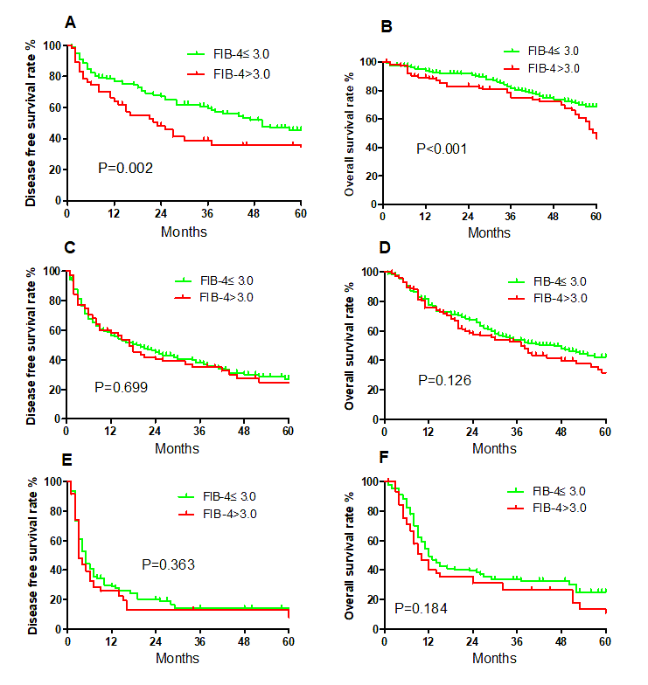
Figure 1: Kaplan-Meier survival curves comparing disease-free survival (DFS) and overall survival (OS) across different Barcelona Clinic Liver Cancer (BCLC) stages stratified by FIB-4( BCLC stage 0/A :(A), DFS; (B), OS; BCLC stage B: (C), DFS; (D), OS; BCLC stage C: (E), DFS; (F), OS).

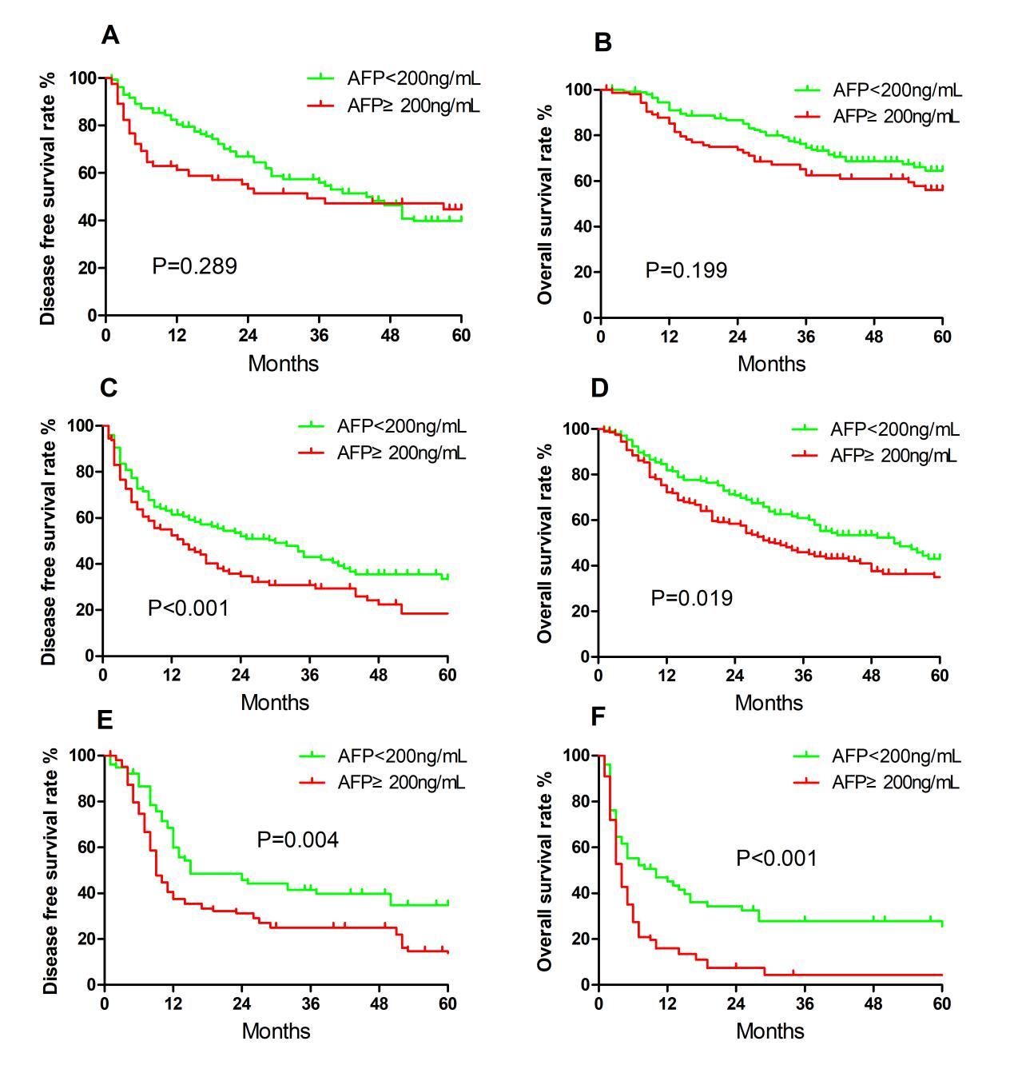

Figure 2: Kaplan-Meier survival curves comparing disease-free survival (DFS) and overall survival (OS) across different Barcelona Clinic Liver Cancer (BCLC) stages stratified by AFP( BCLC stage 0/A :(A), DFS; (B), OS; BCLC stage B: (C), DFS; (D), OS; BCLC stage C: (E), DFS; (F), OS).

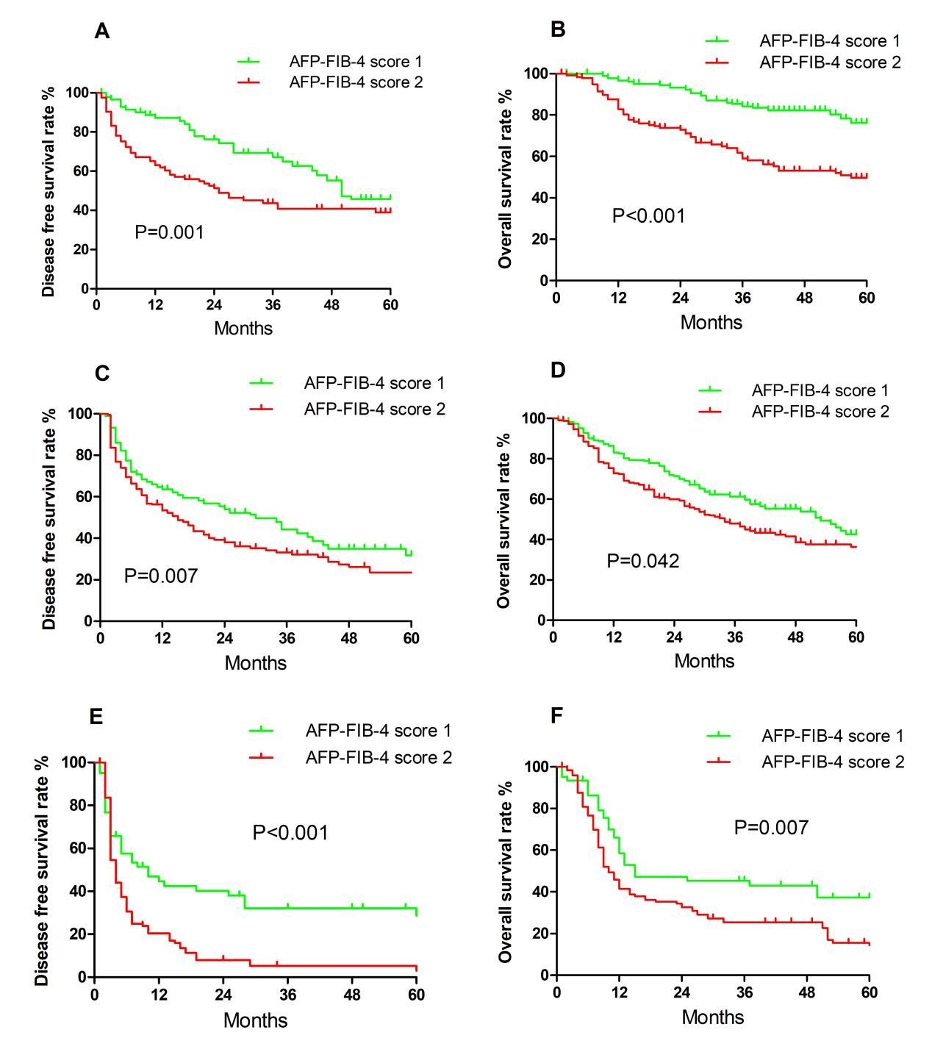
Figure 3: Kaplan-Meier survival curves comparing disease-free survival (DFS) and overall survival (OS) across different Barcelona Clinic Liver Cancer (BCLC) stages stratified by AFP-FIB-4 scores ( BCLC stage 0/A :(A), DFS; (B), OS; BCLC stage B: (C), DFS; (D), OS; BCLC stage C: (E), DFS; (F), OS).

Figure 4: Comparison of the area under the receiver operating characteristic curves of the preoperative AFP, ALBI, FIB-4 index and AFP-FIB-4 scores in predicting long-term survival.

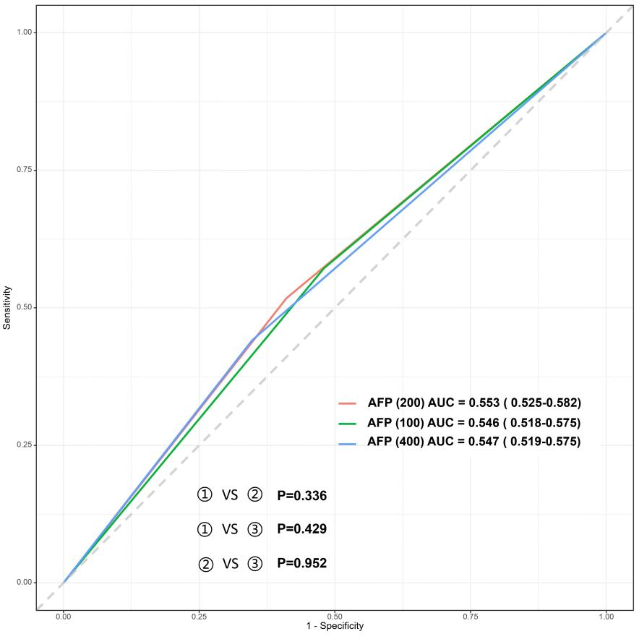

Figure 5: Predictive performance of preoperative AFP for long-term survival across different AFP cutoff values

References:
1. Bray F, Laversanne M, Sung H, Ferlay J, Siegel RL, Soerjomataram I, Jemal A: Global cancer statistics 2022: GLOBOCAN estimates of incidence and mortality worldwide for 36 cancers in 185 countries. CA-CANCER J CLIN 2024, 74(3):229-263.
2. Zhou J, Sun H, Wang Z, Cong W, Zeng M, Zhou W, Bie P, Liu L, Wen T, Kuang M et al: Guidelines for the Diagnosis and Treatment of Primary Liver Cancer (2022 Edition). LIVER CANCER 2023, 12(5):405-444.
3. Chan Y, Zhang C, Wu J, Lu P, Xu L, Yuan H, Feng Y, Chen Z, Wang N: Biomarkers for diagnosis and therapeutic options in hepatocellular carcinoma. MOL CANCER 2024, 23(1):189.
4. Jiang K, Li J, Liu Z, Chen M, Cai W, Liu L, Yin D: Impact of major hepatectomy on recurrence after resection of hepatocellular carcinoma at CNLC Ib stage: a propensity score matching study. INT J SURG 2025, 111(1):857-864.
5. Yasukawa K, Shimizu A, Kubota K, Notake T, Hosoda K, Hayashi H, Soejima Y: Impact of Liver Fibrosis Severity on Oncological Prognosis in Hepatocellular Carcinoma. LIVER CANCER 2024, 13(2):150-160.
6. Yang T, Liu K, Liu C, Zhong Q, Zhang J, Yu J, Liang L, Li C, Wang M, Li Z et al: Impact of postoperative infective complications on long-term survival after liver resection for hepatocellular carcinoma. BRIT J SURG 2019, 106(9):1228-1236.
7. Galun D, Bogdanovic A, Zivanovic M, Zuvela M: Short- and Long-Term Outcomes After Hepatectomy in Elderly Patients with Hepatocellular Carcinoma: An Analysis of 229 Cases from a Developing Country. J HEPATOCELL CARCINO 2021, 8:155-165.
8. Hobeika C, Nault JC, Barbier L, Schwarz L, Lim C, Laurent A, Gay S, Salamé E, Scatton O, Soubrane O et al: Influence of surgical approach and quality of resection on the probability of cure for early-stage HCC occurring in cirrhosis. JHEP REP 2020, 2(6):100153.
9. Wang Y, Yang X, Wang S: Progress and prospects of elastography techniques in the evaluation of fibrosis in chronic liver disease. ARCH MED SCI 2024, 20(6):1784-1792.
10. Heyens LJM, Busschots D, Koek GH, Robaeys G, Francque S: Liver Fibrosis in Non-alcoholic Fatty Liver Disease: From Liver Biopsy to Non-invasive Biomarkers in Diagnosis and Treatment. FRONT MED-LAUSANNE 2021, 8:615978.
11. Maegawa FB, Shehorn L, Aziz H, Kettelle J, Jie T, Riall TS: Association Between Noninvasive Fibrosis Markers and Postoperative Mortality After Hepatectomy for Hepatocellular Carcinoma. JAMA NETW OPEN 2019, 2(1):e187142.
12. Kamada Y, Munekage K, Nakahara T, Fujii H, Sawai Y, Doi Y, Hyogo H, Sumida Y, Imai Y, Miyoshi E et al: The FIB-4 Index Predicts the Development of Liver-Related Events, Extrahepatic Cancers, and Coronary Vascular Disease in Patients with NAFLD. NUTRIENTS 2022, 15(1).
13. Yun SO, Kim JM, Rhu J, Choi G, Joh J: Fibrosis-4 index, a predictor for prognosis of hepatocellular carcinoma patients after curative hepatectomy even in hepatitis B virus dominant populations. ANN SURG TREAT RES 2023, 104(4):195.
14. Åberg F, Asteljoki J, Männistö V, Luukkonen PK: Combined use of the CLivD score and FIB-4 for prediction of liver-related outcomes in the population. HEPATOLOGY 2024, 80(1):163-172.
15. Dong J, Xu X, Ke M, Xiang J, Liu W, Liu X, Wang B, Zhang X, Lv Y: The FIB-4 score predicts postoperative short-term outcomes of hepatocellular carcinoma fulfilling the milan criteria. EJSO-EUR J SURG ONC 2016, 42(5):722-727.
16. Toyoda H, Kumada T, Tada T, Kaneoka Y, Maeda A: A laboratory marker, FIB-4 index, as a predictor for long-term outcomes of hepatocellular carcinoma patients after curative hepatic resection. SURGERY 2015, 157(4):699-707.
17. Zhang J, Luo Y, Li C, Liu J, Xiang H, Wen T: The combination of the preoperative albumin-bilirubin grade and the fibrosis-4 index predicts the prognosis of patients with hepatocellular carcinoma after liver resection. BIOSCI TRENDS 2019, 13(4):351-357.
18. Sterling RK, Lissen E, Clumeck N, Sola R, Correa MC, Montaner J, S Sulkowski M, Torriani FJ, Dieterich DT, Thomas DL et al: Development of a simple noninvasive index to predict significant fibrosis in patients with HIV/HCV coinfection. HEPATOLOGY 2006, 43(6):1317-1325.
19. Wang H, Liu A, Bo W, Feng X, Hu Y, Tian L, Zhang H, Tang X, Zhang L: Fibrosis-4 Model Influences Results of Patients with Hepatocellular Carcinoma Undergoing Hepatectomy. BIOMED RES INT 2018, 2018:4305408.
20. Hu X, Chen R, Wei Q, Xu X: The Landscape Of Alpha Fetoprotein In Hepatocellular Carcinoma: Where Are We? INT J BIOL SCI 2022, 18(2):536-551.
21. Lv X, Zhang P, Zhang E, Yang S: Predictive factors and prognostic models for Hepatic arterial infusion chemotherapy in Hepatocellular carcinoma: a comprehensive review. WORLD J SURG ONCOL 2025, 23(1):166.
22. Yang H, Shen S, Yang Y, Zhou H, Xiang B: Platelet-albumin-bilirubin versus albumin-bilirubin as a predictor of long-term survival for hepatitis B-Induced hepatocellular carcinoma after hepatic resection. BMC CANCER 2025, 25(1):855.
23. Byeon J, Cho E, Kim SB, Choi DW: Extrahepatic recurrence of hepatocellular carcinoma after curative hepatic resection. Korean J Hepatobiliary Pancreat Surg 2012, 16(3):93-97.
24. Zhao H, Hua Y, Lu Z, Gu S, Zhu L, Ji Y, Qiu Y, Dai T, Jin H: Prognostic value and preoperative predictors of microvascular invasion in solitary hepatocellular carcinoma ≤ 5 cm without macrovascular invasion. Oncotarget 2017, 8(37):61203-61214.
25. Lu M, Yin X, Xie X, Xu H, Xu Z, Liu G, Kuang M, Zheng Y: Percutaneous thermal ablation for recurrent hepatocellular carcinoma after hepatectomy. BRIT J SURG 2005, 92(11):1393-1398.
26. Liu L, Qin S, Lin K, Xu Q, Yang Y, Cai J, Zeng Y, Yuan S, Xiang B, Lau WY et al: Development and comprehensive validation of a predictive prognosis model for very early HCC recurrence within one year after curative resection: a multicenter cohort study. INT J SURG 2024, 110(6):3401-3411.
27. Kudo M, Chung H, Osaki Y: Prognostic staging system for hepatocellular carcinoma (CLIP score): its value and limitations, and a proposal for a new staging system, the Japan Integrated Staging Score (JIS score). J GASTROENTEROL 2003, 38(3):207-215.
28. Piñero F, Dirchwolf M, Pessôa MG: Biomarkers in Hepatocellular Carcinoma: Diagnosis, Prognosis and Treatment Response Assessment. CELLS-BASEL 2020, 9(6).
29. Reig M, Forner A, Rimola J, Ferrer-Fàbrega J, Burrel M, Garcia-Criado Á, Kelley RK, Galle PR, Mazzaferro V, Salem R et al: BCLC strategy for prognosis prediction and treatment recommendation: The 2022 update. J HEPATOL 2022, 76(3):681-693.
30. Takamoto T, Nara S, Ban D, Mizui T, Mukai M, Esaki M, Shimada K: Chronological evolution in liver resection for hepatocellular carcinoma: Prognostic trends across three decades in early to advanced stages. EJSO-EUR J SURG ONC 2025, 51(2):109461.
31. Yen Y, Cheng Y, Wang J, Lin C, Chen C, Wang C: Adherence to the modified Barcelona Clinic Liver Cancer guidelines: Results from a high-volume liver surgery center in East Asias. PLOS ONE 2021, 16(3):e249194.
32. Tsai M, Yen Y, Huang P, Sou F, Lin C, Cho W, Wang H, Chen D, Chang K, Wu C et al: The Pre- and Postoperative FIB-4 Indexes Are Good Predictors to the Outcomes of HBV-Related HCC Patients after Resection. GASTROENT RES PRACT 2019, 2019:8945798.
33. Yun SO, Kim JM, Rhu J, Choi G, Joh J: Fibrosis-4 index, a predictor for prognosis of hepatocellular carcinoma patients after curative hepatectomy even in hepatitis B virus dominant populations. ANN SURG TREAT RES 2023, 104(4):195-204.
34. Wang T, Zhang K: New Blood Biomarkers for the Diagnosis of AFP-Negative Hepatocellular Carcinoma. FRONT ONCOL 2020, 10:1316.
35. Kocheise L, Schoenlein M, Behrends B, Joerg V, Casar C, Fruendt TW, Renné T, Heumann A, Li J, Huber S et al: EpCAM-positive circulating tumor cells and serum AFP levels predict outcome after curative resection of hepatocellular carcinoma. SCI REP-UK 2023, 13(1):20827.
36. Saillard C, Schmauch B, Laifa O, Moarii M, Toldo S, Zaslavskiy M, Pronier E, Laurent A, Amaddeo G, Regnault H et al: Predicting Survival After Hepatocellular Carcinoma Resection Using Deep Learning on Histological Slides. HEPATOLOGY 2020, 72(6):2000-2013.
37. Zhou J, Yang D: Prognostic Significance of Hemoglobin, Albumin, Lymphocyte and Platelet (HALP) Score in Hepatocellular Carcinoma. J HEPATOCELL CARCINO 2023, 10:821-831.
38. Ho C, Tan EC, Lee P, Chu C, Huang Y, Huo T, Su Y, Hou M, Wu J, Su C: Conventional and machine learning-based risk scores for patients with early-stage hepatocellular carcinoma. CLIN MOL HEPATOL 2024, 30(3):406-420.
39. Tian Y, Niu H, Xu F, Shang-Guan P, Song W: ALBI score combined with FIB-4 index to predict post-hepatectomy liver failure in patients with hepatocellular carcinoma. SCI REP-UK 2024, 14(1):8034.
40. Kim J, Kang W, Sinn DH, Gwak G, Paik Y, Choi MS, Lee JH, Koh KC, Paik SW: Substantial risk of recurrence even after 5 recurrence-free years in early-stage hepatocellular carcinoma patients. CLIN MOL HEPATOL 2020, 26(4):516-528.
41. Liu M, Wen Y: Point-of-care testing for early-stage liver cancer diagnosis and personalized medicine: Biomarkers, current technologies and perspectives. HELIYON 2024, 10(19):e38444.
42. Luo B, Ma F, Liu H, Hu J, Rao L, Liu C, Jiang Y, Kuangzeng S, Lin X, Wang C et al: Cell-free DNA methylation markers for differential diagnosis of hepatocellular carcinoma. BMC MED 2022, 20(1):8.
43. Hanif H, Ali MJ, Susheela AT, Khan IW, Luna-Cuadros MA, Khan MM, Lau DT: Update on the applications and limitations of alpha-fetoprotein for hepatocellular carcinoma. WORLD J GASTROENTERO 2022, 28(2):216-229.
44. Gao R, Cai C, Gan J, Yang X, Shuang Z, Liu M, Li S, Tang H: miR-1236 down-regulates alpha-fetoprotein, thus causing PTEN accumulation, which inhibits the PI3K/Akt pathway and malignant phenotype in hepatoma cells. Oncotarget 2015, 6(8):6014-6028.
45. Li P, Chen P, Peng X, Ma C, Zhang W, Dai X: HOXC6 predicts invasion and poor survival in hepatocellular carcinoma by driving epithelial-mesenchymal transition. Aging (Albany NY) 2018, 10(1):115-130.
46. Wu R, Gao Y, Zhao X, Guo S, Zhou H, Zhang Y, Hou Y, Mei L, Zhi H, Wang P et al: Tumor biology, immune infiltration and liver function define seven hepatocellular carcinoma subtypes linked to distinct drivers, survival and drug response. COMPUT BIOL MED 2023, 167:107593.
47. Sterling RK, Lissen E, Clumeck N, Sola R, Correa MC, Montaner J, S Sulkowski M, Torriani FJ, Dieterich DT, Thomas DL et al: Development of a simple noninvasive index to predict significant fibrosis in patients with HIV/HCV coinfection. HEPATOLOGY 2006, 43(6):1317-1325.
48. Johnson PJ, Berhane S, Kagebayashi C, Satomura S, Teng M, Reeves HL, O'Beirne J, Fox R, Skowronska A, Palmer D et al: Assessment of liver function in patients with hepatocellular carcinoma: a new evidence-based approach-the ALBI grade. J CLIN ONCOL 2015, 33(6):550-558.

