Supplementary material
Supplementary Table 1. CT scanning parameters for the different scanners used in this study.
Parameter | CT 1  n = 164 | CT 2  n = 8 | CT 3  n = 16
CT version | 256-row spiral CT (Dual-energy Revolution CT, GE Healthcare, USA) | 64-row spiral CT (LightSpeedVCT,  GE Healthcare, USA) | 64-row spiral CT (Somatom Definition AS, Siemens Healthcare, Germany)
Tube voltage (kVp) | 80/140 | 120 | 120
Tube current (mAs) | Auto | Auto | Auto
Rotation time (s) | 0.5 | 0.5 | 0.5
Image matrix pixel spacing (mm) | 512×512 | 512×512 | 512×512
Slice thickness (mm) | 1.25 | 1.25 | 1.00

Supplementary Table 2 Comparison of CECT characteristics of the lymph node with the highest Node-RADS score between pN− and pN+ patients.
Characteristics |  | pN- | pN+ | p
Size |  |  |  | < 0.001
Normal |  | 56 (45.2%) | 6 (9.4%)
Enlarged |  | 68 (54.8%) | 58 (90.6%)
Bulk |  | 0 (0%) | 0 (0%)
Configuration
Texture |  |  |  | < 0.001
Homogeneous |  | 116 (93.5%) | 23 (35.9%)
Heterogeneous |  | 6 (4.8%) | 31 (48.4%)
Focal necrosis |  | 2 (1.6%) | 8 (12.5%)
Gross necrosis |  | 0 (0%) | 2 (3.1%)
Border |  |  |  | < 0.001
Smooth |  | 120 (96.8%) | 36 (56.3%)
Irregular |  | 4 (3.2%) | 28 (43.8%)
Shape |  |  |  | 0.067
Oval* |  | 41 (33.1%) | 13 (20.3%)
Spherical** |  | 83 (66.9%) | 51 (79.7%)
*Any shape with a preserved fatty hilum, a kidney-bean-like shape, or oval without a fatty hilum. **Spherical without a fatty hilum.

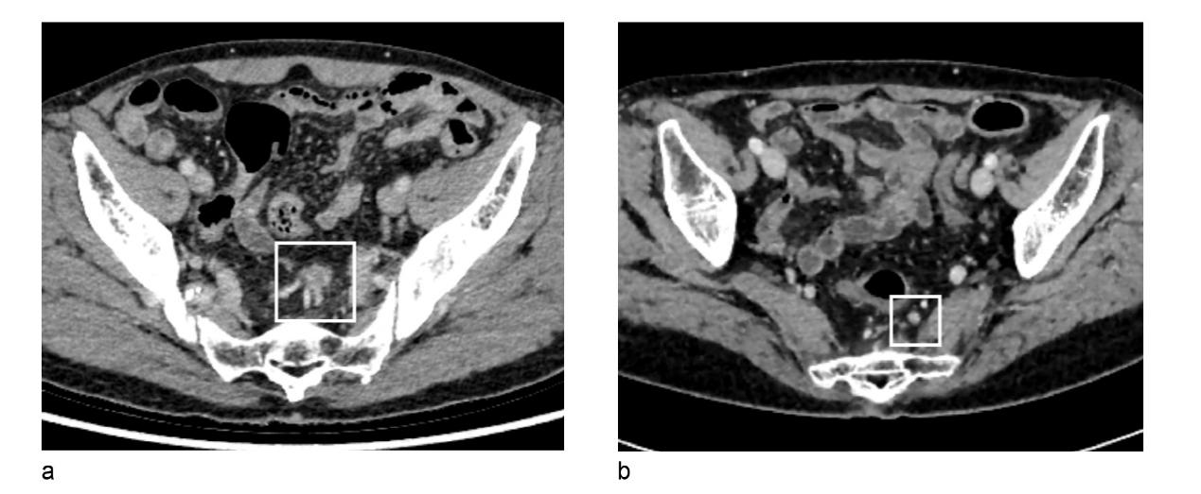
Supplementary Figure 1. Representative examples of Node-RADS categorization in rectal cancer patients. (a) A lymph node (short-axis diameter, 11.2 mm) shows morphologic features of shape (1 point), texture (1 point), and border (1 point), corresponding to Node-RADS category 5. Patient outcome: systemic progression at 35.3 months with multi-organ metastases; overall survival time 42.4 months. (b) A lymph node (short-axis diameter, 6.7 mm) demonstrates shape (1 point), texture (0 point), and border (0 point), classified as Node-RADS category 3. Patient outcome: no evidence of disease at 82.2 months follow-up.

Supplementary Figure 2. Kaplan‒Meier survival curves for Node-RADS category 4 and 5 patients. (a) Overall survival and (b) recurrence-free survival curves. P values were calculated with the log-rank test.

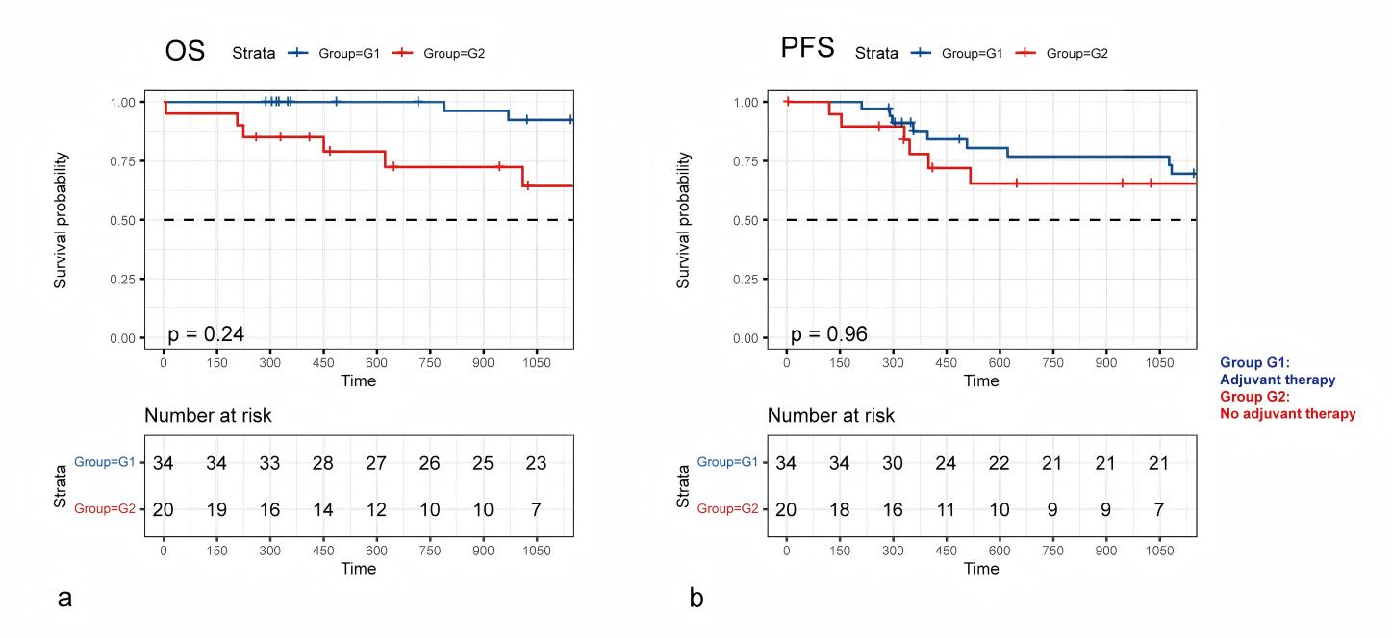
Supplementary Figure 3. Kaplan–Meier curves for overall survival (a) and recurrence-free survival (b) according to postoperative adjuvant chemotherapy status in patients with Node-RADS category 4–5. P values were calculated with the log-rank test.

