Supplementary Material
Supplementary Table S1. Sensitivity analysis of the multivariable logistic regression model for pathological complete response using the primary and strict pCR definitions.
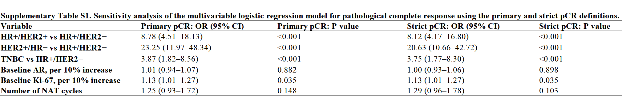Adjusted odds ratios (ORs), 95% confidence intervals (CIs), and two-sided P values are presented. Primary pCR was defined as the absence of residual invasive carcinoma in both the breast and regional lymph nodes (ypT0/is ypN0), irrespective of residual ductal carcinoma in situ. Strict pCR was defined as the absence of both residual invasive carcinoma and carcinoma in situ in the breast, together with no regional lymph node metastasis (ypT0 ypN0). Both models were fitted using the same complete-case cohort and identical covariates. HR+/HER2− was used as the reference molecular subtype. ORs for baseline AR and Ki-67 are reported per 10-percentage-point increase, and the OR for NAT cycles is reported per additional treatment cycle. OR, odds ratio; CI, confidence interval; pCR, pathological complete response; HR, hormone receptor; HER2, human epidermal growth factor receptor 2; TNBC, triple-negative breast cancer; AR, androgen receptor; NAT, neoadjuvant therapy.

Supplementary Table S2. Exploratory comparison of biomarker changes between TCbHP and THP in patients with HER2-positive breast cancer.
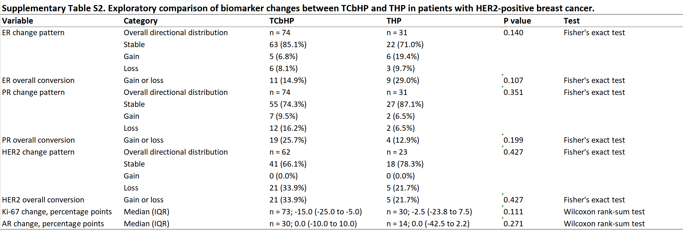
Among patients with HER2-negative disease, 282 of 333 patients (84.7%) received TEC. Because the remaining regimens comprised small and heterogeneous groups, no formal regimen-specific comparison was performed in this subgroup.
Supplementary Table S3. Exploratory associations of biomarker changes with ypT stage and pretreatment Nottingham grade. 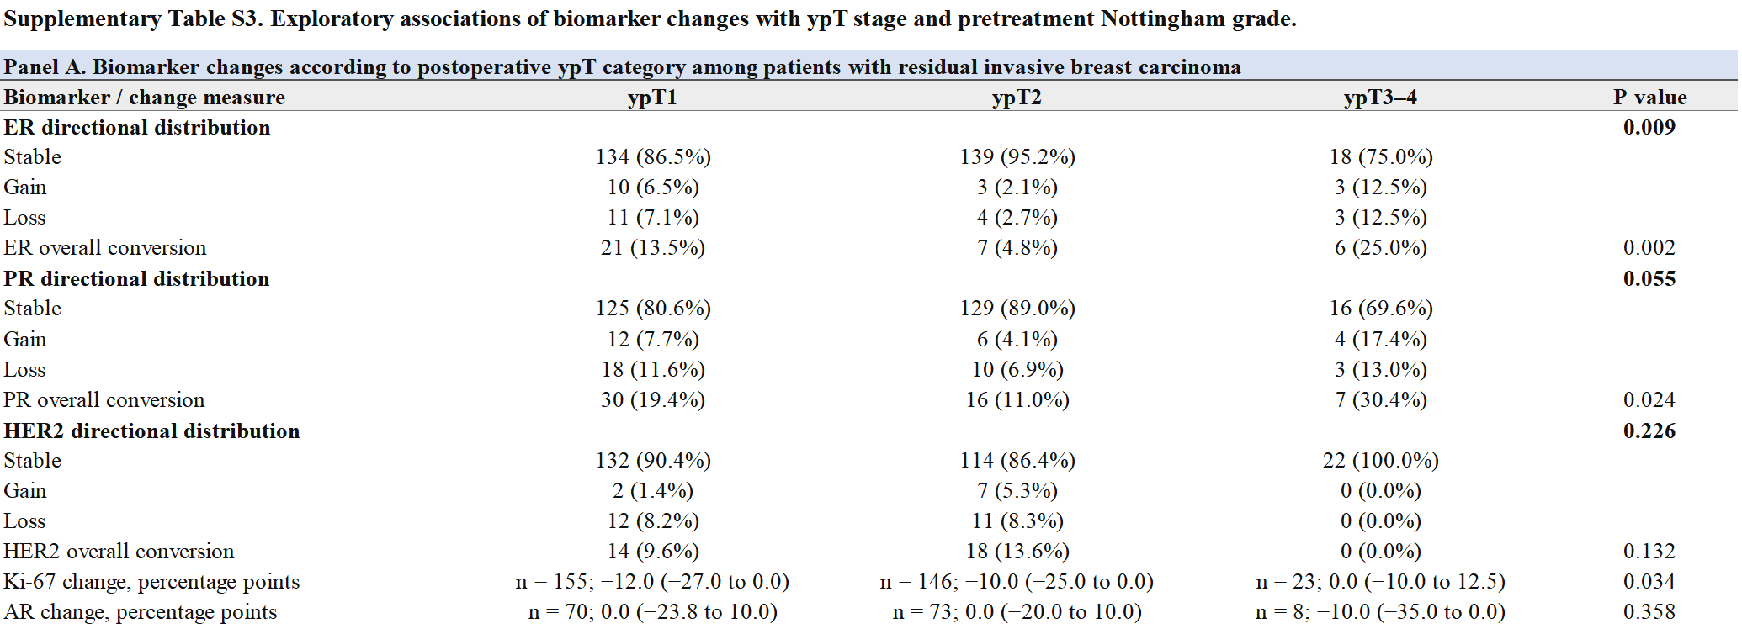
Panel A. Associations of biomarker changes with postoperative ypT stage
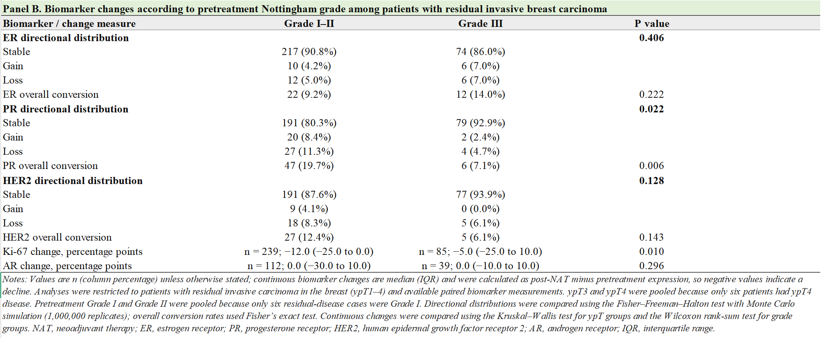
Panel B. Associations of biomarker changes with pretreatment Nottingham grade

Supplementary Table S4. Changes in HER2 expression categories from pretreatment biopsy to post-NAT residual invasive carcinoma.
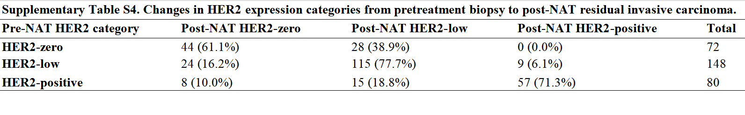
Notes：HER2-low was operationally defined as IHC 1+ or IHC 2+ with non-amplified ISH/FISH; HER2-zero was defined as IHC 0; and HER2-positive was defined as IHC 3+ or IHC 2+ with ISH/FISH amplification. Values are presented as n (row percentage). The analysis included patients with residual invasive carcinoma and classifiable HER2 expression categories at both time points. Cases with IHC 2+ but unavailable ISH/FISH results were excluded. NAT, neoadjuvant therapy; IHC, immunohistochemistry; ISH, in situ hybridization; FISH, fluorescence in situ hybridization.

