SUPPLEMENTARY TABLES

Manuscript title: A multiparametric nomogram to reduce unnecessary EBUS-TBNA in suspected lung cancer: development and internal validation in an anthracosis-prevalent cohort
This supplementary file contains eleven tables (S1–S11) and one figure (S1) that support the methodological choices, sensitivity analyses, and subgroup characterizations presented in the main manuscript. All analyses were performed on the primary cohort of 337 consecutive patients undergoing EBUS-TBNA (184 malignant, 153 benign by EBUS-TBNA cytopathology)

Table S1 Inter-observer agreement for quantitative imaging measurements (n = 337).
Measurement | Reader 1 (mean ± SD) | Reader 2 (mean ± SD) | ICC | 95% CI
Mean Hounsfield unit | 40.7 ± 14.2 | 41.1 ± 14.5 | 0.95 | 0.907–0.969
SUVmax | 8.04 ± 5.51 | 8.18 ± 5.62 | 0.93 | 0.912–0.952
ICC values were interpreted using the Koo and Li (2016) classification: ICC > 0.90 indicates excellent agreement. Each measurement was performed independently by two readers blinded to the patient's clinical data, histopathological diagnosis, and the other reader's evaluations. Readers were two thoracic radiologists (10 and 4 years of experience) for HU, and two nuclear medicine physicians (14 and 9 years of experience) for SUVmax.
ICC, intraclass correlation coefficient; CI, confidence interval; SD, standard deviation; SUVmax, maximum standardized uptake value.

Table S2 Comparison of age functional forms in the multivariable nomogram model (n = 337).
Age formulation | k | Log-likelihood | AIC | BIC | Apparent AUC | Bias-corrected AUC | Brier
Dichotomized (≥ 65 years) — primary | 6 | −180.835 | 373.670 | 396.590 | 0.8130 | 0.8026 | 0.1758
Continuous linear age | 6 | −180.958 | 373.917 | 396.837 | 0.8150 | 0.8046 | 0.1740
RCS (3 knots) | 7 | −180.932 | 375.864 | 402.605 | 0.8151 | 0.8017 | 0.1742
RCS (4 knots) | 8 | −180.812 | 377.623 | 408.184 | 0.8153 | 0.7991 | 0.1742
Tests for non-linearity (RCS vs continuous linear age):
Comparison | LR statistic | df | p value
RCS (3 knots) vs linear age | 0.052 | 1 | 0.819
RCS (4 knots) vs linear age | 0.293 | 2 | 0.864
Four age formulations were compared while holding female sex, short-axis diameter, mean Hounsfield unit value, and SUVmax constant. The four formulations produced clinically indistinguishable discrimination (bias-corrected AUC range 0.799–0.805) and calibration (Brier score 0.174–0.176). Likelihood ratio tests for non-linearity were non-significant. The dichotomized formulation was retained for the principal model on the basis of nomogram interpretability and compatibility with NCCN risk-stratification frameworks.
AIC, Akaike information criterion; BIC, Bayesian information criterion; LR, likelihood ratio; RCS, restricted cubic spline.

Table S3 Multivariable logistic regression including station-specific lymph node variables (Model B) for the prediction of malignant mediastinal lymphadenopathy (n = 337).
Variable | Adjusted OR | 95% CI | p value | VIF
Female sex | 0.28 | 0.16–0.50 | < 0.001 | 1.36
Age ≥ 65 years | 0.44 | 0.26–0.74 | 0.002 | 1.81
Short-axis diameter (per mm) | 1.05 | 1.01–1.09 | 0.014 | 4.45
Mean Hounsfield unit (per unit) | 0.99 | 0.98–1.00 | 0.055 | 2.41
SUVmax (per unit) | 1.17 | 1.10–1.24 | < 0.001 | 3.65
Station 2 (present) | 0.50 | 0.20–1.25 | 0.136 | 1.21
Station 7 (present) | 0.58 | 0.34–0.99 | 0.047 | 1.18
Station 10 (present) | 1.84 | 0.85–3.99 | 0.125 | 1.27
Station 11 (present) | 0.85 | 0.49–1.48 | 0.557 | 1.32
Model B was fit by adding station-specific binary indicators to the five core predictors of Model A. Station 7 (subcarinal) retained an independent association with benignity; remaining station variables were not independently significant.
CI, confidence interval; OR, odds ratio; SUVmax, maximum standardized uptake value; VIF, variance inflation factor.

Table S4 Variance inflation factors and tolerance values for the five core predictors of the principal nomogram (Model A; n = 337).
Predictor | VIF | Tolerance (1/VIF)
Female sex | 1.35 | 0.741
Age ≥ 65 years | 1.78 | 0.562
Short-axis diameter | 4.38 | 0.228
Mean Hounsfield unit | 2.38 | 0.420
SUVmax | 3.59 | 0.279
All VIF values were below the conventional threshold of 5.0, indicating absence of problematic multicollinearity. Continuous age was replaced by the dichotomized variable age ≥ 65 years to resolve elevated VIF observed during exploratory analysis.
VIF, variance inflation factor.

Table S5 LASSO penalized regression sensitivity analysis for variable selection (n = 337).
Variable | MLE β | MLE OR | λ_min β | λ_min OR | λ_1se β | λ_1se OR | Retained at λ_1se
Female sex | −1.245 | 0.288 | −1.135 | 0.322 | −0.835 | 0.434 | Yes
Age ≥ 65 years | −0.875 | 0.417 | −0.745 | 0.475 | −0.384 | 0.681 | Yes
Short-axis diameter (per mm) | +0.053 | 1.054 | +0.046 | 1.047 | +0.028 | 1.029 | Yes
Mean Hounsfield unit (per unit) | −0.012 | 0.988 | −0.010 | 0.990 | −0.005 | 0.995 | Yes
SUVmax (per unit) | +0.149 | 1.161 | +0.132 | 1.141 | +0.088 | 1.092 | Yes
Performance comparison across estimation methods:
Method | AUC | Variables retained | Brier score
Classical MLE (manuscript model) | 0.8130 | 5 | 0.1758
LASSO (λ_min) | 0.8122 | 5 | 0.1775
LASSO (λ_1se) | 0.8074 | 5 | 0.1871
LASSO logistic regression was performed to validate the variable selection. All five candidate predictors entered the LASSO procedure, and coefficients were estimated at both the cross-validated optimum (λ_min) and the 1-standard-error rule (λ_1se). The same five predictors were retained at both penalization levels, with coefficients in the same direction as the maximum-likelihood estimates and within 30% of their magnitude. Discrimination differences between the maximum-likelihood and penalized estimates were negligible (ΔAUC < 0.006). The bootstrap optimism correction applied in the principal analysis (ΔAUC = +0.010) accounts for the mild optimism of unpenalized estimation.
LASSO, least absolute shrinkage and selection operator; MLE, maximum likelihood estimation; OR, odds ratio.

Table S6 Discriminative performance of single radiological parameters and the multiparametric nomogram for the prediction of malignant mediastinal lymphadenopathy (n = 337).
Parameter | AUC (95% CI) | Optimal cutoffᵃ | Sensitivity (%) | Specificity (%) | Youden J
SUVmax | 0.737 (0.684–0.789) | ≥ 8.92 | 56.5 | 79.1 | 0.356
Short-axis diameter (mm) | 0.671 (0.614–0.728) | ≥ 15 | 67.4 | 66.0 | 0.334
Mean Hounsfield unitᵇ | 0.567 (0.506–0.628) | ≤ 49 | 87.5 | 34.6 | 0.221
Multiparametric nomogram | 0.813 (0.768–0.858) | ≥ 0.56 | 67.9 | 81.0 | 0.489
AUC, area under the curve; CI, confidence interval. The Youden index (J = sensitivity + specificity − 1) was used to determine the optimal cutoff for each parameter.
ᵃ Optimal cutoff value for predicting malignancy.
ᵇ Cutoff for HU expressed as the upper bound of the malignancy-suggestive range; HU values ≤ 49 favored malignancy in the present cohort.

Table S7 Internal validation of the multiparametric nomogram by 1000-iteration bootstrap optimism correction (Wang et al. 2023 methodology; n = 337).
Performance metric | Apparent value | Optimism (mean) | Bias-corrected
AUC (discrimination) | 0.813 | 0.010 | 0.803
Calibration intercept | 0.000 | −0.008 | +0.008
Calibration slope | 1.000 | 0.087 | 0.913
Brier scoreᵃ | 0.176 | — | 0.176
The Hosmer-Lemeshow test was non-significant (χ² = 8.14, p = 0.420), supporting adequate calibration. Bootstrap optimism for the Brier score was negligible.
ᵃ The Brier score is reported as the raw mean squared error between observed and predicted probabilities (smaller values indicate better calibration); the corresponding scaled Brier (1 − Brier/Briermax) is 0.291.

Table S8 Pairwise DeLong test comparisons of areas under the receiver operating characteristic curve for the multiparametric nomogram and individual radiological parameters (n = 337).
Comparison | ΔAUC | Z statistic | p valueᵃ
Nomogram vs SUVmax | +0.076 | 3.10 | 0.002
Nomogram vs Short-axis diameter | +0.142 | 5.00 | < 0.001
Nomogram vs Mean Hounsfield unit | +0.246 | 7.07 | < 0.001
SUVmax vs Short-axis diameter | +0.066 | 1.91 | 0.056
SUVmax vs Mean Hounsfield unit | +0.170 | 4.51 | < 0.001
Short-axis vs Mean Hounsfield unit | +0.104 | 2.79 | 0.005
ΔAUC, difference in area under the curve.
ᵃ Two-sided DeLong test for paired AUCs.

Table S9 Sensitivity analysis excluding non-diagnostic hypocellular fibrin cases.
Parameter | Primary cohort (n = 337) | Sensitivity cohort (n = 332) | Δ (sensitivity − primary)
Malignant patients, n | 184 | 182 | −2
Benign patients, n | 153 | 150 | −3
Apparent AUC | 0.8130 | 0.8219 | +0.0089
Bias-corrected AUC | 0.8026 | 0.8116 | +0.0090
Brier score | 0.1758 | 0.1716 | −0.0042
Calibration intercept | 0.000 | 0.000 | 0.000
Calibration slope | 1.000 | 1.000 | 0.000
Adjusted odds ratios across cohorts:
Variable | Primary cohort OR (95% CI), p | Sensitivity cohort OR (95% CI), p
Female sex | 0.29 (0.17–0.49), < 0.001 | 0.27 (0.16–0.46), < 0.001
Age ≥ 65 years | 0.42 (0.25–0.70), 0.001 | 0.38 (0.22–0.65), < 0.001
Short-axis diameter (per mm) | 1.05 (1.02–1.10), 0.006 | 1.07 (1.03–1.12), 0.001
Mean Hounsfield unit (per unit) | 0.99 (0.98–1.00), 0.031 | 0.99 (0.98–1.00), 0.043
SUVmax (per unit) | 1.16 (1.09–1.23), < 0.001 | 1.15 (1.09–1.22), < 0.001
Five patients had non-diagnostic hypocellular fibrin material on EBUS-TBNA and required outcome adjudication. Three were classified as benign on the basis of stable lymph node dimensions and absence of malignant transformation during a minimum 12-month clinical and radiological follow-up. Two were confirmed malignant on repeat sampling. The robustness of this classification was tested by refitting the principal model after excluding all five patients (three benign, two malignant). The exclusion produced a small improvement in discrimination and calibration without altering the direction, magnitude, or statistical significance of any predictor coefficient.
CI, confidence interval; OR, odds ratio.

Table S10 Anthracosis-versus-malignancy subgroup analysis after exclusion of other benign etiologies and of two malignant cases with non-diagnostic index-node cytopathology (n = 293; 111 anthracosis, 182 malignancy).
Variable | Anthracosis (n = 111) | Malignancy (n = 182) | p valueᵃ | Adjusted OR (95% CI), p
Age, years (median, IQR) | 67 (60–73) | 64 (55–70) | 0.020 | —
Age ≥ 65 years, n (%) | 67 (60.4) | 78 (42.9) | 0.005 | 0.31 (0.17–0.55), < 0.001
Female sex, n (%) | 55 (49.5) | 36 (19.8) | < 0.001 | 0.37 (0.20–0.68), 0.001
Short-axis diameter, mm (median, IQR) | 13 (10–16) | 17 (12–22) | < 0.001 | 1.11 (1.05–1.17)ᵇ, < 0.001
Mean Hounsfield unit (median, IQR) | 42 (33–53) | 38 (32–45) | 0.022 | 0.99 (0.98–1.00)ᶜ, 0.022
SUVmax (median, IQR) | 5.69 (3.71–8.10) | 10.27 (6.39–14.49) | < 0.001 | 1.18 (1.10–1.27)ᶜ, < 0.001
Discrimination of the five-predictor model in this subgroup: apparent AUC = 0.828, bootstrap bias-corrected AUC = 0.817; McFadden pseudo-R² = 0.258. All five predictors retained independent significance (p ≤ 0.022).
CI, confidence interval; HU, Hounsfield unit; OR, odds ratio; SUVmax, maximum standardized uptake value.
ᵃ Mann-Whitney U test for continuous variables; Pearson χ² test for categorical variables.
ᵇ Per 1 mm increment.
ᶜ Per 1 unit increment.

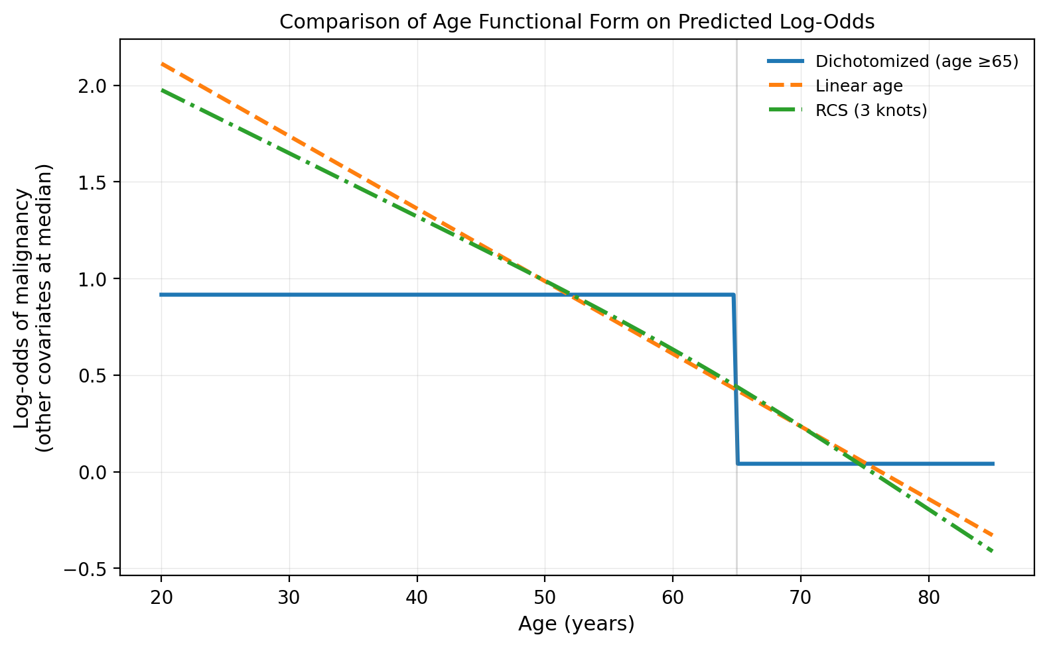
Table S11 Sensitivity analysis restricting the malignant class to primary lung cancer (n = 294; 141 primary lung cancer, 153 benign).
Predictor | Primary model (n = 337) aOR (95% CI), p | Restricted model (n = 294) aOR (95% CI), p
Female sex | 0.29 (0.17–0.49), < 0.001 | 0.22 (0.12–0.41), < 0.001
Age ≥ 65 years | 0.42 (0.25–0.70), 0.001 | 0.54 (0.31–0.94), 0.030
Short-axis diameter (per mm) | 1.05 (1.02–1.10), 0.006 | 1.05 (1.01–1.09), 0.024
Mean Hounsfield unit (per unit) | 0.988 (0.978–0.999), 0.031 | 0.97 (0.96–0.99), 0.007
SUVmax (per unit) | 1.16 (1.09–1.23), < 0.001 | 1.17 (1.09–1.25), < 0.001
Apparent AUC | 0.813 | 0.829
Bootstrap bias-corrected AUC | 0.803 | 0.818
Hosmer–Lemeshow p | 0.420 | 0.031
Bias-corrected calibration slope | 0.913 | 0.924
Brier score | 0.176 | 0.168
Malignant class restricted to primary lung cancer (n = 141: squamous 44, adenocarcinoma 45, small cell 27, NSCLC NOS 18, sarcomatoid 7). Excluded were neuroendocrine tumors (n = 10), hematological malignancies (n = 9), extrapulmonary metastases (n = 22) and two malignancies without a definitive subtype. The benign group (n = 153) was unchanged. Internal validation used 1,000-iteration bootstrap optimism correction. The analysis tests the stability of the coefficients; the restricted model is not proposed as a recalibrated alternative. The Hosmer–Lemeshow test was significant in the restricted model (p = 0.031), while the bias-corrected calibration slope stayed close to unity (0.924). This test is sensitive to grouping at this sample size, and all calibration metrics are reported for both models. The mean HU coefficient in the primary model is reported to three decimal places because the per-unit odds ratio lies close to unity.
aOR, adjusted odds ratio; AUC, area under the curve; CI, confidence interval; NSCLC, non-small-cell lung carcinoma; SUVmax, maximum standardized uptake value.
Figure S1 Comparison of age functional forms on predicted log-odds of malignancy.
Predicted log-odds of malignancy as a function of age, holding female sex at zero (male) and short-axis diameter, mean HU value, and SUVmax at their cohort medians. Three formulations are overlaid: the dichotomized model used in the principal analysis (≥ 65 years; blue solid line, step function), continuous linear age (orange dashed line), and a 3-knot restricted cubic spline (green dash-dotted line). The vertical grey line marks the dichotomization threshold of 65 years. The three curves diverge minimally over the clinically relevant age range, supporting the equivalence of the formulations and the retention of the dichotomized model for nomogram interpretability.
HU, Hounsfield unit; RCS, restricted cubic spline; SUVmax, maximum standardized uptake value.

