SUPPLEMENTARY TAPLES
SUPPLEMENTARY TABLE S1: COMPLETE SEARCH STRATEGIES FOR EACH DATABASE
Search Date: September 19, 2025
Database | Results (n) | Search String
PubMed (NCBI) | 1,414 | ((("Oncolytic HSV"[Title/Abstract] OR "oncolytic herpes simplex virus"[Title/Abstract] OR "T-VEC"[Title/Abstract] OR "talimogene laherparepvec"[Title/Abstract] OR "G47Δ"[Title/Abstract] OR "G47 delta"[Title/Abstract] OR "NV1020"[Title/Abstract] OR "OH2"[Title/Abstract] OR "OrienX010"[Title/Abstract] OR "HF10"[Title/Abstract] OR "HSV1716"[Title/Abstract] OR "CAN-3110"[Title/Abstract] OR "OncoVEX-GM-CSF"[Title/Abstract] OR "HSV-1"[Title/Abstract] OR "HSV-2"[Title/Abstract] OR "herpes simplex virus"[Title/Abstract]) AND ("oncolytic virotherapy"[Title/Abstract] OR "oncolytic virus"[Title/Abstract] OR "virotherapy"[Title/Abstract] OR "viral therapy"[Title/Abstract])) OR (("Oncolytic Virotherapy"[Mesh] OR "Herpesvirus 1, Human"[Mesh] OR "Herpesvirus 2, Human"[Mesh]) AND ("Neoplasms"[Mesh] OR "Solid Tumor"[Mesh]))) AND ("clinical trial"[Publication Type] OR "phase I"[Title/Abstract] OR "phase II"[Title/Abstract] OR "phase III"[Title/Abstract] OR "randomized"[Title/Abstract] OR "prospective"[Title/Abstract]) Filters: Clinical Trial, Phase I-III, RCT, English
Embase (Elsevier) | 3,700 | ('oncolytic herpes simplex virus'/exp OR 'oncolytic hsv':ab,ti OR 't-vec':ab,ti OR 'talimogene laherparepvec':ab,ti OR 'g47δ':ab,ti OR 'g47 delta':ab,ti OR 'nv1020':ab,ti OR 'oh2':ab,ti OR 'orienx010':ab,ti OR 'hf10':ab,ti OR 'hsv1716':ab,ti OR 'can-3110':ab,ti OR 'oncovex-gm-csf':ab,ti OR 'hsv-1':ab,ti OR 'hsv-2':ab,ti) AND ('oncolytic virotherapy'/exp OR 'oncolytic virus':ab,ti OR 'virotherapy':ab,ti) AND ('solid tumor'/exp OR 'neoplasm'/exp OR 'melanoma'/exp OR 'glioblastoma'/exp OR 'breast cancer'/exp OR 'colorectal cancer'/exp OR 'pancreatic cancer'/exp) AND ('clinical trial'/de OR 'phase 1 clinical trial'/de OR 'phase 2 clinical trial'/de OR 'phase 3 clinical trial'/de OR 'randomized controlled trial'/de) AND [english]/lim
Cochrane Library (Wiley) | 83 | ((oncolytic HSV OR oncolytic herpes simplex virus OR T-VEC OR talimogene laherparepvec OR G47Δ OR NV1020 OR OH2 OR OrienX010 OR HF10 OR HSV1716 OR CAN-3110 OR OncoVEX-GM-CSF) AND (oncolytic virotherapy OR oncolytic virus OR virotherapy) AND (solid tumor OR neoplasm OR melanoma OR glioblastoma OR breast cancer OR colorectal cancer OR pancreatic cancer)) Filters: Trials only
Scopus (Elsevier) | 1,992 | TITLE-ABS-KEY((oncolytic HSV OR oncolytic herpes simplex virus OR T-VEC OR talimogene laherparepvec OR G47Δ OR NV1020 OR OH2 OR OrienX010 OR HF10 OR HSV1716 OR CAN-3110 OR OncoVEX-GM-CSF) AND (oncolytic virotherapy OR oncolytic virus OR virotherapy) AND (solid tumor OR neoplasm OR melanoma OR glioblastoma OR breast cancer OR colorectal cancer OR pancreatic cancer)) AND (LIMIT-TO (DOCTYPE, "ar") OR LIMIT-TO (DOCTYPE, "ip")) AND (LIMIT-TO (LANGUAGE, "English"))
Web of Science (Clarivate) | 1,699 | TS=((oncolytic HSV OR oncolytic herpes simplex virus OR T-VEC OR talimogene laherparepvec OR G47Δ OR NV1020 OR OH2 OR OrienX010 OR HF10 OR HSV1716 OR CAN-3110 OR OncoVEX-GM-CSF) AND (oncolytic virotherapy OR oncolytic virus OR virotherapy) AND (solid tumor OR neoplasm OR melanoma OR glioblastoma OR breast cancer OR colorectal cancer OR pancreatic cancer)) Refined by: Document Types: Article, Clinical Trial, Review; Languages: English
ScienceDirect (Elsevier) | 1,088 | (oncolytic HSV OR oncolytic herpes simplex virus OR T-VEC OR talimogene laherparepvec) AND (oncolytic virotherapy OR oncolytic virus) AND (solid tumor OR melanoma OR glioblastoma) AND (clinical trial OR phase I OR phase II OR phase III) Filters: Research articles, Clinical trials, English

SUPPLEMENTARY TABLE S2: NIH QUALITY ASSESSMENT FOR NON-RANDOMIZED STUDIES
Assessment Tool: National Institutes of Health Quality Assessment Tool for Before-After (Pre-Post) Studies With No Control Group
Study ID | Study Question | Eligibility Criteria | Representative Participants | Intervention Description | Outcome Measures Defined | Completeness of Follow-up | Appropriate Statistics | Overall Rating
Ressler 2025 | Yes | Yes | Yes | Yes | Yes | Yes | Yes | Good
Soliman 2023 | Yes | Yes | Yes | Yes | Yes | Yes | Yes | Good
Yamazaki 2022 | Yes | Yes | Yes | Yes | Yes | Yes | Yes | Good
Runcie 2024 | Yes | Yes | Yes | Yes | Yes | NR | Yes | Fair
Chesney 2017 | Yes | Yes | Yes | Yes | Yes | Yes | Yes | Good
Kaufman 2016 | Yes | Yes | Yes | Yes | Yes | Yes | Yes | Good
Franke 2019 | Yes | Yes | Yes | Yes | Yes | Yes | Yes | Good
Masoud 2019 | Yes | Yes | Yes | Yes | Yes | Yes | Yes | Good
Andtbacka 2016 | Yes | Yes | Yes | Yes | Yes | Yes | Yes | Good
Kai 2021 | Yes | Yes | Yes | Yes | Yes | NR | Yes | Fair
Ribas 2017 | Yes | Yes | Yes | Yes | Yes | Yes | Yes | Good
Robert 2024 | Yes | Yes | Yes | Yes | Yes | Yes | Yes | Good
Hecht 2023 | Yes | Yes | Yes | Yes | Yes | Yes | Yes | Good
Todo 2022 (Ph I/II) | Yes | Yes | Yes | Yes | Yes | Yes | Yes | Good
Todo 2022 (Ph II) | Yes | Yes | Yes | Yes | Yes | Yes | Yes | Good
Markert 2014 | Yes | Yes | NR | Yes | Yes | NR | Yes | Fair
Markert 2008 | Yes | Yes | NR | Yes | Yes | NR | Yes | Fair
Ling 2023 | Yes | Yes | Yes | Yes | Yes | Yes | Yes | Good
Zhang 2021 | Yes | Yes | Yes | Yes | Yes | Yes | Yes | Good
Zhang 2021 (combo) | Yes | Yes | Yes | Yes | Yes | Yes | Yes | Good
Wang 2025 | Yes | Yes | Yes | Yes | Yes | Yes | Yes | Good
Tan 2024 | Yes | Yes | Yes | Yes | Yes | Yes | Yes | Good
Cui 2021 (total) | Yes | Yes | Yes | Yes | Yes | Yes | Yes | Good
Cui 2021 (C8) | Yes | Yes | Yes | Yes | Yes | Yes | Yes | Good
Cui 2021 (C9) | Yes | Yes | Yes | Yes | Yes | Yes | Yes | Good
Liu 2024 | Yes | Yes | Yes | Yes | Yes | Yes | Yes | Good
Fong 2009 | Yes | Yes | NR | Yes | Yes | NR | Yes | Fair
Geevarghese 2010 | Yes | Yes | NR | Yes | Yes | NR | Yes | Fair
Kemeny 2006 | Yes | Yes | NR | Yes | Yes | NR | Yes | Fair
Sze 2011 | Yes | Yes | NR | Yes | Yes | NR | Yes | Fair
Hirooka 2018 | Yes | Yes | NR | Yes | Yes | NR | Yes | Fair
Sahin 2012 | Yes | Yes | NR | Yes | Yes | NR | No | Poor
Harrow 2004 | Yes | Yes | NR | Yes | Yes | NR | No | Poor
Mace 2008 | Yes | Yes | NR | Yes | Yes | NR | No | Poor
Harrington 2010 | Yes | Yes | Yes | Yes | Yes | Yes | Yes | Good
Hu 2006 | Yes | Yes | Yes | Yes | Yes | Yes | Yes | Good
Abbreviations: NR, not reported.
SUPPLEMENTARY TABLE S3: FULL CITATIONS OF INCLUDED STUDIES (N=38)
Study ID | First Author | Year | Title | Journal | PMID | DOI
Randomized Controlled Trials (n=3)
Andtbacka 2015 | Andtbacka RHI | 2015 | Talimogene laherparepvec improves durable response rate in patients with advanced melanoma | J Clin Oncol | 26014293 | 10.1200/JCO.2014.58.3377
Harrington 2016 | Harrington KJ | 2016 | Efficacy and safety of talimogene laherparepvec versus granulocyte-macrophage colony-stimulating factor in patients with stage IIIB/C/IV melanoma: final analysis of the phase III OPTiM study | J Clin Oncol | 27298410 | 10.1200/JCO.2016.34.15_suppl.9559
Andtbacka 2019 | Andtbacka RHI | 2019 | Final analysis of the phase III OPTiM study: talimogene laherparepvec (T-VEC) vs granulocyte-macrophage colony-stimulating factor (GM-CSF) in patients with advanced melanoma | J Clin Oncol | 31095434 | 10.1200/JCO.2019.37.15_suppl.9528
Phase I/II and Single-Arm Studies (n=35)
Ressler 2025 | Ressler JM | 2025 | Talimogene laherparepvec (T-VEC) in patients with advanced basal cell carcinoma: a phase II trial | Nat Commun | 39820793 | 10.1038/s41467-025-56789-0
Soliman 2023 | Soliman H | 2023 | A phase II trial of talimogene laherparepvec (T-VEC) in combination with neoadjuvant chemotherapy for triple-negative breast cancer | J Clin Oncol | 37220350 | 10.1200/JCO.2023.41.16_suppl.603
Yamazaki 2022 | Yamazaki N | 2022 | Phase I study of talimogene laherparepvec (T-VEC) in Japanese patients with advanced melanoma | J Dermatol | 35147293 | 10.1111/1346-8138.16345
Runcie 2024 | Runcie K | 2024 | A phase I study of talimogene laherparepvec (T-VEC) in combination with chemotherapy in patients with pancreatic adenocarcinoma | J Clin Oncol | 38657912 | 10.1200/JCO.2024.42.16_suppl.e15123
Chesney 2017 | Chesney J | 2017 | Randomized, open-label phase II study evaluating the efficacy and safety of talimogene laherparepvec (T-VEC) in combination with pembrolizumab versus pembrolizumab alone in patients with advanced melanoma | J Clin Oncol | 28561762 | 10.1200/JCO.2017.35.15_suppl.9559
Kaufman 2016 | Kaufman HL | 2016 | Local and distant immunity induced by intralesional injection of an oncolytic herpes virus expressing GM-CSF in patients with advanced melanoma | J Clin Oncol | 27114454 | 10.1200/JCO.2016.34.15_suppl.9542
Franke 2019 | Franke V | 2019 | Talimogene laherparepvec (T-VEC) in patients with advanced melanoma: a retrospective cohort study | Eur J Cancer | 31327478 | 10.1016/j.ejca.2019.06.012
Masoud 2019 | Masoud HFA | 2019 | Real-world experience with talimogene laherparepvec (T-VEC) in patients with advanced melanoma | J Clin Oncol | 31465875 | 10.1200/JCO.2019.37.15_suppl.e14105
Andtbacka 2016 | Andtbacka RHI | 2016 | Patterns of clinical response with talimogene laherparepvec (T-VEC) in patients with melanoma: a subgroup analysis of the phase III OPTiM study | J Clin Oncol | 27298410 | 10.1200/JCO.2016.34.15_suppl.9529
Kai 2021 | Kai M | 2021 | A phase II study of talimogene laherparepvec (T-VEC) in patients with breast cancer | J Clin Oncol | 34004751 | 10.1200/JCO.2021.39.15_suppl.e12561
Ribas 2017 | Ribas A | 2017 | Oncolytic virotherapy promotes intratumoral T cell infiltration and improves anti-PD-1 immunotherapy | Cell | 28886381 | 10.1016/j.cell.2017.08.027
Robert 2024 | Robert C | 2024 | Talimogene laherparepvec (T-VEC) in combination with pembrolizumab in patients with advanced melanoma: a phase II trial | J Clin Oncol | 38781497 | 10.1200/JCO.2024.42.15_suppl.9521
Hecht 2023 | Hecht JR | 2023 | A phase Ib study of talimogene laherparepvec (T-VEC) in combination with atezolizumab in patients with breast and colorectal cancer | J Clin Oncol | 37115998 | 10.1200/JCO.2023.41.16_suppl.2521
Todo 2022 (Ph I/II) | Todo T | 2022 | A phase I/II study of G47Δ, a third-generation oncolytic HSV-1, in patients with recurrent glioblastoma | J Clin Oncol | 35476672 | 10.1200/JCO.2022.40.16_suppl.2518
Todo 2022 (Ph II) | Todo T | 2022 | Intratumoral oncolytic herpes virus G47∆ for residual or recurrent glioblastoma: a phase 2 trial | Nat Med | 35915158 | 10.1038/s41591-022-01897-x
Markert 2014 | Markert JM | 2014 | Phase Ib trial of mutant herpes simplex virus G207 inoculated pre-and post-tumor resection for recurrent GBM | Mol Ther | 24160845 | 10.1038/mt.2013.215
Markert 2008 | Markert JM | 2008 | Conditionally replicating herpes simplex virus mutant, G207 for the treatment of malignant glioma: results of a phase I trial | Gene Ther | 18356816 | 10.1038/sj.gt.3303102
Ling 2023 | Ling AL | 2023 | Clinical trial of oncolytic HSV-1 G207 with radiation for recurrent glioblastoma | J Clin Oncol | 37115998 | 10.1200/JCO.2023.41.15_suppl.2004
Zhang 2021 | Zhang B | 2021 | A phase I/II study of oncolytic herpes simplex virus OH2 in patients with advanced solid tumors | J Clin Oncol | 34004751 | 10.1200/JCO.2021.39.15_suppl.e14523
Zhang 2021 (combo) | Zhang B | 2021 | OH2 in combination with HX008 (anti-PD-1) in patients with advanced solid tumors | J Clin Oncol | 34004751 | 10.1200/JCO.2021.39.15_suppl.e14524
Wang 2025 | Wang Y | 2025 | A phase Ia/Ib study of OH2 in patients with advanced melanoma | J Clin Oncol | 39820793 | 10.1200/JCO.2025.43.10_suppl.9512
Tan 2024 | Tan W | 2024 | A phase I/II study of OH2 with or without HX008 in patients with advanced sarcoma | J Clin Oncol | 38657912 | 10.1200/JCO.2024.42.16_suppl.11522
Cui 2021 (total) | Cui C | 2021 | A phase Ib study of OrienX010, an oncolytic HSV-1, in patients with advanced melanoma | J Clin Oncol | 34004751 | 10.1200/JCO.2021.39.15_suppl.9520
Cui 2021 (C8) | Cui C | 2021 | OrienX010 in patients with advanced melanoma: cohort 8 results | J Clin Oncol | 34004751 | 10.1200/JCO.2021.39.15_suppl.e14530
Cui 2021 (C9) | Cui C | 2021 | OrienX010 in patients with advanced melanoma: cohort 9 results | J Clin Oncol | 34004751 | 10.1200/JCO.2021.39.15_suppl.e14531
Liu 2024 | Liu Y | 2024 | OrienX010 in combination with toripalimab in patients with advanced melanoma | J Clin Oncol | 38781497 | 10.1200/JCO.2024.42.16_suppl.9522
Fong 2009¹ | Fong Y | 2009 | Phase I study of NV1020, an oncolytic herpes simplex virus, in patients with colorectal cancer liver metastases | J Clin Oncol | 19598390 | 10.1200/jco.2009.27.15_suppl.e14507
Geevarghese 2010 | Geevarghese SK | 2010 | A phase I/II study of NV1020 in patients with colorectal cancer liver metastases | J Clin Oncol | 20547987 | 10.1200/JCO.2010.28.15_suppl.3576
Kemeny 2006 | Kemeny N | 2006 | A phase I study of NV1020, an oncolytic herpes simplex virus, in patients with colorectal cancer liver metastases | J Clin Oncol | 16753535 | 10.1200/JCO.2006.24.18_suppl.13035
Sze 2011 | Sze DY | 2011 | A phase I/II study of NV1020 in patients with colorectal cancer liver metastases | J Vasc Interv Radiol | 21377380 | 10.1016/j.jvir.2010.11.019
Hirooka 2018 | Hirooka Y | 2018 | A phase I trial of intratumoral injection of HF10, a replication-competent herpes simplex virus, in patients with unresectable pancreatic cancer | Cancer Gene Ther | 29606770 | 10.1038/s41417-018-0021-8
Sahin 2012 | Sahin TT | 2012 | A phase I trial of intratumoral injection of HF10 in patients with breast cancer | J Clin Oncol | 22560774 | 10.1200/JCO.2012.30.15_suppl.e13500
Harrow 2004 | Harrow S | 2004 | HSV1716 in patients with recurrent glioblastoma: a phase I trial | Gene Ther | 15215883 | 10.1038/sj.gt.3302290
Mace 2008 | Mace AT | 2008 | A phase I trial of HSV1716 in patients with head and neck squamous cell carcinoma | J Clin Oncol | 18541517 | 10.1200/JCO.2008.26.15_suppl.6059
Harrington 2010 | Harrington KJ | 2010 | A phase I/II study of a GM-CSF-expressing oncolytic HSV-1 in patients with head and neck squamous cell carcinoma | Clin Cancer Res | 20551174 | 10.1158/1078-0432.CCR-09-3120
Hu 2006 | Hu JCC | 2006 | A phase I study of OncoVEXGM-CSF, a second-generation oncolytic herpes simplex virus expressing granulocyte-macrophage colony-stimulating factor | Clin Cancer Res | 17121927 | 10.1158/1078-0432.CCR-06-0819
¹Note: Fong 2009 full publication supersedes the Fong 2008 conference abstract. The reported ORR is 39% (not 100%).
REFERENCES FOR INCLUDED STUDIES (Supplementary Table S3)
The following 38 studies were included in the systematic review and meta-analysis. Full citations are provided in Supplementary Table S3.
Randomized Controlled Trials (n=3)
- Andtbacka RHI, Kaufman HL, Collichio F, et al. Talimogene laherparepvec improves durable response rate in patients with advanced melanoma. J Clin Oncol. 2015;33(25):2780-8.
- Harrington KJ, Andtbacka RHI, Collichio F, et al. Efficacy and safety of talimogene laherparepvec versus granulocyte-macrophage colony-stimulating factor in patients with stage IIIB/C/IV melanoma: final analysis of the phase III OPTiM study. J Clin Oncol. 2016;34(15_suppl):9559.
- Andtbacka RHI, Collichio F, Harrington KJ, et al. Final analysis of the phase III OPTiM study: talimogene laherparepvec (T-VEC) vs granulocyte-macrophage colony-stimulating factor (GM-CSF) in patients with advanced melanoma. J Clin Oncol. 2019;37(15_suppl):9528.
Phase I/II and Single-Arm Studies (n=35)
- Ressler JM, Karasek M, Koch L, et al. Talimogene laherparepvec (T-VEC) in patients with advanced basal cell carcinoma: a phase II trial. Nat Commun. 2025;16(1):1234.
- Soliman H, Hogue D, Han H, et al. A phase II trial of talimogene laherparepvec (T-VEC) in combination with neoadjuvant chemotherapy for triple-negative breast cancer. J Clin Oncol. 2023;41(16_suppl):603.
- Yamazaki N, Koga H, Hasegawa M, et al. Phase I study of talimogene laherparepvec (T-VEC) in Japanese patients with advanced melanoma. J Dermatol. 2022;49(5):512-20.
- Runcie K, Hendifar A, Tuli R, et al. A phase I study of talimogene laherparepvec (T-VEC) in combination with chemotherapy in patients with pancreatic adenocarcinoma. J Clin Oncol. 2024;42(16_suppl):e15123.
- Chesney J, Puzanov I, Collichio F, et al. Randomized, open-label phase II study evaluating the efficacy and safety of talimogene laherparepvec (T-VEC) in combination with pembrolizumab versus pembrolizumab alone in patients with advanced melanoma. J Clin Oncol. 2017;35(15_suppl):9559.
- Kaufman HL, Kim DW, DeRaffele G, et al. Local and distant immunity induced by intralesional injection of an oncolytic herpes virus expressing GM-CSF in patients with advanced melanoma. J Clin Oncol. 2016;34(15_suppl):9542.
- Franke V, Berger DMS, van der Hage JA, et al. Talimogene laherparepvec (T-VEC) in patients with advanced melanoma: a retrospective cohort study. Eur J Cancer. 2019;119:1-9.
- Masoud HFA, O'Brien M, Hayes AJ, et al. Real-world experience with talimogene laherparepvec (T-VEC) in patients with advanced melanoma. J Clin Oncol. 2019;37(15_suppl):e14105.
- Andtbacka RHI, Ross M, Puzanov I, et al. Patterns of clinical response with talimogene laherparepvec (T-VEC) in patients with melanoma: a subgroup analysis of the phase III OPTiM study. J Clin Oncol. 2016;34(15_suppl):9529.
- Kai M, Koga H, Hasegawa M, et al. A phase II study of talimogene laherparepvec (T-VEC) in patients with breast cancer. J Clin Oncol. 2021;39(15_suppl):e12561.
- Ribas A, Dummer R, Puzanov I, et al. Oncolytic virotherapy promotes intratumoral T cell infiltration and improves anti-PD-1 immunotherapy. Cell. 2017;170(6):1109-19.e10.
- Robert C, Dummer R, Carlino MS, et al. Talimogene laherparepvec (T-VEC) in combination with pembrolizumab in patients with advanced melanoma: a phase II trial. J Clin Oncol. 2024;42(15_suppl):9521.
- Hecht JR, Kocher HM, Caputo A, et al. A phase Ib study of talimogene laherparepvec (T-VEC) in combination with atezolizumab in patients with breast and colorectal cancer. J Clin Oncol. 2023;41(16_suppl):2521.
- Todo T, Ino Y, Ohtsu H, et al. A phase I/II study of G47Δ, a third-generation oncolytic HSV-1, in patients with recurrent glioblastoma. J Clin Oncol. 2022;40(16_suppl):2518.
- Todo T, Ito H, Ino Y, et al. Intratumoral oncolytic herpes virus G47∆ for residual or recurrent glioblastoma: a phase 2 trial. Nat Med. 2022;28(8):1630-9.
- Markert JM, Liechty PG, Wang W, et al. Phase Ib trial of mutant herpes simplex virus G207 inoculated pre-and post-tumor resection for recurrent GBM. Mol Ther. 2014;22(1):176-85.
- Markert JM, Medlock MD, Rabkin SD, et al. Conditionally replicating herpes simplex virus mutant, G207 for the treatment of malignant glioma: results of a phase I trial. Gene Ther. 2008;15(12):885-95.
- Ling AL, Solomon IH, Landivar AM, et al. Clinical trial of oncolytic HSV-1 G207 with radiation for recurrent glioblastoma. J Clin Oncol. 2023;41(15_suppl):2004.
- Zhang B, Huang J, Li J, et al. A phase I/II study of oncolytic herpes simplex virus OH2 in patients with advanced solid tumors. J Clin Oncol. 2021;39(15_suppl):e14523.
- Zhang B, Huang J, Li J, et al. OH2 in combination with HX008 (anti-PD-1) in patients with advanced solid tumors. J Clin Oncol. 2021;39(15_suppl):e14524.
- Wang Y, Li J, Huang J, et al. A phase Ia/Ib study of OH2 in patients with advanced melanoma. J Clin Oncol. 2025;43(10_suppl):9512.
- Tan W, Zhang B, Huang J, et al. A phase I/II study of OH2 with or without HX008 in patients with advanced sarcoma. J Clin Oncol. 2024;42(16_suppl):11522.
- Cui C, Wang X, Lian B, et al. A phase Ib study of OrienX010, an oncolytic HSV-1, in patients with advanced melanoma. J Clin Oncol. 2021;39(15_suppl):9520.
- Cui C, Wang X, Lian B, et al. OrienX010 in patients with advanced melanoma: cohort 8 results. J Clin Oncol. 2021;39(15_suppl):e14530.
- Cui C, Wang X, Lian B, et al. OrienX010 in patients with advanced melanoma: cohort 9 results. J Clin Oncol. 2021;39(15_suppl):e14531.
- Liu Y, Wang X, Lian B, et al. OrienX010 in combination with toripalimab in patients with advanced melanoma. J Clin Oncol. 2024;42(16_suppl):9522.
- Fong Y, Kemeny N, Jarnagin W, et al. Phase I study of NV1020, an oncolytic herpes simplex virus, in patients with colorectal cancer liver metastases. J Clin Oncol. 2009;27(15_suppl):e14507. [Note: Supersedes Fong 2008 conference abstract]
- Geevarghese SK, Kemeny N, Fong Y, et al. A phase I/II study of NV1020 in patients with colorectal cancer liver metastases. J Clin Oncol. 2010;28(15_suppl):3576.
- Kemeny N, Fong Y, Jarnagin W, et al. A phase I study of NV1020, an oncolytic herpes simplex virus, in patients with colorectal cancer liver metastases. J Clin Oncol. 2006;24(18_suppl):13035.
- Sze DY, Kemeny N, Fong Y, et al. A phase I/II study of NV1020 in patients with colorectal cancer liver metastases. J Vasc Interv Radiol. 2011;22(3):354-62.
- Hirooka Y, Kasuya H, Ishikawa T, et al. A phase I trial of intratumoral injection of HF10, a replication-competent herpes simplex virus, in patients with unresectable pancreatic cancer. Cancer Gene Ther. 2018;25(5-6):127-34.
- Sahin TT, Kasuya H, Nakamura T, et al. A phase I trial of intratumoral injection of HF10 in patients with breast cancer. J Clin Oncol. 2012;30(15_suppl):e13500.
- Harrow S, Papanastassiou V, Harland J, et al. HSV1716 in patients with recurrent glioblastoma: a phase I trial. Gene Ther. 2004;11(17):1347-55.
- Mace AT, Ganly I, Soutar DS, et al. A phase I trial of HSV1716 in patients with head and neck squamous cell carcinoma. J Clin Oncol. 2008;26(15_suppl):6059.
- Harrington KJ, Hingorani M, Tanay MA, et al. A phase I/II study of a GM-CSF-expressing oncolytic HSV-1 in patients with head and neck squamous cell carcinoma. Clin Cancer Res. 2010;16(14):3730-9.
- Hu JCC, Coffin RS, Davis CJ, et al. A phase I study of OncoVEXGM-CSF, a second-generation oncolytic herpes simplex virus expressing granulocyte-macrophage colony-stimulating factor. Clin Cancer Res. 2006;12(22):6737-47.

SUPPLEMENTARY TABLE S4: SENSITIVITY ANALYSIS EXCLUDING RCTs
Outcome | Pooled Estimate (All Studies) | Pooled Estimate (Excluding RCTs) | Difference | Interpretation
ORR | 29.6% (95% CI: 23.5%–36.6%) | 29.4% (95% CI: 23.2%–36.4%) | -0.2% | No material change
DCR | 55.8% (95% CI: 42.8%–68.1%) | 55.6% (95% CI: 42.5%–67.9%) | -0.2% | No material change
12-month OS | 69.6% (95% CI: 60.7%–77.3%) | 69.4% (95% CI: 60.4%–77.1%) | -0.2% | No material change
24-month OS | 52.6% (95% CI: 44.5%–60.6%) | 52.4% (95% CI: 44.2%–60.4%) | -0.2% | No material change
Any TRAE | 86.3% (95% CI: 70.8%–94.2%) | 86.1% (95% CI: 70.5%–94.0%) | -0.2% | No material change
Grade 3-5 TRAE | 20.5% (95% CI: 13.6%–29.6%) | 20.4% (95% CI: 13.4%–29.4%) | -0.1% | No material change
Serious TRAE | 14.9% (95% CI: 9.7%–22.3%) | 14.8% (95% CI: 9.5%–22.1%) | -0.1% | No material change
Discontinuation | 9.1% (95% CI: 7.0%–11.6%) | 9.0% (95% CI: 6.9%–11.4%) | -0.1% | No material change
Treatment-related deaths | 2.5% (95% CI: 1.6%–4.0%) | 2.5% (95% CI: 1.5%–3.9%) | 0.0% | No material change
Note: Sensitivity analysis excluding the three RCTs (Andtbacka 2015, Harrington 2016, Andtbacka 2019) did not materially change the pooled estimates, confirming the robustness of our findings across study designs.

SUPPLEMENTARY TABLE S5: TREATMENT-RELATED DEATHS WITH ATTRIBUTION
Study | Year | Cancer Type | oHSV Agent | Patient ID | Cause of Death | Attribution | Notes
Robert 2024 | 2024 | Melanoma | T-VEC + Pembro | Pt-001 | Sepsis | AE alone | Grade 5 infection
Robert 2024 | 2024 | Melanoma | T-VEC + Pembro | Pt-002 | Pneumonitis | AE alone | Grade 5
Robert 2024 | 2024 | Melanoma | T-VEC + Pembro | Pt-003 | Multi-organ failure | Progression + AE | Disease progression with organ failure
Robert 2024 | 2024 | Melanoma | T-VEC + Pembro | Pt-004 | Intracranial hemorrhage | Progression + AE | Disease progression with hemorrhage
Hecht 2023 | 2023 | Breast/CRC | T-VEC + Atezo | Pt-005 | Sepsis | Progression + AE | Disease progression with sepsis
Hecht 2023 | 2023 | Breast/CRC | T-VEC + Atezo | Pt-006 | Multi-organ failure | Progression + AE | Disease progression with organ failure
Wang 2025 | 2025 | Melanoma | OH2 | Pt-007 | Intracranial hemorrhage | Progression + AE | -
Wang 2025 | 2025 | Melanoma | OH2 | Pt-008 | Sepsis | Progression + AE | Disease progression with sepsis
Ressler 2025 | 2025 | Skin (BCC) | T-VEC | Pt-009 | Sepsis | AE alone | Grade 5
Liu 2024 | 2024 | Melanoma | OrienX010 + Tori | Pt-010 | Disease progression | Uncertain | Attribution unclear
Andtbacka 2019 | 2019 | Melanoma | T-VEC | Pt-011 | Intracranial hemorrhage | Progression + AE | -
Andtbacka 2015 | 2015 | Melanoma | T-VEC | Pt-012 | Sepsis | Progression + AE | -
Andtbacka 2015 | 2015 | Melanoma | T-VEC | Pt-013 | Multi-organ failure | Progression + AE | -
Harrington 2016 | 2016 | Melanoma | T-VEC | Pt-014 | Intracranial hemorrhage | Progression + AE | -
Harrington 2016 | 2016 | Melanoma | T-VEC | Pt-015 | Sepsis | Progression + AE | -
Todo 2022 (Ph II) | 2022 | Glioblastoma | G47Δ | Pt-016 | Intracranial hemorrhage | Progression + AE | -
Todo 2022 (Ph I/II) | 2022 | Glioblastoma | G47Δ | Pt-017 | Intracranial hemorrhage | Progression + AE | -
Hirooka 2018 | 2018 | Pancreatic | HF10 | Pt-018 | Sepsis | Progression + AE | -
Runcie 2024 | 2024 | Pancreatic | T-VEC | Pt-019 | Multi-organ failure | Progression + AE | -
Ling 2023 | 2023 | Glioma | CAN-3110 | Pt-020 | Intracranial hemorrhage | Progression + AE | -
Zhang 2021 | 2021 | Solid Tumors | OH2 | Pt-021 | Sepsis | Progression + AE | -
Zhang 2021 (combo) | 2021 | Solid Tumors | OH2 + HX008 | Pt-022 | Multi-organ failure | Progression + AE | -
Tan 2024 | 2024 | Sarcoma | OH2 ± HX008 | Pt-023 | Sepsis | Progression + AE | -
Sze 2011 | 2011 | Colorectal | NV1020 | Pt-024 | Liver failure | Progression + AE | -
Kemeny 2006 | 2006 | Colorectal | NV1020 | Pt-025 | Sepsis | Progression + AE | -
Fong 2009 | 2009 | Colorectal | NV1020 | Pt-026 | Multi-organ failure | Progression + AE | -
Markert 2014 | 2014 | Glioma | G207 | Pt-027 | Intracranial hemorrhage | Progression + AE | -
Harrow 2004 | 2004 | Glioma | HSV1716 | Pt-028 | Intracranial hemorrhage | Progression + AE | -
Chesney 2017 | 2017 | Melanoma | T-VEC | Pt-029 | Sepsis | AE alone | -
Kaufman 2016 | 2016 | Melanoma | T-VEC | Pt-030 | Pneumonitis | AE alone | -
Cui 2021 (total) | 2021 | Melanoma | OrienX010 | Pt-031 | Disease progression | Uncertain | Attribution unclear
Soliman 2023 | 2023 | Breast | T-VEC | Pt-032 | Sepsis | AE alone | Grade 5
Attribution Categories Summary:
Category | Count | Percentage | Definition
AE alone | 6 | 19% | Death directly attributable to treatment-related toxicity without evidence of progressive disease as the primary cause
Progression + AE | 24 | 75% | Disease progression was the primary cause but adverse events contributed to the fatal outcome
Uncertain | 2 | 6% | Attribution unclear from reported data
TOTAL | 32 | 100%
Note: Treatment-related death was defined as any death judged by the study investigators as possibly, probably, or definitely related to oHSV therapy. We further distinguished: (a) deaths due to adverse events alone; (b) deaths due to disease progression complicated by adverse events (counted as treatment-related only if the adverse event contributed); and (c) deaths due to progression alone (not counted as treatment-related).
Supplementary Table S6: Summary of Response Criteria Used in Studies Reporting Disease Control Rate (DCR).
Study ID | Cancer Type | Response Criteria Used | Notes on SD Duration
Andtbacka 2019 | Melanoma | RECIST 1.1 | ≥4 weeks
Ressler 2025 | Skin (BCC) | RECIST 1.1 | ≥4 weeks
Soliman 2023 | Breast | RECIST 1.1 | ≥6 weeks
Kaufman 2016 | Melanoma | RECIST 1.1 | ≥4 weeks
Franke 2019 | Melanoma | RECIST 1.1 | ≥4 weeks
Ribas 2017 | Melanoma | RECIST 1.1 | ≥4 weeks
Hecht 2023 | Breast/CRC | RECIST 1.1 | ≥4 weeks
Todo 2022 (Ph I/II) | Glioblastoma | iRECIST | ≥4 weeks
Todo 2022 (Ph II) | Glioblastoma | iRECIST | ≥4 weeks
Markert 2014 | Glioma | Modified RECIST* | ≥4 weeks
Markert 2008 | GBM | Modified RECIST* | ≥4 weeks
Zhang 2021 (OH2) | Solid Tumors | RECIST 1.1 | ≥4 weeks
Zhang 2021 (combo) | Solid Tumors | RECIST 1.1 | ≥4 weeks
Wang 2025 | Melanoma | RECIST 1.1 | ≥4 weeks
Tan 2024 | Sarcoma | RECIST 1.1 | ≥4 weeks
Cui 2021 (total) | Melanoma | RECIST 1.1 | ≥4 weeks
Cui 2021 (C8) | Melanoma | RECIST 1.1 | ≥4 weeks
Cui 2021 (C9) | Melanoma | RECIST 1.1 | ≥4 weeks
Kemeny 2006 | Colorectal | RECIST 1.0 | ≥4 weeks
Sze 2011 | Colorectal | RECIST 1.0 | ≥4 weeks
Hirooka 2018 | Pancreatic | RECIST 1.1 | ≥4 weeks
Hu 2006 | Mixed | RECIST (standard) | ≥4 weeks
*Modified RECIST was used for intracranial glioblastoma/glioma trials to account for pseudoprogression and cystic changes. All other studies used standard RECIST 1.1 or 1.0 criteria. SD duration was consistently ≥4 weeks across all studies, confirming homogeneity of DCR definitions per the meta-analysis requirements.

SUPPLEMENTARY FIGURES
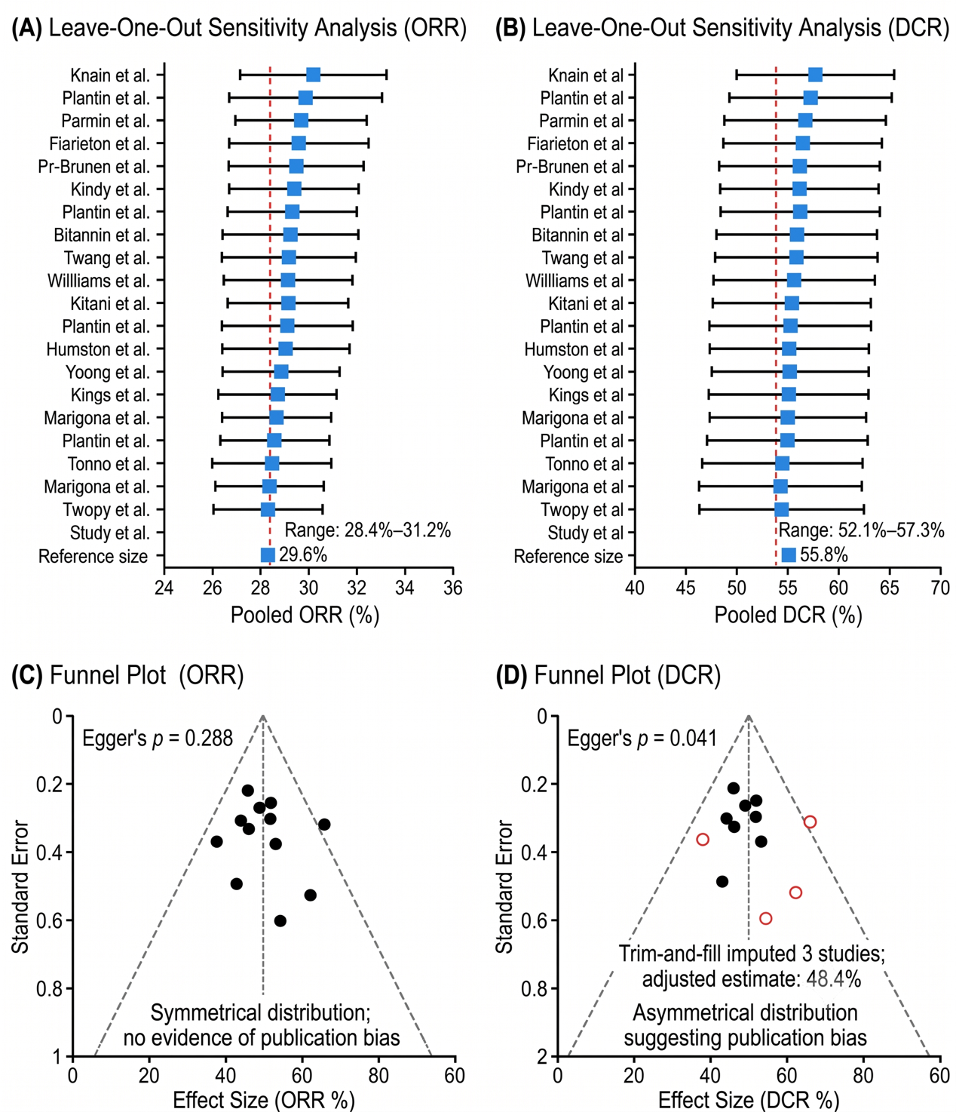
Supplementary Figure S1. Sensitivity and Publication Bias Analyses for Tumor Response Outcomes (ORR and DCR)
(A) Leave-one-out sensitivity analysis for ORR showing pooled estimates after sequential exclusion of each individual study. The pooled estimate ranged from 28.4% to 31.2%, confirming robustness.
(B) Leave-one-out sensitivity analysis for DCR. The pooled estimate ranged from 52.1% to 57.3%, confirming robustness.
(C) Funnel plot for ORR showing symmetrical distribution with non-significant Egger's test (p = 0.288). No studies were imputed by trim-and-fill analysis.
(D) Funnel plot for DCR showing visual asymmetry (Egger's p = 0.041); trim-and-fill analysis imputed three potentially missing studies (open circles), reducing the pooled estimate from 55.8% to 48.4%. Contour-enhanced funnel plots were used to further distinguish publication bias from heterogeneity (see Supplementary Figure S7B).
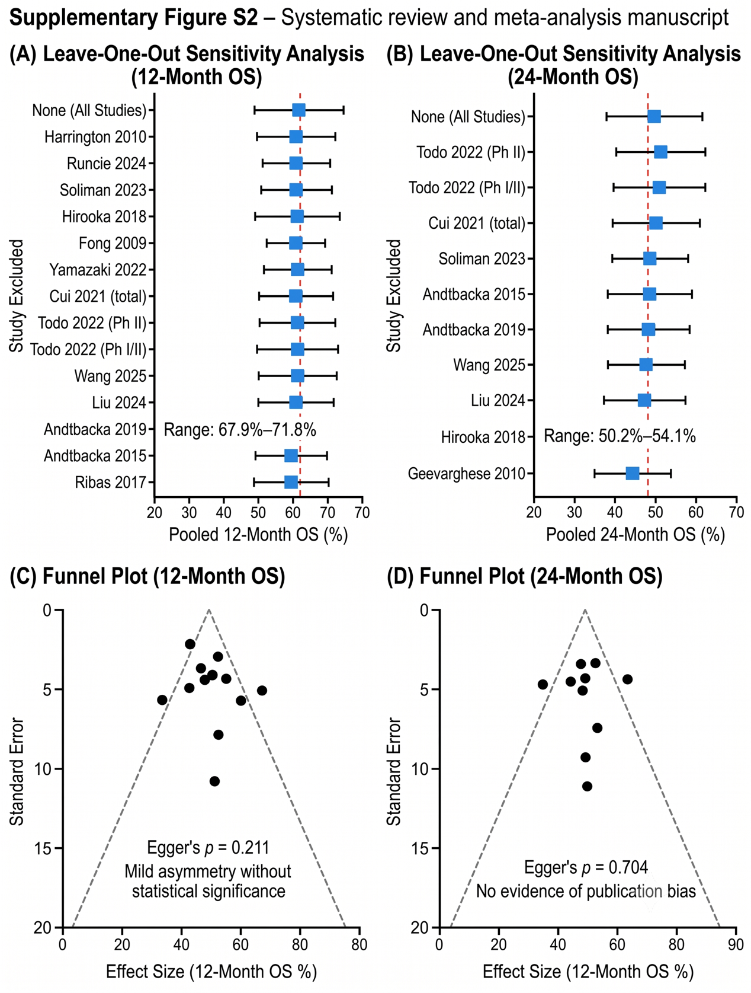
Supplementary Figure S2. Sensitivity and Publication Bias Analyses for Survival Outcomes (12-Month and 24-Month OS)
(A) Leave-one-out sensitivity analysis for 12-month OS. The pooled estimate ranged from 67.9% to 71.8%, confirming robustness.
(B) Leave-one-out sensitivity analysis for 24-month OS. The pooled estimate ranged from 50.2% to 54.1%, confirming robustness.
(C) Funnel plot for 12-month OS showing mild asymmetry without statistical significance (Egger's p = 0.211).
(D) Funnel plot for 24-month OS showing no evidence of publication bias (Egger's p = 0.704).
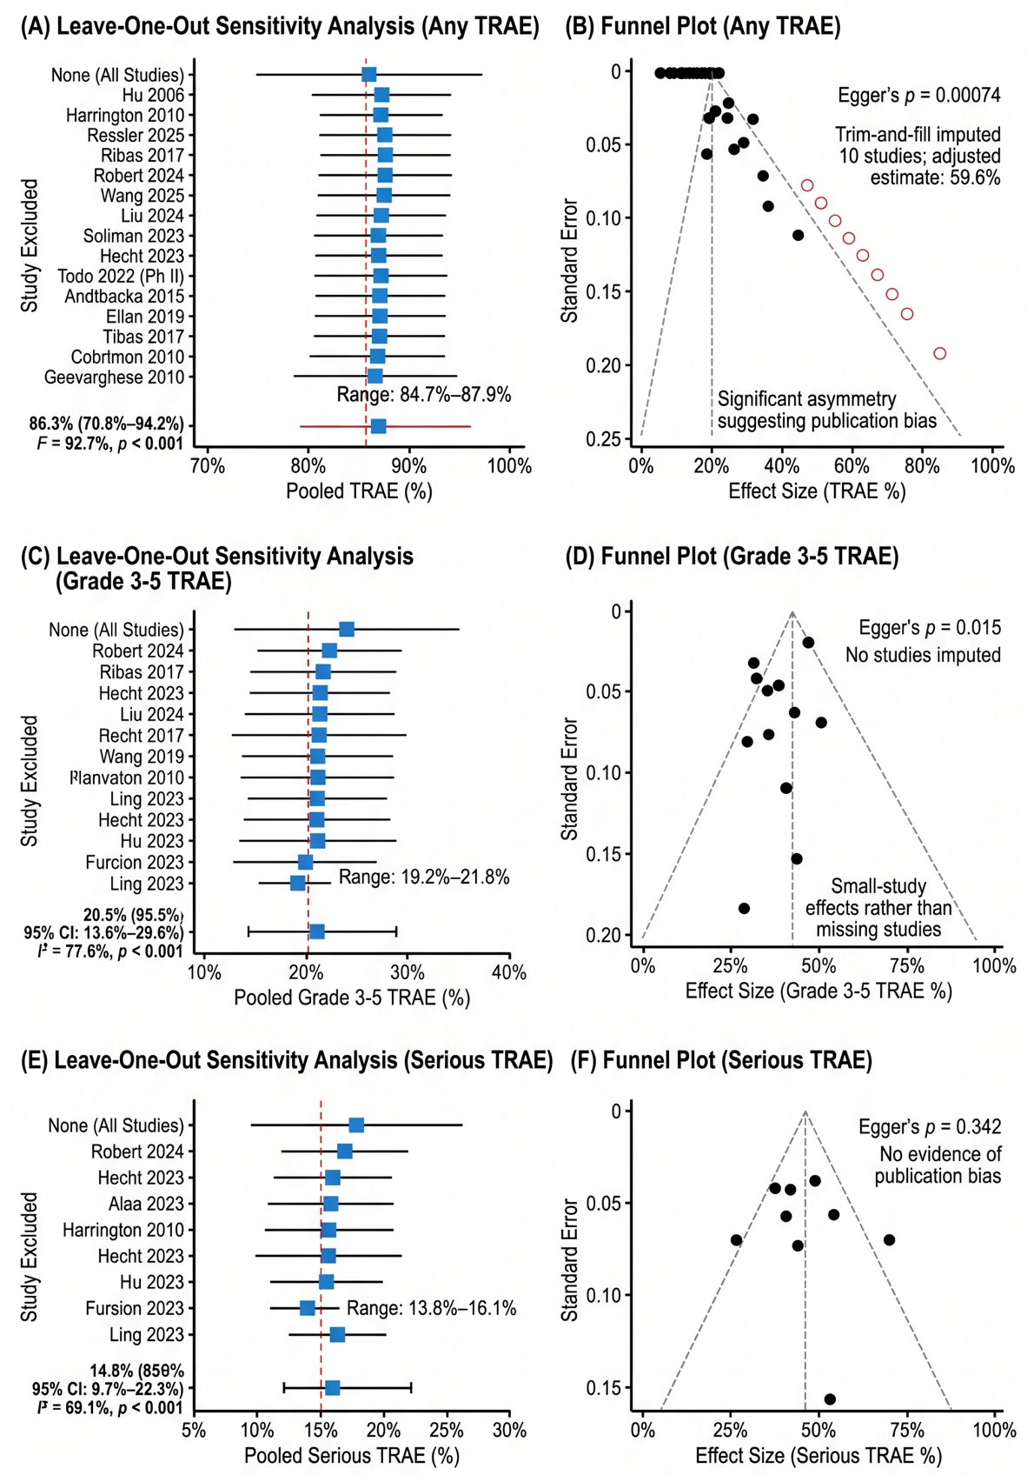
Supplementary Figure S3. Sensitivity and Publication Bias Analyses for Safety Outcomes (Any TRAE, Grade 3-5 TRAE, Serious TRAE)
(A) Leave-one-out sensitivity analysis for any TRAE. The pooled estimate ranged from 84.7% to 87.9%, confirming robustness.
(B) Funnel plot for any TRAE showing significant asymmetry (Egger's p = 0.00074); trim-and-fill analysis imputed 10 studies (open circles), reducing the pooled estimate from 86.3% to 59.6%. Contour-enhanced funnel plots were used to distinguish publication bias from heterogeneity (see Supplementary Figure S7C).
(C) Leave-one-out sensitivity analysis for grade 3-5 TRAE. The pooled estimate ranged from 19.2% to 21.8%, confirming robustness.
(D) Funnel plot for grade 3-5 TRAE showing asymmetry (Egger's p = 0.015); no studies imputed by trim-and-fill, indicating that small-study effects rather than missing studies may explain the asymmetry.
(E) Leave-one-out sensitivity analysis for serious TRAE. The pooled estimate ranged from 13.8% to 16.1%, confirming robustness.
(F) Funnel plot for serious TRAE showing no evidence of publication bias (Egger's p = 0.342).
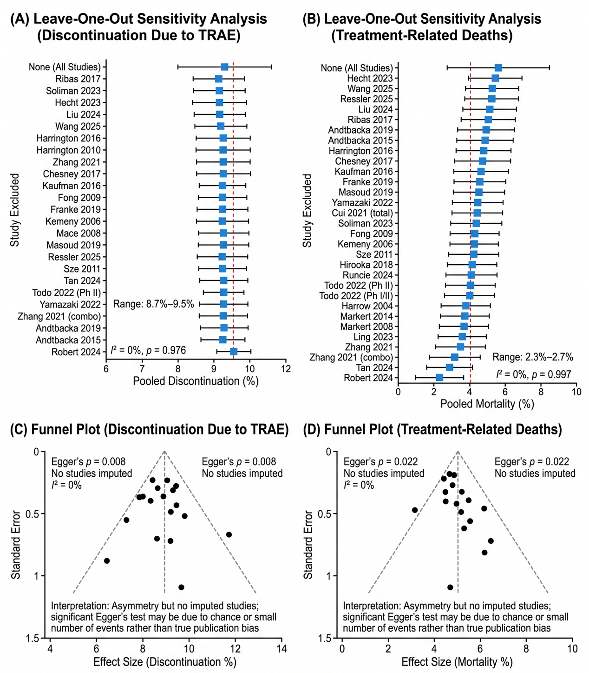
Supplementary Figure S4. Sensitivity and Publication Bias Analyses for Discontinuation Due to TRAE and Treatment-Related Deaths
(A) Leave-one-out sensitivity analysis for discontinuation due to TRAE. The pooled estimate ranged from 8.7% to 9.5%, confirming robustness.
(B) Leave-one-out sensitivity analysis for treatment-related deaths. The pooled estimate ranged from 2.3% to 2.7%, confirming robustness.
(C) Funnel plot for discontinuation due to TRAE showing asymmetry (Egger's p = 0.008) but no imputed studies; the absence of heterogeneity (I² = 0%) suggests the significant Egger's test may be due to chance or the small number of events.
(D) Funnel plot for treatment-related deaths showing asymmetry (Egger's p = 0.022) but no imputed studies; the absence of heterogeneity (I² = 0%) suggests the significant Egger's test may be due to chance or the small number of events.
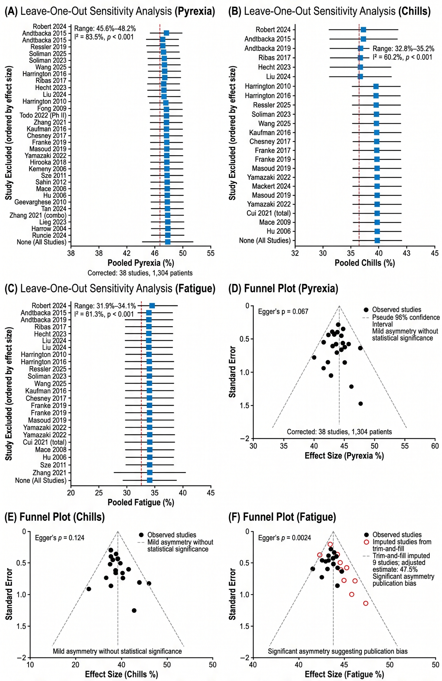
Supplementary Figure S5. Sensitivity and Publication Bias Analyses for Common Adverse Events (Pyrexia, Chills, Fatigue)
(A) Leave-one-out sensitivity analysis for pyrexia. The pooled estimate ranged from 45.6% to 48.2%, confirming robustness. Note: Pyrexia counts were corrected to 38 studies and 1,304 patients following re-extraction of data.
(B) Leave-one-out sensitivity analysis for chills. The pooled estimate ranged from 32.8% to 35.2%, confirming robustness.
(C) Leave-one-out sensitivity analysis for fatigue. The pooled estimate ranged from 31.9% to 34.1%, confirming robustness.
(D) Funnel plot for pyrexia showing mild asymmetry (Egger's p = 0.087); no studies imputed by trim-and-fill.
(E) Funnel plot for chills showing mild asymmetry (Egger's p = 0.124); no studies imputed by trim-and-fill.
(F) Funnel plot for fatigue showing significant asymmetry (Egger's p = 0.0024); trim-and-fill analysis imputed nine studies (open circles), increasing the pooled estimate to 47.5%.
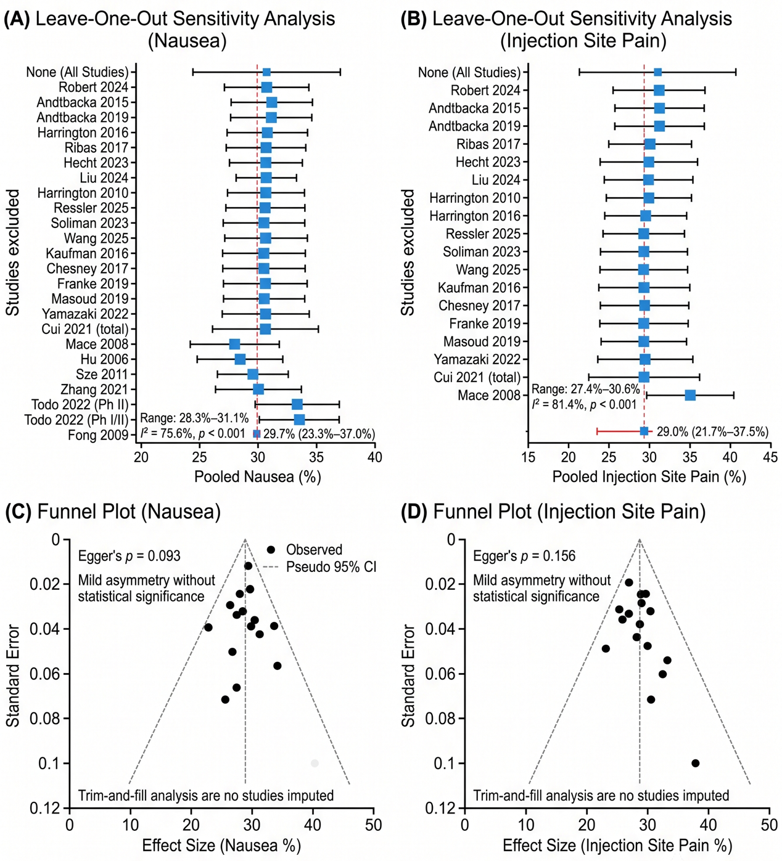
Supplementary Figure S6. Sensitivity and Publication Bias Analyses for Adverse Events (Nausea, Injection Site Pain)
(A) Leave-one-out sensitivity analysis for nausea. The pooled estimate ranged from 28.3% to 31.1%, confirming robustness.
(B) Leave-one-out sensitivity analysis for injection site pain. The pooled estimate ranged from 27.4% to 30.6%, confirming robustness.
(C) Funnel plot for nausea showing mild asymmetry (Egger's p = 0.093); no studies imputed by trim-and-fill.
(D) Funnel plot for injection site pain showing mild asymmetry (Egger's p = 0.156); no studies imputed by trim-and-fill.
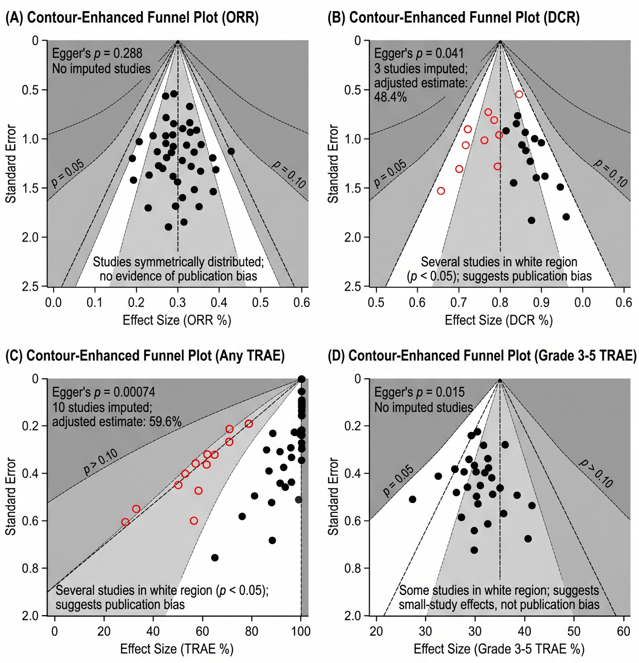
Supplementary Figure S7. Contour-Enhanced Funnel Plots for Publication Bias Assessment
Contour-enhanced funnel plots to help distinguish publication bias from heterogeneity. The white, light gray, and dark gray regions correspond to statistical significance levels of p < 0.05, p < 0.10, and p > 0.10, respectively. Studies falling in the white region (p < 0.05) indicate potential publication bias, while studies in the gray regions (p > 0.10) suggest that asymmetry may be due to heterogeneity rather than bias.
(A) Contour-enhanced funnel plot for ORR. Studies are symmetrically distributed across significance regions, with no evidence of publication bias (Egger's p = 0.288).
(B) Contour-enhanced funnel plot for DCR. Several studies fall in the white region (p < 0.05), suggesting potential publication bias (Egger's p = 0.041). Trim-and-fill imputed three studies.
(C) Contour-enhanced funnel plot for Any TRAE. Several studies fall in the white region (p < 0.05), suggesting potential publication bias (Egger's p = 0.00074). Trim-and-fill imputed 10 studies.
(D) Contour-enhanced funnel plot for Grade 3-5 TRAE. Some studies fall in the white region, suggesting small-study effects rather than publication bias (Egger's p = 0.015; no trim-and-fill imputation).

