Table S1: XGBoost hyperparameters
Parameter | Value
n_estimators | 100
max_depth | 6
learning_rate | 0.1
subsample | 0.8
colsample_bytree | 0.8
min_child_weight | 1
gamma | 0

Table S2: Event counts by split and time window
Cohort | Total N | Recurrence, n (%) | Non-recurrence, n (%)
Training | 269 | 119 (44.2%) | 150 (55.8%)
Validation | 89 | 40 (44.9%) | 49 (55.1%)
Test | 89 | 44 (49.4%) | 45 (50.6%)
Test: 0–1Y | 89 | 38 (42.7%) | 51 (57.3%)
Test: 1–2Y | 89 | 23 (25.8%) | 66 (74.2%)
Test: ＞2Y | 89 | 16 (18.0%) | 73 (82.0%)

Table S3: Univariate analysis of the training set
Characteristic | 0 to 12M |  | 12 to 24M |  | 24M more
Characteristic | OR (95% CI) | P value | OR (95% CI) | P value | OR (95% CI) | P value
Gender | 0.607 (0.282 - 1.188) | 0.169 | 0.42 (0.18 - 0.861) | 0.028 | 0.429 (0.173 - 0.914) | 0.043
Age | 0.98 (0.957 - 1.003) | 0.092 | 1.011 (0.988 - 1.035) | 0.352 | 0.991 (0.968 - 1.016) | 0.476
GPC3 | 2.114 (1.245 - 3.726) | 0.007 | 1.181 (0.728 - 1.947) | 0.506 | 2.014 (1.17 - 3.601) | 0.014
BMI | 0.989 (0.897 - 1.087) | 0.816 | 0.982 (0.892 - 1.077) | 0.698 | 0.986 (0.891 - 1.087) | 0.782
Diabetes | 0.748 (0.434 - 1.254) | 0.282 | 0.584 (0.335 - 0.984) | 0.049 | 0.734 (0.417 - 1.25) | 0.267
BCLC A | 2.35 (1.182 - 5.224) | 0.023 | 1.974 (1.038 - 4.09) | 0.05 | 1.29 (0.695 - 2.559) | 0.44
WBC | 1.12 (0.986 - 1.269) | 0.077 | 0.964 (0.839 - 1.097) | 0.585 | 0.949 (0.819 - 1.089) | 0.475
PLT | 1 (0.996 - 1.004) | 0.986 | 1.003 (0.999 - 1.007) | 0.098 | 1.002 (0.998 - 1.007) | 0.245
HGB | 1.002 (0.989 - 1.017) | 0.756 | 0.994 (0.981 - 1.008) | 0.376 | 1.011 (0.996 - 1.027) | 0.171
PT | 1.107 (1.021 - 1.311) | 0.163 | 0.933 (0.795 - 1.011) | 0.365 | 0.883 (0.743 - 1.004) | 0.142
INR | 0.89 (0.526 - 1.544) | 0.67 | 0.692 (0.418 - 1.163) | 0.157 | 0.844 (0.494 - 1.484) | 0.545
AFP | 1.888 (1.167 - 3.073) | 0.01 | 2.05 (1.279 - 3.308) | 0.003 | 1.674 (1.02 - 2.758) | 0.042
AST | 0.999 (0.995 - 1.002) | 0.55 | 1 (0.997 - 1.003) | 0.98 | 0.998 (0.993 - 1.002) | 0.359
ALT | 1.008 (1.002 - 1.014) | 0.005 | 1 (0.993 - 1.006) | 0.997 | 0.994 (0.984 - 1.002) | 0.186
TB | 0.972 (0.937 - 1.004) | 0.11 | 0.982 (0.949 - 1.012) | 0.264 | 0.98 (0.945 - 1.013) | 0.261
ALB | 1.016 (0.964 - 1.072) | 0.569 | 0.971 (0.924 - 1.022) | 0.262 | 0.971 (0.921 - 1.025) | 0.286
Size | 1.516 (1.043 - 2.26) | 0.034 | 2.014 (1.361 - 3.073) | 0.001 | 1.571 (1.065 - 2.384) | 0.028
Liver disease type | 1.169 (0.636 - 2.25) | 0.626 | 0.657 (0.376 - 1.177) | 0.149 | 0.6 (0.336 - 1.098) | 0.09

Table S4: mRMR of the training set
Rank | 0 to 12M |  | 12 to 24M |  | 24M more
Rank | Feature | Score | Feature | Score | Feature | Score
1 | Size | 0.020203366 | Size | 0.016569302 | AFP | 0.019458955
2 | AFP | 0.017572015 | BCLC | 0.012968634 | GPC3 | 0.016909742
3 | HGB | 0.015672208 | GPC3 | 0.009194634 | Gender | 0.013227039
4 | GPC3 | 0.010825224 | Gender | 0.007904727 | AST | 0.010180974
5 | Age | 0.00876569 | PT | 0.006458683 | PT | 0.009510764
6 | TB | 0.004989647 | AFP | 0.003742332 | Size | 0.007337691
7 | PT | 0.004896722 | ALT | 0.003277488 | HGB | 0.004844306
8 | ALB | 0.004856886 | TB | 0.003228159 | BMI | 0.004837581
9 | BCLC | 0.004560231 | INR | 0.003128159 | ALB | 0.004704766
10 | WBC | 0.004534224 | AST | 0.003088934 | ALT | 0.003653208
11 | BMI | 0.003733096 | PLT | 0.00306093 | Liver disease type | 0.003637261
12 | ALT | 0.003174494 | Diabetes | 0.003054576 | TB | 0.003382015
13 | INR | 0.002174494 | Liver disease type | 0.002527442 | PLT | 0.003096223
14 | Gender | 0.0015417 | ALB | 0.001833211 | Age | 0.002920527
15 | PLT | 0.001240674 | Age | 0.001501032 | Diabetes | 0.000948622
16 | Diabetes | 0.000885562 | HGB | 0.001003356 | BCLC | 0.000461044
17 | AST | 0.000444701 | BMI | 0.000963344 | WBC | 0.000326479
18 | Liver disease type | 0.000372189 | WBC | 0.000333228 | INR | 0.00030479

Table S5: MI for the training set
Rank | 0 to 12 |  | 12 to 24 |  | 24 more
Rank | Feature | MI Value | Feature | MI Value | Feature | MI Value
1 | Size | 0.025678515 | Size | 0.015896429 | Size | 0.013937095
2 | Gender | 0.017291256 | AFP | 0.009968634 | Gender | 0.012909742
3 | AFP | 0.009672208 | HGB | 0.008814495 | TB | 0.011227039
4 | GPC3 | 0.00876569 | TB | 0.006849118 | PLT | 0.008870856
5 | Diabetes | 0.008464352 | Gender | 0.006458683 | ALT | 0.007719464
6 | HGB | 0.003921601 | GPC3 | 0.006009816 | GPC3 | 0.005608134
7 | PT | 0.003742235 | ALT | 0.002536635 | HGB | 0.003751593
8 | ALB | 0.003485767 | PLT | 0.00253307 | ALB | 0.003659327
9 | Age | 0.003400668 | Diabetes | 0.002290932 | PT | 0.003628186
10 | BMI | 0.002799822 | WBC | 0.001883672 | BCLC | 0.002739906
11 | ALT | 0.002412239 | Age | 0.001125774 | AST | 0.002458356
12 | TB | 0.001156275 | INR | 0.001092372 | AFP | 0.002322167
13 | PLT | 0.000994706 | ALB | 0.000892581 | Age | 0.002190395
14 | WBC | 0.000664172 | PT | 0.000752517 | Diabetes | 0.000711467
15 | AST | 0.000560307 | BMI | 0.000722508 | Liver disease type | 0.000327565
16 | INR | 0.000100939 | AST | 0.000249921 | WBC | 0.000274779
17 | Liver disease type | 4.65E-05 | Liver disease type | 0.000190872 | INR | 0.000200316
18 | BCLC | 0 | BCLC | 0 | BMI | 0.000100316

Table S6: GPC-3 incremental value
Metric | Value | 95% CI | P value
AUC | +0.041 | 0.015–0.068 | 0.008
NRI | 0.312 | 0.128–0.496 | 0.001
IDI | 0.058 | 0.026–0.090 | <0.001

Figure S1 Calibration curves for the XGB model across time windows. Calibration plots with 1000 bootstrap iterations are shown for (A) 0–1 year, (B) 1–2 years, and (C) >2 years.

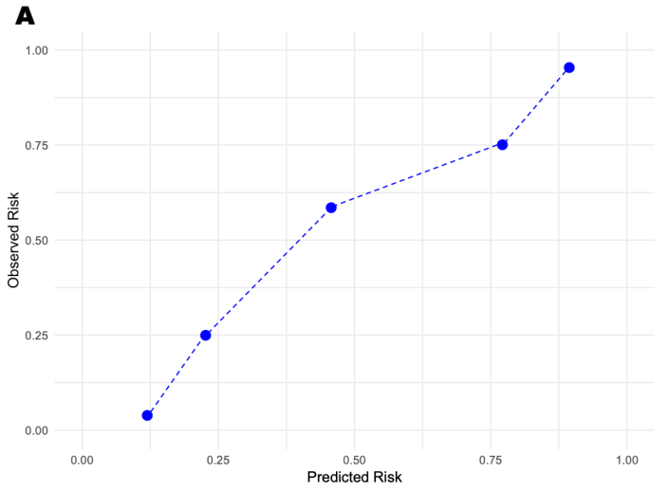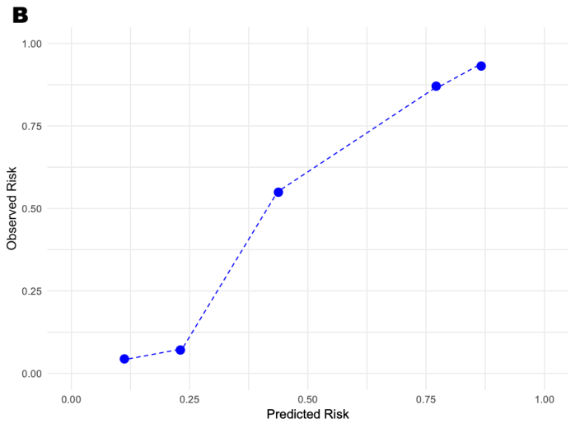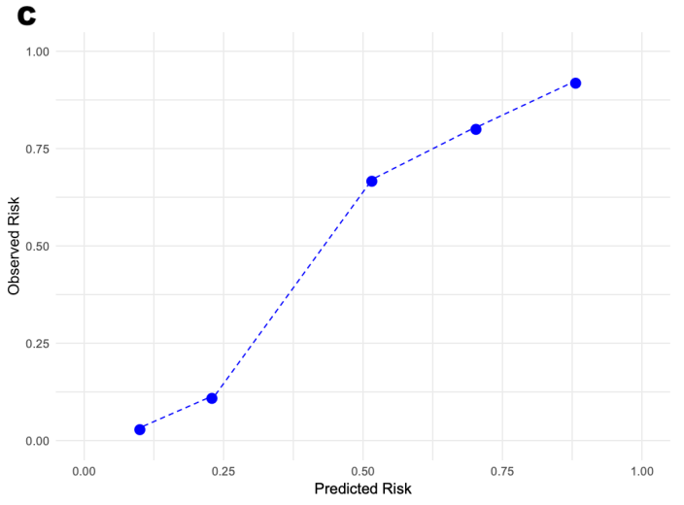
Figure S2 Decision Curve Analysis for the XGB model across time windows. Net benefit is plotted against threshold probability for (A) 0–1 year, (B) 1–2 years, and (C) >2 years. The blue solid line represents the XGB model, the gray dashed line represents the "treat all" strategy, and the gray dotted line (net benefit = 0) represents the "treat none" strategy. The XGB model demonstrates positive net benefit across a wide range of clinically relevant threshold probabilities for all three time windows.
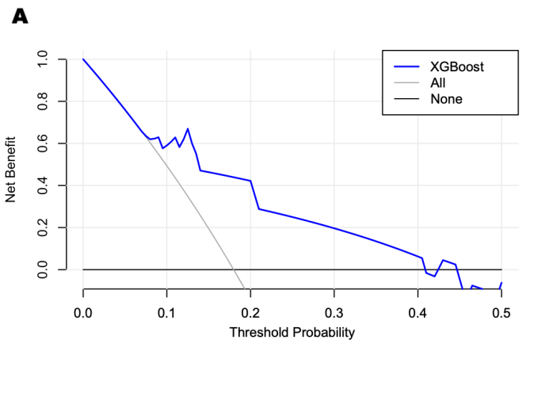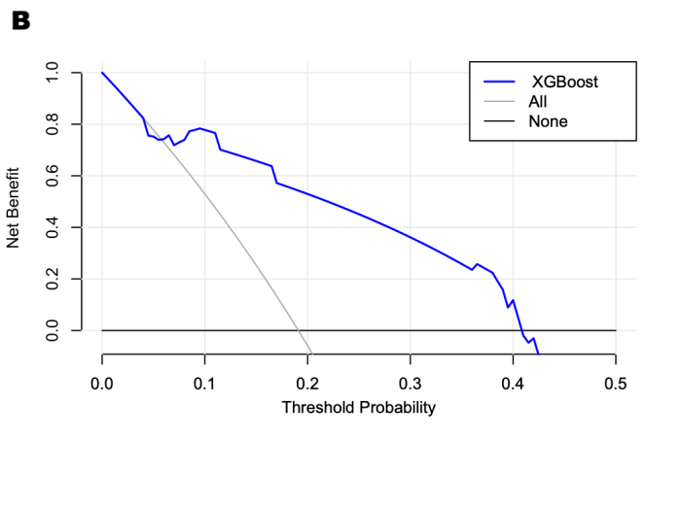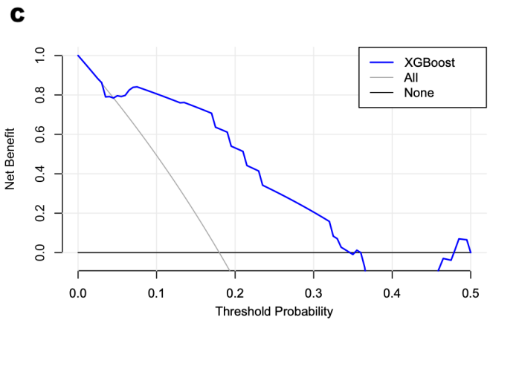
Figure S3 SHAP analysis of the XGB model. (A) Feature importance bar plot showing mean absolute SHAP values. (B) SHAP summary (swarm) plot showing the distribution of SHAP values for each feature; yellow indicates high feature values and purple indicates low feature values. Tumor size and AFP were the most influential predictors, followed by GPC-3, gender, and BCLC stage.
