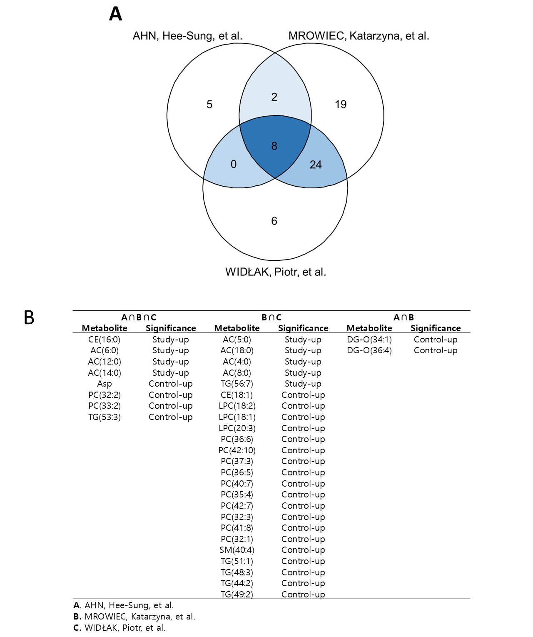
Figure S1. Comparison of metabolite distribution between study subjects and reference controls. Metabolite distributions were compared with those of the normal control group in the three reference groups, and the numbers of metabolites with significantly different distributions are displayed in a Venn diagram (A). Metabolites with significantly different distributions are listed in the table (B).

