Supplementary data
Table S1. Clinical Characteristics of Participants
Variables | Cancer | Benign
Number | 80 | 297
Age ± SD | 58.7 ± 14.3 | 49.28 ± 12.13
P value | < 0.001
Age
≤30s | 7 (8.75%) | 78 (26.26%)
40s | 16 (20.00%) | 82 (27.61%)
50s | 18 (22.50%) | 73 (24.58%)
60s | 20 (25.00%) | 41 (14.48%)
≥70s | 19 (23.75%) | 23 (7.74%)
Menopausal status
Pre | 21 (26.25%) | 206 (69.36%)
Post | 59 (73.75%) | 91 (30.64%)
Obstetric history
Yes | 69 (86.25%) | 206 (69.36%)
No | 11 (13.75%) | 91 (30.64%)
Histology
Ovarian cancer
Serous | 42 (52.50%) | -
High grade | 37 (46.25%) | -
Low grade | 1 (1.25%) | -
Borderline | 4 (5.00%) | -
Non-serous | 33 (41.25%) | -
Mucinous | 14 (17.50%) | -
Clear cell | 10 (12.50%) | -
Granulosa cell | 5 (6.25%) | -
Endometrioid | 4 (5.00%) | -
NOS | 5 (6.25%) | -
Controls
Uterine& Cervix disorders, benign |  | 77 (25.93%)
Adenomyoma | - | 1 (0.34%)
Adenomyomatous polyp | - | 1 (0.34%)
Adenomyosis | - | 4 (1.34%)
Atypical polypoid adenomyoma | - | 1 (0.34%)
Bartholin duct abscess | - | 1 (0.34%)
Chronic endometritis | - | 1 (0.34%)
Endometrial polyp | - | 27 (9.09%)
Endometrial hyperplasia | - | 1 (0.34%)
Endometriosis | - | 17 (5.72%)
Hydrosalpinx | - | 1 (0.34%)
Leiomyoma | - | 6 (2.02%)
Ulterine prolapse | - | 16 (5.39%)
Ovarian disorders, benign |  | 220 (74.07%)
Mature cystic teratoma | - | 58 (19.53%)
Mucinous cystadenofibroma | - | 4 (1.34%)
Mucinous cystadenoma | - | 22 (7.41%)
Paratubal cyst | - | 18 (6.06%)
Parovarian cyst | - | 32 (10.77%)
Seromucinous cystadenoma | - | 4 (1.34%)
Serous cyst | - | 2 (0.67%)
Serous cystadenofibroma | - | 1 (0.34%)
Serous cystadenoma | - | 73 (24.58%)
Stromal hyperplasia | - | 3 (1.01%)
Stromal hyperthecosis and inclusion cyst | - | 1 (0.34%)
Cellular fibroma | - | 2 (0.67%)
FIGO stage
I - II | 35 (43.75%) | -
III - IV | 34 (42.50%) | -
NA | 11 (13.75%) | -

Table S2. Median Value of Each Biomarker
Variables | OC | Control | P-value
CA125 (U/mL, IQR*) | 60.38 (7.89 - 406.97) | 1.80 (0.81 – 7.35) | <0.001
HE4 (pmol/L, IQR) | 110.50 (59.68 – 405.50) | 47.50 (47.50 - 61.70) | <0.001
Trx1 (U/mL, IQR) | 28.03 (16.68 – 48.42) | 23.48 (14.67 – 32.25) | 0.04
*: IQR: interquartile range

Table S3. Comparison of Clinical Performance of Each Biomarker
Variable | Cut-off | Sensitivity (95% CI) | Specificity (95% CI) | AUC(95% CI)
CA125 | 35 U/mL | 53.75 (42.2 - 65.0) | 93.60 (90.23 - 95.87) | 0.832(0.774 - 0.888)
HE4 | 60.5 pmol/L* | 73.75 (62.7 - 83.0) | 80.13 (75.23 - 84.28) | 0.812(0.744 - 0.875)
Trx1 | 22.8 U/mL | 62.5(51.55 – 72.31) | 80.81 (75.95 - 84.88) | 0.768(0.709 - 0.825)
*<40 yr: ≤60.50 pmol/L; 40-49 yr: ≤76.20 pmol/L; 50-59 yr: ≤ 74.3 pmol/L; 60-69 yr: ≤ 82.90 pmol/L; ≥70 yr: ≤104.00 pmol/L

Table S4. Logistic Regression Analysis Formula
No. | Variables |  |  | Logistic regression
1 | Trx1 | CA125 |  | = -5.2987803+0.6031702*LN(Trx1)+1.0569049*LN(CA125)
2 | Trx1 |  | HE4 | = -3.36309 + 0.0071977*LN(Trx1) + 0.027003*LN(HE4)
3 |  | CA125 | HE4 | = -3.20844 + 0.020201*LN(CA125) + 0.022415*LN(HE4)
4 | Trx1 | CA125 | HE4 | = -3.43072 + 0.0089423*LN(Trx1) + 0.020206*LN(CA125) + 0.021454*LN(HE4)

Table S5. Median Biomarker Levels According to Clinical Characteristics of Patients with Ovarian Cancer
Variables | N (%) | CA125 (IQR*) | P Value | HE4 (IQR) | P Value | Trx1 (IQR) | P Value
Age
≤30s | 7 (8.75) | 14.03  (8.43 - 141.20) | 0.17 | 53.30  (43.85 - 55.20) | <0.001*** | 23.31  (21.41 - 30.88) | 0.31
40s | 16 (20.00) | 17.32  (3.52 - 105.33) | 0.17 | 70.75  (53.75 - 145.50) | <0.001*** | 18.39  (14.36 - 40.31) | 0.31
50s | 18 (22.50) | 182.53  (17.23 - 537.59) | 0.17 | 124.00  (59.43 - 235.00) | <0.001*** | 28.08  (21.27 - 35.34) | 0.31
60s | 20 (25.00) | 79.56  (9.13 - 319.09) | 0.17 | 148.50  (67.98 - 778.25) | <0.001*** | 24.04  (13.6 - 66.97) | 0.31
≥70s | 19 (23.75) | 172.90  (13.38 - 525.89) | 0.17 | 305.00  (101.15 - 818.00) | <0.001*** | 45.25  (27.05 - 50.35) | 0.31
Menstruation
Menses | 21 (26.25) | 12.78  (4.07 - 119.54) | 0.01* | 59.10  (48.00 - 82.50) | <0.001*** | 22.28  (16.33 - 40.06) | 0.41
Menopause | 59 (73.75) | 152.85  (11.16 - 491.98) | 0.01* | 155.00  (75.65 - 600.50) | <0.001*** | 30.45  (17.01 - 49.42) | 0.41
Obstetric history
Obstetric history | 69 (86.25) | 67.20  (6.53 - 425.31) | 0.66 | 116.00  (62.5 - 533) | 0.11 | 28.27  (15.31 - 50.31) | 0.9
No history | 11 (13.75) | 29.07  (13.41 - 141.20) | 0.66 | 80.30  (53.80 - 119.00) | 0.11 | 26.69  (19.93 - 38.22) | 0.9
His-pathological results
High grade papillary serous | 37 | 375.90  (100.27 - 561.00) | <0.001*** | 399.00  (113.00 - 782.00) | <0.001*** | 35.08  (19.81 – 51.27) | 0.45
Low grade papillary serous | 1 | 1.77  (NA) | <0.001*** | 116.00  (NA) | <0.001*** | 10.25  (NA) | 0.45
Serous boderline | 4 | 42.61  (19.50 – 85.36) | <0.001*** | 52.15  (43.68 – 64.80) | <0.001*** | 22.75  (21.85 – 23.30) | 0.45
Clear cell | 10 | 8.32  (3.46 – 97.64) | <0.001*** | 73.70  (55.60 – 107.63) | <0.001*** | 16.14  (13.21 – 35.20) | 0.45
Granulos cell | 5 | 1.51  (0.69 – 2.20) | <0.001*** | 56.50  (40.70-82.80) | <0.001*** | 32.88  (19.19 – 88.11) | 0.45
Endometroid | 4 | 186.04  (36.13 – 453.80) | <0.001*** | 405.00  (174.75 – 692.00) | <0.001*** | 36.34  (31.39 – 41.45) | 0.45
Mucinous | 14 | 20.73  (8.09 – 46.20) | <0.001*** | 63.40  (55.45 – 106.93) | <0.001*** | 28.08  (17.94 – 44.72) | 0.45
Others | 5 | 32.00  (22.56 – 119.54) | <0.001*** | 53.30  (52.90 – 66.20) | <0.001*** | 24.16  (17.22 – 26.69) | 0.45
FIGO stage
I | 33 | 12.78  (3.22 – 45.54) | <0.001*** | 72.00  (53.80 – 126.00) | <0.001*** | 27.73  (17.22 – 41.06) | 0.77
II | 2 | 339.06  (219.67 – 458.45) | <0.001*** | 112.50  (110.75 – 114.25) | <0.001*** | 48.50  (30.10 – 66.90) | 0.77
III | 22 | 427.52  (205.04 – 558.43) | <0.001*** | 386.00  (205.75 – 887.75) | <0.001*** | 35.83  (16.58 – 51.05) | 0.77
IV | 12 | 180.31  (7.29 – 462.47) | <0.001*** | 579.50  (114.00 – 778.25) | <0.001*** | 29.53  (10.45 – 50.85) | 0.77
NA | 11 | 32.00  (14.55 – 173.21) | <0.001*** | 59.30  (53.60 – 67.65) | <0.001*** | 23.31  (17.93 – 34.42) | 0.77
*: IQR: interquartile range

Figures
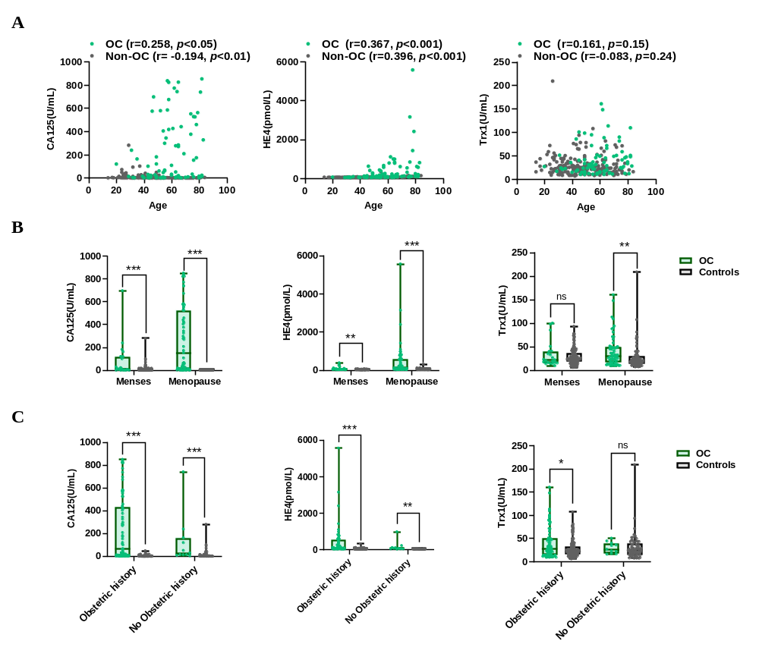
Figure S1. Correlation between Clinical Variables and Individual Biomarkers for Ovarian. (A) Correlation analysis of CA125, HE4, and Trx1 with age in patients with and without ovarian cancer. The Pearson correlation coefficient (r) is indicated. (B) Box-and-whisker plots depicting CA125, HE4, and Trx1 expression levels based on menopausal status in patients with and without ovarian cancer. (C) Box-and-whisker plots illustrating CA125, HE4, and Trx1 expression levels according to obstetric history in patients with and without ovarian cancer. Box-and-whisker plots show the median (center line), interquartile range (box), and min to max range (whiskers). Individual dots represent individual patients. A single asterisk (*) indicates p < 0.05, two asterisks (**) indicate p < 0.01, three asterisks (***) indicate p < 0.001, and ‘ns’ denotes non-significant differences.

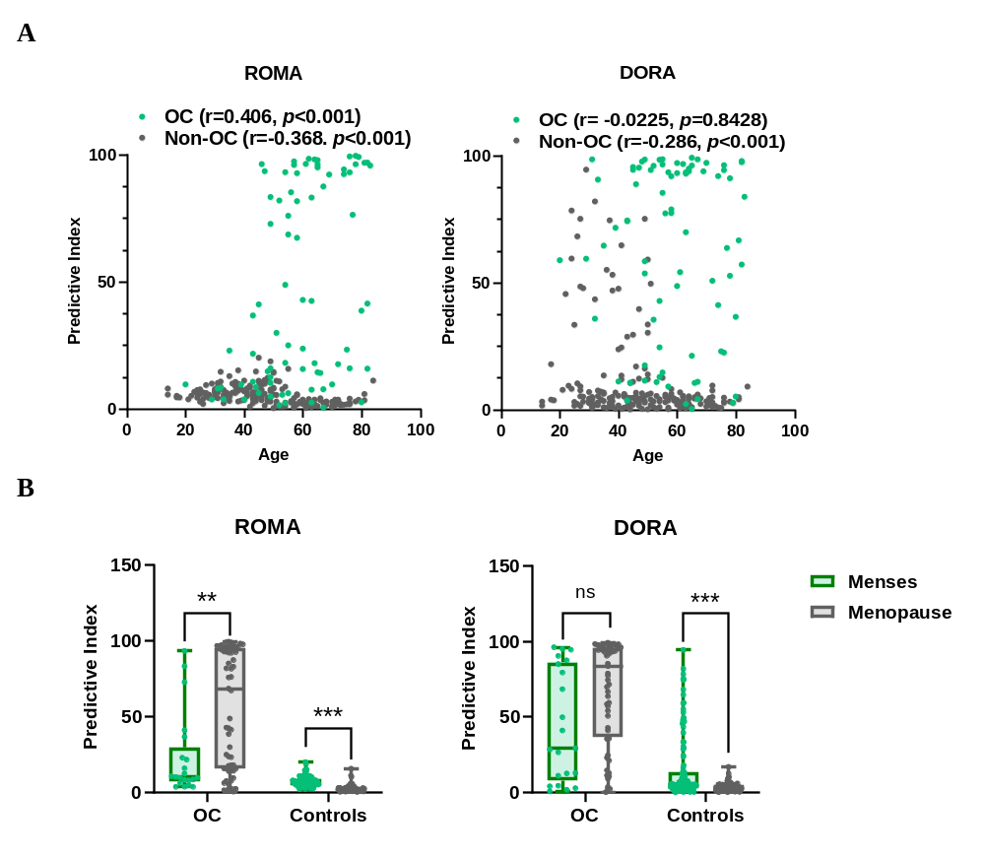
Figure S2. Comparison of Clinical Performance between ROMA and DORA by Age, Menses and Menopause Status. (A) Correlation analysis between age and the ROMA and DORA algorithms in patients with and without ovarian cancer. The R value represents the Pearson correlation coefficient. (B) Box-and-whisker plot comparing the ROMA and DORA algorithms according to menopausal status. Box-and-whisker plots show the median (center line), interquartile range (box), and min to max range (whiskers). Individual dots represent individual patients. Two asterisks (**) indicate a p-value of less than 0.01, and three asterisks (***) indicate a p-value of less than 0.001. "ns" denotes a statistically non-significant result.

