Electronic Supplementary Materials

MUC5AC for Early Detection of Pancreatic Cancer: A Systematic Review and Meta-analysis
Nourhan Saeed Bakry^{1,2,3}, Rasha S. Farag⁴, Xiang-Yu Meng⁵, Qiao-Li Wang^{6,7}
¹ Department of Oncology-Pathology, Karolinska Institutet, Stockholm, Sweden
² Harvard Medical School, Boston, United States
³ Beni-Suef Governorate of Health, Beni-Suef, Egypt
⁴ Department of Clinical Research, Damietta Directorate for Health Affairs, Egyptian Ministry of Health and Population, Damietta, Egypt
⁵ Health Science Center, Hubei Minzu University, Enshi, China
⁶ Department of Translational Medicine, SciLifeLab, Lund University, Malmö, Sweden
⁷ Department of Clinical Science, Intervention, and Technology, Karolinska Institutet, Stockholm, Sweden

Corresponding Authors: Qiaoli Wang, MD, PhD, Department of Translational Medicine, Lund University, Jan Waldenströms gata 35, Malmö, 20502, Sweden. Email: qiaoli.wang@med.lu.se; Xiang-Yu Meng, MD, PhD, Health Science Center, Hubei Minzu University, Enshi, China. Email: mengxy_whu@163.com.

List of the supplementary documents

1. Supplementary Appendix
Appendix S1: Definition of cases and controls
Appendix S2: Quality assessment

2. Supplementary Tables
Table S1. Search Strategy
Table S2. Characteristics of the Included Studies
Table S3. Clinical Utility of MUC5AC for All Comparisons
Table S4. Influence Analysis before and after Removing Very Low-quality Studies
Table S5. Threshold Effect Assessment and Influence Analysis After removing Heterogeneous Studies in Each Comparison
Table S6. Meta-regression for All Comparisons
Table S7. Studies Included in the Systematic Review but not Included in Meta-Analysis
Table S8. Subgroup Analysis by Blood and Tissue Samples

3. Supplementary Figures
Fig.S1 Probability Modifying Plots for All Comparisons
Fig.S2 Bivariate Box Plots for All Comparisons
Fig.S3 ROC Plane Curves for All Comparisons
Fig.S4 Meta-regression for All Comparisons
Fig.S5 Overall Quality Assessment by QUADAS-2
Fig.S6 Individual Display for Quality Assessment by QUADAS-2
Fig. S7 Deeks’ Funnel Plots for Four Comparisons

1.Supplementary Appendix
Appendix S1: Definition of cases and controls
Pancreatic cancer (PC) cases included the following pathologies: adenocarcinoma, ductal adenocarcinoma, invasive ductal adenocarcinoma, invasive carcinoma, cystic ductal adenocarcinoma, infiltrative carcinoma, invasive ductal carcinoma, acinar ductal adenocarcinoma, mucinous cystadenocarcinoma, colloid carcinoma and unspecified others (referred to as PC). Specimens were generally collected from different patients; however, in a few studies [2-9], multiple specimens were collected from the same patient. In one study, PC specimens were obtained from autopsies [9].
Pancreatic cancer precursors (PCP) included the following pathologies: intraductal papillary mucinous neoplasm, mucinous cystic neoplasm, and pancreatic intraepithelial neoplasia. Most of the PCP specimens were obtained from patients without accompanying PC; however, in a few studies, they were from tissues adjacent to PC [2, 5, 8-14].
Benign diseases of pancreas (BD) mostly referred to chronic pancreatitis. Other included BDs were pseudocyst, serous cystic neoplasm, pseudo-papillary neoplasia, duodenal ulcer, choledochocele, common bile duct stone, biliary stricture, biliary dilation, non-PCP pancreatic cysts, benign cystic neoplasm, sphincter of Oddi evaluations, cholelithiasis, and mucinous cystadenoma. Most of the BD specimens were obtained from different patients; however, in one study [4], they were from pancreatic non-neoplastic peri-tumoral tissues.
Healthy control (HC) specimens were mainly from PC-adjacent tissues and PCP-adjacent tissues. In other studies, HC tissue specimens were collected from patients who underwent gastrectomy with distal pancreatectomy [15], organ donors [1, 9, 12, 16-17], and pancreatic disease non-neoplastic adjacent tissues [18]. For other types of sample sources, such as pancreatic juice, blood, and cyst fluid, samples were obtained from individuals with familial or genetic risk for PC, those undergoing surveillance for pancreatic cysts, and healthy individuals.
Appendix S2: Quality assessment
In addition to the signaling questions provided in the Quality Assessment of Diagnostic Accuracy Studies (QUADAS-2) guide [19], we added two more questions to better assess the applicability concern (AC) of the patient selection item and the risk of bias (RoB) of the index test item. These questions were: “were case and control specimens collected from different patients?” and “was the index text (if immunohistochemistry) confirmed by two or more pathologists?, respectively. “Yes” indicated that control specimens (such as BD or PCP) were obtained from individuals different from those who provided the case specimens, and that two or more pathologists confirmed the index test results, respectively.
RoB was scored as “low” if “yes” was answered to 2 of 3 signaling questions in the patient selection item, 2 of 3 signaling questions in the index test item, 2 of 2 signaling questions in the reference test item, and 3 of 3 signaling questions in the flow and timing item. Additionally, in the patient selection item, AC was scored “low” if two of these items were applicable: demographics was reported (including staging of pancreatic cancer and grading of precursors), control specimens were withdrawn from different individuals than case specimens, and definition of cases and controls matched the review question. However, if only the case and control definition did not match the review question, AC was judged “unclear”. For the index test item, AC was scored “low” if the conduction of the test and its interpretation were evidenced by literature. Despite that, if MUC5AC was measured from an RNA sample, the AC was judged “unclear”. For the reference test item, the AC decision was similar to the RoB decision. High RoB was scored if the answers to all of the signaling questions were “no”, and “unclear” was scored if there was a combination of “yes” and “no” or if all the answers were unclear.
2. Supplementary Tables
Table S1. Search Strategy
Search engine | Search strategy | Number of retrieved articles
PubMed | 1.("Pancreatic neoplasms"[mesh] OR ((pancreatic[tiab] OR pancreas[tiab]) AND (cancer*[tiab] OR carcinoma*[tiab] OR adenocarcinoma*[tiab] OR neoplasm*[tiab] OR neoplasia*[tiab] OR malignan* Or tumor* OR tumour* [tiab])) OR intraductal papillary mucinous neoplasm[tiab] OR pancreatic intraepithelial neoplasia*[tiab] OR mucinous pancreatic cyst*[tiab] OR mucinous cystic neoplasm*[tiab] OR panin[tiab] OR IPMN[tiab] OR MCN[tiab])  2.AND  3. ("Gastric Mucins"[mesh:noexp] OR "Mucin 5AC"[MeSH] OR muc5ac[tiab] OR muc 5ac[tiab] OR mucin 5ac[tiab] OR mucins 5ac[tiab] OR mucin5ac[tiab]) | 309
Embase | 1. 'pancreas carcinoma'/exp OR 'Pancreatobiliary cancer'/de OR (((pancreatic OR pancreas) NEAR/6 (cancer* OR carcinoma* OR adenocarcinoma* OR neoplasm* OR neoplasia* OR malignan* OR tumour* OR tumor*)) OR 'intraductal papillary mucinous neoplasm' OR 'pancreatic intraepithelial neoplasia*' OR 'mucinous pancreatic cyst*' OR 'mucinous cystic neoplasm*' OR panin OR IPMN OR MCN):ab,kw,ti  2. 'mucin 5AC'/exp OR (muc5ac OR 'muc 5ac' OR (mucin* NEAR/4 5ac) OR mucin5ac):ab,kw,ti  3. #1 AND #2 | 762
Web of Science Core Collection | 1. TI=(((pancreatic OR pancreas) NEAR/6 (cancer* OR carcinoma* OR adenocarcinoma* OR neoplasm* OR neoplasia* OR malignan* OR tumour* OR tumor*)) OR "intraductal papillary mucinous neoplasm" OR "pancreatic intraepithelial neoplasia*" OR "mucinous pancreatic cyst*" OR "mucinous cystic neoplasm*" OR panin OR IPMN OR MCN) OR AB=(((pancreatic OR pancreas) NEAR/6 (cancer* OR carcinoma* OR adenocarcinoma* OR neoplasm* OR neoplasia* OR malignan*)) OR "intraductal papillary mucinous neoplasm" OR "pancreatic intraepithelial neoplasia*" OR "mucinous pancreatic cyst*" OR "mucinous cystic neoplasm*" OR panin OR IPMN OR MCN) OR AK=(((pancreatic OR pancreas) NEAR/6 (cancer* OR carcinoma* OR adenocarcinoma* OR neoplasm* OR neoplasia* OR malignan*)) OR "intraductal papillary mucinous neoplasm" OR "pancreatic intraepithelial neoplasia*" OR "mucinous pancreatic cyst*" OR "mucinous cystic neoplasm*" OR panin OR IPMN OR MCN)  2. TI=(muc5ac OR "muc 5ac" OR (mucin* NEAR/4 5ac) OR mucin5ac) OR AB=(muc5ac OR "muc 5ac" OR (mucin* NEAR/4 5ac) OR mucin5ac) OR AK=(muc5ac OR "muc 5ac" OR (mucin* NEAR/4 5ac) OR mucin5ac)  3. #1 AND #2 | 273
Google Scholar | (pancreas|pancreatic|intraductal papillary mucinous|mucinous cystic) (cancer|adenocarcinoma|carcinoma|neoplasm|tumor) (muc5ac|mucin 5ac) | The first 200 relevant articles were retrieved

Table S2. Characteristics of the Included Studies: in the Supplementary Excel sheet.

Table S3. Clinical Utility of MUC5AC For All Comparisons
Comparison | DOR  (95% CI) | LR+ve  (95% CI) | LR-ve  (95% CI) | Unconditional PPV  (95% CI) | Unconditional NPV  (95% CI)
PC vs. HC | 69 (19-244) | 21.7 (6.5-72.6) | 0.32 (0.22-0.46) | 0.00 (0.00-0.00) | 1.00 (1.00-1.00)
PC vs. BD | 19 (10-36) | 6.9 (4-11.9) | 0.36 (0.26-0.50) | 0.03 (0.02-0.04) | 1.00 (0.98-1.00)
PCP vs. HC | 278 (24- 3224) | 58.8 (3.6-967.8) | 0.21 (0.09-0.48) | 0.88 (0.77-0.98) | 0.98 (0.89-1.00)
PCP vs. BD | 107 (11-1019) | 18.4 (4.8-70.4) | 0.17 (0.04-0.75) | 1.00 (0.99-1.00) | 0.25 (0.25-0.26)
PC vs. PCP | 0.00 (0.00-1.00) | 0.9 (0.8-1.0) | 2.16 (1.11-4.19) | 0.00 (0.00-0.00) | 1.00 (1.00-1.00)

Abbreviations: BD (benign diseases of pancreas), CI (confidence interval), DOR (diagnostic odds ratio), HC (healthy control), LR+ve (likelihood ratio positive), LR-ve (likelihood ratio negative), NPV (negative predictive value), PC (pancreatic cancer), PCP (pancreatic cancer precursor), PPV (positive predictive value).

Table S4. Influence Analysis before and after Removing Very Low-quality Studies
Comparison | Sensitivity (95% CI)  Specificity (95% CI)  AUC (95% CI) | Tau. sq | Very low-quality studiesª | Sensitivity (95% CI)  Specificity (95% CI)  AUC (95% CI)  (without very low-quality studies) | Tau. sq
PC vs. HC | 0.69 (0.57-0.80)  0.97 (0.89-0.99)  0.92 (0.90-0.94) | S= 1.21  Sp= 3.03 | Balague et al. 1994 [17]  Ho et al. 2003 [35] | 0.69 (0.55-0.80)  0.97 (0.89-0.99)  0.93 (0.90-0.95) | S= 1.30  Sp= 3.19
PCP vs. HC | 0.79 (0.57-0.92)  0.99 (0.79-1.00)  0.95 (0.93-0.97) | S= 2.86  Sp= 13.03 | Ho et al. 2003 [35] | 0.76 (0.53-0.90)  0.99 (0.75-1.00)  0.95 (0.92-0.96) | S=2.65  Sp= 18.86
PC vs. PCP | 0.81 (0.64-0.91)  0.09 (0.04-0.17)  0.30 (0.26-0.34) | S= 3.10  Sp= 2.02 | Ho et al. 2003 [35]  Yonezawa et al. 2002 [21] | 0.83 (0.65-0.93)  0.09 (0.04-0.18)  0.32 (0.28-0.36) | S= 3.44  Sp=2.17
Abbreviations: BD (benign diseases of pancreas), CI (confidence interval), HC (healthy control), PC (pancreatic cancer), PCP (pancreatic cancer precursor), S (sensitivity), Sp (specificity).
Footnotes:
ª Very low-quality studies are the studies that demonstrated “no” or only one “yes” in the seven items in QUADAS-2. Please note that the remaining comparisons do not contain very low-quality studies.

Table S5: Threshold Effect Assessment and Influence Analysis After removing Heterogeneous Studies in Each Comparison

Comparison | Threthold effect estimate  ρ_{aβ} (95% CI) | Sensitivity (95% CI)  Specificity (95% CI)  AUC (95% CI) | Heterogeneity  (Tau. sq) | Heterogenous studies | Sensitivity (95% CI)  Specificity (95% CI)  AUC (95% CI)  (After leaving out heterogenous studies) | Heterogeneity  (Tau. sq)
PC vs. HC | -0.38 (-0.77-0.21) | S=0.69 (0.57-0.80)  Sp=0.97 (0.89-0.99)  AUC=0.92 (0.90-0.94) | Tau.sq (S)= 1.21  Tau.sq (Sp)=3.03 | Ohuchida et al. 2006 [7]  Terris el al. 2002 [36]  Levink et al. 2022 [37]  Sanada et al. 2006 [14]  Doi et al. 2020 [2] | S=0.74 (0.69-0.79)  Sp=0.97(0.90-0.99)  AUC=0.86(0.83-0.89) | Tau.sq (S)=0.14  Tau.sq (Sp)=2.70
PC vs. BD | -0.64 (-0.97-0.47) | S: 0.67 (0.55-0.77)  Sp: 0.90 (0.83-0.95)  AUC: 0.88 (0.85-0.91) | Tau.sq (S)=0.80  Tau.sq (Sp)=0.88 | Giorgadze et al. 2006 [3]  Kigure at al. 2006 [5]  Staal et al. 2019 [29]  Andrianifahanana at al. 2001 [16] | S=0.70 (0.65-0.75)  Sp=0.87 (0.78-0.92)  AUC=0.80 (0.77-0.84). | Tau.sq (S)=0.08  Tau.sq (Sp)=0.65
PCP vs. HC | -0.93 (-0.99-0.21) | S=0.79 (0.57-0.92)  Sp=0.99 (0.79-1.00)  AUC=0.95 (0.93-0.97) | Tau.sq =2.86  Tau.sq=13.03 | Ji et al. 2006 [38]  Terris at el. 2002 [36] | S=0.77 (0.50-0.91)  Sp= 0.99 (0.91-1.00)  AUC=0.98 (0.97-0.99) | Tau.sq (S)=2.99  Tau.sq (Sp)=3.32
PCP vs. BD | 0.09 (-0.88-0.92) | S=0.88 (0.44-0.98)  Sp=0.95 (0.85-0.99)  AUC=0.97 (0.95-0.98) | Tau.sq = 5.79  Tau.sq=0.66 | Ji et al. 2006 [39] | S=0.76 (0.35-0.95)  Sp=0.97 (0.80-1.00)  AUC=0.97 (0.96-0.98) | Tau.sq (S)=3.23  Tau.sq (Sp)=1.49
PC vs. PCP | -0.75 (-0.94 - -0.23) | S=0.81 (0.64-0.91)  Sp=0.09 (0.04-0.17)  AUC=0.30 (0.26-0.34) | Tau.sq (S) = 3.10  Tau.sq (Sp)=2.02 | Lüttges et al. 2001 [40]  Ohuchida et al. 2006 [7]  Giorgadze et al. 2006 [3]  Doi et al. 2020 [2]  Sanada et al. 2006 [14]  Yeh et al. 2005 [41] | S=0.79 (0.68-0.87),  Sp=0.09 (0.05-0.15)  AUC=0.32 (0.28-0.36) | Tau.sq (S)=0.74  Tau(Sp)=0.59
Abbreviations: AUC (area under the curve), BD (benign diseases of pancreas), CI (confidence interval), HC (healthy control), PCP (pancreatic cancer precursor), PC (pancreatic cancer), Tau.sq (tau squared).

Table S6. Meta-regression for all Comparisons
Comparison | Overall | Study Characteristics | Subgroups | No of Studies/Arms | Sensitivity  (95% CI) | P-value | Specificity  (95% CI) | P-value
PC vs. HC | Sensitivity  (95% CI)  0.69  (0.57-0.80)  Tau.sq= 1.21  Specificity  (95% CI)  0.97  (0.89-0.99)  Tau.sq=3.03 | Year | Before 2010 | 9 | 0.69 (0.51-0.83) Tau.sq = 2.20 | 1.00 | 0.95 (0.82-0.99)  Tau.sq = 3.16 | 0.37
PC vs. HC |  | Year | After 2010 | 9 | 0.69 (0.52-0.83)  Tau.sq = 0.78 | 1.00 | 0.98 (0.89-1.00)  Tau.sq = 2.86 | 0.37
PC vs. HC |  | Continent | Europe | 6 | 0.65 (0.45-0.81)  Tau.sq = 0.46 | 0.13 | 0.88 (0.70-0.96)  Tau.sq = 0.08 | 0.01
PC vs. HC |  | Continent | Asia | 5 | 0.54 (0.32-0.75)  Tau.sq = NA | 0.13 | 1.00 (0.00-1.00)  Tau.sq = NA | 0.01
PC vs. HC |  | Continent | North America | 7 | 0.81 (0.66-0.90)  Tau.sq = 0.40 | 0.13 | 0.95 (0.85-0.99)  Tau.sq = 3.6 | 0.01
PC vs. HC |  | Sample size | Small | 5 | 0.73 (0.47-0.89)  Tau.sq = 1.99 | 0.75 | 0.98(0.77 -1.00)  Tau.sq = 4.50 | 0.62
PC vs. HC |  | Sample size | Large | 13 | 0.68 (0.54-0.80)  Tau.sq = 0.94 | 0.75 | 0.97 (0.88-0.99)  Tau.sq = 3.00 | 0.62
PC vs. HC |  | Quality | High quality | 7 | 0.58 (0.42-0.72)  Tau.sq = 1.20 | 0.02 | 0.95 (0.82-0.99)  Tau.sq = 4.10 | 0.27
PC vs. HC |  | Quality | Low quality | 11 | 0.82 (0.68-0.90)  Tau.sq = 0.90 | 0.02 | 0.98 (0.90-1.00) Tau.sq = 3.23 | 0.27
PC vs. HC |  | Sample source ª | Tissue | 16 | 0.71 (0.55-0.83)  Tau.sq = 1.24 | <0.01 | 0.97 (0.91-0.99)  Tau.sq = 3.37 | <0.01
PC vs. HC |  | Sample source ª | Blood | 2 | 0.36 (0.07-0.80)  Tau.sq = N/A | <0.01 | 0.91 (0.61-0.98)  Tau.sq = N/A | <0.01
PC vs. HC |  | Sample source ª | Pancreatic juice | 1 | 0.39 (0.27-0.53)  Tau.sq = N/A | <0.01 | 0.81 (0.73-0.87)  Tau.sq = N/A | <0.01
PC vs. HC |  | Study design | Case-control | 7 | 0.68 (0.47-0.83)  Tau.sq = 0.37 | 0.79 | 0.95 (0.79-0.99)  Tau.sq = 1.69 | 0.56
PC vs. HC |  | Study design | Case-only and others ^{b} | 11 | 0.71 (0.54-0.83)  Tau.sq = 2.11 | 0.79 | 0.97 (0.89-0.99)  Tau.sq = 3.13 | 0.56
PC vs. BD | Sensitivity  (95% CI)  0.67  (0.55-0.77)  Tau.sq=0.80  Specificity  (95% CI)  0.90  (0.83-0.95)  Tau.sq=0.88 | Year | Before 2010 | 6 | 0.71 (0.49-0.86)  Tau.sq = 2.56 | 0.69 | 0.91 (0.75-0.97)  Tau.sq = 1.86 | 0.95
PC vs. BD |  | Year | After 2010 | 10 | 0.66 (0.51-0.78)  Tau.sq = 0.48 | 0.69 | 0.90 (0.82-0.95)  Tau.sq = 0.82 | 0.95
PC vs. BD |  | Continent | Europe | 5 | 0.71 (0.56-0.83)  Tau.sq = 0.00 | 0.01 | 0.93 (0.81-0.97)  Tau.sq = 0.86 | 0.79
PC vs. BD |  | Continent | Asia | 4 | 0.74 (0.56-0.86)  Tau.sq = 0.31 | 0.01 | 0.87 (0.71-0.95)  Tau.sq = 0.90 | 0.79
PC vs. BD |  | Continent | North America | 6 | 0.65 (0.51-0.77) Tau.sq = 0.77 | 0.01 | 0.87 (0.74-0.94)  Tau.sq = 0.57 | 0.79
PC vs. BD |  | Continent | Europe/North America | 1 | 0.06 (0.00-0.30)  Tau.sq = N/A | 0.01 | 0.90 (0.55-1.00)  Tau.sq = N/A | 0.79
PC vs. BD |  | Sample size | Small | 7 | 0.67 (0.48-0.82)  Tau.sq = 1.99 | 1.0 | 0.93 (0.84-0.97)  Tau.sq = 0.00 | 0.25
PC vs. BD |  | Sample size | Large | 9 | 0.67 (0.52-0.79)  Tau.sq = 0.56 | 1.0 | 0.87 (0.76-0.93)  Tau.sq = 0.94 | 0.25
PC vs. BD |  | Quality | High quality | 9 | 0.65 (0.49-0.78)  Tau.sq = 0.55 | 0.67 | 0.89 (0.80-0.95)  Tau.sq = 0.88 | 0.47
PC vs. BD |  | Quality | Low quality | 7 | 0.70 (0.52-0.83)  Tau.sq = 1.54 | 0.67 | 0.93 (0.79-0.98)  Tau.sq = 6.44 | 0.47
PC vs. BD |  | Sample source | Tissue | 7 | 0.65 (0.48-0.79)  Tau.sq = 1.29 | 0.53 | 0.95 (0.86-0.98)  Tau.sq = 0.05 | 0.10
PC vs. BD |  | Sample source | Blood | 5 | 0.61 (0.43-0.77)  Tau.sq = 0.84 | 0.53 | 0.88 (0.78-0.94)  Tau.sq = 1.11 | 0.10
PC vs. BD |  | Sample source | Cyst fluid | 1 | 0.75 (0.35-0.97)  Tau.sq = N/A | 0.53 | 0.98 (0.87-1.00)  Tau.sq = N/A | 0.10
PC vs. BD |  | Sample source | EUS/FNA and FNAB | 3 | 0.80 (0.59-0.92)  Tau.sq = 0.05 | 0.53 | 0.76 (0.51-0.91)  Tau.sq = 1.80 | 0.10
PC vs. BD |  | Study design | Case-control | 14 | 0.65 (0.53-0.76)  Tau.sq= 1.78 | 0.40 | 0.90 (0.83-0.95)  Tau.sq= 1.05 | 0.88
PC vs. BD |  | Study design | Case-only and others ^{b} | 2 | 0.78 (0.47-0.93)  Tau.sq = N/A | 0.40 | 0.91 (0.61-0.99)  Tau.sq = N/A | 0.88
PCP vs. HC | Sensitivity  (95% CI)  0.79  (0.57-0.92) Tau.sq =2.86  Specificity  (95% CI)  0.99(0.79-1.00)  Tau.sq=13.03 | Year | Before 2010 | 10 | 0.85 (0.68-0.94)  Tau.sq = 1.01 | 0.03 | 0.96 (0.68-1.00)  Tau.sq = 10.81 | 0.09
PCP vs. HC |  | Year | After 2010 | 3 | 0.38 (0.11-0.75)  Tau.sq = 0.68 | 0.03 | 1.00 (0.00-1.00)  Tau.sq = 20.19 | 0.09
PCP vs. HC |  | Precursor ª | IPMN | 6 | 0.87 (0.53-0.97)  Tau.sq = 5.87 | <0.01 | 0.90 (0.29-1.00)  Tau.sq = 17.6 | 0.39
PCP vs. HC |  | Precursor ª | PanIN | 6 | 0.77 (0.41-0.94) Tau.sq = 1.27 | <0.01 | 0.99 (0.83-1.00)  Tau.sq = 2.90 | 0.39
PCP vs. HC |  | Precursor ª | MCN | 2 | 0.39 (0.08-0.82)  Tau.sq = N/A | <0.01 | 0.97 (0.22-1.00)  Tau.sq = N/A | 0.39
PCP vs. HC |  | Continent | Europe | 3 | 0.77(0.30-0.96)  Tau.sq = 0.00 | 0.71 | 0.98 (0.28-1.00)  Tau.sq = 0.00 | 0.87
PCP vs. HC |  | Continent | Asia | 6 | 0.85 (0.55-0.97)  Tau.sq = 3.42 | 0.71 | 0.98 (0.38-1.00)  Tau.sq = 34.73 | 0.87
PCP vs. HC |  | Continent | North America | 4 | 0.68 (0.28-0.93)  Tau.sq = 3.16 | 0.71 | 1.00 (0.66-1.00)  Tau.sq = 5.02 | 0.87
PCP vs. HC |  | Sample size | Small | 7 | 0.93 (0.74-0.98)  Tau.sq = 3.43 | 0.03 | 0.99 (0.33-1.00)  Tau.sq = 12.41 | 0.59
PCP vs. HC |  | Sample size | Large | 6 | 0.60 (0.30-0.84) Tau.sq = 1.34 | 0.03 | 1.00 (0.69-1.00)  Tau.sq = 27.97 | 0.59
PCP vs. HC |  | Quality | Low quality | 7 | 0.93 (0.76-0.98)  Tau.sq = 0.35 | 0.01 | 0.89 (0.39-0.99)  Tau.sq = 4.57 | 0.07
PCP vs. HC |  | Quality | High quality ^{c} | 6 | 0.58 (0.34-0.78)  Tau.sq = NA | 0.01 | 1.00 (0.85-1.00)  Tau.sq = NA | 0.07
PCP vs. HC |  | Sample source ^{c} | Tissue | 12 | 0.78 (0.64-0.87)  Tau.sq = 1.18 | 0.02 | 0.89 (0.77-0.95)  Tau.sq = 13.31 | 0.80
PCP vs. HC |  | Sample source ^{c} | Blood | 1 | 0.16 (0.08-0.28)  Tau.sq = N/A | 0.02 | 0.91 (0.59-1.00)  Tau.sq = N/A | 0.80
PCP vs. HC |  | Study design | Case-control | 3 | 0.57 (0.21-0.87)  Tau.sq = 2.12 | 0.28 | 0.85 (0.49-0.97)  Tau.sq = 15.14 | 0.69
PCP vs. HC |  | Study design | Case-only | 10 | 0.79 (0.59-0.90)  Tau.sq = 2.17 | 0.28 | 0.90 (0.78-0.96)  Tau.sq = 11.32 | 0.69
PCP vs. BD | Sensitivity  (95% CI)  0.88  (0.44-0.98)  Tau.sq = 5.79  Specificity  (95% CI)  0.95  (0.85-0.99)  Tau.sq=0.66 | Year | Including and before 2010 | 3 | 0.93 (0.42-1.00)  Tau.sq = 4.14 | 0.53 | 0.88 (0.74-0.95)  Tau.sq = 0.16 | 0.03
PCP vs. BD |  | Year | After 2010 | 3 | 0.78 (0.16-0.98)  Tau.sq = 5.3 | 0.53 | 0.99 (0.90-1.00)  Tau.sq = 0.08 | 0.03
PCP vs. BD |  | Precursors ª | IPMN | 3 | 0.73 (0.30-0.94)  Tau.sq = 8.46 | 0.89 | 0.95 (0.87-0.98)  Tau.sq = 0.86 | 0.46
PCP vs. BD |  | Precursors ª | PanIN | 1 | 0.90 (0.68-0.99)  Tau.sq = N/A | 0.89 | 0.83 (0.36-1.00)  Tau.sq = N/A | 0.46
PCP vs. BD |  | Precursors ª | MCN | 2 | 0.67 (0.17-0.95)  Tau.sq = N/A | 0.89 | 0.95 (0.84-0.99)  Tau.sq = N/A | 0.46
PCP vs. BD |  | Precursors ª | Mixed Precursors ^{d} | 2 | 0.73 (0.21-0.97)  Tau.sq = N/A | 0.89 | 0.86(0.71-0.94)  Tau.sq = N/A | 0.46
PCP vs. BD |  | Continent | Europe | 1 | 0.86 (0.68-0.96)  Tau.sq = N/A | 0.02 | 0.98 (0.87-1.00)  Tau.sq = N/A | 0.76
PCP vs. BD |  | Continent | Asia | 2 | 0.97 (0.84-0.99)  Tau.sq = N/A | 0.02 | 0.96 (0.70-1.00)  Tau.sq = N/A | 0.76
PCP vs. BD |  | Continent | Asia and Europe | 1 | 1.00 (0.59-1.00)  Tau.sq = N/A | 0.02 | 1.00(0.77-1.00)  Tau.sq = N/A | 0.76
PCP vs. BD |  | Continent | North America | 2 | 0.31 (0.13-0.58)  Tau.sq = N/A | 0.02 | 0.93 (0.65-0.99)  Tau.sq = N/A | 0.76
PCP vs. BD |  | Sample size | Small | 2 | 0.97 (0.41-1.00)  Tau.sq = N/A | 0.32 | 1.00 (0.00-1.00)  Tau.sq = N/A | 0.14
PCP vs. BD |  | Sample size | Large | 4 | 0.78 (0.26-0.97)  Tau.sq = 6.53 | 0.32 | 0.94 (0.82-0.98)  Tau.sq = 0.53 | 0.14
PCP vs. BD |  | Quality ^{c} | Low quality | 1 | 0.90 (0.68-0.99)  Tau.sq = N/A | 0.53 | 0.83 (0.36-1.00)  Tau.sq = N/A | 0.51
PCP vs. BD |  | Quality ^{c} | High quality | 5 | 0.75 (0.39-0.94)  Tau.sq = 8.04 | 0.53 | 0.92 (0.85-0.96)  Tau.sq = 0.84 | 0.51
PCP vs. BD |  | Sample source ^{c} | Tissue | 2 | 0.95 (0.83-0.99)  Tau.sq = N/A | 0.01 | 0.89 (0.65-0.97)  Tau.sq = N/A | 0.96
PCP vs. BD |  | Sample source ^{c} | Blood | 1 | 0.16 (0.08-0.28)  Tau.sq = N/A | 0.01 | 0.93 (0.68-1.00)  Tau.sq = N/A | 0.96
PCP vs. BD |  | Sample source ^{c} | Cyst fluid | 2 | 0.71 (0.50-0.86)  Tau.sq = N/A | 0.01 | 0.92 (0.77-0.98)  Tau.sq = N/A | 0.96
PCP vs. BD |  | Sample source ^{c} | EUS/FNA | 1 | 0.88 (0.47-1.00)  Tau.sq = N/A | 0.01 | 0.93 (0.68-1.00)  Tau.sq = N/A | 0.96
PCP vs. BD |  | Study design ^{c} | Case-control | 5 | 0.75 (0.39-0.94)  Tau.sq = 8.04 | 0.53 | 0.92 (0.85-0.96)  Tau.sq = 0.64 | 0.51
PCP vs. BD |  | Study design ^{c} | Case-only | 1 | 0.90 (0.68-0.99)  Tau.sq = N/A | 0.53 | 0.83 (0.36-1.00)  Tau.sq = N/A | 0.51
PC vs. PCP | Sensitivity  (95% CI)  0.81  (0.64-0.91)  Tau.sq = 3.10  Specificity  (95% CI)  0.09  (0.04-0.17)  Tau.sq=2.02 | Year | Before 2010 | 14 | 0.83 (0.63-0.93)  Tau.sq = 3.86 | 0.69 | 0.06 (0.03-0.14)  Tau.sq = 2.26 | 0.14
PC vs. PCP |  | Year | After 2010 | 5 | 0.77 (0.38-0.95)  Tau.sq = 1.79 | 0.69 | 0.18 (0.06-0.43)  Tau.sq = 1.30 | 0.14
PC vs. PCP |  | Precursor ª | IPMN | 8 | 0.81 (0.61-0.92)  Tau.sq = 2.17 | 0.16 | 0.04 (0.02-0.09)  Tau.sq = 1.38 | <0.01
PC vs. PCP |  | Precursor ª | PanIN | 11 | 0.77 (0.53-0.91)  Tau.sq = 3.04 | 0.16 | 0.20 (0.11-0.34)  Tau.sq = 1.15 | <0.01
PC vs. PCP |  | Precursor ª | MCN and others ^{e} | 4 | 0.96 (0.76-0.99)  Tau.sq = 0.52 | 0.16 | 0.09 (0.02-0.35)  Tau.sq = 4.10 | <0.01
PC vs. PCP |  | Continent | Europe | 3 | 0.87 (0.44-0.98)  Tau.sq = 7.04 | 0.77 | 0.05 (0.01-0.24)  Tau.sq = 3.12 | 0.43
PC vs. PCP |  | Continent | Asia | 12 | 0.77 (0.53-0.91)  Tau.sq = 3.43 | 0.77 | 0.08 (0.03-0.19)  Tau.sq = 2.72 | 0.43
PC vs. PCP |  | Continent | North America | 4 | 0.85 (0.50-0.97)  Tau.sq = 0.71 | 0.77 | 0.19 (0.05-0.53)  Tau.sq = 0.00 | 0.43
PC vs. PCP |  | Sample source | Tissue | 17 | 0.80 (0.61-0.90)  Tau.sq = 3.23 | 0.53 | 0.08 (0.04-0.17)  Tau.sq = 2.55 | 0.61
PC vs. PCP |  | Sample source | Cyst fluid | 1 | 0.75 (0.35-0.97)  Tau.sq = N/A | 0.53 | 0.14 (0.04-0.32)  Tau.sq = N/A | 0.61
PC vs. PCP |  | Sample source | EUS/FNA | 1 | 0.97 (0.83-1.00)  Tau.sq = N/A | 0.53 | 0.33 (0.04-0.78)  Tau.sq = N/A | 0.61
PC vs. PCP |  | Sample size | Small | 8 | 0.94 (0.80-0.98)  Tau.sq = 0.31 | 0.02 | 0.06 (0.02-0.19)  Tau.sq = 0.98 | 0.38
PC vs. PCP |  | Sample size | Large | 11 | 0.68 (0.45-0.84)  Tau.sq = 2.96 | 0.02 | 0.12 (0.05-0.24)  Tau.sq = 2.34 | 0.38
PC vs. PCP |  | Quality | Low quality | 12 | 0.89 (0.75-0.95)  Tau.sq = 1.94 | 0.03 | 0.07 (0.03-0.18)  Tau.sq = 1.01 | 0.54
PC vs. PCP |  | Quality | High quality | 7 | 0.56 (0.28-0.81)  Tau.sq = 2.25 | 0.03 | 0.11 (0.04-0.30)  Tau.sq = 2.97 | 0.54
PC vs. PCP |  | Study design | Case control | 10 | 0.83 (0.59-0.94)  Tau.sq = 3.03 | 0.77 | 0.05 (0.02-0.11)  Tau.sq = 1.49 | 0.04
PC vs. PCP |  | Study design | Case-only | 9 | 0.79 (0.53-0.93)  Tau.sq = 2.83 | 0.77 | 0.18 (0.09-0.33)  Tau.sq = 1.43 | 0.04

Abbreviations: BD (benign diseases of pancreas), CI (confidence interval), EUS-FNA/FNAB: (endoscopic ultrasound-fine needle aspirate/fine needle aspiration biopsy), HC (healthy control), PC (pancreatic cancer), PCP (pancreatic cancer precursor).
Footnotes:
ª In this meta-regression subgroup, some studies reported results for more than one level; therefore, the total number of studies/arms exceeds the total number of studies/arms for this comparison.
^{b} Others means case-control and case-only.
^{c} The meta-regression analysis of this subgroup or the calculation of Tau.sq was conducted by adding a continuity correction (0.5).
^{d} Others refer to mixed precursors (MCN and IPMN).
^{e} Others refer to unclear subtype.

Table S7. Studies Included in the Systematic Review but not Included in Meta-Analysis

Comparison | Study ID | Cases vs. Controls | Sample Source | Measurement Method | Direction of Effect | Conclusions
PC vs. HC | Rico et al [20] | 33 PC vs. HC  (numbers of HC were not provided) | Tissue | IHC | 63.6% of all PDAC cases expressed MUC5AC protein, while it was absent from all the HCs. | MUC5AC showed higher expression in PC compared to BD in four out of five tissue-based studies and two blood-based studies. In contrast, one tissue-based study demonstrated higher expression in HC.
PC vs. HC | Yonezawa et al. 2002 [21] | 39 PC vs. HC  (numbers of HC were not provided) | Tissue | IHC | MUC5AC protein was expressed only in 39.5% of PC cases, but in all HC.
PC vs. HC | Kaur et al, 2017 [22] | PC vs. HC  (case and control numbers were not provided) | Tissue | IHC | MUC5AC was overexpressed in PC, while it was negative in HC.
PC vs. HC | Carpenter et al 2023 [12] | PC (unclear how many) vs 30 HC | Tissue | Multiplex fluorescence IHC | MUC5AC expression was higher in PC compared to HC
PC vs. HC | Luka et al. 2010 [23] | 5 PC vs 28 HC | Blood | ELISA | MUC5AC showed 0.7 log higher expression in PC compared to HC
PC vs. HC | Jonckheere et al. 2020 [24] | 179 PC vs 171 HC | Tissue | RNA seq | MUC5AC expression was statistically significant higher in PC compared to HC
PC vs. HC | Pan et al. 2014 [25] | 6 PC vs 5 HC | Tissue | Mass spectrometry | N-glycopeptides derived from MUC5AC were significantly higher in PC compared to HC.
PC vs. HC | Yue et al. 2009 [26] | 23 PC vs 23 HC | Blood | Array-based sandwich assay | MUC5AC expression was significantly elevated in 35% of PC compared to faint expression in few HC. Additionally, the MUC5AC glycan elevations demonstrated higher prevalence (65%) than the elevation of MUC5AC expression (35%).
PC vs. BD | Chen et al. 2006 [27] | 1 PC vs. 10 BD | PJ | Mass spectrometry | MUC5AC level showed a 3.7-fold increase in the PC case versus the pooled BD. | In three blood-based studies, MUC5AC exhibited increased expression and moderate-high ability to discriminate PC from BD. Additionally, in two PJ-based studies and two tissue-based studies, elevated MUC5AC expression in PC compared with BD was also reported.
PC vs. BD | Ohuchida et al., 2006 [7] | 24 PC vs. 39 BD | PJ | RT-PCR | AUC= 0.76
PC vs. BD | Tang et al., 2016 [28] | 108 PC vs. 91 BD (discovery cohort)  47 PC vs. 69 BD (validation cohort) | Blood | Antibody microarray | Discovery cohort: AUC= 0.89  Validation cohort: AUC= 0.86
PC vs. BD | Staal et al. 2019 [29] | 71 PC vs. 76 BD  (test cohort) | Blood | ELISA | Stage I-II PC: AUC= 0.66  Stage III-IV PC: AUC= 0.69
PC vs. BD | Wiktorowicz et al [30] | 101 PC vs. 33 BD | Tissue | RT-PCR | AUC=0.77
PC vs. BD | Freylikhman et al. 2025 [31] | 10 PA vs 14 BD (5CP+3SCN+6PCy) | EUS-FNA  Blood | RT-PCR | MUC5AC expression was statistically significantly higher in PC compared to BD in EUS-FNA. Also, it was higher in blood in PC compared to BD, however no statistical difference was reported.
PC vs. BD | Zińczuk et al. 2018 [32] | 38 PC vs 23 BD (CP) | Tissue | IHC | MUC5AC expression was significantly higher in PDAC compared to BD, with a mean (±SD) expression of 1.53 (±1.26) and 1.21 (±1.11), respectively.
PCP vs. HC | Kaur et al, 2017 [22] | PCP (PanIN) vs. HC  (numbers of PCP and HC were not provided) | Blood | ELISA | MUC5AC showed a positivity in PanIN (1a, 1b, II, and III), while it was negative in HC. | MUC5AC exhibited higher expression in PanIN compared with HC in two tissue-based studies as well as one blood-based study. Additionally, its expression further increased in higher grades of PanIN.
PCP vs. HC | Carpenter et al 2023 [12] | 18 PCP (PanIN) vs 30 HC | Tissue | Multiplex fluorescence IHC | MUC5AC was higher in PanIN compared to HC
PCP vs. HC | Zińczuk et al. 2018 [32] | 204 PCP (PanIN) sp. vs 35 HC sp. | Tissue | IHC | MUC5AC expression was significantly higher in PanIN compared to HC. Additionally, its expression was significantly higher in high-grade lesions (PanIN-2, and -3) compared to low-grade lesions (PanIN-1A and -1B), with a mean (±SD) of 2.50 (±1.06), 2.63 (±1.06), 0.93 (±0.60), and 1.62 (±0.86), respectively.
PCP vs. BD | Jabbar et al., 2018 [33] | PCP (MCN+IPMN) vs. BD (SCN+PCy )  Total number of cases and control: 35 | Cyst fluid | Mass spectrometry | MUC5AC showed a sensitivity of 100%, a specificity of 94%, and an AUC of 0.97. | MUC5AC displayed high discriminating ability and elevated expression when comparing PCP with BD in cyst fluid, and cytology and EUS/FNA samples, respectively.
PCP vs. BD | Freylikhman et al. 2025 [31] | 7 PCP (IPMN+MCN) vs. 14 BD (5CP+3SCN+6PCy) | EUS-FNA,  Cytology, and  Blood | RT-PCR | MUC5AC was differentially expressed in PCP compared to BD in cytology and EUS-FNA samples. It was also higher in blood in PCP compared to BD; however no statistical difference was reported.
PC vs. PCP | Carpenter et al 2023 [12] | 18 PCP (PanIN) vs. PC  (numbers of PC were not provided) | Tissue | Multiplex fluorescence IHC | MUC5AC expression was higher in PanIN and also in PC. | No difference was observed in MUC5AC expression in PC compared with PCP in two studies, regardless of sample source (tissue, EUS/FNA, or blood)
PC vs. PCP | Freylikhman et al. 2025 [31] | 10 PA vs. 7 PCP (IPMN+MCN) | EUS-FNA and  Blood | RT-PCR | No difference is observed in MUC5AC expression in EUS-FNA nor in Blood in PC compared to PCP.
Other comparisons | Jabbar et al., 2018 [33] | PC and HGD vs. PCP and BD (low-grade IPMN, low-grade MCN, SCN, and PCy) (validation cohort)  Total number of cases and controls: 35 | Cyst fluid | Mass spectrometry | MUC5AC expression showed a sensitivity of 86%, a specificity of 93%, and an AUC of 0.97 in PC and HGD compared to PCP and BD. | Other comparisons revealed that MUC5AC can discriminate PC along with high-grade lesions from low-grade lesions (including PCP and BD). Additionally, further evidence supported the high expression of MUC5AC in PC compared with HC and its poor ability to discriminate PC from PCP.
Other comparisons | Wang et al. 2024 [34] | 22 PDAC vs. 18 PCP (IPMN) (in addition to HC in the control group) | Tissue | Spatial transcriptomics | MUC5AC was differentially expressed in PC compared to HC only. It also showed an AUC of 0.3 to differentiate PC from IPMN or HC

Abbreviations: AUC (area under the curve), BD (benign diseases of pancreas), CP (chronic pancreatitis), ELISA (enzyme-linked immunosorbent assay), EUS/FNA (endoscopic ultrasound/fine needle aspiration), HC (healthy control), HGD (high-grade dysplasia), IHC (immunohistochemistry), IPMN (intraductal papillary mucinous neoplasm), PA (pancreatic adenocarcinoma), PanIN (pancreatic intraepithelial neoplasia, PCP (pancreatic cancer precursor), PCy (pseudocyst), PC (pancreatic cancer), PJ (pancreatic juice), MCN (mucinous cystic neoplasia), RT-PCR (real-time polymerase chain reaction), SCN (serous cystic neoplasm), SD (standard deviation).

Table S8: Subgroup Analysis by Blood and Tissue Samples
Comparison name | Sample source | Number of studies | PPV (95% CI) | NPV (95% CI)
PC vs. BD | Blood | 5 | 0.02 (0.01-0.04) | 1.00 (0.98-1.00)
PC vs. BD | Tissue | 7 | 0.04 (0.02-0.06) | 1.00 (0.97-1.00)
PC vs. BD in Blood |  | Sensitivity (95% CI) | Specificity (95% CI) | AUC (95% CI)
PC vs. BD in Blood | By PC stages
PC vs. BD in Blood | Early stage | 0.67 (0.53-0.79) | 0.83 (0.71-0.91) | 0.82 (0.78-0.85)
PC vs. BD in Blood | Late stage | 0.70 (0.57-0.81) | 0.86 (0.71-0.94) | NA
PCP vs. HC in tissue | By PCP grade
PCP vs. HC in tissue | Low-to-intermediate | 0.82 (0.54-0.95) | 0.98 (0.63-1.00) | 0.98 (0.96-0.99)
PCP vs. HC in tissue | High-to-invasive | 0.88 (0.70-0.96) | 0.98 (0.60-1.00) | 0.95 (0.93-0.97)
Abbreviations: AUC (area under the curve), BD (benign diseases of pancreas), CI (confidence interval), HC (healthy control), PCP (pancreatic cancer precursor), NPV (negative predictive value), PC (pancreatic cancer), PPV (positive predictive value).

3.Supplementary Figures
Fig.S1

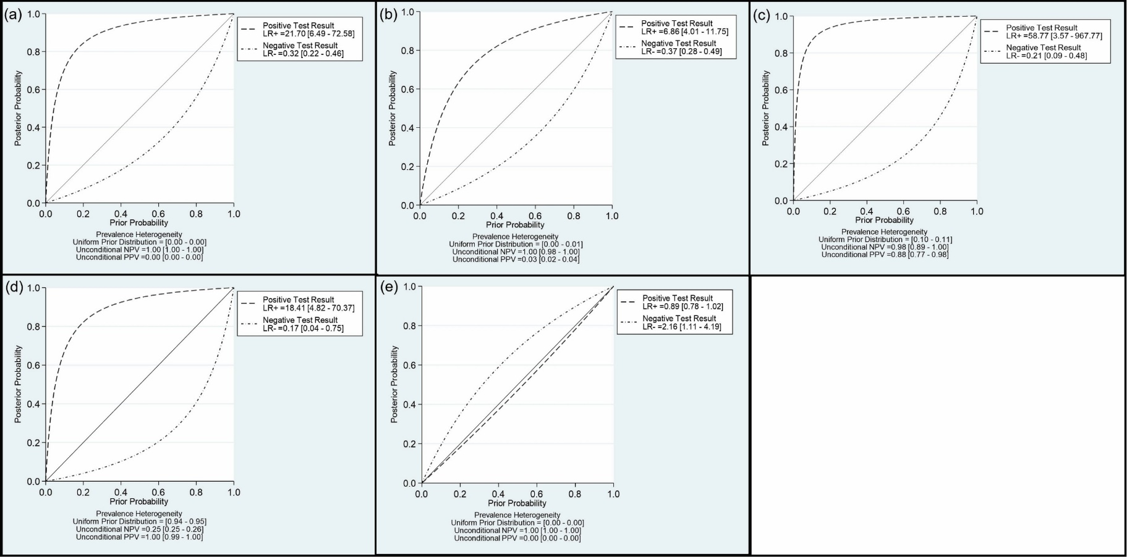
Fig.S1 Probability Modifying Plots for All Comparisons. These plots utilize pre- and post-test probabilities to calculate positive predictive values and negative predictive values of MUC5AC.
a. This plot compares pancreatic cancer vs. healthy control using pre- and post-test probabilities of 0.000012 and 0.000043, respectively.
b. This plot compares pancreatic cancer vs. benign diseases of pancreas using pre- and post-test probabilities of 0.0018 and 0.0065, respectively.
c. This plot compares pancreatic cancer precursor vs. healthy control using pre- and post-test probabilities of 0.102 and 0.114, respectively.
d. This plot compares pancreatic cancer precursor vs. benign diseases of pancreas using pre- and post-test probabilities of 0.94 and 0.95, respectively.
e. This plot compares pancreatic cancer vs. pancreatic cancer precursor using pre- and post-test probabilities of 0.00010 and 0.00033, respectively.
All the figures were generated by STATA 17.

Fig.S2
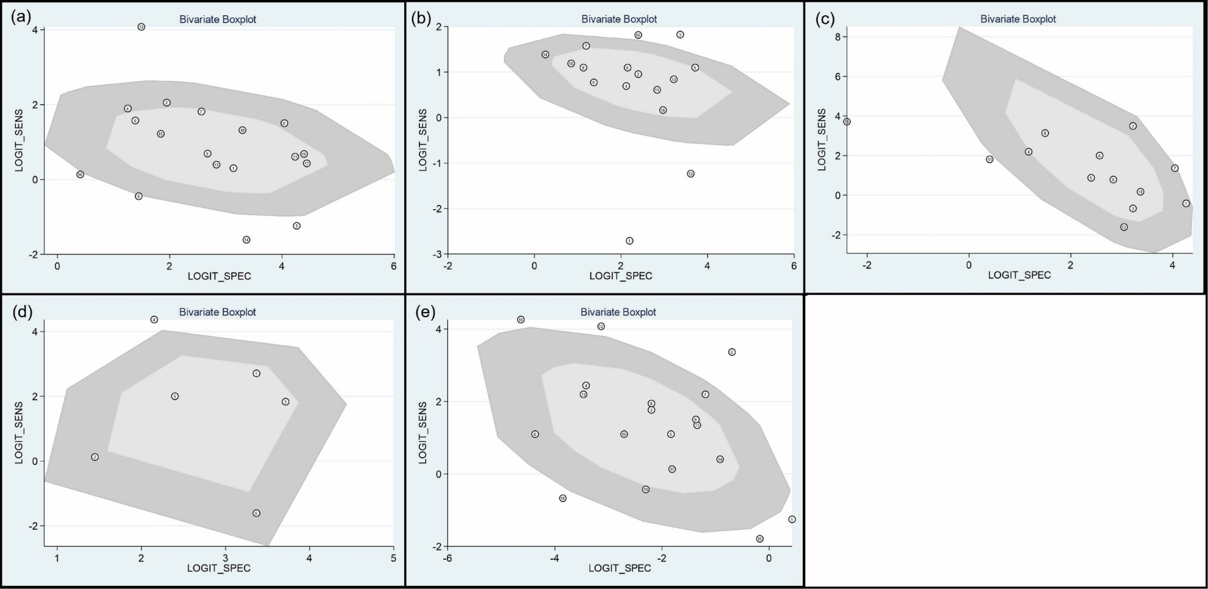
Fig.S2 Bivariate Box Plots for All Comparisons. These plots were created to provide a visual representation of heterogeneity and threshold effect for the five comparisons: a. Pancreatic cancer vs. healthy control. b. Pancreatic cancer vs. benign diseases of pancreas c. Pancreatic cancer precursor vs. healthy control. d. Pancreatic cancer precursor vs. benign diseases of pancreas e. Pancreatic cancer vs. pancreatic cancer precursor. These plots were generated by STATA 17.

Fig.S3
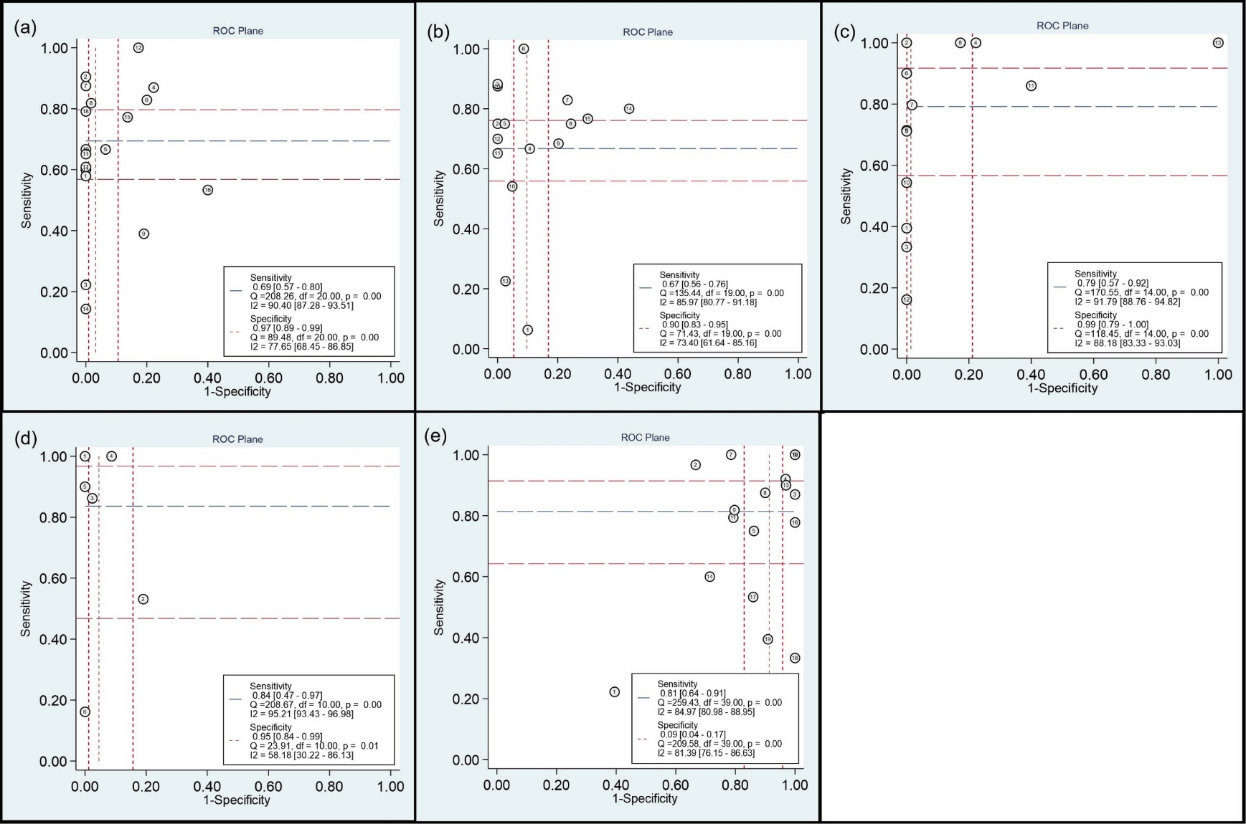
Fig.S3 ROC Plane Curves for All Comparisons. These plots were generated to provide a visual evaluation of threshold effect for the five comparisons: a. Pancreatic cancer vs. healthy control. b. Pancreatic cancer vs. benign diseases of pancreas c. Pancreatic cancer precursor vs. healthy control. d. Pancreatic cancer precursor vs. benign diseases of pancreas e. Pancreatic cancer vs. pancreatic cancer precursor. These plots were generated by STATA 17.

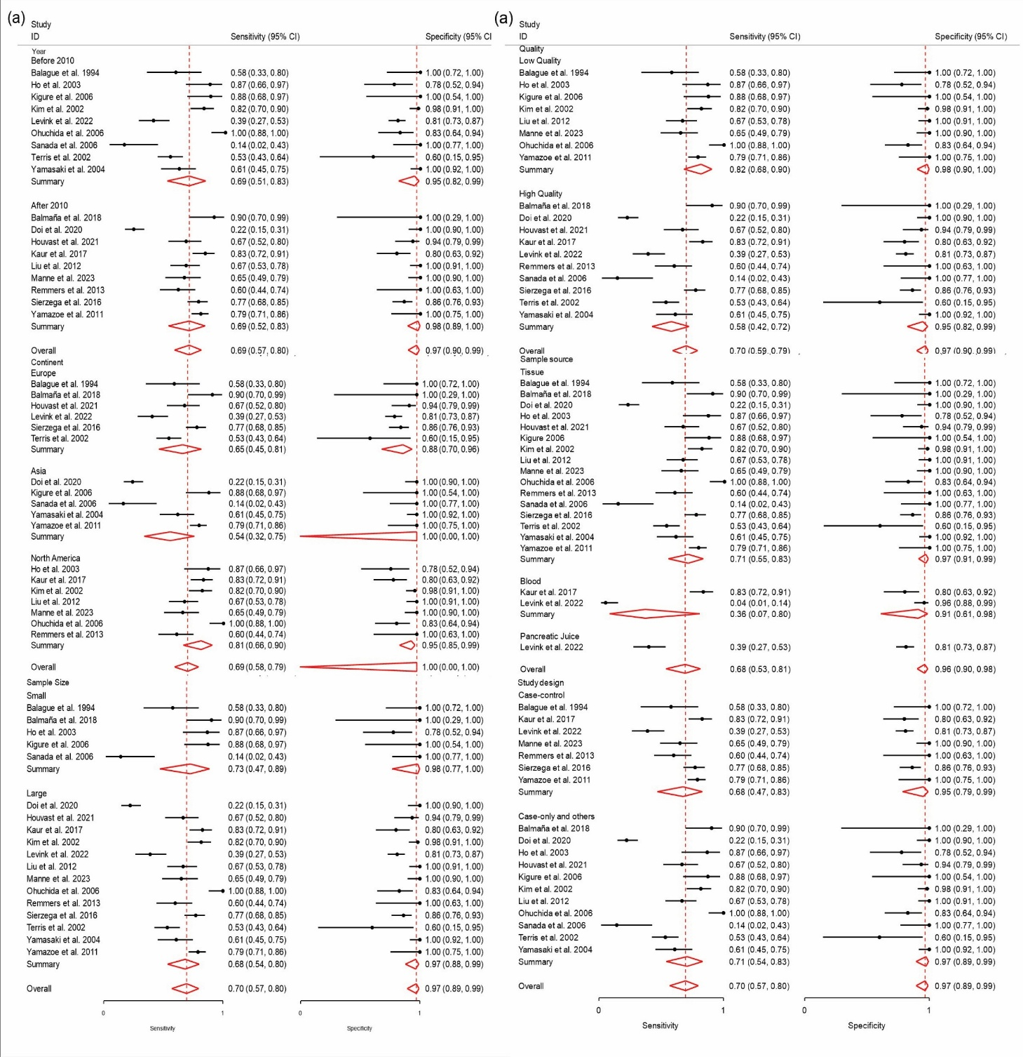
Pancreatic Cancer vs. Healthy Control
Part 2
Part 1
Fig.S4
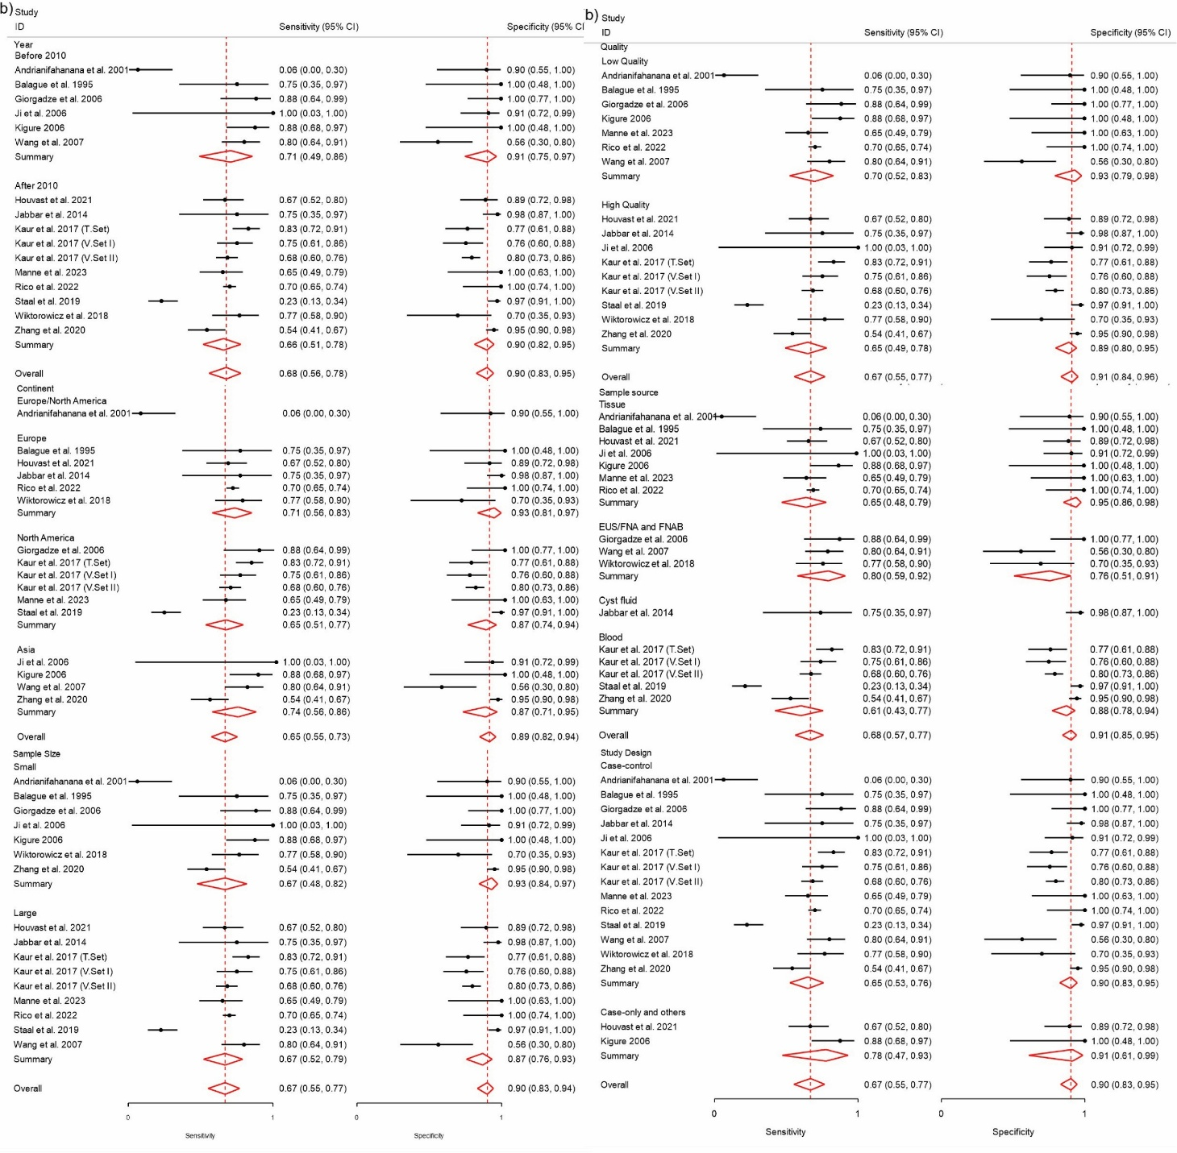
Pancreatic Cancer vs. Benign Diseases of Pancreas
Part 2
Part 1
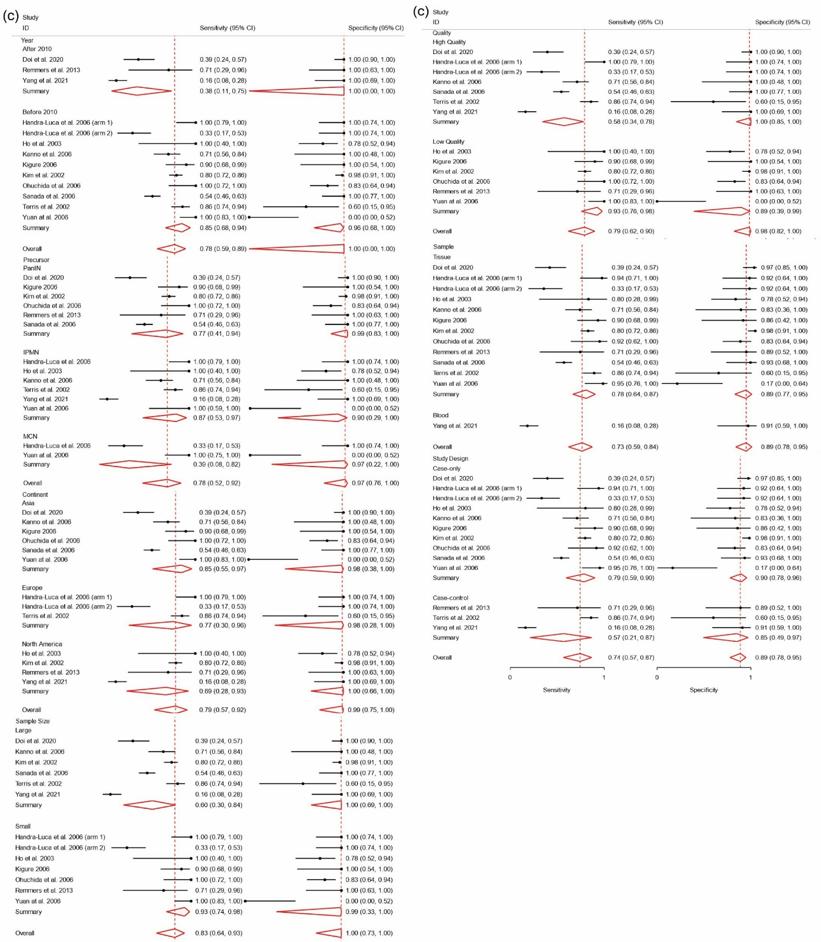
Pancreatic Cancer Precursor vs. Healthy Control
Part 2
Part 1
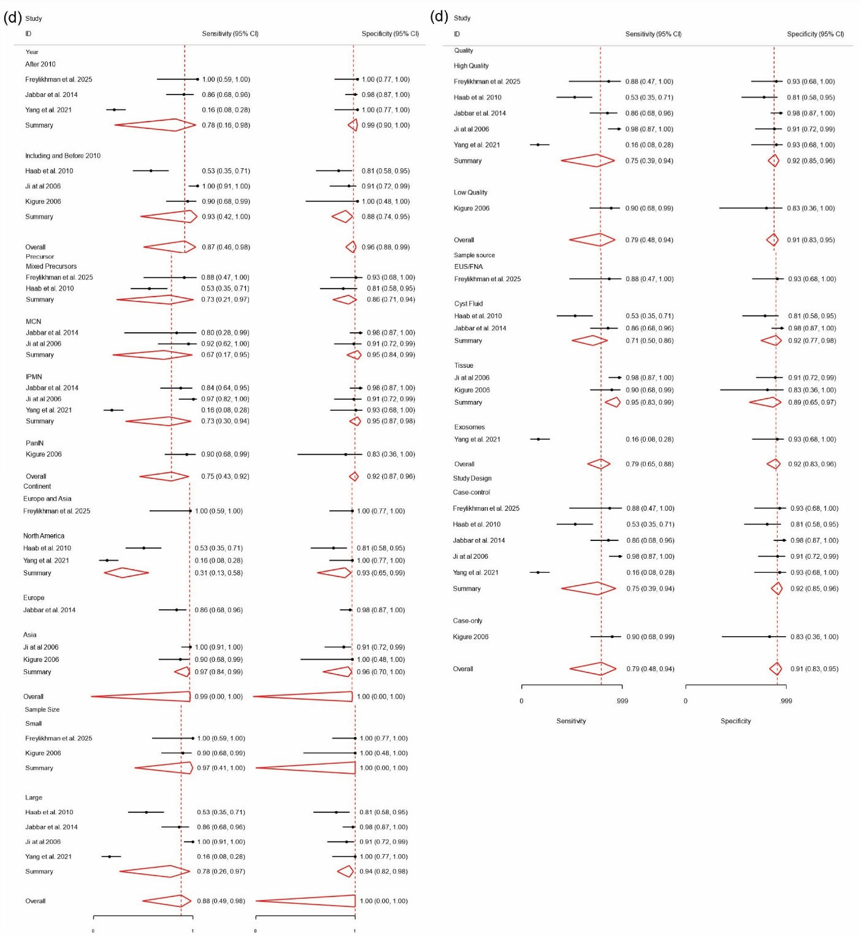
Pancreatic Cancer Precursor vs. Benign Diseases of Pancreas
Part 2
Part 1
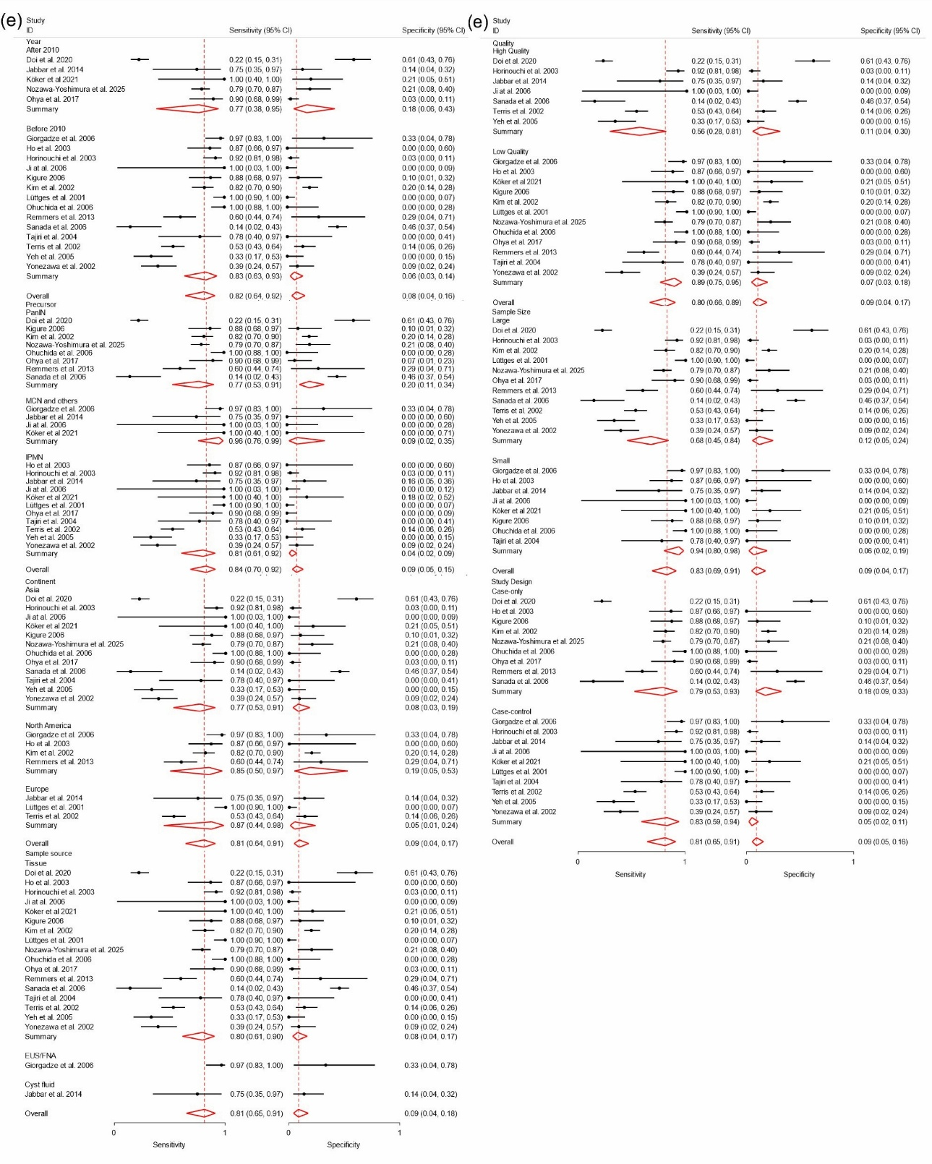
Pancreatic Cancer vs. Pancreatic Cancer Precursor
Part 2
Part 1
Fig. S4 Meta-regression for all Comparisons. The meta-regression was conducted based on the following covariates: year, continent, sample size, study quality, sample source, study design, and pancreatic cancer precursor grade (if applicable) for all the comparisons: a. Pancreatic cancer vs. healthy control. b. Pancreatic cancer vs. benign diseases of pancreas c. Pancreatic cancer precursor vs. healthy control. d. Pancreatic cancer precursor vs. benign diseases of pancreas. e. Pancreatic cancer vs. pancreatic cancer precursor. Meta-regressions were conducted by a bivariate meta-regression model and all the figures were generated by STATA 17.

Fig.S5
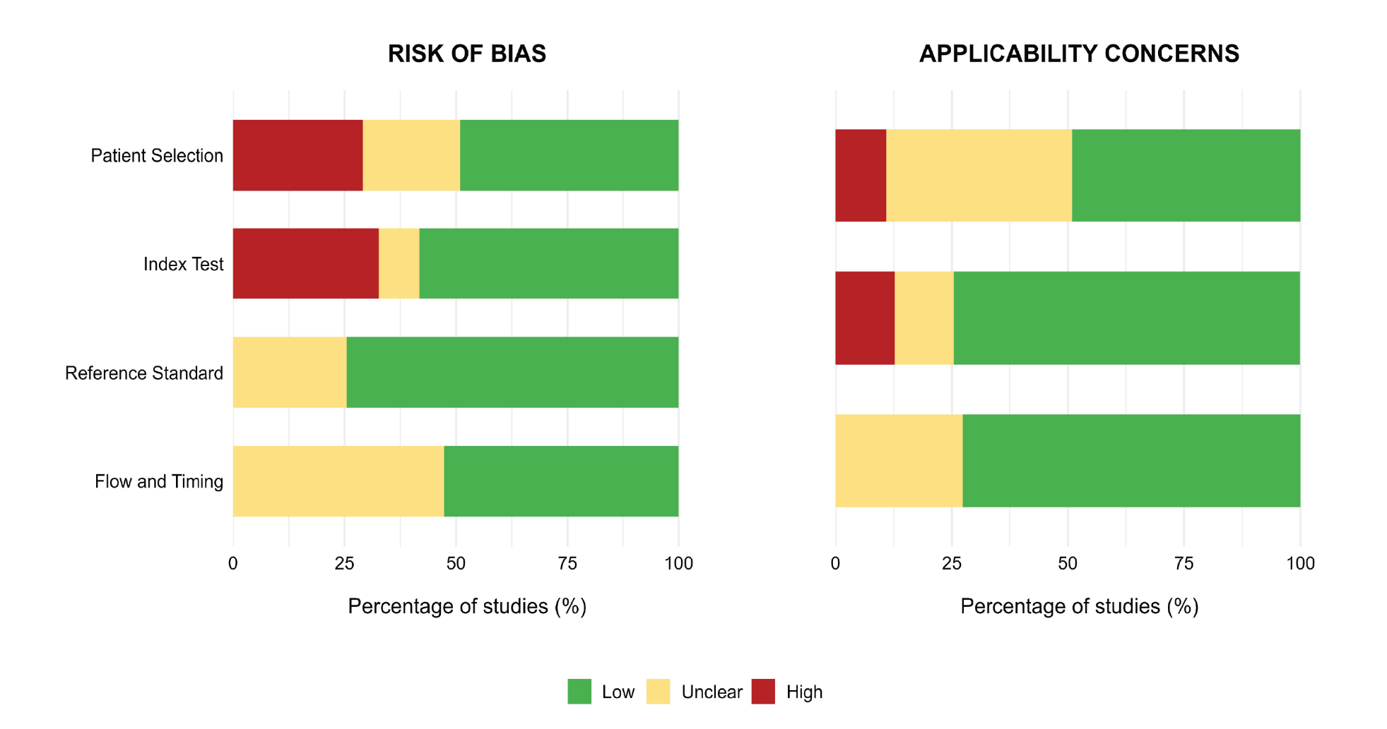
Fig.S5 Overall Quality Assessment by QUADAS-2. This graph shows the percentage of included studies with low, unclear, or high risk of bias across the following items: Patient Selection, Index Test, Reference Standard, and Flow and Timing. It also shows the percentage of studies with low, unclear, or high risk of applicability concerns for the Patient Selection, Index Test, and Reference Standard items. Abbreviations: AC: applicability concern, QUADAS-2: Quality Assessment of Diagnostic Accuracy Studies, and RoB: risk of bias. This image was generated by RStudio 4.2.3.

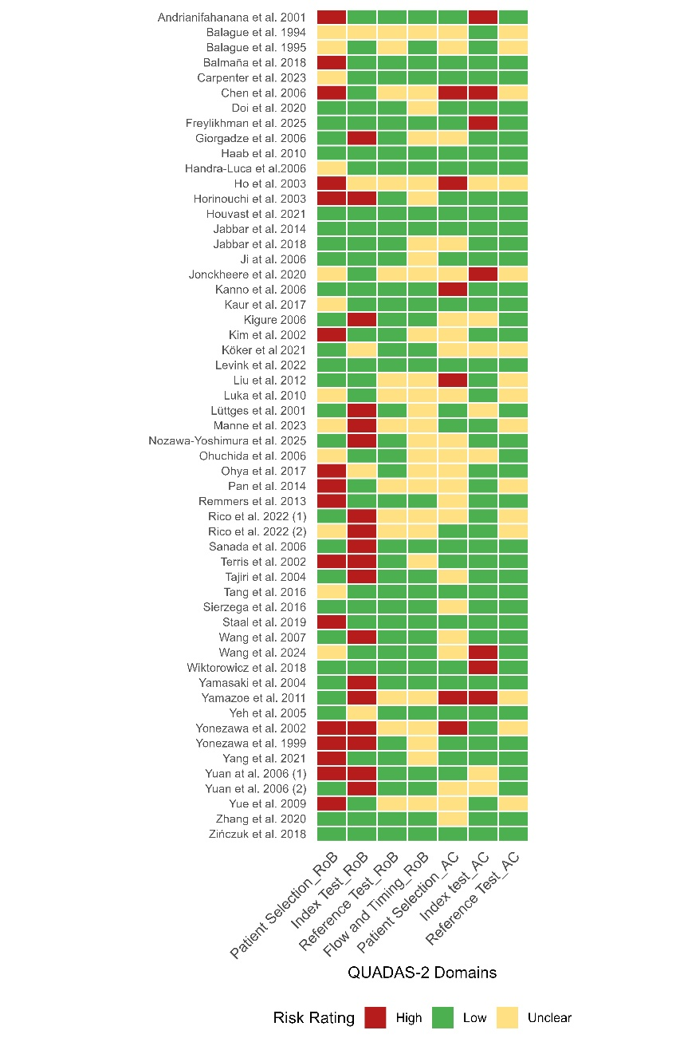
Fig.S6 Individual Display for Quality Assessment by QUADAS-2. This graph shows the assessment of each study scored as having low, unclear, or high risk across the following items of QUADAS-2: the risk of bias items: Patient Selection, Index Test, Reference Standard, and Flow and Timing, and the applicability concerns items: Patient Selection, Index Test, and Reference Standard. Note that Rico et al 2022 (1) refers to ref. (35), Rico et al 2022 (2) refers to ref. (34), Yuan et at 2006 (1) refers to ref. (51) and Yuan et al 2006 (2) refers to ref. (52) in the in the Supplementary Table 2. Abbreviations: AC: applicability concern, QUADAS-2: Quality Assessment of Diagnostic Accuracy Studies, and RoB: risk of bias. This image was generated by RStudio 4.2.3.

Fig.S6

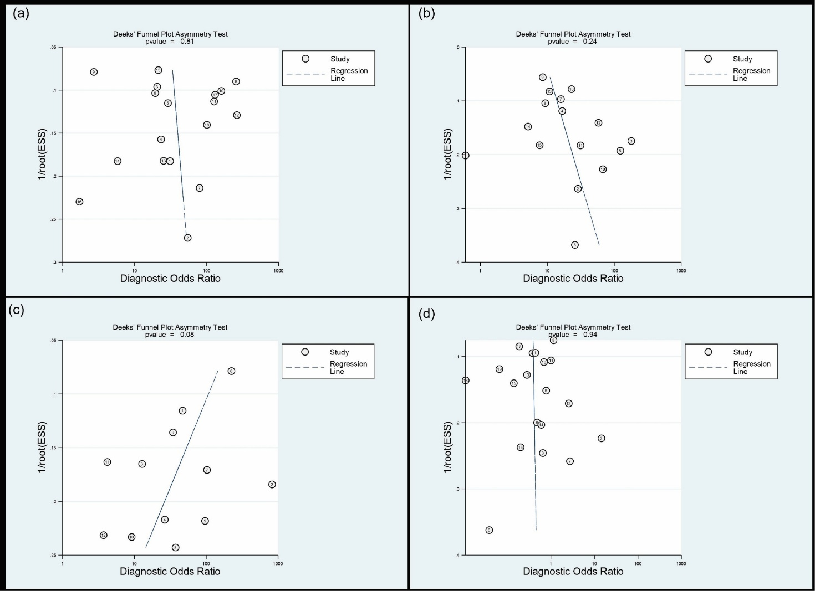
Fig.S7 Deeks’ Funnel Plots for All Comparisons. These plots were created to assess publication bias (P<0.1) for four comparisons: a. Pancreatic cancer vs. healthy control. b. Pancreatic cancer vs. benign diseases of pancreas c. Pancreatic cancer precursor vs. healthy control. d. Pancreatic cancer vs. pancreatic cancer precursor. Note that the pancreatic cancer precursor vs. benign diseases of pancreas comparison was not assessed for publication bias since the number of included studies (n=6) was fewer than 10. These Funnel blots were generated by STATA 17.

Fig.S7

References List:
[1] Balagué C, Audié JP, Porchet N, et al. In situ hybridization shows distinct patterns of mucin gene expression in normal, benign, and malignant pancreas tissues. Gastroenterol. 1995;109,953–64.
[2] Doi N, Ino Y, Angata K, et al. Clinicopathological significance of core 3 O-glycan synthetic enzyme, β1,3-N-acetylglucosaminyltransferase 6 in pancreatic ductal adenocarcinoma PLoS One. 2020;doi: 10.1371/journal.pone.0242851.
[3] Giorgadze TA, Peterman H, Baloch ZW, et al. Diagnostic utility of mucin profile in fine-needle aspiration specimens of the pancreas: an immunohistochemical study with surgical pathology correlation. Cancer. 2006;108,186–197.
[4] Houvast RD, Thijse K, Groen JV, et al. An Immunohistochemical Evaluation of Tumor-Associated Glycans and Mucins as Targets for Molecular Imaging of Pancreatic Ductal Adenocarcinoma. Cancers (Basel). 2021;doi: 10.3390/cancers13225777.
[5] Kigure S. Immunohistochemical study of the association between the progression of pancreatic ductal lesions and the expression of MUC1, MUC2, MUC5AC, and E-cadherin. Rinsho Byori. 2006;54,447–452.
[6] Liu H, Shi J, Anandan V, et al. Reevaluation and identification of the best immunohistochemical panel (pVHL, Maspin, S100P, IMP-3) for ductal adenocarcinoma of the pancreas. Arch Pathol Lab Med. 2012;136,601–609.
[7] Ohuchida K, Mizumoto K, Yamada D, et al. Quantitative analysis of MUC1 and MUC5AC mRNA in pancreatic juice for preoperative diagnosis of pancreatic cancer. Int J Cancer. 2006;118,405–411.
[8] Ohya A, Yamanoi K, Shimojo H, et al. Gastric gland mucin-specific O-glycan expression decreases with tumor progression from precursor lesions to pancreatic cancer. Cancer Sci. 2017;108,1897–1902.
[9] Remmers N, Anderson JM, Linde EM, et al. Aberrant expression of mucin core proteins and o-linked glycans associated with progression of pancreatic cancer. Clin Cancer Res. 2013;19,1981–1993.
[10] Handra-Luca A, Fléjou JF, Rufat P, et al. Human pancreatic mucinous cystadenoma is characterized by distinct mucin, cytokeratin and CD10 expression compared with intraductal papillary-mucinous adenoma. Histopathol. 2006; 48,813–821.
[11] Kim GE, Bae HI, Park HU, et al. Aberrant expression of MUC5AC and MUC6 gastric mucins and sialyl Tn antigen in intraepithelial neoplasms of the pancreas. Gastroenterol. 2002;123,1052–60.
[12] Carpenter ES, Elhossiny AM, Kadiyala P et al. Analysis of Donor Pancreata Defines the Transcriptomic Signature and Microenvironment of Early Neoplastic Lesions. Cancer Discov. 2023;13,1324–1345, Jun. 2023.
[13] Nozawa‐Yoshimura Y, Ishida K , Onozaki M, et al. Immunohistochemical Classification of High‐Grade Pancreatic Intraepithelial Neoplasia and Ductal Cancerization in Pancreatic Ductal Adenocarcinoma Using p53, SMAD4, and Mucin Expression. APMIS. 2025;doi: 10.1111/apm.70106.
[14] Sanada Y, Yoshida K, Ohara M, et al, Histopathologic Evaluation of Stepwise Progression of Pancreatic Carcinoma with Immunohistochemical Analysis of Gastric Epithelial Transcription Factor SOX2: Comparison of Expression Patterns between Invasive Components and Cancerous or Nonneoplastic Intraductal Components, Pancreas. 2006;doi: 10.1097/01.mpa.0000202947.80117.a0.
[15] Yamazoe S, Tanaka H, Iwauchi T, et al. Identification of HLA-A*0201- and A*2402-restricted epitopes of mucin 5AC expressed in advanced pancreatic cancer. Pancreas. 2011;40,896–904.
[16] Andrianifahanana M, Moniaux N, Schmied BM, et al. Mucin (MUC) gene expression in human pancreatic adenocarcinoma and chronic pancreatitis: A potential role of MUC4 as a tumor marker of diagnostic significance. Clin Cancer Res. 2001;12:4033-4040.
[17] Balagué C, Gambús G, Carrato C, et al. Altered expression of MUC2, MUC4, and MUC5 mucin genes in pancreas tissues and cancer cell lines. Gastroenterol. 1994;106,1054–61.
[18] Balmaña M, Duran A, Gomes C, et al. Analysis of sialyl-Lewis x on MUC5AC and MUC1 mucins in pancreatic cancer tissues. Int J Biol Macromol. 2018;112,33–45.
[19] Whiting PF, Rutjes AWS, Westwood ME, et al. QUADAS-2: A Revised Tool for the Quality Assessment of Diagnostic Accuracy Studies. Ann Intern Med. 2011;155,529–536.
[20] Rico SD, Mahnken M, Büscheck F, et al. MUC5AC Expression in Various Tumor Types and Nonneoplastic Tissue: A Tissue Microarray Study on 10 399 Tissue Samples. Technol Cancer Res Treat. 2021; doi: 10.1177/15330338211043328.
[21] Yonezawa S, Nakamura A, Horinouchi M, et al. The expression of several types of mucin is related to the biological behavior of panceatic neoplasms. J HepatoBiliary Pancreat Surg. 2002;9:328–341.
[22] Kaur S, Smith LM, Patel A, et al. A Combination of MUC5AC and CA19-9 Improves the Diagnosis of Pancreatic Cancer: A Multicenter Study. Am J Gastroenterol. 2017;112,172–183.
[23] Luka J, Arlen PM, Bristol A, et al. Development of a Serum Biomarker Assay That Differentiates Tumor-Associated MUC5AC (NPC-1C ANTIGEN) from Normal MUC5AC. J Biomed Biotechnol. 2011;doi: 10.1155/2011/934757.
[24] Jonckheere N, Auwercx J, Bachir H, et al. Unsupervised Hierarchical Clustering of Pancreatic Adenocarcinoma Dataset from TCGA Defines a Mucin Expression Profile that Impacts Overall Survival. Cancers (Basel). 2020;doi: 10.3390/cancers12113309.
[25] Pan S, Chen R, Tamura Y et al. Quantitative Glycoproteomics Analysis Reveals Changes in N-Glycosylation Level Associated with Pancreatic Ductal Adenocarcinoma. J Proteome Res. 2014;13,1293–1306.
[26] Yue T, Goldstein IJ, Hollingsworth MA, et al. The Prevalence and Nature of Glycan Alterations on Specific Proteins in Pancreatic Cancer Patients Revealed Using Antibody-Lectin Sandwich Arrays. Mol Cel Proteomics, 2009;8,1697–1707.
[27] Chen R, Pan S, Yi EY, et al. Quantitative proteomic profiling of pancreatic cancer juice. Proteomics. 2006;6,3871–3879.
[28] Tang H, Partyka K, Hsueh P, et al. Glycans Related to the CA19-9 Antigen Are Increased in Distinct Subsets of Pancreatic Cancers and Improve Diagnostic Accuracy Over CA19-9. Cell Mol Gastroenterol Hepatol. 2016;2,210-221.
[29] Staal B, Liu Y, Barnett D, et al. The sTRA Plasma Biomarker: Blinded Validation of Improved Accuracy Over CA19-9 in Pancreatic Cancer Diagnosis. Clin Cancer Res. 2019;25,2745–2754.
[30] Wiktorowicz M, Mlynarski D, Pach R, et al. Rationale and feasibility of mucin expression profiling by qRT-PCR as diagnostic biomarkers in cytology specimens of pancreatic cancer. Pancreatol. 2018;18,977–982.
[31] Freylikhman O, Seyfedinova S, Kamalova V et al. RNA Signature as Potential Diagnostic Marker for Differentiation of Pancreatic Cysts: A Pilot Study, Int J Mol Sci. 2025;doi: 10.3390/ijms26199680.
[32] Zińczuk, J, Zaręba K.2B,C, Pryczynicz A, et al. Significance of mucin expression in pancreatic intraepithelial neoplasia ( PanIN ) – precursor lesions of pancreatic ductal adenocarcinoma ( PDAC ). 2018;18;63-73.
[33] Jabbar KS, Arike L, Verbeke CS, et al. Highly Accurate Identification of Cystic Precursor Lesions of Pancreatic Cancer Through Targeted Mass Spectrometry: A Phase IIc Diagnostic Study. J Clin Oncol. 2018;36,367–375.
[34] Wang J, Seo JW, Kare AJ, et al. Spatial transcriptomic analysis drives PET imaging of tight junction protein expression in pancreatic cancer theranostics. BioRxiv. 2024, doi: 10.1101/2024.01.07.574209.
[35] Ho JJL, Han SW, Pan PL, et al. Methylation status of promoters and expression of MUC2 and MUC5AC mucins in pancreatic cancer cells. Int J Oncol. 2003;22,273–279.

