Supplemental Materials

Supplemental Tables

Supplemental Table S1 The levels of soluble immune checkpoint proteins in RCC patients and healthy controls
Protein names | Cancer patients (N=40)  (median [IQR] pg/ml) | Health controls (N=40)  (median [IQR] pg/ml) | P value | qª
sTIM-3 | 2451.91 [1219.33, 3339.52] | 1932.60 [1197.08, 3516.75] | 0.725 | 0.785
sCD28 | 246.92 [164.93, 367.10] | 247.10 [134.91, 414.91] | 0.885 | 0.885
sCD137 | 83.35 [68.43, 120.50] | 83.35 [33.42, 117.87] | 0.093 | 0.172
sCD27 | 588.32 [158.71, 2090.26] | 337.83 [151.32, 1701.52] | 0.532 | 0.651
sCTLA-4 | 38.18 [26.80, 50.43] | 27.71 [14.18, 35.52] | 0.006 | 0. 019
sHVEM | 12.50 [8.48, 27.68] | 11.39 [5.23, 21.21] | 0.224 | 0.323
sIDO | 46.70 [31.92, 63.34] | 39.03 [24.16, 64.52] | 0.142 | 0.230
sLAG-3 | 56.36 [29.52, 79.05] | 41.29 [23.02, 53.83] | 0.024 | 0.058
sBTLA | 905.25 [666.27, 1518.93] | 502.47 [322.37, 702.75] | <0.001 | 0.004
sGITR | 104.46 [76.23, 148.39] | 66.20 [30.90, 94.63] | <0.001 | 0.004
sCD80 | 516.23 [353.11, 865.98] | 299.41 [138.71, 465.10] | 0.001 | 0.009
sPD-1 | 100.94 [66.36, 138.57] | 75.58 [42.61, 97.48] | 0.027 | 0.058
sPD-L2 | 4310.39 [3344.17, 5268.96] | 4440.25 [2502.72, 5288.87] | 0.551 | 0.651
qª, false discovery rate (FDR) adjusted P value using the Benjamini–Hochberg method.
Significant values in bold font.

Supplemental Table S2 The relationships between SIC score and clinicopathologic characteristics of RCC patients
Variables | SIC score (median [IQR]) | P value
Participants (N=80) |  |  | <0.001
Cancer patients | 0.52 [-0.69, 1.27]
Health controls | -1.44 [-2.04, 0.19]
Stage (N=40) |  |  | 0.297
Early | 0.49 [-0.70, 1.02]
Late | 1.26 [0.21, 1.60]
Histological type (N=40) |  |  | 0.553
ccrenal cancer | 0.16 [-0.72, 1.01]
pRCC | 1.21 [0.82, 1.67]
chRCC | 0.19 [-0.63, 1.35]
Others | 0.33 [-1.00, 2.29]
Histological grade (N=40) |  |  | 0.156
1 | -0.08 [-0.53, 0.05]
2 | 0.16 [-0.92, 0.89]
3 | 0.55 [0.11, 1.31]
4 | 0.77 [0.05, 1.50]
Abbreviations: ccRCC, Clear cell renal cell carcinoma; pRCC, Papillary renal cell carcinoma; chRCC, Chromophobe renal cell carcinoma.

Supplemental Table S3 Variance Inflation Factors [VIFs] for variables in Model 1 and Model 2
Variables | Model 1(VIFs) | Model 2 (VIFs)
Age | 1.31 | 1.37
BMI | 1.21 | 1.22
Sex | 1.07 | 1.09
Smoking | 1.00 | 1.00
Hypertension | 1.23 | 1.23
Diabetes | 1.01 | 1.06
SIC score | - | 1.10
Abbreviations: VIFs, variance inflation factors. VIF > 5 indicates significant multicollinearity.
Supplemental Table S4 Interaction analysis between SIC score and clinical variables
Clinical variable | Interaction coefficient (β) | SE | OR (95% CI) | P value
Age | 0.014 | 0.012 | 1.014 [0.989, 1.039] | 0.275
BMI | -0.041 | 0.033 | 0.960 [0.899,1.025] | 0.214
Sex | -0.317 | 0.269 | 0.729 [0.431,1.233] | 0.238
Smoking | -0.282 | 792.102 | 0.754 [0,Inf] | 0.999
Hypertension | 0.270 | 0.272 | 1.310 [0.765,2.242] | 0.321
Diabetes | 0.809 | 0.876 | 2.246 [0.400,12.601] | 0.355

Supplemental Table S5 The gene expression of immune checkpoints in ccRCC tumor tissues and normal tissues in TCGA-KIRC
Genes | Tumor tissues N=483  median [IQR]) | Normal tissues (N=68)  (median [IQR]) | P value | qª
PDCD1 (PD-1) | 2.21 [1.37, 3.28] | 0.59 [0.35, 1.01] | <0.001 | <0.001
CD274 (PD-L1) | 2.54 [2.01, 3.06] | 2.12 [1.81, 2.51] | <0.001 | <0.001
HAVCR2 (TIM-3) | 5.99 [4.92, 6.90] | 3.93 [1.92, 5.03] | <0.001 | <0.001
CTLA4 | 1.44 [0.77, 2.25] | 0.21 [0.11, 0.41] | <0.001 | <0.001
BTLA | 0.76 [0.48, 1.26] | 0.25 [0.20, 0.55] | <0.001 | <0.001
LAG3 | 2.55 [1.69, 3.65] | 0.72 [0.45, 1.03] | <0.001 | <0.001
IDO1 (IDO) | 4.56 [3.42, 5.41] | 0.95 [0.70, 1.75] | <0.001 | <0.001
TNFRSF14 (HVEM) | 5.88 [5.32, 6.43] | 3.79 [3.59, 4.02] | <0.001 | <0.001
CD27 | 2.89 [1.99, 4.03] | 0.67 [0.38, 1.05] | <0.001 | <0.001
TNFRSF9 (CD137) | 1.75 [0.91, 2.74] | 0.24 [0.14, 0.41] | <0.001 | <0.001
CD28 | 1.90 [1.29, 2.50] | 0.84 [0.50, 1.43] | <0.001 | <0.001
TNFRSF18 (GITR) | 1.87 [1.28, 2.42] | 0.42 [0.25, 0.71] | <0.001 | <0.001
CD80 | 0.76 [0.45, 1.18] | 0.15 [0.10, 0.27] | <0.001 | <0.001
PDCD1LG2 (PD-L2) | 2.75 [2.13, 3.30] | 1.95 [1.61, 2.25] | <0.001 | <0.001
qª, false discovery rate (FDR) adjusted P value using the Benjamini–Hochberg method.
Significant values in bold font.

Supplemental Table S6 The gene expression of immune checkpoints in ccRCC tumor tissues and normal tissues in GEO
Genes | Tumor tissues (N=72)  (median [IQR]) | Normal tissues (N=72)  (median [IQR]) |  | P value |  | qª
PDCD1 (PD-1) | 5.85 [4.34, 6.56] | 4.52 [4.10, 5.81] | 0.004 |  | 0.020
CD274 (PD-L1) | 8.33 [7.87, 8.64] | 7.47 [7.17, 7.73] | <0.001 |  | <0.001
HAVCR2 (TIM-3) | 9.98 [9.36, 10.47] | 9.73 [9.35, 10.18] | 0.101 |  | 0.101
CTLA4 | 6.91 [6.02, 7.30] | 4.65 [3.37, 5.63] | <0.001 |  | <0.001
BTLA | 6.24 [5.83, 6.77] | 5.34 [4.77, 5.99] | <0.001 |  | <0.001
LAG3 | 7.22 [6.55, 8.05] | 6.00 [5.03, 6.38] | <0.001 |  | <0.001
IDO1 (IDO) | 10.05 [9.41, 10.72] | 7.09 [6.38, 7.68] | <0.001 |  | <0.001
TNFRSF14 (HVEM) | 10.57 [10.14, 10.84] | 9.79 [9.56, 9.94] | <0.001 |  | <0.001
CD27 | 8.47 [7.77, 9.44] | 7.27 [6.96, 7.57] | <0.001 |  | <0.001
TNFRSF9 (CD137) | 7.69 [6.79, 8.98] | 5.92 [5.38, 6.48] | <0.001 |  | <0.001
CD28 | 7.22 [6.50, 7.69] | 6.36 [5.97, 6.66] | <0.001 |  | <0.001
TNFRSF18 (GITR) | 6.71 [6.34, 7.02] | 6.85 [6.40, 7.31] | 0.052 |  | 0.065
CD80 | 7.06 [6.74, 7.42] | 7.33 [7.01, 7.62] | 0.013 |  | 0.023
PDCD1LG2 (PD-L2) | 3.63 [3.11, 5.18] | 4.36 [3.69, 5.46] | 0.014 |  | 0.023
qª, false discovery rate (FDR) adjusted P value using the Benjamini–Hochberg method.
Significant values in bold font.

Supplemental Figures
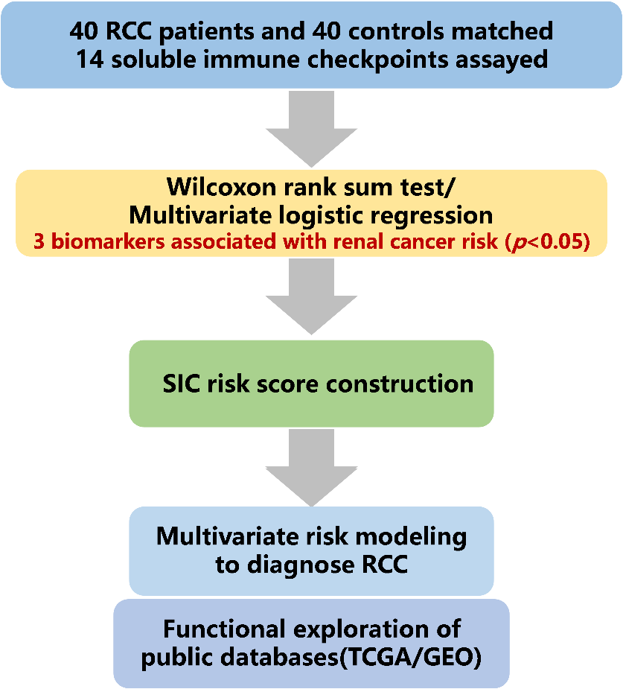
Supplemental Figure S1 Schematic design of the study
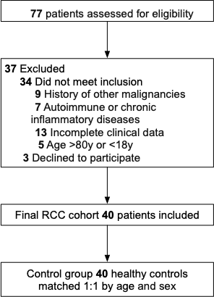
Supplemental Figure S2 Flowchart of patient inclusion and exclusion

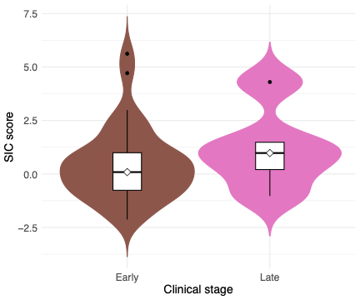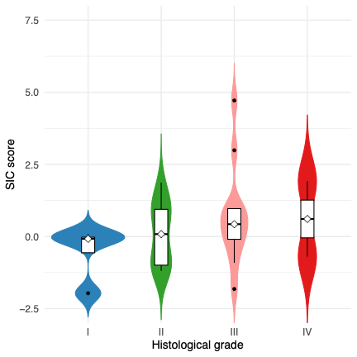
Supplemental Figure S3 Violin plot of SIC score by tumor stage (Clinical stage, Early and Late; Histological grade, I-IV)
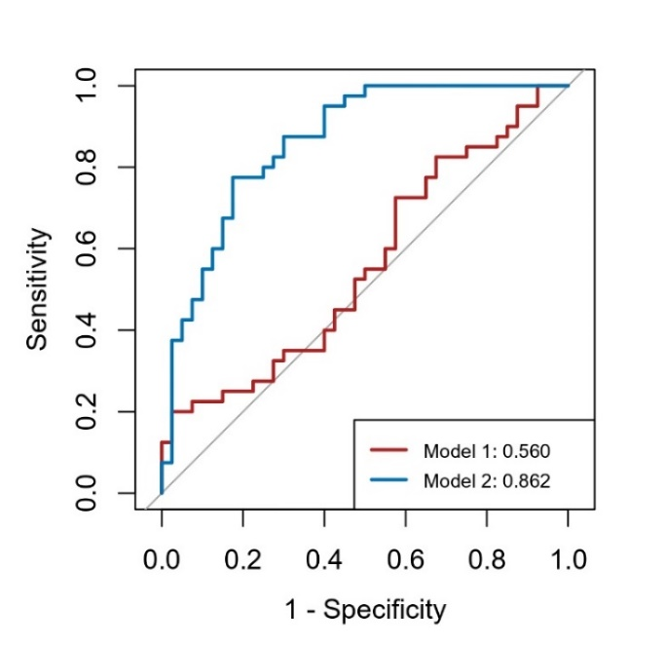
Supplemental Figure S4 ROC curve of the two predictive models
Model 1: clinical variables including age, sex, smoking, BMI, diabetes and hypertension; Model 2: clinical variables + SIC score.

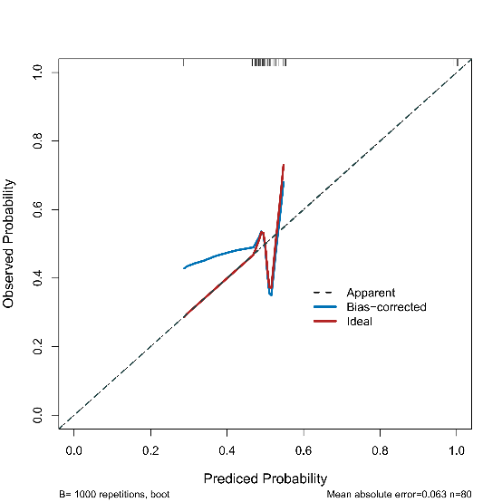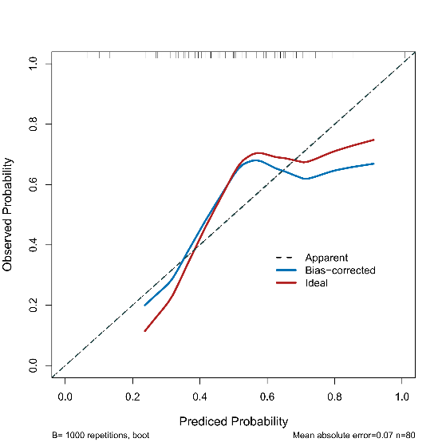
Supplemental Figure S5 Calibration curve of the predictive models
Left: Model 1, Right: Model 2. The dotted line is the performance of the model, while the solid line corrects for any bias in the model. The dashed line is the reference line where a model would lie.

