Supplementary Materials-Index
Table S1 Detailed search strategy 2
Modified Newcastle–Ottawa Scale (NOS) for cohort studies (MAX = 7) 3
Table S2 NOS-7 scores for the included studies: 3
Table S3 Full-text articles reviewed but not included. 4
Table S4 Study-level pathology spectrum and histological details of pulmonary nodules (benign/PLC/MBC and subtypes). 5
Table S5 Expanded pooled patient and nodule characteristics by analytic population (full version of Table 2). 7
Table S6a Study-level extracted dataset for the pulmonary nodule cohort (raw data). 8
Table S6b Study-level extracted dataset for the invasive diagnostic intervention cohort (raw data). 9
Table S6c Study-level extracted dataset for pathologically confirmed nodules by diagnosis group (PLC vs MBC vs benign) (raw data). 10
Figure S1 Meta-regression of pulmonary nodule prevalence by publication year in CT-only cohorts. 12
Figure S2 Pulmonary nodule prevalence in CT-only cohorts by detection setting (initial staging vs. follow-up surveillance). 12
Figure S3 Benign proportion among pathologically confirmed pulmonary nodules 13
Figure S4 Primary lung cancer proportion among pathologically confirmed pulmonary nodules. 13
Figure S5 Metastatic breast cancer proportion among pathologically confirmed pulmonary nodules. 14
Figure S6 Funnel plots for pulmonary nodule prevalence in CT-only cohorts and pathological proportions among pathologically confirmed pulmonary nodules. 15
Figure S7 Leave-one-out sensitivity analyses using a random-effects model. 16
Figure S8 Sensitivity analyses excluding studies that enrolled male breast cancer patients. 17

Table S1 Detailed search strategy
Database | Search strategy
PubMed  n=1655 | #1 | "Breast carcinoma"[Title] OR "Breast cancer"[Title] OR "Breast cancers"[Title] OR "Breast tumor"[Title] OR "Breast tumors"[Title]
PubMed  n=1655 | #2 | "Lung cancer"[Title/Abstract] OR "Lung cancers"[Title/Abstract] OR "lung neoplasm"[Title/Abstract] OR "lung neoplasms"[Title/Abstract] OR "Lung nodule"[Title/Abstract] OR "Lung nodules"[Title/Abstract] OR "Pulmonary nodule"[Title/Abstract] OR "Pulmonary nodules"[Title/Abstract]
PubMed  n=1655 | #3 | ("1900/01/01"[Date - Publication] : "2025/10/16"[Date - Publication])
PubMed  n=1655 | #4 | #1 AND #2 AND #3
Embase  n=1363 | #1 | 'Breast carcinoma':ab OR 'Breast cancer':ab OR 'Breast cancers':ab OR 'Breast tumor':ab OR 'Breast tumors':ab
Embase  n=1363 | #2 | 'Lung cancer':ab OR 'Lung cancers':ab OR 'lung neoplasm':ab OR 'lung neoplasms':ab OR 'Lung nodule':ab OR 'Lung nodules':ab OR 'Pulmonary nodule':ab OR 'Pulmonary nodules':ab
Embase  n=1363 | #3 | [01-01-1900 to 16-10-2025]/pd
Embase  n=1363 | #4 | #1 AND #2 AND #3
Web of Science  n=287 | #1 | AB=("Lung Neoplasms" OR "Lung cancer" OR "Lung cancers" OR "lung neoplasms" OR "Lung nodule" OR "Lung nodules" OR "Pulmonary nodule" OR "Pulmonary nodules")
Web of Science  n=287 | #2 | TI=("Breast Neoplasms" OR "Breast carcinoma" OR "Breast cancer" OR "Breast cancers" OR "Breast tumor" OR "Breast tumors")
Web of Science  n=287 | #3 | DOP=1900-01-01/2025-10-16
Web of Science  n=287 | #4 | #1 AND #2 AND #3
Cochrane Library  n=216 | #1 | (“Breast tumor”):ti OR (“Breast tumor”):ti OR (“Breast Neoplasms”):ti OR (“Breast carcinoma”):ti OR (“Breast cancer”):ti OR (“Breast cancers”):ti
Cochrane Library  n=216 | #2 | (“Lung Neoplasms”):ti,ab,kw OR (“Lung cancer”):ti,ab,kw OR (“Lung cancers”):ti,ab,kw OR (“lung neoplasm”):ti,ab,kw OR (“Lung nodule”):ti,ab,kw OR (“Lung nodules”):ti,ab,kw OR (“Pulmonary nodule”):ti,ab,kw OR (“Pulmonary nodules”):ti,ab,kw
Cochrane Library  n=216 | #3 | #1 AND #2
Cochrane Library  n=216 | Search date | 16 October 2025
CBM  n=183 | #1 | ("肺结节"[中文标题:智能] OR "肺癌"[中文标题:智能] OR "肺肿瘤"[中文标题:智能]) AND ("乳腺癌"[中文标题:智能] OR "乳腺肿瘤"[中文标题:智能])
CBM  n=183 | Search date | 16 October 2025
Wanfang  n=270 | #1 | ((题名:("乳腺癌") or 题名:("乳腺肿瘤"))) and ((题名:("肺结节") or 题名:("肺癌") or 题名:("肺肿瘤")))
Wanfang  n=270 | Search date | 16 October 2025
CNKI  n=230 | #1 | (TI="乳腺癌" or TI="乳腺肿瘤") and (TI="肺结节" or TI="肺癌" or TI="肺肿瘤")
CNKI  n=230 | Search date | 16 October 2025

Modified Newcastle–Ottawa Scale (NOS) for cohort studies (MAX = 7)
Risk of bias was assessed using a modified Newcastle–Ottawa Scale (NOS) tailored to the included cohorts (maximum 7 points; Table S2). Higher scores indicate lower risk of bias; studies scoring 6–7 points were considered high quality.

Selection (3 points):
Q1. Representativeness of the exposed cohort (★ if truly/somewhat representative).
Q2. Ascertainment of exposure (★ if based on secure records, e.g., medical records/registries).
Q3. Demonstration that the outcome of interest was not present at the start of follow-up (★ if clearly stated).

Comparability (1 point):
Q4. Comparability of cohorts on the basis of design or analysis (★ if analyses controlled for key confounders relevant to the study question).

Outcome (3 points):
Q5. Assessment of outcome (★ if independent blind assessment or reliable record linkage).
Q6. Follow-up long enough for outcomes to occur (★ if mean/median follow-up ≥5 years).
Q7. Adequacy of follow-up (★ if complete follow-up or ≥90% follow-up with low risk of attrition bias).

Table S2 NOS-7 scores for the included studies:
Author | Q1 | Q2 | Q3 | Q4 | Q5 | Q6 | Q7 | TOTAL (max7)
Cahan 1975 | ★ | ★ |  | ★ | ★ | ★ | ★ | 6
J J Casey 1984 | ★ | ★ | ★ | ★ | ★ | ★ |  | 6
F Tanaka 2005 | ★ | ★ | ★ |  | ★ | ★ | ★ | 6
Chang 2006 | ★ | ★ | ★ | ★ |  | ★ | ★ | 6
Rena 2007 | ★ | ★ | ★ | ★ | ★ | ★ | ★ | 7
Lee 2008 | ★ | ★ | ★ | ★ | ★ |  | ★ | 6
Rao 2009 | ★ | ★ |  | ★ | ★ |  | ★ | 5
M Kitada 2011 | ★ | ★ | ★ |  | ★ | ★ | ★ | 6
K Tanaka 2013 | ★ | ★ | ★ | ★ | ★ | ★ | ★ | 7
Park 2014 | ★ | ★ | ★ | ★ | ★ | ★ | ★ | 7
Liu 2015 | ★ | ★ | ★ |  | ★ |  |  | 4
Kasibhatla 2015 | ★ | ★ |  |  | ★ |  |  | 3
Brothers 2016 | ★ | ★ | ★ | ★ | ★ | ★ |  | 6
Feng Li 2016 | ★ | ★ | ★ | ★ | ★ |  | ★ | 6
SB Krishna 2016 | ★ | ★ | ★ | ★ | ★ |  | ★ | 6
Song 2017 | ★ | ★ | ★ | ★ | ★ | ★ | ★ | 7
B Dull 2017 | ★ | ★ | ★ |  | ★ | ★ | ★ | 6
Matsuura 2018 | ★ | ★ | ★ | ★ | ★ | ★ | ★ | 7
Mori 2019 | ★ | ★ | ★ | ★ | ★ |  | ★ | 6
Alvarez 2020 | ★ | ★ |  | ★ | ★ |  | ★ | 5
Hai Xu 2020 | ★ | ★ | ★ | ★ | ★ |  | ★ | 6
M Abe 2021 | ★ | ★ | ★ |  | ★ | ★ | ★ | 6
He 2022 | ★ | ★ | ★ | ★ | ★ |  | ★ | 6
Zhao 2022 | ★ | ★ | ★ | ★ | ★ | ★ | ★ | 7
HS Ryu 2024 | ★ | ★ | ★ | ★ | ★ |  | ★ | 6
Xue 2024 | ★ | ★ |  | ★ | ★ |  |  | 4
Huei-Yi 2025 | ★ | ★ |  | ★ | ★ | ★ | ★ | 6

Table S3 Full-text articles reviewed but not included.
No | Study ID | Title | Exclusion reason
1 | L. Evangelista 2010 | Clinical implication of 18F-FDG PET/CT in the definition and management of indeterminable lung nodules detected by CT | No prespecified outcomes (none of 3 proportions extractable).
2 | Evangelista 2012 | Indeterminate pulmonary nodules on CT images in breast cancer patient: The additional value of 18F-FDG PET/CT | Diagnostic-performance study without extractable data for the prespecified outcomes.
3 | Kim 2014 | A New Isolated Mediastinal Lymph Node or Small Pulmonary Nodule Arising during Breast Cancer Surveillance Following Curative Surgery | No prespecified outcomes (none of 3 proportions extractable).
4 | T. Kinoshita 2015 | The Availability of Pre- and Intraoperative Evaluation of a Solitary Pulmonary Nodule in Breast Cancer Patients | No prespecified outcomes (none of 3 proportions extractable).
5 | S. Wang 2018 | Computed tomography features of solitary pulmonary nodules in breast cancer patients: differential diagnosis between primary lung adenocarcinoma and metastatic pulmonary breast cancer | Duplicate/overlapping dataset; excluded.
6 | Zhu 2019 | 18F-FDG-PET/CT features of suspected solitary pulmonary lesions in breast cancer patients following previous curative treatment | Cohort overlap with He 2022;
7 | G. Lin 2022 | Application of dual-energy CT in differential diagnosis of lung metastases and benign nodules in breast cancer | Diagnostic-performance study without extractable data for the prespecified outcomes.
8 | G.S. Quah 2022 | Incidental findings on SPECT/CT lymphoscintigraphy in breast cancer: the proposed Westmead SPECT/CT incidental findings classification | No extractable data for the prespecified outcomes.
9 | MAF Hafez 2023 | Diagnostic analysis of pulmonary nodules using Multi-Slice Computed Tomography (MSCT) chest in breast cancer patients | No prespecified outcomes (none of 3 proportions extractable).
10 | Hammer 2016 | Predictive factors for malignancy in incidental pulmonary nodules detected in breast cancer patients at baseline CT | Data for patients undergoing baseline CT after breast cancer diagnosis were not separately extractable.

Table S4 Study-level pathology spectrum and histological details of pulmonary nodules (benign/PLC/MBC and subtypes).
Study ID | Benign | MBC | PLC | Multiple/  Solitary | Solid (N) | Part-solid (N) | GGO (N) | Other malignancy | Benign pathology (details) | Primary lung cancer histology (ADC/SCC/ SCLC /Other)
Cahan 1975 | 6 | 23 | 43 | 5/67 | NR | NR | NR | NR | 2 hamartomas;  1 neurilemmoma;  1 grantuloma;  1 dermoid cyst;  1 benign fat pad. | 14/21/5/3
J J Casey 1984 | 2 | 18 | 22 | NR | NR | NR | NR | NR | NR | NR
F Tanaka 2005 | 7 | 39 | 6 | 29/23 | NR | NR | NR | NR | 2 Pulmonary tuberculosis;  2 Hamartoma;  1 Sclerosing hemangioma;  1 Organizing pneumonia;  1 Paragonimiasis. | 5/1/0/0
Chang 2006 | 0 | 9 | 21 | 9/51 | NR | NR | NR | NR | 0 | NA/NA/3/NA
Rena 2007 | 14 | 27 | 38 | 3/76 | 79 | 0 | 0 | NR | 6 Hamartoma;  3 Organizing pneumonia;  1 Sclerosing hemangioma;  1 Dirofilariasis;  1 Hemangiopericitoma;  1 Adenoma;  1 Tumourlet. | 27/8/0/3
Lee2008 | NR | NR | NR | NR | NR | NR | NR | NR | NR | NR
Rao2009 | NR | NR | NR | NR | NR | NR | NR | NR | NR | NR
M Kitada 2011 | 3 | 8 | 3 | NR | NR | NR | NR | NR | 2 mycobacteriosis;  1 mycosis. | 3/0/0/0
K Tanaka 2013 | 2 | 7 | 19 | Solitary | 14 | 14 | 2 | 1 | NR | 19/0/0/1
Park 2014 | NR | NR | NR | Solitary | NR | NR | NR | NR | NR | NR
Liu 2015 | 35 | 71 | 59 | NR | NR | NR | NR | NR | 11 hyperplasia;  9 pneumonia;  6 granuloma;  4 sclerosing hemangioma;  4 pulmonary fibrosis; | NR
Kasibhatla2015 | NR | NR | NR | NR | NR | NR | NR | NR | NR | NR
Brothers 2016 | NR | NR | NR | NR | NR | NR | NR | NR | NR | NR
Feng Li 2016 | 14 | 35 | 26 | 586/226 | NR | NR | NR | 6 | NR | NR
SB Krishna 2016 | NR | NR | NR | 15/13 | NR | NR | NR | NR | NR | NR
Song 2017 | 20 | 52 | 70 | 25/142 | NR | NR | NR | NR | NR | NR
B Dull 2017 | NR | NR | NR | NR | NR | NR | NR | NR | NR | NR
Matsuura 2018 | 7 | 25 | 21 | 23/30 | NR | NR | NR | NR | 4 inflammation;  2 organizing pneumonia;  1 hamartoma. | 17/0/1/3
Mori 2019 | 21 | 13 | 28 | 16/46 | NR | NR | NR | NR | 8 inflammatory mass;  6 intrapulmonary lymph node;  6 benign conditions;  1 nontuberculous mycobacteriosis. | NR
Hai Xu 2020 | 1 | 0 | 30 | 275/418 | 0 | 91 | 602 | NR | 1 Inflammation | 29/0/0/1
Alvarez 2020 | 17 | 27* | 10* | 40/15 | 43 | 15 | 0 | 2 | 2 hamartomas | 8/0/0/2
M Abe 2021 | 4 | 12* | 20* | 4/32 | 24 | 5 | 3 | 1 | 2 nontuberculous mycobacterial;  2 Organizing pneumonia | 19/0/0/1
He 2022 | NR | 41 | 65 | NR | NR | NR | NR | NR | NR | 22/29/11/3
Zhao 2022 | 20 | 27 | 63 | 25/110 | NR | NR | NR | NR | NR | 63/0/0/0
HS Ryu 2024 | NR | NR | NR | 15/54 | 0 | 10 | 59 | NR | NR | 13/0/0/0
Xue 2024 | 58 | 48 | 72 | 0/178 | NR | NR | NR | NR | NR | 40 invasive ADC; 21 AIS; 11 SCC
Huei-Yi 2025 | NR | 10 | NR | 41/153 | NR | NR | NR | NR | NR | NR
Abbreviations: ADC, adenocarcinoma; GGO, ground-glass opacity; MBC, metastatic breast cancer; NR, not reported; PLC, primary lung cancer; SCC, squamous cell carcinoma; SCLC, small-cell lung cancer.

Table S5 Expanded pooled patient and nodule characteristics by analytic population (full version of Table 2).
Characteristic | Pulmonary nodule cohort |  | Invasive diagnostic intervention cohort
Age, years | 54.5 (52.2–56.9) | k=3; N=956; I²=85.8% | 58.6 (56.6–60.6) | k=12; N=721; I²=86.1%
Follow-up, months | 41.0 (23.3–58.8) | k=2; N=858; I²=89.7% | — | —
DFI, months | — | — | 58.0 (4.8–111.2) | k=3; N=229; I²=96.5%
Maximum nodule diameter, mm | 5.5 (4.7–6.2) | k=4; N=980; I²=82.2% | 12.2 (9.2–15.2) | k=7; N=494; I²=98.4%
Solitary nodule proportion | 55.3% (32.8–76.7) | k=5; N=1794; I²=98.7% | 75.8% (57.2–87.9) | k=9; N=540; I²=90.3%
Multiple nodule proportion | 44.7% (23.3–67.2) | k=5; N=1794; I²=98.7% | 24.2% (12.1–42.8) | k=9; N=540; I²=90.3%
Metachronous presentation proportion# | — | — | 85.1% (78.0–90.2) | k=5; N=418; I²=52.6%
Progression proportion | 23.6% (4.5–51.4) | k=3; N=796; I²=96.0% | — | —
Smoking history proportion | 33.1% (1.2–80.7) | k=3; N=110; I²=95.4% | 6.1% (1.6–20.3) | k=3; N=208; I²=74.0%
Node-positive proportion | — | — | 44.7% (31.3–59.0) | k=3; N=208; I²=74.4%
Stage 0 proportion | 0.2% (0.0–0.8) | k=3; N=412; I²=0.0% | 3.2% (1.1–9.4) | k=5; N=290; I²=45.5%
Stage I proportion | 26.9% (21.0–33.2) | k=3; N=412; I²=42.6% | 29.5% (19.5–42.0) | k=5; N=290; I²=75.4%
Stage II proportion | 57.7% (31.5–81.8) | k=3; N=412; I²=96.1% | 40.9% (32.1–50.2) | k=5; N=290; I²=58.5%
Stage III proportion | 14.4% (6.4–24.9) | k=2; N=228; I²=58.0% | 18.3% (8.2–36.0) | k=5; N=290; I²=88.0%
Stage IV proportion | 8.7% (0.0–41.8) | k=2; N=228; I²=95.0% | 4.3% (1.4–12.4) | k=5; N=290; I²=63.6%
ER-positive proportion | 71.2% (54.7–85.2) | k=1; N=32; I²=NA | 65.5% (57.5–72.6) | k=5; N=287; I²=41.7%
PR-positive proportion | 71.2% (54.7–85.2) | k=1; N=32; I²=NA | 58.1% (51.1–64.7) | k=3; N=203; I²=0.0%
HER2-positive proportion | 36.9% (30.7–43.4) | k=2; N=220; I²=0.0% | 34.4% (16.3–58.6) | k=4; N=241; I²=90.2%
TNBC proportion | 13.3% (3.6–27.8) | k=2; N=263; I²=86.0% | 25.5% (18.1–34.6) | k=1; N=106; I²=NA
Ipsilateral location proportion | — | — | 51.7% (42.8–60.5) | k=2; N=120; I²=0.0%
Solid nodule proportion | 0.1% (0.0–0.3) | k=2; N=762; I²=0.0% | 53.8% (27.6–78.1) | k=4; N=151; I²=84.1%
GGO nodule proportion | 86.7% (84.2–89.0) | k=2; N=762; I²=0.0% | 31.8% (20.0–46.7) | k=4; N=151; I²=66.3%
Part-solid nodule proportion | 13.4% (11.0–15.9) | k=2; N=762; I²=0.0% | 10.9% (1.6–48.4) | k=4; N=151; I²=89.8%
Mixed nodule proportion | — | — | 1.3% (0.3–5.2) | k=4; N=151; I²=0.0%
Abbreviations: CI, confidence interval; DFI, disease-free interval; ER, estrogen receptor; HER2, human epidermal growth factor receptor 2; I², I-squared heterogeneity statistic; k, number of studies; MBC, metastatic breast cancer; N, total sample size; NA, not applicable; PLC, primary lung cancer; PR, progesterone receptor; TNBC, triple-negative breast cancer; GGO, ground-glass opacity.
Values are means or proportions (%) with 95% CIs. I² describes between-study heterogeneity and is not applicable to estimates based on a single study.
The pulmonary nodule cohort includes only studies explicitly reporting CT as the sole imaging modality. The invasive diagnostic intervention cohort comprises patients whose nodules underwent biopsy and/or surgical resection. The two columns describe different analytic populations and do not constitute a direct comparison.
# Metachronous presentation follows the classifications reported in the contributing studies. Smoking history is recorded as a binary variable, not pack-years. A dash indicates that no estimate is presented.

Table S6a Study-level extracted dataset for the pulmonary nodule cohort (raw data).
Study_ID | Nodule patients | Age, years | Smoking  history | Stage  0 | Stage  I | Stage  II | Stage  III | Stage  IV | Max diameter (mm) | ER+ | PR+ | HER2+ | TNBC | Follow-up, months | Progression
Chang 2006 | 60 |  |  | 3 | 15 | 26 | 4 | 6 |  | 28/47
Lee2008 | 34 |  | 5/34 | 0 | 5 | 22 | 7 | 0 | 6.76±4.18 | 23/32 | 23/32 | 11/26 |  |  | 10/34
Liu 2015 | 165 |  |  |  |  |  |  |  |  |  |  |  |  | 51±73.57
SB Krishna 2016 | 28 |  |  |  |  |  |  |  | 4±3.23 | 16/28 |  |  |  | 13±7.46 | 4/28
Kasibhatla 2015 | 7 |  | 7/7
Feng Li 2016 | 812
B Dull 2017 | 184 |  |  | 0 | 51 | 133 |  |  | 4.61±4.28
Hai Xu 2020 | 693 | 53±12.63 |  |  |  |  |  |  | 4.97±1.49 |  |  |  |  | 32.8±32.02 | 52/693
HS Ryu 2024 | 69 | 58.1±10.6 | 1/69 |  |  |  |  |  | 6.3±3.6 |  |  |  | 14/69 |  | 27/69
Huei-Yi 2025 | 194 | 53.4±10.6 |  | 0 | 58 | 71 | 21 | 44 |  |  |  | 70/194 | 15/194
Abbreviations: ER, estrogen receptor; HER2, human epidermal growth factor receptor 2; m, months; N, number of patients; PR, progesterone receptor; SD, standard deviation; TNBC, triple-negative breast cancer.
This table presents the study-level extracted data. Only data from studies explicitly reporting CT as the sole imaging modality were used to calculate the pooled results for the pulmonary nodule cohort in Table S5. Blank cells indicate unavailable data.

Table S6b Study-level extracted dataset for the invasive diagnostic intervention cohort (raw data).
Study ID | Intervention Patients | Age, years | Smoking  history | Stage 0 | Stage I | Stage II | Stage III | Stage IV | Max diameter (mm) | ER+ | PR+ | HER2+ | TNBC | DFI, months | Metachronous | Node positive | Ipsilateral
Cahan 1975 | 72 | 59±8.19 |  |  |  |  |  |  |  |  |  |  |  |  | 62/72 | 22/49
F Tanaka 2005 | 52 | 55.8±9.96 |  |  |  |  |  |  |  |  |  |  |  | 99.2±118.76
Chang 2006 | 30 |  |  | 3 | 9 | 10 | 3 | 5 |  | 17/25
Rena 2007 | 79 | 63±8.28 |  |  |  |  |  |  | 18±4.76 |  |  |  |  |  | 79
M Kitada 2011 | 14 | 58.4±9.37
K Tanaka 2013 | 30 | 58±9.56 | 3/30 |  |  |  |  |  | 12±3.92 |  |  |  |  | 68±54.65 | 23/30 |  | 15/30
Song 2017 | 147 | 54.9±7.78 | 2/147 |  |  |  |  |  | 11±3.6 |  |  |  |  | 11.9±19.38 | 121/147
Matsuura 2018 | 53 | 63±12.58 |  | 3 | 24 | 20 | 6 | 0 |  | 38/51 | 30/51 | 28/40 |  |  |  | 17/53
Mori 2019 | 62 | 61±11.4 |  | 0 | 23 | 27 | 8 | 2 | 13±9.68 | 31/51 |  | 6/51
Hai Xu 2020 | 31 | 54.67±17.1 |  |  |  |  |  |  | 6.93±2.33
Alvarez 2020 | 55 | 59.3±12.28 |  | 0 | 5 | 17 | 28 | 3 | 8.34±3.45 | 39/54 | 30/46 | 11/44
M Abe 2021 | 36 | 60±11.11 | 4/31
He 2022 | 106 |  |  |  |  |  |  |  |  | 60/106 | 58/106 | 42/106 | 27/106 |  |  | 59/106
Zhao 2022 | 90 | 55.08±9.84 |  | 0 | 26 | 49 | 15 | 0 | 16.3±5.7 |  |  |  |  |  | 79/90 |  | 47/90
Abbreviations: DFI, disease-free interval; ER, estrogen receptor; HER2, human epidermal growth factor receptor 2; m, months; PR, progesterone receptor; TNBC, triple-negative breast cancer.
This cohort comprises patients whose nodules underwent biopsy and/or surgical resection and is not restricted to CT-only studies. Blank cells indicate unavailable data.

Table S6c Study-level extracted dataset for pathologically confirmed nodules by diagnosis group (PLC vs MBC vs benign) (raw data).
Study ID | Group | Sample | Age, years | Smoking  history | Solitary/  Multiple | Max diameter (mm) | DFI, months | Stage 0/1/2/3/4 | ER± | Ipsilateral
Cahan 1975 | PLC | 43 | 51 | 17/27 | 40/3 | NR | NR | NR | NR | NR
Cahan 1975 | MBC | 23 | 48 | 1/12 | 21/2 | NR | NR | NR | NR | NR
Cahan 1975 | Benign | 6 | 50 | 1/5 | 6/0 | NR | NR | NR | NR | NR
F Tanaka 2005 | PLC | 6 | 63.8±7.41 | NR | 4/2 | NR | NR | NR | NR | NR
F Tanaka 2005 | MBC | 39 | 53.7±9.32 | NR | 14/25 | NR | NR | NR | NR | NR
F Tanaka 2005 | Benign | 7 | 60.9±15.39 | NR | 5/2 | NR | NR | NR | NR | NR
Chang 2006 | PLC | 21 | 71±2.3 | NR | 19/2 | NR | NR | 3/9/7/1/1 | 15/18 | NR
Chang 2006 | MBC | 9 | 57±3.6 | NR | 6/3 | NR | NR | 0/0/3/2/4 | 2/7 | NR
Rena 2007 | PLC | 38 | NR | NR | NR | 22±5.5 | 179±88.5 | NR | NR | NR
Rena 2007 | MBC | 27 | NR | NR | NR | 17±5.5 | 50±22.8 | NR | NR | NR
Rena 2007 | Benign | 14 | NR | NR | NR | 17±4.78 | NR | NR | NR | NR
K Tanaka 2013 | PLC | 20 | 62±9.63 | 1/20 | NR | 13±4.0 | 94±59.7 | NR | NR | 20/20
K Tanaka 2013 | MBC | 7 | 54±6.23 | 1/7 | NR | 10±5.9 | 41±27.8 | NR | NR | 4/7
K Tanaka 2013 | Benign | 2 | NR | NR | NR | NR | NR | NR | NR | NR
Alvarez 2020 | PLC | 10 | NR | NR | 4/5 | 8.6±1.1 | NR | NR | NR | NR
Alvarez 2020 | MBC | 27 | NR | NR | 6/20 | 7.7±2.5 | NR | NR | NR | NR
Alvarez 2020 | Benign | 17 | NR | NR | 4/13 | 6.4±2.6 | NR | NR | NR | NR
M Abe 2021 | PLC | 20* | 59.8±12.6 | 2/17 | 19/1 | 17.3±7.8 | 122.5±99 | NR | NR | NR
M Abe 2021 | MBC | 12* | 57.5±9.2 | 2/9 | 9/3 | 16.8±7.0 | 111±80.7 | NR | NR | NR
He 2022 | PLC | 65 | 55.42±11.08 | NR | NR | 22.39±8.94 | 65.64±18.36 | NR | 42/65 | NR
He 2022 | MBC | 41 | 43.72±9.85 | NR | NR | 16.24±10.53 | 34.32±12.84 | NR | 18/41 | NR
Zhao 2022 | PLC | 63 | 55.81±8.94 | NR | NR | 16.3±6.9 | 1.5±0.5 | 0/25/29/9/0 | NR | 31/63
Zhao 2022 | MBC | 27 | 53.37±11.67 | NR | NR | 15.7±7.2 | 56.25±43.48 | 01/20/6/0 | NR | 16/27
Xue 2024 | PLC | 72 | 59 (43, 76) † | 9/63 | 72/0 | 35.1 ± 14.9 | 91 (12.7, 141)† | 0/5/42/18/7 | NR | 37/72
Xue 2024 | MBC | 48 | 53 (36, 64) | 8/40 | 48/0 | 31.3 ± 11.2 | 49.9 (18.5, 87.5) | 0/5/16/15/12 | NR | 27/48
Xue 2024 | Benign | 58 | NR | NR | 58/0 | NR | NR | NR | NR | NR
Abbreviations: DFI, disease-free interval; ER, estrogen receptor; MBC, metastatic breast cancer; PLC, primary lung cancer; NR, not reported.
† median (range)
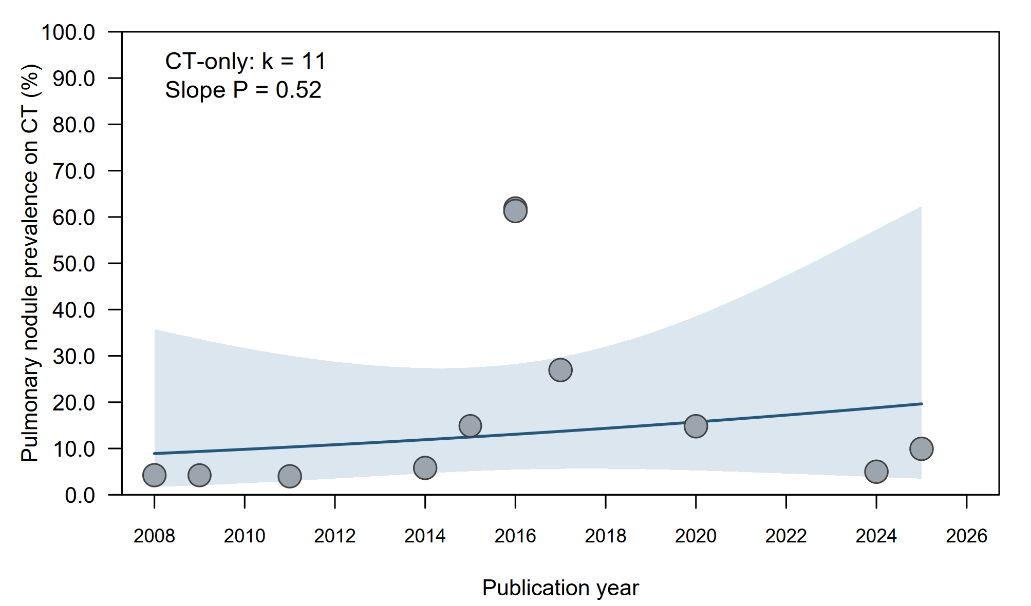

Figure S1 Meta-regression of pulmonary nodule prevalence by publication year in CT-only cohorts.

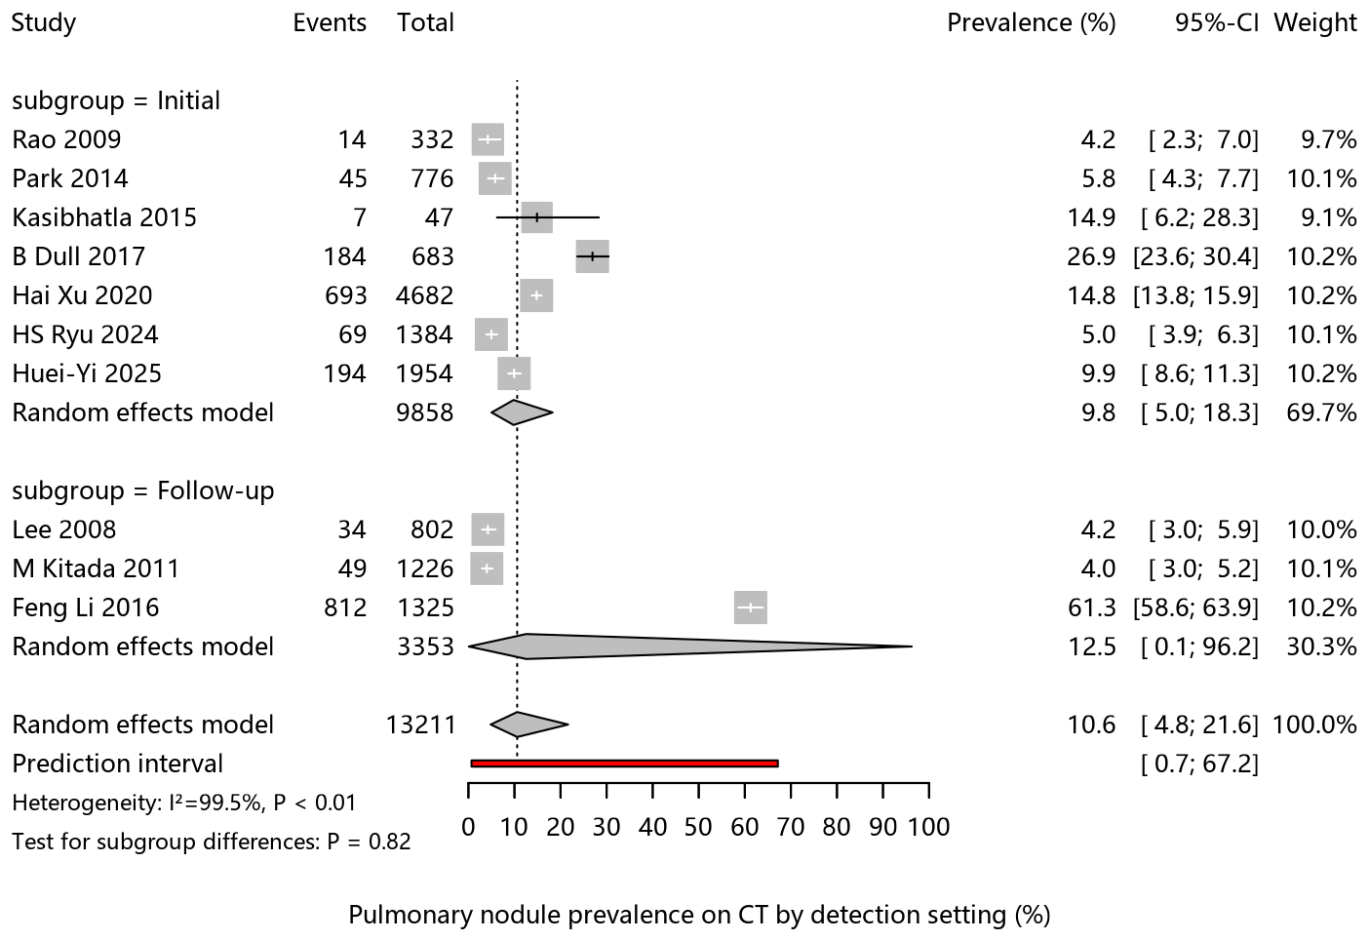

Figure S2 Pulmonary nodule prevalence in CT-only cohorts by detection setting (initial staging vs. follow-up surveillance).
Brothers 2016 was included in the overall prevalence analysis but excluded from the detection-setting subgroup analysis because the setting was not reported.

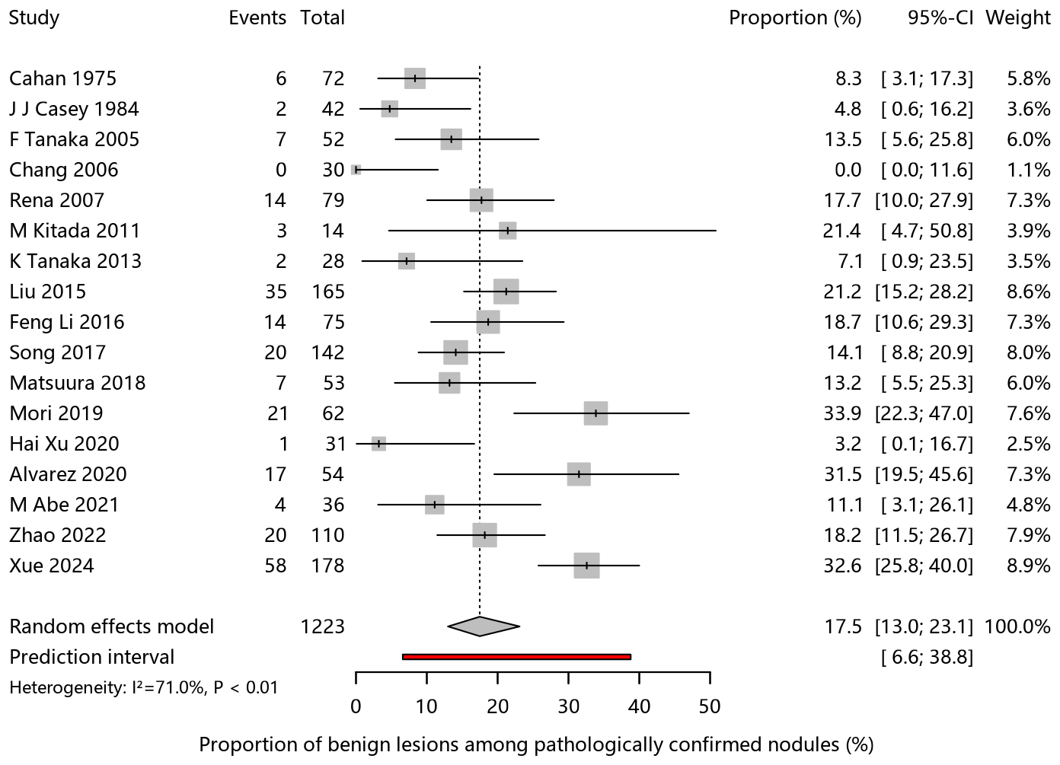

Figure S3 Benign proportion among pathologically confirmed pulmonary nodules

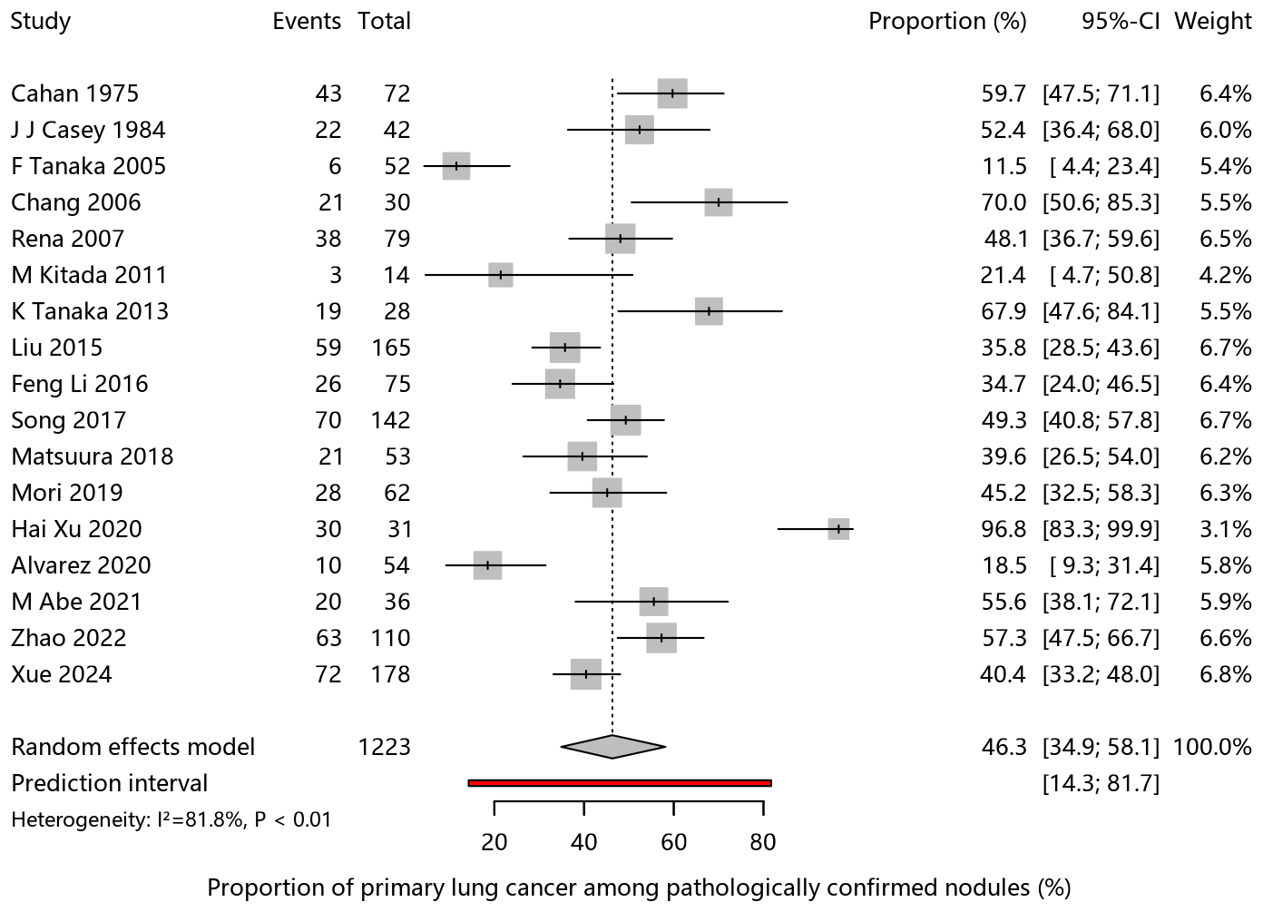

Figure S4 Primary lung cancer proportion among pathologically confirmed pulmonary nodules.

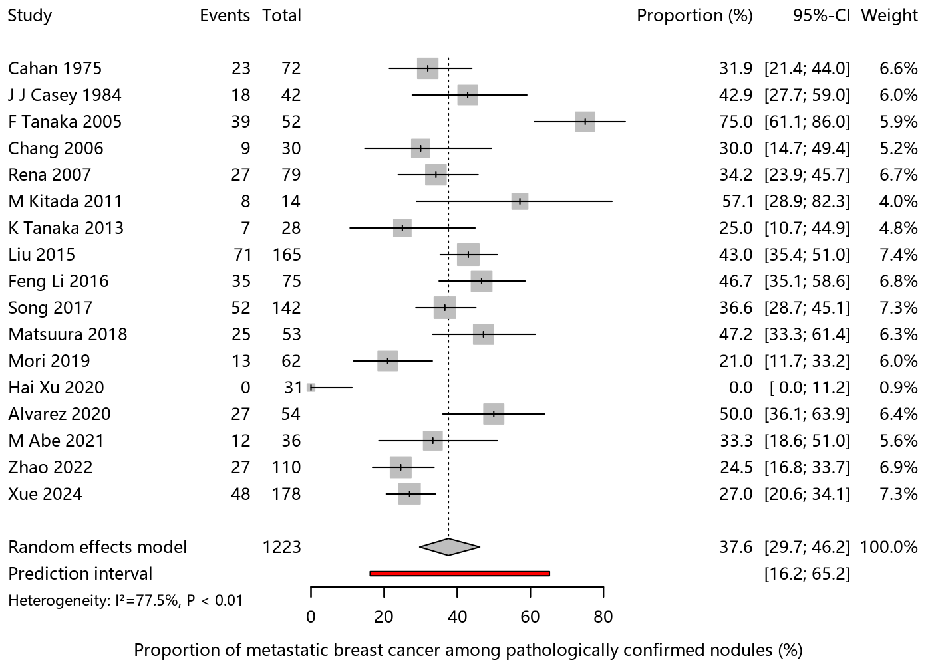

Figure S5 Metastatic breast cancer proportion among pathologically confirmed pulmonary nodules.
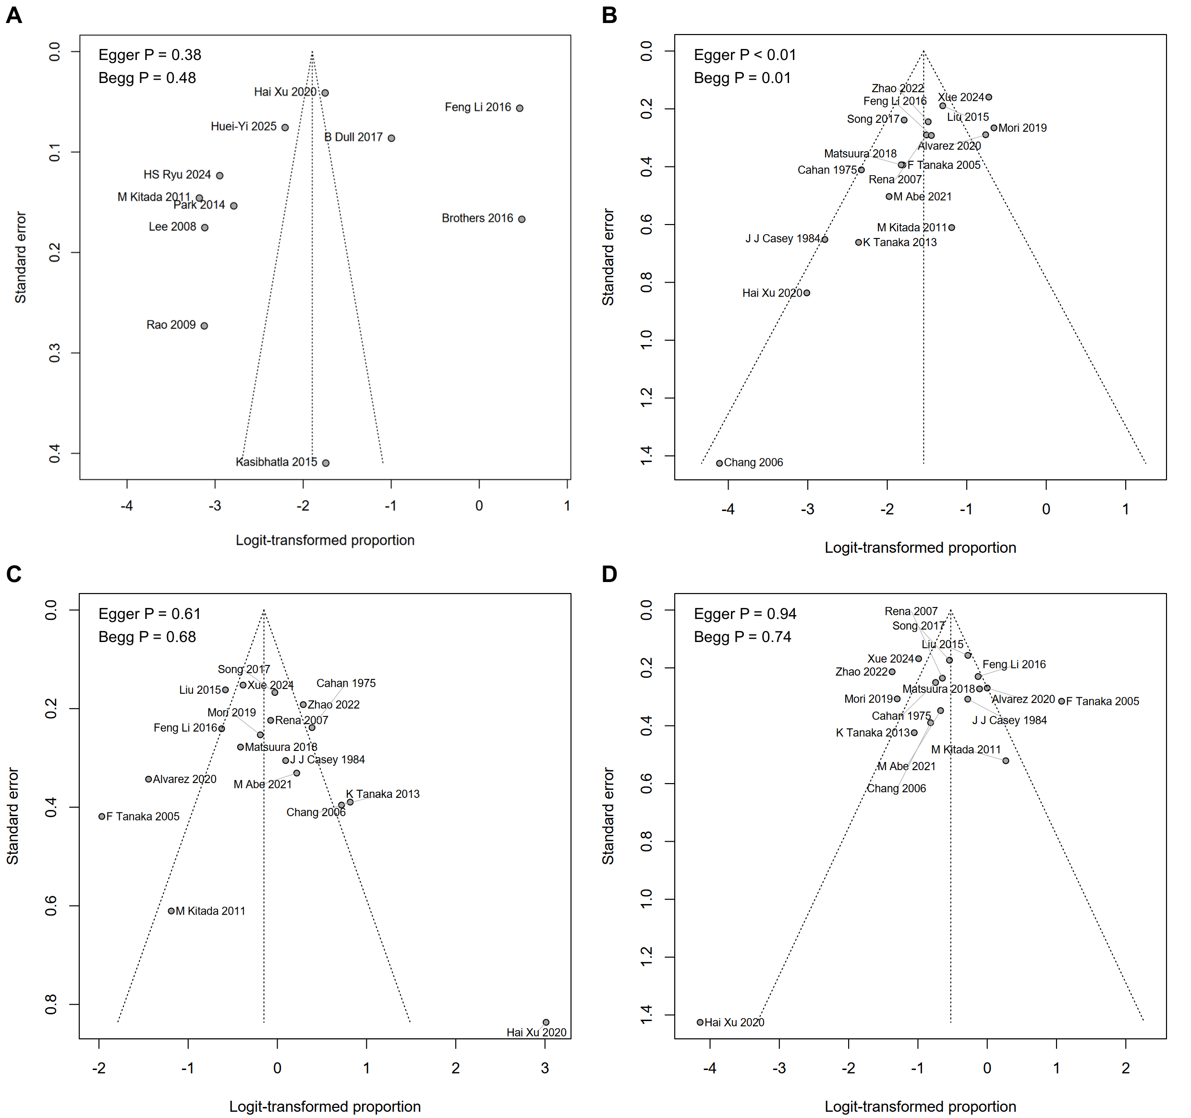

Figure S6 Funnel plots for pulmonary nodule prevalence in CT-only cohorts and pathological proportions among pathologically confirmed pulmonary nodules.
(A) Pulmonary nodule prevalence among breast cancer patients; (B) Benign proportion among pathologically confirmed pulmonary nodules; (C) PLC proportion among pathologically confirmed pulmonary nodules; (D) MBC proportion among pathologically confirmed pulmonary nodules.

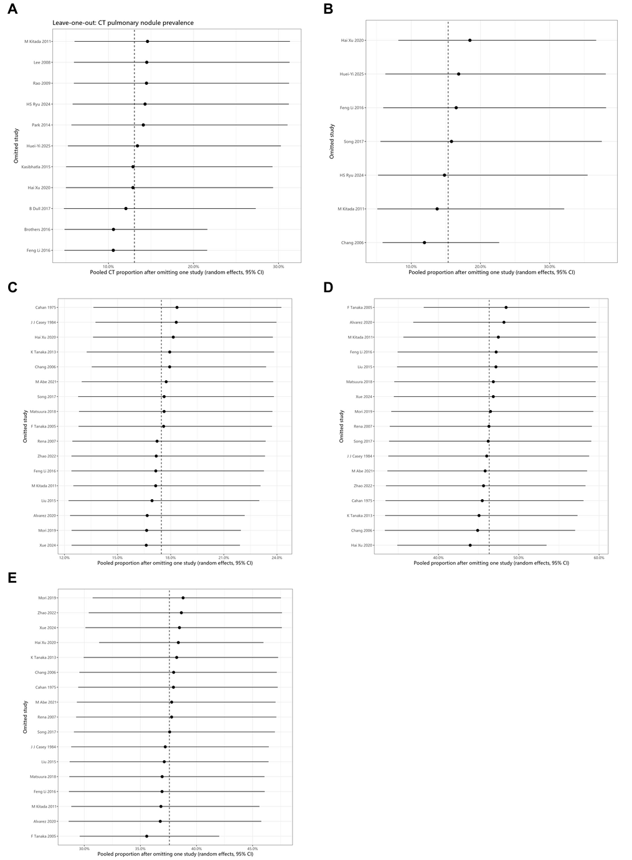

Figure S7 Leave-one-out sensitivity analyses using a random-effects model.
Panels correspond to: (A) pulmonary nodule prevalence among breast cancer patients; (B) proportion undergoing invasive diagnostic intervention; (C) benign proportion among pathologically confirmed nodules; (D) primary lung cancer (PLC) proportion; (E) metastatic breast cancer (MBC) proportion.
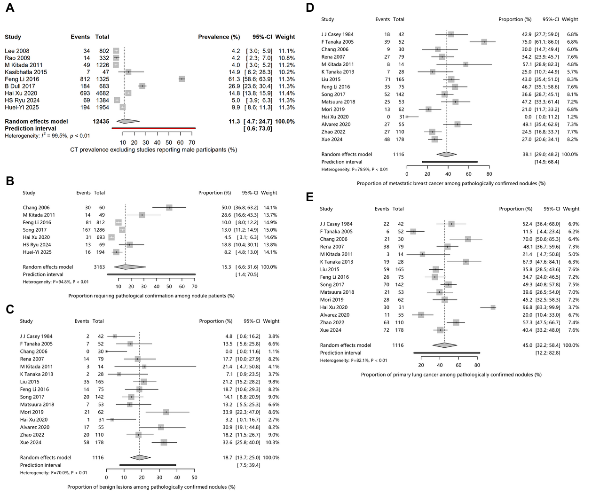

Figure S8 Sensitivity analyses excluding studies that enrolled male breast cancer patients.
(A) prevalence of pulmonary nodules among breast cancer patients; (B) proportion of nodule patients undergoing invasive diagnostic intervention (e.g., biopsy or surgery); (C) proportion of benign diagnoses among pathologically confirmed nodules; (D) proportion of MBC among pathologically confirmed nodules; (E) proportion of PLC among pathologically confirmed nodules.

