supplementary materials
Table S1: Baseline Feature Comparability of Training Set and Validation Set
Variable | Level | Overall | Training | Validation | P value | SMD
Age, years |  | 51.10 (44.30–57.80) | 50.50 (43.40–57.40) | 52.60 (45.60–58.80) | 0.042 | 0.150
BMI, kg/m² |  | 24.60 (22.50–26.60) | 24.50 (22.40–26.80) | 24.80 (22.50–26.50) | 0.850 | 0.013
Drainage duration, days |  | 15.00 (13.00–17.00) | 15.00 (13.00–17.00) | 15.00 (13.00–17.00) | 0.749 | 0.024
Weekly exercise, min |  | 146.00 (73.00–239.00) | 152.00 (74.00–239.00) | 141.50 (72.00–244.00) | 0.294 | 0.062
Hypertension | No | 664 (88.4%) | 463 (88.2%) | 201 (88.9%) | 0.769 | 0.023
 | Yes | 87 (11.6%) | 62 (11.8%) | 25 (11.1%)
Clinical stage | 0-II | 575 (76.6%) | 411 (78.3%) | 164 (72.6%) | 0.090 | 0.133
 | III | 176 (23.4%) | 114 (21.7%) | 62 (27.4%)
Pathological type | Non-invasive | 36 (4.8%) | 27 (5.1%) | 9 (4.0%) | 0.495 | 0.056
 | Invasive | 715 (95.2%) | 498 (94.9%) | 217 (96.0%)
Surgical side | Non-dominant | 379 (50.5%) | 263 (50.1%) | 116 (51.3%) | 0.757 | 0.025
 | Dominant | 372 (49.5%) | 262 (49.9%) | 110 (48.7%)
Breast surgery type | Mastectomy | 574 (76.4%) | 397 (75.6%) | 177 (78.3%) | 0.068 | 0.137
 | Breast-conserving | 159 (21.2%) | 119 (22.7%) | 40 (17.7%)
 | Reconstruction | 18 (2.4%) | 9 (1.7%) | 9 (4.0%)
Axillary procedure | SLNB | 260 (34.6%) | 184 (35.0%) | 76 (33.6%) | 0.708 | 0.030
 | ALND | 491 (65.4%) | 341 (65.0%) | 150 (66.4%)
Adjuvant chemotherapy | No | 222 (29.6%) | 160 (30.5%) | 62 (27.4%) | 0.063 | 0.168
 | Yes (with paclitaxel) | 470 (62.6%) | 317 (60.4%) | 153 (67.7%)
 | Yes (without paclitaxel) | 59 (7.9%) | 48 (9.1%) | 11 (4.9%)
Postoperative radiotherapy | No | 447 (59.5%) | 312 (59.4%) | 135 (59.7%) | 0.938 | 0.006
 | Yes | 304 (40.5%) | 213 (40.6%) | 91 (40.3%)
Endocrine therapy | No | 260 (34.6%) | 190 (36.2%) | 70 (31.0%) | 0.168 | 0.111
 | Yes | 491 (65.4%) | 335 (63.8%) | 156 (69.0%)
Wound complications | No | 610 (81.2%) | 422 (80.4%) | 188 (83.2%) | 0.367 | 0.073
 | Yes | 141 (18.8%) | 103 (19.6%) | 38 (16.8%)

Table S2: diagnosis of multicollinearity and separation
Diagnostic | Term | Result
Multicollinearity | BMI | GVIF = 1.162; df = 1; adjusted GVIF = 1.078
Multicollinearity | age_years | GVIF = 1.088; df = 1; adjusted GVIF = 1.043
Multicollinearity | clinical_stage_group | GVIF = 1.580; df = 1; adjusted GVIF = 1.257
Multicollinearity | drain_removal_days | GVIF = 1.249; df = 1; adjusted GVIF = 1.117
Multicollinearity | hypertension | GVIF = 1.079; df = 1; adjusted GVIF = 1.039
Multicollinearity | lymph_node_surgery_type | GVIF = 1.162; df = 1; adjusted GVIF = 1.078
Multicollinearity | postoperative_radiotherapy | GVIF = 1.171; df = 1; adjusted GVIF = 1.082
Multicollinearity | surgery_type | GVIF = 1.177; df = 2; adjusted GVIF = 1.042
Multicollinearity | weekly_exercise_minutes | GVIF = 1.133; df = 1; adjusted GVIF = 1.064
Multicollinearity | wound_complications | GVIF = 1.288; df = 1; adjusted GVIF = 1.135
Separation | (Intercept) | No infinite separating direction detected
Separation | BMI | No infinite separating direction detected
Separation | age_years | No infinite separating direction detected
Separation | clinical_stage_groupIII | No infinite separating direction detected
Separation | drain_removal_days | No infinite separating direction detected
Separation | hypertensionYes | No infinite separating direction detected
Separation | lymph_node_surgery_typeALND | No infinite separating direction detected
Separation | postoperative_radiotherapyYes | No infinite separating direction detected
Separation | surgery_typeBreast-conserving | No infinite separating direction detected
Separation | surgery_typeReconstruction | No infinite separating direction detected
Separation | weekly_exercise_minutes | No infinite separating direction detected
Separation | wound_complicationsYes | No infinite separating direction detected

Table S3: Sensitivity Model for Mandatory Inclusion of Adjuvant Chemotherapy
Variable | Level or comparison | Beta | SE | OR (95% CI) | P value | Global P
BMI, kg/m² | Per 1-unit increase | 0.204 | 0.057 | 1.226 (1.097–1.371) | <0.001 | <0.001
Age, years | Per 1-unit increase | 0.047 | 0.016 | 1.048 (1.015–1.082) | 0.004 | 0.003
Clinical stage | 0-II (Ref) |  |  | Ref |  | <0.001
 | III vs 0-II | 3.432 | 0.410 | 30.935 (13.845–69.119) | <0.001
Drainage duration, days | Per 1-unit increase | 0.278 | 0.058 | 1.321 (1.180–1.480) | <0.001 | <0.001
Hypertension | No (Ref) |  |  | Ref |  | 0.003
 | Yes vs No | 1.256 | 0.421 | 3.512 (1.539–8.016) | 0.003
Axillary procedure | SLNB (Ref) |  |  | Ref |  | 0.022
 | ALND vs SLNB | 0.908 | 0.411 | 2.480 (1.108–5.550) | 0.027
Postoperative radiotherapy | No (Ref) |  |  | Ref |  | 0.008
 | Yes vs No | 0.848 | 0.324 | 2.335 (1.237–4.409) | 0.009
Breast surgery type | Mastectomy (Ref) |  |  | Ref |  | 0.007
 | Breast-conserving vs Mastectomy | -1.227 | 0.408 | 0.293 (0.132–0.652) | 0.003
 | Reconstruction vs Mastectomy | -0.603 | 1.141 | 0.547 (0.058–5.121) | 0.597
Weekly exercise, min | Per 1-unit increase | -0.005 | 0.001 | 0.995 (0.993–0.998) | <0.001 | <0.001
Wound complications | No (Ref) |  |  | Ref |  | <0.001
 | Yes vs No | 1.940 | 0.380 | 6.958 (3.307–14.642) | <0.001
Adjuvant chemotherapy | No (Ref) |  |  | Ref |  | 0.259
 | Yes (with paclitaxel) vs No | 0.098 | 0.343 | 1.103 (0.563–2.161) | 0.775
 | Yes (without paclitaxel) vs No | -1.013 | 0.750 | 0.363 (0.083–1.581) | 0.177

Table S4: incremental predictive value of perioperative and rehabilitation-related variables
Metric | Conventional model | Full model | Difference or test statistic
Training AUC | 0.878 | 0.937 | -
Validation AUC | 0.828 | 0.941 | -
Validation Brier score | 0.151 | 0.090 | -
Validation delta-AUC (95% bootstrap CI) | - | - | 0.113 (0.066-0.168)
Paired DeLong P (validation) | - | - | <0.001
Likelihood-ratio test (training) | - | - | chi-square = 96.83, df = 3, P = <0.001
Continuous NRI (95% CI) | - | - | 1.117 (0.867-1.355)
NRI component, events | - | - | 0.500 (0.281-0.688)
NRI component, non-events | - | - | 0.617 (0.494-0.741)
IDI (95% CI) | - | - | 0.185 (0.126-0.243)

Figure S1: STROBE-style flowchart of the research cohort

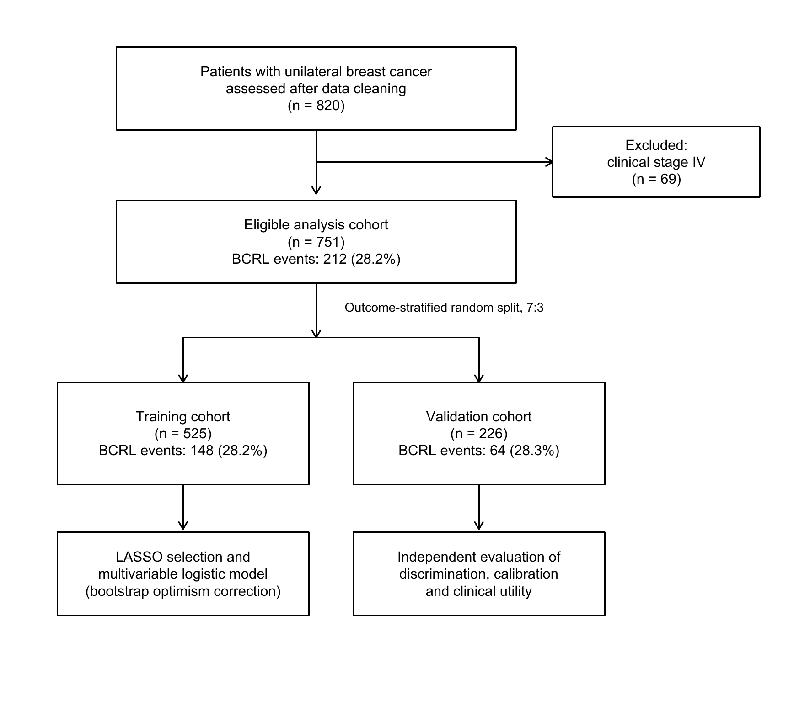
Figure S1: ROC curve and decision curve analysis of incremental value of perioperative/rehabilitation variables
