Supplementary Material Contents

Appendix 1. Literature retrieval strategy 1
Appendix 2. Basic Information of Included Literature 6
Appendix 3. Risk of bias assessment for included studies 20
Appendix 4. The Consistency Test of Direct Evidence and Indirect Evidence by Node Splitting Method 27
Appendix 5. Network Connectivity 29
Appendix 6. Consistent and UME models fit comparison 31
Appendix 7. Nonlinear functions and model-fit comparison 32
Appendix 8. Models fit comparison 33
Appendix 9. Network transitivity 36
Appendix 10. Effectiveness ranking of different exercise modalities 39
Appendix 11. Sensitivity Analysis 42
11.1 Network Evidence Diagram 42
11.2 SUCRA Sensitivity Analysis 43
Appendix 12. Summary of findings and GRADE assessment 44

Appendix 1. Literature retrieval strategy
Database | Search strategies | Results
Pubmed | #1 ("Neoplasms"[Mesh]) OR (Neoplasm*[Title/Abstract] OR Tumor*[Title/Abstract] OR Cancer*[Title/Abstract] OR Malignan*[Title/Abstract]) OR ((Breast[Title/Abstract] OR Lung[Title/Abstract] OR Pulmonary[Title/Abstract] OR Gastric[Title/Abstract] OR Stomach[Title/Abstract]) AND (Neoplasm*[Title/Abstract] OR Tumor*[Title/Abstract] OR Cancer*[Title/Abstract] OR Carcinoma[Title/Abstract])) OR (Lymphoma[Title/Abstract] OR Leukemia[Title/Abstract]) | 5642984
 | #2 ("Exercise"[Mesh]) OR ( (Exercis*[Title/Abstract] OR "Physical Activ*"[Title/Abstract] OR "Physical Exertion"[Title/Abstract]) OR ("Aerobic Exercise"[Title/Abstract] OR "Isometric Exercise"[Title/Abstract] OR "Acute Exercise"[Title/Abstract] OR "Exercise Training"[Title/Abstract]) OR ("Resistance Training"[Title/Abstract] OR "Strength Training"[Title/Abstract] OR "Endurance Training"[Title/Abstract]) OR ("High Intensity Interval Training"[Title/Abstract] OR HIIT[Title/Abstract] OR "Sprint Interval Training"[Title/Abstract]) OR (Jogging[Title/Abstract] OR Walking[Title/Abstract] OR Swimming[Title/Abstract] OR Calisthenics[Title/Abstract]) OR (Dance[Title/Abstract] OR Dancing[Title/Abstract]) OR ("Mind-Body Therap*"[Title/Abstract] OR "Mind-Body Medicine"[Title/Abstract] OR Yoga[Title/Abstract] OR "Tai Chi"[Title/Abstract] OR Taiji[Title/Abstract] OR "Tai Chi Chuan"[Title/Abstract] OR "Qi Gong"[Title/Abstract] OR "Qigong"[Title/Abstract] OR "Chi Kung"[Title/Abstract]) OR ("Cool-down"[Title/Abstract] OR "Warm-down"[Title/Abstract]) OR ("Weight-bearing Exercise"[Title/Abstract] OR "Weight Lifting"[Title/Abstract])) | 757740
 | #3 ("Quality of Life"[Mesh]) OR (("quality of life"[Title/Abstract] OR "quality of lives"[Title/Abstract]) OR (QOL[Title/Abstract] OR HRQOL[Title/Abstract] OR HRQL[Title/Abstract]) OR ("health related quality of life"[Title/Abstract] OR "health-related quality of life"[Title/Abstract]) OR ("life quality"[Title/Abstract]) OR ("EORTC QLQ-C30"[Title/Abstract] OR "QLQ-C30"[Title/Abstract]) OR ("FACT-G"[Title/Abstract] OR "Functional Assessment of Cancer Therapy - General"[Title/Abstract]) OR ("FACT-B"[Title/Abstract] OR "FACT-Breast"[Title/Abstract]) OR ("FACT-HN"[Title/Abstract]) OR ("FACT-An"[Title/Abstract]) OR ("SF-36"[Title/Abstract] OR "Short Form 36"[Title/Abstract] OR "MOS SF-36"[Title/Abstract]) OR ("SF-12"[Title/Abstract] OR "Short Form 12"[Title/Abstract]) OR ("WHOQOL"[Title/Abstract] OR "WHO QOL"[Title/Abstract])) | 561025
 | #4 ("Randomized Controlled Trial as Topic"[Mesh] OR "Controlled Clinical Trial as Topic"[Mesh]) OR ( (controlled clinical trial[Title/Abstract]) OR trial[Title/Abstract]) OR (RCT[Title/Abstract]) OR ("double-blind method"[Title/Abstract] OR "single-blind method"[Title/Abstract])) OR (randomized controlled trial[pt] OR controlled clinical trial[pt]) | 1359961
 | #5 (#1 AND #2 AND #3 AND #4) | 961
Web of Science | #1 TS=(Neoplasm* OR Tumor* OR Cancer* OR Malignan* OR "Breast Neoplasm*" OR "Neoplasm, Breast*" OR "Breast Tumor*" OR "Tumor, Breast*" OR "Breast Cancer*" OR "Cancer, Breast*" OR "Breast Carcinoma*" OR "Carcinoma, Breast*" OR "Lung Neoplasm*" OR "Neoplasm, Lung*" OR "Lung Tumor*" OR "Tumor, Lung*" OR "Lung Cancer*" OR "Cancer, Lung*" OR "Pulmonary Neoplasm*" OR "Neoplasm, Pulmonary*" OR "Gastric Neoplasm*" OR "Neoplasm, Gastric*" OR "Stomach Neoplasm*" OR "Neoplasm, Stomach*" OR "Gastric Cancer*" OR "Cancer, Gastric*" OR "Stomach Cancer*" OR "Cancer, Stomach*" OR "Gastric Carcinoma*" OR "Carcinoma, Gastric*" OR "Stomach Carcinoma*" OR "Carcinoma, Stomach*" OR Lymphoma* OR Leukemia*) | 5212783
 | #2 TS=(Exercis* OR "Exercise, Physical*" OR "Physical Exercise*" OR "Physical Activ*" OR "Activity, Physical*" OR "Physical Exertion*" OR "Exertion, Physical*" OR "Aerobic Exercise*" OR "Exercise, Aerobic*" OR "Isometric Exercise*" OR "Exercise, Isometric*" OR "Acute Exercise*" OR "Exercise, Acute*" OR "Exercise Training*" OR "Training, Exercise*" OR "Resistance Training*" OR "Training, Resistance*" OR "Strength Training*" OR "Training, Strength*" OR "Endurance Training*" OR "Training, Endurance*" OR "High Intensity Interval Training*" OR "High-Intensity Interval Training*" OR "Interval Training, High-Intensity*" OR HIIT OR "Sprint Interval Training*" OR "Training, Sprint Interval*" OR "High-Intensity Intermittent Exercise*" OR "Exercise, High-Intensity Intermittent*" OR "Jogging*" OR "Walking*" OR "Swimming*" OR "Calisthenics*" OR "Physical Stamina*" OR "Stamina, Physical*" OR "Dance*" OR "Dancing*" OR "Mind-Body Therap*" OR "Therap*, Mind-Body" OR "Mind-Body Medicine*" OR "Yoga*" OR "Tai Chi*" OR "Tai-chi*" OR "Tai Chi Chuan*" OR Taiji* OR" Taijiquan*" OR "Qi Gong*" OR "Qigong*" OR "Chi Kung*" OR "Ch'i Kung*" OR "Cool-down*" OR "Cool Down*" OR "Warm-down*" OR "Warm Down*" OR "Weight-bearing Exercise*" OR "Exercise, Weight-bearing*" OR "Weight Lifting*" OR "Weight-Lifting*") | 661730
 | #3 TS=("Quality of Life" OR "Life, Quality of" OR QOL OR HRQOL OR HRQL OR "Health Related Quality of Life" OR "Health-Related Quality of Life" OR "Life Quality" OR "Quality, Life" OR "EORTC QLQ-C30" OR "QLQ-C30" OR "FACT-G" OR "Functional Assessment of Cancer Therapy - General" OR "FACT-B" OR "FACT-Breast" OR "FACT-HN" OR "FACT-An" OR "SF-36" OR "Short Form 36" OR "MOS SF-36" OR "SF-12" OR "Short Form 12" OR "WHOQOL" OR "WHO QOL" OR "World Health Organization Quality of Life") | 55112
 | #4 TS=("Randomized Controlled Trial*" OR "Controlled Clinical Trial*" OR "Clinical Trial, Randomized" OR "Clinical Trial, Controlled" OR RCT OR "Randomi?ed Controlled Trial*" OR "Double-Blind Method*" OR "Method*, Double-Blind" OR "Single-Blind Method*" OR "Method*, Single-Blind") | 1310162
 | #5 (#1 AND #2 AND #3 AND #4) | 809
Embase | #1 'neoplasm'/exp OR 'neoplasm' OR 'neoplasms' OR 'neoplasia' OR 'tumor'/exp OR 'tumor' OR 'tumors' OR 'tumour' OR 'tumours' OR 'cancer'/exp OR 'cancer' OR 'cancers' OR 'malignancy'/exp OR 'malignancy' OR 'malignancies' OR 'malignant' OR 'breast'/exp AND 'neoplasm'/exp OR 'neoplasm' OR 'tumor'/exp OR 'tumor' OR 'cancer'/exp OR 'cancer' OR 'carcinoma'/exp OR 'carcinoma' OR 'lung'/exp AND 'neoplasm'/exp OR 'neoplasm' OR 'tumor'/exp OR 'tumor' OR 'cancer'/exp OR 'cancer' OR 'carcinoma'/exp OR 'carcinoma' OR  'pulmonary'/exp AND 'neoplasm'/exp OR 'neoplasm' OR 'stomach'/exp AND 'neoplasm'/exp OR 'neoplasm' OR 'tumor'/exp OR 'tumor' OR 'cancer'/exp OR 'cancer' OR 'carcinoma'/exp OR 'carcinoma' OR 'gastric'/exp AND 'neoplasm'/exp OR 'neoplasm' OR 'tumor'/exp OR 'tumor' OR 'cancer'/exp OR 'cancer' OR 'carcinoma'/exp OR 'carcinoma' OR 'lymphoma'/exp OR 'lymphoma' OR 'lymphomas' OR 'leukemia'/exp OR 'leukemia' OR 'leukemias' OR 'leukaemia' | 902524
 | #2 'exercise'/exp OR 'exercise' OR 'exercises' OR 'exercising' OR 'physical activity'/exp OR 'physical activity' OR 'physical activities' OR 'physical exertion'/exp OR 'physical exertion' OR  'aerobic exercise'/exp OR 'aerobic exercise' OR 'isometric exercise'/exp OR 'isometric exercise' OR 'acute exercise' OR 'exercise training' OR 'resistance training'/exp OR 'resistance training' OR 'strength training'/exp OR 'strength training' OR 'endurance training'/exp OR 'endurance training' OR 'high intensity interval training'/exp OR 'high intensity interval training' OR 'hiit' OR 'sprint interval training' OR 'jogging'/exp OR 'jogging' OR 'walking'/exp OR 'walking' OR  'swimming'/exp OR 'swimming' OR 'calisthenics' OR 'dance'/exp OR 'dance' OR 'dancing' OR  'mind body therapy'/exp OR 'mind body therapy' OR 'mind-body medicine' OR 'yoga'/exp OR 'yoga' OR 'tai chi'/exp OR 'tai chi' OR 'taiji' OR 'tai chi chuan' OR 'qi gong'/exp OR 'qi gong' OR 'qigong' OR 'chi kung' OR 'cooling down' OR 'warm up exercise'/exp OR 'warm up' OR 'weight bearing'/exp OR 'weight bearing' OR 'weight lifting'/exp OR 'weight lifting' | 147242
 | #3 'quality of life'/exp OR 'quality of life' OR 'health-related quality of life' OR 'life quality' OR 'eortc qlq-c30' OR 'qlq-c30' OR 'functional assessment of cancer therapy general' OR 'fact-g' OR 'functional assessment of cancer therapy breast' OR 'fact-b' OR 'functional assessment of cancer therapy head and neck' OR 'fact-hn' OR 'functional assessment of cancer therapy anemia' OR 'fact-an' OR 'sf-36' OR 'short form 36' OR 'medical outcomes study short form 36' OR 'sf-12' OR 'short form 12' OR 'whoqol' OR 'who quality of life' OR 'well-being' | 331927
 | #4 'randomized controlled trial'/exp OR 'randomized controlled trial' OR 'randomised controlled trial' OR 'controlled clinical trial'/exp OR 'controlled clinical trial' OR rct OR 'double blind procedure'/exp OR 'double blind procedure' OR 'single blind procedure'/exp OR 'single blind procedure' OR 'crossover procedure'/exp OR 'crossover procedure' OR 'randomization'/exp OR 'randomization' OR 'randomisation' OR 'clinical trial'/exp OR 'clinical trial' AND random* | 1429760
 | #5 (#1 AND #2 AND #3 AND #4) | 772
Cochrane Library | #1 MeSH descriptor: [Neoplasms] explode all trees | 131110
 | #2 (Neoplasms):ti,ab,kw OR (Neoplasms):ti,ab,kw OR (Tumor):ti,ab,kw OR (Tumors):ti,ab,kw OR (Cancer):ti,ab,kw OR (Cancers):ti,ab,kw OR (Malignancy):ti,ab,kw OR (Malignancies):ti,ab,kw OR (Malignant):ti,ab,kw OR (Benign Neoplasm):ti,ab,kw OR (Benign Neoplasms):ti,ab,kw OR (Breast Neoplasm):ti,ab,kw OR (Breast Tumor):ti,ab,kw OR (Breast Cancer):ti,ab,kw OR (Breast Carcinoma):ti,ab,kw OR (Lung Neoplasm):ti,ab,kw OR (Lung Cancer):ti,ab,kw OR (Pulmonary Neoplasm):ti,ab,kw OR (Gastric Neoplasm):ti,ab,kw OR (Stomach Neoplasm):ti,ab,kw OR (Gastric Cancer):ti,ab,kw OR (Stomach Cancer):ti,ab,kw OR (Liver Neoplasm):ti,ab,kw OR (Liver Cancer):ti,ab,kw OR (Hepatic Neoplasm):ti,ab,kw OR (Hepatocellular Cancer):ti,ab,kw OR (Prostate Neoplasm):ti,ab,kw OR (Prostate Cancer):ti,ab,kw OR (Prostatic Neoplasm):ti,ab,kw OR (Rectal Neoplasm):ti,ab,kw OR (Rectal Cancer):ti,ab,kw OR (Rectum Neoplasm):ti,ab,kw OR (Esophageal Neoplasm):ti,ab,kw OR (Esophageal Cancer):ti,ab,kw OR (Esophagus Neoplasm):ti,ab,kw OR (Pancreatic Neoplasm):ti,ab,kw OR (Pancreatic Cancer):ti,ab,kw OR (Pancreas Neoplasm):ti,ab,kw OR (Pancreatic Carcinoma):ti,ab,kw OR (Cervical Neoplasm):ti,ab,kw OR (Cervical Cancer):ti,ab,kw OR (Uterine Cervical Neoplasm):ti,ab,kw OR (Cervix Neoplasm):ti,ab,kw OR (Skin Neoplasm):ti,ab,kw OR (Skin Cancer):ti,ab,kw OR (Lymphoma):ti,ab,kw OR (Lymphomas):ti,ab,kw OR (Leukemia):ti,ab,kw OR (Leukemias):ti,ab,kw OR (Leucocythemia):ti,ab,kw OR (Thyroid Neoplasm):ti,ab,kw OR (Thyroid Cancer):ti,ab,kw OR (Thyroid Carcinoma):ti,ab,kw OR (Oral Neoplasm):ti,ab,kw OR (Oral Cancer):ti,ab,kw OR (Mouth Neoplasm):ti,ab,kw OR (Laryngeal Neoplasm):ti,ab,kw OR (Larynx Cancer):ti,ab,kw OR (Laryngeal Cancer):ti,ab,kw | 321270
 | #3 (#1 OR #2) | 311322
 | #4 MeSH descriptor: [Exercise] explode all trees | 40979
 | #5 (Exercise):ti,ab,kw OR (Exercise):ti,ab,kw OR (Exercises):ti,ab,kw OR (Physical Activity):ti,ab,kw OR (Physical Activity):ti,ab,kw OR (Physical Activities):ti,ab,kw OR (Physical Exertion):ti,ab,kw OR (Physical Exertion):ti,ab,kw OR (Aerobic Exercise):ti,ab,kw OR (Isometric Exercise):ti,ab,kw OR (Acute Exercise):ti,ab,kw OR (Exercise Training):ti,ab,kw OR (Resistance Training):ti,ab,kw OR (Strength Training):ti,ab,kw OR (Endurance Training):ti,ab,kw OR (Physical Stamina):ti,ab,kw OR (Stamina):ti,ab,kw OR (High Intensity Interval Training):ti,ab,kw OR (HIIT):ti,ab,kw OR (Sprint Interval Training):ti,ab,kw OR (High-Intensity Intermittent Exercise):ti,ab,kw OR (Jogging):ti,ab,kw OR (Walking):ti,ab,kw OR (Swimming):ti,ab,kw OR (Calisthenics):ti,ab,kw OR (Dance):ti,ab,kw OR (Ballet):ti,ab,kw OR (Jazz Dance):ti,ab,kw OR (Tap Dance):ti,ab,kw OR (Modern Dance):ti,ab,kw OR (Hip-Hop Dance):ti,ab,kw OR (Line Dancing):ti,ab,kw OR (Salsa Dancing):ti,ab,kw OR (Square Dance):ti,ab,kw OR (Mind-Body Therapies):ti,ab,kw OR (Mind-Body Therapy):ti,ab,kw OR (Mind-Body Medicine):ti,ab,kw OR (Yoga):ti,ab,kw OR (Yoga):ti,ab,kw OR (Tai Chi):ti,ab,kw OR (Tai-chi):ti,ab,kw OR (Taiji):ti,ab,kw OR (Taijiquan):ti,ab,kw OR (Tai Chi Chuan):ti,ab,kw OR (T'ai Chi):ti,ab,kw OR (Qi Gong):ti,ab,kw OR (Ch'i Kung):ti,ab,kw OR (Baduanjin):ti,ab,kw OR (Wuqinxi):ti,ab,kw OR (Liuzijue):ti,ab,kw OR (Yijinjing):ti,ab,kw OR (eight-section brocade):ti,ab,kw OR (Cool Down Exercise):ti,ab,kw OR (Cooldown Exercise):ti,ab,kw OR (Cooling-Down Exercise):ti,ab,kw OR (Warm-Down Exercise):ti,ab,kw OR (Warming-Down Exercise):ti,ab,kw OR (Weight-Lifting):ti,ab,kw OR (Weight-Bearing Exercise):ti,ab,kw OR (Strengthening Program):ti,ab,kw OR (Weight-Lifting Exercise Program):ti,ab,kw OR (Weight-Bearing Exercise Program):ti,ab,kw | 229723
 | #6 (#4 OR #5) | 230275
 | #7 MeSH descriptor: [Randomized Controlled Trial] explode all trees | 34
 | #8 (Randomized Controlled Trials):ti,ab,kw OR (Randomized Controlled Trials as Topic):ti,ab,kw OR (Randomized Controlled Trial):ti,ab,kw OR (RCT):ti,ab,kw OR (Randomly Allocated):ti,ab,kw OR (Random Allocation):ti,ab,kw OR (Random Assignment):ti,ab,kw OR (Randomized Trial):ti,ab,kw OR (Controlled Clinical Trial):ti,ab,kw OR (Parallel Group Trial):ti,ab,kw OR (Placebo Controlled Trial):ti,ab,kw OR (Double-Blind Trial):ti,ab,kw OR (Single-Blind Trial):ti,ab,kw | 1112243
 | #9 (#7 OR #8) | 1132892
 | #10 MeSH descriptor: [Quality of Life] explode all trees | 923
 | #11 ("Quality of Life"):ti,ab,kw OR ("Life, Quality of"):ti,ab,kw OR (QOL):ti,ab,kw OR (HRQOL):ti,ab,kw OR (HRQL):ti,ab,kw OR ("Health Related Quality of Life"):ti,ab,kw OR ("Health-Related Quality of Life"):ti,ab,kw OR ("Life Quality"):ti,ab,kw OR ("Quality, Life"):ti,ab,kw OR ("EORTC QLQ-C30"):ti,ab,kw OR ("QLQ-C30"):ti,ab,kw OR ("FACT-G"):ti,ab,kw OR ("Functional Assessment of Cancer Therapy - General"):ti,ab,kw OR ("FACT-B"):ti,ab,kw OR ("FACT-Breast"):ti,ab,kw OR ("FACT-HN"):ti,ab,kw OR ("FACT-An"):ti,ab,kw OR ("SF-36"):ti,ab,kw OR ("Short Form 36"):ti,ab,kw OR ("MOS SF-36"):ti,ab,kw OR ("SF-12"):ti,ab,kw OR ("Short Form 12"):ti,ab,kw OR (WHOQOL):ti,ab,kw OR("WHO QOL"):ti,ab,kw OR ("World Health Organization Quality of Life"):ti,ab,kw | 5177
 | #12 (#10 OR #11) | 4524
 | #13 (#3 AND #6 AND #9 AND #12) | 1023

Appendix 2. Basic Information of Included Literature
Study | Country | Sample size (I/C) | Age  (mean±SD） | Intervention | Control | Cancer type | Frequency and Duration | Intervention duration (weeks) | Weekly exercise volume(MET-min/week) | Outcome
Mustian KM 2009 [1] | USA | 19/19 | 56.6± 13.7/63.3 ± 9.4 | Aerobic+resistance exercise | Usual care | Breast and prostate cancer | 7sessions/week  45min/session | 4 | 1732.5 | FACIT-F
Alibhai SM 2014 [2] | Canada | 19/17 | 53.9±8.2/58.8±8.8 | Aerobic+resistance exercise | Usual care | Acute myeloid leukemia | 5sessions/week  30min/session | 12 | 825 | EORTC QLQ-C30
Furzer BJ 2016 [3] | Australia | 18/19 | 48.2±12.3/49.6±14.1 | Aerobic+resistance exercise | Usual care | Haematological cancer | 3sessions/week  30min/session | 12 | 495 | FACT-G
Owusu, C 2022 [4] | USA | 90/97 | 71.81±5.99/71.95 ±5.82 | Aerobic+resistance exercise | Usual care | Breast cancer | 3sessions/week  60min/session | 20 | 990 | FACT-G
Dieli-Conwright, CM 2018 [5] | USA | 50/50 | ≥18 | Aerobic+resistance exercise | Usual care | Breast cancer | 3sessions/week  80min/session | 16 | 1320 | FACT-G
Galvão, DA 2010 [6] | Australia | 26/25 | 69.5±7.3/70.1±7.3 | Aerobic+resistance exercise | Usual care | Prostate Cancer | 2sessions/week  40min/session | 12 | 440 | EORTC QLQ-C30
Neuzillet C 2023 [7] | French | 87/85 | ≥18 | Aerobic+resistance exercise | Usual care | Pancreatic Cancer | 5sessions/week  30min/session | 16 | 825 | EORTC QLQ-C30
Falz, R 2023 [8] | Germany | 62/60 | 54.4 ± 11/54.6 ± 12 | Aerobic+resistance exercise | Usual care | cancer | 3sessions/week  30min/session | 24 | 495 | EORTC QLQ-C30
van Waart, H 2015 [9] | Netherlands | 71/69/66 | 49.9±8.4/50.5±10.1 | IG1:Aerobic+resistance exercise  IG2:Aerobic exercise | Usual care | Breast cancer | 5sessions/week  30min/session | 12 | 825 | EORTC QLQ-C30
Koevoets, E 2022 [10] | Netherlands | 84/86 | 52.1±8.6/52.5±8.7 | Aerobic+resistance exercise | Usual care | Breast cancer | 4sessions/week  60min/session | 24 | 1320 | EORTC QLQ-C30
Machado P 2024 [11] | Portugal | 20/21 | 66.4±7.2/68.7±10.3 | Aerobic+resistance exercise | Usual care | Lung cancer | 5sessions/week  40min/session | 4 | 1100 | EORTC QLQ-C30
D'Silva, C 2025 [12] | India | 38/39 | 54.26±10.43/54.59±11.10 | Aerobic+resistance exercise | Walking | Head and Neck cancer | IG:5sessions/week  20min/session  CG:5sessions/week  10min/session | 7 | 550 | FACT-HN
Mardani A 2021 [13] | Iran | 40/40 | 69.40±5.77/70.39 ±5.45 | Aerobic+resistance exercise | Usual care | Prostate cancer | 4sessions/week  30min/session | 12 | 660 | EORTC QLQ-C30
Saarto T 2012 [14] | Finland | 263/237 | 52.3(36-68)/52.4(35-68) | Aerobic+resistance exercise | Usual care | Breast cancer | 3sessions/week  60min/session | 48 | 990 | EORTC QLQ-C30
Casanovas-Álvarez, A 2024 [15] | Spain | 30/31 | 49.2±10.9/54.7 ±12.1 | Aerobic+resistance exercise | Usual care | Breast cancer | 2sessions/week  75min/session | 11 | 825 | EORTC QLQ-C30
Kim, J. 2019 [16] | South Korea | 30/28 | 55.7±8.7/56.8±10.2 | Aerobic+resistance exercise | Usual care | Colorectal cancer | 7sessions/week  60min/session | 12 | 2310 | FACT-C
Soriano-Maldonado, A 2023 [17] | Spain | 32/28 | 52.6±8.8/52.0 ±9.4 | Aerobic+resistance exercise | Walking | Breast cancer | 2sessions/week  60min/session | 12 | 660 | FACT-B
Milne, H. M 2008 [18] | Australia | 29/29 | 55.2±8.4/55.1±8.0 | Aerobic+resistance exercise | Usual care | Breast cancer | 3sessions/week  30min/session | 12 | 495 | FACT-G
Kenkhuis MF 2024 [19] | Netherlands | 31/33 | 55.5±10.4/59.7±10.6 | Aerobic+resistance exercise | Usual care | Ovarian cancer | 5sessions/week  60min/session | 18 | 1650 | EORTC QLQ-C30
Porserud A 2024 [20] | Sweden | 47/43 | 71.3±9.1/71.3±7.8 | Aerobic+resistance exercise | Usual care | Urinary bladder cancer | 2sessions/week  50min/session | 12 | 550 | EORTC QLQ-C30
De Luca, V 2016 [21] | Italy | 10/10 | 50.2±9.7/46.0±2.8 | Aerobic+resistance exercise | Usual care | Breast cancer | 2sessions/week  90min/session | 24 | 990 | FACT-G
An KY 2020 [22] | Canada | 104/101 | ≥18 | Aerobic+resistance exercise | HIIT | Breast cancer | 3sessions/week  60min/session | 17 | 990 | FACT-B
Uhm, K. E 2017 [23] | South Korea | 167/172 | 49.3±8.0/51.3±10.7 | Aerobic+resistance exercise | Usual care | Breast cancer | 2sessions/week  45min/session | 12 | 495 | EORTC QLQ-C30
Morey MC 2009 [24] | USA | 319/322 | 73.0±5.0/73.1±5.1 | Aerobic+resistance exercise | Usual care | Cancer | 7sessions/week  30min/session | 48 | 1155 | SF-36
Cornette T 2016 [25] | France | 13/13 | 52(37-73)/49(37-68) | Aerobic+resistance exercise | Usual care | Breast cancer | 3sessions/week  45min/session | 27 | 742.5 | EORTC QLQ-C30
Midtgaard J 2013 [26] | Denmark | 73/80 | 48.2±10.1/46.2±11.6 | Aerobic+resistance exercise | Usual care | Cancer | 1sessions/week  90min/session | 48 | 495 | EORTC QLQ-C30
Baglia, M. L 2019 [27] | USA | 45/38 | 62.0±7.0/60.5±7.0 | Aerobic+resistance exercise | Usual care | Breast cancer | 3sessions/week  50min/session | 48 | 825 | FACT-G
Arbane G 2011 [28] | UK | 22/21 | 65.4 (47–82)/62.6 (32–47) | Aerobic+resistance exercise | Usual care | Non-small cell lung cancer | 2sessions/week  30min/session | 12 | 330 | EORTC QLQ-C30
Hayes SC 2013 [29] | Australia | 67/60 | 52.2±8.6/53.9±7.7 | Aerobic+resistance exercise | Usual care | Breast cancer | 5sessions/week  45min/session | 32 | 1237.5 | FACT-B
McCourt O 2023 [30] | UK | 15/18 | 59.3±9.4/61.3±8.7 | Aerobic+resistance exercise | Usual care | Myeloma undergoing | 3sessions/week  40min/session | 12 | 660 | EORTC QLQ-C30
Antunes P 2024 [31] | Portugal | 44/41 | 49.66±9.43/51.02 ±9.54 | Aerobic+resistance exercise | Usual care | Breast cancer | 3sessions/week  30min/session | 12 | 495 | EORTC QLQ-C30
Ndjavera W 2020 [32] | UK | 24/20 | 71.4±5.4/72.5±4.2 | Aerobic+resistance exercise | Usual care | Prostate cancer | 5sessions/week  60min/session | 12 | 1650 | FACT-P
Rossi A 2016 [33] | USA | 12/12 | 64±10/65±5 | Aerobic+resistance exercise | Usual care | Endometrial cancer | 2sessions/week  60min/session | 12 | 660 | FACT-G
Edvardsen, E 2015 [34] | Norway | 25/29 | 64.4±9.3/65.9±8.5 | Aerobic+resistance exercise | Usual care | Lung cancer | 3sessions/week  60min/session | 20 | 990 | EORTC QLQ-C30
Vincent F 2020 [35] | France | 29/26 | 50.0(37-72)/56.5(30-69)/50.0(29-72) | Aerobic+resistance exercise | Usual care | Breast cancer | 3sessions/week  60min/session | 24 | 990 | EORTC QLQ-C30
Touraine C 2025 [36] | France | 72/71 | 18–75 | Aerobic+resistance exercise | Usual care | Breast cancer | 3sessions/week  40min/session | 24 | 660 | EORTC QLQ-C30
Hojan K 2017 [37] | Poland | 35/31 | 65.7±6.2/67.9±4.9 | Aerobic+resistance exercise | Usual care | Prostate cancer | 3sessions/week  90min/session | 40 | 1485 | EORTC QLQ-C30
Landry S 2018 [38] | France | 17/12 | 51±2/53±4 | Aerobic+resistance exercise | Usual care | Breast cancer | 3sessions/week  90min/session | 12 | 1485 | FACT-G
Buffart LM 2014 [39] | Netherlands | 147/67 | 48.8±10.9/51.3±8.8 | Aerobic+resistance exercise | Usual care | Cancer | 2sessions/week  120min/session | 12 | 1320 | EORTC QLQ-C30
Haines TP 2010 [40] | Australia | 36/37 | 55.9±10.5/54.2±11.5 | Aerobic+resistance exercise | Usual care | Breast cancer | 2sessions/week  60min/session | 12 | 660 | EORTC QLQ-C30
Mendizabal-Gallastegui N 2023 [41] | Spain | 28/28 | 56.5±7.8/57.1±8.9 | Aerobic+resistance exercise | Usual care | Gastrointestinal, Breast, or Non−small cell Lung cancers | 3sessions/week  60min/session | 8 | 990 | EORTC QLQ-C30
Hojan K 2016 [42] | Poland | 27/27 | 67.4±8.3/69.9±7.2 | Aerobic+resistance exercise | Usual care | Prostate cancer | 5sessions/week  50min/session | 8 | 1375 | EORTC QLQ-C30
Kampshoff CS 2015 [43] | Netherlands | 91/91 | 54±11.0/53±11.3/54±10.9 | Aerobic+resistance exercise | Usual care | Cancer | 2sessions/week  30min/session | 12 | 330 | EORTC QLQ-C30
Henke CC 2014 [44] | Germany | 18/11 | ≥18 | Aerobic+resistance exercise | Usual care | Lung cancer | 5sessions/week  30min/session | 3 | 825 | EORTC QLQ-C30
Bloch Z 2025 [45] | Denmark | 66/71 | 65±8/64±9 | Aerobic+resistance exercise | Usual care | Lung cancer | 2sessions/week  90min/session | 12 | 990 | EORTC QLQ-C30
Buffart LM 2015 [46] | Australia and New Zealand | 50/50 | 71.9±5.6/71.5±7.2 | Aerobic+resistance exercise | Usual care | Prostate cancer | 2sessions/week  60min/session | 24 | 660 | EORTC QLQ-C30
Paulo TRS 2019 [47] | Brazil | 15/14 | 63.2±7.1/66.6±9.6 | Aerobic+resistance exercise | Usual care | Breast cancer | 3sessions/week  60min/session | 36 | 990 | EORTC QLQ-C30
Buchan J 2016 [48] | Australia | 19/20 | 58.5(54.2-62.8)/53.7(48.9-58.5) | Resistance exercise | Aerobic exercise | Breast cancer | 3sessions/week  50min/session | 12 | 600 | FACT-B
Schmidt T 2015 [49] | Germany | 21/20/26 | 53±12.55/56±10.15/54±11.19 | IG1:Resistance exercise  IG2:Aerobic exercise | Usual care | Breast cancer | 3sessions/week  60min/session | 20 | 720 | EORTC QLQ-C30
Livingston PM 2015 [50] | Australia | 47/83 | 66.9±8.2/64.7±8.7 | Resistance exercise | Usual care | Prostate cancer | 3sessions/week  50min/session | 12 | 675 | EORTC QLQ-C30
Courneya KS 2007 [51] | Canada | 64/66/69 | 49.5(25-76)/49(30-75)/49(26-78) | IG1:Resistance exercise  IG2:Aerobic exercise | Usual care | Breast cancer | IG1:3sessions/week  30min/session  IG2:3sessions/week  45min/session | 17 | 360 | FACT-An
Sun J 2023 [52] | China | 120/120 | 67.10±5.76/63.68±7.01 | Resistance exercise | Usual care | Cancer | 5sessions/week  40min/session | 12 | 800 | SF-36
Hu Q 2021 [53] | China | 67/65 | 44.7±15.1/46.2±13.5 | Resistance exercise | Usual care | Nasopharyngeal carcinoma | 2sessions/week  60min/session | 12 | 480 | EORTC QLQ-C30
Schmidt ME 2015 [54] | Germany | 45/32 | 52.2±9.9/53.3±10.2 | Resistance exercise | Usual care | Breast cancer | 2sessions/week  60min/session | 12 | 480 | EORTC QLQ-C30
Hong Y 2020 [55] | China | 94/96 | 55.4 ± 11.6/52.3 ± 12.4 | Resistance exercise | Usual care | Gastrointestinal cancer | 2sessions/week  60min/session | 12 | 480 | EORTC QLQ-C30
Nilsen TS 2015 [56] | Norway | 27/30 | 66±6.6/66±5 | Resistance exercise | Usual care | Prostate cancer | 3sessions/week  30min/session | 16 | 405 | EORTC QLQ-C30
De Lazzari N 2024 [57] | Germany | 15/16 | 61 (30-86)/63.0 (37-74) | Resistance exercise | Usual care | Pancreatic or Biliary tract cancer | 3sessions/week  40min/session | 8 | 504 | EORTC QLQ-C30
Rogers LQ 2013 [58] | USA | 5/8 | 54.76±10.6/65.56±12.5 | Resistance exercise | Usual care | Head and Neck cancer | 2sessions/week  60min/session | 12 | 480 | FACT-G
Steindorf K 2019 [59] | Germany | 9/17 | 61±9.3/58.7±8.4 | Resistance exercise | Usual care | Pancreatic cancer | 2sessions/week  60min/session | 24 | 480 | EORTC QLQ-C30
Segal RJ 2009 [60] | Canada | 40/40/41 | 66.4±7.6/66.2±6.8/65.3±7.6 | IG1:Resistance exercise  IG2:Aerobic exercise | Usual care | Prostate cancer | IG1:3sessions/week  30min/session  IG2:3sessions/week  45min/session | 24 | 360 | FACT-G
Steindorf K 2014 [61] | Germany | 78/74 | 55.2±9.5/56.4±8.7 | Resistance exercise | Usual care | Breast cancer | 2sessions/week  60min/session | 12 | 480 | EORTC QLQ-C30
Christensen JF 2014 [62] | Denmark | 14/13 | 34.4±7.6/35.8±8.9 | Resistance exercise | Usual care | Testicular germ cell cancer | 3sessions/week  60min/session | 9 | 720 | EORTC QLQ-C30
Hagstrom AD 2016 [63] | Australia | 19/15 | 51.2±8.5/52.7±9.4 | Resistance exercise | Usual care | Breast cancer | 3sessions/week  60min/session | 16 | 720 | FACT-G
Ashton RE 2021 [64] | UK | 20/22 | 64.6 ± 6.2/66.9 ± 6.8 | Resistance exercise | Usual care | Prostate cancer | 3sessions/week  45min/session | 24 | 540 | FACT-G
Kocamaz D 2025 [65] | Turkey | 40/30 | 49.35±10.17/49.78±8.83 | Resistance exercise | Usual care | Breast cancer | 2sessions/week  50min/session | 12 | 400 | EORTC QLQ-C30
Park JH 2015 [66] | South Korea | 59/50 | 51.38±7.24/53.42±8.12 | Resistance exercise | Usual care | Breast and Colorectal cancer | 2sessions/week  50min/session | 4 | 400 | EORTC QLQ-C30
Cešeiko R 2019 [67] | Latvia | 27/28 | 48.2 ± 6.7/49.0 ± 8.0 | Resistance exercise | Usual care | Breast cancer | 2sessions/week  20min/session | 12 | 210 | EORTC QLQ-C30
Chuang TY 2017 [68] | China | 48/48 | 55.85±16.78/64.54±15.51 | Qigong | Usual care | lymphoma | 7sessions/week  50min/session | 3 | 1225 | EORTC QLQ-C30
Cheung DST 2022 [69] | China | 15/13 | 69.20 ± 3.88/69.46 ± 2.66 | Qigong | Usual care | Cancer | 3sessions/week  50min/session | 16 | 525 | EORTC QLQ-C30
Cheng D 2021 [70] | China | 30/30/26 | ≥55 | IG1:Qigong  IG2:Resistance exercise | Usual care | Cancer | 3sessions/week  40min/session | 12 | 420 | QLQ-CCC
Wen L 2022 [71] | China | 36/39 | 45.55±8.99/47.07±9.43 | Qigong | Usual care | Nasopharyngeal carcinoma | 3sessions/week  40min/session | 12 | 700 | FACT-G
Wei X 2022 [72] | China | 32/35 | 52±43.60/55±50.62 | Qigong | Usual care | Breast cancer | 5sessions/week  30min/session | 12 | 525 | FACT-B
Sprod LK 2012 [73] | USA | 9/10 | 54.33±3.55/52.70±2.11 | Qigong | Usual care | Breast cancer | 3sessions/week  60min/session | 12 | 630 | SF-36
Santa Mina D 2013 [74] | Canada | 32/34 | 72.1±8.9/70.6±9.5 | Aerobic exercise | Resistance exercise | Prostate cancer | IG:5sessions/week  60min/session  CG:3sessions/week  50min/session | 24 | 2100 | PORPUS
Courneya KS 2003 [75] | Canada | 58/30 | 59.92±10.73/61.13±9.93 | Aerobic exercise | Usual care | Colorectal cancer | 5sessions/week  30min/session | 16 | 1050 | FACT-G
Adams-Campbell LL 2023 [76] | USA | 15/15 | 63.3±3.2/64.5±3.2 | Aerobic exercise | Usual care | Breast cancer | 5sessions/week  15min/session | 8 | 525 | FACT-B
Messaggi-Sartor M 2019 [77] | Spain | 10/13 | 64.2±8.1/64.8±8.9 | Aerobic exercise | Usual care | Non-small cell lung cancer | 3sessions/week  60min/session | 8 | 1260 | EORTC QLQ-C30
Dimeo FC 2004 [78] | Germany | 34/35 | 55.1±10/60±9.5 | Aerobic exercise | Usual care | Cancer | 5sessions/week  30min/session | 3 | 1050 | EORTC QLQ-C30
Yu Z 2024 [79] | China | 35/37 | 68.3±4.3/69.6±4.8 | Aerobic exercise | Usual care | Lung cancer | 6sessions/week  30min/session | 2 | 1260 | EORTC QLQ-C30
Takemura N 2024 [80] | China | 64/60/63 | 61.43±8.29/61.67±7.39/61.12±10.38 | IG1:Aerobic exercise  IG2:Taichi | Usual care | Cancer | 2sessions/week  60min/session | 16 | 840 | EORTC QLQ-C30
Courneya KS 2008 [81] | Canada | 26/29 | 54(25-77)/58(40-77) | Aerobic exercise | Usual care | Anemic cancer | 3sessions/week  40min/session | 12 | 840 | FACI-An
Scott E 2013 [82] | UK | 41/38 | 55.6±10.2/55.9±8.9 | Aerobic exercise | Usual care | Breast cancer | 3sessions/week  30min/session | 24 | 630 | FACT-G
Ergun M 2013 [83] | Turkey | 20/20/20 | 49.65±8.25/55.05±6.85/50.30±10.37 | IG1:Aerobic exercise  IG2:Aerobic+resistance exercise | Usual care | Breast cancer | IG1:3sessions/week  30min/session  IG2:3sessions/week  75min/session | 12 | 630 | EORTC QLQ-C30
Al-Majid S 2015 [84] | USA | 6/7 | 47.9+10.4/52.7+10.7 | Aerobic exercise | Usual care | Cancer | 4sessions/week  20min/session | 12 | 560 | FACT-B
Burnham TR 2002 [85] | USA | 12/6 | 50.7±8.2/56±10.1 | Aerobic exercise | Usual care | Cancer | 3sessions/week  30min/session | 10 | 630 | QLI
Swisher AK 2015 [86] | USA | 13/10 | 53.8 (43-65)/53.6 (36-71) | Aerobic exercise | Usual care | Breast cancer | 5sessions/week  30min/session | 12 | 1050 | FACT-B
Cadmus LA 2009 [87] | USA | 37/37 | 54.5±8.2/54.0±10.9 | Aerobic exercise | Usual care | Breast cancer | 5sessions/week  30min/session | 24 | 1050 | FACT-B
Scott JM 2018 [88] | USA | 33/32 | 52±10/56±12 | Aerobic exercise | Usual care | Breast cancer | 3sessions/week  45min/session | 12 | 945 | FACT-G
Pinto BM 2013 [89] | USA | 19/24 | 59.5±11.2/55.6±8.24 | Aerobic exercise | Usual care | Colorectal cancer | 5sessions/week  30min/session | 12 | 1050 | FACT-C
Ligibel JA 2012 [90] | USA | 48/51 | 53.1±10.8/55.5±10.6 | Aerobic exercise | Usual care | Cancer | 5sessions/week  45min/session | 16 | 1575 | EORTC QLQ-C30
Li H 2024 [91] | China | 21/19 | 47.38±1.96/48.47±2.13 | Aerobic exercise | Usual care | Breast cancer | 3sessions/week  60min/session | 12 | 1260 | FACT-B
Poier D 2019 [92] | Germany | 28/54 | 58.6±10.0/56.4±7.7 | Aerobic exercise | Usual care | Breast cancer | 5sessions/week  30min/session | 10 | 1050 | EORTC QLQ-C30
DeMello MM 2018 [93] | USA | 18/18 | 55.62±9.55/54.89±7.76 | Aerobic exercise | Usual care | Breast cancer | 3sessions/week  30min/session | 12 | 630 | FACT-B
Culos-Reed SN 2010 [94] | Canada | 40/25 | 67.2±8.8/68.0±8.4 | Aerobic exercise | Usual care | Prostate cancer | 5sessions/week  60min/session | 16 | 2100 | EORTC QLQ-C30
Lahart IM 2016 [95] | UK | 40/40 | 53.6 ± 9.4/52.4 ± 10.3 | Aerobic exercise | Usual care | Breast cancer | 5sessions/week  30min/session | 24 | 1050 | FACT-B
Courneya KS 2003 [96] | Canada | 24/28 | 59±5/58±6 | Aerobic exercise | Usual care | Breast cancer | 3sessions/week  35min/session | 15 | 735 | FACT-B
Courneya KS 2009 [97] | Canada | 62/60 | 18-80 | Aerobic exercise | Usual care | Lymphoma | 3sessions/week  30min/session | 12 | 630 | FACT-An
Ligibel JA 2016 [98] | USA | 32/43 | 49.3±9.6/50.7±9.4 | Aerobic exercise | Usual care | Breast cancer | 3sessions/week  50min/session | 16 | 1050 | EORTC QLQ-C30
Daley AJ 2007 [99] | UK | 33/33 | 51.6±8.8/51.1±8.6 | Aerobic exercise | Usual care | Breast cancer | 3sessions/week  50min/session | 8 | 1050 | FACT-B
Courneya KS 2011 [100] | Canada | 160/160 | 50–74 | Aerobic exercise | Usual care | Breast cancer | 5sessions/week  45min/session | 48 | 1575 | SF-36
Murtezani A 2014 [101] | Kosovo | 30/32 | 53±11/51±11 | Aerobic exercise | Usual care | Breast cancer | 3sessions/week  35min/session | 10 | 735 | FACT-B
Shobeiri F 2016 [102] | Iran | 30/30 | 42.70±9.60/43.50±8.60 | Aerobic exercise | Usual care | Breast cancer | 2sessions/week  45min/session | 10 | 630 | EORTC QLQ-C30
Ma X 2025 [103] | China | 12/12 | 43.00±10.23/44.25±8.97 | Yoga | Usual care | Gynecological cancer | 2sessions/week  70min/session | 6 | 420 | FACT-G
Culos-Reed SN 2006 [104] | Canada | 18/18 | ≥18 | Yoga | Usual care | Breast cancer | 1sessions/week  75min/session | 7 | 225 | EORTC QLQ-C30
Cramer H 2016 [105] | Germany | 27/27 | 68.70±9.13/67.81±10.37 | Yoga | Usual care | Colorectal cancer | 1sessions/week  90min/session | 10 | 270 | FACT-C
Jong MC 2018 [106] | Netherlands | 39/29 | 51±8/51±7.3 | Yoga | Usual care | Breast cancer | 1sessions/week  75min/session | 12 | 225 | EORTC QLQ-C30
Eyigor S 2018 [107] | Turkey | 22/14 | 52.3±9.5/51.5±7.3 | Yoga | Usual care | Breast cancer | 2sessions/week  60min/session | 10 | 360 | EORTC QLQ-C30
Liu W 2022 [108] | China | 61/63 | ≥18 | Yoga | Usual care | Breast cancer | 1sessions/week  90min/session | 8 | 270 | FACT-B
Pasyar N 2019 [109] | Iran | 12/15 | 51.6±10.46/51.8±11.4 | Yoga | Usual care | Breast cancer | 3sessions/week  60min/session | 8 | 540 | EORTC QLQ-C30
Namazinia M 2023 [110] | Iran | 34/35 | 49.0±9.6/45.2±12.6 | Yoga | Usual care | Cancer | 1sessions/week  30min/session | 4 | 90 | EORTC QLQ-C30
Eyigör S 2021 [111] | Turkey | 15/16 | 51.40±10.6/50.7±7.6 | Yoga | Usual care | Breast cancer | 2sessions/week  60min/session | 10 | 360 | EORTC QLQ-C30
Littman AJ 2012 [112] | USA | 27/27 | 60.6±7.1/58.2±8.8 | Yoga | Usual care | Breast cancer | 5sessions/week  30min/session | 24 | 450 | FACT-G
Moadel AB 2007 [113] | USA | 84/44 | 55.11±10.07/54.23±9.81 | Yoga | Usual care | Breast cancer | 1sessions/week  90min/session | 12 | 270 | FACT-G
Stan DL 2016 [114] | USA | 18/16 | 61.4±7.0/63.0±9.3 | Yoga | Usual care | Breast cancer | 5sessions/week  90min/session | 12 | 1350 | FACT-B
Đorđević D 2024 [115] | Germany | 79/38 | 54(32-70)/52(28-71) | Yoga | Usual care | Breast cancer | 2sessions/week  45min/session | 6 | 270 | EORTC QLQ-C30
Cramer H 2015 [116] | Germany | 19/21 | 48.3 ± 4.8/50.0 ± 6.7 | Yoga | Usual care | Breast cancer | 1sessions/week  90min/session | 12 | 270 | FACT-B
Schmitt J 2016 [117] | Germany | 13/13 | 53±8/54±9 | HIIT | Aerobic exercise | Cancer | 3sessions/week  30min/session | 3 | 720 | EORTC QLQ-C30
Kang DW 2022 [118] | Canada | 26/26 | 63.4±7.1 | HIIT | Usual care | Prostate cancer | 3sessions/week  40min/session | 12 | 960 | EORTC QLQ-C30
Mijwel S 2018 [119] | Sweden | 70/60 | 54.4±10.3/52.6±10.2 | HIIT | Usual care | Breast cancer | 2sessions/week  60min/session | 16 | 960 | EORTC QLQ-C30
Isanejad A 2023 [120] | Iran | 10/10/10 | 44.00±9.14/46.29±6.29/44.90±5.02 | IG1:HIIT  IG2:Aerobic exercise | Usual care | Breast cancer | IG1:3sessions/week  30min/session  IG2:3sessions/week  40min/session | 12 | 720 | FACT-G
Hwang CL 2012 [121] | China | 13/11 | 61.0±6.3/58.5±8.2 | HIIT | Usual care | Non-small cell lung cancer | 3sessions/week  40min/session | 8 | 960 | EORTC QLQ-C30
Piraux E 2021 [122] | Belgium | 24/24/24 | 67.4±8.9/67.9±7.1/71.9±8.1 | IG1:HIIT  IG2:Resistance exercise | Usual care | Prostate cancer | IG1:3sessions/week  40min/session  IG2:3sessions/week  30min/session | 8 | 960 | FACT-G
Djurhuus SS 2023 [123] | Denmark | 20/10 | ≥18 | HIIT | Usual care | Prostate cancer | 4sessions/week  25min/session | 8 | 800 | FACT-G
Anandavadivelan P 2024 [124] | Sweden | 60/57 | 54.4 ± 10.3/52.6 ± 10.2 | HIIT | Usual care | Breast cancer | 2sessions/week  60min/session | 16 | 960 | EORTC QLQ-C30
Baguley BJ 2022 [125] | Australia | 12/10 | 66.6±7.6/65.1±7.9 | HIIT | Usual care | Prostate cancer | 3sessions/week  35min/session | 12 | 840 | FACT-G
Klavina A 2024 [126] | Latvia | 17/20 | 48.56±7.84/48.53±8.21 | HIIT | Usual care | Breast cancer | 3sessions/week  30min/session | 24 | 720 | EORTC QLQ-C30
Donnelly CM 2011 [127] | UK | 12/17 | 53.5±8.7/52.1±11.8 | Walking | Usual care | Gynaecological cancer | 5sessions/week  30min/session | 12 | 525 | FACT-G
Backman M 2014 [128] | Sweden | 33/31 | 20-79 | Walking | Usual care | Breast and Colorectal cancer | 7sessions/week  60min/session | 10 | 1470 | EORTC QLQ-C30
Tsianakas V 2017 [129] | UK | 13/14 | 65±11.7/66.2±10.2 | Walking | Usual care | Cancer | 3sessions/week  30min/session | 12 | 315 | FACT-G
Frensham LJ 2018 [130] | Australia | 46/45 | 65.2±9.3/66.1±9.4 | Walking | Usual care | Cancer | 5sessions/week  30min/session | 12 | 525 | SF-36
Lin Y 2022 [131] | China | 49/47/48 | 49.58±10.91)/51.69±10.14) | IG1:Walking  IG2:Resistance exercise | Usual care | Breast cancer | IG1:5sessions/week  35min/session  IG2:3sessions/week  30min/session | 24 | 612.5 | FACT-B
Wang YJ 2011 [132] | China | 35/37 | 48.40±10.15/52.3±8.84 | Walking | Usual care | Breast cancer | 5sessions/week  30min/session | 6 | 525 | FACT-G
Christensen JF 2019 [133] | Denmark | 16/18 | 60.3±8.9/57.8±10.4 | Walking | Usual care | Cancer | 3sessions/week  50min/session | 12 | 525 | FACT-G
Bade BC 2021 [134] | USA | 20/19 | 66.55±7.28/63.20±9.80 | Walking | Usual care | Lung cancer | 7sessions/week  30min/session | 12 | 735 | EORTC QLQ-C30
Chang YL 2020 [135] | China | 44/44 | 56±8.9/56±10.0 | Walking | Usual care | Esophageal cancer | 5sessions/week  30min/session | 12 | 525 | EORTC QLQ-C30
Chen HM 2025 [136] | China | 42/41 | 59.81±8.79/57.81±6.44 | Walking | Usual care | Esophageal cancer | 3sessions/week  40min/session | 12 | 420 | EORTC QLQ-C30
Sandel SL 2005 [137] | USA | 19/19 | 59.7±9.8/59.5±13.3 | Dance | Usual care | Breast cancer | 2sessions/week  30min/session | 12 | 270 | FACT-B
He X 2022 [138] | China | 88/88 | 47.99±8.62/48.32±10.00 | Dance | Usual care | Breast cancer | 5sessions/week  30min/session | 16 | 675 | FACT-B
Ho RT 2016 [139] | China | 66/64 | 48.6±7.7/49.1±8.7 | Dance | Usual care | Breast cancer | 2sessions/week  90min/session | 3 | 810 | FACT-B
Odynets T 2019 [140] | Ukraine | 40/30 | 58.84±1.36/59.40±1.24 | Dance | Yoga | Breast cancer | IG:3sessions/week  60min/session  CG:1sessions/week  60min/session | 48 | 810 | FACT-B
Eyigor S 2010 [141] | Turkey | 27/15 | 48.52±7.62/49.73±8.71 | Dance | Walking | Breast cancer | IG:3sessions/week  60min/session  CG:3sessions/week  30min/session | 8 | 810 | EORTC QLQ-C30
Yang YH 2025 [142] | China | 33/33 | 53.8±8.9/52.8±11.6 | Dance | Usual care | Breast cancer | 1sessions/week  60min/session | 12 | 270 | EORTC QLQ-C30
Shinde SB 2024 [143] | India | 64/60 | 50.87±8.36/49.71±8.04 | Multimodal exercise | Usual care | Breast cancer | 5sessions/week  60min/session | 48 | 1500 | FACT-B
Zhang H 2023 [144] | China | 90/90 | 48.58±14.77/49.27±10.33 | Multimodal exercise | Usual care | Breast cancer | 7sessions/week  60min/session | 5 | 2100 | EORTC QLQ-C30
Mikkelsen MK 2022 [145] | Denmark | 29/34 | 72.1(67.3-74.5)/71.5(68.5-75.3) | Multimodal exercise | Usual care | Cancer | 2sessions/week  60min/session | 13 | 600 | EORTC QLQ-C30
Quist M 2020 [146] | Denmark | 110/108 | 65.2±8.2/63.5±8.7 | Multimodal exercise | Usual care | Lung cancer | 2sessions/week  60min/session | 12 | 900 | FACT-G
Zimmer P 2018 [147] | Germany | 17/13 | 68.53(50-81)/70.00(50-81) | Multimodal exercise | Usual care | Colorectal cancer | 2sessions/week  60min/session | 8 | 300 | FACT-G
Fernandez-Rodriguez EJ 2023 [148] | Spain | 21/22 | 61.13±13.33/65.79±11.40 | Multimodal exercise | Usual care | Cancer | 3sessions/week  20min/session | 4 | 300 | FACT-G
Andersen C 2013 [149] | Denmark | 106/107 | 47.1±10.8/47.8±10.4 | Multimodal exercise | Usual care | Cancer | 3sessions/week  90min/session | 6 | 1350 | FACT-G

Appendix 3. Risk of bias assessment for included studies
Study | Random sequence generation | Allocation concealment | Blinding of participants and personnel | Blinding of outcome assessment | Incomplete outcome data | Selective reporting | Other bias | Risk category
Mustian KM 2009 [1] | Low | Low | Low | Unclear | Low | Low | Low | Low
Alibhai SM 2014 [2] | Low | Low | Low | Low | Low | Low | Low | Low
Furzer BJ 2016 [3] | Low | Low | Low | Low | Low | Low | Low | Low
Owusu, C 2022 [4] | Low | Low | Low | Unclear | Low | Low | Unclear | Unclear
Dieli-Conwright, CM 2018 [5] | Low | Low | Low | Unclear | Low | Low | Low | Low
Galvão, DA 2010 [6] | Low | Low | Unclear | Low | Low | Low | Low | Low
Neuzillet C 2023 [7] | Low | Low | High | Low | Low | Low | Low | High
Falz, R 2023 [8] | Low | Low | Low | Low | Low | Low | Low | Low
van Waart, H 2015 [9] | Low | Unclear | Low | Low | Low | Low | Low | Low
Koevoets, E 2022 [10] | Low | Low | Low | Unclear | Low | Low | Low | Low
Machado P 2024 [11] | Low | Low | Low | Unclear | Low | Low | Low | Low
D'Silva, C 2025 [12] | Low | Low | Low | Low | Low | Low | Low | Low
Mardani A 2021 [13] | Low | Low | High | Low | Low | Low | Low | High
Saarto T 2012 [14] | Low | Low | Low | Low | Low | Low | Low | Low
Casanovas-Álvarez, A 2024 [15] | Low | Low | Low | Low | Unclear | Low | Low | Low
Kim, J. 2019 [16] | Low | Low | Low | Low | Low | Low | Low | Low
Soriano-Maldonado, A 2023 [17] | Low | Unclear | Unclear | Low | Low | Low | Low | Unclear
Milne, H. M 2008 [18] | Low | Low | Low | Low | Low | Low | Low | Low
Kenkhuis MF 2024 [19] | Low | Low | Unclear | Low | Low | Low | Low | Low
Porserud A 2024 [20] | Low | Unclear | Low | Low | Low | Low | Low | Low
De Luca, V 2016 [21] | Low | Unclear | Unclear | Low | Low | Low | Low | Unclear
An, K. Y 2020 [22] | Low | Low | Low | Low | Low | Low | Low | Low
Uhm, K. E 2017 [23] | Low | Low | Low | Low | Low | Low | Low | Low
Morey MC 2009 [24] | Low | Low | Low | Low | Low | Low | Low | Low
Cornette T 2016 [25] | Low | Low | High | Low | Unclear | Low | Low | High
Midtgaard J 2013 [26] | Low | Low | Unclear | Low | Low | Low | Low | Low
Baglia, M. L 2019 [27] | Low | Low | Unclear | Unclear | Low | Low | Low | Unclear
Arbane G 2011 [28] | Low | Low | Unclear | Low | Low | Low | Low | Low
Hayes SC 2013 [29] | Low | Low | Unclear | Low | Low | Low | Low | Low
McCourt O 2023 [30] | Low | Low | Low | Low | Low | Low | Low | Low
Antunes P 2024 [31] | Low | Low | Low | Low | Low | Low | Low | Low
Ndjavera W 2020 [32] | Low | Low | Low | Low | Low | Low | Low | Low
Rossi A 2016 [33] | Low | Low | Low | Low | Low | Low | Low | Low
Edvardsen, E 2015 [34] | Low | Low | Low | Low | Low | Low | Low | Low
Vincent F 2020 [35] | Low | Unclear | Unclear | Unclear | Low | Low | Low | Unclear
Touraine C 2025 [36] | Low | Low | Low | Low | Low | Low | Low | Low
Hojan K 2017 [37] | Low | Low | Low | Low | Low | Low | Low | Low
Landry S 2018 [38] | Low | Low | Low | Low | Low | Low | Low | Low
Buffart LM 2014 [39] | Low | Low | Low | Low | Low | Low | Low | Low
Haines TP 2010 [40] | Low | Low | Low | Low | Low | Low | Low | Low
Mendizabal-Gallastegui N 2023 [41] | Low | Unclear | Low | Low | Low | Low | Low | Low
Hojan K 2016 [42] | Low | High | Low | Low | Low | Low | Low | High
Kampshoff CS 2015 [43] | Low | Low | Unclear | Low | Low | Low | Low | Low
Henke CC 2014 [44] | Low | Low | Unclear | Low | Low | Low | Low | Low
Bloch Z 2025 [45] | Low | Low | Low | Low | Low | Low | Low | Low
Buffart LM 2015 [46] | Low | Low | Low | Low | Low | Low | Low | Low
Paulo TRS 2019 [47] | Low | Low | Low | Low | Low | Low | Low | Low
Buchan J 2016 [48] | Low | Low | Low | Low | Low | Low | Low | Low
Schmidt T 2015 [49] | Low | Low | Low | Low | Low | Low | Low | Low
Livingston PM 2015 [50] | Low | Low | Low | Low | Low | Low | Low | Low
Courneya KS 2007 [51] | Low | Low | Low | Low | Low | Low | Low | Low
Sun J 2023 [52] | Low | Low | Unclear | Low | Low | Low | Low | Low
Hu Q 2021 [53] | Low | Low | Low | Low | Low | Low | Low | Low
Schmidt ME 2015 [54] | Low | Low | Low | Unclear | Low | Low | Low | Low
Hong Y 2020 [55] | Low | High | High | Unclear | Low | Low | Unclear | High
Nilsen TS 2015 [56] | Low | Low | Low | Low | Unclear | Low | Low | Low
De Lazzari N 2024 [57] | Low | Low | Low | Low | Low | Low | Low | Low
Rogers LQ 2013 [58] | Low | Low | Low | Low | Low | Low | Low | Low
Steindorf K 2019 [59] | Low | Low | Low | Low | Low | Low | Low | Low
Segal RJ 2009 [60] | Low | Low | Low | Low | Low | Low | Low | Low
Steindorf K 2014 [61] | Low | Low | Low | Low | Low | Low | Low | Low
Christensen JF 2014 [62] | Low | Low | Low | Low | Low | Low | Low | Low
Hagstrom AD 2016 [63] | Low | Low | Low | Low | Low | Low | Low | Low
Ashton RE 2021 [64] | Low | Low | Low | Low | High | Low | Low | High
Kocamaz D 2025 [65] | Low | Low | Low | Low | Low | Low | Low | Low
Park JH 2015 [66] | Low | Unclear | Unclear | Low | Low | Low | Low | Unclear
Cešeiko R 2019 [67] | Low | Low | High | Unclear | Low | Low | Low | High
Chuang TY 2017 [68] | Low | Low | Low | Low | Low | Low | Low | Low
Cheung DST 2022 [69] | Low | Low | Low | Low | Low | Low | Low | Low
Cheng D 2021 [70] | Low | Low | Low | Low | Low | Low | Low | Low
Wen L 2022 [71] | Low | Low | Low | Low | Low | Low | Low | Low
Wei X 2022 [72] | Low | Low | Unclear | Low | Low | Low | Low | Low
Sprod LK 2012 [73] | Low | Low | Low | Low | Low | Low | Low | Low
Santa Mina D 2013 [74] | Low | Low | Low | Low | Low | Low | Low | Low
Courneya KS 2003 [75] | Low | Low | Low | Low | Low | Low | Low | Low
Adams-Campbell LL 2023 [76] | Low | Low | Low | Low | Low | Low | Low | Low
Messaggi-Sartor M 2019 [77] | Low | Low | Low | Low | Low | Low | Low | Low
Dimeo FC 2004 [78] | Low | Low | Low | Low | Low | Low | Low | Low
Yu Z 2024 [79] | Low | Low | Low | Low | Low | Low | Low | Low
Takemura N2024 [80] | Low | Low | Unclear | Low | Low | Low | Low | Low
Courneya KS 2008 [81] | Low | Low | Low | Low | Low | Low | Low | Low
Scott E 2013 [82] | Low | Low | Low | Low | Low | Low | Low | Low
Ergun M 2013 [83] | Low | Low | Low | Low | Low | Low | Low | Low
Al-Majid S 2015 [84] | Low | Unclear | High | Unclear | Low | Low | Low | High
Burnham TR 2002 [85] | Low | Low | Low | Low | Low | Low | Unclear | Low
Swisher AK 2015 [86] | Low | Low | Low | Low | Low | Low | Low | Low
Cadmus LA 2009 [87] | Low | Low | Low | Low | Low | Low | Low | Low
Scott JM 2018 [88] | Low | Low | Low | Low | Low | Low | Low | Low
Pinto BM 2013 [89] | Low | Low | Low | Low | Low | Low | Low | Low
Ligibel JA 2012 [90] | Low | Low | Unclear | Low | Low | Low | Low | Low
Li H 2024 [91] | Low | Low | Low | Low | Low | Low | Low | Low
Poier D 2019 [92] | Low | Low | Low | Low | Low | Low | Low | Low
DeMello MM 2018 [93] | Low | Low | Low | Low | Low | Low | Low | Low
Culos-Reed SN 2010 [94] | Low | Low | Low | Low | Low | Low | Low | Low
Lahart IM 2016 [95] | Low | Low | Low | Low | Low | Low | Low | Low
Courneya KS 2003 [96] | Low | Low | Low | Low | Low | Low | Low | Low
Courneya KS 2009 [97] | Low | Low | Low | Low | Low | Low | Low | Low
Ligibel JA 2016 [98] | Low | Low | High | Low | Low | Low | Low | High
Daley AJ 2007 [99] | Low | Low | Low | Low | Low | Low | Low | Low
Courneya KS 2011 [100] | Low | Low | Low | Low | Low | Low | Low | Low
Murtezani A 2014 [101] | Low | Low | Low | Low | Low | Low | Low | Low
Shobeiri F 2016 [102] | Low | Low | Low | Low | Low | Low | Low | Low
Ma X 2025 [103] | Low | Low | Low | Low | Low | Low | Low | Low
Culos-Reed SN 2006 [104] | Low | Low | Low | Low | Low | Low | Low | Low
Cramer H 2016 [105] | Low | Low | Unclear | Low | Low | Low | Low | Low
Jong MC 2018 [106] | Low | Low | Low | Low | Low | Low | Low | Low
Eyigor S 2018 [107] | Low | Low | Low | Low | Low | Low | Low | Low
Liu W 2022 [108] | Low | Low | Low | Low | Low | Low | Low | Low
Pasyar N 2019 [109] | Low | Low | Unclear | Low | Low | Low | Low | Low
Namazinia M 2023 [110] | Low | Low | Low | Low | Low | Low | Low | Low
Eyigör S 2021 [111] | Low | Low | Low | Low | Low | Low | Low | Low
Littman AJ 2012 [112] | Low | Low | Low | Low | High | Low | Low | High
Moadel AB 2007 [113] | Low | Low | Low | Low | Low | Low | Low | Low
Stan DL 2016 [114] | Low | Low | Low | Low | Low | Low | Low | Low
Đorđević D 2024 [115] | Low | Low | Low | Low | Low | Low | Low | Low
Cramer H 2015 [116] | Low | Low | Low | Low | Low | Low | Low | Low
Schmitt J 2016 [117] | Low | Low | Low | Low | Low | Low | Low | Low
Kang DW 2022 [118] | Low | Low | Low | Low | Low | Low | Low | Low
Mijwel S 2018 [119] | Low | Low | Low | Low | Low | Low | Low | Low
Isanejad A 2023 [120] | Low | Low | Low | Low | Low | Low | Low | Low
Hwang CL 2012 [121] | Low | Low | Low | Low | Low | Low | Low | Low
Piraux E 2021 [122] | Low | Low | Low | Low | Low | Low | Low | Low
Djurhuus SS 2023 [123] | Low | Low | Unclear | Low | Low | Low | Low | Low
Anandavadivelan P 2024 [124] | Low | Low | Low | Low | Low | Low | Low | Low
Baguley BJ 2022 [125] | Low | Low | Low | Low | Low | Low | Low | Low
Klavina A 2024 [126] | Low | Low | High | Low | Low | Low | Low | High
Donnelly CM 2011 [127] | Low | Low | Low | Low | Low | Low | Low | Low
Backman M 2014 [128] | Low | Low | Low | Low | Low | Low | Low | Low
Tsianakas V 2017 [129] | Low | Low | Low | Low | Unclear | Low | Low | Low
Frensham LJ 2018 [130] | Low | Low | Low | Low | Low | Low | Low | Low
Lin Y 2022 [131] | Low | Low | Unclear | Low | Low | Low | Low | Low
Wang YJ 2011 [132] | Low | Low | Low | Low | Low | Low | Low | Low
Christensen JF 2019 [133] | Low | Low | Low | Low | Low | Low | Low | Low
Bade BC 2021 [134] | Low | Low | Low | Low | Low | Low | Unclear | Low
Chang YL 2020 [135] | Low | Low | Low | Low | Low | Low | Low | Low
Chen HM 2025 [136] | Low | Low | Low | Low | Low | Low | Low | Low
Sandel SL 2005 [137] | Low | Low | Unclear | Low | Low | Low | Low | Low
He X 2022 [138] | Low | Low | Low | Low | Low | Low | Low | Low
Ho RT 2016 [139] | Low | Low | Low | Low | Low | Low | Low | Low
Odynets T 2019 [140] | Low | Low | Low | Low | Low | Low | Low | Low
Eyigor S 2010 [141] | Low | Low | Low | Low | Low | Low | Low | Low
Yang YH 2025 [142] | Low | Low | Low | Low | Low | Low | Low | Low
Shinde SB 2024 [143] | Low | Low | Low | Low | Low | Low | Low | Low
Zhang H 2023 [144] | Low | Unclear | High | Low | Low | Low | Low | High
Mikkelsen MK 2022 [145] | Low | Low | Low | Low | Low | Low | Low | Low
Quist M 2020 [146] | Low | Low | Low | Low | Low | Low | Low | Low
Zimmer P 2018 [147] | Low | Low | Low | Low | Low | Low | Low | Low
Fernandez-Rodriguez EJ 2023 [148] | Low | Low | Low | Low | Low | Low | Low | Low
Andersen C 2013 [149] | Low | Low | Unclear | Low | Low | Low | Low | Low

Appendix 4. The Consistency Test of Direct Evidence and Indirect Evidence by Node Splitting Method

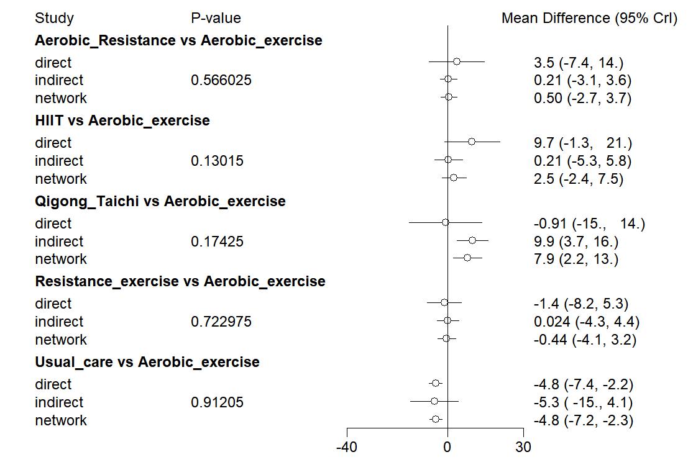
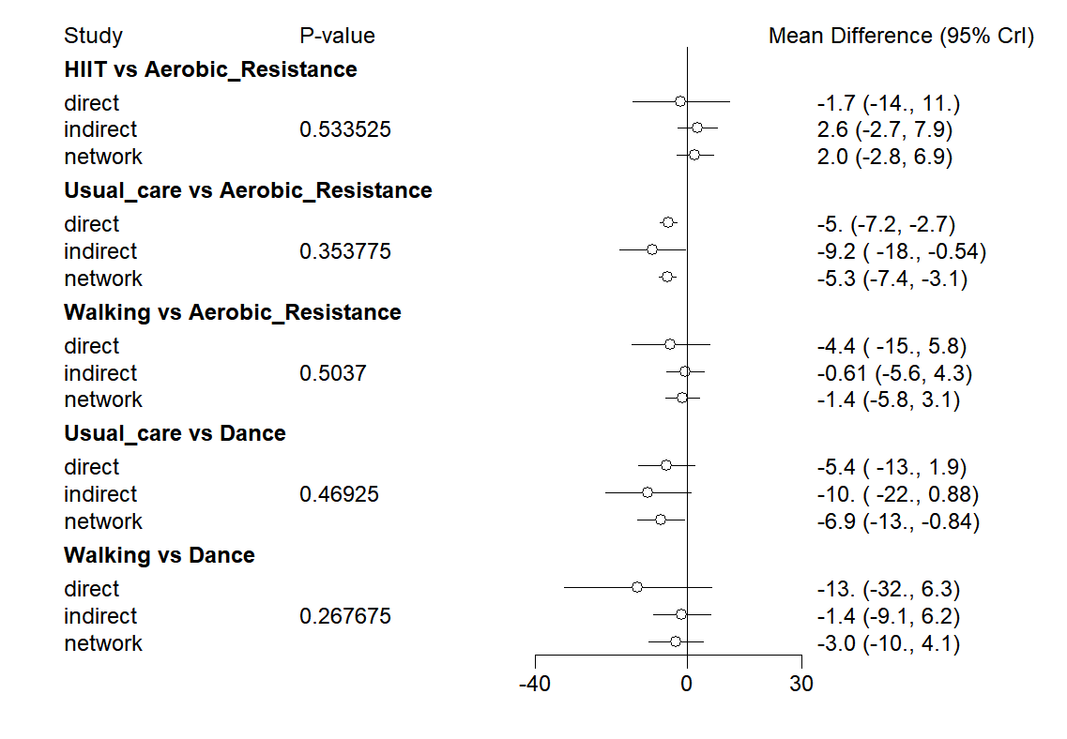
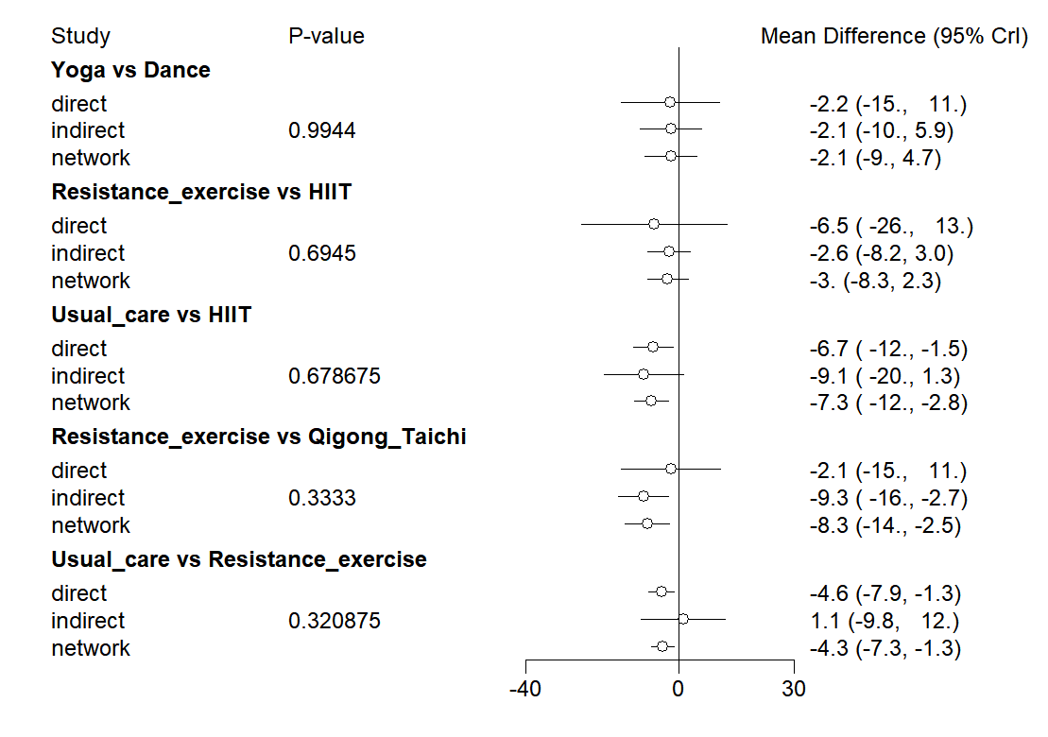
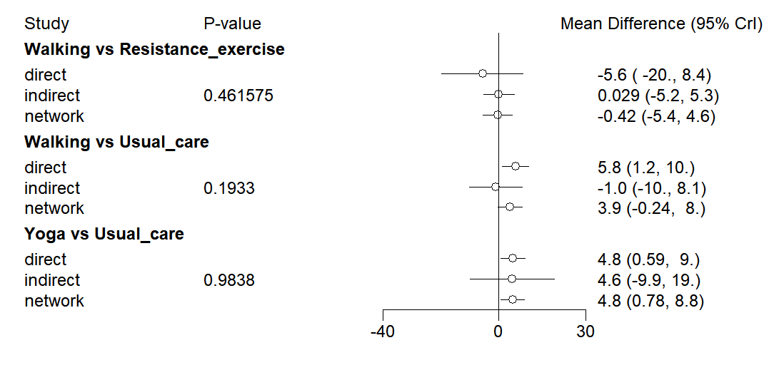

Appendix 5. Network Connectivity
Network connectivity plot of the included studies. All intervention nodes were connected within a single network, with no isolated nodes or disconnected sub-networks. This fully connected network allowed direct and indirect comparisons across all exercise modalities and dose levels.

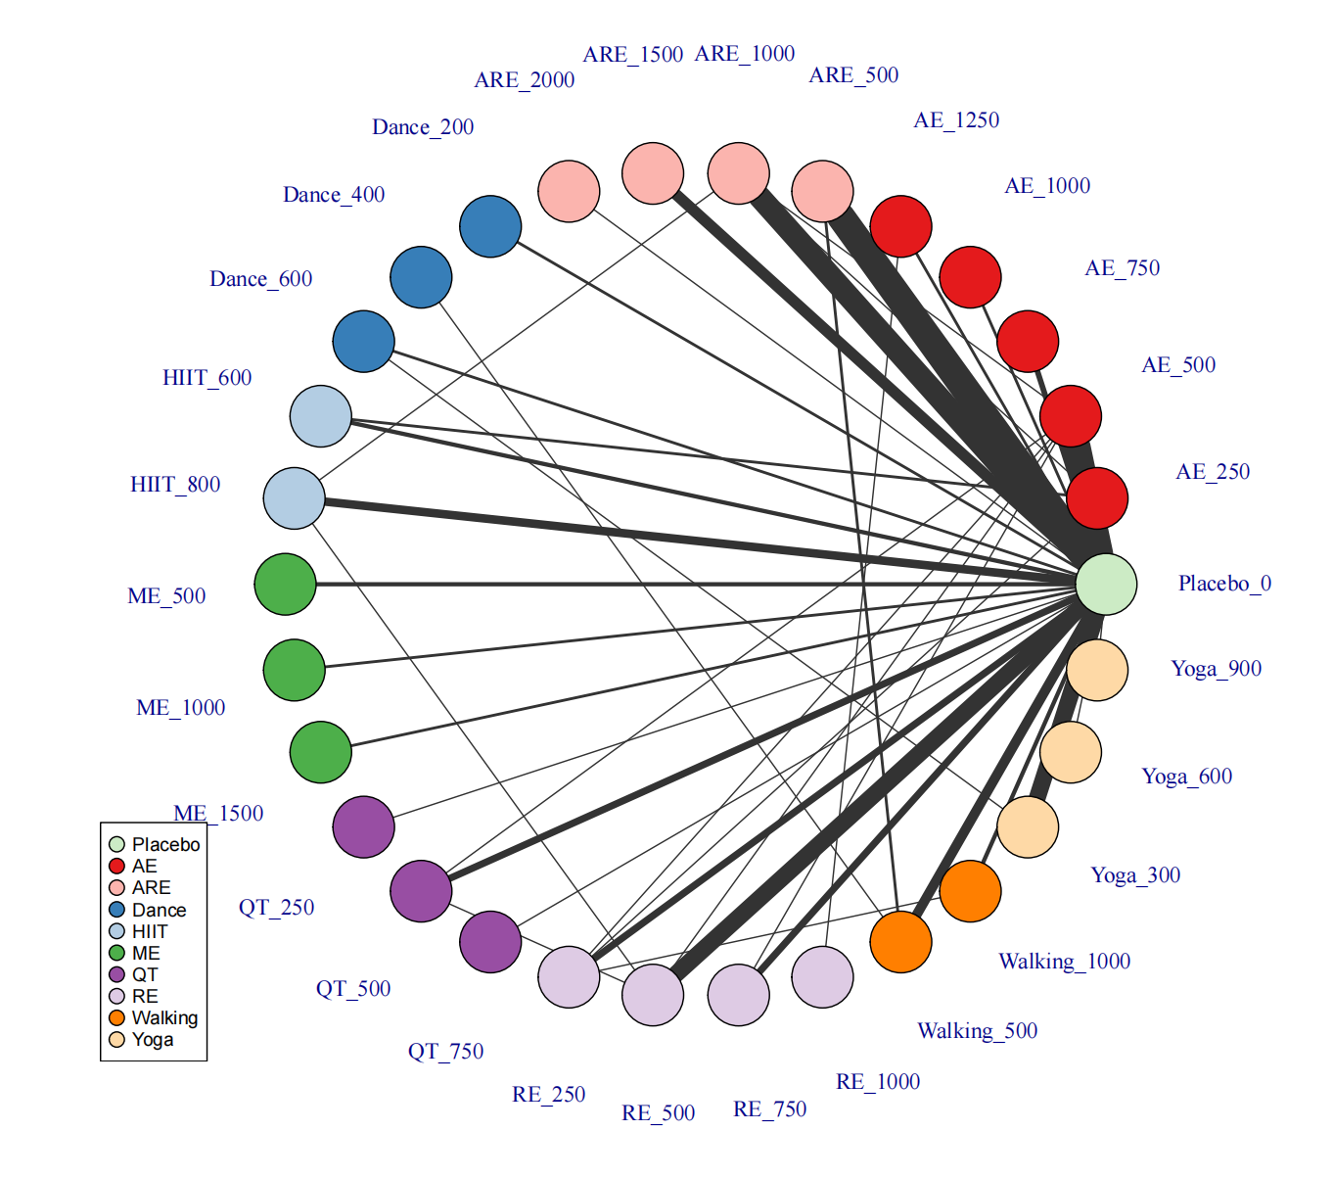
Note: Treatment-level network. The first label indicates the specific intervention and the second
one is the corresponding dose of that intervention.

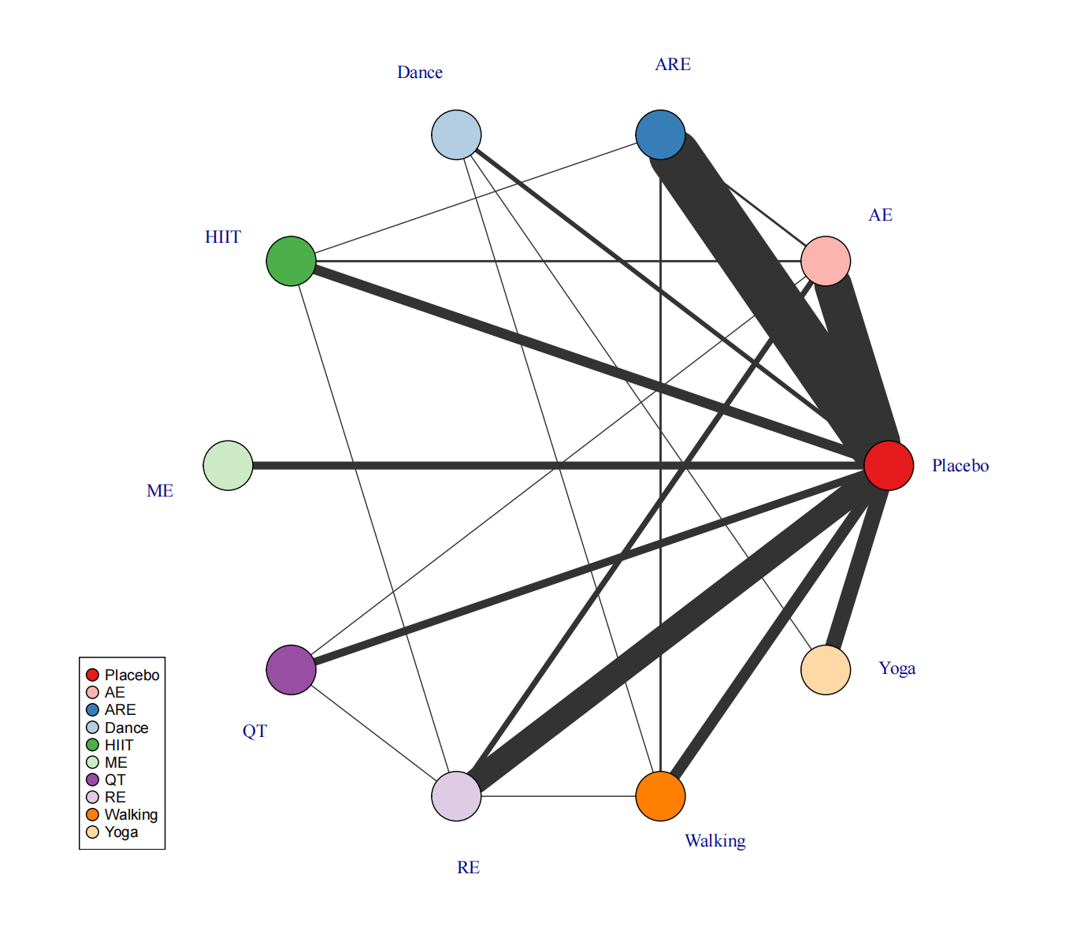
Note: Agent-level network.

Appendix 6. Consistent and UME models fit comparison

Model | pD | Residual deviance | DIC | SD
Consistent | 302.52 | 300.62 | 1724.68 | 5.49
UME | 308.22 | 300.98 | 1730.75 | 5.54

Appendix 7. Nonlinear functions and model-fit comparison

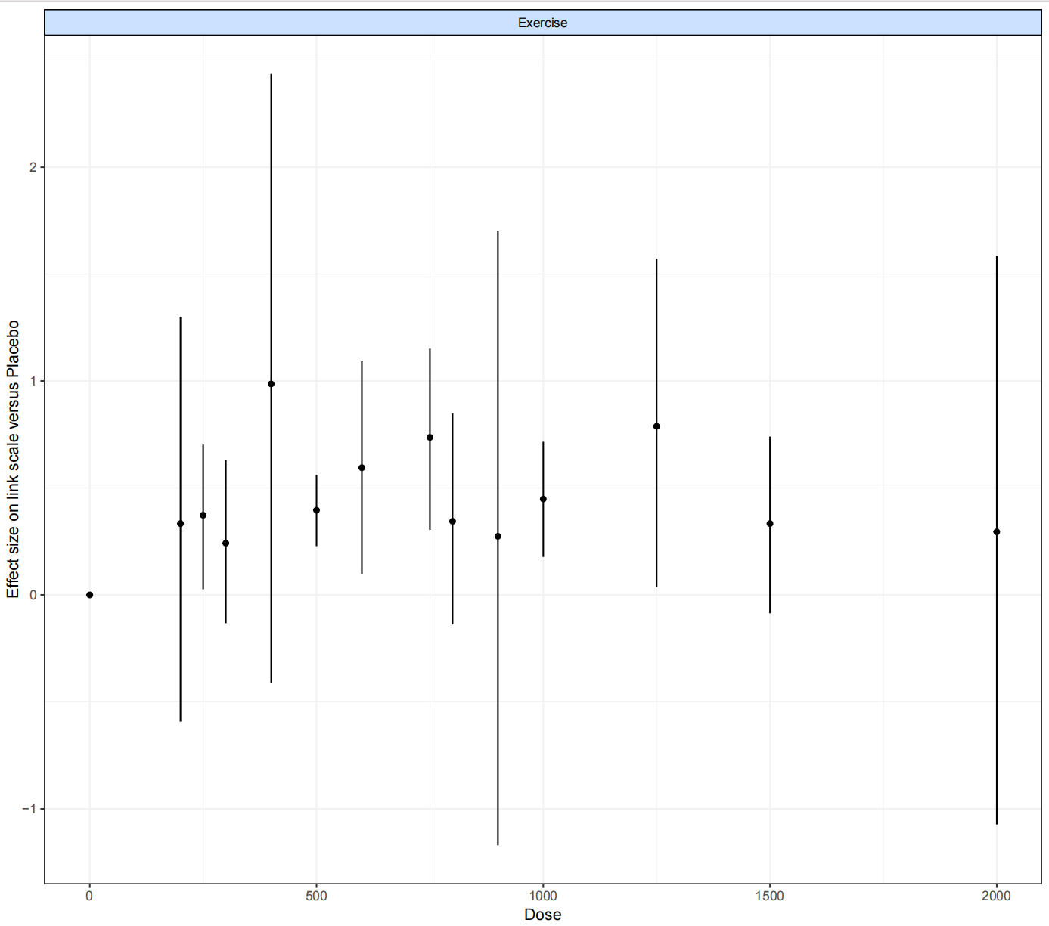
Note: "Split" NMA of overall exercise.

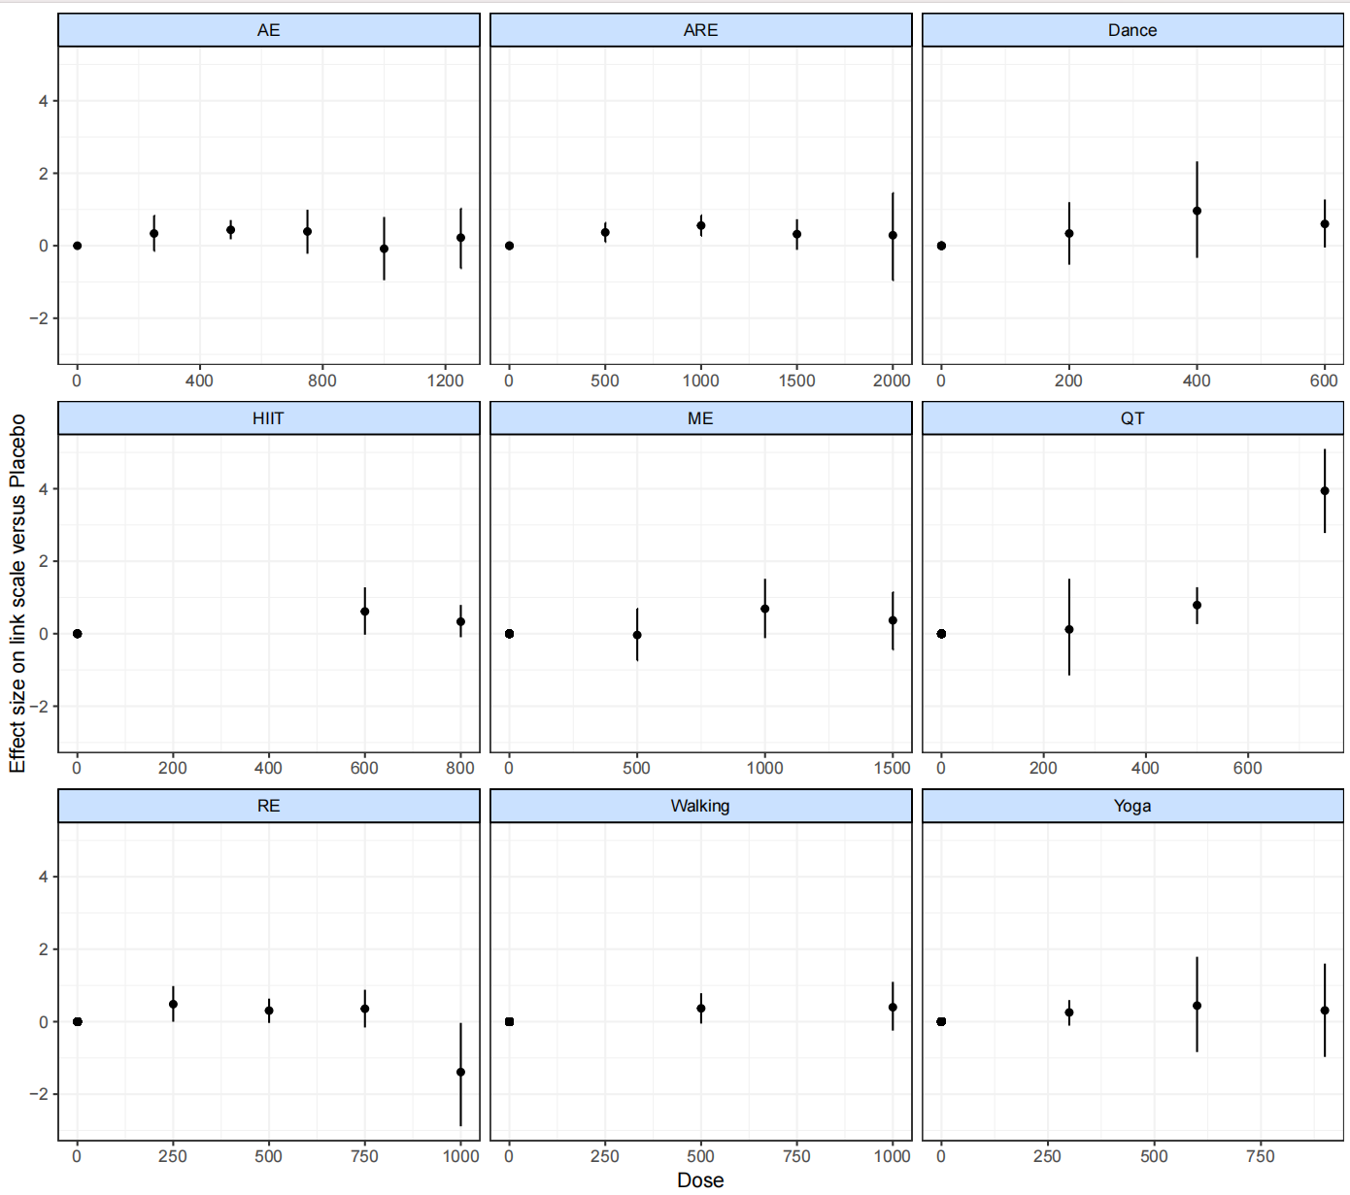
Note: Split" NMA of different exercise agents.

Appendix 8. Models fit comparison

Model | DIC | SD | Deviance | Residual deviance | pD
Emax (common treatment effects) | 2912.6 | NA | 1623.326 | 191.041 | 187.2
Restricted cubic spline (common treatment effects; 3 knots) | 2810.6 | NA | 1641.127 | 178.027 | 182.4
Restricted cubic spline (random treatment effects; 3 knots) | 1696.3 | 0.539  (0.99, 1.42) | 931.454 | 198.420 | 199.2
Non-parametric monotonically up (common treatment effects) | 2719.3 | NA | 1459.31 | 186.239 | 171.6
Quadratic (2nd degree polynomial, common treatment effects) | 995.5 | NA | 741.733 | 166.318 | 171.5
Quadratic (2nd degree polynomial, random treatment effects) | 631.8 | 0.218  (0.42, 1.36) | 684.745 | 105.998 | 87.9

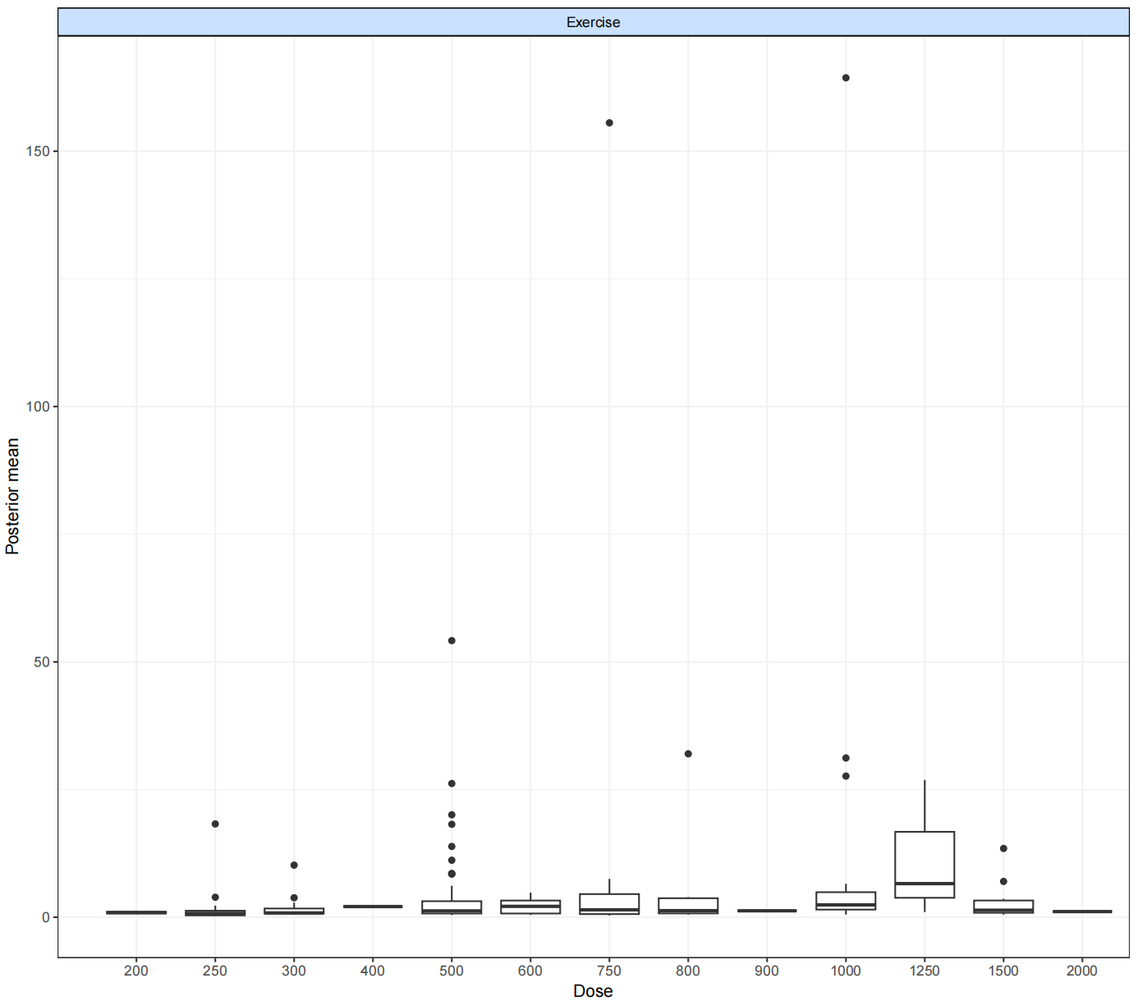
Note: Deviance plot at overall exercise.

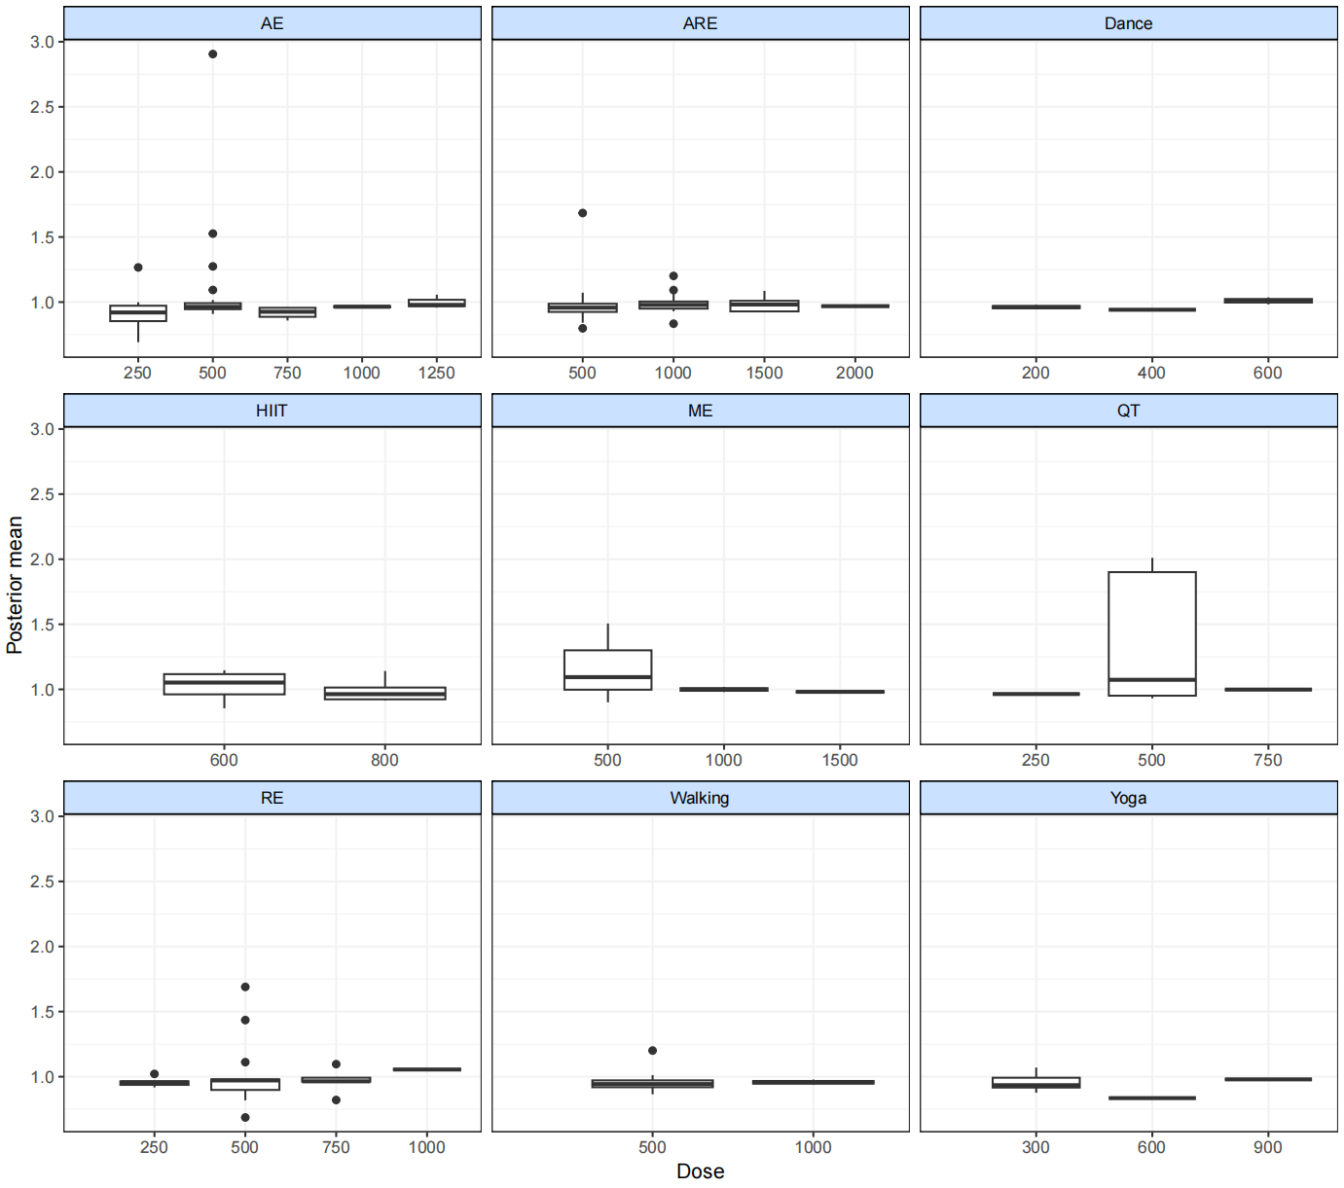
Note: Deviance plots at treatment-level.

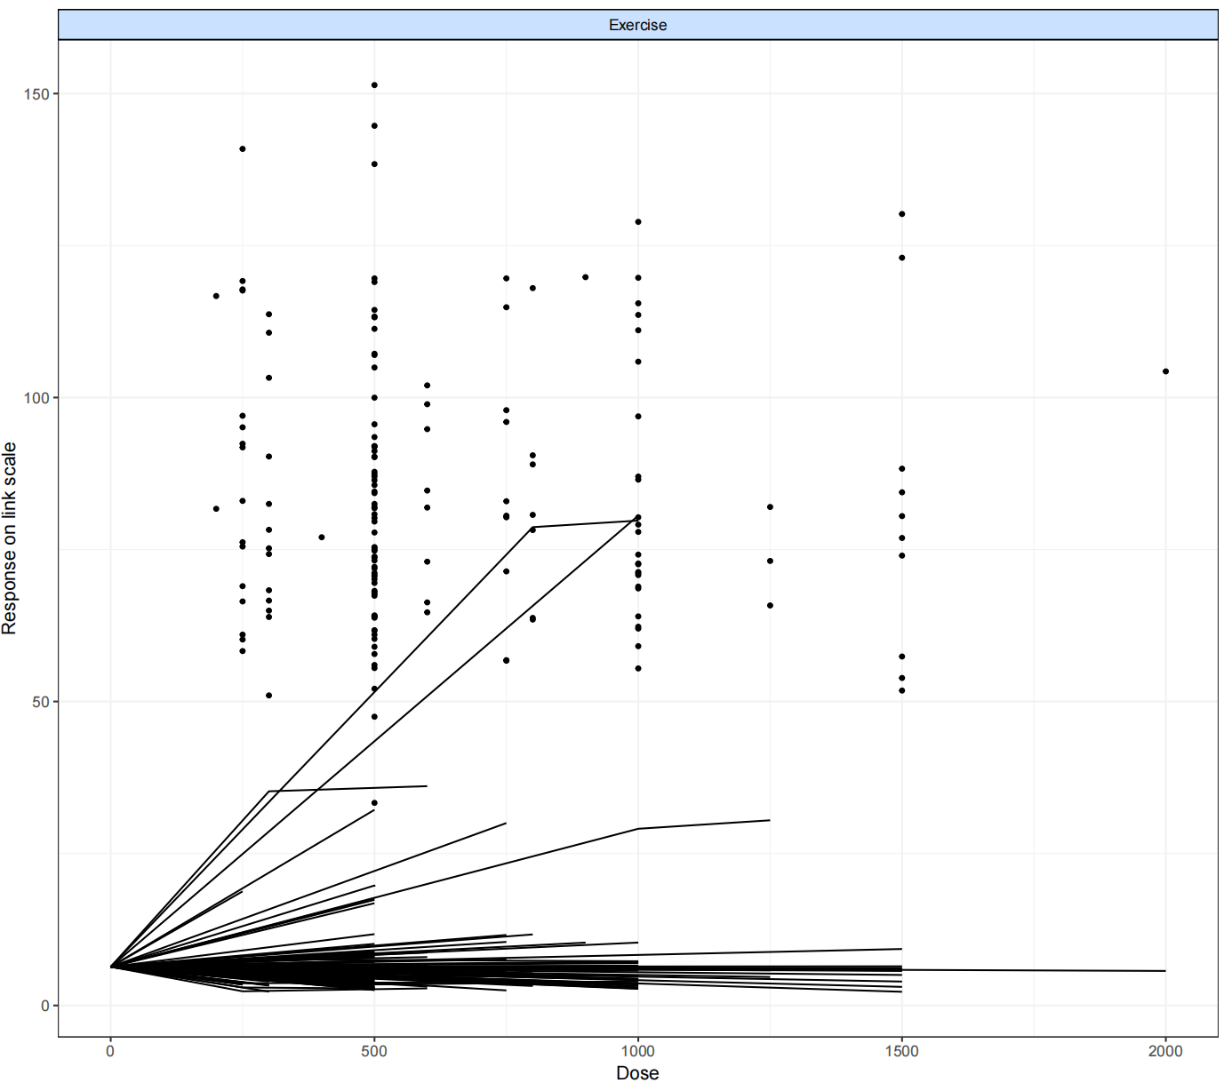
Note: Fit plots at the overall exercise level.

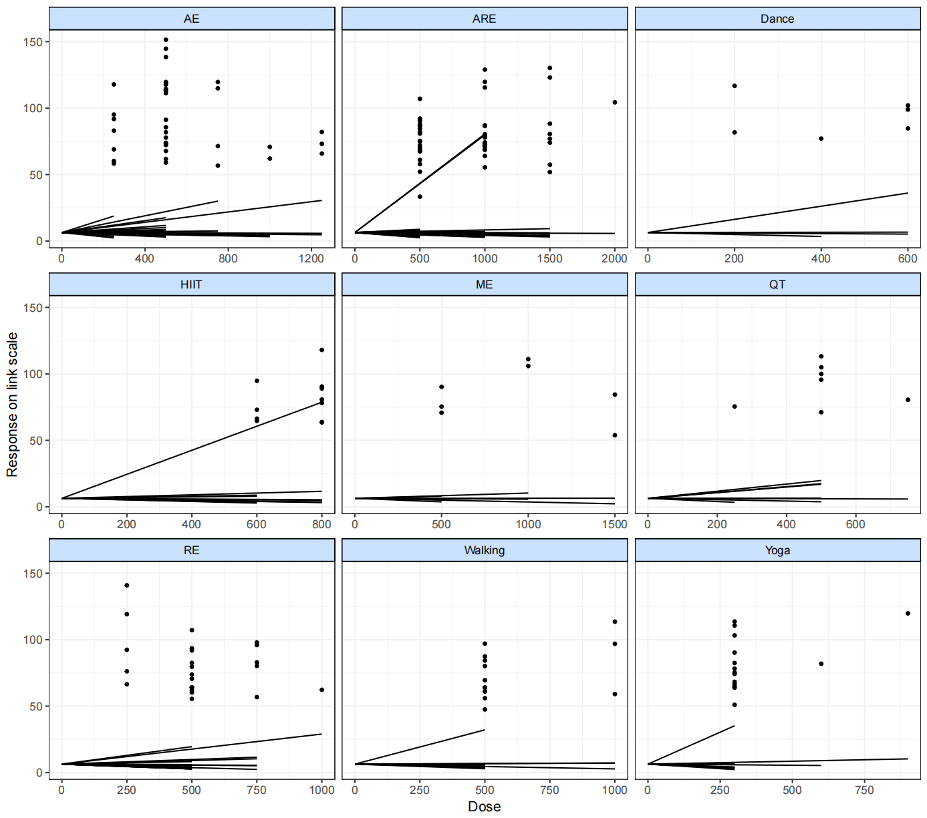
Note: Fit plots at agent-level.

Appendix 9. Network transitivity
Node-splitting analysis of consistency
Comparison | P-value | Median | 2.50% | 97.50%
AE_250 vs AE_500 | 0.778
->direct |  | 0.343 | -1.098 | 0.988
->indirect |  | 0.553 | -0.871 | 0.671
->MBNMA |  | -0.143 | -0.132 | 0.813
AE_500 vs ARE_1000 | 0.90
->direct |  | 3.006 | 2.091 | 4.001
->indirect |  | 0.157 | -0.127 | 0.145
->MBNMA |  | 0.178 | -0.321 | 0.256
AE_1250 vs RE_1000 | 0.972
->direct |  | -0.544 | -3.323 | 1.349
->indirect |  | -0.365 | -1.890 | 0.978
->MBNMA |  | -0.976 | -1.765 | 0.556
ARE_500 vs Wa_500 | 0.976
->direct |  | 0.423 | -2.098 | 1.239
->indirect |  | -0.339 | -1.520 | 2.259
->MBNMA |  | 0.091 | 0.117 | 2.198
ARE_1000 vs HIIT_800 | 0.697
->direct |  | 0.119 | -1.479 | 1.567
->indirect |  | 0.269 | -0.789 | 1.239
->MBNMA |  | 0.489 | -0.121 | 1.298
Da_600 vs Yo_300 | 0.387
->direct |  | 0.449 | -0.232 | 1.890
->indirect |  | 0.878 | 0.425 | 1.988
->MBNMA |  | 0.425 | -0.117 | 0.982
HIIT_800 vs RE_500 | 0.765
->direct |  | 0.998 | -0.239 | 1.621
->indirect |  | 0.765 | 0.214 | 1.290
->MBNMA |  | 0.879 | 0.991 | 2.051
QT_500 vsRE_500 | 0.421
->direct |  | 0.771 | 2.279 | 0.282
->indirect |  | 0.189 | 0.379 | 0.654
->MBNMA |  | 0.557 | 0.372 | 0.990
QT_750 vs RE_250 | 0.609
->direct |  | 0.228 | 0.198 | 1.108
->indirect |  | 0.576 | 0.276 | 0.798
->MBNMA |  | 0.980 | 0.259 | 0.990
RE_250 vs RE_500 | 0.608
->direct |  | 0.379 | 1.127 | 1.119
->indirect |  | 0.054 | 0.422 | 0.514
->MBNMA |  | 0.662 | 0.353 | 0.918
Wa_500 vs Da_400 | 0.422
->direct |  | 0.329 | 1.009 | 2.237
->indirect |  | -0.379 | 1.119 | 2.371
->MBNMA |  | -0.323 | 0.969 | 1.129
Yo_600 vs Yo_900 | 0.662
->direct |  | 0.229 | -1.231 | 1.941
->indirect |  | -0.239 | -1.798 | 0.879
->MBNMA |  | -0.159 | -1.216 | 0.829
Ae_500 vs Placebo_0 | 0.091
->direct |  | 2.598 | 1.198 | 2.981
->indirect |  | -0.298 | -1.798 | 0.981
->MBNMA |  | -0.167 | -1.219 | 0.871
AE_1250 vs Placebo_0 | 0.897
->direct |  | -0.523 | -2.289 | 1.269
->indirect |  | 0.057 | -1.219 | 0.887
->MBNMA |  | 0.089 | -0.025 | 0.298
ARE_1000 vs Placebo_0 | 0.567
->direct |  | -0.528 | -2.237 | 1.279
->indirect |  | -0.568 | -1.789 | 0.798
->MBNMA |  | -0.523 | -1.454 | 0.489
Da_600 vs Placebo_0 | 0.517
->direct |  | 0.623 | -1.089 | 2.347
->indirect |  | -0.227 | -1.442 | 0.897
->MBNMA |  | 0.162 | -0.924 | 0.669
HIIT_600 vs Placebo_0 | 0.514
->direct |  | -0.002 | -1.679 | 1.665
->indirect |  | 1.089 | 0.523 | 1.688
->MBNMA |  | 0.127 | -0.987 | 0.667
HIIT_800 vs Placebo_0 | 0.651
->direct |  | 0.789 | -0.231 | 1.998
->indirect |  | 0.997 | 0.354 | 1.678
->MBNMA |  | 0.998 | 0.442 | 1.276
QT_500 vs Placebo_0 | 0.789
->direct |  | 0.993 | -0.248 | 2.317
->indirect |  | 0.787 | 0.231 | 1.452
->MBNMA |  | 0.879 | 0.423 | 1.276
RE_500 vs Placebo_0 | 0.776
->direct |  | 0.624 | -0.142 | 2.198
->indirect |  | 0.092 | -0.226 | 1.678
->MBNMA |  | 0.876 | 0.098 | 1.645
RE_750 vs Placebo_0 | 0.987
->direct |  | -0.087 | -2.443 | 2.265
->indirect |  | -0.098 | -1.178 | 0.998
->MBNMA |  | 0.124 | -0.098 | 0.987
Wa_500 vs Placebo_0 | 0.567
->direct |  | -0.667 | -1.342 | 0.889
->indirect |  | 0.998 | 0.353 | 1.668
->MBNMA |  | 0.956 | 0.453 | 1.542
Yo_300 vs Placebo_0 | 0.665
->direct |  | 0.933 | -0.287 | 3.121
->indirect |  | 0.678 | -0.154 | 1.597
->MBNMA |  | 0.798 | 0.091 | 1.654

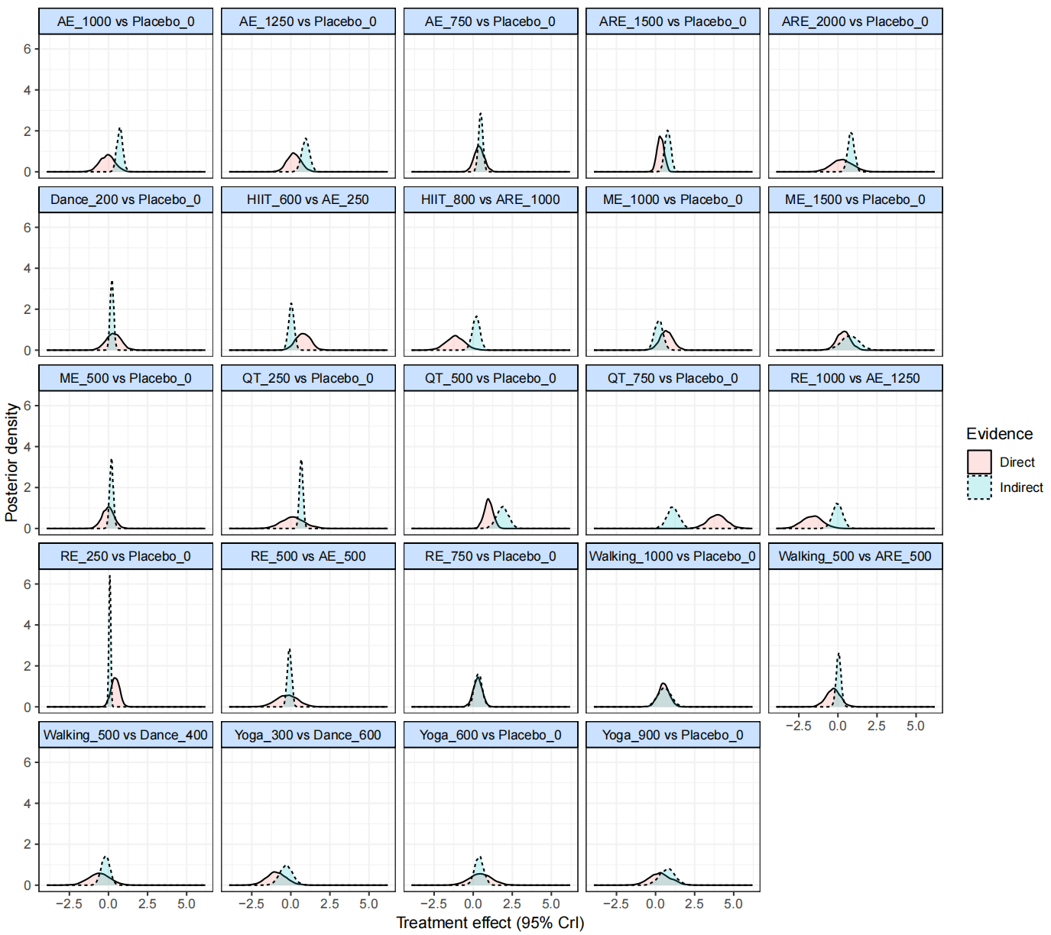
Note: Node-splitting analysis (density plot).

Appendix 10. Effectiveness ranking of different exercise modalities

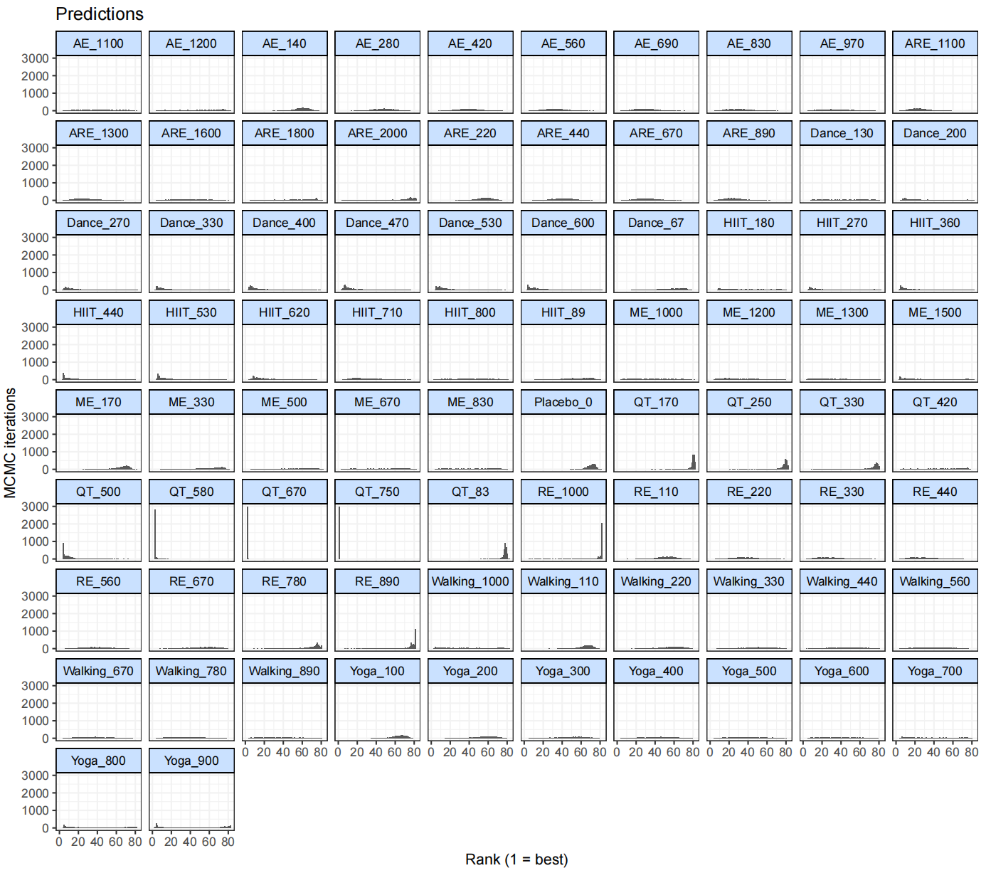
Note: Effectiveness rankings by exercise modality. The number that follows the exercise intervention indicates the dose of exercise (MET-min/week).

Predicted rankings (from best to worst)
Treatment | Mean | Median | 2.5% | 97.5%
QT_750 | 1.00 | 1 | 1.00 | 1.00
QT_670 | 2.00 | 2 | 2.00 | 2.00
QT_580 | 3.16 | 3 | 3.00 | 5.00
QT_500 | 10.07 | 7 | 4.00 | 35.00
Dance_530 | 19.04 | 14 | 5.00 | 59.00
Dance_470 | 19.06 | 13 | 5.00 | 61.00
Dance_400 | 21.20 | 13 | 4.00 | 69.00
Dance_600 | 23.03 | 16 | 4.00 | 71.00
ARE_1100 | 24.52 | 24 | 8.00 | 45.00
Dance_330 | 24.63 | 15 | 4.00 | 73.00
HIIT_530 | 24.76 | 16 | 5.00 | 72.00
ARE_890 | 25.15 | 24 | 8.00 | 46.03
HIIT_440 | 25.54 | 16 | 4.00 | 75.00
HIIT_620 | 25.89 | 20 | 7.00 | 67.00
ARE_1300 | 28.08 | 27 | 10.00 | 52.00
RE_330 | 28.47 | 27 | 8.00 | 57.00
HIIT_360 | 28.48 | 19 | 4.00 | 77.00
RE_440 | 28.81 | 28 | 8.00 | 57.00
Dance_270 | 28.87 | 20 | 5.00 | 76.00
AE_690 | 29.77 | 29 | 10.00 | 53.00
HIIT_710 | 30.19 | 27 | 8.00 | 64.00
ARE_670 | 30.62 | 30 | 12.00 | 52.03
AE_830 | 30.75 | 30 | 10.00 | 57.00
AE_560 | 32.32 | 32 | 12.00 | 55.00
HIIT_270 | 33.34 | 27 | 7.00 | 78.00
ME_1500 | 33.54 | 27 | 4.00 | 78.00
ME_1300 | 33.54 | 30 | 6.00 | 74.00
ME_1200 | 34.52 | 32 | 7.00 | 72.00
Dance_200 | 34.89 | 29 | 7.00 | 78.00
AE_970 | 34.99 | 34 | 9.00 | 67.00
Walking_780 | 35.62 | 34 | 9.00 | 68.00
RE_220 | 36.26 | 36 | 14.00 | 61.03
Walking_890 | 36.31 | 35 | 6.00 | 73.00
Walking_670 | 36.55 | 36 | 10.00 | 67.00
ME_1000 | 37.71 | 37 | 6.00 | 73.00
Walking_1000 | 38.15 | 36 | 4.00 | 78.00
RE_560 | 38.36 | 38 | 14.00 | 65.00
AE_420 | 38.57 | 38 | 17.00 | 61.00
Yoga_600 | 39.07 | 38 | 8.00 | 73.00
Walking_560 | 39.16 | 39 | 11.00 | 69.00
Yoga_700 | 39.53 | 38 | 6.00 | 77.00
ARE_1600 | 40.03 | 40 | 11.00 | 72.00
Yoga_500 | 40.34 | 41 | 10.00 | 71.00
HIIT_180 | 40.64 | 39 | 9.00 | 76.00
Yoga_800 | 41.03 | 40 | 5.00 | 80.00
AE_1100 | 41.10 | 41 | 7.98 | 74.00
ME_830 | 41.14 | 42 | 6.00 | 76.00
HIIT_800 | 41.16 | 41 | 7.00 | 75.00
ARE_440 | 41.18 | 41 | 21.00 | 61.00
Yoga_900 | 42.92 | 44 | 4.00 | 82.00
Yoga_400 | 43.48 | 45 | 13.00 | 72.00
Dance_130 | 43.49 | 44 | 11.00 | 76.00
Walking_440 | 43.79 | 44 | 13.00 | 72.00
QT_420 | 44.57 | 46 | 8.00 | 76.00
ME_670 | 45.30 | 47 | 7.98 | 78.00
AE_1200 | 46.56 | 49 | 6.00 | 79.00
AE_280 | 47.91 | 48 | 28.00 | 66.00
Yoga_300 | 48.75 | 51 | 18.00 | 73.00
Walking_330 | 49.68 | 51 | 19.00 | 73.03
ARE_1800 | 50.18 | 53 | 10.00 | 78.00
ME_500 | 50.68 | 54 | 11.00 | 79.00
RE_110 | 52.10 | 52 | 33.00 | 69.00
RE_670 | 54.14 | 56 | 23.98 | 74.03
HIIT_89 | 54.24 | 57 | 22.00 | 74.00
Yoga_200 | 55.82 | 58 | 28.00 | 75.00
ARE_220 | 56.02 | 57 | 39.00 | 70.00
Dance_67 | 56.35 | 59 | 26.00 | 75.00
Walking_220 | 56.75 | 58 | 29.00 | 75.00
ME_330 | 57.22 | 61 | 21.00 | 77.00
ARE_2000 | 58.96 | 68 | 9.00 | 82.00
AE_140 | 59.84 | 60 | 44.00 | 72.00
Yoga_100 | 63.98 | 65 | 47.00 | 75.00
Walking_110 | 64.50 | 66 | 48.00 | 75.00
ME_170 | 64.55 | 67 | 42.00 | 76.00
RE_780 | 68.54 | 73 | 36.00 | 80.00
QT_330 | 70.30 | 76 | 30.00 | 80.00
Placebo_0 | 70.54 | 71 | 60.00 | 77.00
RE_890 | 76.03 | 79 | 46.00 | 81.00
QT_250 | 77.21 | 79 | 57.00 | 82.00
QT_83 | 77.52 | 78 | 72.00 | 80.00
QT_170 | 79.39 | 80 | 70.00 | 82.00
RE_1000 | 79.55 | 82 | 57.98 | 82.00

Appendix 11. Sensitivity Analysis

11.1 Network Evidence Diagram

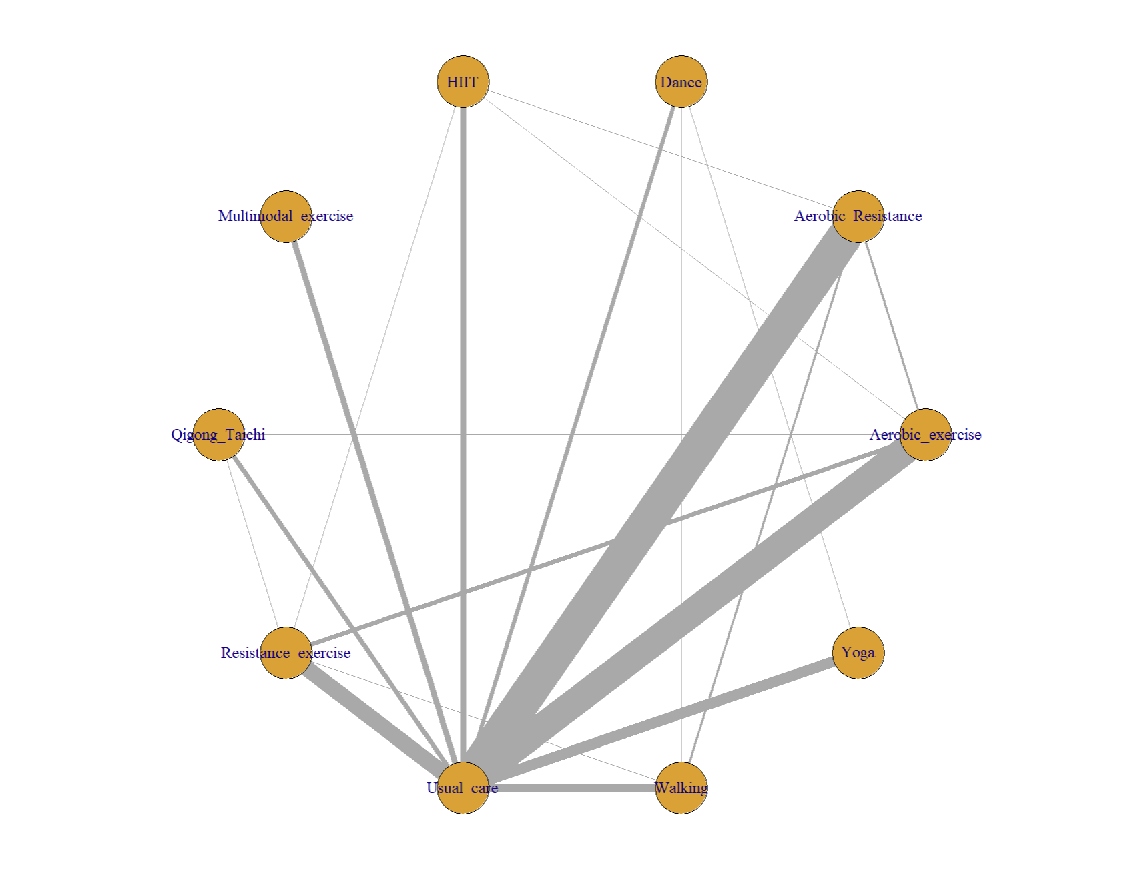

11.2 SUCRA Sensitivity Analysis
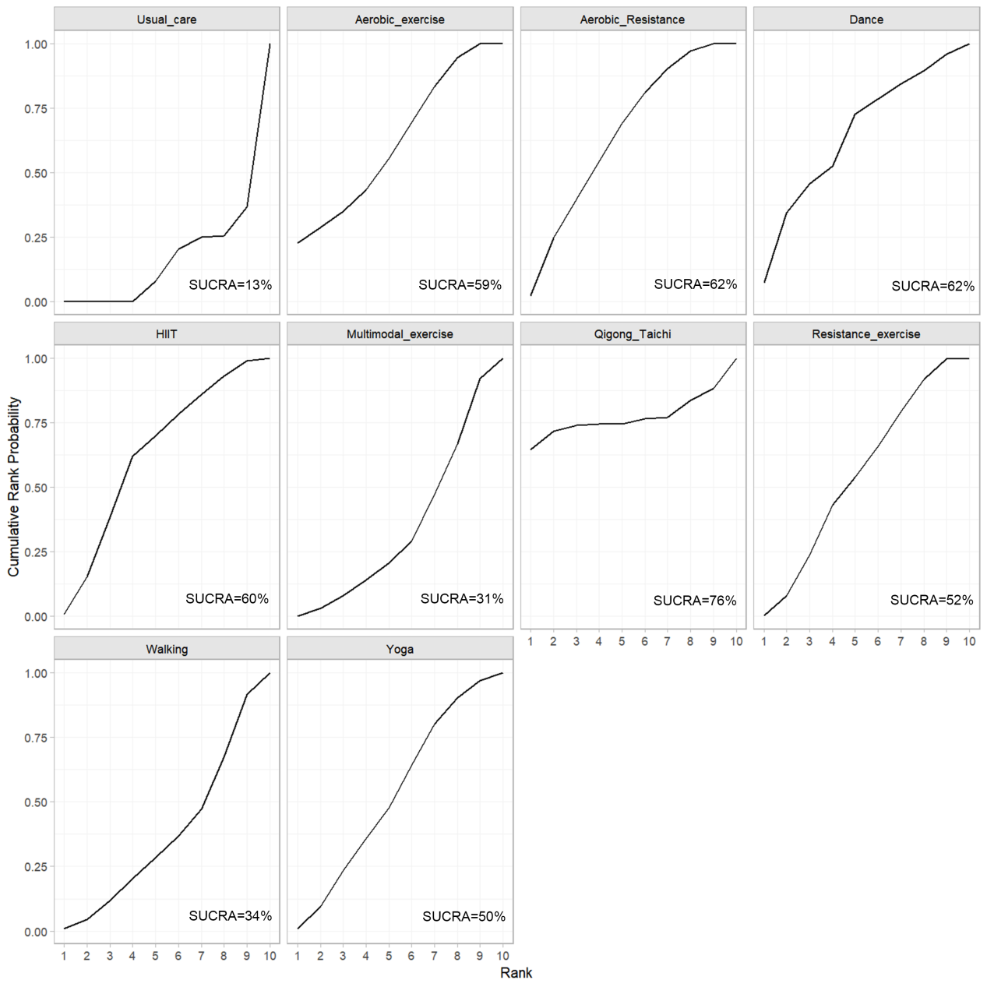

Appendix 12. Summary of findings and GRADE assessment
Comparison | Nature of the evidence | Confidence | Downgrading due to
AE vs CG | Mixed | Low | Imprecision¹; Study limitations²
ARE vs CG | Mixed | Low | Imprecision¹; Study limitations²
Da vs CG | Mixed | Low | Imprecision¹; Study limitations²
HIIT vs CG | Mixed | Very low | Imprecision¹ ;Study limitations² Indirectness³
ME vs CG | Mixed | Very low | Imprecision¹ ;Study limitations² Indirectness³
QT vs CG | Mixed | Low | Study limitations²; Indirectness³
WK vs CG | Mixed | Very low | Imprecision¹ ;Study limitations² Indirectness³
YG vs CG | Mixed | Low | Imprecision¹; Study limitations²
RE vs CG | Mixed | Low | Study limitations²; Indirectness³
AE vs ARE | Mixed | Low | Study limitations²; Indirectness³
AE vs Da | Indirect | Low | Imprecision¹; Study limitations²
AE vs HIIT | Mixed | Low | Imprecision¹; Study limitations²
AE vs ME | Indirect | Low | Imprecision¹; Study limitations²
AE vs QT | Indirect | Low | Imprecision¹; Study limitations²
AE vs WK | Indirect | Low | Imprecision¹; Study limitations²
AE vs YG | Indirect | Low | Imprecision¹; Study limitations²
AE vs RE | Mixed | Low | Imprecision¹; Study limitations²
ARE vs Da | Indirect | Low | Study limitations²; Indirectness³
ARE vs HIIT | Indirect | Low | Study limitations²; Indirectness³
ARE vs ME | Indirect | Low | Study limitations²; Indirectness³
ARE vs QT | Indirect | Low | Study limitations²; Indirectness³
ARE vs WK | Mixed | Low | Study limitations²; Indirectness³
ARE vs YG | Indirect | Low | Study limitations²; Indirectness³
ARE vs RE | Indirect | Low | Study limitations²; Indirectness³
Da vs HIIT | Indirect | Low | Study limitations²; Indirectness³
Da vs ME | Indirect | Low | Study limitations²; Indirectness³
Da vs QT | Indirect | Low | Study limitations²; Indirectness³
Da vs WK | Mixed | Low | Study limitations²; Indirectness³
Da vs YG | Mixed | Low | Study limitations²; Indirectness³
Da vs RE | Indirect | Low | Study limitations²; Indirectness³
HIIT vs ME | Indirect | Very low | Imprecision¹ ;Study limitations² Indirectness³
HIIT vs QT | Indirect | Very low | Imprecision¹ ;Study limitations² Indirectness³
HIIT vs WK | Indirect | Very low | Imprecision¹ ;Study limitations² Indirectness³
HIIT vs YG | Indirect | Very low | Imprecision¹ ;Study limitations² Indirectness³
HIIT vs RE | Mixed | Very low | Imprecision¹ ;Study limitations² Indirectness³
ME vs QT | Indirect | Very low | Imprecision¹ ;Study limitations² Indirectness³
ME vs WK | Indirect | Very low | Imprecision¹ ;Study limitations² Indirectness³
ME vs YG | Indirect | Very low | Imprecision¹ ;Study limitations² Indirectness³
ME vs RE | Indirect | Very low | Imprecision¹ ;Study limitations² Indirectness³
QT vs WK | Indirect | Low | Study limitations²; Indirectness³
QT vs YG | Indirect | Low | Study limitations²; Indirectness³
QT vs RE | Mixed | Low | Study limitations²; Indirectness³
WK vs YG | Indirect | Very low | Imprecision¹ ;Study limitations² Indirectness³
WK vs RE | Mixed | Very low | Imprecision¹ ;Study limitations² Indirectness³
YG vs RE | Indirect | Low | Study limitations²; Indirectness³
Note: Imprecision¹: A small sample size leads to an imprecise confidence interval, limitations²: Lack of blinding and inadequate allocation concealment, Indirectness³: Inconsistency in the common comparator.

Reference
1. Mustian KM, Peppone L, Darling TV, Palesh O, Heckler CE, Morrow GR. A 4-week home-based aerobic and resistance exercise program during radiation therapy: a pilot randomized clinical trial. J Support Oncol. 2009;7:158–67.
2. Alibhai SMH, O’Neill S, Fisher-Schlombs K, Breunis H, Timilshina N, Brandwein JM, et al. A pilot phase II RCT of a home-based exercise intervention for survivors of AML. Support Care Cancer. 2014;22:881–9. https://doi.org/10.1007/s00520-013-2044-8.
3. Furzer BJ, Ackland TR, Wallman KE, Petterson AS, Gordon SM, Wright KE, et al. A randomised controlled trial comparing the effects of a 12-week supervised exercise versus usual care on outcomes in haematological cancer patients. Support Care Cancer. 2016;24:1697–707. https://doi.org/10.1007/s00520-015-2955-7.
4. Owusu C, Margevicius S, Nock NL, Austin K, Bennet E, Cerne S, et al. A randomized controlled trial of the effect of supervised exercise on functional outcomes in older African American and non-Hispanic White breast cancer survivors: Are there racial differences in the effects of exercise on functional outcomes? Cancer. 2022;128:2320–38. https://doi.org/10.1002/cncr.34184.
5. Dieli-Conwright CM, Courneya KS, Demark-Wahnefried W, Sami N, Lee K, Sweeney FC, et al. Aerobic and resistance exercise improves physical fitness, bone health, and quality of life in overweight and obese breast cancer survivors: a randomized controlled trial. Breast Cancer Res. 2018;20:124. https://doi.org/10.1186/s13058-018-1051-6.
6. Galvão DA, Taaffe DR, Spry N, Joseph D, Newton RU. Combined resistance and aerobic exercise program reverses muscle loss in men undergoing androgen suppression therapy for prostate cancer without bone metastases: a randomized controlled trial. J Clin Oncol. 2010;28:340–7. https://doi.org/10.1200/JCO.2009.23.2488.
7. Neuzillet C, Bouché O, Tournigand C, Chibaudel B, Bauguion L, Bengrine-Lefevre L, et al. Effect of Adapted Physical Activity in Patients With Advanced Pancreatic Cancer: The APACaP GERCOR Randomized Trial. J Natl Compr Canc Netw. 2023;21:1234-1242.e17. https://doi.org/10.6004/jnccn.2023.7065.
8. Falz R, Bischoff C, Thieme R, Tegtbur U, Hillemanns P, Stolzenburg J-U, et al. Effect of home-based online training and activity feedback on oxygen uptake in patients after surgical cancer therapy: a randomized controlled trial. BMC Med. 2023;21:293. https://doi.org/10.1186/s12916-023-03010-6.
9. van Waart H, Stuiver MM, van Harten WH, Geleijn E, Kieffer JM, Buffart LM, et al. Effect of Low-Intensity Physical Activity and Moderate- to High-Intensity Physical Exercise During Adjuvant Chemotherapy on Physical Fitness, Fatigue, and Chemotherapy Completion Rates: Results of the PACES Randomized Clinical Trial. J Clin Oncol. 2015;33:1918–27. https://doi.org/10.1200/JCO.2014.59.1081.
10. Koevoets EW, Schagen SB, de Ruiter MB, Geerlings MI, Witlox L, van der Wall E, et al. Effect of physical exercise on cognitive function after chemotherapy in patients with breast cancer: a randomized controlled trial (PAM study). Breast Cancer Res. 2022;24:36. https://doi.org/10.1186/s13058-022-01530-2.
11. Machado P, Pimenta S, Garcia AL, Nogueira T, Silva S, Dos Santos CL, et al. Effect of Preoperative Home-Based Exercise Training on Quality of Life After Lung Cancer Surgery: A Multicenter Randomized Controlled Trial. Ann Surg Oncol. 2024;31:847–59. https://doi.org/10.1245/s10434-023-14503-2.
12. D’Silva C, Shetty V, Fernandes D, Jean-Pierre B, Kumari N S, Srivastava S, et al. Effect of Structured Exercise-based rehabilitation on Sarcopenia and Quality of life among Head and Neck Cancer Patients Undergoing Chemo-radiotherapy: A Randomized Controlled Trial. Asian Pac J Cancer Prev. 2025;26:1653–60. https://doi.org/10.31557/APJCP.2025.26.5.1653.
13. Mardani A, Pedram Razi S, Mazaheri R, Haghani S, Vaismoradi M. Effect of the exercise programme on the quality of life of prostate cancer survivors: A randomized controlled trial. Int J Nurs Pract. 2021;27:e12883. https://doi.org/10.1111/ijn.12883.
14. Saarto T, Penttinen HM, Sievänen H, Kellokumpu-Lehtinen P-L, Hakamies-Blomqvist L, Nikander R, et al. Effectiveness of a 12-month exercise program on physical performance and quality of life of breast cancer survivors. Anticancer Res. 2012;32:3875–84.
15. Casanovas-Álvarez A, Estanyol B, Ciendones M, Padròs J, Cuartero J, Barnadas A, et al. Effectiveness of an Exercise and Educational-Based Prehabilitation Program in Patients With Breast Cancer Receiving Neoadjuvant Chemotherapy (PREOptimize) on Functional Outcomes: A Randomized Controlled Trial. Phys Ther. 2024;104:pzae151. https://doi.org/10.1093/ptj/pzae151.
16. Kim JY, Lee MK, Lee DH, Kang DW, Min JH, Lee JW, et al. Effects of a 12-week home-based exercise program on quality of life, psychological health, and the level of physical activity in colorectal cancer survivors: a randomized controlled trial. Support Care Cancer. 2019;27:2933–40. https://doi.org/10.1007/s00520-018-4588-0.
17. Soriano-Maldonado A, Díez-Fernández DM, Esteban-Simón A, Rodríguez-Pérez MA, Artés-Rodríguez E, Casimiro-Artés MA, et al. Effects of a 12-week supervised resistance training program, combined with home-based physical activity, on physical fitness and quality of life in female breast cancer survivors: the EFICAN randomized controlled trial. J Cancer Surviv. 2023;17:1371–85. https://doi.org/10.1007/s11764-022-01192-1.
18. Milne HM, Wallman KE, Gordon S, Courneya KS. Effects of a combined aerobic and resistance exercise program in breast cancer survivors: a randomized controlled trial. Breast Cancer Res Treat. 2008;108:279–88. https://doi.org/10.1007/s10549-007-9602-z.
19. Kenkhuis M-F, Stelten S, Hartman YA, Brouwer CG, Ten Tusscher MR, van Lonkhuijzen LR, et al. Effects of a combined exercise and dietary intervention on body composition, physical functioning and fatigue in patients with ovarian cancer: results of the PADOVA trial. Br J Cancer. 2024;131:101–9. https://doi.org/10.1038/s41416-024-02694-8.
20. Porserud A, Karlsson P, Aly M, Rydwik E, Torikka S, Henningsohn L, et al. Effects of an exercise intervention in primary care after robot-assisted radical cystectomy for urinary bladder cancer: a randomised controlled trial. BMC Cancer. 2024;24:891. https://doi.org/10.1186/s12885-024-12647-2.
21. De Luca V, Minganti C, Borrione P, Grazioli E, Cerulli C, Guerra E, et al. Effects of concurrent aerobic and strength training on breast cancer survivors: a pilot study. Public Health. 2016;136:126–32. https://doi.org/10.1016/j.puhe.2016.03.028.
22. An K-Y, Morielli AR, Kang D-W, Friedenreich CM, McKenzie DC, Gelmon K, et al. Effects of exercise dose and type during breast cancer chemotherapy on longer-term patient-reported outcomes and health-related fitness: A randomized controlled trial. Int J Cancer. 2020;146:150–60. https://doi.org/10.1002/ijc.32493.
23. Uhm KE, Yoo JS, Chung SH, Lee JD, Lee I, Kim JI, et al. Effects of exercise intervention in breast cancer patients: is mobile health (mHealth) with pedometer more effective than conventional program using brochure? Breast Cancer Res Treat. 2017;161:443–52. https://doi.org/10.1007/s10549-016-4065-8.
24. Morey MC, Snyder DC, Sloane R, Cohen HJ, Peterson B, Hartman TJ, et al. Effects of home-based diet and exercise on functional outcomes among older, overweight long-term cancer survivors: RENEW: a randomized controlled trial. JAMA. 2009;301:1883–91. https://doi.org/10.1001/jama.2009.643.
25. Cornette T, Vincent F, Mandigout S, Antonini MT, Leobon S, Labrunie A, et al. Effects of home-based exercise training on VO2 in breast cancer patients under adjuvant or neoadjuvant chemotherapy (SAPA): a randomized controlled trial. Eur J Phys Rehabil Med. 2016;52:223–32.
26. Midtgaard J, Christensen JF, Tolver A, Jones LW, Uth J, Rasmussen B, et al. Efficacy of multimodal exercise-based rehabilitation on physical activity, cardiorespiratory fitness, and patient-reported outcomes in cancer survivors: a randomized, controlled trial. Ann Oncol. 2013;24:2267–73. https://doi.org/10.1093/annonc/mdt185.
27. Baglia ML, Lin I-H, Cartmel B, Sanft T, Ligibel J, Hershman DL, et al. Endocrine-related quality of life in a randomized trial of exercise on aromatase inhibitor-induced arthralgias in breast cancer survivors. Cancer. 2019;125:2262–71. https://doi.org/10.1002/cncr.32051.
28. Arbane G, Tropman D, Jackson D, Garrod R. Evaluation of an early exercise intervention after thoracotomy for non-small cell lung cancer (NSCLC), effects on quality of life, muscle strength and exercise tolerance: randomised controlled trial. Lung Cancer. 2011;71:229–34. https://doi.org/10.1016/j.lungcan.2010.04.025.
29. Hayes SC, Rye S, Disipio T, Yates P, Bashford J, Pyke C, et al. Exercise for health: a randomized, controlled trial evaluating the impact of a pragmatic, translational exercise intervention on the quality of life, function and treatment-related side effects following breast cancer. Breast Cancer Res Treat. 2013;137:175–86. https://doi.org/10.1007/s10549-012-2331-y.
30. McCourt O, Fisher A, Ramdharry G, Land J, Roberts AL, Rabin N, et al. Exercise prehabilitation for people with myeloma undergoing autologous stem cell transplantation: results from PERCEPT pilot randomised controlled trial. Acta Oncol. 2023;62:696–705. https://doi.org/10.1080/0284186X.2023.2178326.
31. Antunes P, Joaquim A, Sampaio F, Nunes C, Ascensão A, Vilela E, et al. Exercise Training Benefits Health-Related Quality of Life and Functional Capacity during Breast Cancer Chemotherapy: A Randomized Controlled Trial. Med Sci Sports Exerc. 2024;56:600–11. https://doi.org/10.1249/MSS.0000000000003341.
32. Ndjavera W, Orange ST, O’Doherty AF, Leicht AS, Rochester M, Mills R, et al. Exercise-induced attenuation of treatment side-effects in patients with newly diagnosed prostate cancer beginning androgen-deprivation therapy: a randomised controlled trial. BJU Int. 2020;125:28–37. https://doi.org/10.1111/bju.14922.
33. Rossi A, Garber CE, Ortiz M, Shankar V, Goldberg GL, Nevadunsky NS. Feasibility of a physical activity intervention for obese, socioculturally diverse endometrial cancer survivors. Gynecol Oncol. 2016;142:304–10. https://doi.org/10.1016/j.ygyno.2016.05.034.
34. Edvardsen E, Skjønsberg OH, Holme I, Nordsletten L, Borchsenius F, Anderssen SA. High-intensity training following lung cancer surgery: a randomised controlled trial. Thorax. 2015;70:244–50. https://doi.org/10.1136/thoraxjnl-2014-205944.
35. Vincent F, Deluche E, Bonis J, Leobon S, Antonini M-T, Laval C, et al. Home-Based Physical Activity in Patients With Breast Cancer: During and/or After Chemotherapy? Impact on Cardiorespiratory Fitness. A 3-Arm Randomized Controlled Trial (APAC). Integr Cancer Ther. 2020;19:1534735420969818. https://doi.org/10.1177/1534735420969818.
36. Touraine C, Jacot W, Gourgou S, Carayol M, Senesse P, Ninot G, et al. Impact of adapted physical activity and diet counselling on health-related quality of life in women undergoing adjuvant breast cancer therapy. Sci Rep. 2025;15:8215. https://doi.org/10.1038/s41598-025-91569-w.
37. Hojan K, Kwiatkowska-Borowczyk E, Leporowska E, Milecki P. Inflammation, cardiometabolic markers, and functional changes in men with prostate cancer. A randomized controlled trial of a 12‑month exercise program. Pol Arch Intern Med. 2017;127:25–35. https://doi.org/10.20452/pamw.3888.
38. Landry S, Chasles G, Pointreau Y, Bourgeois H, Boyas S. Influence of an Adapted Physical Activity Program on Self-Esteem and Quality of Life of Breast Cancer Patients after Mastectomy. Oncology. 2018;95:188–91. https://doi.org/10.1159/000489265.
39. Buffart LM, Ros WJG, Chinapaw MJM, Brug J, Knol DL, Korstjens I, et al. Mediators of physical exercise for improvement in cancer survivors’ quality of life. Psychooncology. 2014;23:330–8. https://doi.org/10.1002/pon.3428.
40. Haines TP, Sinnamon P, Wetzig NG, Lehman M, Walpole E, Pratt T, et al. Multimodal exercise improves quality of life of women being treated for breast cancer, but at what cost? Randomized trial with economic evaluation. Breast Cancer Res Treat. 2010;124:163–75. https://doi.org/10.1007/s10549-010-1126-2.
41. Mendizabal-Gallastegui N, Arietaleanizbeaskoa MS, Latorre PM, García-Álvarez A, Sancho A, Iruarrizaga E, et al. Nurse-Supervised Exercise for People with Stage IV Cancer: The EFICANCER Randomized Clinical Trial. Semin Oncol Nurs. 2023;39:151448. https://doi.org/10.1016/j.soncn.2023.151448.
42. Hojan K, Kwiatkowska-Borowczyk E, Leporowska E, Górecki M, Ozga-Majchrzak O, Milecki T, et al. Physical exercise for functional capacity, blood immune function, fatigue, and quality of life in high-risk prostate cancer patients during radiotherapy: a prospective, randomized clinical study. Eur J Phys Rehabil Med. 2016;52:489–501.
43. Kampshoff CS, Chinapaw MJM, Brug J, Twisk JWR, Schep G, Nijziel MR, et al. Randomized controlled trial of the effects of high intensity and low-to-moderate intensity exercise on physical fitness and fatigue in cancer survivors: results of the Resistance and Endurance exercise After ChemoTherapy (REACT) study. BMC Med. 2015;13:275. https://doi.org/10.1186/s12916-015-0513-2.
44. Henke CC, Cabri J, Fricke L, Pankow W, Kandilakis G, Feyer PC, et al. Strength and endurance training in the treatment of lung cancer patients in stages IIIA/IIIB/IV. Support Care Cancer. 2014;22:95–101. https://doi.org/10.1007/s00520-013-1925-1.
45. Bloch Z, Jensen S, Sørensen V, Langer SW, Quist M. The Effect of Exercise on Quality of Life in Patients With Advanced Lung Cancer: A Secondary Analysis of a Randomized Controlled Trial. Clin Lung Cancer. 2025;26:e582–90. https://doi.org/10.1016/j.cllc.2025.07.005.
46. Buffart LM, Newton RU, Chinapaw MJ, Taaffe DR, Spry NA, Denham JW, et al. The effect, moderators, and mediators of resistance and aerobic exercise on health-related quality of life in older long-term survivors of prostate cancer. Cancer. 2015;121:2821–30. https://doi.org/10.1002/cncr.29406.
47. Paulo TRS, Rossi FE, Viezel J, Tosello GT, Seidinger SC, Simões RR, et al. The impact of an exercise program on quality of life in older breast cancer survivors undergoing aromatase inhibitor therapy: a randomized controlled trial. Health Qual Life Outcomes. 2019;17:17. https://doi.org/10.1186/s12955-019-1090-4.
48. Buchan J, Janda M, Box R, Schmitz K, Hayes S. A Randomized Trial on the Effect of Exercise Mode on Breast Cancer-Related Lymphedema. Med Sci Sports Exerc. 2016;48:1866–74. https://doi.org/10.1249/MSS.0000000000000988.
49. Schmidt T, Weisser B, Dürkop J, Jonat W, Van Mackelenbergh M, Röcken C, et al. Comparing Endurance and Resistance Training with Standard Care during Chemotherapy for Patients with Primary Breast Cancer. Anticancer Res. 2015;35:5623–9.
50. Livingston PM, Craike MJ, Salmon J, Courneya KS, Gaskin CJ, Fraser SF, et al. Effects of a clinician referral and exercise program for men who have completed active treatment for prostate cancer: A multicenter cluster randomized controlled trial (ENGAGE). Cancer. 2015;121:2646–54. https://doi.org/10.1002/cncr.29385.
51. Courneya KS, Segal RJ, Mackey JR, Gelmon K, Reid RD, Friedenreich CM, et al. Effects of aerobic and resistance exercise in breast cancer patients receiving adjuvant chemotherapy: a multicenter randomized controlled trial. J Clin Oncol. 2007;25:4396–404. https://doi.org/10.1200/JCO.2006.08.2024.
52. Sun J, Ge L, Cao C, Yao W, Wang X. Effects of resistance exercise in elderly cancer patients. Afr Health Sci. 2023;23:298–304. https://doi.org/10.4314/ahs.v23i2.34.
53. Hu Q, Zhao D. Effects of resistance exercise on complications, cancer-related fatigue and quality of life in nasopharyngeal carcinoma patients undergoing chemoradiotherapy: A randomised controlled trial. Eur J Cancer Care (Engl). 2021;30:e13355. https://doi.org/10.1111/ecc.13355.
54. Schmidt ME, Wiskemann J, Armbrust P, Schneeweiss A, Ulrich CM, Steindorf K. Effects of resistance exercise on fatigue and quality of life in breast cancer patients undergoing adjuvant chemotherapy: A randomized controlled trial. Int J Cancer. 2015;137:471–80. https://doi.org/10.1002/ijc.29383.
55. Hong Y, Wu C, Wu B. Effects of Resistance Exercise on Symptoms, Physical Function, and Quality of Life in Gastrointestinal Cancer Patients Undergoing Chemotherapy. Integr Cancer Ther. 2020;19:1534735420954912. https://doi.org/10.1177/1534735420954912.
56. Nilsen TS, Raastad T, Skovlund E, Courneya KS, Langberg CW, Lilleby W, et al. Effects of strength training on body composition, physical functioning, and quality of life in prostate cancer patients during androgen deprivation therapy. Acta Oncol. 2015;54:1805–13. https://doi.org/10.3109/0284186X.2015.1037008.
57. De Lazzari N, Götte M, Kasper S, Meier E, Schuler M, Pogorzelski M, et al. P-move: a randomized control trial of exercise in patients with advanced pancreatic or biliary tract cancer (aPBC) receiving beyond first-line chemotherapy. Support Care Cancer. 2024;32:437. https://doi.org/10.1007/s00520-024-08650-9.
58. Rogers LQ, Anton PM, Fogleman A, Hopkins-Price P, Verhulst S, Rao K, et al. Pilot, randomized trial of resistance exercise during radiation therapy for head and neck cancer. Head Neck. 2013;35:1178–88. https://doi.org/10.1002/hed.23118.
59. Steindorf K, Clauss D, Tjaden C, Hackert T, Herbolsheimer F, Bruckner T, et al. Quality of Life, Fatigue, and Sleep Problems in Pancreatic Cancer Patients—A Randomized Trial on the Effects of Exercise. Dtsch Arztebl Int. 2019;116:471–8. https://doi.org/10.3238/arztebl.2019.0471.
60. Segal RJ, Reid RD, Courneya KS, Sigal RJ, Kenny GP, Prud’Homme DG, et al. Randomized controlled trial of resistance or aerobic exercise in men receiving radiation therapy for prostate cancer. J Clin Oncol. 2009;27:344–51. https://doi.org/10.1200/JCO.2007.15.4963.
61. Steindorf K, Schmidt ME, Klassen O, Ulrich CM, Oelmann J, Habermann N, et al. Randomized, controlled trial of resistance training in breast cancer patients receiving adjuvant radiotherapy: results on cancer-related fatigue and quality of life. Ann Oncol. 2014;25:2237–43. https://doi.org/10.1093/annonc/mdu374.
62. Christensen JF, Tolver A, Andersen JL, Rørth M, Daugaard G, Hojman P. Resistance training does not protect against increases in plasma cytokine levels among germ cell cancer patients during and after chemotherapy. J Clin Endocrinol Metab. 2014;99:2967–76. https://doi.org/10.1210/jc.2013-4495.
63. Hagstrom AD, Marshall PWM, Lonsdale C, Cheema BS, Fiatarone Singh MA, Green S. Resistance training improves fatigue and quality of life in previously sedentary breast cancer survivors: a randomised controlled trial. Eur J Cancer Care (Engl). 2016;25:784–94. https://doi.org/10.1111/ecc.12422.
64. Ashton RE, Aning JJ, Tew GA, Robson WA, Saxton JM. Supported progressive resistance exercise training to counter the adverse side effects of robot-assisted radical prostatectomy: a randomised controlled trial. Support Care Cancer. 2021;29:4595–605. https://doi.org/10.1007/s00520-021-06002-5.
65. Kocamaz D, Fidancioğlu NA, Yilmaz RC, Ünal K, Düger T, Bircan HY, et al. The effect of low-intensity resistance exercise training on Serum tumor biomarkers and quality of life in women with breast cancer: A randomized controlled trial. Cancer Biomark. 2025;42:18758592251329201. https://doi.org/10.1177/18758592251329201.
66. Park J-H, Lee J, Oh M, Park H, Chae J, Kim D-I, et al. The effect of oncologists’ exercise recommendations on the level of exercise and quality of life in survivors of breast and colorectal cancer: A randomized controlled trial. Cancer. 2015;121:2740–8. https://doi.org/10.1002/cncr.29400.
67. Cešeiko R, Eglītis J, Srebnijs A, Timofejevs M, Purmalis E, Erts R, et al. The impact of maximal strength training on quality of life among women with breast cancer undergoing treatment. Exp Oncol. 2019;41:166–72. https://doi.org/10.32471/exp-oncology.2312-8852.vol-41-no-2.13249.
68. Chuang T-Y, Yeh M-L, Chung Y-C. A nurse facilitated mind-body interactive exercise (Chan-Chuang qigong) improves the health status of non-Hodgkin lymphoma patients receiving chemotherapy: Randomised controlled trial. Int J Nurs Stud. 2017;69:25–33. https://doi.org/10.1016/j.ijnurstu.2017.01.004.
69. Cheung DST, Chau PH, Lam T-C, Ng AYM, Kwok TWH, Takemura N, et al. A pilot randomized controlled trial using Baduanjin qigong to reverse frailty status among post-treatment older cancer survivors. J Geriatr Oncol. 2022;13:682–90. https://doi.org/10.1016/j.jgo.2022.02.014.
70. Cheng D, Wang X, Hu J, Dai L-L, Lv Y, Feng H, et al. Effect of Tai Chi and Resistance Training on Cancer-Related Fatigue and Quality of Life in Middle-Aged and Elderly Cancer Patients. Chin J Integr Med. 2021;27:265–72. https://doi.org/10.1007/s11655-021-3278-9.
71. Wen L, Chen X, Cui Y, Zhang M, Bai X. Effects of Baduanjin exercise in nasopharyngeal carcinoma patients after chemoradiotherapy: a randomized controlled trial. Support Care Cancer. 2022;31:79. https://doi.org/10.1007/s00520-022-07548-8.
72. Wei X, Yuan R, Yang J, Zheng W, Jin Y, Wang M, et al. Effects of Baduanjin exercise on cognitive function and cancer-related symptoms in women with breast cancer receiving chemotherapy: a randomized controlled trial. Support Care Cancer. 2022;30:6079–91. https://doi.org/10.1007/s00520-022-07015-4.
73. Sprod LK, Janelsins MC, Palesh OG, Carroll JK, Heckler CE, Peppone LJ, et al. Health-related quality of life and biomarkers in breast cancer survivors participating in tai chi chuan. J Cancer Surviv. 2012;6:146–54. https://doi.org/10.1007/s11764-011-0205-7.
74. Santa Mina D, Alibhai S MH, Matthew AG, Guglietti CL, Pirbaglou M, Trachtenberg J, et al. A randomized trial of aerobic versus resistance exercise in prostate cancer survivors. J Aging Phys Act. 2013;21:455–78. https://doi.org/10.1123/japa.21.4.455.
75. Courneya KS, Friedenreich CM, Quinney HA, Fields ALA, Jones LW, Fairey AS. A randomized trial of exercise and quality of life in colorectal cancer survivors. Eur J Cancer Care (Engl). 2003;12:347–57. https://doi.org/10.1046/j.1365-2354.2003.00437.x.
76. Adams-Campbell LL, Hicks J, Makambi K, Randolph-Jackson P, Mills M, Isaacs C, et al. An 8-week exercise study to improve cancer treatment related fatigue and QOL among African American breast cancer patients undergoing radiation treatment: A pilot randomized clinical trial. J Natl Med Assoc. 2023;115:199–206. https://doi.org/10.1016/j.jnma.2023.01.011.
77. Messaggi-Sartor M, Marco E, Martínez-Téllez E, Rodriguez-Fuster A, Palomares C, Chiarella S, et al. Combined aerobic exercise and high-intensity respiratory muscle training in patients surgically treated for non-small cell lung cancer: a pilot randomized clinical trial. Eur J Phys Rehabil Med. 2019;55:113–22. https://doi.org/10.23736/S1973-9087.18.05156-0.
78. Dimeo FC, Thomas F, Raabe-Menssen C, Pröpper F, Mathias M. Effect of aerobic exercise and relaxation training on fatigue and physical performance of cancer patients after surgery. A randomised controlled trial. Support Care Cancer. 2004;12:774–9. https://doi.org/10.1007/s00520-004-0676-4.
79. Yu Z, Xie G, Qin C, He H, Wei Q. Effect of postoperative exercise training on physical function and quality of life of lung cancer patients with chronic obstructive pulmonary disease: A randomized controlled trial. Medicine (Baltimore). 2024;103:e37285. https://doi.org/10.1097/MD.0000000000037285.
80. Takemura N, Cheung DST, Fong DYT, Lee AWM, Lam T-C, Ho JC-M, et al. Effectiveness of Aerobic Exercise and Tai Chi Interventions on Sleep Quality in Patients With Advanced Lung Cancer: A Randomized Clinical Trial. JAMA Oncol. 2024;10:176–84. https://doi.org/10.1001/jamaoncol.2023.5248.
81. Courneya KS, Jones LW, Peddle CJ, Sellar CM, Reiman T, Joy AA, et al. Effects of aerobic exercise training in anemic cancer patients receiving darbepoetin alfa: a randomized controlled trial. Oncologist. 2008;13:1012–20. https://doi.org/10.1634/theoncologist.2008-0017.
82. Scott E, Daley AJ, Doll H, Woodroofe N, Coleman RE, Mutrie N, et al. Effects of an exercise and hypocaloric healthy eating program on biomarkers associated with long-term prognosis after early-stage breast cancer: a randomized controlled trial. Cancer Causes Control. 2013;24:181–91. https://doi.org/10.1007/s10552-012-0104-x.
83. Ergun M, Eyigor S, Karaca B, Kisim A, Uslu R. Effects of exercise on angiogenesis and apoptosis-related molecules, quality of life, fatigue and depression in breast cancer patients. Eur J Cancer Care (Engl). 2013;22:626–37. https://doi.org/10.1111/ecc.12068.
84. Al-Majid S, Wilson LD, Rakovski C, Coburn JW. Effects of exercise on biobehavioral outcomes of fatigue during cancer treatment: results of a feasibility study. Biol Res Nurs. 2015;17:40–8. https://doi.org/10.1177/1099800414523489.
85. Burnham TR, Wilcox A. Effects of exercise on physiological and psychological variables in cancer survivors. Med Sci Sports Exerc. 2002;34:1863–7. https://doi.org/10.1097/00005768-200212000-00001.
86. Swisher AK, Abraham J, Bonner D, Gilleland D, Hobbs G, Kurian S, et al. Exercise and dietary advice intervention for survivors of triple-negative breast cancer: effects on body fat, physical function, quality of life, and adipokine profile. Support Care Cancer. 2015;23:2995–3003. https://doi.org/10.1007/s00520-015-2667-z.
87. Cadmus LA, Salovey P, Yu H, Chung G, Kasl S, Irwin ML. Exercise and quality of life during and after treatment for breast cancer: results of two randomized controlled trials. Psychooncology. 2009;18:343–52. https://doi.org/10.1002/pon.1525.
88. Scott JM, Iyengar NM, Nilsen TS, Michalski M, Thomas SM, Herndon J, et al. Feasibility, safety, and efficacy of aerobic training in pretreated patients with metastatic breast cancer: A randomized controlled trial. Cancer. 2018;124:2552–60. https://doi.org/10.1002/cncr.31368.
89. Pinto BM, Papandonatos GD, Goldstein MG, Marcus BH, Farrell N. Home-based physical activity intervention for colorectal cancer survivors. Psychooncology. 2013;22:54–64. https://doi.org/10.1002/pon.2047.
90. Ligibel JA, Meyerhardt J, Pierce JP, Najita J, Shockro L, Campbell N, et al. Impact of a telephone-based physical activity intervention upon exercise behaviors and fitness in cancer survivors enrolled in a cooperative group setting. Breast Cancer Res Treat. 2012;132:205–13. https://doi.org/10.1007/s10549-011-1882-7.
91. Li H, Sang D, Gong L, Wang B, Wang Y, Jia X, et al. Improving physical and mental health in women with breast cancer undergoing anthracycline-based chemotherapy through wearable device-based aerobic exercise: a randomized controlled trial. Front Public Health. 2024;12:1451101. https://doi.org/10.3389/fpubh.2024.1451101.
92. Poier D, Büssing A, Rodrigues Recchia D, Beerenbrock Y, Reif M, Nikolaou A, et al. Influence of a Multimodal and Multimodal-Aerobic Therapy Concept on Health-Related Quality of Life in Breast Cancer Survivors. Integr Cancer Ther. 2019;18:1534735418820447. https://doi.org/10.1177/1534735418820447.
93. DeMello MM, Pinto BM, Mitchell S, Dunsiger SI, Stein K. Peer support for physical activity adoption among breast cancer survivors: Do the helped resemble the helpers? Eur J Cancer Care (Engl). 2018;27:e12849. https://doi.org/10.1111/ecc.12849.
94. Culos-Reed SN, Robinson JW, Lau H, Stephenson L, Keats M, Norris S, et al. Physical activity for men receiving androgen deprivation therapy for prostate cancer: benefits from a 16-week intervention. Support Care Cancer. 2010;18:591–9. https://doi.org/10.1007/s00520-009-0694-3.
95. Lahart IM, Metsios GS, Nevill AM, Kitas GD, Carmichael AR. Randomised controlled trial of a home-based physical activity intervention in breast cancer survivors. BMC Cancer. 2016;16:234. https://doi.org/10.1186/s12885-016-2258-5.
96. Courneya KS, Mackey JR, Bell GJ, Jones LW, Field CJ, Fairey AS. Randomized controlled trial of exercise training in postmenopausal breast cancer survivors: cardiopulmonary and quality of life outcomes. J Clin Oncol. 2003;21:1660–8. https://doi.org/10.1200/JCO.2003.04.093.
97. Courneya KS, Sellar CM, Stevinson C, McNeely ML, Peddle CJ, Friedenreich CM, et al. Randomized controlled trial of the effects of aerobic exercise on physical functioning and quality of life in lymphoma patients. J Clin Oncol. 2009;27:4605–12. https://doi.org/10.1200/JCO.2008.20.0634.
98. Ligibel JA, Giobbie-Hurder A, Shockro L, Campbell N, Partridge AH, Tolaney SM, et al. Randomized trial of a physical activity intervention in women with metastatic breast cancer. Cancer. 2016;122:1169–77. https://doi.org/10.1002/cncr.29899.
99. Daley AJ, Crank H, Saxton JM, Mutrie N, Coleman R, Roalfe A. Randomized trial of exercise therapy in women treated for breast cancer. J Clin Oncol. 2007;25:1713–21. https://doi.org/10.1200/JCO.2006.09.5083.
100. Courneya KS, Tamburrini A-L, Woolcott CG, McNeely ML, Karvinen KH, Campbell KL, et al. The Alberta Physical Activity and Breast Cancer Prevention Trial: quality of life outcomes. Prev Med. 2011;52:26–32. https://doi.org/10.1016/j.ypmed.2010.10.014.
101. Murtezani A, Ibraimi Z, Bakalli A, Krasniqi S, Disha ED, Kurtishi I. The effect of aerobic exercise on quality of life among breast cancer survivors: a randomized controlled trial. J Cancer Res Ther. 2014;10:658–64. https://doi.org/10.4103/0973-1482.137985.
102. Shobeiri F, Masoumi SZ, Nikravesh A, Heidari Moghadam R, Karami M. The Impact of Aerobic Exercise on Quality of Life in Women with Breast Cancer: A Randomized Controlled Trial. J Res Health Sci. 2016;16:127–32.
103. Ma X, Shang M, Wong CL, Qi Y, Chan DNS. A pilot randomized controlled trial of a yoga program for alleviating cancer-related fatigue and psychological distress in women with gynecological cancer. Eur J Oncol Nurs. 2025;74:102731. https://doi.org/10.1016/j.ejon.2024.102731.
104. Culos-Reed SN, Carlson LE, Daroux LM, Hately-Aldous S. A pilot study of yoga for breast cancer survivors: physical and psychological benefits. Psychooncology. 2006;15:891–7. https://doi.org/10.1002/pon.1021.
105. Cramer H, Pokhrel B, Fester C, Meier B, Gass F, Lauche R, et al. A randomized controlled bicenter trial of yoga for patients with colorectal cancer. Psychooncology. 2016;25:412–20. https://doi.org/10.1002/pon.3927.
106. Jong MC, Boers I, Schouten van der Velden AP, Meij S van der, Göker E, Timmer-Bonte ANJH, et al. A Randomized Study of Yoga for Fatigue and Quality of Life in Women with Breast Cancer Undergoing (Neo) Adjuvant Chemotherapy. J Altern Complement Med. 2018;24:942–53. https://doi.org/10.1089/acm.2018.0191.
107. Eyigor S, Uslu R, Apaydın S, Caramat I, Yesil H. Can yoga have any effect on shoulder and arm pain and quality of life in patients with breast cancer? A randomized, controlled, single-blind trial. Complement Ther Clin Pract. 2018;32:40–5. https://doi.org/10.1016/j.ctcp.2018.04.010.
108. Liu W, Liu J, Ma L, Chen J. Effect of mindfulness yoga on anxiety and depression in early breast cancer patients received adjuvant chemotherapy: a randomized clinical trial. J Cancer Res Clin Oncol. 2022;148:2549–60. https://doi.org/10.1007/s00432-022-04167-y.
109. Pasyar N, Barshan Tashnizi N, Mansouri P, Tahmasebi S. Effect of yoga exercise on the quality of life and upper extremity volume among women with breast cancer related lymphedema: A pilot study. Eur J Oncol Nurs. 2019;42:103–9. https://doi.org/10.1016/j.ejon.2019.08.008.
110. Namazinia M, Mazlum SR, Mohajer S, Lopez V. Effects of laughter yoga on health-related quality of life in cancer patients undergoing chemotherapy: a randomized clinical trial. BMC Complement Med Ther. 2023;23:192. https://doi.org/10.1186/s12906-023-04028-2.
111. Eyigör S, Apaydin S, Yesil H, Tanıgor G, Hopanci Bicakli D. Effects of Yoga on Phase Angle and Quality of Life in Patients with Breast Cancer: A Randomized, Single-Blind, Controlled Trial. Complement Med Res. 2021;28:523–32. https://doi.org/10.1159/000515494.
112. Aj L, Lc B, R C, Cm U, J R, B M, et al. Randomized controlled pilot trial of yoga in overweight and obese breast cancer survivors: effects on quality of life and anthropometric measures. Supportive care in cancer : official journal of the Multinational Association of Supportive Care in Cancer. 2012;20. https://doi.org/10.1007/s00520-010-1066-8.
113. Moadel AB, Shah C, Wylie-Rosett J, Harris MS, Patel SR, Hall CB, et al. Randomized controlled trial of yoga among a multiethnic sample of breast cancer patients: effects on quality of life. J Clin Oncol. 2007;25:4387–95. https://doi.org/10.1200/JCO.2006.06.6027.
114. Stan DL, Croghan KA, Croghan IT, Jenkins SM, Sutherland SJ, Cheville AL, et al. Randomized pilot trial of yoga versus strengthening exercises in breast cancer survivors with cancer-related fatigue. Support Care Cancer. 2016;24:4005–15. https://doi.org/10.1007/s00520-016-3233-z.
115. Đorđević D, Garnier J, van Mackelenbergh T, Seitz S, Mundhenke C. The impact of online yoga on sleep and quality of life in women with breast cancer: a randomized trial. Arch Gynecol Obstet. 2024;310:571–5. https://doi.org/10.1007/s00404-024-07563-6.
116. Cramer H, Rabsilber S, Lauche R, Kümmel S, Dobos G. Yoga and meditation for menopausal symptoms in breast cancer survivors-A randomized controlled trial. Cancer. 2015;121:2175–84. https://doi.org/10.1002/cncr.29330.
117. Schmitt J, Lindner N, Reuss-Borst M, Holmberg H-C, Sperlich B. A 3-week multimodal intervention involving high-intensity interval training in female cancer survivors: a randomized controlled trial. Physiol Rep. 2016;4:e12693. https://doi.org/10.14814/phy2.12693.
118. Kang D-W, Fairey AS, Boulé NG, Field CJ, Wharton SA, Courneya KS. A Randomized Trial of the Effects of Exercise on Anxiety, Fear of Cancer Progression and Quality of Life in Prostate Cancer Patients on Active Surveillance. J Urol. 2022;207:814–22. https://doi.org/10.1097/JU.0000000000002334.
119. Mijwel S, Backman M, Bolam KA, Jervaeus A, Sundberg CJ, Margolin S, et al. Adding high-intensity interval training to conventional training modalities: optimizing health-related outcomes during chemotherapy for breast cancer: the OptiTrain randomized controlled trial. Breast Cancer Res Treat. 2018;168:79–93. https://doi.org/10.1007/s10549-017-4571-3.
120. Isanejad A, Nazari S, Gharib B, Motlagh AG. Comparison of the effects of high-intensity interval and moderate-intensity continuous training on inflammatory markers, cardiorespiratory fitness, and quality of life in breast cancer patients. J Sport Health Sci. 2023;12:674–89. https://doi.org/10.1016/j.jshs.2023.07.001.
121. Hwang C-L, Yu C-J, Shih J-Y, Yang P-C, Wu Y-T. Effects of exercise training on exercise capacity in patients with non-small cell lung cancer receiving targeted therapy. Support Care Cancer. 2012;20:3169–77. https://doi.org/10.1007/s00520-012-1452-5.
122. Piraux E, Caty G, Renard L, Vancraeynest D, Tombal B, Geets X, et al. Effects of high-intensity interval training compared with resistance training in prostate cancer patients undergoing radiotherapy: a randomized controlled trial. Prostate Cancer Prostatic Dis. 2021;24:156–65. https://doi.org/10.1038/s41391-020-0259-6.
123. Djurhuus SS, Simonsen C, Toft BG, Thomsen SN, Wielsøe S, Røder MA, et al. Exercise training to increase tumour natural killer-cell infiltration in men with localised prostate cancer: a randomised controlled trial. BJU Int. 2023;131:116–24. https://doi.org/10.1111/bju.15842.
124. Anandavadivelan P, Mijwel S, Wiklander M, Kjoe PLM, Luijendijk M, Bergh J, et al. Five-year follow-up of the OptiTrain trial on concurrent resistance and high-intensity interval training during chemotherapy for patients with breast cancer. Sci Rep. 2024;14:15333. https://doi.org/10.1038/s41598-024-65436-z.
125. Baguley BJ, Adlard K, Jenkins D, Wright ORL, Skinner TL. Mediterranean Style Dietary Pattern with High Intensity Interval Training in Men with Prostate Cancer Treated with Androgen Deprivation Therapy: A Pilot Randomised Control Trial. Int J Environ Res Public Health. 2022;19:5709. https://doi.org/10.3390/ijerph19095709.
126. Klavina A, Ceseiko R, Campa M, Jermolenko GF, Eglitis K, Llorente A, et al. The Effect of High-Intensity Interval Training on Quality of Life and Incidence of Chemotherapy Side Effects in Women With Breast Cancer. Integr Cancer Ther. 2024;23:15347354241297385. https://doi.org/10.1177/15347354241297385.
127. Donnelly CM, Blaney JM, Lowe-Strong A, Rankin JP, Campbell A, McCrum-Gardner E, et al. A randomised controlled trial testing the feasibility and efficacy of a physical activity behavioural change intervention in managing fatigue with gynaecological cancer survivors. Gynecol Oncol. 2011;122:618–24. https://doi.org/10.1016/j.ygyno.2011.05.029.
128. Backman M, Wengström Y, Johansson B, Sköldengen I, Börjesson S, Tärnbro S, et al. A randomized pilot study with daily walking during adjuvant chemotherapy for patients with breast and colorectal cancer. Acta Oncol. 2014;53:510–20. https://doi.org/10.3109/0284186X.2013.873820.
129. Tsianakas V, Harris J, Ream E, Van Hemelrijck M, Purushotham A, Mucci L, et al. CanWalk: a feasibility study with embedded randomised controlled trial pilot of a walking intervention for people with recurrent or metastatic cancer. BMJ Open. 2017;7:e013719. https://doi.org/10.1136/bmjopen-2016-013719.
130. Frensham LJ, Parfitt G, Dollman J. Effect of a 12-Week Online Walking Intervention on Health and Quality of Life in Cancer Survivors: A Quasi-Randomized Controlled Trial. Int J Environ Res Public Health. 2018;15:2081. https://doi.org/10.3390/ijerph15102081.
131. Lin Y, Wu C, He C, Yan J, Chen Y, Gao L, et al. Effectiveness of three exercise programs and intensive follow-up in improving quality of life, pain, and lymphedema among breast cancer survivors: a randomized, controlled 6-month trial. Support Care Cancer. 2022;31:9. https://doi.org/10.1007/s00520-022-07494-5.
132. Wang Y-J, Boehmke M, Wu Y-WB, Dickerson SS, Fisher N. Effects of a 6-week walking program on Taiwanese women newly diagnosed with early-stage breast cancer. Cancer Nurs. 2011;34:E1-13. https://doi.org/10.1097/NCC.0b013e3181e4588d.
133. Christensen JF, Sundberg A, Osterkamp J, Thorsen-Streit S, Nielsen AB, Olsen CK, et al. Interval Walking Improves Glycemic Control and Body Composition After Cancer Treatment: A Randomized Controlled Trial. J Clin Endocrinol Metab. 2019;104:3701–12. https://doi.org/10.1210/jc.2019-00590.
134. Bade BC, Gan G, Li F, Lu L, Tanoue L, Silvestri GA, et al. Randomized trial of physical activity on quality of life and lung cancer biomarkers in patients with advanced stage lung cancer: a pilot study. BMC Cancer. 2021;21:352. https://doi.org/10.1186/s12885-021-08084-0.
135. Chang Y-L, Tsai Y-F, Hsu C-L, Chao Y-K, Hsu C-C, Lin K-C. The effectiveness of a nurse-led exercise and health education informatics program on exercise capacity and quality of life among cancer survivors after esophagectomy: A randomized controlled trial. Int J Nurs Stud. 2020;101:103418. https://doi.org/10.1016/j.ijnurstu.2019.103418.
136. Chen H-M, Huang C-S, Wu Y-C, Chien L-I, Hsu P-K. The effects of a 3-month walking and dietary education program on the quality of life of patients with esophageal cancer: a 1-year follow-up randomized controlled trial. Support Care Cancer. 2025;33:441. https://doi.org/10.1007/s00520-025-09489-4.
137. Sandel SL, Judge JO, Landry N, Faria L, Ouellette R, Majczak M. Dance and movement program improves quality-of-life measures in breast cancer survivors. Cancer Nurs. 2005;28:301–9. https://doi.org/10.1097/00002820-200507000-00011.
138. He X, Ng MSN, Choi KC, So WKW. Effects of a 16-week dance intervention on the symptom cluster of fatigue-sleep disturbance-depression and quality of life among patients with breast cancer undergoing adjuvant chemotherapy: A randomized controlled trial. Int J Nurs Stud. 2022;133:104317. https://doi.org/10.1016/j.ijnurstu.2022.104317.
139. Ho RTH, Fong TCT, Cheung IKM, Yip PSF, Luk M-Y. Effects of a Short-Term Dance Movement Therapy Program on Symptoms and Stress in Patients With Breast Cancer Undergoing Radiotherapy: A Randomized, Controlled, Single-Blind Trial. J Pain Symptom Manage. 2016;51:824–31. https://doi.org/10.1016/j.jpainsymman.2015.12.332.
140. Odynets T, Briskin Y, Todorova V. Effects of Different Exercise Interventions on Quality of Life in Breast Cancer Patients: A Randomized Controlled Trial. Integr Cancer Ther. 2019;18:1534735419880598. https://doi.org/10.1177/1534735419880598.
141. Eyigor S, Karapolat H, Yesil H, Uslu R, Durmaz B. Effects of pilates exercises on functional capacity, flexibility, fatigue, depression and quality of life in female breast cancer patients: a randomized controlled study. Eur J Phys Rehabil Med. 2010;46:481–7.
142. Yang Y-H, Chao Y-L, Lin Y-F, Liu P-C, Chang K-J, Hou I-C. Home-based remote dance program with biopsychosocial model improves quality of life in breast cancer patients: A randomized controlled trial. J Bodyw Mov Ther. 2025;43:376–85. https://doi.org/10.1016/j.jbmt.2025.04.029.
143. Shinde SB, Jain PP, Gudur A, Patil SK, Shinde RV. Effect of Multi-component Exercise Program on Body Composition and Physical, Emotional and Social well being in Breast Cancer Survivors. Asian Pac J Cancer Prev. 2024;25:4397–406. https://doi.org/10.31557/APJCP.2024.25.12.4397.
144. Zhang H, Meng Y, Jiang R, Ge S, Song M. Effect of Multimodal Exercise on Cancer-Related Fatigue in Patients Undergoing Simultaneous Radiotherapy and Chemotherapy: A Randomized Trial in Patients with Breast Cancer. Altern Ther Health Med. 2023;29:233–7.
145. Mikkelsen MK, Lund CM, Vinther A, Tolver A, Johansen JS, Chen I, et al. Effects of a 12-Week Multimodal Exercise Intervention Among Older Patients with Advanced Cancer: Results from a Randomized Controlled Trial. Oncologist. 2022;27:67–78. https://doi.org/10.1002/onco.13970.
146. Quist M, Langer SW, Lillelund C, Winther L, Laursen JH, Christensen KB, et al. Effects of an exercise intervention for patients with advanced inoperable lung cancer undergoing chemotherapy: A randomized clinical trial. Lung Cancer. 2020;145:76–82. https://doi.org/10.1016/j.lungcan.2020.05.003.
147. Zimmer P, Trebing S, Timmers-Trebing U, Schenk A, Paust R, Bloch W, et al. Eight-week, multimodal exercise counteracts a progress of chemotherapy-induced peripheral neuropathy and improves balance and strength in metastasized colorectal cancer patients: a randomized controlled trial. Support Care Cancer. 2018;26:615–24. https://doi.org/10.1007/s00520-017-3875-5.
148. Fernandez-Rodriguez EJ, Sanchez-Gomez C, Mendez-Sanchez R, Recio-Rodriguez JI, Puente-Gonzalez AS, Gonzalez-Sanchez J, et al. Multimodal Physical Exercise and Functional Rehabilitation Program in Oncological Patients with Cancer-Related Fatigue-A Randomized Clinical Trial. Int J Environ Res Public Health. 2023;20:4938. https://doi.org/10.3390/ijerph20064938.
149. Andersen C, Rørth M, Ejlertsen B, Stage M, Møller T, Midtgaard J, et al. The effects of a six-week supervised multimodal exercise intervention during chemotherapy on cancer-related fatigue. Eur J Oncol Nurs. 2013;17:331–9. https://doi.org/10.1016/j.ejon.2012.09.003.

