Supplementary Figures and Tables
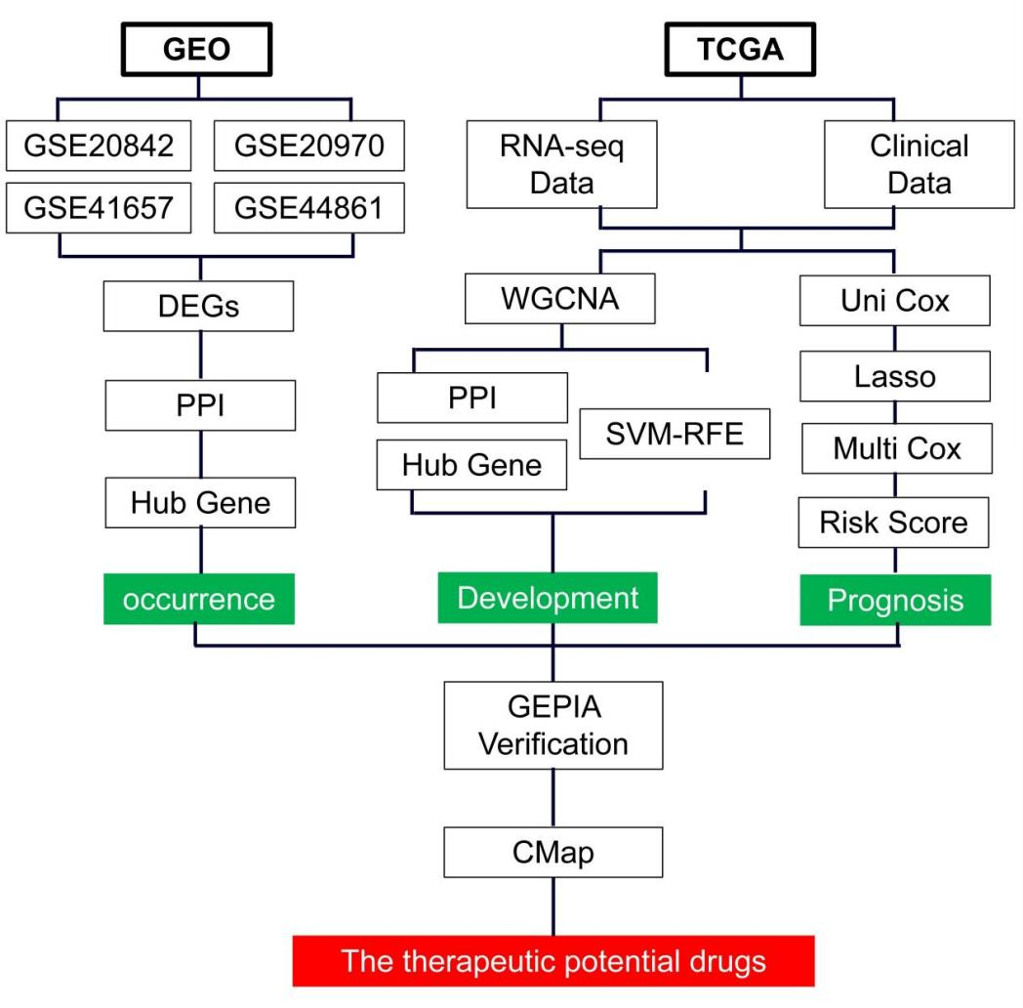
Supplementary Figure S1.
Flow chart. Identified marker genes of CRC using systematic bioinformatic analysis. Identified the potential therapeutic drugs via CMap analysis.
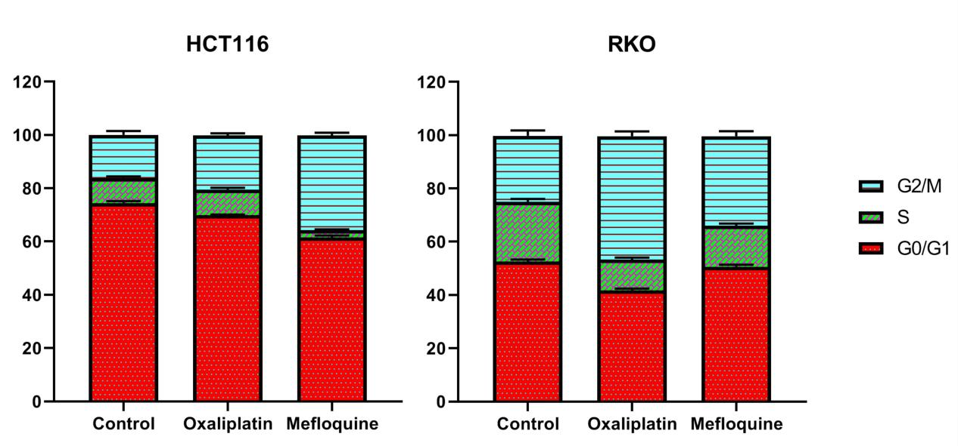
Supplementary Figure S2.
Quantification of cell cycle changes induced by mefloquine on HCT116 and RKO. Each experiment was repeated at least three times, and the data were presented as mean values with SD.

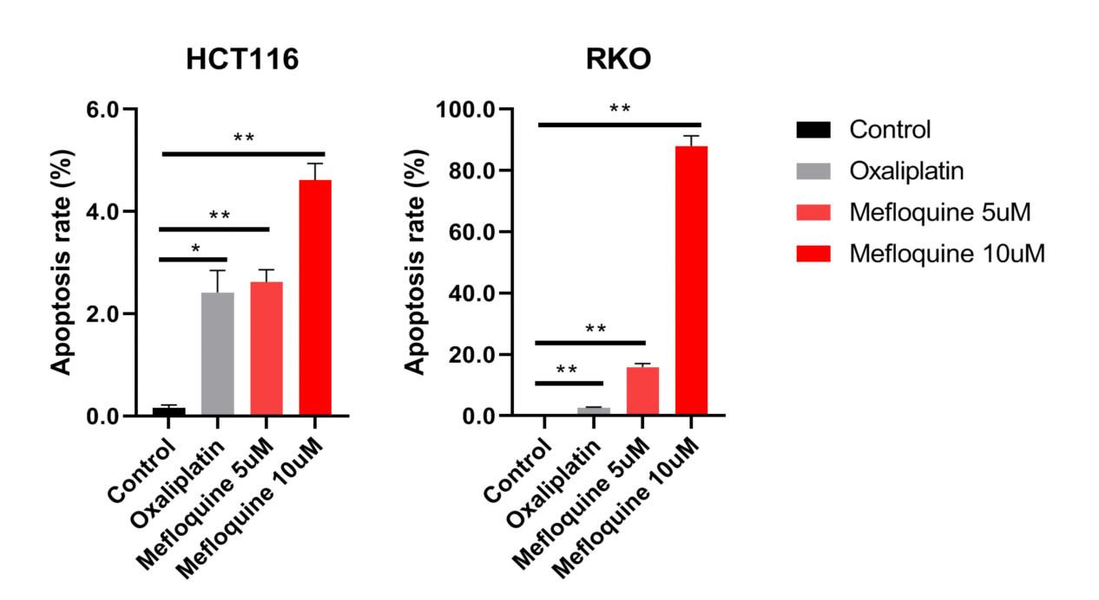
Supplementary Figure S3.
Quantification of apoptosis rate induced by mefloquine on HCT116 and RKO. Each experiment was repeated at least three times, and the data were presented as mean values with SD, and *P < 0.05, **P < 0.01.

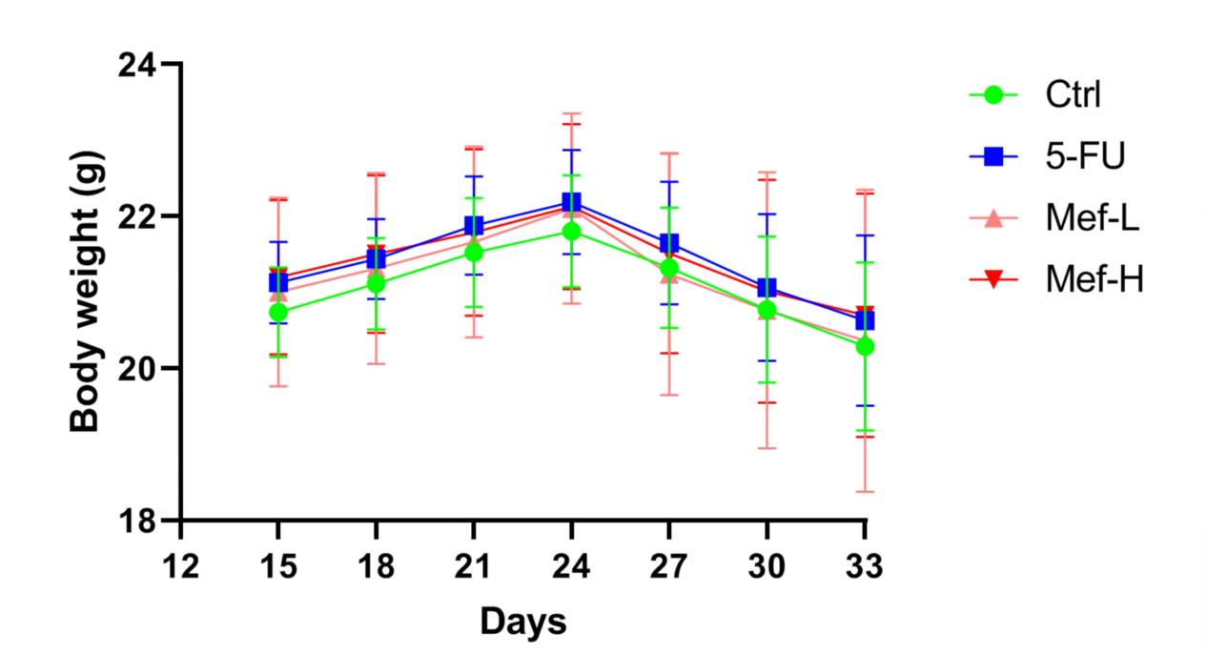
Supplementary Figure S4.
The body weights of mice with xenograft tumors was monitored. "Ctrl" indicated the control group. The data were presented as mean values with SD.

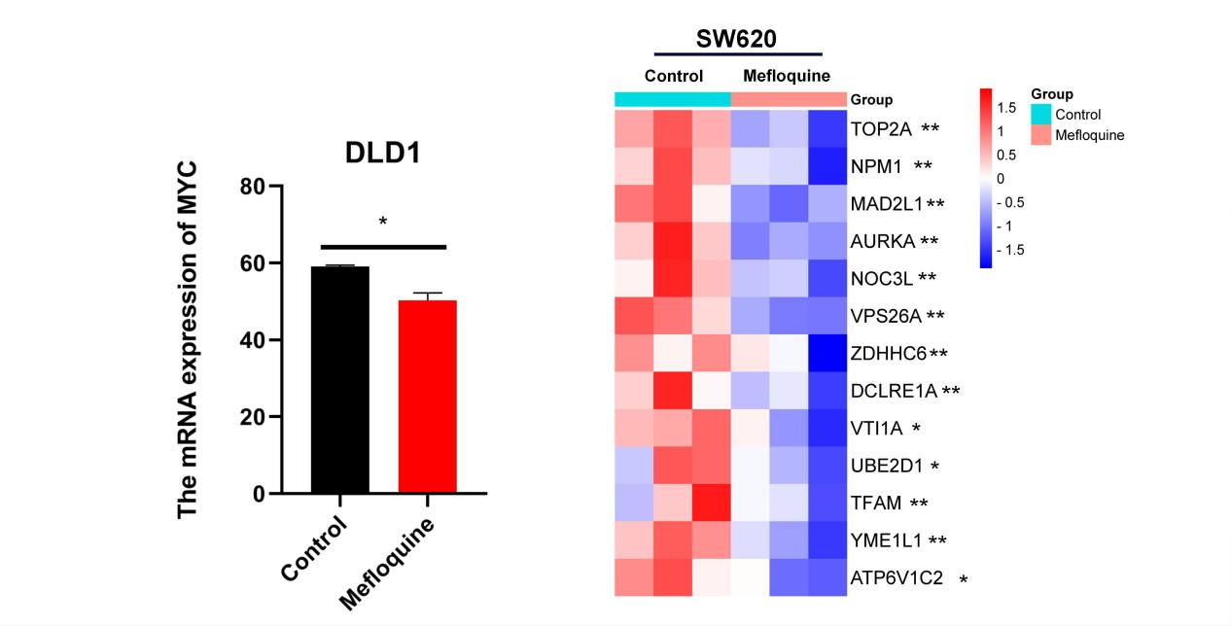
Supplementary Figure S5.
After treated by mefloquine, the expression of CRC’s marker genes in DLD1 and SW620 were analyzed. The data were presented as mean values with SD, and *P < 0.05, **P < 0.01.

Supplementary Table 1. 432 common genes over-expressed in CRC tissue.
ABHD2 ABL2 ACD ACSL6 ADCY3 ADRM1 AGFG1 AGO2 AGRN AHCY AKAP11 ALDH1B1 ANXA3 APBB2 API5 APTX AREG ASB9 ASCC3 ASPH ASPM ATAD2 ATF7IP ATIC ATP11A ATP6V1F AURKA AZGP1 B3GNTL1 BACE2 BBS9 BCL2L1 BGN BID BMP4 BMP7 BORA C11orf95 C19orf53 C2CD2 C4BPB CACNA1D CAMKMT CAND1 CBLL1 CBX4 CCDC86 CCDC93 CCL20 CCL24 CCNO CCT2 CD46 CDCA4 CDH6 CDR2L CDV3 CELF1 CEMIP CFB CHEK2 CHTOP CIAO1 CKMT2 CLDN1 CLPB CNN2 COBLL1 COL11A1 COL4A1 COMP COMT CORIN CPSF6 CUL4A CUL7 CXCL1 CXCL2 CXCL3 CXCL8 CYHR1 DAP3 DCLRE1B DDX19A DDX31 DDX46 DEF8 DESI1 DHRS2 DHX9 DIDO1 DKC1 DKK2 DLGAP4 DNAAF5 DNAJA3 DNAJC15 DOCK6 DOCK9 DPEP1 DPY19L1 DPY19L4 DSN1 DUOX2 ECM1 ECT2 EDAR EEF1D EEF1E1 EIF2AK2 EIF2S2 EIF3M ELAVL1 ELOVL5 ENC1 ENOPH1 EPHB2 EPHB3 EPRS EREG ETS2 ETV4 EVPL EXOSC4 FABP6 FAM60A FANCI FASN FAT1 FNTA FTSJ1 FXYD5 GABRE GAD1 GALNT11 GALNT6 GAPVD1 GARS GATC GID8 GINS4 GLCE GLO1 GNL3L GPC4 GPR143 GPSM2 GRB7 GTF2E1 GTF2F2 GTF2I GTF2IRD1 GTF3A GTPBP4 GYG2 GZMB HILPDA HMGB1 HMMR HN1L HOMER1 HSPE1 HYAL2 IDE IFI6 IFITM1 IKBKB IL15RA IL24 IL33 ILF3 IMPDH1 INHBA INTS7 INVS IPO4 IRAK1 ITGA6 ITGB8 JAG2 KANK1 KANSL1L KCTD20 KIAA0895 KIF20B KIF23 KLK10 KLK7 KPNA1 L3MBTL1 LGR5 LPGAT1 LRP8 LRRC6 MAD2L1 MCCC2 MCFD2 MCM4 MCTS1 MELK MEMO1 MET METTL22 METTL5 METTL9 MFAP2 MGAT5 MINA MKI67 MKLN1 MLLT10 MLXIPL MMP14 MORC4 MRE11A MRM2 MRPL17 MRPL57 MRTO4 MSR1 MTHFD1 MYC NAA10 NAA15 NAT9 NCL NEBL NEK3 NENF NF1 NFAT5 NFE2L3 NFYA NLE1 NOL8 NONO NOX4 NPEPL1 NPM1 NSDHL NT5DC2 NUDT21 NUP107 NUP62CL NUTF2 ODAM OLA1 ORC2 ORC3 OSBPL10 OSMR PAFAH1B3 PALB2 PAM16 PAQR4 PDCD2 PDCD5 PDZK1IP1 PERP PFKM PHC2 PHF20 PHLDA1 PIBF1 PITRM1 PITX1 PLA2G16 PLEKHA8 PLOD3 PLXNA1 PLXNA3 PMEPA1 POFUT1 POLB POLR1D POP1 PPA1 PPP1R13L PPP1R3D PPP2R3B PRAF2 PRKDC PROSER1 PROX1 PRPF4 PRSS22 PSMA1 PTBP3 PTK2 PTP4A3 PTPN12 PTPN4 PTPRO PUS1 R3HDM1 RAB11FIP3 RAB22A RAD50 RAD51B RANBP9 RASAL2 RBCK1 RBM28 RCBTB1 RCN1 REG3A RFC2 RFC5 RGS16 RHBDF2 RNASEH1 RNF114 RNF39 RNF43 RRM1 RRM2 RTEL1 S100A11 SCD SEPHS1 SERPINB5 SH3BP4 SH3TC2 SHB SHMT2 SKIL SKP2 SLC11A2 SLC12A2 SLC22A3 SLC25A37 SLC41A3 SLC4A2 SLC5A1 SLC6A6 SLC7A1 SLC7A6 SLCO4A1 SMARCC1 SMC4 SND1 SNHG17 SNRPE SNRPF SNTB1 SOD2 SORD SOX4 SOX9 SPIDR SRPX2 SSB SSBP1 SSSCA1 STAM STX16 STX6 SULT2B1 SUPT20H SYNCRIP TAF2 TAF4B TARBP1 TBC1D16 TBC1D4 TBX3 TBXAS1 TCF3 TFDP1 TGFBI TGIF1 TGM2 THEM6 THUMPD2 TIMELESS TIMP1 TIPIN TKT TM7SF2 TM9SF4 TMCC1 TMEM123 TMEM165 TMEM39A TMEM63A TMEM8B TMEM97 TNFSF15 TNNI3 TOP2A TPM4 TRAF5 TRAP1 TRIM16L TSN TTC17 TTF2 TTI1 TTLL4 TTPAL TWISTNB TXLNG UBD UBE2H UBE2I UBFD1 UNC93A UPF3A UQCC1 URB2 USP10 USPL1 UTP11 VEGFA VSNL1 WDR33 WDR59 WWC1 WWC3 XPO4 YAP1 YEATS2 ZBTB18 ZC3H15 ZFP64 ZMYM2 ZMYND8 ZNF107 ZNF146 ZNF337 ZNF593 ZNF84

Supplementary Table 2. 438 common genes under-expressed in CRC tissue.
A2M ABCA5 ABCD3 ABCG2 ACAA2 ACADVL ACVR2A ADAMDEC1 ADCY9 ADD1 ADGRL3 ADH6 ADTRP AGFG2 AHNAK AKAP13 AKAP9 AKR1B10 AKR1C1 AKR7A2 ANK3 ANKRD12 APPBP2 AQP8 ARF6 ARHGAP44 ARHGEF18 ARID3B ARL14 ARPIN ARRB1 ASAP3 ASPA ATP1B3 ATP2A3 ATP2B1 ATP5A1 ATP5F1 ATP5J ATP5L ATP5O ATP6V0D1 ATP6V1D AVPI1 B2M BAG1 BCAR3 BCAT2 BEST2 BEX1 BHLHE41 BIN2 BLOC1S1 BMP2K BMP3 BTBD3 BTG1 BTK BTNL8 C2CD2L C2orf72 C9orf40 CA1 CA12 CA2 CA4 CA7 CAB39 CACNA2D2 CALCOCO2 CALM1 CAMK2N1 CANT1 CAP1 CCDC25 CCDC68 CCL23 CD160 CD177 CD244 CD3G CD48 CD96 CDC14A CDH19 CDK20 CDKN1A CEACAM1 CEACAM7 CEP70 CES2 CFD CHFR CHGA CHMP2A CHP1 CHRNA1 CITED2 CLCA4 CLDN8 CLU CNDP2 CNNM2 COL4A5 COX11 COX5B COX6A1 COX7A2 CPT2 CPVL CRADD CROT CSDE1 CTAGE5 CTSD CTSW CXCL12 CYCS CYP4F12 DAZAP2 DCTN2 DEFB1 DHRS11 DMXL1 DMXL2 DNAJC28 DNASE1L3 DPP8 DPT EAPP ECE1 ECH1 EDF1 EIF2AK3 ELAC1 ELAVL4 EMP1 ENSA ENTPD5 ERBIN ETFDH ETHE1 EVI2B FABP1 FABP2 FAM107A FAM117A FAM134A FAM162A FAM174B FAM46C FAM53B FCGBP FCMR FGF9 FH FKBP1B FMO4 FNBP1 FOXF2 FOXN3 FTH1 FUCA1 FZD5 GAREM1 GAS7 GBA3 GCNT2 GCNT3 GFI1 GGNBP2 GHR GIMAP5 GLRX5 GMFB GNG7 GOT1 GPBP1L1 GPD1L GPM6B GPR107 GPR15 GREM2 GSN GSTM4 GUCA2A GUCA2B GUSB HADH HADHB HCLS1 HECTD3 HGD HHLA2 HIGD1A HRASLS2 HSD17B11 HSD17B2 ID3 IGLL1 IKZF1 IL1R2 IL6R IMPA1 INSL5 IQGAP2 IRF4 IST1 ITGB7 ITM2A ITM2C ITPKA JOSD1 KAT2B KAT5 KCTD12 KCTD9 KIAA0232 KIAA1109 KIF1C KLF6 KLF9 KRAS KTN1 LETM1 LGALS3 LGR4 LITAF LPAR1 LPP LRRC1 LRRC19 LY9 LYST MAF MAN2B1 MAPK6 MAPK7 MARCKS MAST2 MATN2 MAZ MBD2 MED8 MEP1A METTL7A MFSD9 MGAT4A MGLL MPC1 MS4A12 MT1E MTMR9 MTUS1 MUT MXD4 MXI1 MYH11 MYL6 MZB1 NAAA NAALADL1 NAP1L2 NARS NCOA4 NDN NDUFA13 NDUFA6 NDUFB1 NDUFB8 NDUFC1 NDUFS2 NDUFS3 NIT1 NR3C1 OGN OPN3 P2RY1 PADI2 PANK3 PAQR5 PARM1 PBX1 PCK1 PCSK5 PCSK6 PCSK7 PDCD4 PDE6A PDE9A PDLIM1 PER1 PEX26 PHKB PHYH PIK3CG PINK1 PIP4K2C PLAC8 PLCD1 PLCE1 PLCG2 PLD1 PLLP PLP1 PLPP1 PLPP3 PLS1 PNLIPRP2 PPARD PPARGC1A PPP1R12B PPP2R3A PRDX6 PRKACB PRKAR2B PRKCB PRSS16 PSEN1 PTP4A1 PTPRR PURA PYY RAB1A RAB4B RABGAP1L RALBP1 RALGAPA1 RBM38 RDH5 RETSAT RGS13 RGS9 RHOF RNF138 RNF167 RPS6KA5 RRAS2 RTCB RYBP SARAF SCAMP2 SCGB2A1 SCGN SCNN1B SDHA SEC14L5 SECISBP2L SEMA6A SEPP1 SFRP1 SGK1 SIRT6 SLC17A4 SLC25A20 SLC25A5 SLC26A2 SLC26A3 SLC30A10 SLC30A4 SLC35D1 SLC4A4 SLC6A8 SLCO4C1 SMCHD1 SMIM14 SMPD1 SMPDL3A SNRK SNX24 SOCS2 SOX10 SPAG7 SPECC1L SPIB SPN SPON1 SRI SRPX SRSF5 SSBP2 STBD1 STMN2 SUGCT SULT1B1 SVIL SYNE1 SYNM SYT17 SYTL2 TAOK3 TARP TCF21 TCL1A TDP2 TEX11 TLE4 TLR3 TMBIM4 TMEM100 TMEM140 TNFRSF13B TNFSF12 TOX4 TRAK2 TRANK1 TRAPPC8 TRIM10 TRIM36 TSPAN1 TSPAN7 UGDH UGP2 UGT1A6 UNC13B UNC5B UNC5C UQCR10 UQCRFS1 UQCRH VAPA VDAC2 VPS45 VPS4B VTI1B VWA5A WSB2 WSCD1 XK XYLT1 YES1 ZAP70 ZBTB16 ZFAND6 ZNF211 ZNF350 ZNF415 ZNF821

Supplementary Table 3. Hub genes for common over-expressed in CRC tissue by different CytoHubba methods.
Category | Rank methods in CytoHubba
Category | EPC | MNC | Closeness | Degree
1 | MYC | MYC | MYC | MYC
2 | TOP2A | TOP2A | NPM1 | TOP2A
3 | RRM1 | NPM1 | TOP2A | NPM1
4 | NPM1 | RRM1 | RRM1 | EPRS1
5 | MCM4 | MRTO4 | ELAVL1 | RRM1
6 | CHEK2 | MCM4 | EPRS1 | ELAVL1
7 | MAD2L1 | EPRS1 | CXCL8 | MRTO4
8 | RRM2 | DHX9 | PALB2 | AURKA
9 | FANCI | CXCL8 | DHX9 | MCM4
10 | AURKA | ELAVL1 | DKC1 | CXCL8
11 | SMC4 | PALB2 | AURKA | MAD2L1
12 | DHX9 | FANCI | MAD2L1 | DHX9
13 | ELAVL1 | AURKA | GTPBP4 | GTPBP4
14 | RFC2 | MAD2L1 | UBE2I | CCT2
15 | KIF23 | GTPBP4 | NCL | PALB2

Supplementary Table 4. 219 Genes associated with CRC survival analyzed by Univariate Cox proportional hazards regression analysis based on TCGA data (P < 0.05).
PCOLCE2 NAT1 RNU6.140P PPP1R1A TIMP1 CPT2 CALB2 NAT2 HSF4 SNAI1 ASPHD1 TRAP1 PDZD4 ATOH1 ITLN1 GPX3 SLC35D1 ACOX1 KPNA2 FABP4 SCG2 H19 GPSM2 PLIN4 C4orf19 PRELP COMP XXbac.B476C20.9 SNHG16 IGLV7.43 MYOM1 CLCA1 CCNF MMP10 PCSK5 C2CD4A AGRN CLDN23 SCGB2A1 HIGD1A CD36 ASPG SLC12A2 CRYAB TPSG1 SUCLG2 FJX1 AOC3 LGALS4 CXXC5 CHPF NGFR MAD2L1 SLC4A4 CLU SRPX BMP5 MPC1 MMP3 IGKV2D.29 FIGF KCTD9 CCL24 SNORD17 HEPACAM2 SFRP2 IGKV2D.24 PPIL1 RAB36 HMMR SULT1B1 HAND1 ARHGEF25 PPARGC1A PLOD3 MMP1 CXCL1 EPHX4 SFTA2 NOTCH3 ATP6V1C2 TMEM236 TPM2 C2CD4B F2RL1 CCT2 CCL28 TNS1 CILP PALM IGSF9 MTM1 PTRF EREG CADM3 AXIN2 SEPP1 PXMP2 PTGIS CTD.2547H18.1 TKT CLCA4 B3GNT6 HSPB7 TINAG C5orf30 BGN DSN1 SNCG CCNJL ZNF692 RP11.54H7.4 RNU4.2 ZG16 DNASE1L3 PARM1 GLP2R ITGA7 BIRC5 ACSL6 IGKV2.24 ADCY5 KIF13B PSRC1 CXCL2 CCNB1 SCARA3 APOD SIGLEC1 CXCL3 ST6GALNAC1 IGHV3.74 ACADM SNORD14E PTTG1 QSOX2 VWA5A SNORD99 CHRDL1 CPA3 OSBPL1A GNG12 MGP NEXN PAQR8 ACACB ANXA3 CTD.2510F5.4 CA2 IGKV6.21 GNG7 FENDRR SFRP5 FCGBP IGLV8.61 THBS4 GAP43 LITAF JAM3 TTYH3 CCNA2 NXPH4 RP11.167N24.6 JAG2 SNHG7 POPDC2 IGLV1.50 CYP2W1 IGJ PGM5 SMPDL3A CLIP3 RBM47 CD177 NXPE4 SPARCL1 CCDC68 CCL11 NIPAL1 ELFN1.AS1 CNN1 IGLV3.19 NEBL SNORA73B LEF1 IGLV7.46 IGKV1.16 XDH MIER1 NFE2L3 LY6E CAPN13 TINCR DIAPH3 GPR15 IGHV3.35 S100P MROH6 CDC45 STC1 VSIG4 SCP2 SPP1 DEFA6 CEACAM7 RP11.150O12.3 ZBTB7C FEV RP11.150O12.6 RETNLB MFI2 PPA1 RANBP1 CDKN2B.AS IGHV3.52 SFXN3 AKR1B10 MYL9 IGHV6.1

Supplementary Table 5. 18 Genes associated with CRC survival analyzed by Lasso regression analysis based on the results of Univariate Cox proportional hazards regression analysis.
TIMP1 H19 SFTA2 ASPHD1 SNAI1 ATP6V1C2 HSF4 AGRN IGLV7.43 CLDN23 ATOH1 RNU6.140P IGKV2D.24 XXbac.B476C20.9 CPT2 ACOX1 NAT1 ASPG CPT2 ACOX1 NAT1 ASPG

Supplementary Table 6. 85 Genes commonly up-regulated in DLD1 and SW620 after mefloquine treated.
LDLR SCD FASN HMGCR ACSL1 PCSK9 HSPA1A NPC1 DHCR7 PNPLA3 MVD LPIN1 INSIG1 MLXIPL LSS RDH11 NPDC1 MFGE8 GSN BHLHE40 STXBP1 LIPG ACSS2 ROGDI MVK SLC5A1 TPP1 OASL SLC26A6 PHC1 RBCK1 SQLE FDFT1 CD82 WIPI1 IGF2R IKBKG TCIRG1 MEGF8 ACAP3 ANKRD52 ABCA7 CLCN6 LMF1 NEU1 NSDHL ABCA2 HSD17B7 LRRC8A TM7SF2 COL6A1 HSPG2 LPCAT4 PIK3R2 MICAL1 TREX1 RHBDF2 GDI1 SMTN TUBA1A LAMA5 SLC22A18 PLXNA3 H6PD SGSM2 ARHGEF4 MROH1 PHKA2 NADSYN1 ADCY6 ANKRD37 DHRS1 RHPN1 B4GALNT3 SLC25A29 MAN2B2 NBEAL2 PBXIP1 SLC12A4 TMEM63A TNFSF12-TNFSF13 DDX60 TAF1C ZSWIM8 EHBP1L1

Supplementary Table 7. 125 Genes commonly down-regulated in DLD1 and SW620 after mefloquine treated.
HSPD1 MT-ATP6 HSPA9 TXNIP CCND1 MT-CO1 DHFR SCO1 MT-CYB SMS MTHFD2 MT-ND2 MT-CO3 VAPB LIAS NPM1 GRSF1 PSAT1 POP1 HNRNPA1 IARS2 ASNS SLC25A32 SNAP29 MRPL3 KLF5 MRPL15 PDE4D PTPN2 AXIN2 KLF10 ZMPSTE24 GRPEL2 THG1L ANP32A EHF ATPAF1 PTMA LANCL2 SLC38A2 PAICS SOX4 LIMS1 ZFAS1 HNRNPC AJUBA NT5C2 CCT5 ETF1 EBAG9 RPL12 ANP32B SRSF6 PTP4A1 EFNB2 IFRD1 KCNE3 SNHG8 POLA1 APOBEC3B CST7 NUDT15 WTAP CNBP ZBED3 MRPL54 TIMM10 OGFOD1 PDCD7 NOL10 TARS1 DESI2 MEX3C RBMX TSC22D1 KHDRBS1 HNRNPU CDV3 ZCCHC8 ARRDC4 LRATD2 RRP15 LINC00511 C19orf33 CCDC174 ZCCHC7 TP53RK CEBPG ORC5 COPS3 SRSF8 H1-0 IARS1 PTP4A2 DNAJC7 EIF3J WDR3 AZIN1 THRAP3 ZSCAN12 FAM107B TADA2A SBDSP1 UTP25 PIGW RBM18 EAPP NGDN RSL1D1 IL20RA C16orf72 NUDT4 RWDD2B GAR1 NIP7 POLR1B PNO1 POLR2M RSL24D1 SH3KBP1 PRR11 SCAF8 UBE2E1 SET SEC11A

Unprocessed versions of all blots
