Contents
Supplementary Table 1: PRISMA Reporting Checklist Page 3
Supplementary Table 2: Literature search terms of the systematic review Page 6
Supplementary Table 3: Items of the NOS checklist Page 7
Supplementary Table 4: Items of the modified NOS checklist for risk of bias assessment Page 8
Supplementary Table 5: Studies and reasons for exclusion at the stage of full-text screening Page 9
Supplementary Table 6. Summary of GRADE assessment for certainty of evidence of overall, disease-specific, and disease-free survival outcomes. Page 10
Supplementary Table 7. Subgroup analysis of association between categorical lymph node density and survival outcomes after radical cystectomy in patients with BC. Page 11
Supplementary Figure 1. Forest plot of the association between categorical lymph node density and overall survival in patients with bladder cancer after radical cystectomy (univariable data). Page 13
Supplementary Figure 2. Publication bias evaluation and sensitivity analysis for overall survival in patients with bladder cancer after radical cystectomy (categorical multivariable data). Page 14
Supplementary Figure 3. Sensitivity analysis for overall survival in patients with bladder cancer after radical cystectomy (categorical multivariable data). A. Leave-One-Out sensitivity analysis. B. Sensitivity analysis excluding low-quality studies (NOS score ≤6). C. Fixed-effects model. Page 15
Supplementary Figure 4. Sensitivity analysis for overall survival in patients with bladder cancer after radical cystectomy (continuous multivariable data). A. Leave-One-Out sensitivity analysis. B. Sensitivity analysis excluding low-quality studies (NOS score ≤6). C. Fixed-effects model. Page 16
Supplementary Figure 5. Forest plot of the association between categorical lymph node density and disease-specific survival in patients with bladder cancer after radical cystectomy (univariable data) Page 17
Supplementary Figure 6. Publication bias evaluation and sensitivity analysis for disease-specific survival in patients with bladder cancer after radical cystectomy (categorical multivariable data). A. Leave-One-Out sensitivity analysis. B. Sensitivity analysis excluding low-quality studies (NOS score ≤6). Page 18
Supplementary Figure 7. Sensitivity analysis restricted to pathological node-positive (pN+) patients for disease-specific survival in patients with bladder cancer after radical cystectomy (categorical multivariable data). Page 19
Supplementary Figure 8. Leave-One-Out sensitivity analysis for disease-specific survival in patients with bladder cancer after radical cystectomy (continuous multivariable data). Page 20
Supplementary Figure 9. Forest plot of the association between continuous lymph node density and disease-specific survival in patients with bladder cancer after radical cystectomy (univariable data). Page 21
Supplementary Figure 10. Forest plot of the association between categorical lymph node density and disease-free survival in patients with bladder cancer after radical cystectomy (univariable data). Page 22
Supplementary Figure 11. Publication bias evaluation and sensitivity analysis for disease-free survival in patients with bladder cancer after radical cystectomy (categorical multivariable data). A. Leave-One-Out sensitivity analysis. B. Fixed-effects model. Page 23
Supplementary Figure 12. Leave-One-Out sensitivity analysis for disease-free survival in patients with bladder cancer after radical cystectomy (continuous multivariable data). Page 24
References Page 25

Supplementary Table 1: PRISMA Reporting Checklist.
Section and Topic | Item # | Checklist item | Location where item is reported
TITLE
Title | 1 | Identify the report as a systematic review. | Page 1
ABSTRACT
Abstract | 2 | See the PRISMA 2020 for Abstracts checklist. | Page 4
INTRODUCTION
Rationale | 3 | Describe the rationale for the review in the context of existing knowledge. | Page 6-7
Objectives | 4 | Provide an explicit statement of the objective(s) or question(s) the review addresses. | Page 7
METHODS
Eligibility criteria | 5 | Specify the inclusion and exclusion criteria for the review and how studies were grouped for the syntheses. | Page 8
Information sources | 6 | Specify all databases, registers, websites, organisations, reference lists and other sources searched or consulted to identify studies. Specify the date when each source was last searched or consulted. | Page 8
Search strategy | 7 | Present the full search strategies for all databases, registers and websites, including any filters and limits used. | Supplementary Table 2
Selection process | 8 | Specify the methods used to decide whether a study met the inclusion criteria of the review, including how many reviewers screened each record and each report retrieved, whether they worked independently, and if applicable, details of automation tools used in the process. | Page 8-9
Data collection process | 9 | Specify the methods used to collect data from reports, including how many reviewers collected data from each report, whether they worked independently, any processes for obtaining or confirming data from study investigators, and if applicable, details of automation tools used in the process. | Page 9
Data items | 10a | List and define all outcomes for which data were sought. Specify whether all results that were compatible with each outcome domain in each study were sought (e.g. for all measures, time points, analyses), and if not, the methods used to decide which results to collect. | Page 9
Data items | 10b | List and define all other variables for which data were sought (e.g. participant and intervention characteristics, funding sources). Describe any assumptions made about any missing or unclear information. | Page 9
Study risk of bias assessment | 11 | Specify the methods used to assess risk of bias in the included studies, including details of the tool(s) used, how many reviewers assessed each study and whether they worked independently, and if applicable, details of automation tools used in the process. | Page 9-10
Effect measures | 12 | Specify for each outcome the effect measure(s) (e.g. risk ratio, mean difference) used in the synthesis or presentation of results. | Page 9-10
Synthesis methods | 13a | Describe the processes used to decide which studies were eligible for each synthesis (e.g. tabulating the study intervention characteristics and comparing against the planned groups for each synthesis (item #5)). | Page 10-11
Synthesis methods | 13b | Describe any methods required to prepare the data for presentation or synthesis, such as handling of missing summary statistics, or data conversions. | Page 10-11
Synthesis methods | 13c | Describe any methods used to tabulate or visually display results of individual studies and syntheses. | Page 10-11
Synthesis methods | 13d | Describe any methods used to synthesize results and provide a rationale for the choice(s). If meta-analysis was performed, describe the model(s), method(s) to identify the presence and extent of statistical heterogeneity, and software package(s) used. | Page 10-11
Synthesis methods | 13e | Describe any methods used to explore possible causes of heterogeneity among study results (e.g. subgroup analysis, meta-regression). | Page 11
Synthesis methods | 13f | Describe any sensitivity analyses conducted to assess robustness of the synthesized results. | Page 10-11
Reporting bias assessment | 14 | Describe any methods used to assess risk of bias due to missing results in a synthesis (arising from reporting biases). | Page 10-11
Certainty assessment | 15 | Describe any methods used to assess certainty (or confidence) in the body of evidence for an outcome. | Page 9
RESULTS
Study selection | 16a | Describe the results of the search and selection process, from the number of records identified in the search to the number of studies included in the review, ideally using a flow diagram. | Page 11
Study selection | 16b | Cite studies that might appear to meet the inclusion criteria, but which were excluded, and explain why they were excluded. | Supplementary Table 5
Study characteristics | 17 | Cite each included study and present its characteristics. | Page 12
Risk of bias in studies | 18 | Present assessments of risk of bias for each included study. | Page 13
Results of individual studies | 19 | For all outcomes, present, for each study: (a) summary statistics for each group (where appropriate) and (b) an effect estimates and its precision (e.g. confidence/credible interval), ideally using structured tables or plots. | Table 1, 2
Results of syntheses | 20a | For each synthesis, briefly summarise the characteristics and risk of bias among contributing studies. | Page 13-15
Results of syntheses | 20b | Present results of all statistical syntheses conducted. If meta-analysis was done, present for each the summary estimate and its precision (e.g. confidence/credible interval) and measures of statistical heterogeneity. If comparing groups, describe the direction of the effect. | Page 13-15, Figure 3-4
Results of syntheses | 20c | Present results of all investigations of possible causes of heterogeneity among study results. | Page 16, Supplementary Table 7
Results of syntheses | 20d | Present results of all sensitivity analyses conducted to assess the robustness of the synthesized results. | Page 13-15, Supplementary Figures 2, 3, 4, 6, 7, 8, 11, 12
Reporting biases | 21 | Present assessments of risk of bias due to missing results (arising from reporting biases) for each synthesis assessed. | Figure 2, Page 13
Certainty of evidence | 22 | Present assessments of certainty (or confidence) in the body of evidence for each outcome assessed. | Supplementary Table 6, Page 13
DISCUSSION
Discussion | 23a | Provide a general interpretation of the results in the context of other evidence. | Page 16-22
Discussion | 23b | Discuss any limitations of the evidence included in the review. | Page 22-23
Discussion | 23c | Discuss any limitations of the review processes used. | Page 22-23
Discussion | 23d | Discuss implications of the results for practice, policy, and future research. | Page 21-22
OTHER INFORMATION
Registration and protocol | 24a | Provide registration information for the review, including register name and registration number, or state that the review was not registered. | Page 8
Registration and protocol | 24b | Indicate where the review protocol can be accessed, or state that a protocol was not prepared. | Page 8
Registration and protocol | 24c | Describe and explain any amendments to information provided at registration or in the protocol. | Page 8
Support | 25 | Describe sources of financial or non-financial support for the review, and the role of the funders or sponsors in the review. | Page 26
Competing interests | 26 | Declare any competing interests of review authors. | Page 26
Availability of data, code and other materials | 27 | Report which of the following are publicly available and where they can be found: template data collection forms; data extracted from included studies; data used for all analyses; analytic code; any other materials used in the review. | Page 26

From: Page MJ, McKenzie JE, Bossuyt PM, Boutron I, Hoffmann TC, Mulrow CD, et al. The PRISMA 2020 statement: an updated guideline for reporting systematic reviews. BMJ 2021;372:n71. doi: 10.1136/bmj.n71.

Supplementary Table 2: Literature search strategy of the systematic review.
Query |  | Results  8.11.2025
PubMed
#1 | ("Urinary Bladder Neoplasms"[Mesh] OR "Bladder cancer*"[tiab] OR "Bladder tumor*"[tiab] OR " Bladder Neoplasm*"[tiab] OR "Malignant Tumor of Urinary Bladder"[tiab] OR BC[tiab] OR "Bladder tumor" OR "Cystectomy"[Mesh] OR "Cystectom*"[tiab] OR RC[tiab]) | 164,103
#2 | ("lymph node density"[tiab] OR "lymph node ratio"[tiab] OR LND[tiab] OR LNR[tiab]) | 4,133
#3 | #1 AND #2 | 237
SCOPUS
#1 | TITLE-ABS-KEY ("Bladder cancer*" OR "Bladder tumor*" OR " Bladder Neoplasm*" OR "Malignant Tumor of Urinary Bladder" OR bc OR "Cystectom*" OR rc) | 356,133
#2 | TITLE-ABS-KEY ("lymph node density" OR "lymph node ratio" OR LND OR LNR) | 5,809
#3 | #1 AND #2 | 292
Web of Science
#1 | (TI=("Bladder cancer*" OR "Bladder tumor*" OR " Bladder Neoplasm*" OR "Malignant Tumor of Urinary Bladder" OR BC OR "Cystectom*" OR RC))  OR  (AB=("Bladder cancer*" OR "Bladder tumor*" OR " Bladder Neoplasm*" OR "Malignant Tumor of Urinary Bladder" OR BC OR "Cystectom*" OR RC)) | 260,532
#2 | (TI=("lymph node density" OR "lymph node ratio" OR LND OR LNR))  OR  (AB=("lymph node density" OR "lymph node ratio" OR LND OR LNR)) | 5,068
#3 | #1 AND #2 | 235
EMBASE
#1 | ('bladder cancer*'/exp OR 'bladder tumor*'/exp OR 'bladder neoplasm*'/exp OR 'Malignant Tumor of Urinary Bladder'/exp OR bc OR 'cystectom*'/exp OR rc) | 552,827
#2 | ('lymph node density' OR 'lymph node ratio' OR LND OR LNR) | 7,477
#3 | #1 AND #2 | 567
TOTAL |  | 1331
DUPLICATES |  | 649
TOTAL AFTER REMOVING DUPLICATES |  | 682

Supplementary Table 3: Items of the NOS checklist ¹.
SELECTION | 1 | Representativeness of the Exposed Cohort:  - Truly representative of the average patient with mental illness (eg, severity of illness, comorbidities) in the community*  - Somewhat representative of the average (eg, severity of illness, comorbidities) in the community*  - Selected group of users eg HIV+, pregnant, elderly, significant physical disabilities  - No description of the derivation of the cohort
SELECTION | 2 | Selection of the Non-Exposed Cohort:  - Drawn from the same community as the exposed cohort*  - Drawn from a different source  - No description of the derivation of the non-exposed cohort
SELECTION | 3 | Ascertainment of Exposure  - Secure record (eg, medical records) *  - Structured interview *  - Written self-report  - No description
SELECTION | 4 | Demonstration that Outcome of Interest Was Not Present at Start of Study:  - Yes*  - No
COMPARABILITY | 1 | Comparability of Cohorts on the Basis of the Design or Analysis:  - Study controls for SES (or some reasonable proxy of SES), age, race, gender*  - Study controls for any additional factor* (these criteria could be modified to indicate specific control for a second important factor)  - Inadequate degree of control
OUTCOME | 1 | Assessment of Outcome:  - Independent or blind assessment stated in the paper, or confirmation of the outcome by reference to secure records (x-rays, medical records, etc)*  - Record linkage (eg, identified through ICD codes on database records) *  - Self-report (ie, no reference to original medical records or x-rays to confirm the outcome)  - No description
OUTCOME | 2 | Was Follow-up Long Enough for Outcomes to Occur?  - Yes (select an adequate follow up period for outcome of interest) *  - No
OUTCOME | 3 | Adequacy of Follow-up of Cohorts:  - Complete follow-up—all subjects accounted for*  - Subjects lost to follow-up unlikely to introduce bias—small number lost (LESS than 20% follow-up, or description provided of those lost) *  - Follow-up rate MORE than 20% and no description of those lost  - No statement
NOTE:
Thresholds for converting the Newcastle-Ottawa scales to Agency for Healthcare Research and Quality standards (good, fair, and poor):
Good quality: 3 or 4 stars in selection domain AND 1 or 2 stars in comparability domain AND 2 or 3 stars in outcome/exposure domain.
Fair quality: 2 stars in selection domain AND 1 or 2 stars in comparability domain AND 2 or 3 stars in outcome/exposure domain.
Poor quality: 0 or 1 star in selection domain OR 0 stars in comparability domain OR 0 or 1 stars in outcome/exposure domain.

Supplementary Table 4: Items of the modified NOS checklist for risk of bias assessment ¹.
SELECTION  (Maximum 4 stars) | 1 | Representativeness of the cohort (1 star):  - ☆: Multi-center database, population-based registry, or institutional database with adequate sample size (>100 patients for the condition studied)  - No star: Single center with limited sample size or highly selected population
SELECTION  (Maximum 4 stars) | 2 | Selection of the Non-Exposed Cohort:  - ☆: Drawn from the same community as the exposed cohort  - No star: Drawn from a different source  - No star: No description of the derivation of the non-exposed cohort
SELECTION  (Maximum 4 stars) | 3 | Ascertainment of Exposure/Predictor Variable (2 stars):  - ☆: Objective measurement from validated sources (i.e., pathology reports, laboratory results, diagnostic imaging with standardized criteria, and validated diagnostic codes)  - No star: Unclear ascertainment method or based on unreliable sources
SELECTION  (Maximum 4 stars) | 4 | Demonstration that Outcome of Interest Was Not Present at Start of Study:  - ☆: Yes  - No star: No
COMPARABILITY  (Maximum 2 stars) | 1 | Adjustment for confounders in analysis (award 1 star for EACH of the following [maximum 2 stars]):  - ☆: Disease-specific/pathological confounders: Adjustment for relevant disease staging, severity markers, histological features, or tumor characteristics specific to the condition studied  - ☆: Clinical/demographic confounders: Adjustment for age, sex, comorbidities (using validated indices), and relevant treatment variables (prior therapies, concurrent treatments)
OUTCOME  (Maximum 3 stars) | 1 | Assessment of Outcome:  - ☆: Independent or blind assessment stated in the paper, or confirmation of the outcome by reference to secure records (x-rays, medical records, etc.)  - ☆: Record linkage (i.e., identified through ICD codes on database records)  - No star: Self-report (i.e., no reference to original medical records or x-rays to confirm the outcome)  - No star: No description
OUTCOME  (Maximum 3 stars) | 2 | Was Follow-up Long Enough for Outcomes to Occur?  - ☆: Yes (minimum of 5-years)  - No star: No
OUTCOME  (Maximum 3 stars) | 3 | Adequacy of Follow-up of Cohorts:  - ☆: Complete follow-up—all subjects accounted for  - ☆: Subjects lost to follow-up unlikely to introduce bias—small number lost (LESS than 20% follow-up, or description provided of those lost)  - No star: Follow-up rate MORE than 20% and no description of those lost  - No star: No statement
NOTE:
Thresholds for converting the Newcastle-Ottawa scales to Agency for Healthcare Research and Quality standards (good, fair, and poor):
Good quality: 3 or 4 stars in selection domain AND 1 or 2 stars in comparability domain AND 2 or 3 stars in outcome/exposure domain.
Fair quality: 2 stars in selection domain AND 1 or 2 stars in comparability domain AND 2 or 3 stars in outcome/exposure domain.
Poor quality: 0 or 1 star in selection domain OR 0 stars in comparability domain OR 0 or 1 stars in outcome/exposure domain.

Supplementary Table 5: Studies and reasons for exclusion at the stage of full-text screening.
Study | Exclusion Reason
²⁻⁵ | No survival outcome investigated
⁶⁻⁵⁴ | No LND reported
⁵⁵⁻⁵⁹ | Non-English papers
⁶⁰⁻⁷⁵ | No association between LND and survival outcomes investigated
⁷⁶⁻⁸⁰ | Some patients underwent partial cystectomy
⁸¹ | Guideline
⁸² | Correspondence

Supplementary Table 6. Summary of GRADE assessment for certainty of evidence of overall, disease-specific, and disease-free survival outcomes.
Outcome | Studies | HR (95% CI) | Downgrades |  |  |  |  | Upgrades |  |  | Overall certainty
Outcome | Studies | HR (95% CI) | Risk of bias | Inconsistency | Indirectness | Imprecision | Publication bias | Dose-response gradient | Large effects | Residual confounding
Overall survival (categorical lymph node density) | 13 | 1.97 (1.71 to 2.26) | - | Not serious (I² = 31.17%) | - | - | - | + | - | - | High  (⊕⊕⊕⊕)
Disease-specific survival (categorical lymph node density) | 17 | 2.24 (1.71 to 2.92) | - | Serious (I² = 88.17%) | - | - | - | + | + | - | Moderate (⊕⊕⊕◯)
Disease-free survival (categorical lymph node density) | 11 | 1.77 (1.48 to 2.11) | - | Not serious (I² = 0%) | - | - | - | + | - | - | High  (⊕⊕⊕⊕)
Overall survival (continuous lymph node density) | 4 | 1.02 (1.01 to 1.02) | - | Not serious (I2 = 42.8%) | - | - | - | + | - | - | High  (⊕⊕⊕⊕)
Disease-specific survival (continuous lymph node density) | 5 | 1.01 (1.00 to 1.02) | - | Serious (I² = 90.62%) | - | - | - | + | - | - | Moderate (⊕⊕⊕◯)
Disease-free survival (continuous lymph node density) | 3 | 1.02 (1.01 to 1.03) | - | Serious (I² = 90.39%) | - | - | - | + | - | - | Moderate (⊕⊕⊕◯)
GRADE symbols: ⊕⊕⊕⊕ High; ⊕⊕⊕◯ Moderate; ⊕⊕◯◯ Low; ⊕◯◯◯ Very low.

Supplementary Table 7. Subgroup analysis of association between categorical lymph node density and survival outcomes after radical cystectomy in patients with BC.
 |  |  | Overall survival |  |  |  |  |  |  | Disease-specific survival |  |  |  |  |  |  | Disease-free survival
Subgroup | Studies | N |  | HR (95% CI) | I² (%) | p-valueª | P^{b} |  | Studies | N | HR (95% CI) | I²(%) | p-valueª | P^{b} |  | Studies | N | HR (95% CI) | I²(%) | p-valueª | P^{b}
Number of patients |  |  |  |  |  |  | 0.648 |  |  |  |  |  |  | 0.408 |  |  |  |  |  |  | -
<100 | 10 | 367 |  | 1.900 (1.546-2.335) | 16.88 | 0.237 |  |  | 12 | 412 | 2.390 (1.607-3.556) | 82.44 | <0.001 |  |  | 11 | 360 | 1.77 (1.481-2.114) | 0 | 0.708
≥100 | 3 | 1578 |  | 2.035 (1.649-2.511) | 65.4 | 0.05 |  |  | 5 | 2020 | 1.97 (1.569-2.475) | 79.69 | 0.003 |  |  | - | - | - | - | -
Adjuvant Chemotherapy |  |  |  |  |  |  | 0.011 |  |  |  |  |  |  | 0.001 |  |  |  |  |  |  | 0.165
Yes | 11 | 1648 |  | 1.835 (1.684-1.999) | 0 | 0.345 |  |  | 14 | 2126 | 2.191 (1.767-2.715) | 74.45 | <0.001 |  |  | 10 | 340 | 1.81 (1.510-2.168) | 0 | 0.812
No | - | - |  | - | - | - |  |  | 1 | 20 | 0.28 (0.086-0.910) | - | - |  |  | 1 | 20 | 0.870 (0.314-2.407) | - | -
Unknown | 2 | 297 |  | 2.407 (1.989-2.911) | 0 | 0.89 |  |  | 2 | 286 | 4.189 (1.464-11.983) | 96.23 | <0.001 |  |  | - | - | - | - | -
Neoadjuvant Chemotherapy |  |  |  |  |  |  | 0.659 |  |  |  |  |  |  | 0.218 |  |  |  |  |  |  | 0.484
Yes | 5 | 225 |  | 2.131 (1.647-2.757) | 0 | 0.549 |  |  | 2 | 50 | 4.69 (1.915-11.486) | 87.07 | 0.006 |  |  | 3 | 172 | 1.846 (1.347-2.530) | 0 | 0.581
No | 4 | 176 |  | 1.700 (1.126-2.568) | 49.8 | 0.097 |  |  | 11 | 833 | 2.004 (1.412-2.844) | 83.07 | <0.001 |  |  | 7 | 152 | 1.659 (1.320-2.085) | 0 | 0.590
Unknown | 4 | 1544 |  | 2.023 (1.67-2.451) | 53.1 | 0.112 |  |  | 4 | 1549 | 2.165 (1.917-2.444) | 7.74 | 0.561 |  |  | 1 | 36 | 2.5 (1.301-4.804) | - | -
Type of BC |  |  |  |  |  |  | 0.172 |  |  |  |  |  |  | 0.286 |  |  |  |  |  |  | 0.776
Urothelial and non-Urothelial | 3 | 1251 |  | 1.845 (1.675-2.031) | 0 | 0.278 |  |  | 4 | 1283 | 1.422 (0.669-3.022) | 88.53 | 0.011 |  |  | 2 | 56 | 1.59 (0.571-4.426) | 65.83 | 0.087
Urothelial | 9 | 652 |  | 1.913 (1.579-2.316) | 32.54 | 0.230 |  |  | 11 | 1031 | 2.659 (1.903-3.717) | 86.53 | <0.001 |  |  | 8 | 304 | 1.808 (1.477-2.213) | 0 | 0.807
Unknown | 1 | 42 |  | 4.09 (1.778-9.409) | - | - |  |  | 2 | 118 | 1.998 (1.103-3.619) | 71.67 | 0.06 |  |  | 1 | NR | 1.49 (0.981-2.492) | - | -
LND cut-off |  |  |  |  |  |  | 0.284 |  |  |  |  |  |  | 0.052 |  |  |  |  |  |  | 0.991
4 | 1 | 68 |  | 1.923 (1.191-3.104) | - | - |  |  | - | - | - | - | - |  |  | 1 | 68 | 1.940 (1.144-3.291) | - | -
9 | - | - |  | - | - | - |  |  | 1 | 40 | 2.12 (1.174-3.828) | - | - |  |  | - | - | - | - | -
10 | 1 | 15 |  | 2.2 (1.097-4.410) | - | - |  |  | 1 | 20 | 0.28 (0.086-0.910) | - | - |  |  | 2 | 35 | 1.595 (0.485-5.242) | 63.24 | 0.099
11 | - | - |  | - | - | - |  |  | 1 | 46 | 3.03 (1.383-6.637) | - | - |  |  | - | - | - | - | -
18 | - | - |  | - | - | - |  |  | 2 | 58 | 1.999 (0.935-4.273) | 62.50 | 0.102 |  |  | 2 | 58 | 1.717 (1.117-2.641) | 0 | 0.324
20 | 5 | 182 |  | 1.846 (1.252-2.721) | 54.66 | 0.075 |  |  | 6 | 677 | 2.255 (1.471-3.455) | 86.97 | <0.001 |  |  | 5 | 199 | 1.739 (1.360-2.226) | 0 | 0.532
25 | 2 | 136 |  | 2.471 (1.202-5.082) | 46.03 | 0.173 |  |  | 1 | 32 | 1.89 (1.017-3.511) | - | - |  |  | 1 | NR | 1.91 (1.170-3.119) | - | -
30 | 2 | 1223 |  | 1.83 (1.661-2.016) | 0 | 0.986 |  |  | 3 | 1273 | 2.101 (1.862-2.371) | 0 | 0.461 |  |  | - | - | - | - | -
50 | 2 | 321 |  | 2.358 (1.958-2.839) | 0 | 0.535 |  |  | 2 | 286 | 4.189 (1.464-11.983) | 96.23 | <0.001 |  |  | - | - | - | - | -
ª P-values for within-group heterogeneity were derived from Cochran's Q test and I² statistic.
^{b} P-values for between-group differences were calculated using Cochran's Q test for subgroup heterogeneity.
The data used in the subgroup analysis are multivariable results.
BC: Bladder cancer; HR: Hazard ratio; CI: Confidence interval.

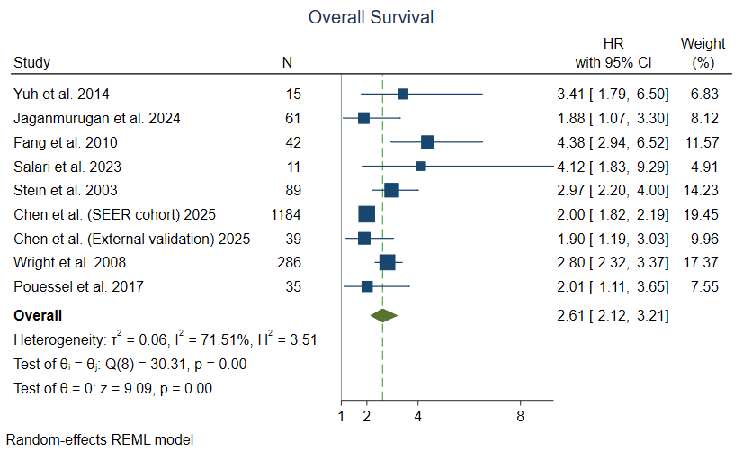
Supplementary Figure 1. Forest plot of the association between categorical lymph node density and overall survival in patients with bladder cancer after radical cystectomy (univariable data).

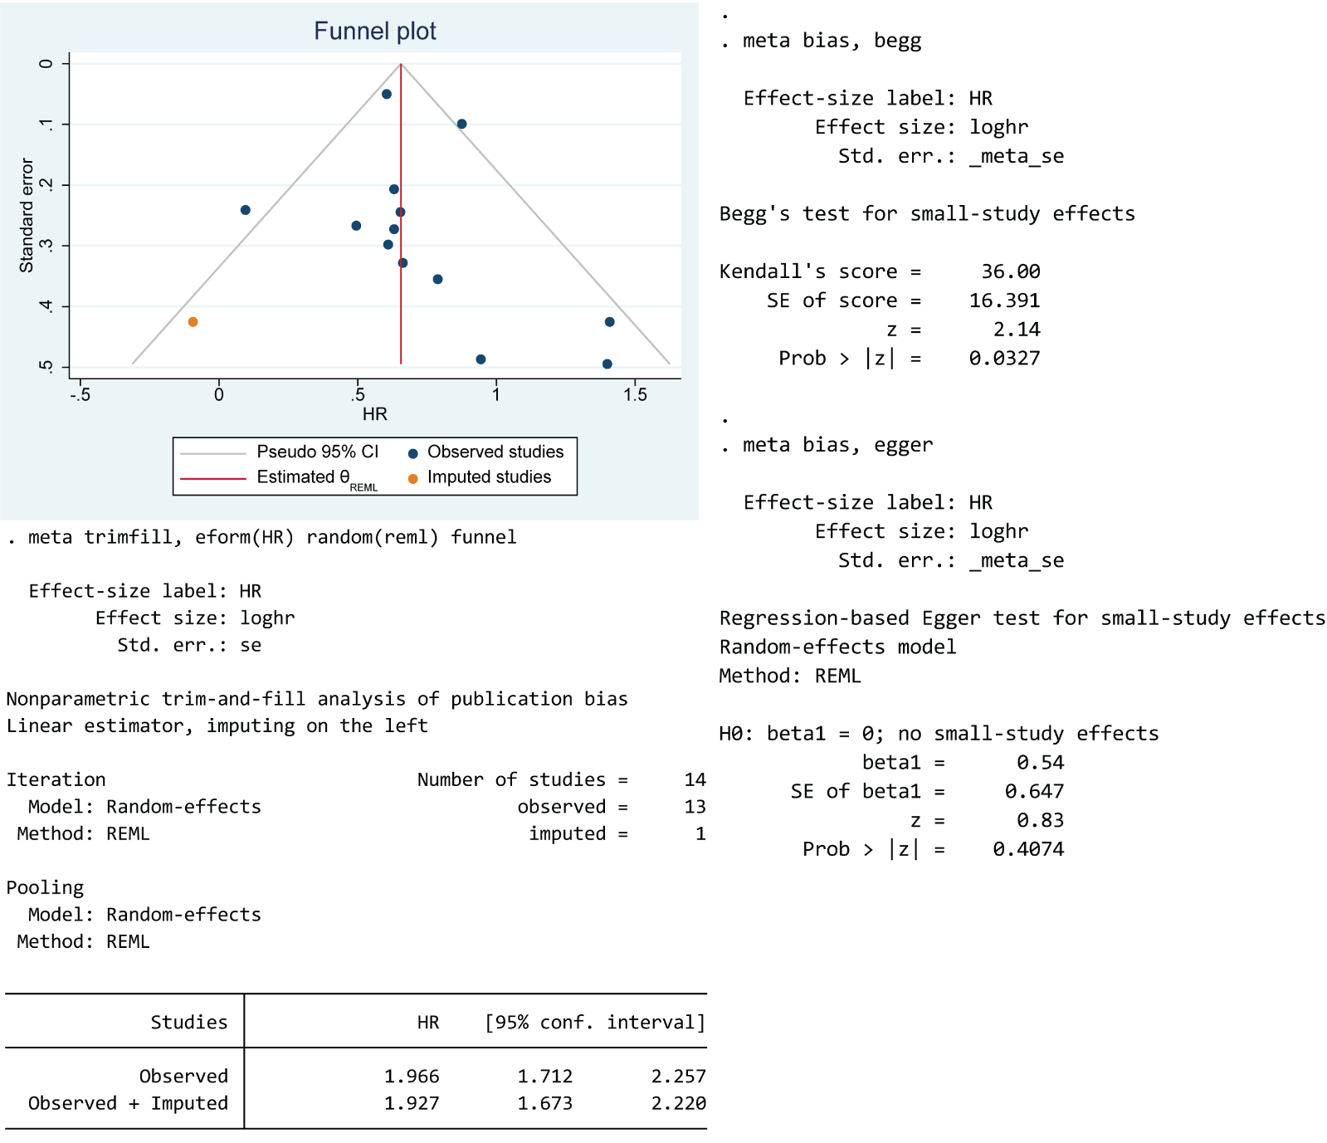
Supplementary Figure 2. Publication bias evaluation and sensitivity analysis for overall survival in patients with bladder cancer after radical cystectomy (categorical multivariable data).

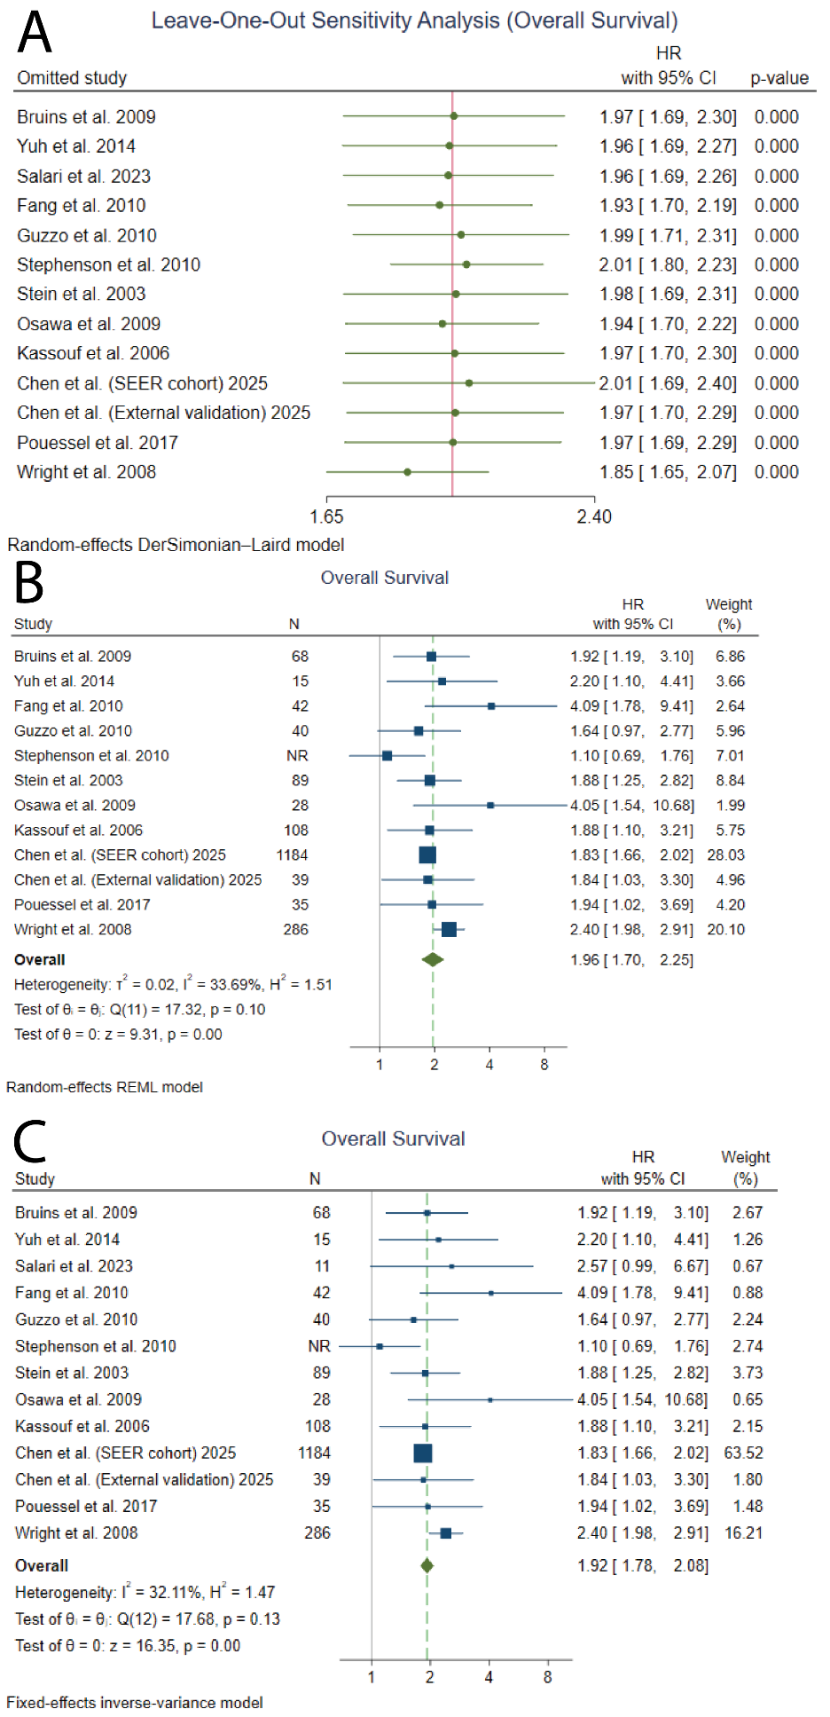
Supplementary Figure 3. Sensitivity analysis for overall survival in patients with bladder cancer after radical cystectomy (categorical multivariable data). A. Leave-One-Out sensitivity analysis. B. Sensitivity analysis excluding low-quality studies (NOS score ≤6). C. Fixed-effects model. NR: Not reported.

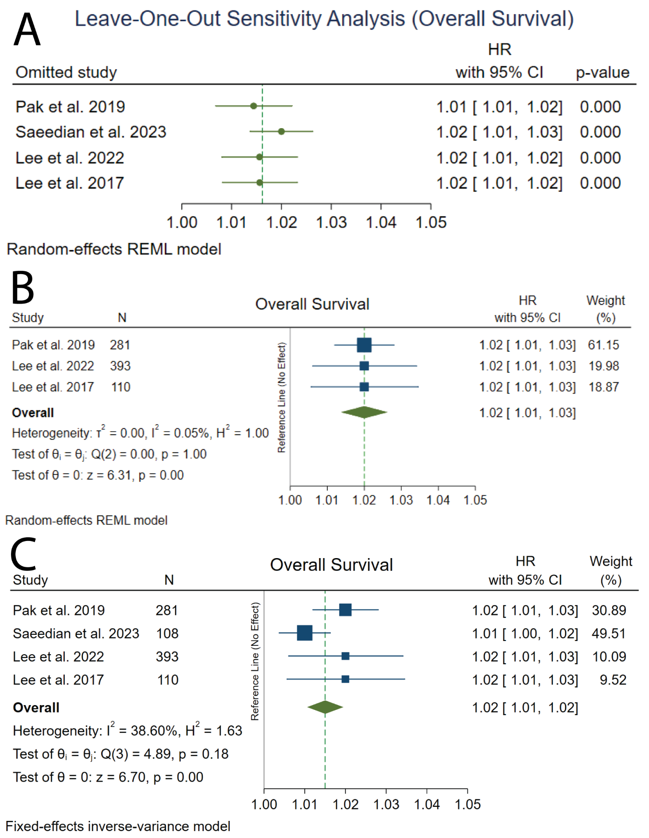
Supplementary Figure 4. Sensitivity analysis for overall survival in patients with bladder cancer after radical cystectomy (continuous multivariable data). A. Leave-One-Out sensitivity analysis. B. Sensitivity analysis excluding low-quality studies (NOS score ≤6). C. Fixed-effects model.

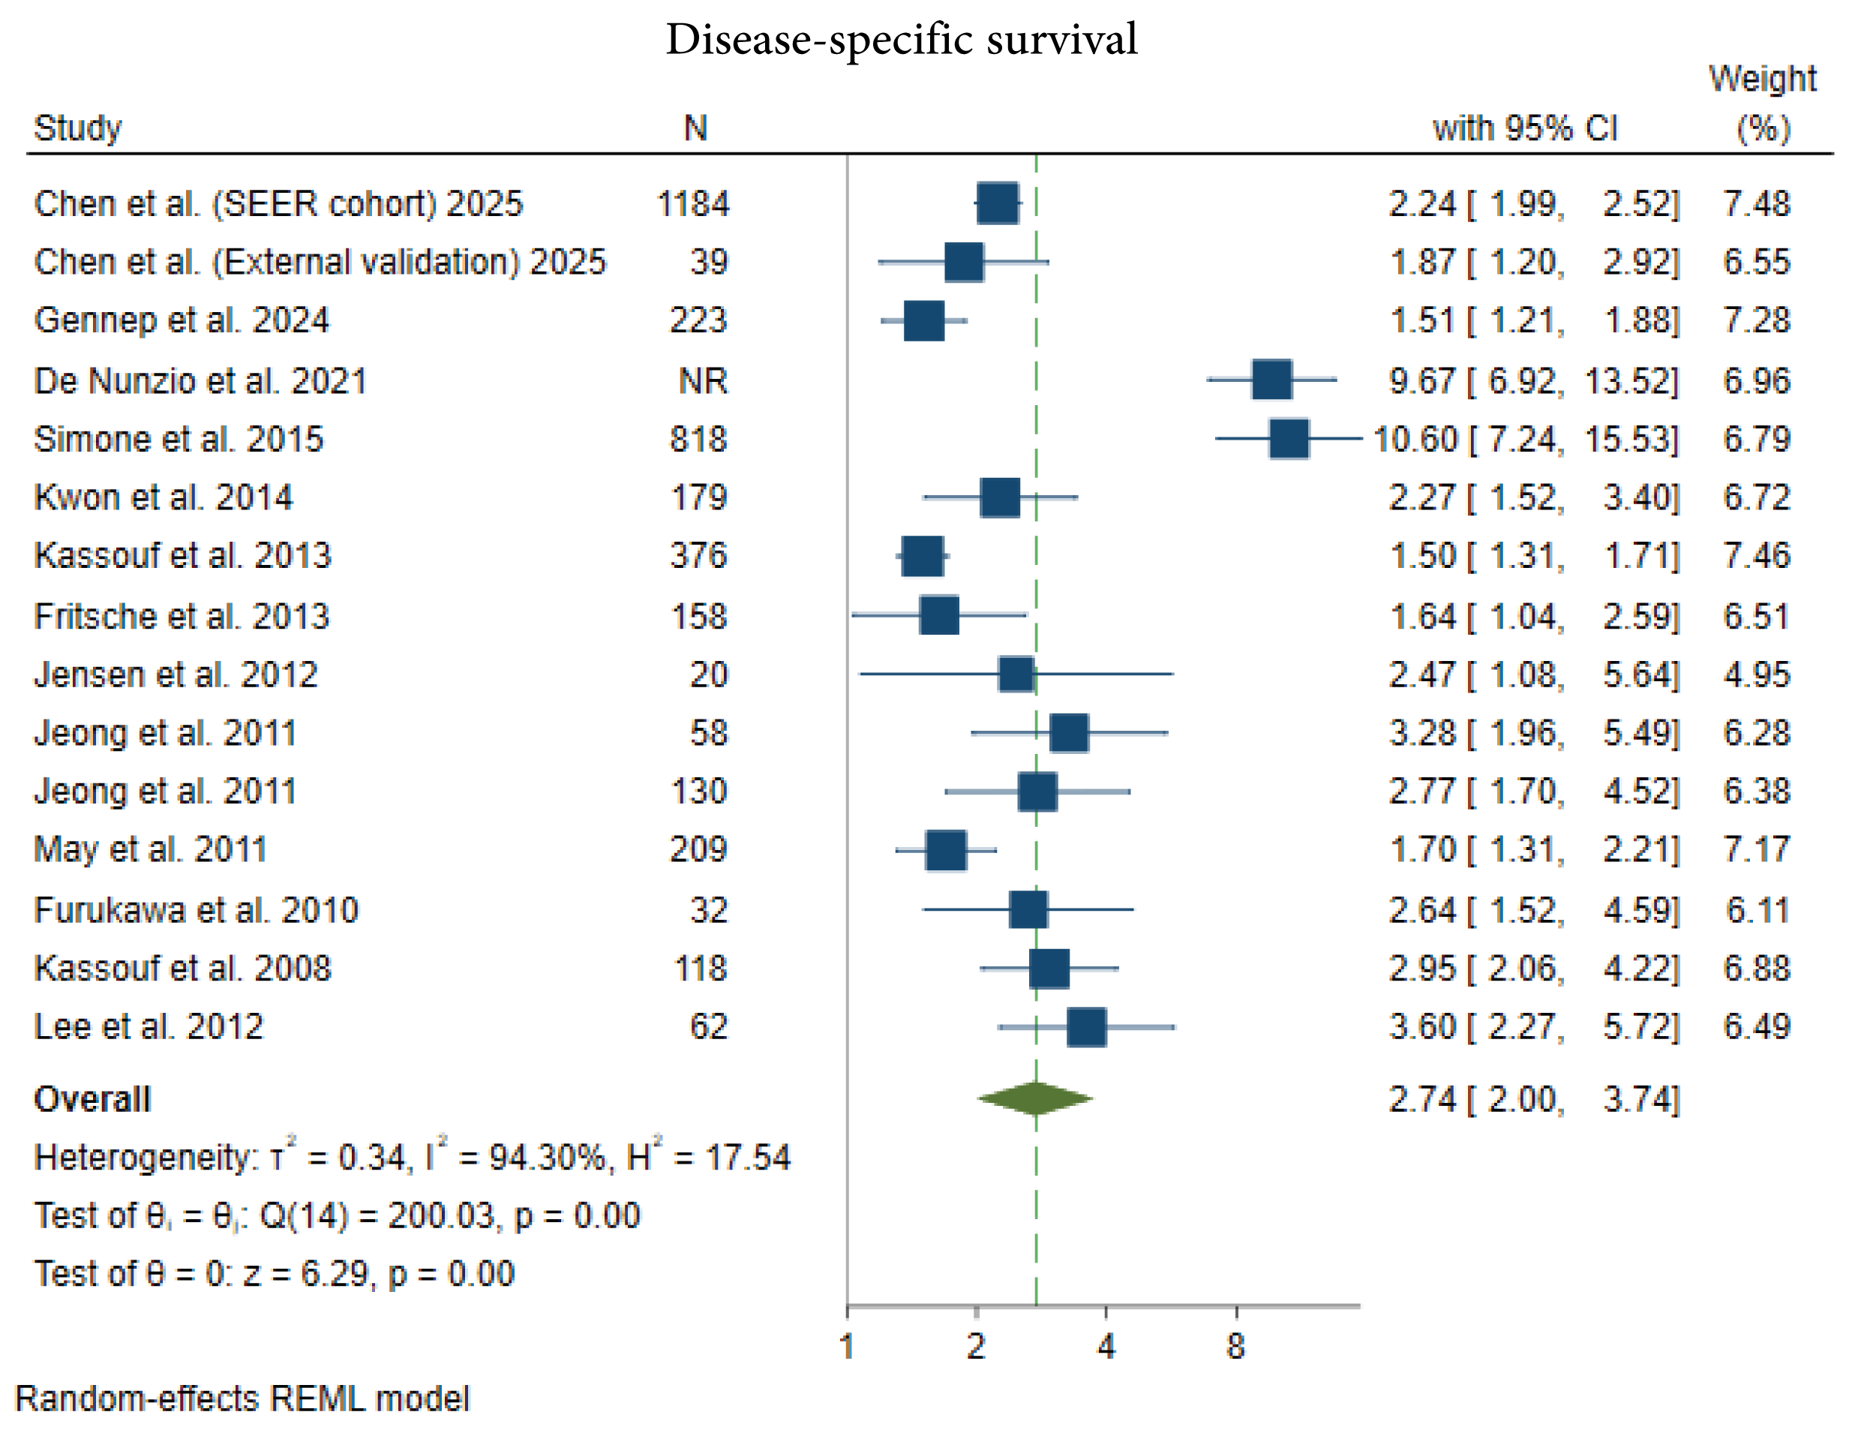Supplementary Figure 5. Forest plot of the association between categorical lymph node density and disease-specific survival in patients with bladder cancer after radical cystectomy (univariable data). NR: Not reported.

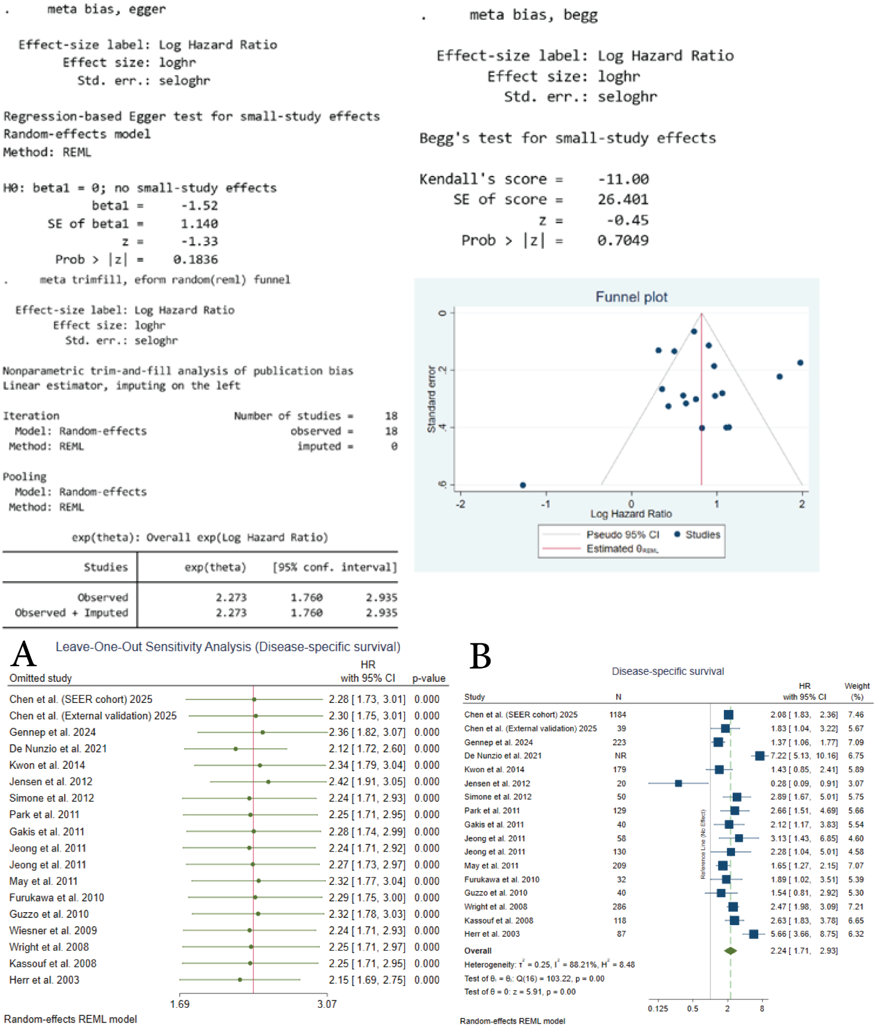Supplementary Figure 6. Publication bias evaluation and sensitivity analysis for disease-specific survival in patients with bladder cancer after radical cystectomy (categorical multivariable data). A. Leave-One-Out sensitivity analysis. B. Sensitivity analysis excluding low-quality studies (NOS score ≤6). NR: Not reported.

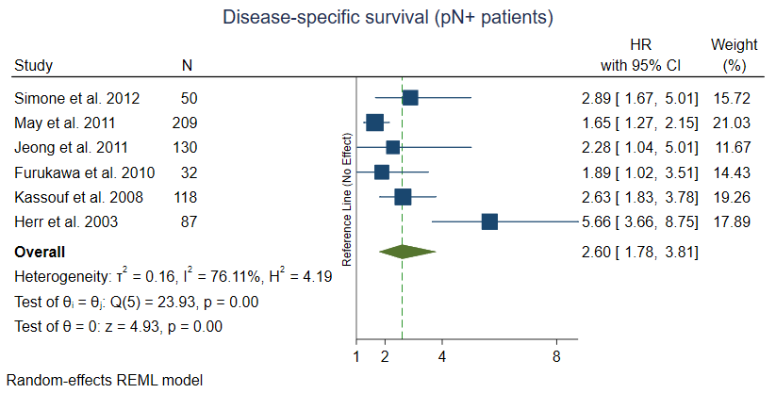
Supplementary Figure 7. Sensitivity analysis restricted to pathological node-positive (pN+) patients for disease-specific survival in patients with bladder cancer after radical cystectomy (categorical multivariable data).

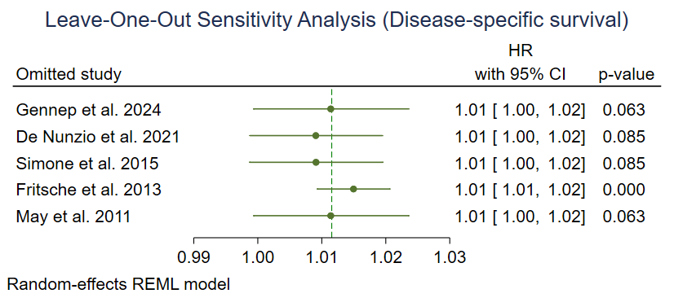
Supplementary Figure 8. Leave-One-Out sensitivity analysis for disease-specific survival in patients with bladder cancer after radical cystectomy (continuous multivariable data).

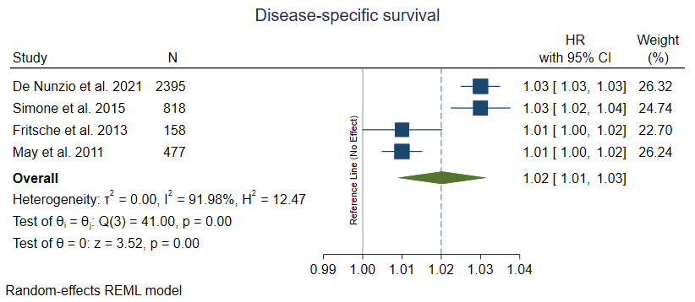Supplementary Figure 9. Forest plot of the association between continuous lymph node density and disease-specific survival in patients with bladder cancer after radical cystectomy (univariable data).
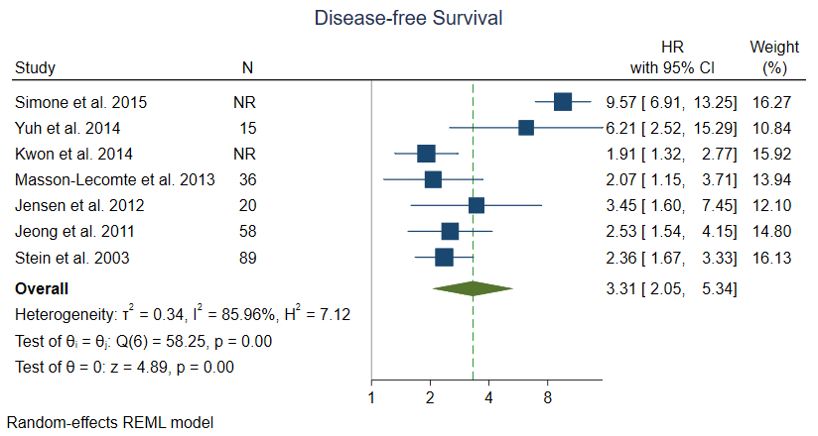
Supplementary Figure 10. Forest plot of the association between categorical lymph node density and disease-free survival in patients with bladder cancer after radical cystectomy (univariable data). NR: Not reported.

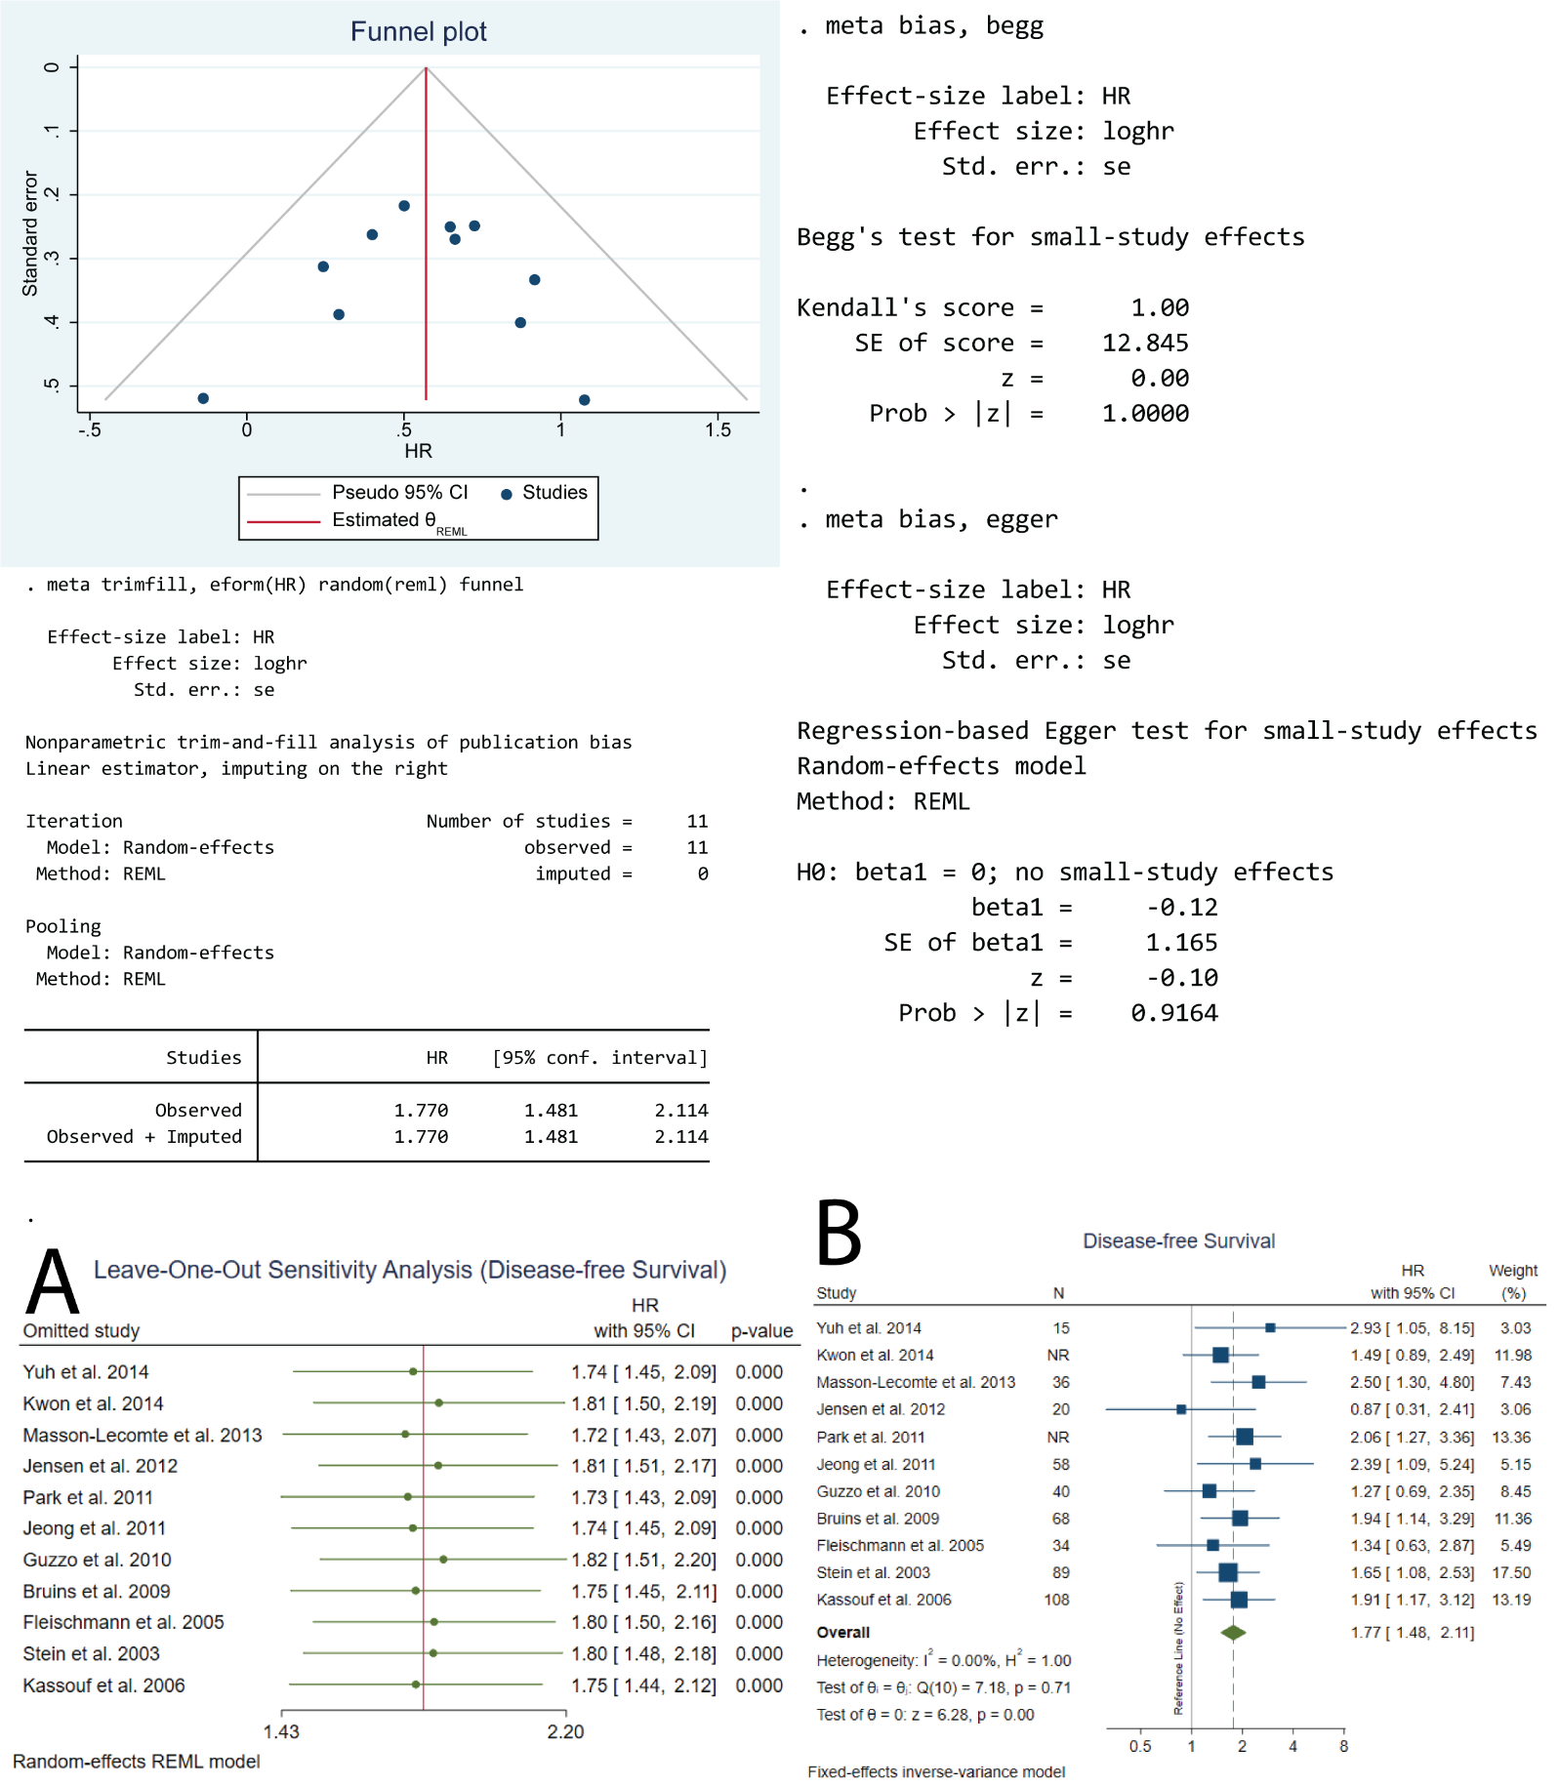
Supplementary Figure 11. Publication bias evaluation and sensitivity analysis for disease-free survival in patients with bladder cancer after radical cystectomy (categorical multivariable data). A. Leave-One-Out sensitivity analysis. B. Fixed-effects model. NR: Not reported.

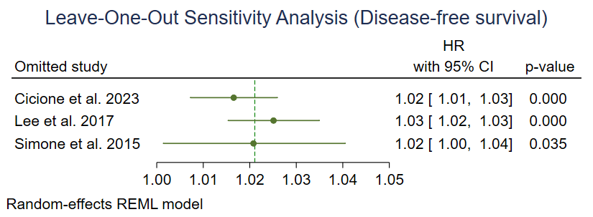
Supplementary Figure 12. Leave-One-Out sensitivity analysis for disease-free survival in patients with bladder cancer after radical cystectomy (continuous multivariable data).

References
1. Wells GA, Shea B, O’Connell D, et al. The Newcastle-Ottawa Scale (NOS) for assessing the quality of nonrandomised studies in meta-analyses. 2000;
2. Chen EC, Papa N, Lawrentschuk N, Bolton D, Sengupta S. Incidence and risk factors of venous thromboembolism after pelvic uro-oncologic surgery--a single center experience. BJU Int. Apr 2016;117 Suppl 4:50-3. doi:10.1111/bju.13238
3. Eismann L, Rodler S, Tamalunas A, et al. Computed-tomography based scoring system predicts outcome for clinical lymph node-positive patients undergoing radical cystectomy. International Braz J Urol. Jan-Feb 2022;48(1):89-98. doi:10.1590/s1677-5538.Ibju.2021.0329
4. Gallardo AC, Candela L, Rueda OB, et al. The Cancer of the Bladder Risk Assessment (COBRA) score accurately predicts cancer-specific survival after radical cystectomy: external validation and lymphovascular invasion assessment value to improve its performance. Clinical Genitourinary Cancer. Jun 2022;20(3):199-209. doi:10.1016/j.clgc.2021.12.010
5. Shin YS, Han K, Lee J, et al. Lymphatic embolization for early postoperative lymphatic leakage after radical cystectomy for bladder cancer. Article. PLoS ONE. 2024;19(9)doi:10.1371/journal.pone.0305240
6. Power NE, Kassouf W, Bell D, et al. Natural history of pT3-4 or node positive bladder cancer treated with radical cystectomy and no neoadjuvant chemotherapy in a contemporary North-American multi-institutional cohort. Article. Canadian Urological Association Journal. 2012;6(6):E217-E223. doi:10.5489/cuaj.119
7. Shariat SF, Ehdaie B, Rink M, et al. Clinical nodal staging scores for bladder cancer: A proposal for preoperative risk assessment. Article. European Urology. 2012;61(2):237-242. doi:10.1016/j.eururo.2011.10.011
8. Smith AB, Raynor MC, Pruthi RS. Peri- and postoperative outcomes of robot-assisted radical cystectomy (RARC). Bju International. Sep 2011;108(6B):969-975. doi:10.1111/j.1464-410X.2011.10456.x
9. Afferi L, Zamboni S, Karnes RJ, et al. The impact of treatment modality on survival in patients with clinical node-positive bladder cancer: results from a multicenter collaboration. Article. World Journal of Urology. 2021;39(2):443-451. doi:10.1007/s00345-020-03205-z
10. Al-Nader M, Krafft U, Darr C, et al. Impact of Extended Versus Limited Lymph Node Dissection on Surgical Outcome, Recurrence Patterns and Survival After Radical Cystectomy. Article. Clinical Genitourinary Cancer. 2025;23(3)doi:10.1016/j.clgc.2025.102337
11. Böyük A, Şanlı Ö, Erdem S, et al. The association between variant urothelial histologies, pathological stage and disease specific survival in patients with bladder cancer. Turk J Urol. Jan 2018;44(1):24-30. doi:10.5152/tud.2017.48107
12. DellʼOglio P, Tappero S, Panunzio A, et al. Age represents the main driver of surgical decision making in patients candidate to radical cystectomy. Article. Journal of Surgical Oncology. 2023;128(1):142-154. doi:10.1002/jso.27255
13. Domanowska E, Jozwicki W, Domaniewski J, et al. Muscle-invasive urothelial cell carcinoma of the human bladder: multidirectional differentiation and ability to metastasize. Human Pathology. May 2007;38(5):741-746. doi:10.1016/j.humpath.2006.11.001
14. Dorin RP, Daneshmand S, Eisenberg MS, et al. Lymph Node Dissection Technique Is More Important Than Lymph Node Count in Identifying Nodal Metastases in Radical Cystectomy Patients: A Comparative Mapping Study. European Urology. Nov 2011;60(5):946-952. doi:10.1016/j.eururo.2011.07.012
15. Eapen R, Liew MS, Tafreshi A, et al. Lymphadenectomy with radical cystectomy at an Australian tertiary referral institution: time trends and impact on oncological outcomes. Anz Journal of Surgery. Jul-Aug 2015;85(7-8):535-539. doi:10.1111/ans.12772
16. Faraj KS, Judge N, Chang YHH, Blodgett G, Stanton ML, Tyson MD. Variation in Lymph Node Yield after Radical Cystectomy. Article. American Journal of Clinical Pathology. 2021;156(3):391-398. doi:10.1093/ajcp/aqaa247
17. Ghazi A, Zimmermann R, Al-Bodour A, Shefler A, Janetschek G. Optimizing the Approach for Lymph Node Dissection during Laparoscopic Radical Cystectomy. European Urology. Jan 2010;57(1):71-78. doi:10.1016/j.eururo.2009.06.024
18. Gierth M, Fritsche HM, Buchner H, et al. Clinical and pathological nodal staging score for urothelial carcinoma of the bladder: An external validation. Article. World Journal of Urology. 2014;32(2):365-371. doi:10.1007/s00345-013-1105-4
19. Gschwend JE, Heck MM, Lehmann J, et al. Extended Versus Limited Lymph Node Dissection in Bladder Cancer Patients Undergoing Radical Cystectomy: Survival Results from a Prospective, Randomized Trial(Figure presented.). Article. European Urology. 2019;75(4):604-611. doi:10.1016/j.eururo.2018.09.047
20. Guru KA, Sternberg K, Wilding GE, et al. The lymph node yield during robot-assisted radical cystectomy. Bju International. Jul 2008;102(2):231-234. doi:10.1111/j.1464-410X.2008.07589.x
21. Heck MM, Koll FJ, Retz M, et al. Molecular lymph node staging for bladder cancer patients undergoing radical cystectomy with pelvic lymph node dissection. Urologic Oncology-Seminars and Original Investigations. Jul 2020;38(7)639.e11. doi:10.1016/j.urolonc.2020.01.018
22. Jensen JB, Ulhøi BP, Jensen KM. Lymph node mapping in patients with bladder cancer undergoing radical cystectomy and lymph node dissection to the level of the inferior mesenteric artery. BJU Int. Jul 2010;106(2):199-205. doi:10.1111/j.1464-410X.2009.09118.x
23. Jensen JB, Ulhøi BP, Jensen KM. Prognostic value of lymph-node dissection in patients undergoing radical cystectomy following previous oncological treatment for bladder cancer. Scand J Urol Nephrol. Dec 2011;45(6):436-43. doi:10.3109/00365599.2011.609832
24. Ji JX, Lai CH, Lai SC, et al. Prognostic Value of the Extent of Lymphadenectomy for Overall Survival Among Patients with Non-muscle Invasive Bladder Cancer, A Retrospective Cohort Study. Annals of Surgical Oncology. Jul 2025;doi:10.1245/s10434-025-17654-6
25. Kanno T, Ito K, Kita Y, et al. Impact of lymph node dissection during surgery on the efficacy of pembrolizumab in patients with metastatic urothelial carcinoma. Int J Urol. May 2025;32(5):593-597. doi:10.1111/iju.70002
26. Khadhouri S, Miller C, Cresswell J, et al. The British Association of Urological Surgeons radical cystectomy audit 2014/2015: An update on current practice, and an analysis of the effect of centre and surgeon case volume. Journal of Clinical Urology. Jan 2019;12(1):39-46. doi:10.1177/2051415818792448
27. Khanna A, Miest T, Sharma V, et al. Role of Lymphadenectomy during Radical Cystectomy for Nonmuscle-Invasive Bladder Cancer: Results from a Multi-Institutional Experience. Journal of Urology. Mar 2022;207(3):551-558. doi:10.1097/ju.0000000000002266
28. Lenis AT, Fero KE, Ojeaburu L, et al. The role of neoadjuvant chemotherapy, lymph node dissection, and treatment delay in patients with muscle-invasive bladder cancer undergoing partial cystectomy. Urologic Oncology-Seminars and Original Investigations. Aug 2021;39(8)doi:10.1016/j.urolonc.2021.01.016
29. Lenis AT, Lec PM, Michel J, et al. Predictors of adequate lymph node dissection in patients with non-muscle invasive bladder cancer undergoing radical cystectomy and effect on survival. Urologic Oncology-Seminars and Original Investigations. Oct 2020;38(10)doi:10.1016/j.urolonc.2020.04.027
30. Long GW, Hu ZQ, Liu Z, et al. Partial and radical cystectomy provides equivalent oncologic outcomes in bladder cancer when combined with adequate lymph node dissection: A population-based study. Urologic Oncology-Seminars and Original Investigations. Jul 2023;41(7):e1-e8. doi:10.1016/j.urolonc.2023.02.004
31. Mari A, Muto G, Di Maida F, et al. Oncological impact of inflammatory biomarkers in elderly patients treated with radical cystectomy for urothelial bladder cancer. Arab J Urol. Aug 26 2020;19(1):2-8. doi:10.1080/2090598x.2020.1814974
32. Marshall SJ, Hayn MH, Stegemann AP, et al. Impact of surgeon and volume on extended lymphadenectomy at the time of robot-assisted radical cystectomy: Results from the International Robotic Cystectomy Consortium (IRCC). Article. BJU International. 2013;111(7):1075-1080. doi:10.1111/j.1464-410X.2012.11583.x
33. Maruf M, Sidana A, Purnell S, Jain AL, Brancato SJ, Agarwal PK. Lymph node dissection during radical cystectomy following prior radiation therapy: results from the SEER database. International Urology and Nephrology. Feb 2018;50(2):257-262. doi:10.1007/s11255-017-1751-3
34. Mata DA, Groshen S, Von Rundstedt FC, et al. Variability in Surgical Quality in a Phase III Clinical Trial of Radical Cystectomy in Patients With Organ-Confined, Node-Negative Urothelial Carcinoma of the Bladder. Journal of Surgical Oncology. Jun 2015;111(7):923-928. doi:10.1002/jso.23903
35. Mazzone E, Preisser F, Nazzani S, et al. More Extensive Lymph Node Dissection Improves Survival Benefit of Radical Cystectomy in Metastatic Urothelial Carcinoma of the Bladder. Article. Clinical Genitourinary Cancer. 2019;17(2):105-113.e2. doi:10.1016/j.clgc.2018.11.003
36. Miguel CM, Kosinski KE, Fazzari MJ, et al. Pathologic measures of quality compare favorably in patients undergoing robot-assisted radical cystectomy to open cystectomy cohorts: a National Cancer Database analysis. Journal of Robotic Surgery. Aug 2020;14(4):609-614. doi:10.1007/s11701-019-01031-z
37. Moller MK, Hoyer S, Jensen JB. Extended versus superextended lymph-node dissection in radical cystectomy: subgroup analysis of possible recurrence-free survival benefit. Scandinavian Journal of Urology. Jun 2016;50(3):175-180. doi:10.3109/21681805.2015.1132473
38. Necchi A, Mariani L, Lo Vullo S, et al. Lack of Effectiveness of Postchemotherapy Lymphadenectomy in Bladder Cancer Patients with Clinical Evidence of Metastatic Pelvic or Retroperitoneal Lymph Nodes Only: A Propensity Score-based Analysis. Article. European Urology Focus. 2019;5(2):242-249. doi:10.1016/j.euf.2017.05.006
39. Orré M, Latorzeff I, Fléchon A, et al. Adjuvant radiotherapy after radical cystectomy for muscle-invasive bladder cancer: A retrospective multicenter study. Plos One. Apr 2017;12(4)e0174978. doi:10.1371/journal.pone.0174978
40. Pai A, Nair R, Ayres B, et al. Comparative outcomes of open and robotic-assisted radical cystectomy in an enhanced recovery programme era. Journal of Clinical Urology. May 2015;8(3):215-221. doi:10.1177/2051415814553650
41. Porreca A, Di Gianfrancesco L, Artibani W, et al. Robotic-assisted, laparoscopic, and open radical cystectomy: surgical data of 1400 patients from The Italian Radical Cystectomy Registry on intraoperative outcomes. Central European Journal of Urology. 2022;75(2):135-144. doi:10.5173/ceju.2022.0284
42. Rice KR, Koch MO, Kao CS, et al. Lymph node metastases in patients with urothelial carcinoma variants: Influence of the specific variant on nodal histology. Urologic Oncology-Seminars and Original Investigations. Jan 2015;33(1)20.e23. doi:10.1016/j.urolonc.2014.06.012
43. Struck JP, Hupe MC, Heinisch A, et al. RLC score (R status, lymphovascular invasion, C-reactive protein) predicts survival following radical cystectomy for muscle-invasive bladder cancer. Aktuelle Urologie. Dec 2022;53(06):545-551. doi:10.1055/a-1310-3583
44. Wang K, Shi H, Mao W, et al. Role of lymph node dissection in radical cystectomy. Article. Oncology Letters. 2020;20(1):409-419. doi:10.3892/ol.2020.11563
45. Xie W, Bi J, Wei Q, et al. Survival after radical cystectomy for bladder cancer: Multicenter comparison between minimally invasive and open approaches. Article. Asian Journal of Urology. 2020;7(3):291-300. doi:10.1016/j.ajur.2020.06.002
46. Yuk HD, Jeong CW, Kwak C, Kim HH, Ku JH. Lymphovascular invasion have a similar prognostic value as lymph node involvement in patients undergoing radical cystectomy with urothelial carcinoma. Scientific Reports. Oct 2018;815928. doi:10.1038/s41598-018-34299-6
47. Zennami K, Takahara K, Nukaya T, et al. The Role of Lymph Node Dissection in Patients With Muscle-Invasive Bladder Cancer Who Underwent Radical Cystectomy Following Neoadjuvant Chemotherapy. Clinical Genitourinary Cancer. Apr 2024;22(2):1-9. doi:10.1016/j.clgc.2023.06.016
48. Piotrowicz S, Poletajew S, Czarniecki SW, et al. Extent of lymphadenectomy in patients with bladder cancer undergoing radical cystectomy - a multi-institutional analysis. Central European Journal of Urology. 2016;69(4):323-326. doi:10.5173/ceju.2016.902
49. Brooks M, Godoy G, Sun M, Shariat SF, Amiel GE, Lerner SP. External Validation of Bladder Cancer Predictive Nomograms for Recurrence, Cancer-Free Survival and Overall Survival following Radical Cystectomy. J Urol. Feb 2016;195(2):283-9. doi:10.1016/j.juro.2015.08.093
50. Gandaglia G, Popa I, Abdollah F, et al. The effect of neoadjuvant chemotherapy on perioperative outcomes in patients who have bladder cancer treated with radical cystectomy: a population-based study. Eur Urol. Sep 2014;66(3):561-8. doi:10.1016/j.eururo.2014.01.014
51. Nuhn P, May M, Sun M, et al. External validation of postoperative nomograms for prediction of all-cause mortality, cancer-specific mortality, and recurrence in patients with urothelial carcinoma of the bladder. Eur Urol. Jan 2012;61(1):58-64. doi:10.1016/j.eururo.2011.07.066
52. Soria F, Pisano F, Gontero P, et al. Predictors of oncological outcomes in T1G3 patients treated with BCG who undergo radical cystectomy. World J Urol. Nov 2018;36(11):1775-1781. doi:10.1007/s00345-018-2450-0
53. Yafi FA, Aprikian AG, Chin JL, et al. Contemporary outcomes of 2287 patients with bladder cancer who were treated with radical cystectomy: a Canadian multicentre experience. BJU Int. Aug 2011;108(4):539-45. doi:10.1111/j.1464-410X.2010.09912.x
54. Yang Z, Bai Y, Liu M, Hu X, Han P. Development and validation of a prognostic nomogram for predicting cancer-specific survival after radical cystectomy in patients with bladder cancer:A population-based study. Cancer Med. Dec 2020;9(24):9303-9314. doi:10.1002/cam4.3535
55. Ma J, Gao B, Xiao P, Zhang Y, Wu D, An W. Tracing effect of new nano-carbon on pelvic lymph nodes of patients during laparoscopic radical cystectomy and its safety evaluation. Article. Journal of Jilin University Medicine Edition. 2019;45(3):582-586. doi:10.13481/j.1671-587x.20190319
56. Sataer X, Wang W, Li Q, Maitituerxun M, Rexiati M. Comparison of efficacy between extended pelvic lymph node dissection and standard pelvic lymph node dissection in open radical cystectomy. Article. Chinese Journal of Urology. 2019;40(3):188-193. doi:10.3760/cma.j.issn.1000-6702.2019.03.006
57. Hao H, Wu X, Zheng W, et al. Characteristics of lymph node metastasis in patients undergoing radical cystectomy for bladder cancer: a retrospective single-center study of 522 cases. Article. Beijing da xue xue bao Yi xue ban = Journal of Peking University Health sciences. 2014;46(4):524-527.
58. Liu XZ, Shen KH, Yan XD, et al. [Clinical significance of radical cystectomy with extended lymphadenectomy]. Article. Beijing da xue xue bao Yi xue ban = Journal of Peking University Health sciences. 2011;43(4):574-578.
59. Özcan MF, Gök B, Canda AE, Özdemir AT, Akbulut Z, Atmaca AF. Relationship Between Lymph Node Metastases and Pathological Stage in Bladder Cancer. Journal of Clinical and Analytical Medicine. Sep 2013;4(5):357-359. doi:10.4328/jcam.1104
60. Stein JP, Penson DF, Cai J, et al. Radical cystectomy with extended lymphadenectomy: Evaluating separate package versus en bloc submission for node positive bladder cancer. Journal of Urology. Mar 2007;177(3):876-881. doi:10.1016/j.juro.2006.10.043
61. Ather MH, Alam Z, Jamshaid A, Siddiqui KM, Sulaiman MN. Separate submission of standard lymphadenectomy in 6 packets versus en bloc lymphadenectomy in bladder cancer. Article. Urology journal. 2008;5(2):94-98.
62. Dharaskar A, Kumar V, Kapoor R, Jain M, Mandhani A. Does extended lymph node dissection affect the lymph node density and survival after radical cystectomy? Indian Journal of Cancer. Apr-Jun 2011;48(2):230-233. doi:10.4103/0019-509x.82896
63. Elabbady A, Hashad MM, Kotb AF, Abdullah DM, Beltagy A. Lymph node density in muscle-invasive transitional cell carcinoma of the urinary bladder; De novo versus progressive disease. International Journal of Health Sciences-Ijhs. Jul-Aug 2017;11(3):24-28.
64. Hadjizacharia P, Stein JP, Cai J, Miranda G. The impact of positive soft tissue surgical margins following radical cystectomy for high-grade, invasive bladder cancer. World Journal of Urology. Feb 2009;27(1):33-38. doi:10.1007/s00345-008-0345-1
65. Meijer RPP, Nunnink CJM, Wassenaar AE, et al. Standard Lymph Node Dissection for Bladder Cancer: Significant Variability in the Number of Reported Lymph Nodes. Journal of Urology. Feb 2012;187(2):446-450. doi:10.1016/j.juro.2011.10.029
66. Muilwijk T, Akand M, Soria F, et al. The Cancer of the Bladder Risk Assessment (COBRA) score for estimating cancer-specific survival after radical cystectomy: external validation in a large bi-institutional cohort. Article. BJU International. 2020;126(6):704-714. doi:10.1111/bju.15163
67. Oszwald A, Wasinger G, Larnaudie L, et al. Pathological reporting of cystectomy lymph nodes: a retrospective analysis of experience in Paris. World Journal of Urology. Nov 2021;39(11):4029-4035. doi:10.1007/s00345-021-03630-8
68. Rouanne M, Girma A, Neuzillet Y, et al. Potential impact of 18F-FDG PET/CT on patients selection for neoadjuvant chemotherapy before radical cystectomy. Article. European Journal of Surgical Oncology. 2014;40(12):1724-1730. doi:10.1016/j.ejso.2014.08.479
69. Sasaki Y, Daizumoto K, Fukuta K, et al. Lymph node dissection during radical cystectomy for bladder cancer: A two-center comparative study of robotic versus open surgery. Asian Journal of Endoscopic Surgery. Oct 2023;16(4):724-730. doi:10.1111/ases.13234
70. Sasaki Y, Izumi K, Fukuta K, et al. Impact of lymph node dissection on surgical and oncological outcomes in patients undergoing robot-assisted radical cystectomy for bladder cancer: a multicenter retrospective study. Journal of Robotic Surgery. Mar 2024;18(1)141. doi:10.1007/s11701-024-01893-y
71. Siemens DR, Mackillop WJ, Peng Y, et al. Processes of care and the impact of surgical volumes on cancer-specific survival: A population-based study in bladder cancer. Article. Urology. 2014;84(5):1049-1056. doi:10.1016/j.urology.2014.06.070
72. Wang S, Zhang DH, Bai YC, Liu F, Qi XL, Xie LP. Clinical Outcomes of Pelvic Lymph Node Dissection Before Versus After Robot-Assisted Laparoscopic Radical Cystectomy. Journal of Laparoendoscopic & Advanced Surgical Techniques. Aug 2023;33(8):776-781. doi:10.1089/lap.2023.0118
73. Zehnder P, Moltzahn F, Mitra AP, et al. Radical cystectomy with super-extended lymphadenectomy: Impact of separate vs en bloc lymph node submission on analysis and outcomes. Article. BJU International. 2016;117(2):253-259. doi:10.1111/bju.12956
74. Kölükçü E, Atilgan D, Kuyucu YE, Özbek LM, Unsal V. Relationship Between Lymph Node Metastasis and Lymph Node Density and Preoperative Neutrophil-Lymphocyte Ratio in Patients Undergoing Radical Cystectomy. Uroonkoloji Bulteni-Bulletin of Urooncology. Sep 2021;20(3):168-173. doi:10.4274/uob.galenos.2021.1809
75. Pedrosa JA, Kaimakliotis HZ, Monn MF, et al. Critical analysis of the 2010 TNM classification in patients with lymph node-positive bladder cancer: influence of lymph node disease burden. Urol Oncol. Oct 2014;32(7):1003-9. doi:10.1016/j.urolonc.2014.04.002
76. Dong F, Shen Y, Gao F, et al. Nomograms to predict individual prognosis of patients with primary small cell carcinoma of the bladder. Article. Journal of Cancer. 2018;9(7):1152-1164. doi:10.7150/jca.23344
77. Liu P, Xu L, Chen GH, Shi BK, Zhang QJ, Chen SZ. Nomograms for predicting survival in patients with micropapillary bladder cancer: a real-world analysis based on the surveillance, epidemiology, and end results database and external validation in a tertiary center. Bmc Urology. Feb 2023;23(1)16. doi:10.1186/s12894-023-01183-z
78. Ma T, Wang X, Tian Z, et al. Nomograms to predict individual prognosis of patients with primary signet ring cell carcinoma of the urinary bladder. Article. Translational Cancer Research. 2021;10(9):3948-3962. doi:10.21037/tcr-21-929
79. Siemens DR, Mackillop WJ, Peng Y, Wei X, Berman D, Booth CM. Lymph node counts are valid indicators of the quality of surgical care in bladder cancer: A population-based study. Article. Urologic Oncology: Seminars and Original Investigations. 2015;33(10):425.e15-425.e23. doi:10.1016/j.urolonc.2015.06.005
80. Zhang G, Li Z, Song D, Fang Z. Nomograms to predict individual prognosis of patients with squamous cell carcinoma of the urinary bladder. Article. BMC Cancer. 2019;19(1)doi:10.1186/s12885-019-6430-6
81. Lange S, Calleris G, Matin SF, Rouprêt M. Optimizing Lymph Node Dissection at the Time of Nephroureterectomy for High-risk Upper Tract Urothelial Carcinoma. Eur Urol Focus. Mar 2023;9(2):280-282. doi:10.1016/j.euf.2023.01.001
82. Froehner M, Koch R, Heberling U, et al. Decreased Overall and Bladder Cancer-Specific Mortality with Adjuvant Chemotherapy After Radical Cystectomy: Multivariable Competing Risk Analysis. Eur Urol. Jun 2016;69(6):984-7. doi:10.1016/j.eururo.2015.06.053

