Supplementary Figures and Tables

Plasma Biomarkers and Long-Term Survival in Head and Neck Squamous Cell Carcinoma Patients: Insights from EGF, VEGF, IL-4, IL-6, IL-8 and MCP-1 at Diagnosis
Svein Erik Emblem Moe, Helene Hersvik Aarstad, Fredrik Erland, Stein Lybak and Hans Jørgen Aarstad

Supplementary Table S1: Concentration and Quartile Values of Measured Cytokines and Growth Factors. The table displays the concentrations of quartile values (25th percentile, median and 75th percentile) as well as minimum and maximum values determined for the measured cytokines and growth faactors in our assay. All values are reported in picograms per milliliter (pg/mL). Differences between the groups, shown in rightmost column, were analyzed using the Mann-Whitney U test.

Analyte | Minimum | 25th Perc. (pg/mL) | Median (pg/mL) | 75th Perc. (pg/mL) | Maximum | HPV(−) versus HPV(+)
IL-6 | 0.20 | 1.35 | 1.88 | 2.93 | 45.03 | p = 0.14
IL-4 | 0 | 0 | 0 | 0 | 14.93 | p = 0.75
MCP-1 | 16.23 | 64.85 | 86.94 | 108.55 | 220.01 | p = 0.92
IL-8 | 0 | 0 | 0.80 | 2.26 | 25.70 | p = 0.67
VEGF | 5.31 | 19.59 | 28.61 | 45.46 | 775.97 | p = 0.14
EGF | 0.16 | 1.05 | 1.52 | 2.29 | 106.67 | p = 0.73

Supplementary Table S2: Correlation Matrix for HPV(+) and HPV(−).
This table displays the correlation matrices comparing HPV(−) (lower triangle) and HPV(+) (upper triangle). Positive correlations are indicated by blue shades, while negative correlations are indicated by red shade. Only correlation coefficients with a p-value < 0.05 are included.
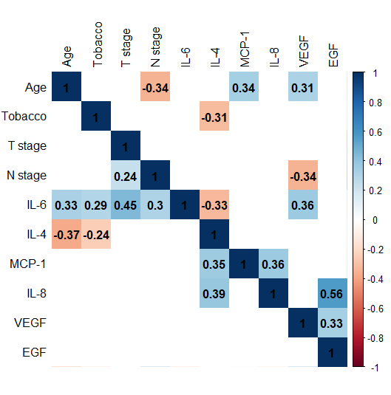

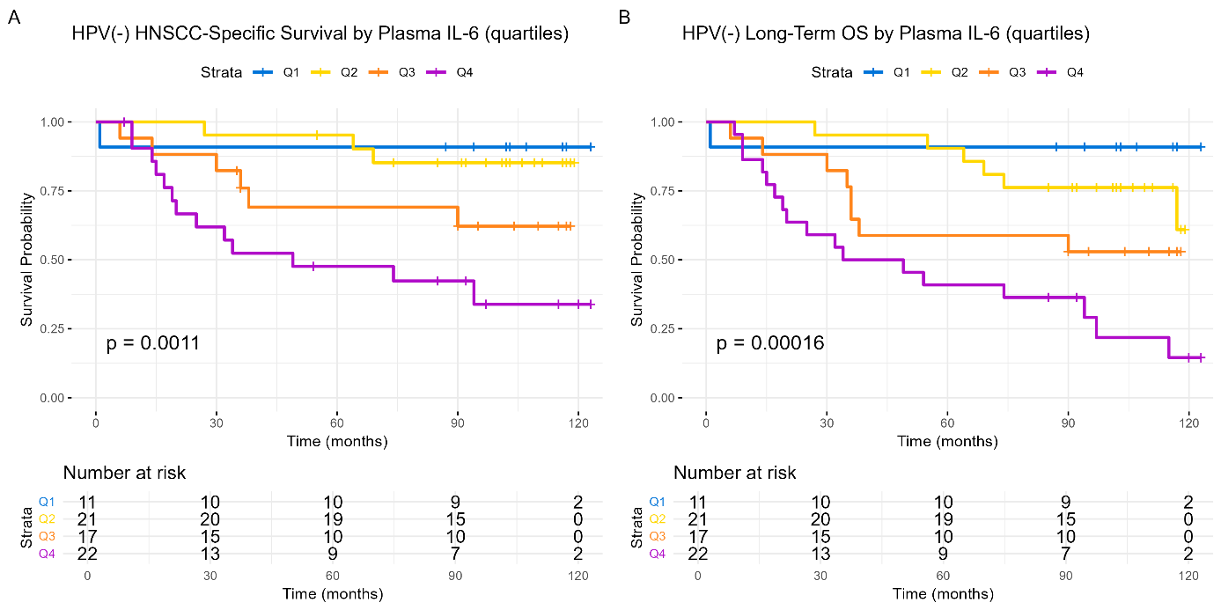

Supplementary Figure S3 Kaplan-Meier prognosis from the pretreatment levels of IL-6 on long-term HNSCC-specific survival and long-term Overall Survival (OS) by quartiles for the HPV(−) cohort.
(A). Long-term HNSCC-specific survival. IL-6 levels are presented as quartiles with Q1(blue), Q2 (yellow), Q3 (orange) and Q4 (purple).
(B) Long-term OS. IL-6 levels are presented as quartiles with Q1(blue), Q2 (yellow), Q3 (orange) and Q4 (purple). The numbers at risk are indicated at the bottom of the graph. The Y-axis represents the probability of survival and X-axis denotes the time in months. Differences between the groups are examined with log-rank tests and presented with p values.

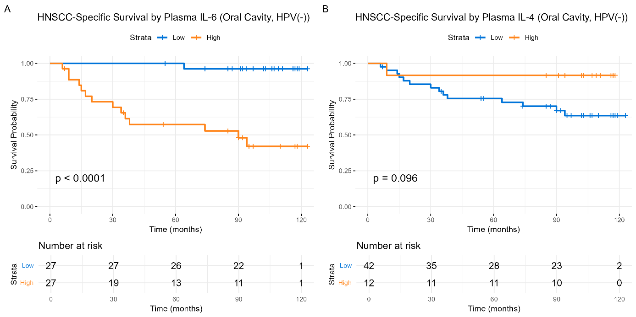

Supplementary Figure S4 Kaplan-Meier curves of long-term HNSCC-specific survival by pretreatment levels of IL-6 and IL-4 in the oral cavity HPV(−) cohort .
(A). Long-term HNSCC-specific survival by IL-6. in oral cavity HPV(−) cohort.
(B). Long-term HNSCC-specific survival by IL-4 in oral cavity HPV(−) cohort.
IL-6 and IL-4 levels are presented as dichotomized values with low values (blue) and high values (orange). The numbers at risk are indicated at the bottom of the graph. The Y-axis represents the probability of survival and X-axis denotes the time in months. Differences between the groups are examined with log-rank tests and presented with p values.

