Ocular Surface Disease Index, Questionnaire and Protocol

Name: attach autokeratometry Sex/Age:
Best Corrected Visual Acuity (BCVA)
Rt. :
Lt. :

Slit Lamp Examination
Lid : cilio-corneal touch (-/-)
Conjunctiva : papilla (-/-) follicle (-/-) injection (-/-)
Cornea : erosion (-/-)
Lens : (-/-)
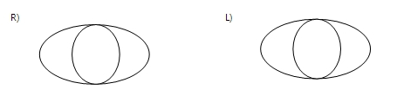
Tear Break Up Time (TBUT)
Rt. : sec
Lt. : sec
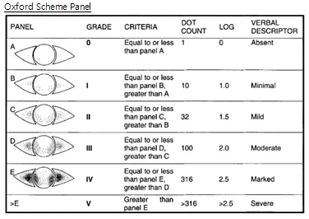
Punctate Epithelial Erosion (PEE) Grade
Rt. :
Lt. :
Strabismus: ortho/ XT/ X/ ET/ E
Ocular Surface Disease Index (OSDI)

Have you experienced any of the following during the last week?

 | All of the time | Most of the time | Half of the time | Some of the time | None of the time
Eyes that are sensitive to light? | 4 | 3 | 2 | 1 | 0
Eyes that feel gritty? | 4 | 3 | 2 | 1 | 0
Painful or sore eyes? | 4 | 3 | 2 | 1 | 0
Blurred vision? | 4 | 3 | 2 | 1 | 0
Poor vision? | 4 | 3 | 2 | 1 | 0
Dryness? | 4 | 3 | 2 | 1 | 0
Tearing? | 4 | 3 | 2 | 1 | 0
Red eye or injection? | 4 | 3 | 2 | 1 | 0
Fatigue or headache? | 4 | 3 | 2 | 1 | 0

Subtotal score for answers = (A)

Have problems with your eyes limited you in performing any of the following during the last week?

 | All of the time | Most of the time | Half of the time | Some of the time | None of the time | N/A
Reading? | 4 | 3 | 2 | 1 | 0 | N/A
Use smartphone? | 4 | 3 | 2 | 1 | 0 | N/A
Use computer? | 4 | 3 | 2 | 1 | 0 | N/A
Watching television? | 4 | 3 | 2 | 1 | 0 | N/A

Subtotal score for answers = (B)

Have your eyes felt uncomfortable in any of the following situations during the last week?

 | All of the time | Most of the time | Half of the time | Some of the time | None of the time | N/A
Windy condition? | 4 | 3 | 2 | 1 | 0 | N/A
Areas with low humidity? | 4 | 3 | 2 | 1 | 0 | N/A
Areas that are air conditioned? | 4 | 3 | 2 | 1 | 0 | N/A
Subtotal score for answers = (C)

Add subtotals A, B, and C to obtain D (D = sum of scores for all questions answered) = (D)

OSDI Score = (D) x 100 / (# of question answered) x 4 = ( )

Ophthalmologic Questionnaire

Please put in a tick in the box √ next to the answer of your choice.

- Medical treatment in ophthalmologic clinic?
Yes □
No □
- Diagnosis?
Strabismus □
Amblyopia □
Refractive error □
Allergic conjunctivitis □
Viral conjunctivitis □
Trichiasis □
Etc □
N/A □
- Use glass?
Yes □ during ( ) years
No □
- Lagophthalmos?
Yes □
No □
- Have atopic disease?
Yes □
No □
- Have allergic disease (rhinitis, conjunctivitis, dermatitis)?
Yes □
No □
- Received medical treatment for allergic disease?
Yes □
No □
- Use ophthalmic solution for allergic conjunctivitis?
Yes □
No □
- Itching sensation?
All of the time □
Most of the time □
Half of the time □
Some of the time □
None of the time □
- Use smartphone?
Yes □ go No. 11
No □ go No. 12
- Mean daily duration of smartphone use?
0-1 hours □
1-2 hours □
2-3 hours □
3- hours □
- Mean daily duration of personal computer use?
0-1 hours □
1-2 hours □
2-3 hours □
3- hours □
- Mean daily duration of watching television?
0-1 hours □
1-2 hours □
2-3 hours □
3- hours □
- Mean daily duration of sleeping?
0-6 hours □
6-7 hours □
7-8 hours □
8-9 hours □
9- hours □
- Mean daily duration of outdoor activitiy?
0-1 hours □
1-2 hours □
2-3 hours □
3- hours □
- Mean daily duration of learning?
0-1 hours □
1-2 hours □
2-3 hours □
3- hours □

